Image Recognition

Introduction:- This program helps sort images by finding ones that look similar. It checks how much a new image looks like existing ones using patterns and visual features. If it finds a match, it puts the new image in the same folder as the matching ones. If no match is found, it creates a new folder for it. It also creates a report showing how similar the new image is to each existing one.

Steps to set up the environment :-

1. Install Visual Studio Code (VS Code)/You can use any other code editor:
Go to https://code.visualstudio.com/ and click "Download for Windows".
Run the downloaded file and follow the setup process.
Accept the license, choose an install location, and continue.
When asked, check the boxes for "Add to PATH" and "Register Code as an editor".
Click Install, then Finish to launch VS Code.

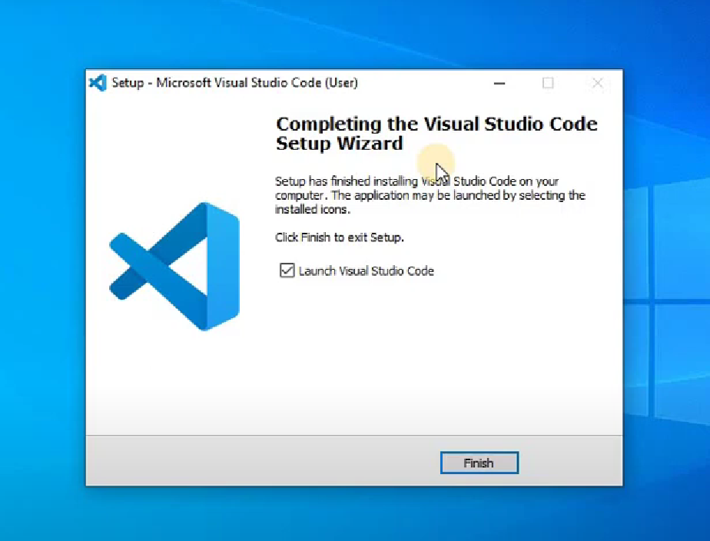

2. Install Python:
Go to https://www.python.org/downloads/ and click "Download Python".
Run the installer file.
Check the box that says "Add Python to PATH" before clicking "Install Now".
Wait for the installation to complete.
Open Command Prompt and type python --version to verify Python is installed.
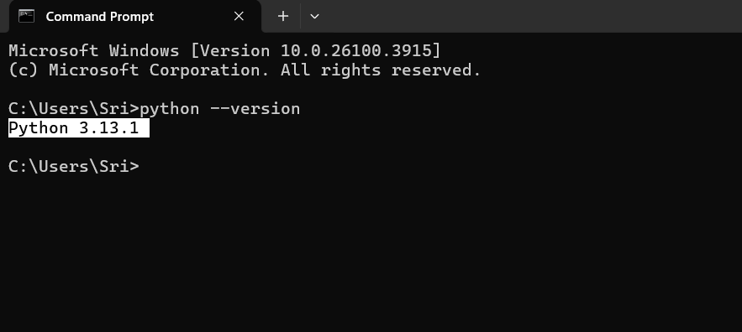

3. Add Python to VS Code:
Open Visual Studio Code.
Go to the Extensions tab on the left.
Search for "Python" and install the one published by Microsoft.
Open or create a Python file, press Ctrl+Shift+P, and select "Python: Select Interpreter".
Choose the Python version you installed.

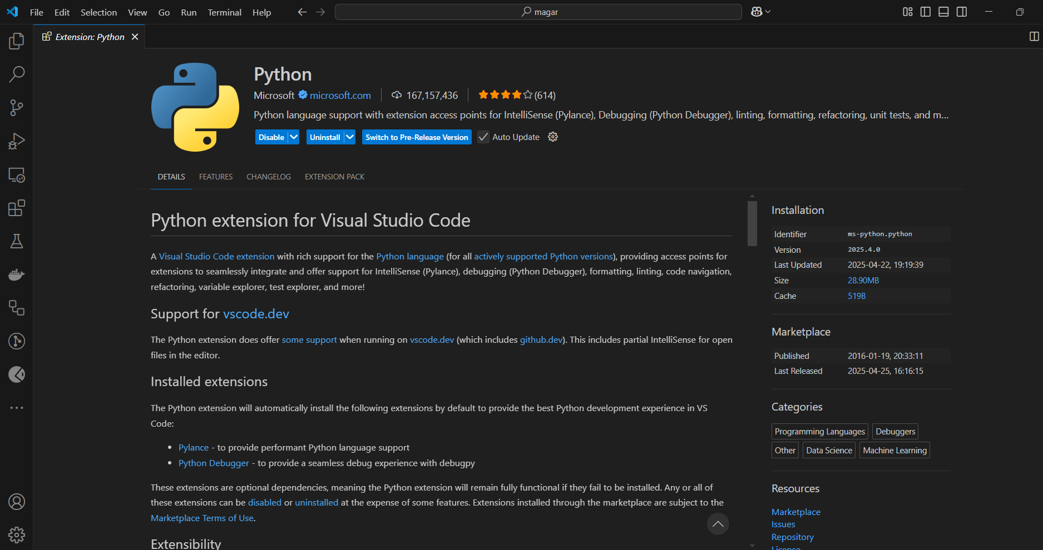

4. Install Required Python Packages:
In VS Code, open the Terminal by clicking Terminal > New Terminal or pressing Ctrl+`.
Type the following command and press Enter:

pip install opencv-python opencv-contrib-python numpy scikit-image ImageHash Pillow

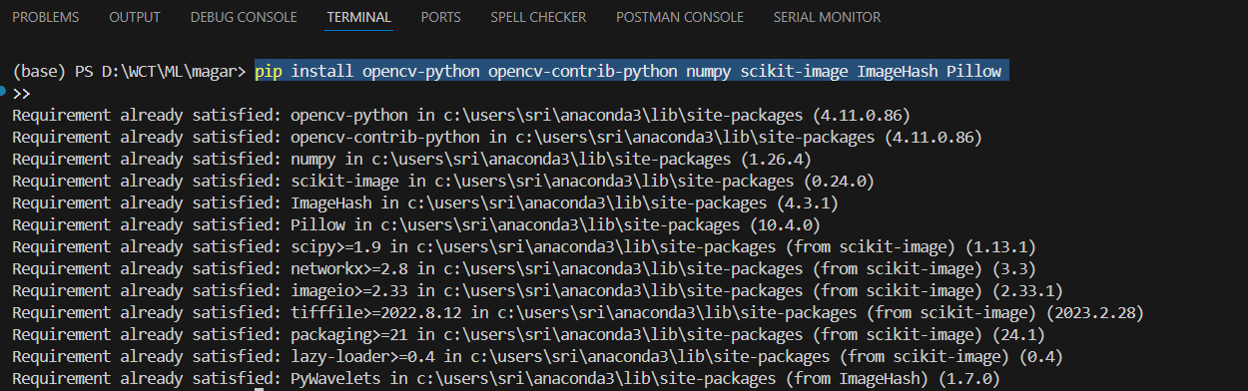

Steps to run the code :-

1.Open the code in VisualStudio Code :- By right clicking on the python file and hover over “Open With” and select “Visual Studio Code”

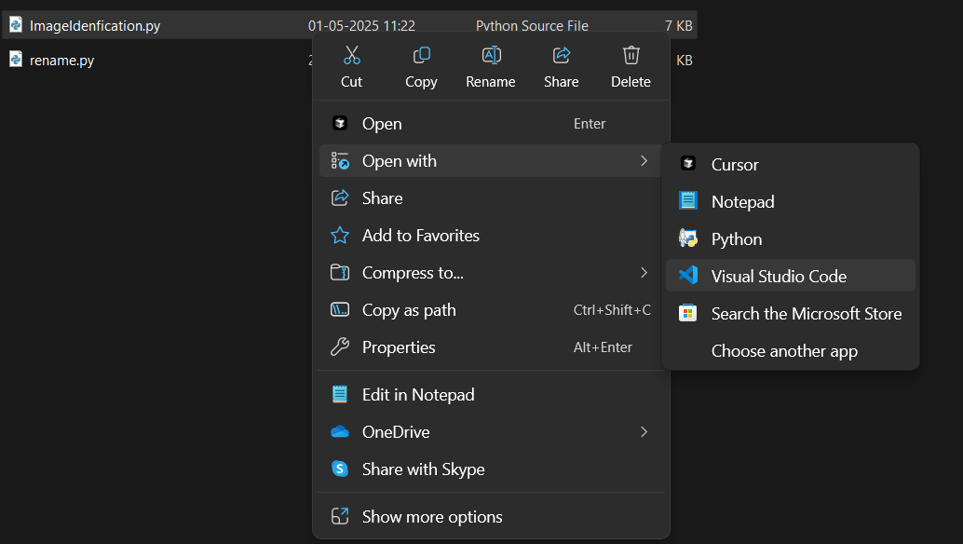

2. Set the path of your target folder:-

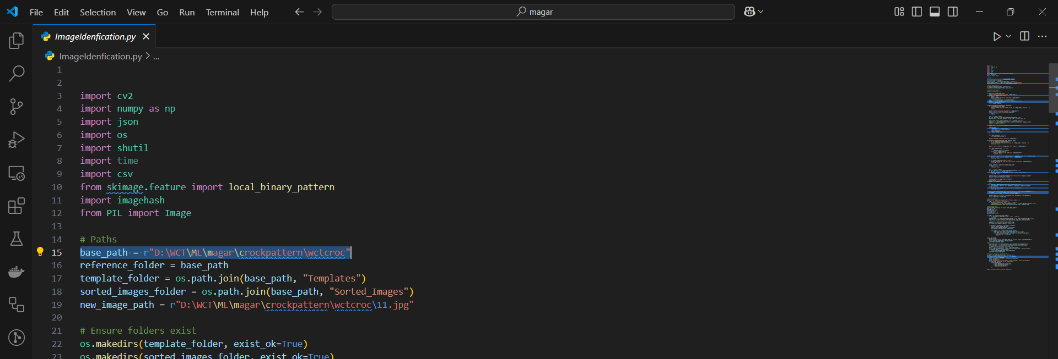

3.Select path of reference image:-

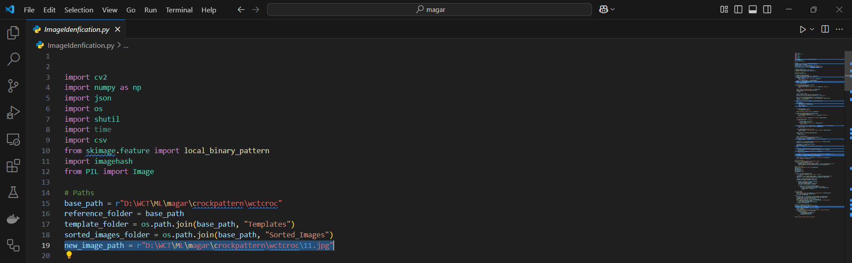

4.Set the threshold between 0.0 to 0.5 , the lower you go the more accuracy :-

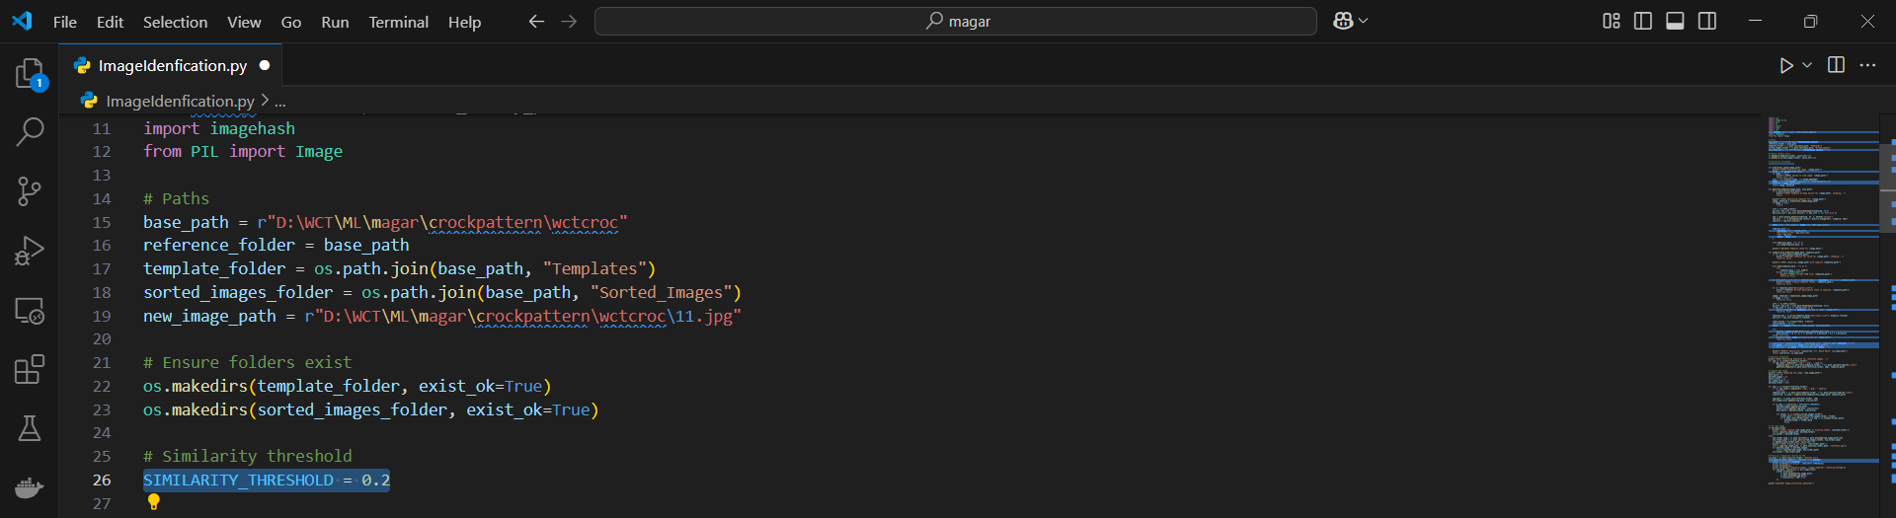

5. Run the code on the top right side :-

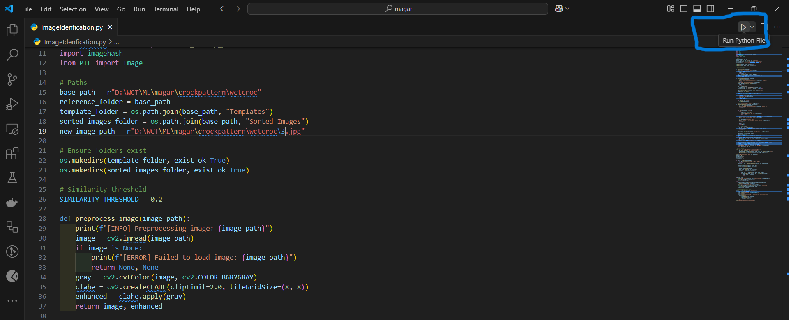

6.Enter the location of your target folder once your code has run and click on the folder called “Sorted Images”.

Note :- The first time you run the code it’s going to take time to run as it will first create template for each file.

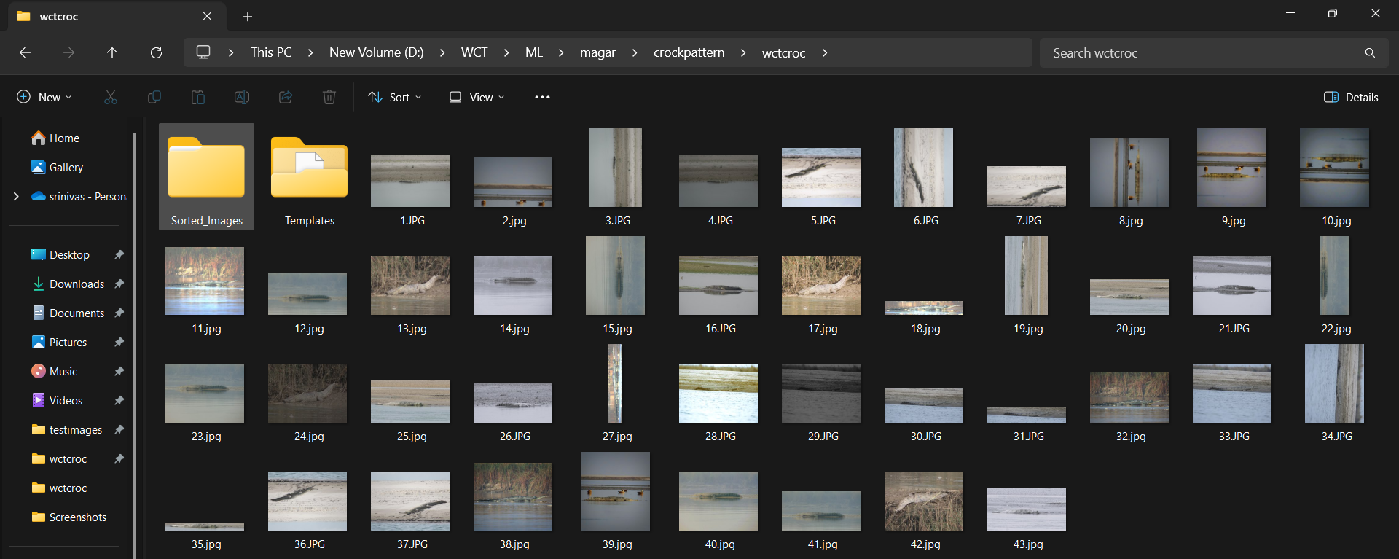

7. Inside the “Sorted Images” you would find a folder with the name same as your reference image . Enter that folder.

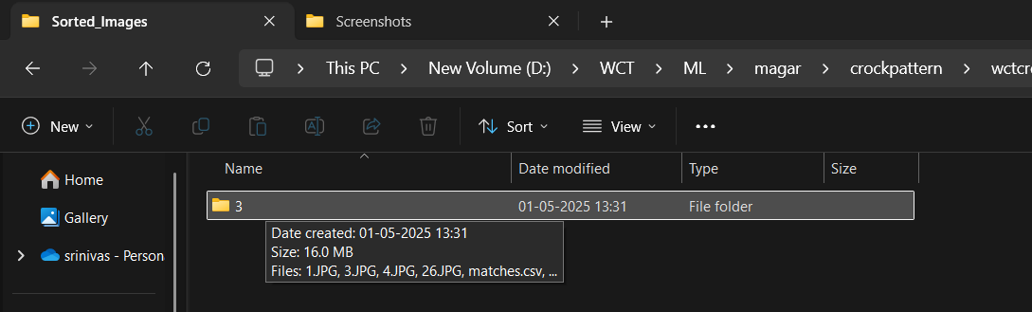

8. Inside the folder you would find all the similar images and your reference image being renamed as “reference image”.

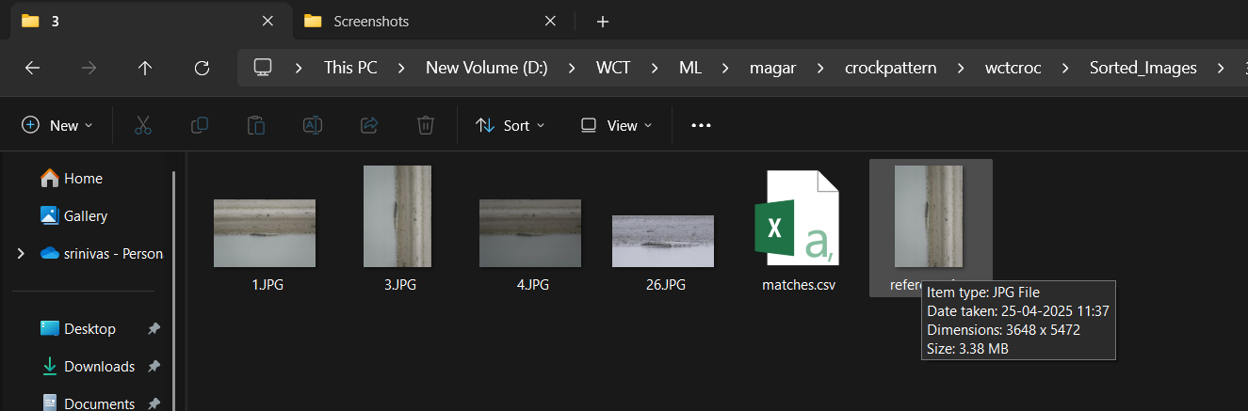

9.Inside the folder you would also find a .csv file named “matches.csv” that contains - the threshold set, reference image name, the name of the image it’s being compared to and match percentage against each image.

