**Title :-** Fitness Cap

**Abstract :-**

Coronavirus disease is an infectious disease caused by the SARS-CoV-2 virus. Covid-19 affects different people in different ways most infected people will develop mild-to-moderate illness and recover without hospitalization there are different symptoms of covid-19 such as fever, low levels of oxygen in the blood. Even when they feel well low oxygen levels can be an early warning sign and medical care is needed. People who are closer than six feet from the infected person are most likely to get infected. There is no device with all the necessary functions to protect and to stay fit especially during covid.

In order to avoid all these situations, to protect ourselves from covid and to stay fit especially during this critical time we have come up with a compact, affordable and handy fitness cap that can be taken around anywhere (portable) with all the necessary features that will help anybody to protect their selves and will also help in maintaining social distance. The fitness cap allows you to measure the body temperature of the person who is wearing the cap also helps to measure the body temperature of the person who's in front, it can also measure oxygen level in the blood, heart rate and also helps in sleep monitoring.

The main objective of this project is to make a fitness cap that provides all the necessary features into a single device making it affordable, suitable and easy for everyone's use so that they can protect their selves and can stay safe.

**Keywords :-**

Fitness Cap

Arduino

Bluetooth

Mobile App

Ultrasonic Distance Sensor

IR temperature Sensor Module

Temperature Sensor Module

Pulse and Oximeter

Gyroscope Module

Buzzer Module

Vibration Disc

**Introduction :-**

Due to Covid-19, people are getting more and more health cautious and want to monitor each and every health aspect. Previously, medical devices like Oximeter, Pulse Meter were restricted to hospitals, but now the situation is changed drastically and nowadays people start carrying these helpful devices with them because the play a major role in self-analysis.

But most medical devices are bulk and expensive. Each device usually serves only one purpose. There is no device which has all the necessary features of health tracking that are required in this pandemic situation in a compact form factor.

To measure body temperature, people use thermometer. This is very essential to know accurately if we have caught a fever, which is very important in controlling the virus spread at an individual level. But we cannot carry a thermometer around as it is very fragile and inconvenient to use as it needs a small amount of time to measure the temperature accurately. And if we want to monitor our temperature while travelling it is not safe to place the thermometer in our mouth as a precaution. Also, it cannot give continuous data as it is not practical to continuously place a thermometer in our mouth. The solution is using a very small temperature sensor, and picking up the reading from the forehead which continuously monitors the temperature.

Social Distancing and minimal person-person contact is the key to beating the virus. Unfortunately, there is no device which helps us in maintaining social distancing. Using a distance sensor is the simplest solution and can help us a lot in minimizing the virus spread.

An indication of a possible infection is often the changes in blood oxygen levels. Monitoring Blood Oxygen Level and Heart Rate is very important feature of any self-monitoring system. Small Oximeters for this purpose are available. But they are often costly and slow. Thus, people don’t tend to buy them. A small sensor for the same can monitor these aspects at the earlobe which also can work continuously without the need of attaching it every time we want to measure it.

Sleep Monitoring is also important for some patients. Some patients have problems of increased heart rate during sleep. This needs to be taken care of. There are machines in hospitals which are used for this. But people cannot be admitted to hospitals for this, as this is a long-term problem. There is no effective alternative that can be performed at individual level. There are smartphone apps for this, but they are not so effective. Small sensors can be used to monitor heart rate and the quality of sleep.

We wanted to incorporate all the required features into a small and affordable package. So, we started to think about solving the problem by making a simple project.

We thought about making a microcontroller system in which various sensors monitor various health aspects. We also thought about incorporating some extra features like helping in maintaining social distancing and monitoring someone else’s temperature.

**Existing Technology :-**

In the existing manual system, a lot of time is spent in a maintaining as well as analysing all individuals factors like pulse rate, oxygen level, temperature as well as sleep tracking. Hence there is a need for an integrated automated system, which has some centralized control over the entire process. Conventional System makes use of huge amounts of paper for recording these medical information, but when proposed system is introduced it will reduce the paper work as well as enhance the overall data analysis . The existing system are physically separated maintained system. All these details are retrieved manually.

**Existing Technology Loophole:-**

There are many devices available in the market for these purposes. For example, Oximeter for blood oxygen level and heart rate; thermometer for body temperature; IR thermometer for temperature of other people.

But there is a major problem here. All these devices are discrete and inconvenient to use. One can’t be pointing an IR thermometer to people all the time. One can’t place an Oximeter on their finger all the time. One can’t place a thermometer on their body continuously – it’s weird! Besides this, one can’t be looking at the readings of so many devices all the time.

A good device is one which does not require the user to consciously operate it. It must do everything itself without making it inconvenient to the user. It must not require user’s continuous attention. It must not disturb the user in any normal situations. It must not require the user to look at the readings continuously, and it must only disturb user when something is wrong or abnormal. It must not look awkward in the society and must not draw unwanted attention. It must be convenient to use and easy to carry everywhere.

**Your approach/Technology Explained/Algorithm**:

Approach :-

* To design a proper health monitoring system:

This system must be effective. Smaller systems made for Health Monitoring usually lack on their effectiveness and performance. Their accuracy is also quite questionable.

* To make it user friendly:

This device should be usable to all the age groups and must be very easy to use. Knowledge and practice required to successfully operate it must be minimal.Hence we incorporated all the required medical feature into a monkey cap which the person can always wear

* To allow users to perform successful self-analysis with this device:

Users must be in a position to firmly analyse their health aspects with this device. They must be able to decide whether they should visit a doctor or not. We did it by displaying all the results on the user’s smartphone

* To help people predict a possibility of being a covid positive:

Covid can sometimes cause no symptoms. Users should be able to analyse themselves and decide about a possibility of infection so they could quarantine themselves. This is done with the help of Temperature Sensor which keeps a check on your own temperature and will trigger an alarm incase your temperature is above normal

* To alarm people about proximity of a person with fever:

To stop the spread of the virus, people need to stay away from possible carriers. The most common symptom of this infection is fever. People need to be sure that the people they are in contact with have not caught fever. They need to stay away from the people who are symptomatic. The system must be able to measure someone else’s temperature in order to check if they have fever or not. We use infrared temperature sensor for that.

* To successfully maintain social distancing and avoid in-person interaction, the key to beat the virus with the help of proximity sensor
* Sleep is very import for anyone especially a medical patient , with the help of gyroscope the cap tracks how deep the wearer slept

**Technology/Components Used :-**

* **Arduino Lilypad Board:**

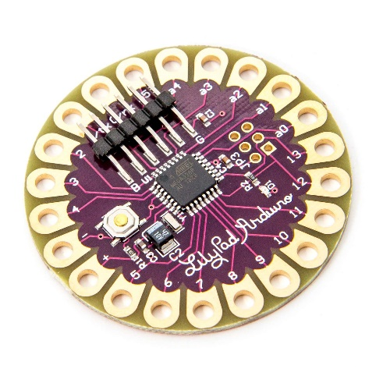This is the brain of the project. It is a microcontroller board based on 8-bit ATmega328p microcontroller chip. This chip is very versatile and powerful for its size and capabilities.

Figure 19: Arduino Lilypad

The Arduino Lilypad Board is functionally and electronically identical to an Arduino Uno besides the fact that it requires an external FTDI breakout board to program the chip and to establish serial communications with a PC, unlike Arduino Uno which has an onboard USB to Serial Chip.

This board operates at 16MHz and has a 5V logic. It has 14 Digital I/O Pins out of which 6 Pins are capable of providing 8-bit PWM output and 2 support external hardware interrupts. It has 6 10-bit Analog Inputs pins. It has 32KB of Flash Memory to store the programs, 2KB of SRAM (runtime memory) to store variables during runtime, and 1KB of EEPROM to store any data that’s meant to be non-volatile.

The main reason why we chose this board is because it is much smaller than Arduino Uno. It has been invented specifically for Wearable Electronics and is meant to be used with conductive threads; thus, it lacks ugly and bulky headers. It is compact because it has SMD (Surface Mounted Device) version of the Atmega328p chip instead of the THT (Through-Hole Technology) version on the UNO, which makes up a significant size difference. Also, it lacks a USB to serial converter which is meant to be connected externally only once for programming the chip.

* F**TDI Breakout Board and USB-A to Mini USB cable:**

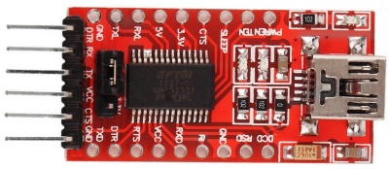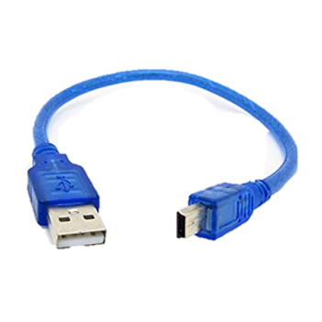To make some Arduino Boards compact and cost efficient, Arduino came up with a wonderful idea. They decided to go with external USB to serial chips for boards that are meant for one time programming in a permanent project. This saves a lot of cost to manufacturers and users alike. Users can buy multiple boards and place them permanently in projects, but they need only one FTDI Breakout Board in their assortment. This allows designing much more compact boards as it takes away a chip and USB connector. Arduino Lilypad and Arduino Pro Mini are some boards which use external FTDI chip.

Figure 20: FTDI Breakout Board

Figure 21: Mini USB Cable

To connect the FTDI Breakout Board to the PC for programming, one needs a compatible cable, a Mini USB cable in our case.

* **HC-05 Bluetooth Module:**

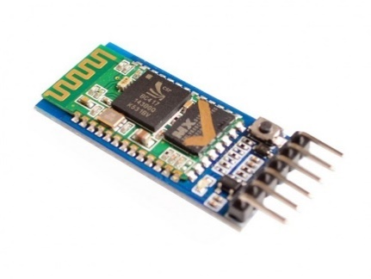HC-05 is an easy to use and cheap connectivity solution. It is easy to set up and easy to pair with other devices. It is very cheap compared to a Wi-Fi Module. Although Wi-Fi is better in terms of connectivity, on advantage Bluetooth allows is that one can connect a smart device to multiple Bluetooth device. So, this will not interrupt use of other devices like earphones while using the Fitness Cap.

Figure 22: HC-05

* **LM35 Temperature Sensor:**

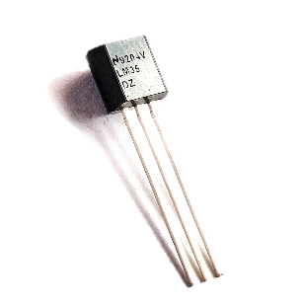LM35 is a very precise and easy to use temperature sensor. Its accuracy is very high. Its output volage is just 1/100th of temperature in degree centigrade. This means this is capable of measuring +ve centigrade temperatures under normal bias. But we can sense -ve temperature as well we using specialized circuit with a -ve voltage source. We chose this sensor over TMP36 because it is much more accurate in the required range and conversion of voltage to temperature is very simply.

Figure 23: LM35

* **HC-SR04 Ultrasonic Distance Sensor:**

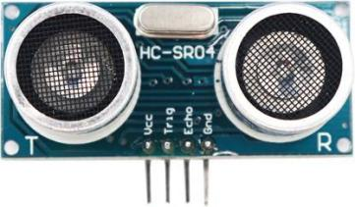HC-SR04 Ultrasonic Distance Sensor is one of the most famous sensors among enthusiasts. Its operation is very simple and it works very fast. It is easily available and is very cheap. It is easy to use and very easy to code. Its accuracy is fascinating. There some other versions of this sensors available but this is the most simple, easy to use and readily available one. LIDAR sensors are a choice over this sensor owing to its high speed, high accuracy and compact form factor, but it is very expensive.

Figure 24: HC-SR04

* **MLX-90614 Infrared Temperature Sensor:**

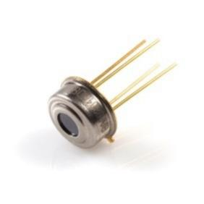MLX-90614 is very fascinating sensor. It uses I2C communication to communicate its readings to the Master Device. It automatically calculates Ambient (its own) and Target Temperatures and stores it in its memory. It does this by using Stephan-Boltzmann law. We just have to extract the readings from its memory which we do by I2C communication. It is available directly (just the component) and in module form (with pull up resistors and capacitor). The Module form is very expensive thus we chose to go with the direct component.

Figure 25: MLX90614

* **MPU-6050 6-Axis IMU (Inertial Measurement Unit):**

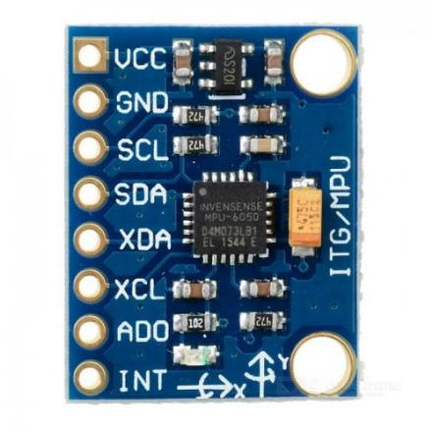We needed a Gyroscope sensor. But tradition Gyroscope would have used 3-Analog Pins, which we couldn’t afford (only 6 Analog Pins). We were already using I2C bus, thus we chose to go with an I2C version. The most readily available and cheapest gyroscope with required features was MPU-6050, which is not only a gyroscope but also an accelerometer and temperature sensor. Like the MLX-90614 IR Temperature Sensor, it automatically does all the calculations and stores it in its memory, we just have to extract it using I2C communication. It does not take any additional pins because I2C bus allows up to 112 different Slave devices to be connected directly.

Figure 26: MPU-6050

* **MAX-30102 Heart Rate and Oximeter Sensor:**

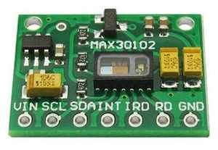This sensor measures Heart Rate and Blood Oxygen Levels. It can be attached to Finger and Earlobe. It was the only easily available and cheap sensor available. It uses I2C communication thus takes no extra pins as we are already using the I2C bus for two other sensors. It sends light and the decodes the reflected pattern to sense the parameters.

Figure 27: MAX-30102

* **Buzzer and Vibrating Disc:**

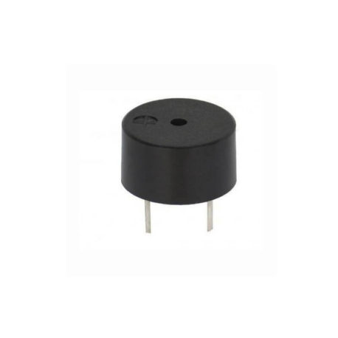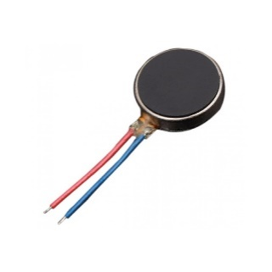Buzzer makes a good output device when acquiring user’s attention is required in case of an emergency. Vibrating Disc is very useful to indicate some conditions to the users without making any loud sound and causing any inconvenience.

Figure 28: Buzzer

Figure 29: Vibration Disc

* **Wires and Conductive Thread:**

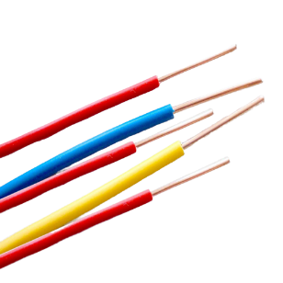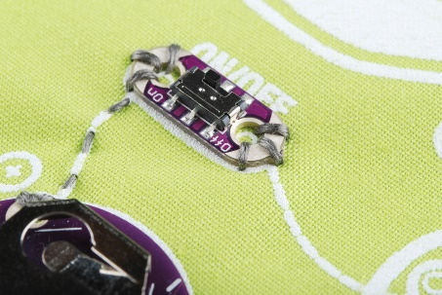These are required for interconnections

Figure 30: Conductive Threads

Figure 31: Wires

* **Some standard electronics components:**

These are required for testing the circuits and setting up some sensors. Pull Up Resistors and a Capacitor is required for IR Temperature Sensor. We also need a 3.3V regulator for IR Temperature Sensor, we choose IC LM1117 for this purpose.

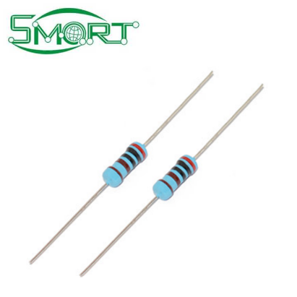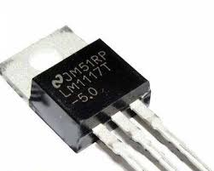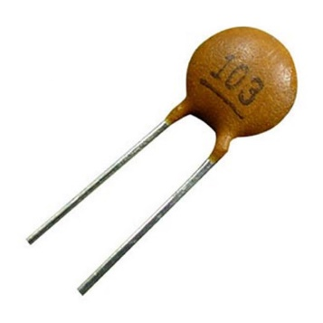

Figure 33: Resistors

Figure 32: Capacitor

Figure 34: Regulator

**Algorithm**

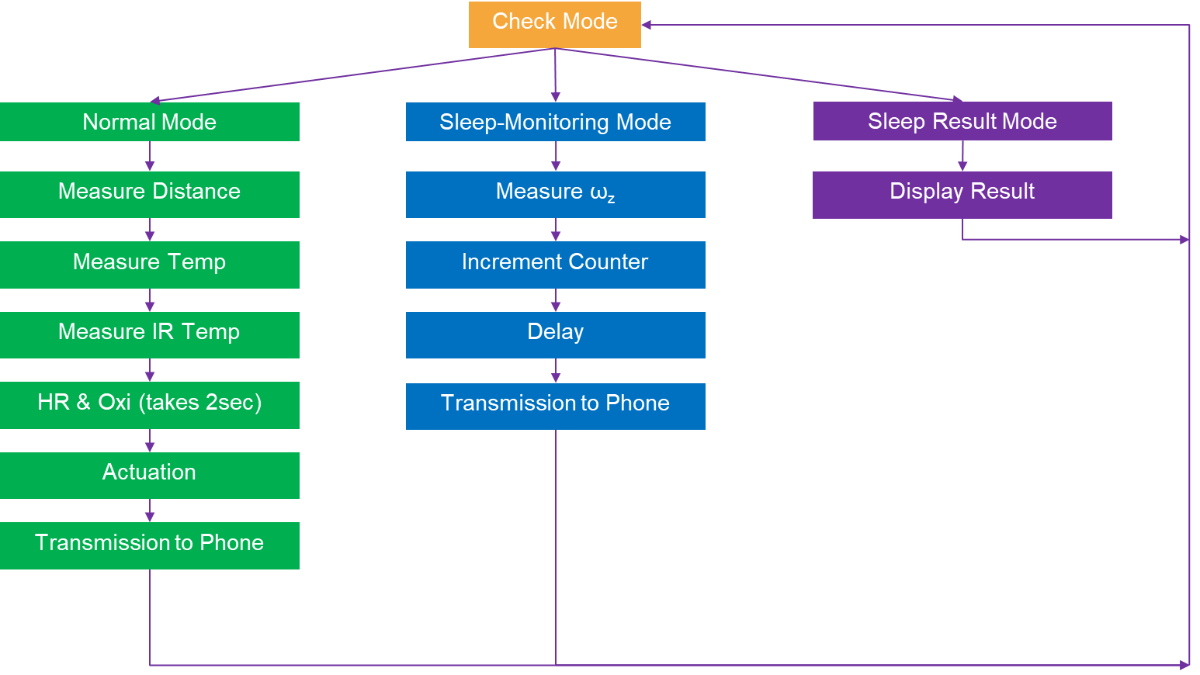

There are three modes in our system namely – Normal Mode, Sleep-Monitoring Mode and Sleep Result Mode.

At each loop, we receive the current mode from the Smartphone. All the modes are continuously being checked.

***Normal Mode***

The Normal mode is the default mode.

It is used to measure the selected parameters –

Ultrasonic Sensor (HC-SR04) is used to measure the distance between the user and the closest individual,

Temperature Sensor (LM35) is used to measure the user’s temperature at the forehead.

IR Temperature Sensor (MLX90614) is used to measure the temperature of the closest individual to the user.

Heart Rate and Oximeter Sensor (MAX30102) is used to measure the heart rate of the user in bpm.

According to the pre-decided thresholds, an actuator in this case a buzzer is used to inform the user of the unusualness of one or more parameters (if Distance<=1m or Target Temperature>=38°C).

This is then further transmitted to Phone via Bluetooth connectivity using our Bluetooth module HC-05 to the Smartphone and displayed on out designed Application.

***Sleep-Monitoring Mode***

Gyroscope-Accelerometer sensor (MPU6050) is used to measure the turns of the user in bed (angular velocity ωz). If the angular velocity ωz is greater than the threshold of 50°/s we increment the turns counter else we continue.

On detection of a turn, a delay is necessary to ensure the turns do not increment as the user is still on his current turn as the ωz is being continuously monitored. This gives the user time to settle.

The current count of turns is transmitted to Smartphone and displayed in the application.

***Sleep Result Mode***

We conclude the User’s sleep as either Deep *Sleep,* *Disturbed Sleep* or Bad Sleep on the basis of the count of turns.

The result is and the final count of turns transmitted to Smartphone and displayed in the application.

## Code (Arduino IDE)

The code was made efficient by using minimum number of libraries. Most of the programming was done by using without any external libraries and only the default Arduino IDE Functions.

We had to avoid all higher levels of abstractions, like libraries, to be more efficient with the coding.

To avoid using too many libraries, we had to study each component and its datasheet from its original manufacturer in order to device an algorithm for the purpose that device served in our project.

The code was optimized by properly structuring it. This was done by declaring and defining a separate function for each separate task. Each function was properly called in the void setup() and void loop() functions in the proper order for the system to work properly.

We have used Arduino IDE’s C Language (modified C) to write this code. Because it is a modification of C, it is one of the most efficient and close-to-hardware High-Level Language.

**Mobile App :-**



We have used MIT App Invertor to create a custom Smartphone (Android) Application for acting as an Interface between the circuit and the user.

The above is the Block-Code for the Application.

This circuit communicates with the smartphone over Bluetooth.

This application acts an interface to the circuit for:

* Displaying all the outputs
* Controlling the mode in which the circuit is operating

**Output**

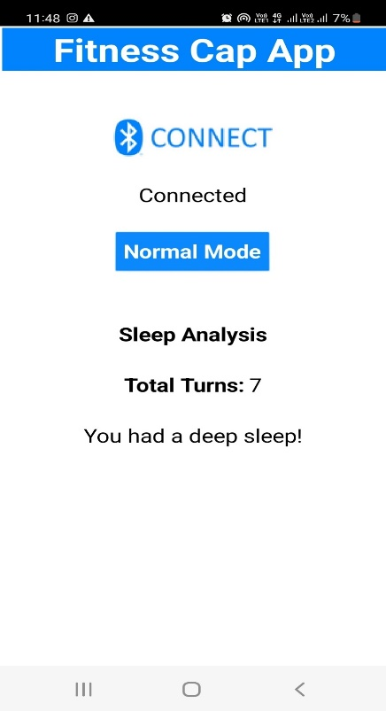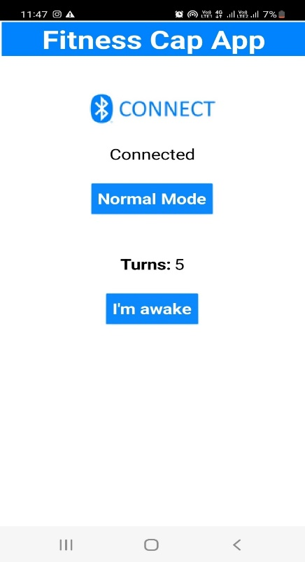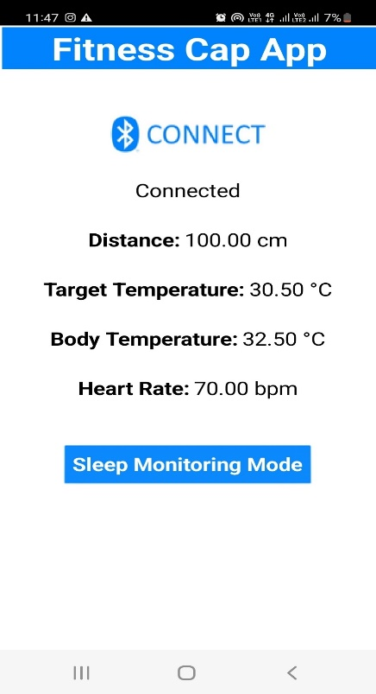

Sleep Result Mode

Sleep-Monitoring Mode

Normal Mode

We can click on Connect button to connect the smartphone to the Cap.

As we know, there are three modes in our system namely – Normal Mode, Sleep-Monitoring Mode and Sleep Result Mode.

Normal Mode is the default mode. We toggle to all the three modes. We can click on Sleep-Monitoring Mode button to turn on Sleep Monitoring Mode. Then, we can click on the ‘I’m awake’ button to get the Sleep Result Mode.

From the Sleep-Monitoring Mode and Sleep Result Mode, we can go back to Normal Mode by Clicking Normal Mode Button.

***Normal Mode***

From the output we can see that it has measured following parameters: -

Distance: - Measures the distance between user and closest individual which is measured in centimetres using ultrasonic sensor (HC-SR04). User is notified via the buzzer if an object comes within 1m range.

Target Temperature: - The approaching object’s temperature is measured and notified. It is measured in degree Celsius using IR Temperature sensor (MLX-90614). If target’s temperature is equal to or above 38°C, user is notifier via the buzzer

Body Temperature: - The user’s temperature is being constantly measured and notified. It is measured in degree Celsius using temperature sensor (LM-35).

Heart Rate: - The user’s pulse is measured and notified. It is measured in beats per minute using Oximeter sensor (MAX-30102).

***Sleep-Monitoring Mode***

It measures and monitors the number of head rotations while sleeping.

For every rotation (with angular speed above 50°/s) it increments the number of turns and displays on the app. It uses Gyroscope-Accelerometer sensor (MPU6050) for measuring number of turns.

***Sleep Result Mode***

If the user moved his/her head frequently during sleep his/her sleep prediction is made and displayed. It displays the kind of sleep the user had either deep sleep, disturbed sleep or bad sleep.

If the number of turns is in the range 0-10 it shows user had deep sleep.

If the number of turns is in the range 11-20 it shows user had disturbed sleep.

If the number of turns is above 20 it shows user had bad sleep.

In the screenshot, as the user had 7 turns, it showed the user had a deep sleep.

**How it overcame issues create by existing technology :-**

It’s an all in one device that not only tracks the person’s health but as well as keeps the wearer safe from possible infectious person.

To perform the various tests a person has to buy separate expensive devices to conduct these tests and those devices are not easy to carry while it’s conducting it’s tests ie makes your movement restrictive . This cap the person can just wear and will have no issues in performing his/her daily chores and keep track of their health status.

The devices are pretty expensive where as this prototype which consists of re-usable modules costed just around 1000 Rs .

In order to use the current device the user has to carefully go through instruction manual in order to use the device correctly and get proper readings . The fitness cap does not require the user to go through such manuals as any user who just knows how to read can directly start using it.

Connected to mobile screen to make sure the readings are big enough to be read by a person with compromised vision .

**Advantages**

* The device is all in one device for medical analysis.
* Easy to wear.
* Economical.
* Light weight and is connect to your mobile hence data can be shared easily.
* The system is user friendly and any one having no medical knowledge can handle it easily.
* Suitable for Doctor’s analysis or the wearer’s analysis basically easily readable data.

**Disadvantages**

* There is a constant need to have a battery for as well as smartphone for the device to perform all the promised tasks.
* Lacks proper security as of this prototype model .
* Since re-usable components are used for the model it’s slightly bulky compared to it’s competitors.
* Out of fashion as the monkey caps maybe be little out of fashion and might not be visually appealing .

**Future Scopes**

The Health & Covid Cap has wide future scope as health is always everybody’s concern, a lot of enhances can be done in future, as in we can modify the project by adding a feature i.e., we can show the persons vaccine dose just by using phone number and cowin beneficiary ID and it can display vaccination details more such kind of features can be added.

We can add new features as and when we require, enhancement can easily be implemented under various situations and according to our future needs. It can further be expanded with voice interactive system facility. A feedback system can also be included which provides the state of the Health & Covid Cap and through that we can also be aware of what exact feature does the wearer wants. Design of the cap can also be modified; providing the customer with a large range of options to select according to their type and comfort.

**References :-**

Muhammad Ali Mazidi - AVR Microcontroller and Embedded Systems: Using Assembly and C – 2010 – Prentice Hall

Muhammad Ali Mazidi - Arduino Programming from Beginning to Advanced– 2019 – MicroDigitalEd.com

MPU6050 Register Map- <https://invensense.tdk.com/wp-content/uploads/2015/02/MPU-6000-Register-Map1.pdf>

MLX90614 Datasheet- <https://www.melexis.com/en/documents/documentation/datasheets/datasheet-mlx90614>

LM35 Datasheet- <https://www.ti.com/lit/ds/symlink/lm35.pdf>