PROJECT SYNOPSIS

**“ Project Title “**



**Indira College of Commerce and Science**

**TY-BBA (CA)**

Project Guide: Project By:

Prof. Shivendu Bhushan Srinivas Sivakumar

Guide Name Shubhangi Chavan Kunal Zende

(TYBBA (CA))

**\*Introduction:-**

Due to Covid-19, people are getting more and more health cautious and want to monitor each and every health aspect. Previously, medical devices like Oximeter, Pulse Meter were restricted to hospitals, but now the situation is changed drastically and nowadays people start carrying these helpful devices with them because the play a major role in self-analysis.

But most medical devices are bulk and expensive. Each device usually serves only one purpose. There is no device which has all the necessary features of health tracking that are required in this pandemic situation in a compact form factor.

To measure body temperature, people use thermometer. This is very essential to know accurately if we have caught a fever, which is very important in controlling the virus spread at an individual level. But we cannot carry a thermometer around as it is very fragile and inconvenient to use as it needs a small amount of time to measure the temperature accurately. And if we want to monitor our temperature while travelling it is not safe to place the thermometer in our mouth as a precaution. Also, it cannot give continuous data as it is not practical to continuously place a thermometer in our mouth. The solution is using a very small temperature sensor, and picking up the reading from the forehead which continuously monitors the temperature.

Social Distancing and minimal person-person contact is the key to beating the virus. Unfortunately, there is no device which helps us in maintaining social distancing. Using a distance sensor is the simplest solution and can help us a lot in minimizing the virus spread.

An indication of a possible infection is often the changes in blood oxygen levels. Monitoring Blood Oxygen Level and Heart Rate is very important feature of any self-monitoring system. Small Oximeters for this purpose are available. But they are often costly and slow. Thus, people don’t tend to buy them. A small sensor for the same can monitor these aspects at the earlobe which also can work continuously without the need of attaching it every time we want to measure it.

Sleep Monitoring is also important for some patients. Some patients have problems of increased heart rate during sleep. This needs to be taken care of. There are machines in hospitals which are used for this. But people cannot be admitted to hospitals for this, as this is a long-term problem. There is no effective alternative that can be performed at individual level. There are smartphone apps for this, but they are not so effective. Small sensors can be used to monitor heart rate and the quality of sleep.

We wanted to incorporate all the required features into a small and affordable package. So, we started to think about solving the problem by making a simple project.

We thought about making a microcontroller system in which various sensors monitor various health aspects. We also thought about incorporating some extra features like helping in maintaining social distancing and monitoring someone else’s temperature.

**\*Existing System:**

In the existing manual system, a lot of time is spent in a maintaining as well as analysing all individuals factors like pulse rate,oxygen level,temperature as well as sleep tracking. Hence there is a need for an integrated automated system, which has some centralized control over the entire process. Conventional System makes use of huge amounts of paper for recording these medical information, but when proposed system is introduced it will reduce the paper work as well as enhance the overall data analysis . The existing system are physically separated maintained system. All these details are retrieved manually.

**Disadvantages Of Existing System:**

1.The existing systems are expensive as well as bulky

2.All data have to be manually recorded to figure out a possible outcome

3.There is no one wearable device that does all the medical data analysis for the person

4. Each data has to be interpreted by a Doctor or someone from the medical field the le man is unable to figure out the data.

5.Not everything in the current systems are easily wearable.

**\*Proposed System:**

Covid-19, or for that matter, any virus/germ spreads at an exponential rate. This happens because as the virus spreads, each new single virus entity will cause virus spread, and since the number of entities have increased, they also contribute to the further spread. Thus, it spreads very rapidly.

This virus has proved to be quite dangerous. The speed with which it got spread to the whole world was surprising. In India, for instance, people were really relieved about the virus. Only few reports came in. But then over the period of 3-4 weeks, school and colleges were shut down. And then complete lockdown was implemented.

The deaths were quite high too. TV reports started showing how bodies were literally dumped. Open places started getting transformed into graveyards.

Even the smallest attempt to control the spread, if implemented correctly and by everyone, everywhere, it would have a very large impact and relief.

If everyone starts monitoring their health properly, he would ab able to decide if he should quarantine himself or not. He would be able to cut the possible chain of patients that he would have created in a possible future.

If everyone starts following social distancing, direct transmission of the virus would literally cease. Indirect transmission is not as effective as direct, and the pandemic situation would soon be relieved.

If everyone would be aware of a possible patient, he would stay away from them. This will put a direct stop to the virus spread. The most common symptom is fever. High forehead temperatures can be used to direct a possible patient.

**Advantages of Proposed System :**

* The device is all in one device for medical analysis.
* Easy to wear.
* Economical.
* Light weight and is connect to your mobile hence data can be shared easily.
* The system is user friendly and any one having no medical knowledge can handle it easily.
* Suitable for Doctor’s analysis or the wearer’s analysis basically easily readable data.
* **Drawbacks of Proposed System :**

There is a constant need to have a battery for as well as smartphone for the device to perform all the promised tasks.

**\*Feasibility study:-**

* Econmical Feasible:-

Our device is costs somewhere around 2000Rs as it’s not factory made but if factory made the estimated price is 500Rs which is pretty cheap when compared to all the sensors it has and it’s applications which in today’s market if you purchase them would cost you not less than 5000Rs

Operational Feasible:-

In the existing system there is lot of data interpretations and analysis . So that is very time consuming and expensive process. As our proposed system is computerised system with a micro chip if it’s own it will be very user friendly system. In our proposed system we used Smart phone as front-end software as everyone is hooked to or familiar with their smart phones hence we are giving the device control as well in the user’s smartphone hence it is very easy to operate by user.

* Technical Feasible:-

In our proposed system we have mentioned the various use of different kinds of sensors which are already available in the market as individual components and in nano forms. Our data is being interpreted by a micro controller called Arduino Lily which is a product of company named “Arduino” known for providing programmable boards for students. The front end we are using is smartphone which today everyone carries .

**\*Function Specification:-**

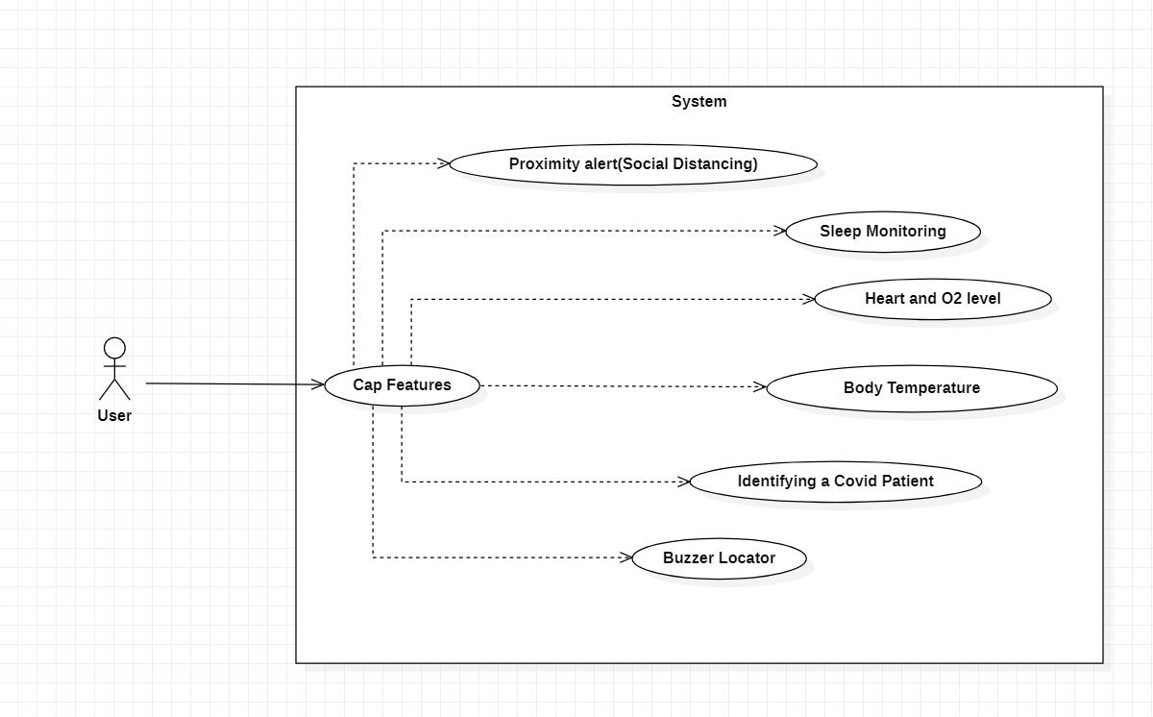

| **Software Requirement** | |
| --- | --- |
| Operating System | Any Smartphone |
| **Software :-** | |
| Front –End Software | Python and MIT appinventor |
| Back-End Software | C/C++ and python |
| **Hardware Requirement** | |
| Processer : | SnapdragonQSD8250 |
| Monitor : | LCD monitor |