Below is the snapshot for driver setting:

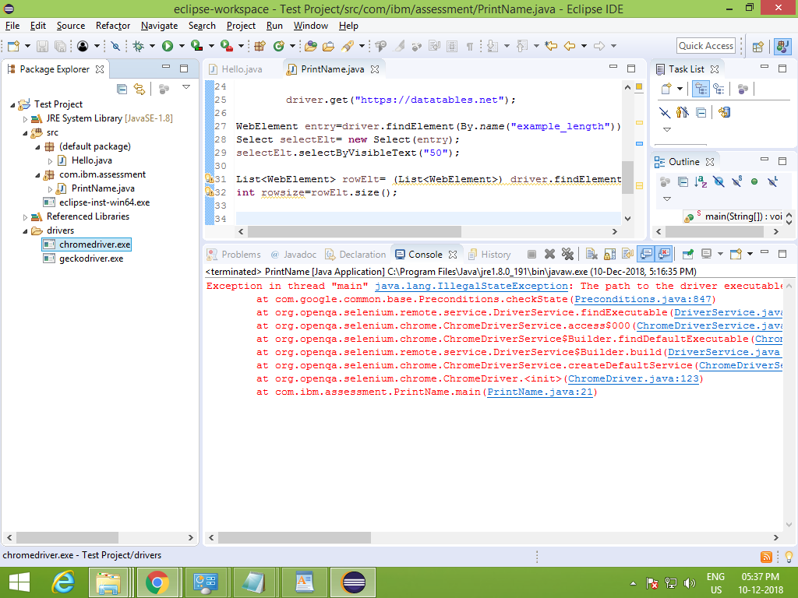

Below is the errors while configuring .I was facing performance issue, as the system is very slow.

if we type anything in eclipse its shwing the written code after some time, not immediately.

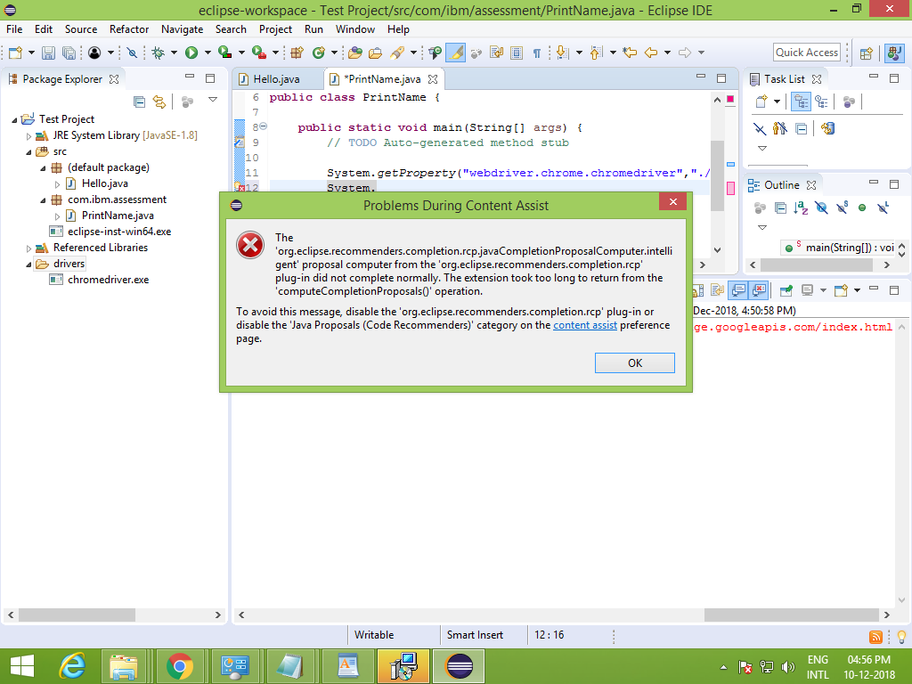

While installing JDK , the eclipse is not responding. u can look at the below snapshot.

Also u can see the below snapshot , that how slow the code is visible after typing.

