**1.Problem Statement**

Write a program to generate user defined exception called NegativeAgeException if the user inputs negative value of age.

**2.Source Code**

/*Generate user defined exception NegativeAgeException if the user

inputs negative value of age*/

**package** mypackage;

**import** java.io.*;

//Creating user defined exception

**class** NegativeAgeException **extends** Exception

{

**private** **int** age;

//Defining constructor

NegativeAgeException(**int** num)

{

age=num;

}

//To print the user defined exception message when age is negative

**public** String toString()

{

return "Negative Age:"+age;

}

}

**public** **class** UserException {

//Defining static method

**static** **void** verifyNumber(**int** num) **throws** NegativeAgeException

{

**if**(num < 0)//check if age is less than 0

//Throwing the user defined exception

**throw** **new** NegativeAgeException(num);

**else**

System.***out***.println("User not entered negative number.");

}

//Declaration of main method

**public** **static** **void** main(String[] args) **throws** IOException

{

System.***out***.println("Enter the Age:");

BufferedReader br=**new** BufferedReader(**new** InputStreamReader(System.***in***));

**int** age=Integer.*parseInt*(br.readLine());

//Handling user defined exception

**try**

{

*verifyNumber*(age);

}

**catch**(NegativeAgeException e)

{

System.***out***.println("User entered "+e);

}

}

} //End of program

**3.Output**

When the user enters the negative number for age:

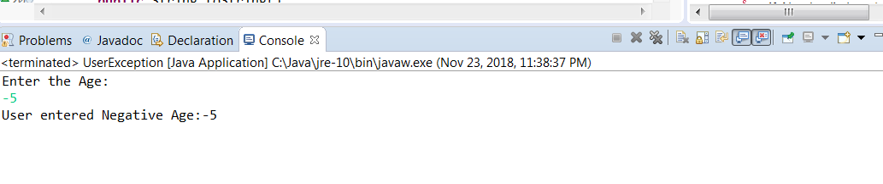

When user does not enter negative number

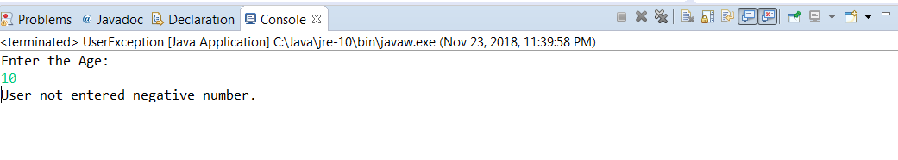

**4.Flow Information**

Firstly, it was created an exception class named NegativeAgeException by extending the Excpetion class. The method toString is written in this class to give description if the negative age is found. When the user enters the number for age ,a static method verifyNumber is used to verify whether the number is negative or not. Then the user defined exception NegativeAgeException is handled when user enters a negative number with help of throw key word. Finally as output, it is displayed that whether user entered negative number or not based on the input.