1. Run the solution from Visual studio by pressing ctrl+f5
2. Go to the Index.html to view contacts list

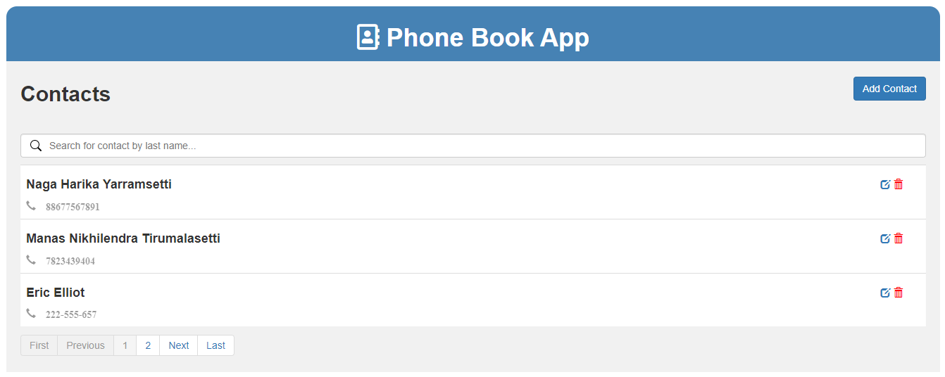

1. Click on Add contact to add new contact details

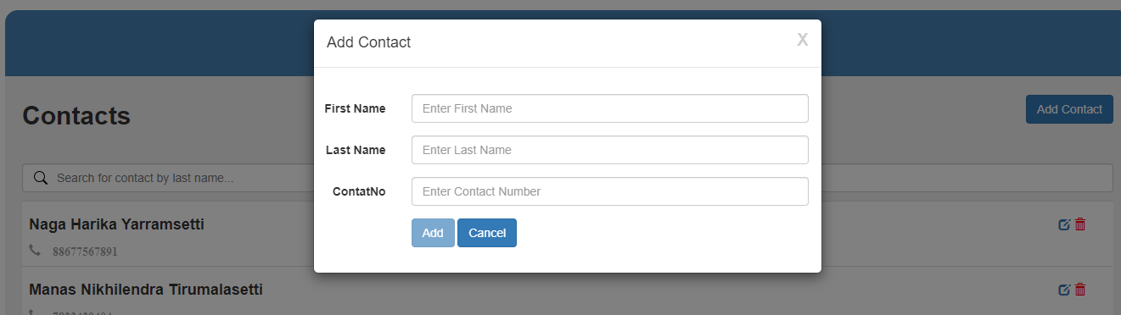

1. Click on Edit button to update existing record from the list.

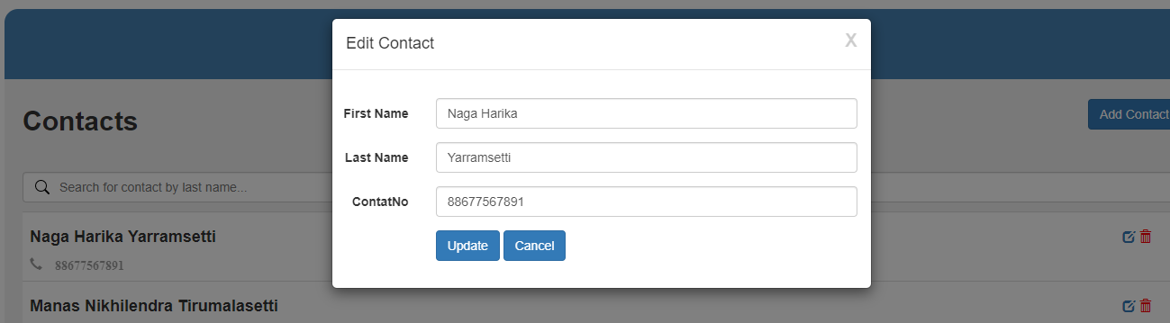

1. Click on Delete button to delete the record from the list.

