1. Write a procedure to take branch_id as parameter and retrieve details of the account_no, first_name, last_name, customer_city, phone_no and loan_amount of the customer who had taken loan from that branch.

Answer:

PROCEDURE loan_proc

(p_branch_id IN loan_details.branch_id%type) IS

CURSOR C1 IS

SELECT a.account_no, c.first_name, c.last_name, c.phone_no, c.customer_city

FROM loan_details l JOIN customer c USING(customer_id)

JOIN account a USING(customer_id) WHERE l.branch_id = p_branch_id;

v_rec c1%rowtype;

BEGIN

OPEN C1;

LOOP

FETCH C1 INTO v_rec;

EXIT WHEN C1%NOTFOUND;

DBMS_OUTPUT.PUT_LINE(v_rec.account_no ||' '|| v_rec.first_name ||' '|| v_rec.last_name ||' '|| v_rec.phone_no ||' '|

| v_rec.customer_city);

END LOOP;

CLOSE C1;

END loan_proc;

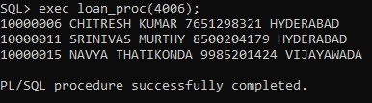

2. Write a procedure to delete internet_banking record of the customers whose account_status is terminated or suspended by taking the customer_id as the parameter.

Answer:

PROCEDURE rem_proc

(P_CUST_ID IN ACCOUNT.CUSTOMER_ID%TYPE)

IS

ACC_STATUS ACCOUNT.ACCOUNT_STATUS%TYPE;

BEGIN

SELECT ACCOUNT_STATUS INTO ACC_STATUS FROM ACCOUNT WHERE CUSTOMER_ID = P_CUST_ID;

IF (ACC_STATUS = 'TERMINATED' OR ACC_STATUS = 'SUSPENDED') THEN

DELETE INTERNET_BANKING WHERE CUSTOMER_ID = P_CUST_ID;

ELSE

DBMS_OUTPUT.PUT_LINE ('THE ACCOUNT STATUS IS NOT SUSPENDED OR TERMINATED');

END IF;

END REM_proc;

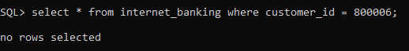

3. Write a function to return the total amount deposited through cheque by all the customers.

CREATE OR REPLACE FUNCTION func_dep

RETURN NUMBER IS

v_dep number;

BEGIN

select sum(transaction_amount) into v_dep from transaction_details

where transaction_type = 'DEPOSIT' and medium_of_transaction = 'CHEQUE';

RETURN(v_dep);

END func_dep;

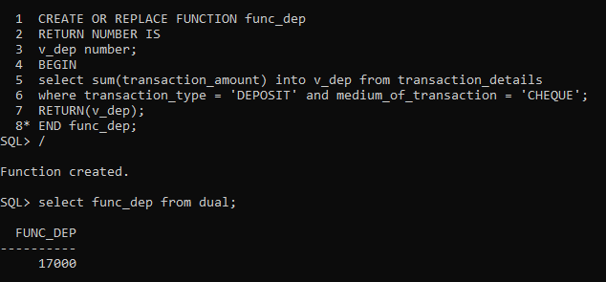

4. Write a trigger to store the old password and the changed password of the internet_banking n the new table.

Answer:

CREATE TABLE internet_banking_mod(

modification_date DATE,

old_password NUMBER,

new_password NUMBER)

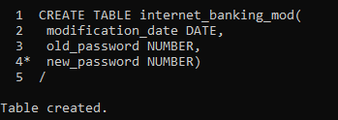

CREATE OR REPLACE PROCEDURE pro_trig (old_password number, new_password number) AS

PRAGMA AUTONOMOUS_TRANSACTION;

BEGIN

INSERT INTO internet_banking_mod VALUES (sysdate,old_password,new_password);

COMMIT;

END pro_trig;

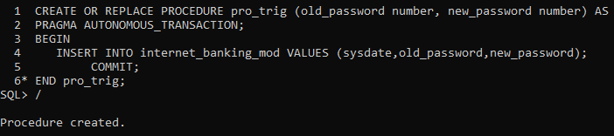

CREATE OR REPLACE TRIGGER trig_pass_update

BEFORE UPDATE ON internet_banking FOR EACH ROW

BEGIN

pro_trig(:old.password, :new.password);

END;

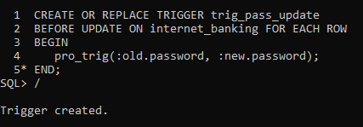

update internet_banking set password = 4998 where login_id = 60011;

select * from internet_banking_mod;

