ASSIGNMENT-1

TASK: >>Create a VPC with 2 subnets and 2 route tables and internet gateway

>>Launch an instance and Attach it with EBS

*VPC Concept

🡪 Search for VPC in search space/bar of AWS home page and click on VPC (refer Fig-1)

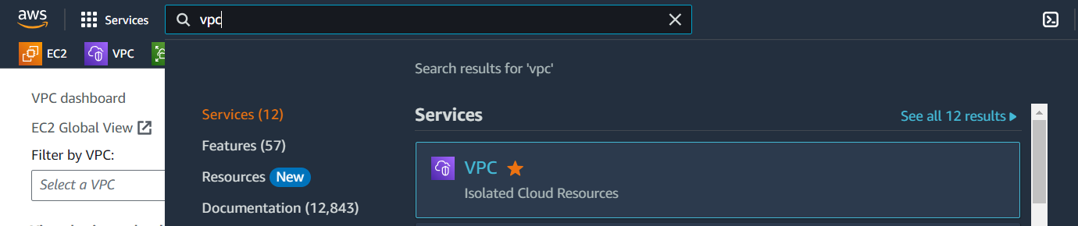

Fig-1

🡪Now click on **Your VPCs** option under Virtual private cloud (refer Fig-2)

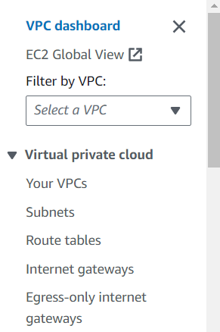

Fig-2

🡪Now click on Create VPC to create our custom VPC (refer Fig-3)

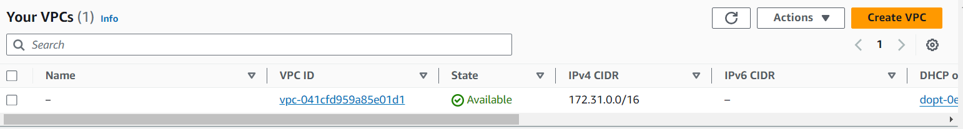

Fig-3

🡪We have to fill few details for our VPC (like name, IPv4 CIDR) and finally click on Create VPC (refer Fig-4 for clear understanding)

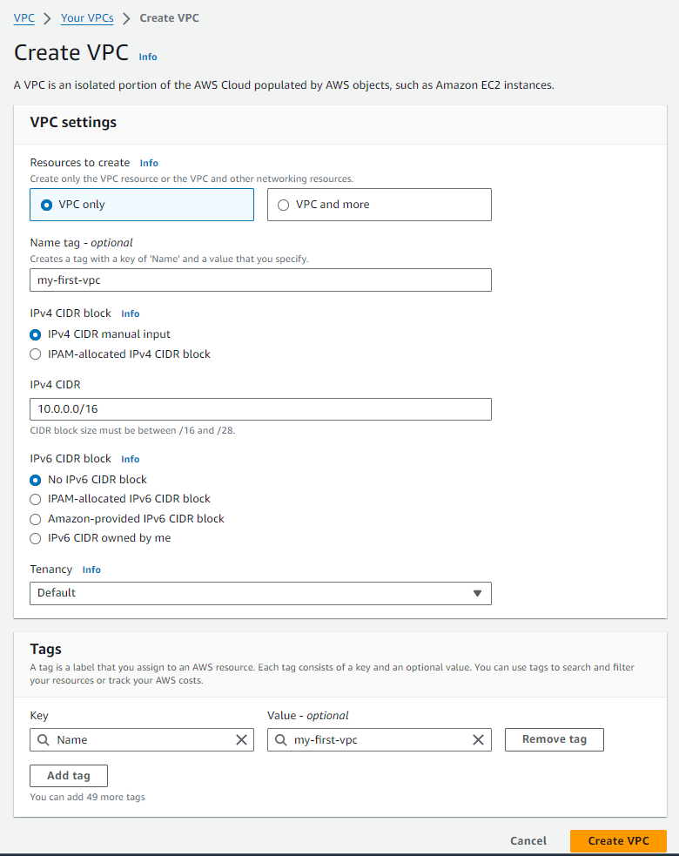

Fig-4

🡪 We have created our custom VPC successfully. Now click on **Internet gateways** from menu and click on Create internet gateway. (refer Fig-5 and Fig-6)

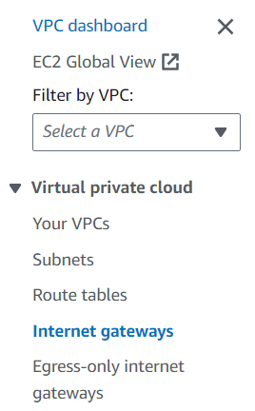

Fig-5

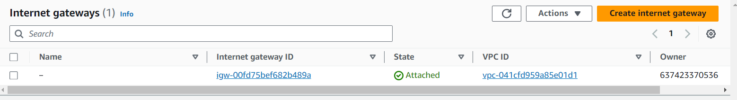

Fig-6

🡪Now, we have to name our internet gateway (name of our choice) and finally click on Create internet gateway. (refer Fig-7)

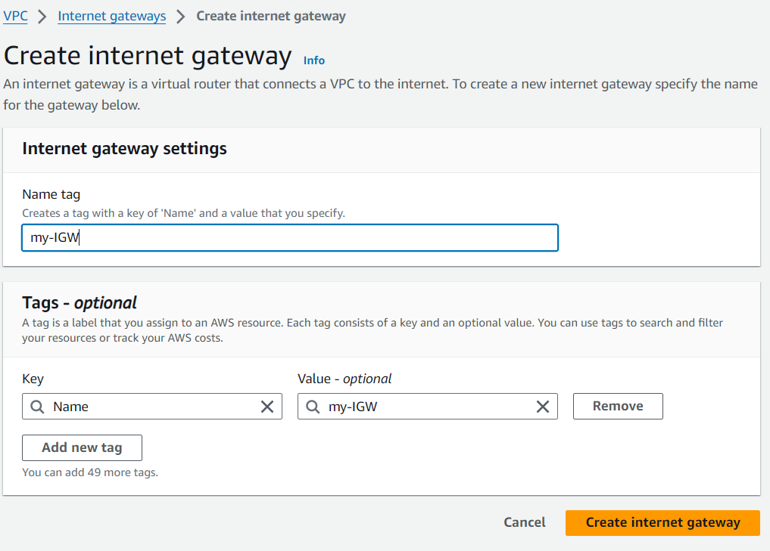

Fig-7

🡪 Now click on **Actions** and click on **Attach to VPC** option. (refer Fig-8)

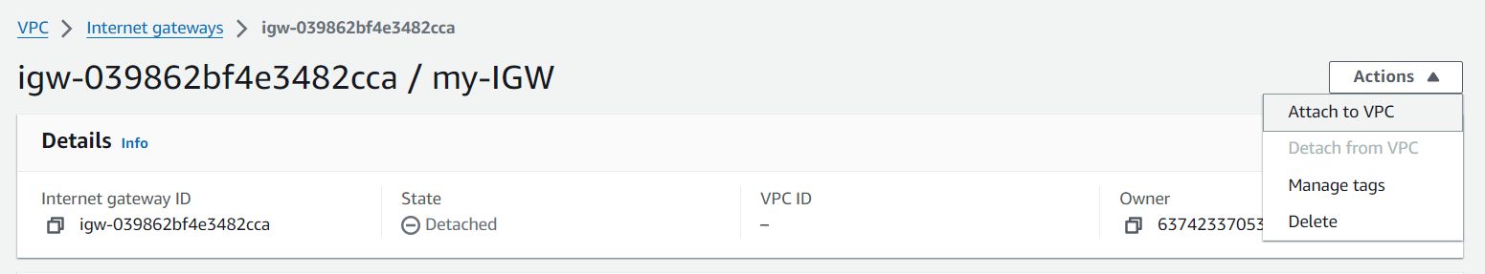

Fig-8

🡪Under Available VPCs section, select our custom VPC that we already created and Finally click on Attach internet gateway. (refer Fig-9)

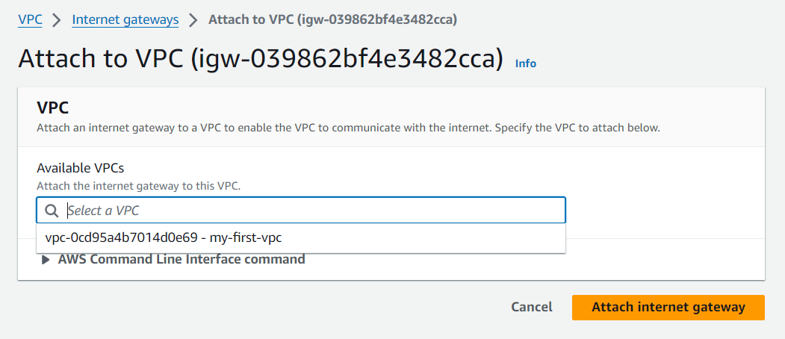

Fig-9

🡪Now we have to create 2 subnets (one is public and another one is private). For this, click on **Subnets** option from menu and click on Create subnet. (refer Fig-10 and Fig-11)

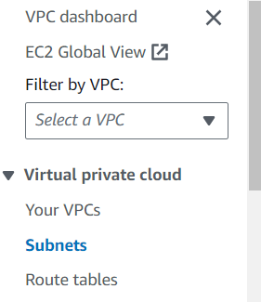

Fig-10



Fig-11

🡪TO create a subnet, first we have to select our VPC (refer Fig-12)

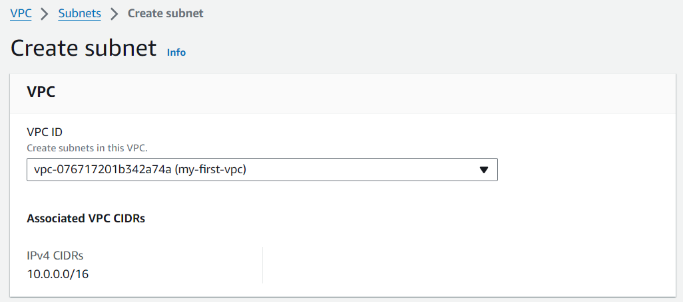

Fig-12

🡪Then we have to mention some details like we have to name our subnet, we have to select Availability zone and we have to enter CIDR under IPv4 subnet CIDR block and finally click on Create subnet button. (refer Fig-13)

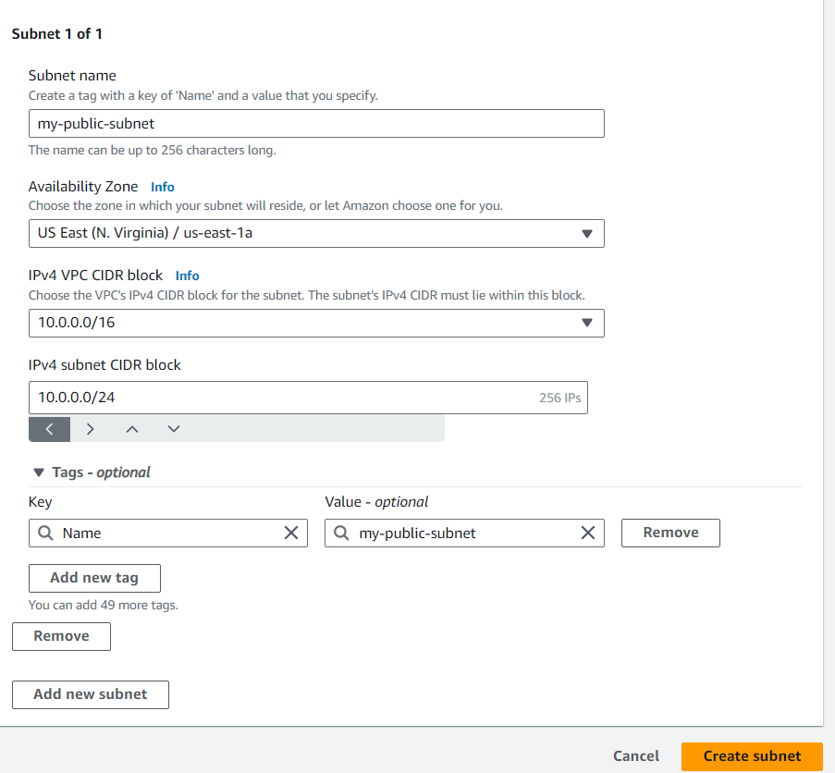

Fig-13

🡪Now we have to create one more subnet (name: my-private-subnet, Availability zone is 1b and CIDR is 10.0.1.0/24)

🡪Go to **Subnets** and we can see our two subnets (refer Fig-14)

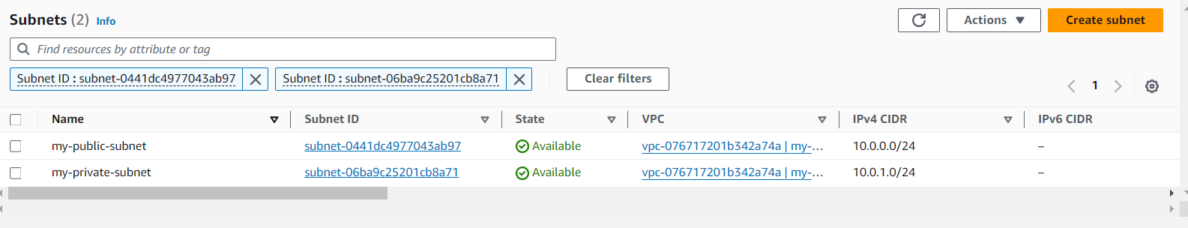

Fig-14

🡪Now we have to create 2 route tables (one is public and another one is private)

🡪 Click on **Route tables** from menu and click on Create route table (refer Fig-15 and Fig-16).

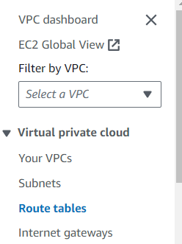

Fig-15

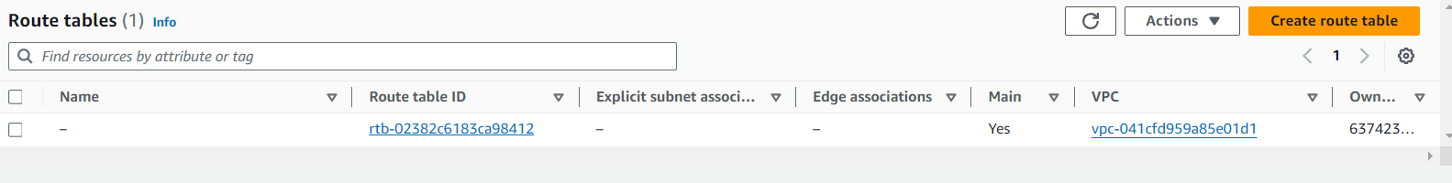

Fig-16

🡪Give name to route table (my-public-RT) and select our custom VPC and finally click on Create route table. (refer Fig-17)

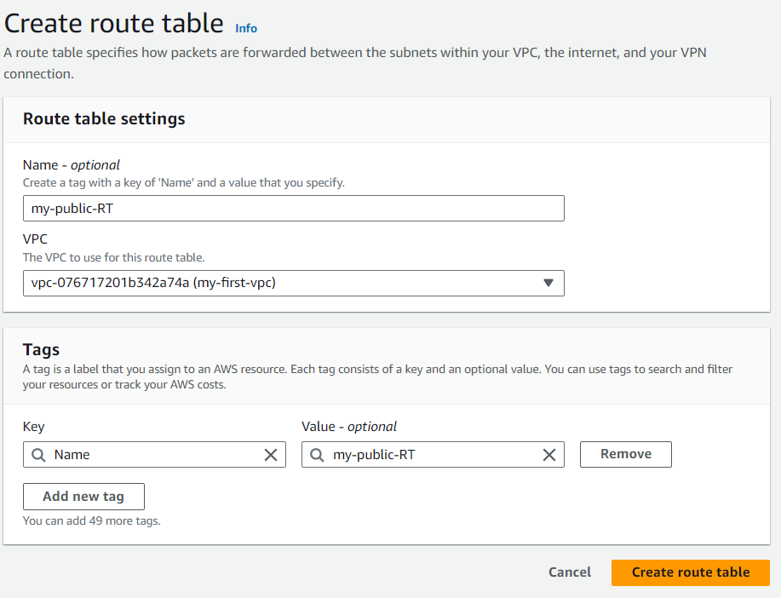

Fig-17

🡪Now click on **Actions**, click on **Edit routes**

🡪click on **Add route**. Select 0.0.0.0/0 as Destination, Select Internet gateway from drop down list and choose our Internet gateway and finally click on Save changes. (refer Fig-18, Fig-19 and Fig-20 for clear view)

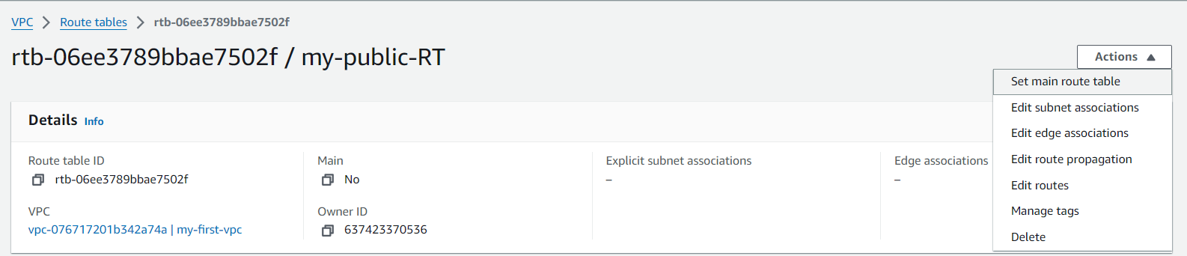

Fig-18

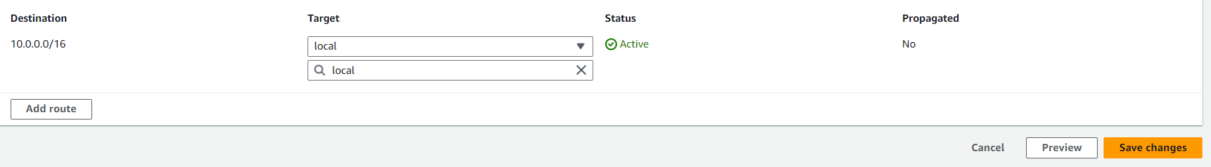

Fig-19

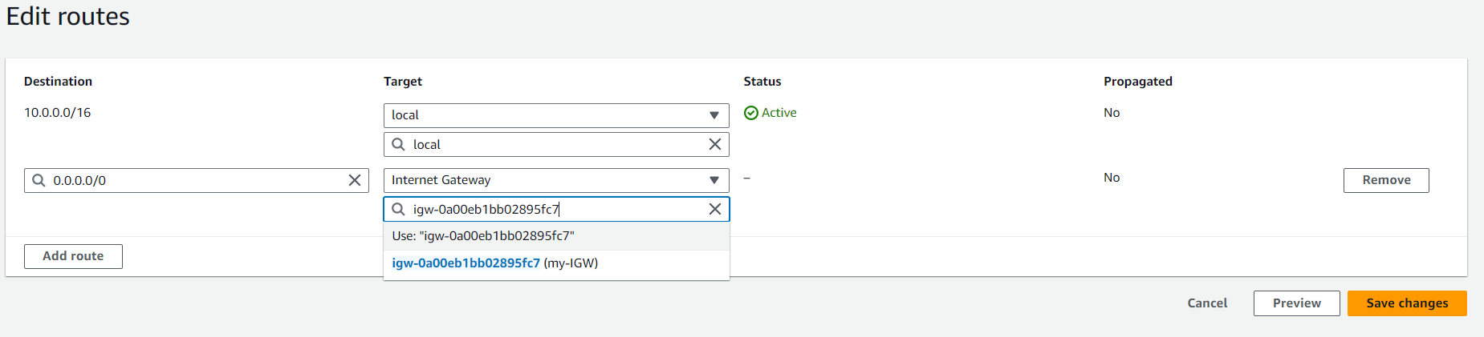

Fig-20

🡪Now click on **Subnet associations** and **Edit subnet associations**. Select public subnet check box and click on Save associations. (refer Fig-21 and 22)

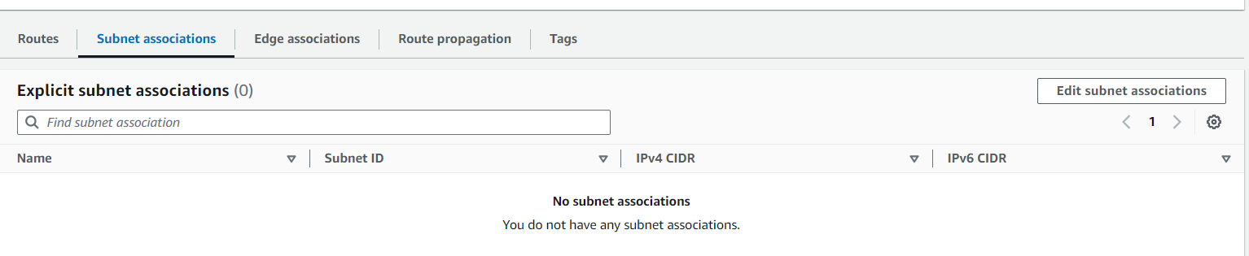

Fig-21

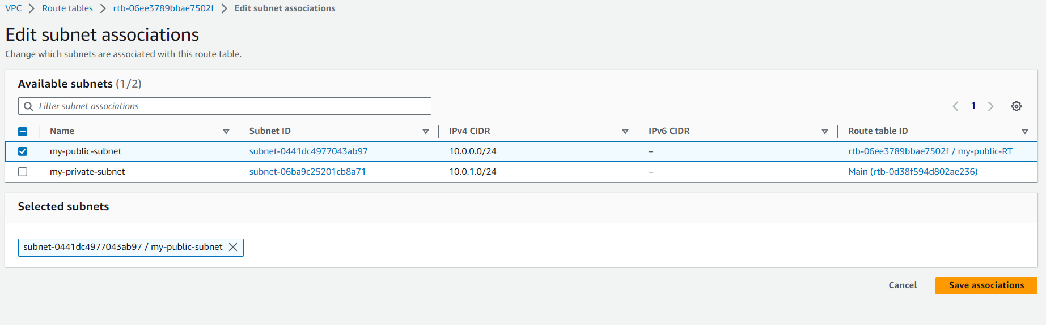

Fig-22

🡪Create one more route table (my-private-RT) and associate with private subnet.

*Note: Here for private route table, we are not going to give internet gateway because we want to make it as private. If we give internet gateway it will become public.

*EBS volume

🡪Search for EC2 in search bar of AWS home page and click on EC2 (refer Fig-23) and click on **instances** form menu and click on Launch instance. (refer Fig-24 and Fig-25)

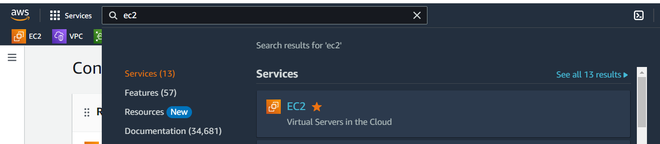

Fig-23

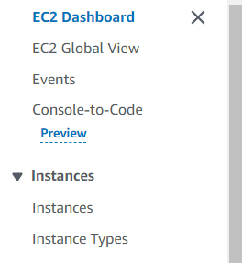

Fig-24

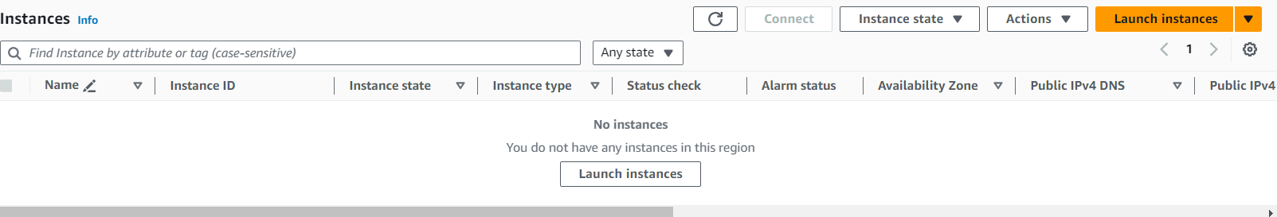

Fig-25

🡪Name our instance of your choice (for ex: ebs). Select OS of your choice (I have selected Amazon Linux). (refer Fig-26)

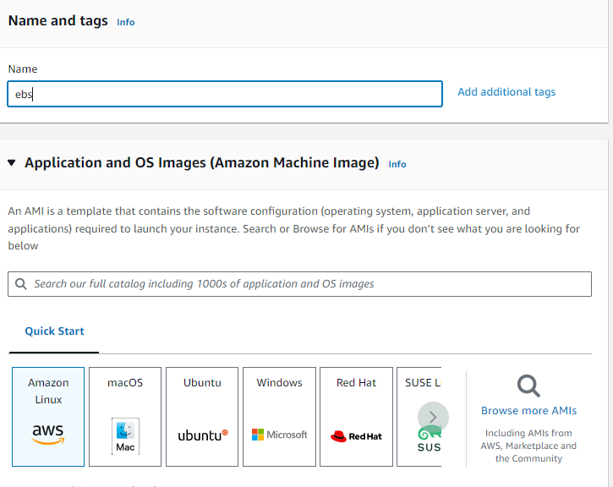Fig-26

🡪We have to create a key pair. So, click on Create new key pair option (refer Fig-27)

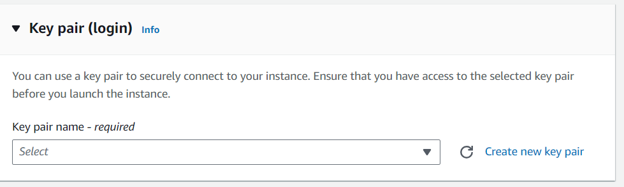

Fig-27

🡪Give name to our key pair and click on Create key pair button. (refer Fig-28)

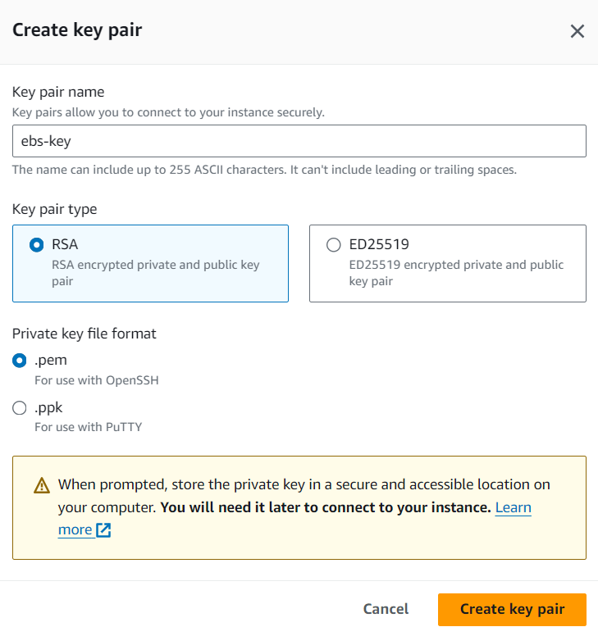

Fig-28

🡪In Network settings area, click on **Edit** and configure with our custom VPC. (refer Fig-29)

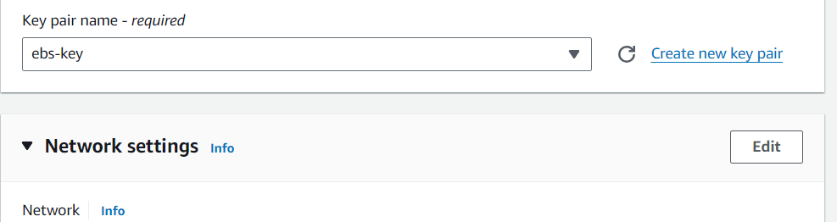

Fig-29

🡪Here select our custom VPC, select availability zone under subnet, Enable the Auto-assign public IP option and finally Launch instance. (refer Fig-30)

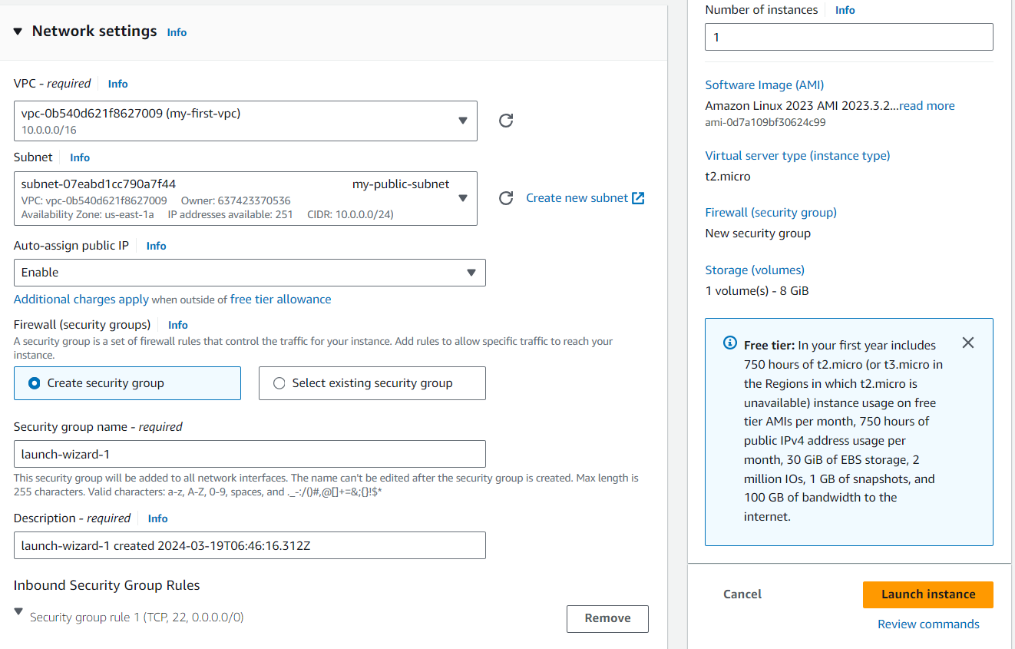

Fig-30

🡪Now click on **instances** and see our instance is in running state, if not please do refresh. (refer Fig-31)



Fig-31

🡪To create new volume, click on **Volumes** option from menu under **Elastic Block Store**. (refer Fig-32)

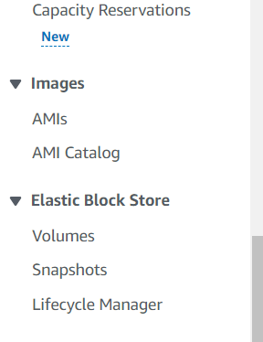

Fig-32

🡪click on Create volume option (refer Fig-33)

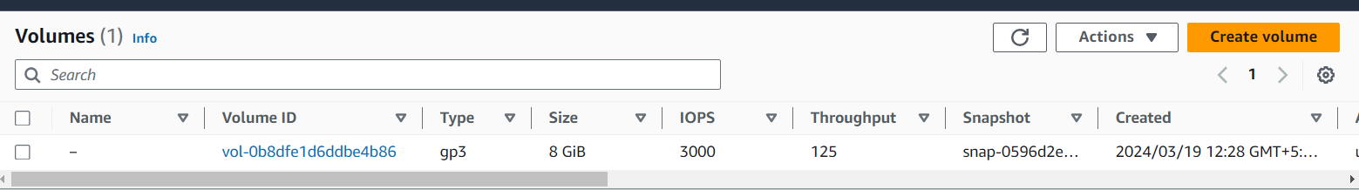

Fig-33

🡪Now Volume settings page will open and here we have to select Volume type based on our requirement, we have to mention size, we have to specify the availability zone and finally click on Create volume button. (refer Fig-34)

*Note: We have to create EBS storage in same availability zone that our instance is running.

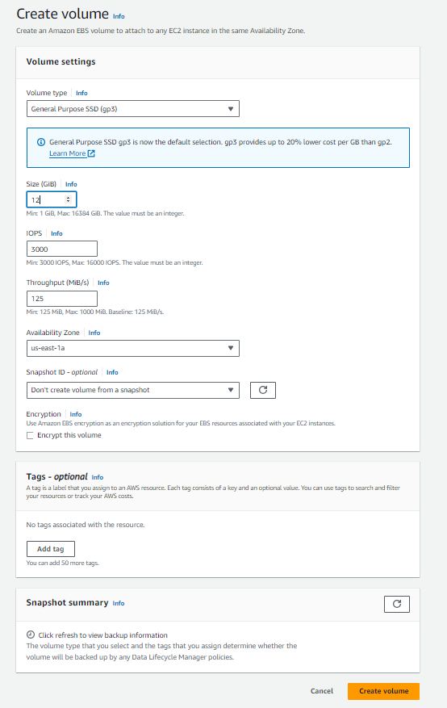

Fig-34

🡪Now we can see our new volume of 12Gib created successfully (refer Fig-35). Now, select our volume, click on **Actions** and Click on **Attach volume**. (refer Fig-36)

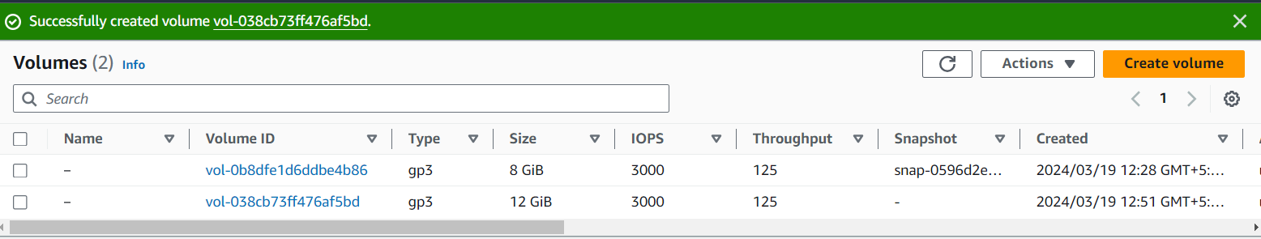

Fig-35

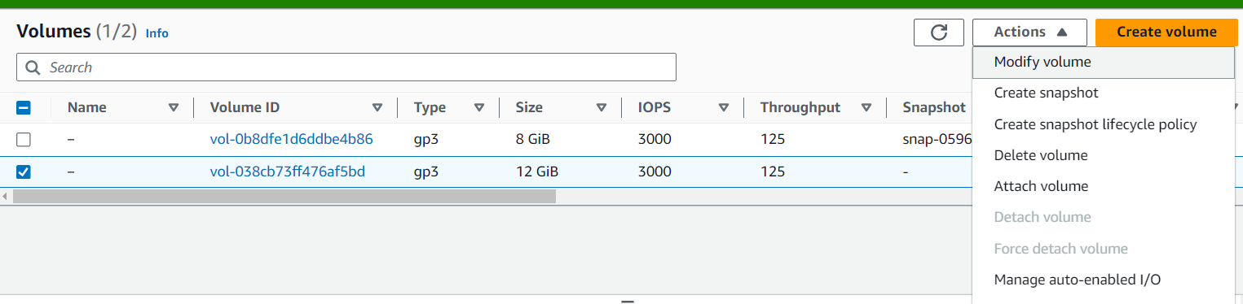

Fig-36

🡪Now we have to select our instance and finally click on Attach volume button. (refer Fig-37)

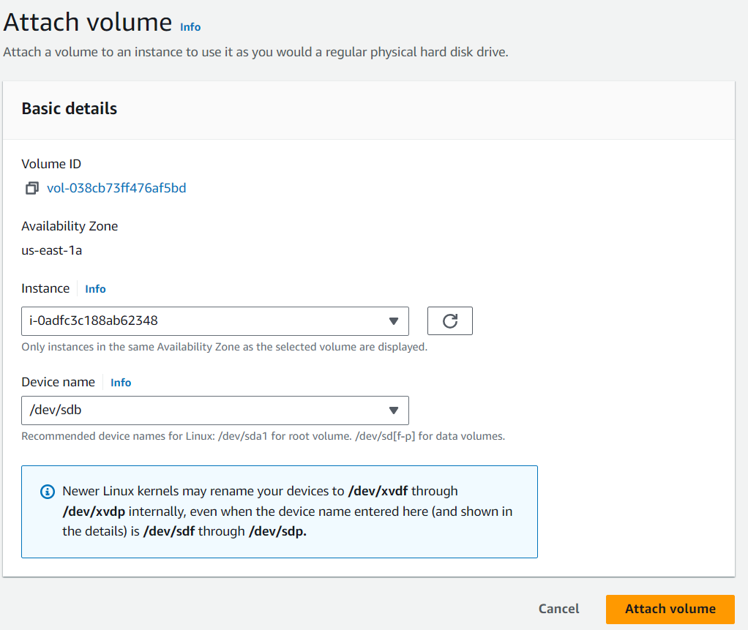

Fig-37

🡪Go to instances, select our instance and click on **Connect** (refer Fig-38)

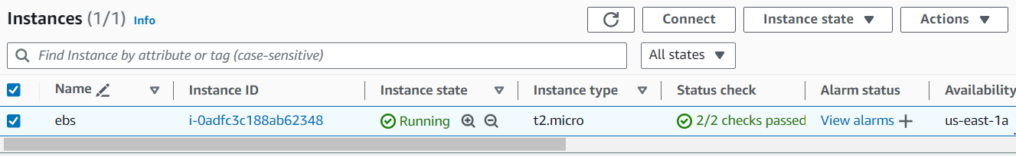

Fig-38

🡪Click on Connect button in instance connect page (refer Fig-39)

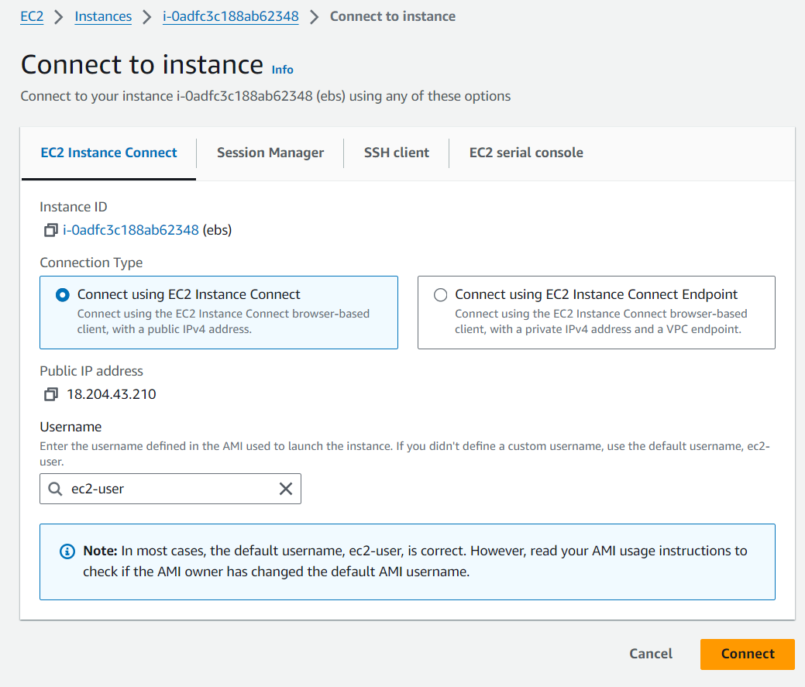

Fig-39

🡪Now we have connected to our server. Give sudo -i to change to root user (refer Fig-40)

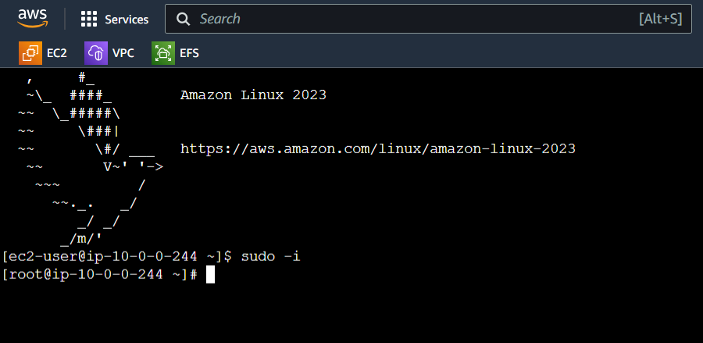

Fig-40

🡪df –h to check the disk space

🡪lsblk to list out block devices (after giving lsblk, it will show our block device. Here it is xvdb)

🡪file –s /dev/xvdb to check whether we have file system on this device.

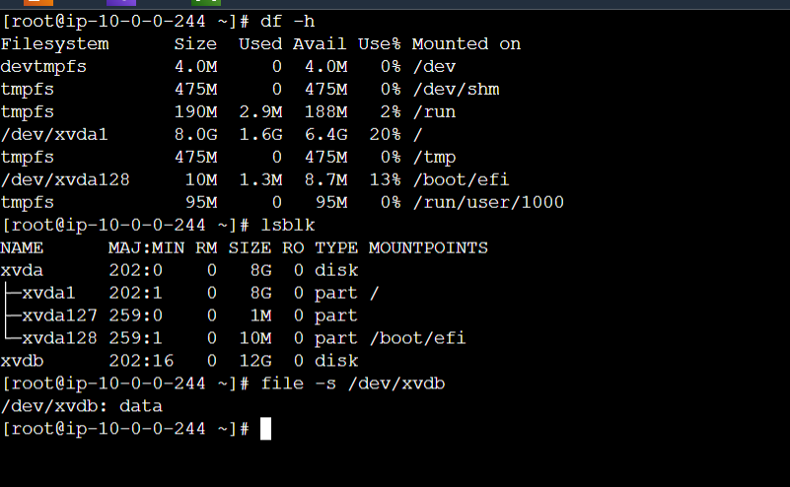

Fig-41

🡪from above its clear that we don’t have a file system. To create file system use below command and check do we have file system or not. (refer Fig-42)

🡪mkfs -t xfs /dev/xvdf

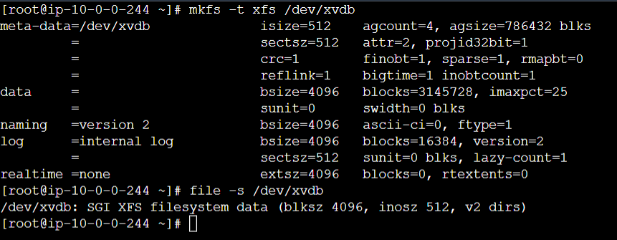

Fig-42

🡪From Fig-42, its clear that now we have file system. Now crate one nested directory to mount our volume.

🡪mkdir –p kalyan/vasu

🡪And finally mount volume by using below command

🡪mount /dev/xvdb kalyan/vasu

🡪Finally give df –h – to check whether our volume is attached or not.

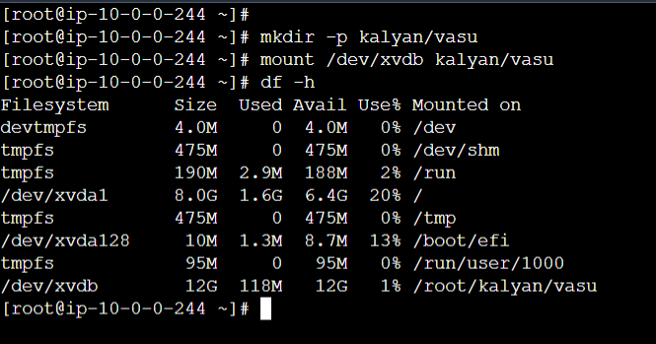

Fig-43

🡪In the above pic, we can see /dev/xvdb with Size 12G. So, our EBS volume attached successfully.