Assignment-3

TASK: Create two S3 buckets in different regions, upload a file in one S3 bucket and transfer the same file from one S3 bucket to other S3 bucket.

🡪First of all, Search for S3 in search bar of AWS home page and click on S3.

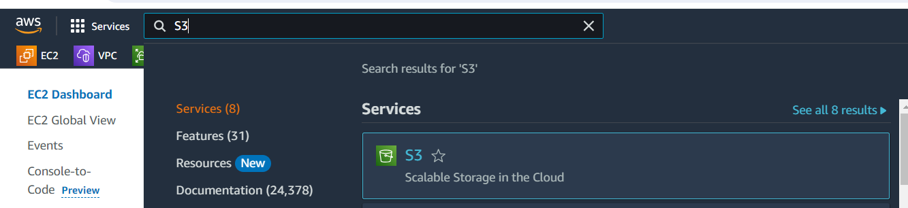

🡪Click on **Buckets** option on left panel and click on **Create bucket** button.

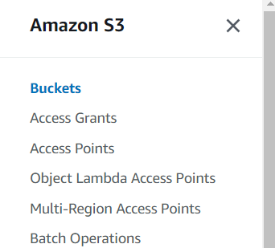

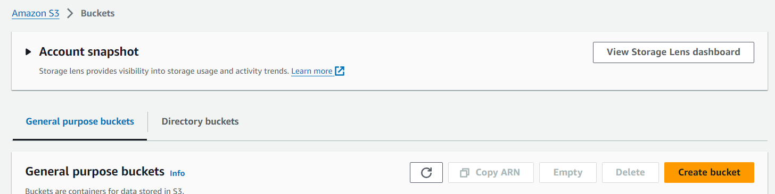

🡪here we have to select Availability Zone and give name of the bucket of our choice. And finally click on Create bucket.

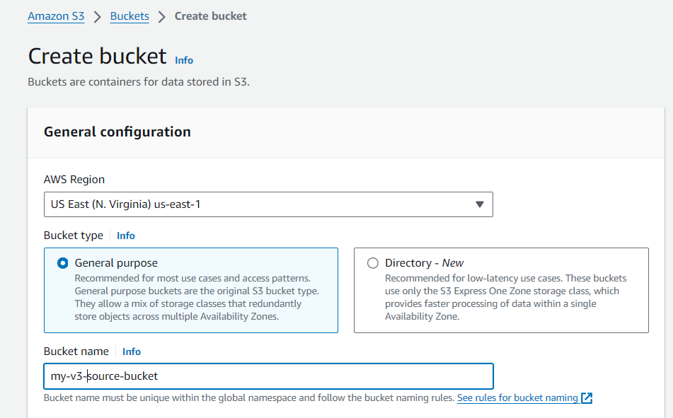

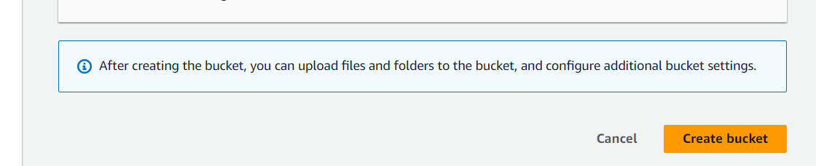

🡪Now create another bucket in a different region.

🡪Go to **Buckets**, click on Create bucket. Here select a different Region (I have selected Mumbai region) and give name and Create bucket.

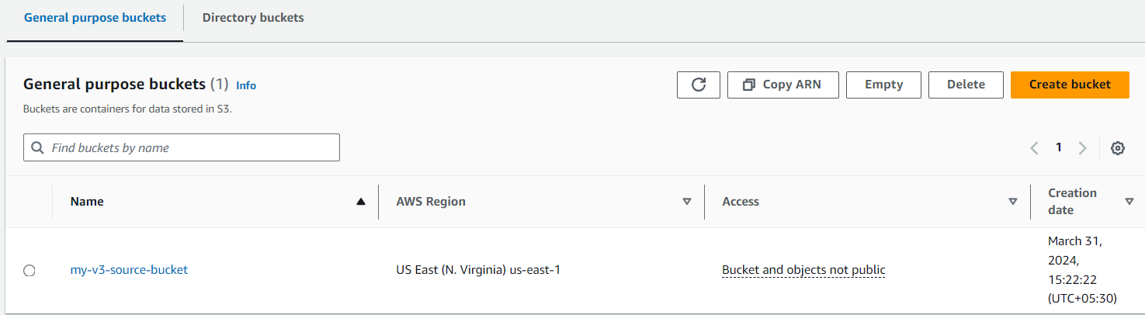

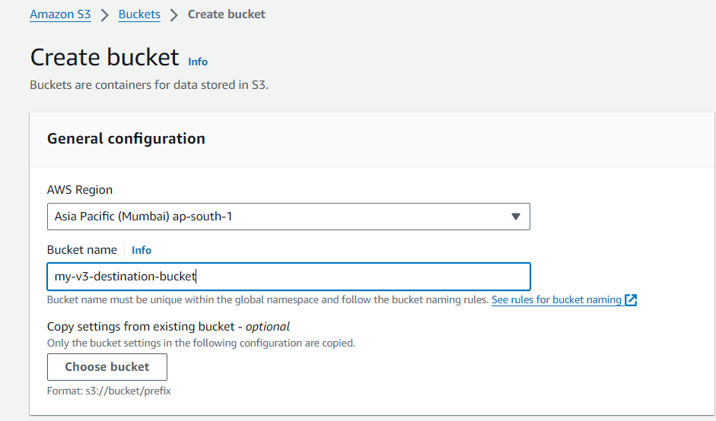

>>Now we have two buckets (both in different regions).

*Note: when we are doing cross region replication, we have to enable versioning for both buckets (source and destination buckets) in both regions.

🡪Click on source bucket (my-v3-source-bucket) and click on **Properties**, scroll down and click on **Edit** option at Bucket Versioning area. Select Enable option (by default it is in suspended mode) under Bucket versioning field and click on Save changes.

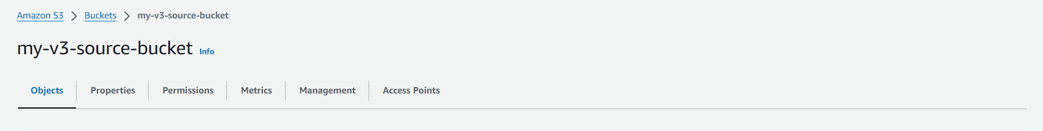

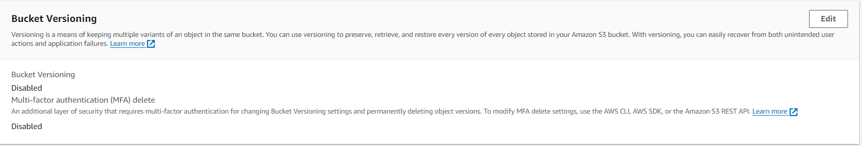

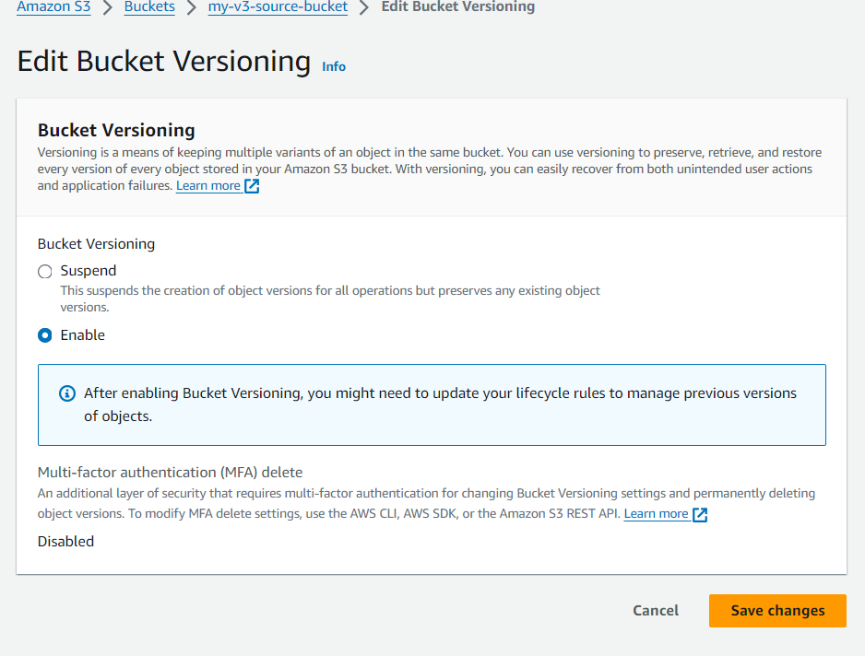

🡪Now do the same for Destination bucket (my-v3-destination-bucket) also.

🡪Now go to source bucket (my-v3-source-bucket), upload any file. We can upload folders as well. Here I’m just uploading a simple text file (**CR_replication.txt**).

🡪click on Upload option and then click on **Add files** option and select our file and click on **Open**

🡪and finally click on Upload

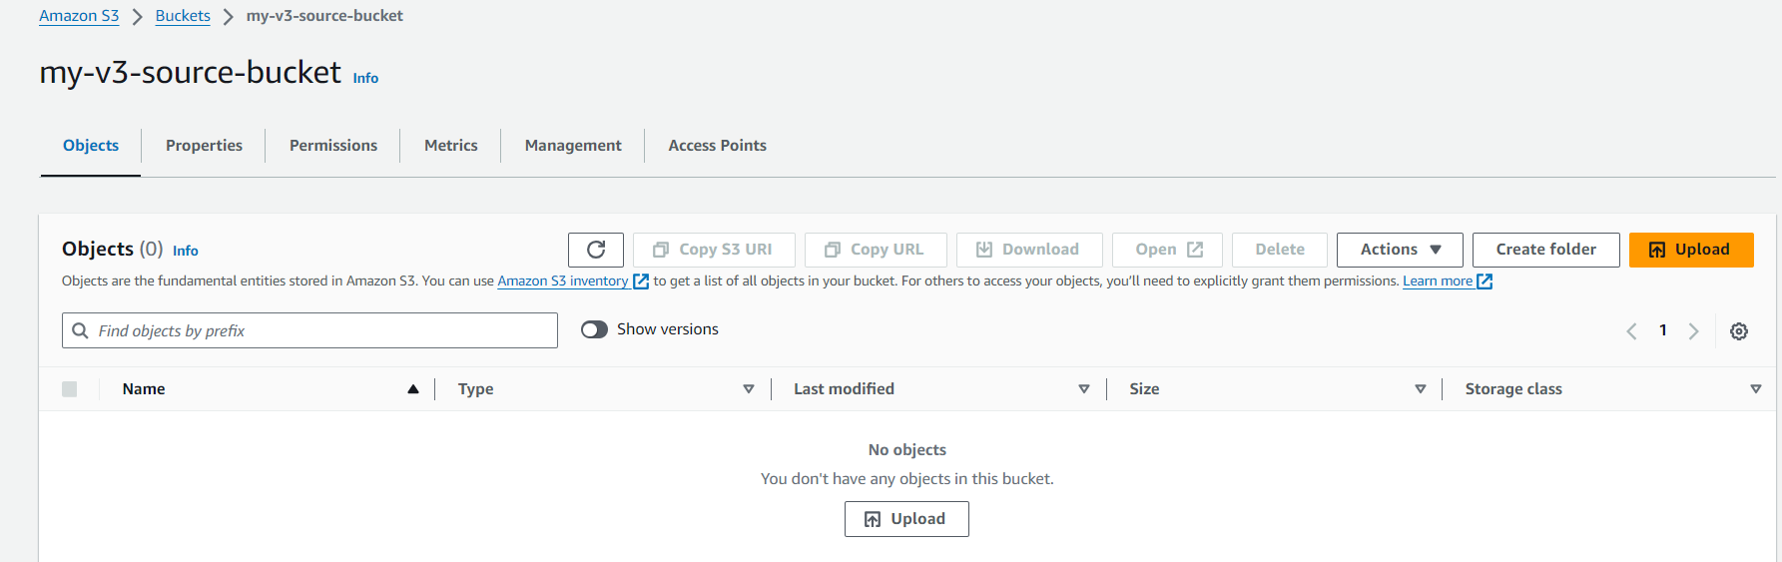

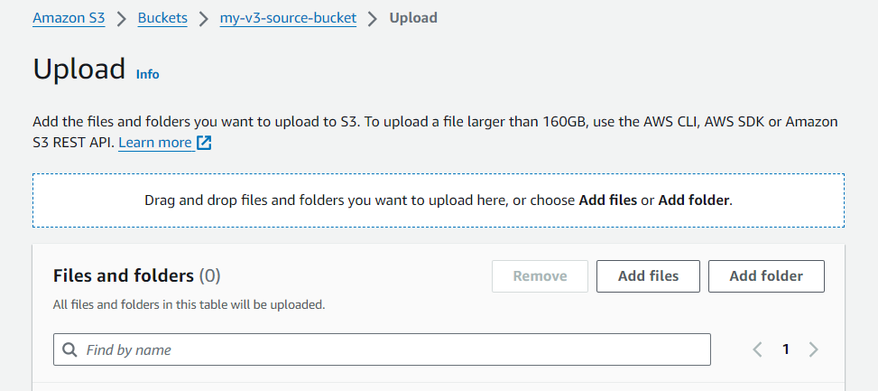

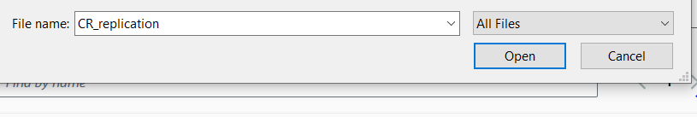

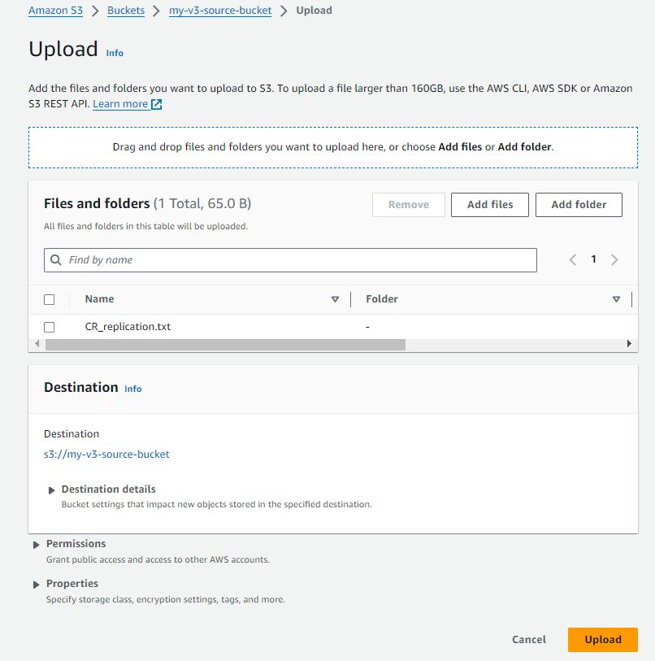

🡪Now our file uploaded successfully. Click on Close button to close upload status notification.

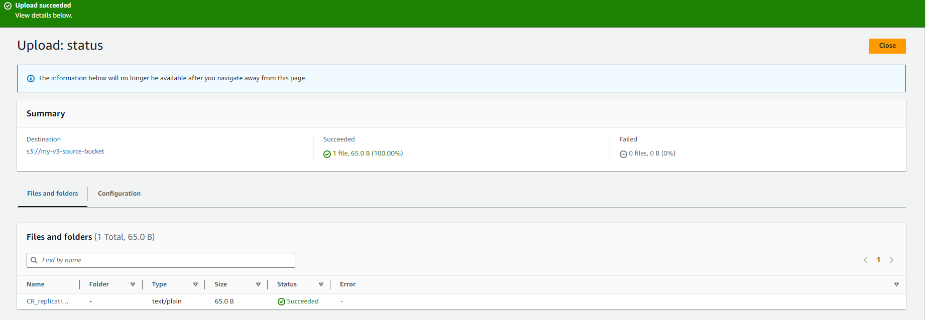

🡪now click on **Management** and click on **Create replication rule** in Replication rules area

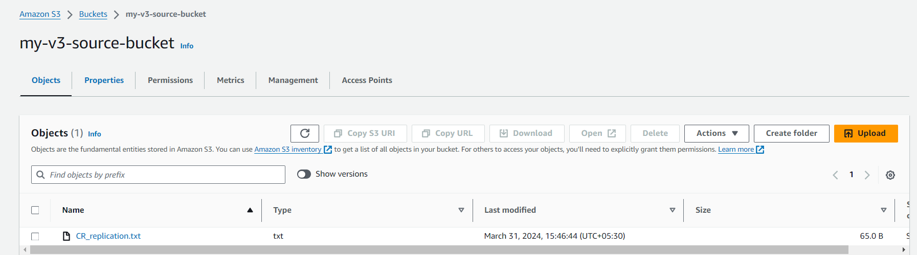

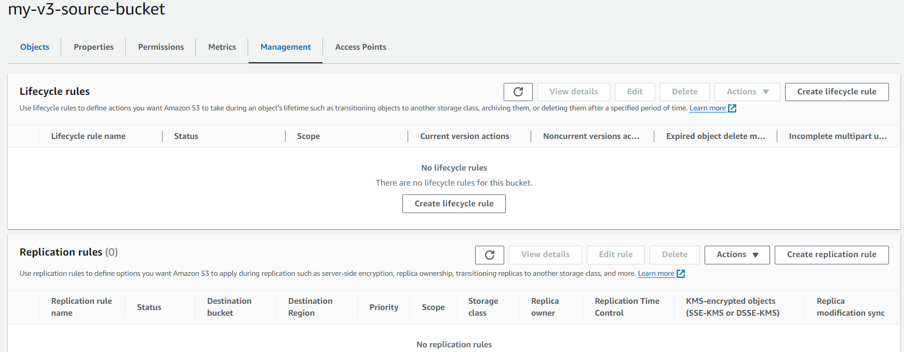

🡪give name and select Apply to all objects in the bucket option

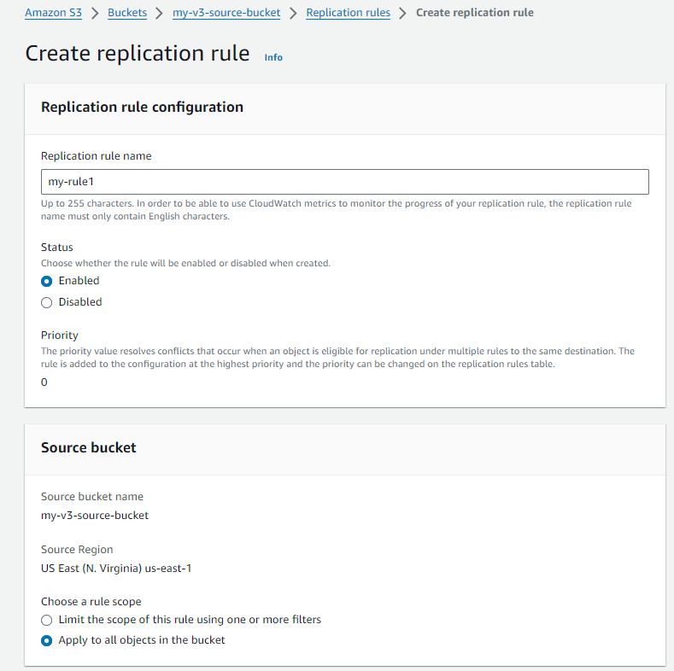

🡪under Destination field, click on **Browse S3** to choose our destination bucket

🡪select our Destination bucket (my-v3-destination-bucket) and click on Choose path option.

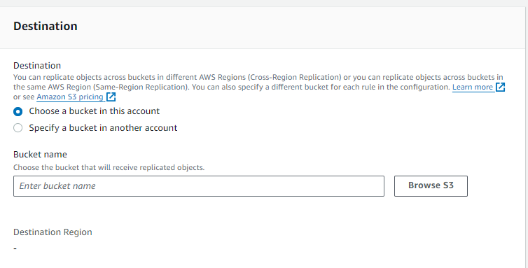

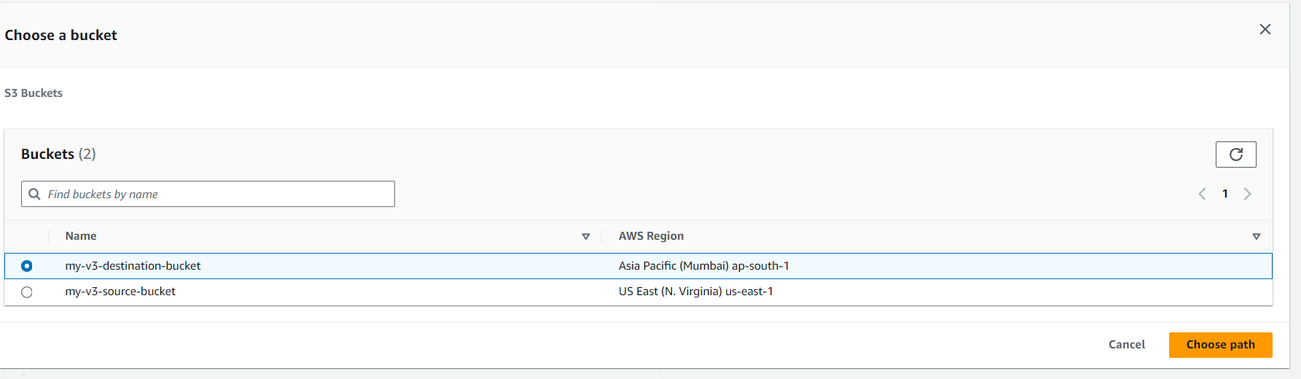

🡪 Now, Under IAM role, select **Create new role** option and select **Replication** **Time Control (RTC)** option under Additional replication options and finally click on Save button.

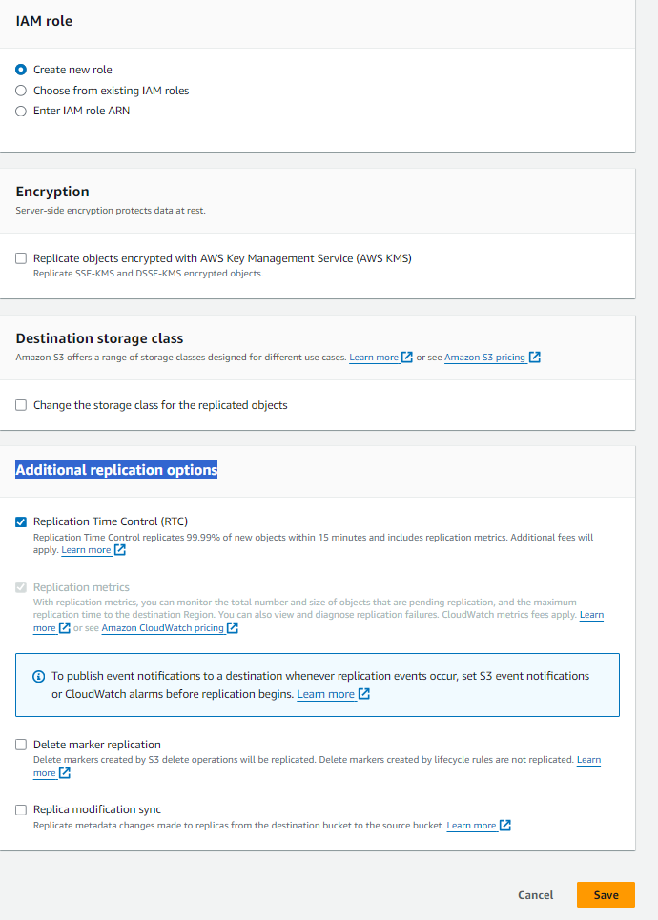

🡪 Now, Replicate existing objects? Dialogue box will appear. Select Yes, replicate existing objects option and click on Submit.

🡪now click on **Browse S3** under Completion report field and select our destination bucket and click on Choose path option.

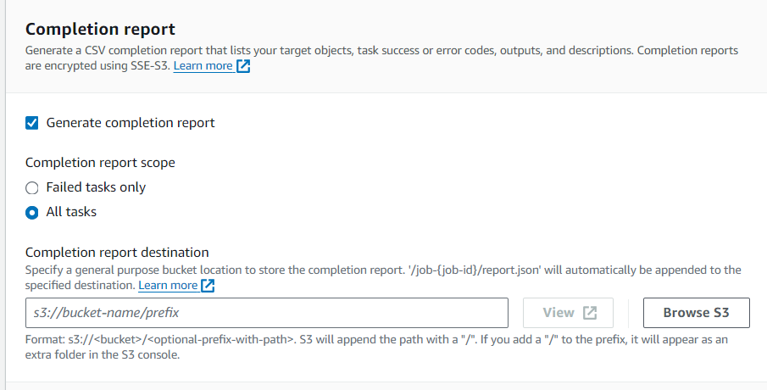

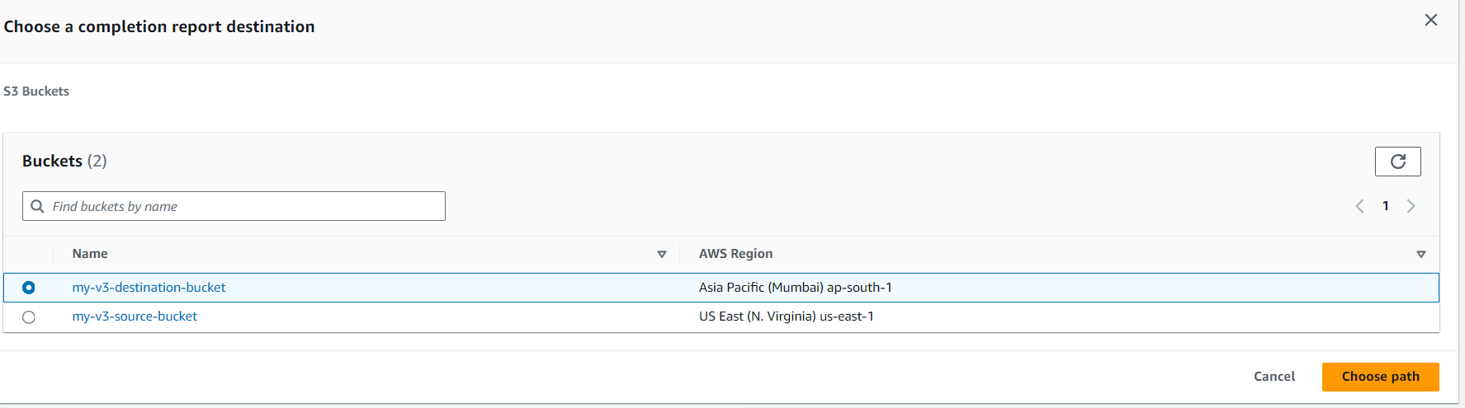

🡪under **Permissions** field, select **Create new role** and finally click on Save button.

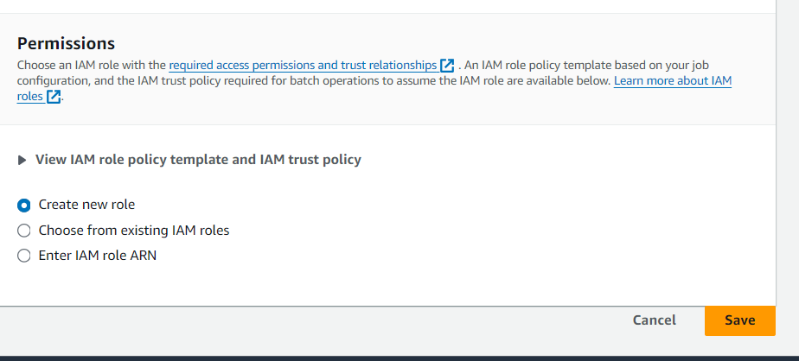

🡪now go and check whether our file replicated or not.

🡪go to source bucket, and there we can our text file which we uploaded (i.e. CR_replication.txt)

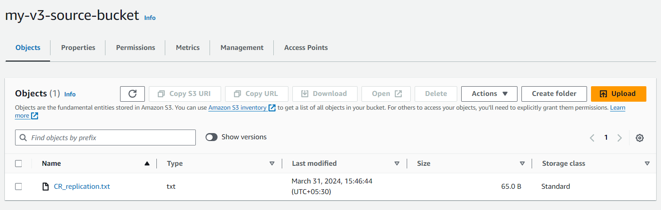

🡪Now go to destination bucket, and check whether the same file is there are not.

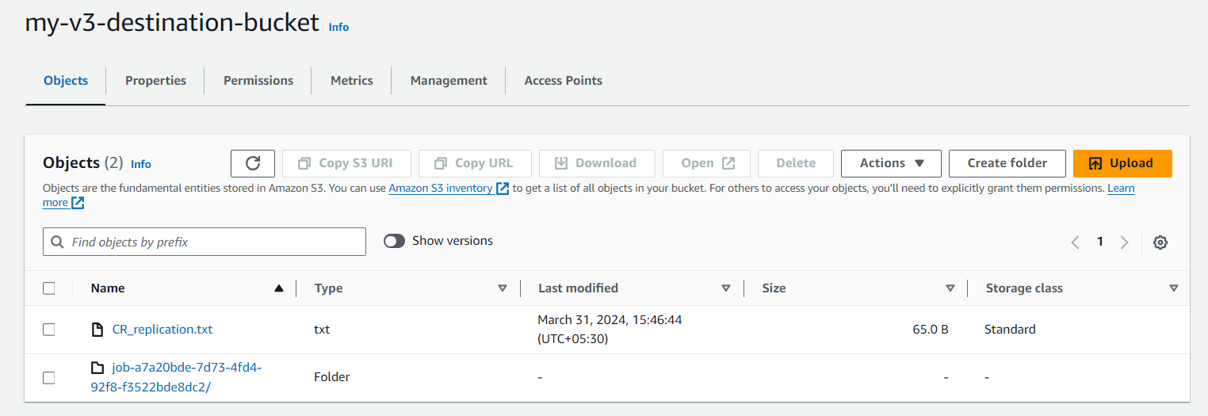

🡪from above pic, it is clear that our file is replicated successfully.