Billing Alarm

>>Create a SNS topic first (or we can create it while creating alarm itself)

>>search for SNS in search bar of AWS console and click on Simple Notification Service

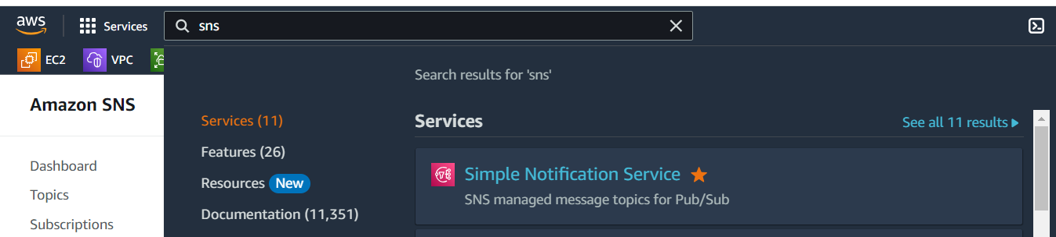

>>click on Topics and click on Create topic

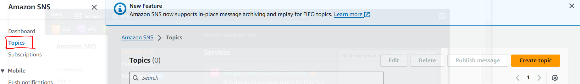

>>select Standard option, give any name to your topic and click on Create topic

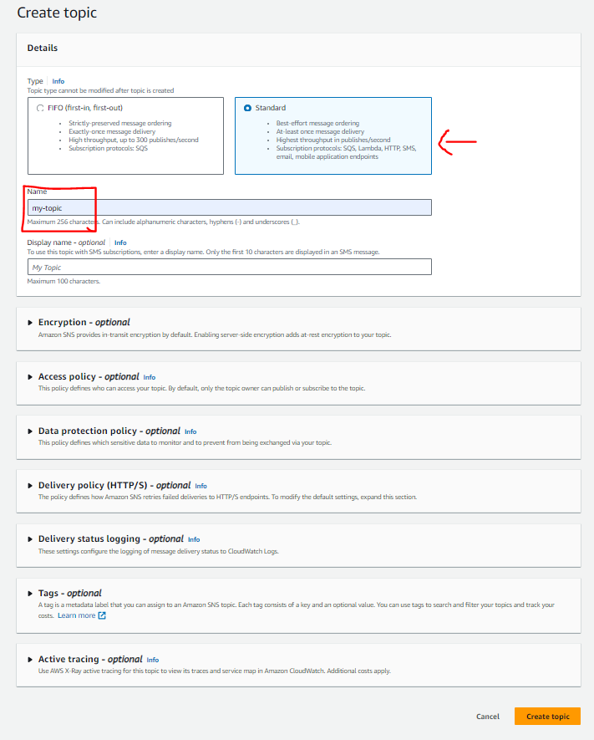

>>now we have to subscribe the topic. So click on Subscriptions and click on Create subscription

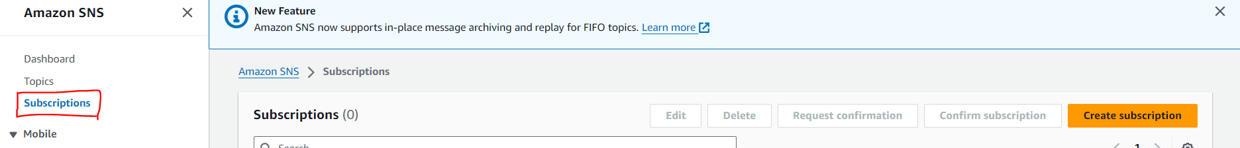

>>under Topic ARN, select our topic (that we already created). Under Protocol field, select Email form drop down. In Endpoint field, give your mail ID and click on Create subscription

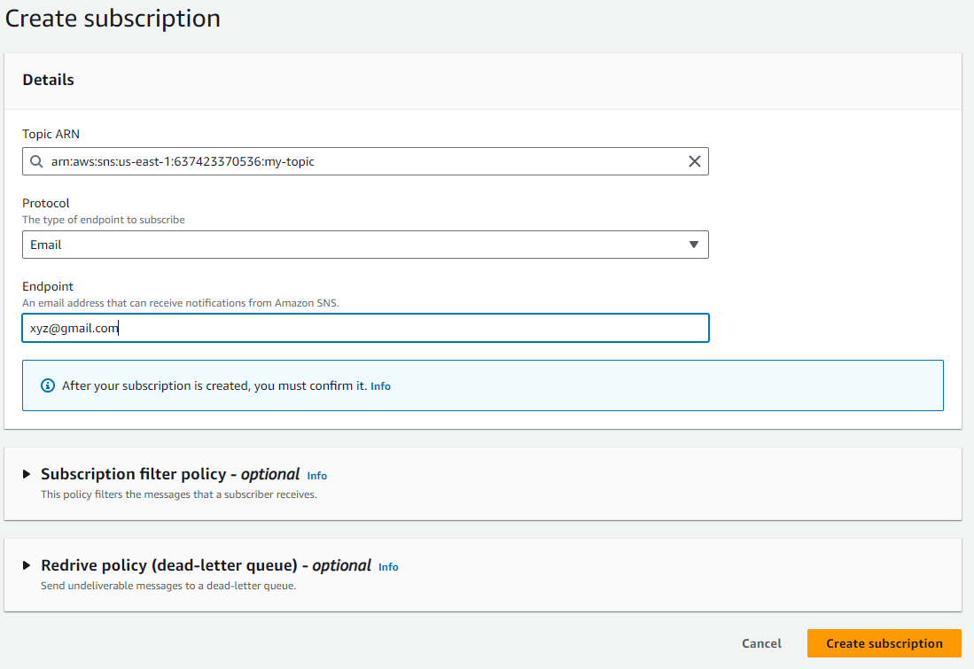

>>now the status is in pending state. Go to your mail box and confirm the subscription.

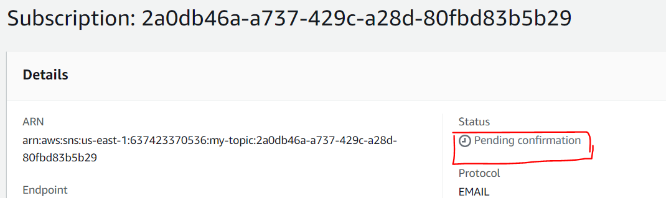

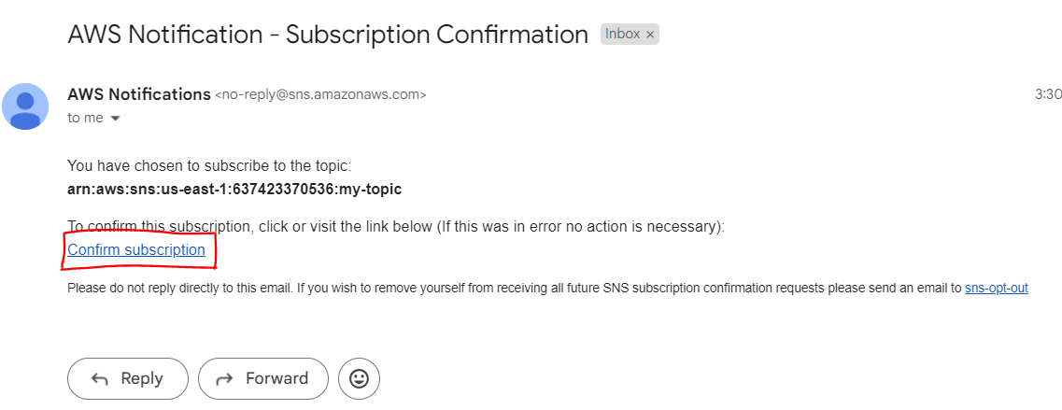

>>after confirmed the subscription in mail box, return to AWS console and do refresh the page and we can see the status as Confirmed

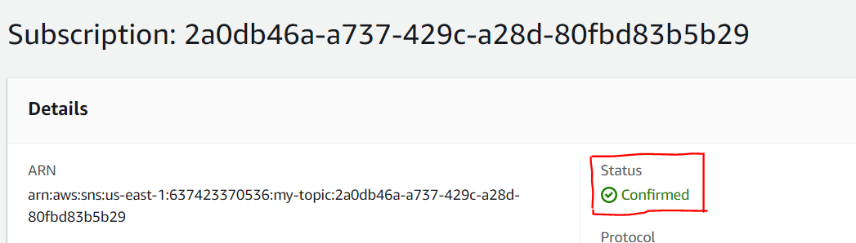

>>now search for cloudwatch and click CloudWatch

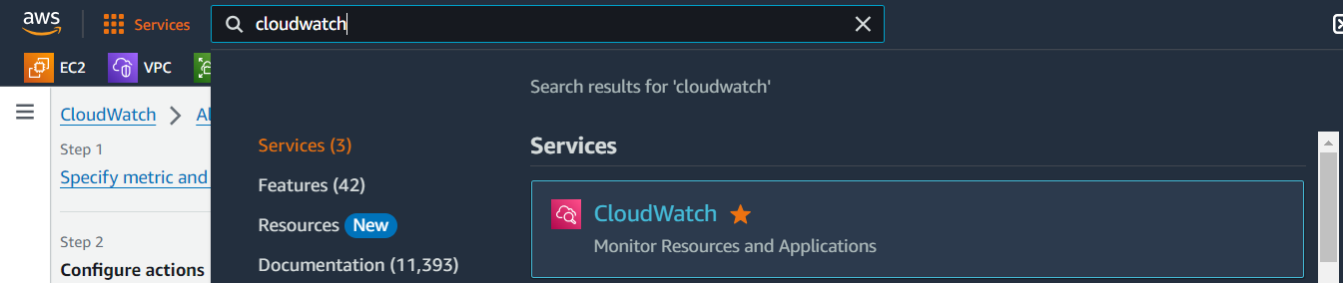

>>click on Billing and click on Create Alarm

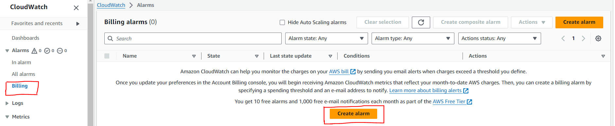

>>select Static option for Threshold type and select condition (I have selected Grater/Equal) and define Threshold value (I have given 5) and click Next

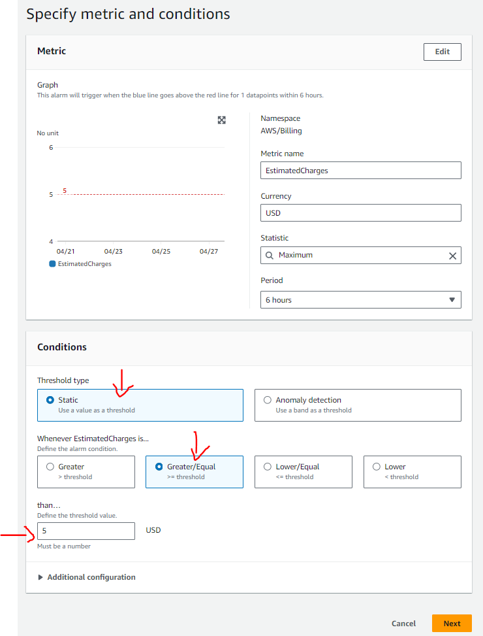

>>in Configure page, select, In alarm option and select an existing topic and select our topic that we already created, scroll down and click on Next

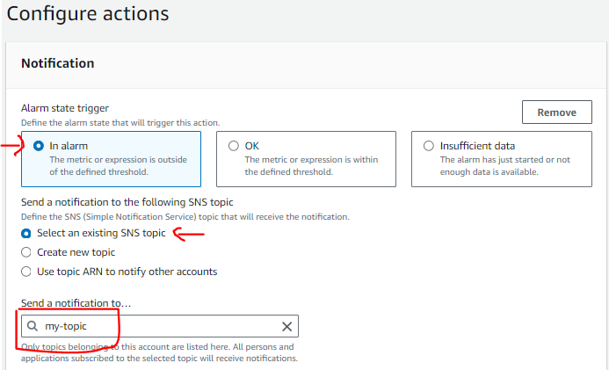

>>give name to your alarm (description is optional) and click on Next

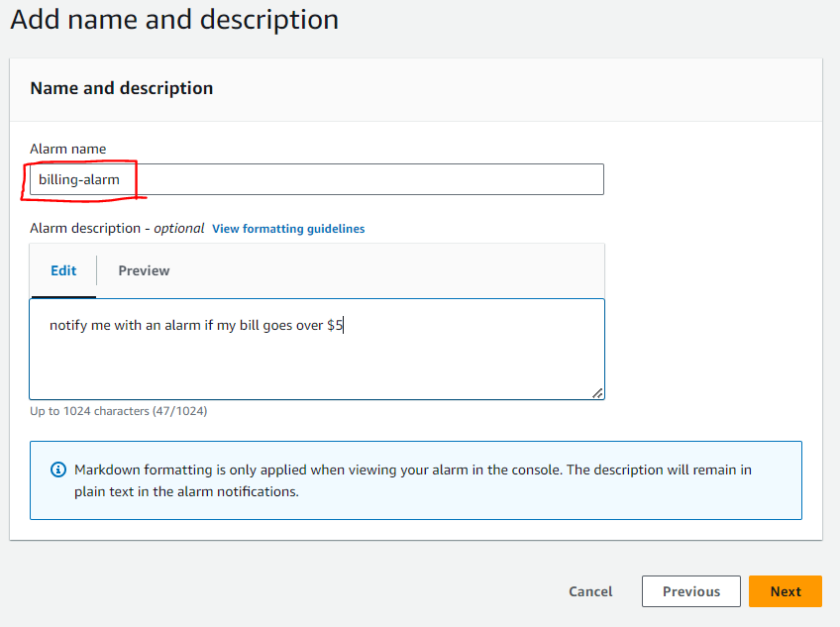

>>in the next page scroll down to bottom, and click on Create alarm button. Now our alarm got created.

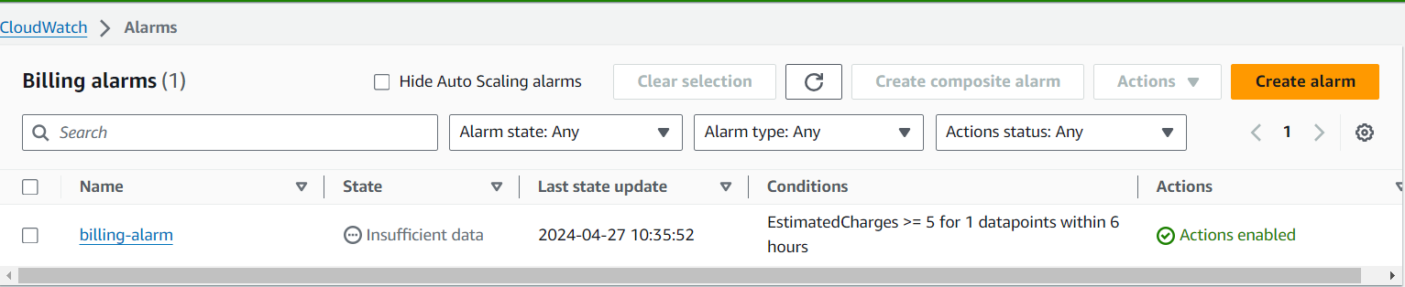

>>once our bill amount crossed/becomes $5, will get email notification