DOCUMENTATION
APPLICATION NAME:E-BUZZ
EBUZZ is an application which can be used to access the information about the latest movies ,videos and trailers .It also tells us about the Cinema Halls in the Delhi/NCR according to the region. EBUZZ uses many “ANDROID”concepts. It has an Search option by which you can access information about Films. It has a movies section which contains the movies which are now running in Cinema Halls and updates itself dynamically whenever there is a change in online database of API used .Video Section
has a list view which displays the list of videos and it is implemented using the 'YOUTUBE API'.
API Used:MoviesDB,Youtubev3,OMdb.
INFORMATION(about the implementation of the APPLICATION)
1.ICON OF THE APP
2.After clicking on the Application icon ,a SPLASH SCREEN appears
3.Home Screen:It contains following elements
- Horizontal Scroll View
- Image Button
- Four section(Each of them is an Image Button and activates an Intent
whenever the button is clicked)
#. Horizontal Scroll View
1.It acts directly in a single layout.
2.orientation:HORIZONTAL.
#.IMAGE BUTTON
- Size of Image Source:300 x 444
- 4 images

SECTIONS IN THE APPLICATION
1.Movies Section
2.Theaters Section
3.Search Section
4.Video Section
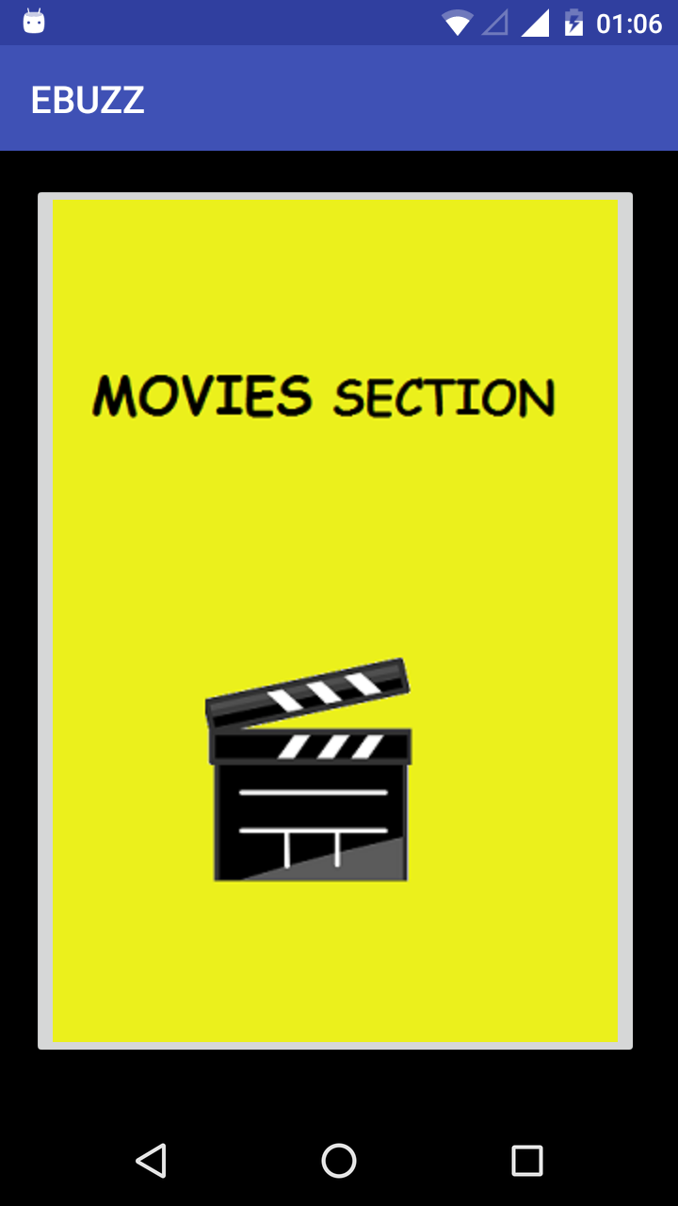
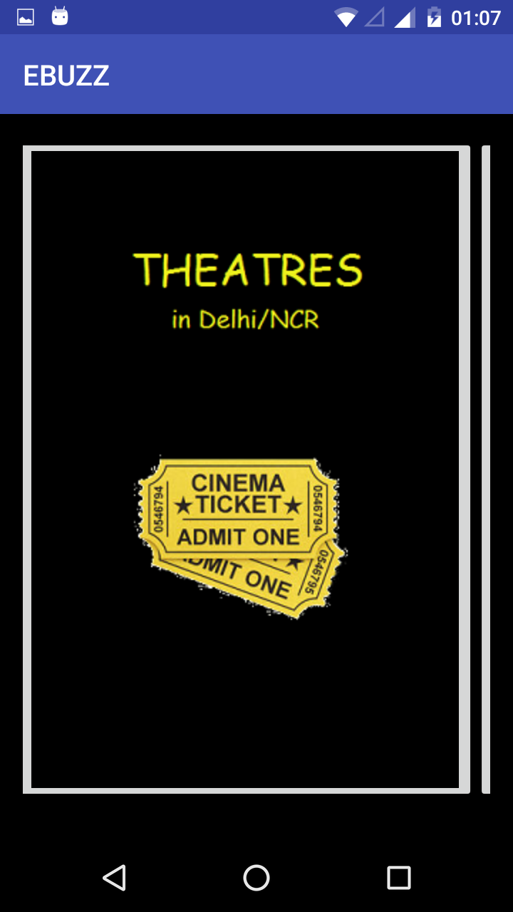

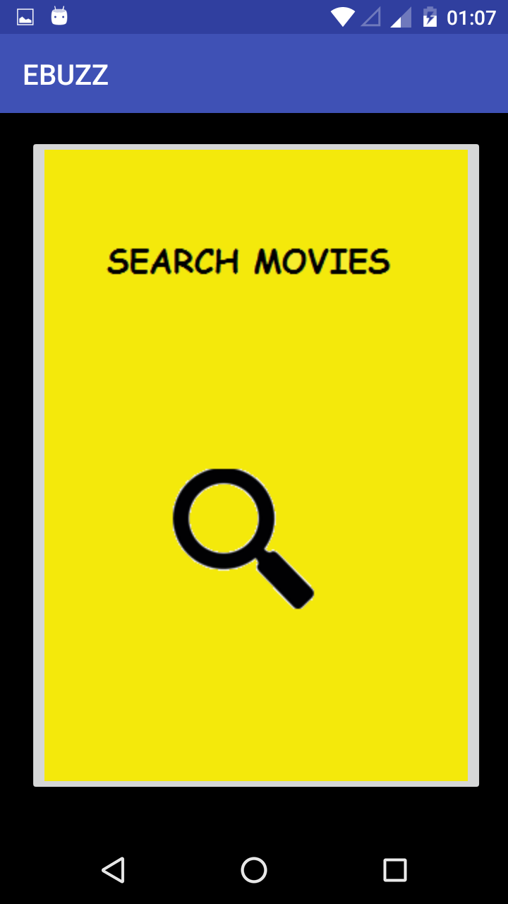
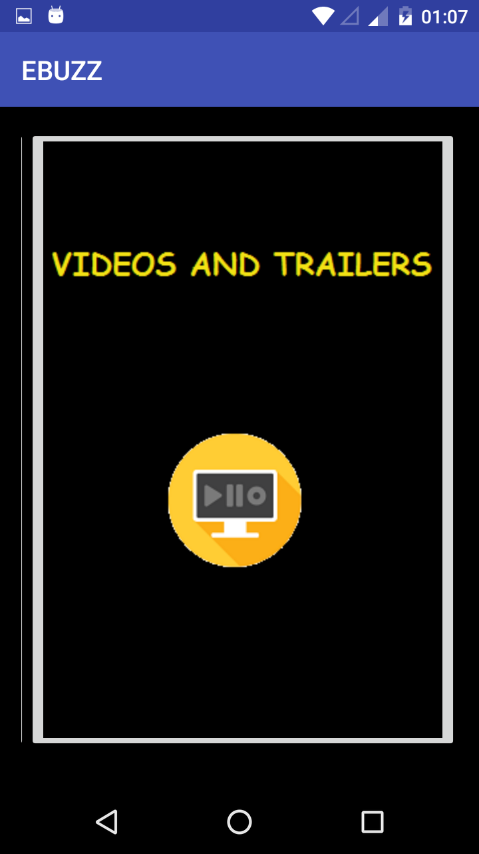

MOVIES SECTION
Clicking on the Movie Section Button it opens an Activity which is displaying poster of the films which are running this week in cinema halls. The Grid View displays two movies in each rows. The information in Grid View is fetch from the MoviesDb api DATABSE whenever an information related to the movies is changed the change reflects in the Grid View.
Implementation:
This dynamic accessing of data is achieved by usage of 'HTTPURLConnection' which establishes a connection between the app and the database. Actually, and URL is build which act as Search Query and access the Database for the Specific Result.
Uses of this class follow a pattern:
- Obtain a newHttpURLConnectionby calling URL.openConnection()and casting the result toHttpURLConnection.
- Prepare the request. The primary property of a request is its URI. Request headers may also include metadata such as credentials, preferred content types, and session cookies.
- Optionally upload a request body. Instances must be configured with setDoOutput(true) if they include a request body. Transmit data by writing to the stream returned by getOutputStream().
- Read the response. Response headers typically include metadata such as the response body's content type and length, modified dates and session cookies. The response body may be read from the stream returned by getInputStream(). If the response has no body, that method returns an empty stream.
- Disconnect. Once the response body has been read, the HttpURLConnection should be closed by calling disconnect(). Disconnecting releases the resources held by a connection so they may be closed or reused.

USAGE OF PICASSO LIBRARY:
It is used to fetch the Image from the Specified URL .

Look Of the Implementation in The Application
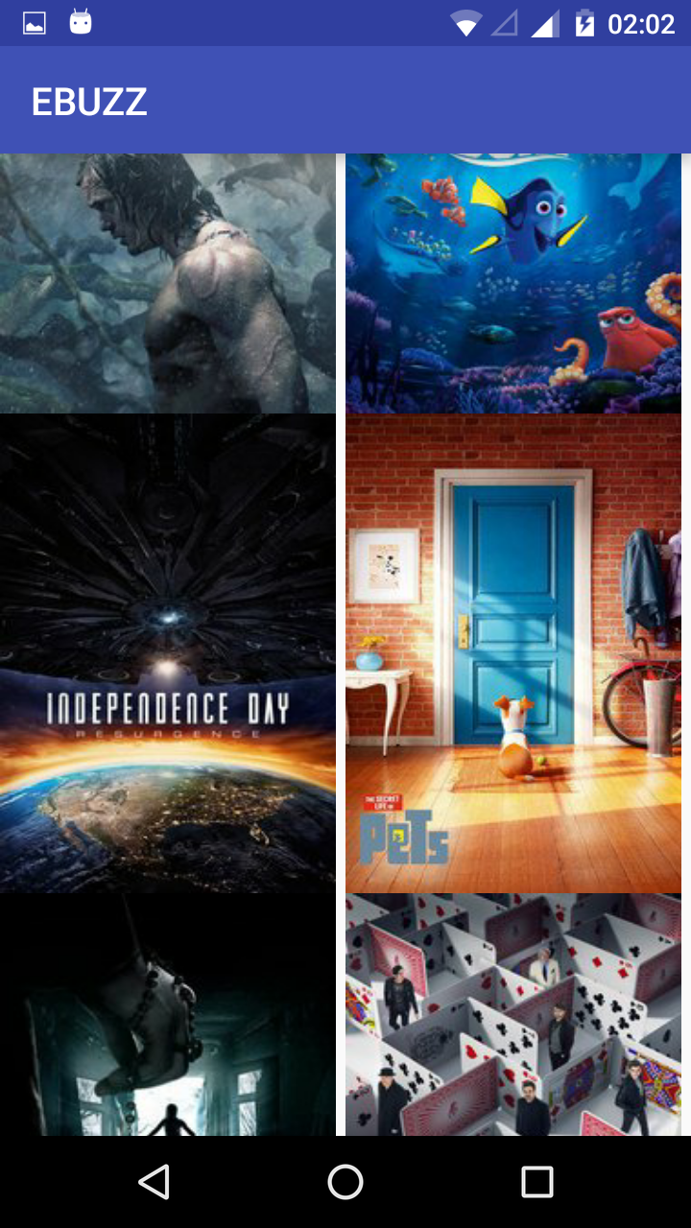

THEATERS SECTION
Clicking on the Theaters section Button an activity will be called which displays a Delhi Map containing Four Buttons which are used for displaying the name of Theater and the address of the Theater in form of an Expandable List View.
Format of Displaying of the Names of the Theaters
- Name of the Theater.
- On clicking the Name of the theater a dropdown is used to display the address
corresponding to that theater.
#.DATA TYPES USED
- ArrayList(String) to store the Information of the Theater(i.e.Theater Name and Theater Address)
- HashMap is used to link child to the parent
  - Parent in this Context is Theater's Name.
  - Child in this Context is the Theater's Address.
#.Classes Made
- Theatres class is used to used to link this main activity to other subactivities(i.e.to the classes associated with different regions).
- Class for different region having arraylist and hashmap.
- Button have an onclickListener that takes them to another activity according to specific intent assign to it .
- Expandable List view class in which the array list containing the name of the Theater's and the Hash Map to which child nodes are linked according to the parent Positon.
- The above class creates a view which is set to the expandable list view adapter.
#Layout(.xml files)
- theatres.xml is used to display the main layout page which will display the images and buttons.
- A xml file for parent and an xml file for the child to specify the layout of parent and child respectively.
- An xml file containing an ExpandableListView.

Implementation In The Application
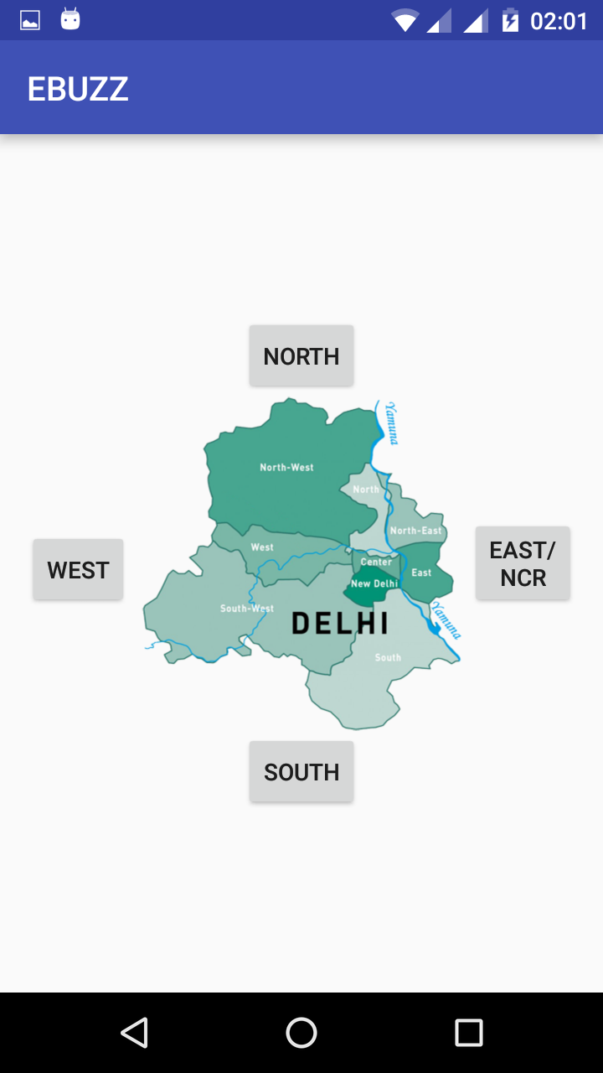
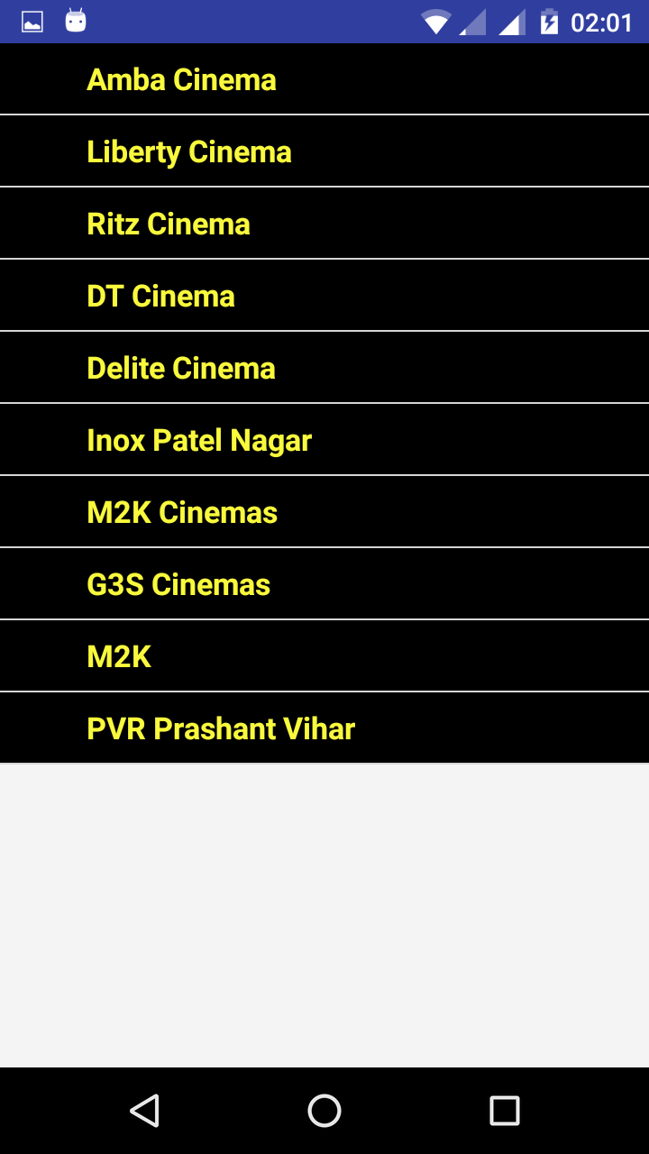
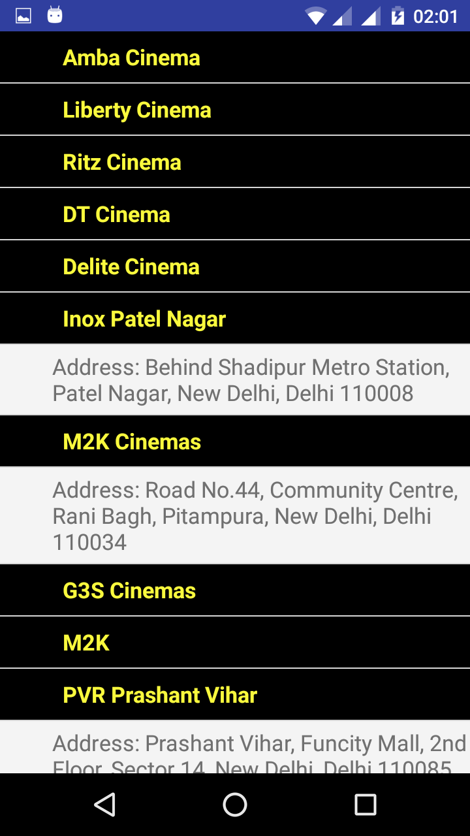
SEARCH SECTION
Click on the Search Movie Image button it opens an activity containing two EditText fields. The first one is to insert the 'Title of the Movie' and the second one is insert the 'Year of Release'.On clicking the button it will start fetching the data from the URL generated with those two Edit Text fields.The format of the data present at that URL is in the form of JSON(JavaScript Object Notation).The JSON is parsed in the second class using Volley library of the Google. After Parsing Required Information is Displayed in the corresponding layout file.
#LIBRARY USED
Volley Jar
Function:
What is Volley library exactly for?
Volley is a library that makes networking for Android apps easier and most importantly, faster.
It manages the processing and caching of network requests and it saves developers valuable time from writing the same network call/cache code again and again. And one more benefit of having less code is less number of bugs and that’s all developers want and aim for.

Advantages of using Volley:
- Volley automatically schedule all network requests. It means that Volley will be taking care of all the network requests your app executes for fetching response or image from web.
- Volley provides transparent disk and memory caching.
- Volley provides powerful cancellation request API. It means that you can cancel a single request or you can set blocks or scopes of requests to cancel.
- Volley provides powerful customization abilities.
- Volley provides Debugging and tracing tools

2 Main classes of Volley:
There are 2 main classes:
1. Request queue
2. Request
Request queue: It is the interest you use for dispatching requests to the network, you can make a request queue on demand if you want, but typically, you’ll instead create it early on, at startup time, and keep it around and use it as a Singleton.
Request: It contains all the necessary details for making web API call. For example: which method to Use (GET or POST), request data to pass, response listener, error listener.
Android volley is a networking library was introduced to make networking calls much easier, faster without writing tons of code. By default all the volley network calls works asynchronously, so we don’t have to worry about using Asynctask anymore.
USAGE OF PICASSO LIBRARY:
- It is used to fetch the Image from the Specified URL .
- In this context the URL of the image is obtained by Poster object in JSON array provided by the Omdb URL .

Implementation In The Application
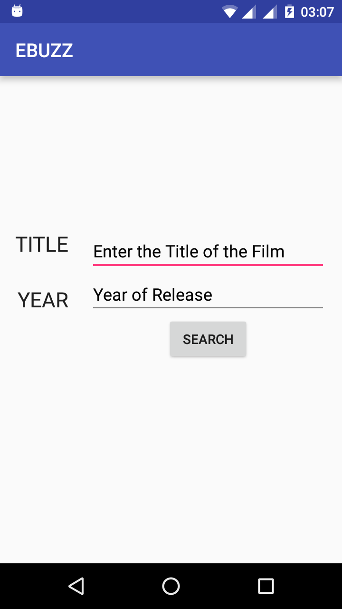
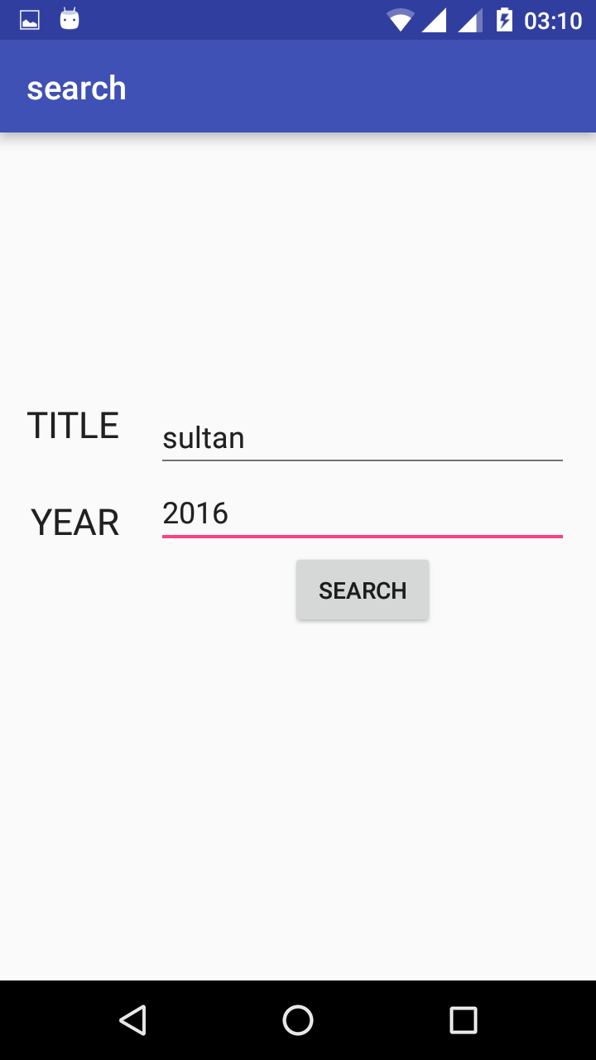

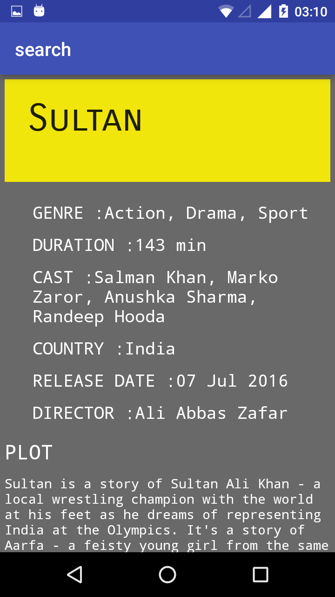
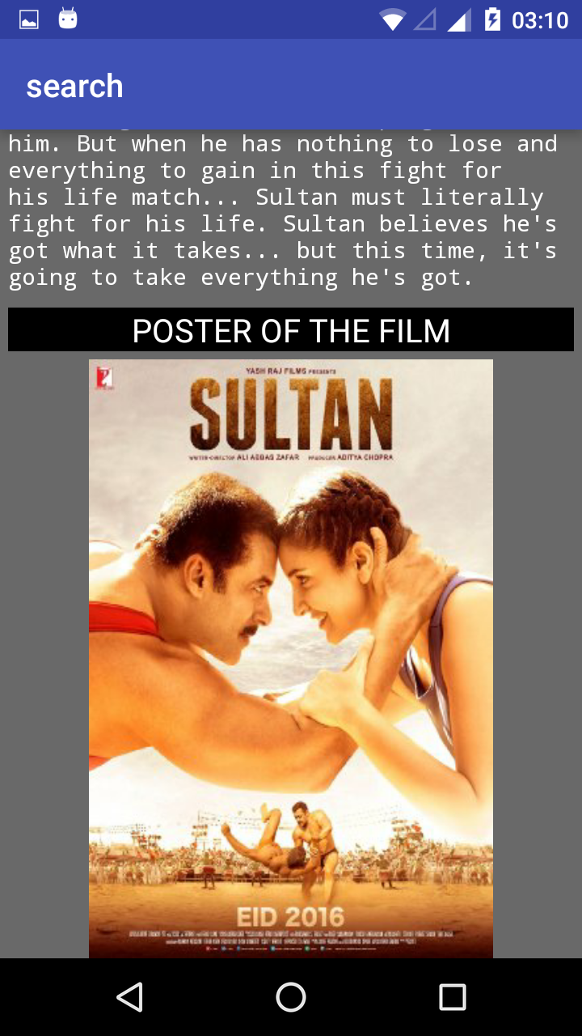

VIDEOS AND TRAILERS SECTION
The videos section contains a list view and custom adapter which displays up when Video section button is clicked is home page.Then on click on any of the component of list view it takes control over to another activity on which youtube vedio is embedded.

#.YouTube API:-Package
It contains all the interfaces and classes of the YouTube Android Player API. This API enables you to easily play YouTube videos and display thumbnails of YouTube videos in your Android application.
There are two ways to play videos.
- The first option is to place a YouTubePlayerFragment or YouTubePlayerView in your View hierarchy and then use the YouTubePlayer to control video playback in the View.
- The second option is to use the YoutubeStandalonePlayer which will start video playback in a separate activity.
YoutubePlayerView:-
A view for displaying YouTube videos. Using this View directly is an alternative to using the YouTubePlayerFragment. To get started, place this view in your view hierarchy and call initialize(String, OnInitializedListener)to create a YouTubePlayer which you can use to load videos into this View.
YoutubeBasedActivity:-
Any activity that wants to directly incorporate YoutubeplayerViewerviews in its UI must extend this activity.
YouTubeInitializationResult:-
Provides the result of initializing the YouTube API Service. If initialization fails, the reason for the failure is provided and, if this error is recoverable by user action, then a mechanism to recover from the error is available
IMPLEMENTATION IN APPLICATION
