Ex. No.: 11

**DATABASE WITH AUTO_INCREMENT SEQUENCES**

**AIM:**

To create Auto_Increment sequence on the given relation.

1.Create Auto_increment fot the DBMS_STUD table

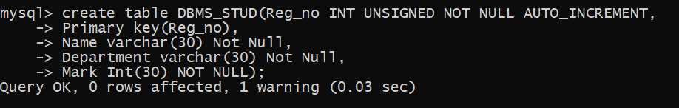

2.Insert the values in the table

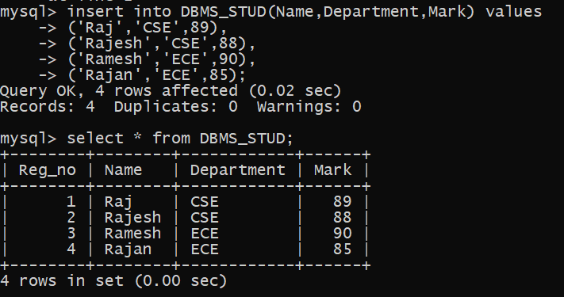

3.Insert the values into the table from no 50

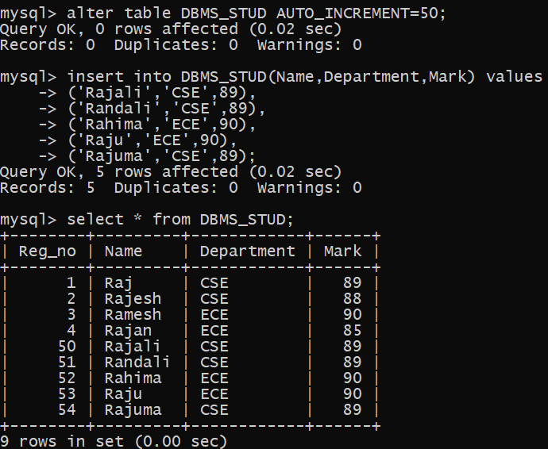

4.Delete the AUTO_INCREMENT

