Ex.No.12

**Simple programming exercise using(REPEAT, WHILE )**

**Aim:**

To learn how to use various MySQL loop statements including while, repeat to run a block of code repeatedly based on a condition.

**Program1**

Write a function to build a string repeatedly until the value of the variable becomes s greater than 5. Then, we display the final string using a SELECT statement.

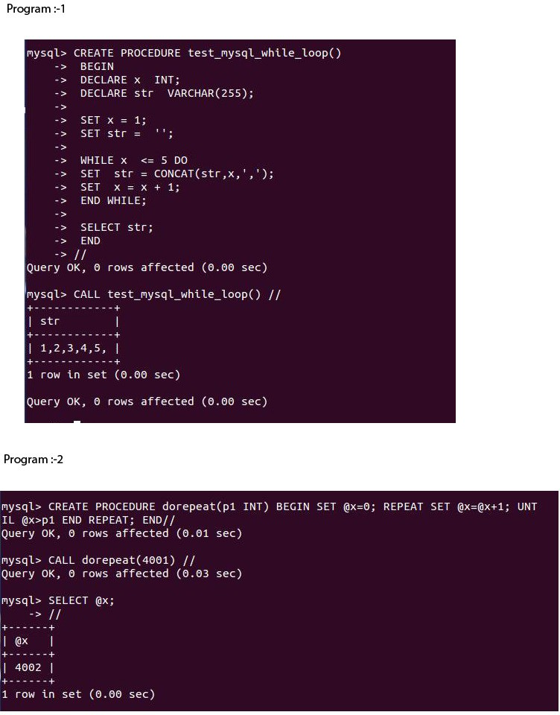

**RESULT:**Thus the Simple programming exercise using(REPEAT, WHILE ) exectuted successfully.