Ex.No: 15

**DCL COMMANADS GRANT, REVOKE**

**Aim:**

To learn how to use various DCL commands GRANT and REVOKE SQL commands

**Procedure**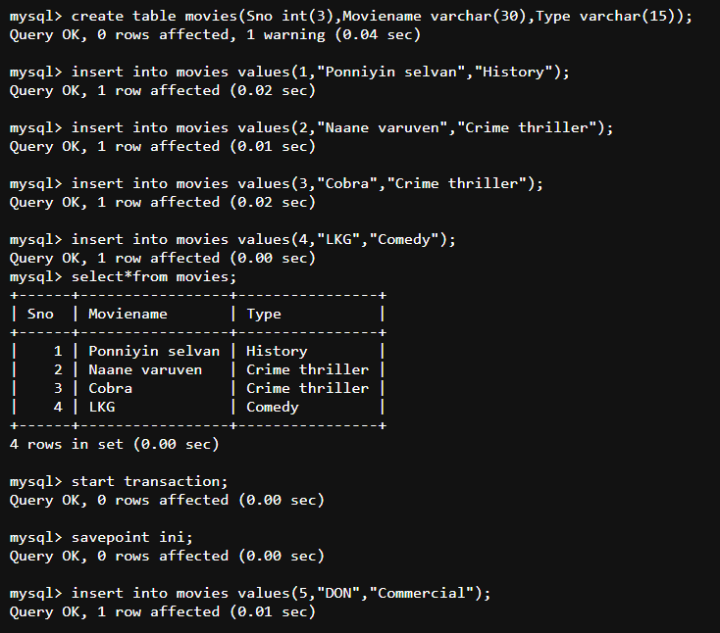

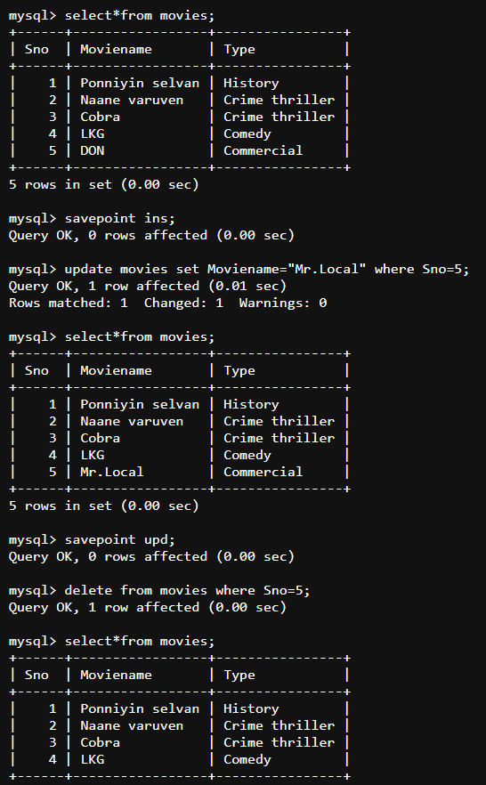

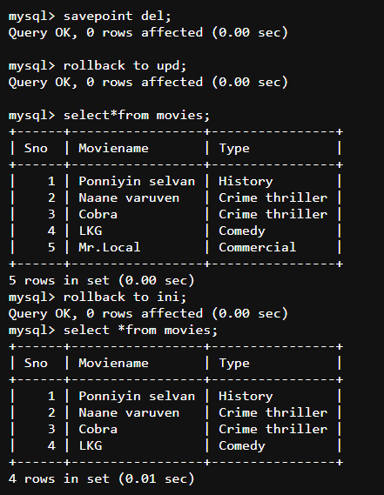

**RESULT:** Thus the DCL commands GRANT and REVOKE SQL executed successfully.