Ex.No.17

**HIGH LEVEL PROGRAMMING EXTENSIONS**

**(FUNCTIONS)**

**Aim:**

To implement Functions using program in MySQL.

Create a function that returns the level of a customer based on credit limit.(Use the IF statement to determine the credit limit).

The table ‘customers’ should have the following attributes:

customers(cno , cname, creditlimit)

If credit limit > 50000 then customer_level = PLATINUM

If credit limit >= 10000 AND credit limit <= 50000 then customer_level = GOLD

If credit limit credit limit < 10000 then customer_level = SILVER

RECURSION in Mysql Procedures

Mysql version should be >= 5.

Have to set system parameters. This means putting the recursion count limit.

SET @@GLOBAL.max_sp_recursion_depth = 255;

SET @@session.max_sp_recursion_depth = 255;

**Program 2**

Write a recursive MySQL procedure compute the factorial of a number .

**OUTPUT;**

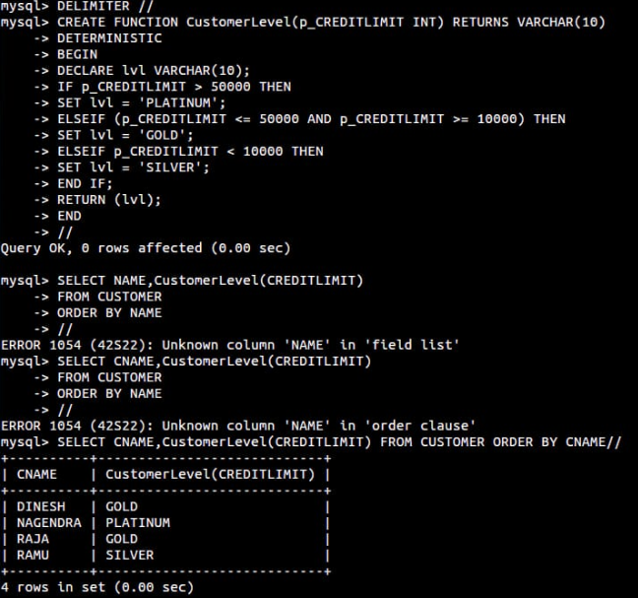

2.

