***USER MANUAL***

**Lab#7 Version 2.1**

**(REAL-TIME DYNAMIC SIMULATOR OF THE ABSORPTION COLUMN)**

***INDUSTRIAL PROCESS CONTROL SOFTWARE***

**© Copyright PiControl Solutions LLC**

**(ALL RIGHTS RESERVED)**

**PiControl Solutions LLC**

**Website: www.PiControlSolutions.com**

**Email: Info@PiControlSolutions.com**

Unauthorized duplication of Lab#7 software

or this manual via any method without the written

consent of PiControl Solutions LLC is prohibited.

1 INTRODUCTION 2

2 SOFTWARE REQUIREMENTS AND INSTALLATION 2

3 SIMPLICITIES OF LAB#4 AND RELATED PRODUCTS 2

4 ABSORPTIO COLUMN SIMULATOR 3

5 GETTING STARTED WITH LAB#7 4

5.1 ABSORPTION COLUMN SCREEN 5

5.2. START-UP PROCEDURE 6

6 OTHER SIMULATION FEATURES 11

6.1 FLOW RATE TRENDS 11

6.2 PLOTTING EXPERIMENTAL PH VS VOLUME AND ANALYZING THE CURVE 12

6.3 SIMULATION SPEED 14

6.4 START / HALT SIMULATION 15

6.5 START / STOP DATA COLLECTION / SAVE DATA 16

6.6 EXIT PRACTICE 17

6.7 SIMULATION TIME 17

6.8 RESTART 18

6.9 HELP 18

6.10 ABOUT 18

6.11 TAG LEGEND 18

6.12 CONTACT SUPPORT 18

# 1 INTRODUCTION

The first part specifies the hardware required to run Lab#7- Absorption Column. It explains the software installation procedure, how to start and use Lab#7 and explains all menu buttons, fields, and describes all screens appearing in Lab#7.

# 2 SOFTWARE REQUIREMENTS AND INSTALLATION

Lab#7 runs on most Windows-based operating systems commonly used all over the world. To install Lab#7, download the program installation setup exe file **(LAB7-Absorption_Column.exe)** from PiControl Solutions website [www.PiControlSolutions.com](http://www.PiControlSolutions.com).

To start the installation, click on the **LAB7- Absorption_Column.exe** file that you received from PiControl. To complete installation, follow all the step-by-step installation instructions on the screen. All Lab#7 files will be installed in the specified program folder. A program Group “Lab#7” will be created with program icons “Lab#7, Configuration, Readme First, Help and License Agreement.

# 3 SIMPLICITIES OF LAB#4 AND RELATED PRODUCTS

Lab#7is very simple to use for any plant operator, control engineer, DCS/PLC technician, or researcher. Lab#7 works entirely in the time domain (seconds, minutes, etc.) It does not use the more complicated “***s***” (Laplace) or the “***Z***” (discrete) domains.

Use of Lab#7 does not require deep academic knowledge of process control theory. PiControl Solutions LLC has other excellent practical process control products aimed at helping the control room and industry personnel, including technicians, engineers, and students. Besides the above product, PiControl also offers various modern process control/OPC products: [www.PiControlSolutions.com](http://www.PiControlSolutions.com).

# 4 ABSORPTIO COLUMN SIMULATOR

Lab#7 is a fully functional real-time simulator developed to provide in-depth training in gas-liquid absorption processes using a packed column. It is specifically designed for academic use in chemical and environmental engineering programs, supporting coursework in mass transfer operations, reaction engineering, and process control. This simulator is an essential tool for students to explore the behavior of absorption systems, offering a practical platform to understand how gases such as carbon dioxide are absorbed into liquid streams under dynamic flow conditions.

The simulator models an absorption column in which water flows from the top of the column downward, while air and CO₂ gases are introduced from the bottom. As the gases rise and the liquid descends through the column packing, carbon dioxide is absorbed into the water, leading to the formation of carbonic acid. This causes a measurable decrease in the pH of the outlet water stream. Using the simulator, students can observe how adjusting the individual flow rates of water, air, and CO₂ influences the extent of absorption and the final pH of the solution.

The system provides real-time feedback through visual indicators and graphical plots. Students can control each of the three flow sources using dedicated input fields and observe their combined effect on column flooding, absorption efficiency, and outlet pH. The simulator demonstrates realistic behavior, such as the pH decreasing sharply when CO₂ is introduced and gradually stabilizing as the system reaches dynamic equilibrium. Furthermore, the simulator includes a built-in pH prediction model based on nonlinear regression, which estimates the resulting pH based on the current flow conditions. This helps students build intuition around the relationship between flow rate adjustments and system chemistry.

The simulator also includes the ability to perform virtual titration experiments on samples collected from the outlet stream. After optimizing the CO₂ absorption, users can simulate adding a NaOH solution to determine the CO₂ concentration based on inflection points on a titration curve. Students can plot the titration curve and use a polynomial trendline to calculate the inflection volume, which can then be used to determine the moles of CO₂ absorbed. This feature allows learners to explore stoichiometry and mass balance concepts while also evaluating column efficiency.

Lab#7 delivers an immersive educational experience that deepens student understanding of absorption column operation. With the ability to simulate industrial conditions and generate reproducible results, this simulator supports critical thinking and problem-solving skills that are vital in real-world applications such as gas scrubbing, air purification, and chemical manufacturing.

# 5 GETTING STARTED WITH LAB#7

Double-click on the Lab#7 icon to start the program. After start-up, you will see the product information window. This window disappears after a few seconds and then you will see the Lab#7 – Pump Menu screen with options shown with separate buttons, as shown in Figure 1:

* Start
* Help
* About
* Exit

**Figure 1. Lab#7 Menu Screen**

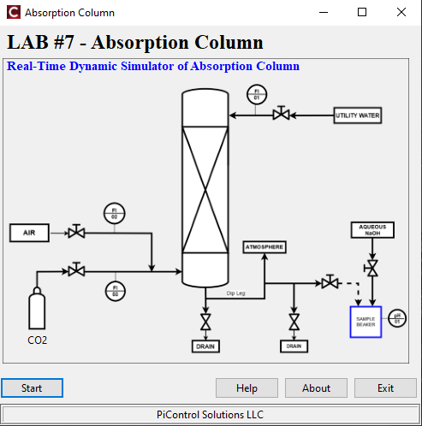

## 5.1 ABSORPTION COLUMN SCREEN

When you click the **"Start"** button, a new window appears displaying the **Absorption Column system**, with the visual layout of the column and its associated components shown clearly on the left side. The user interface includes controls for adjusting the flow rates of **water**, **air**, and **CO₂**, which are the three key inputs to the system. The flow of water enters from the top of the column, while air and CO₂ gases are introduced from the bottom. The gases move upward through the packing material inside the column while water flows downward, enabling absorption to take place. On the right side of the window, as shown in **Figure 2**, there are two chart panels that dynamically plot simulation data. These include real-time flow fluctuations and pH points plotted by the user, with a best-fit curve displayed automatically once at least 10 points are entered.

Lab#7 explains how to start and operate the Absorption Column Simulator in a safe and efficient manner. At the start of the simulation, all flow rates are set to zero, and the column is at equilibrium with no gas-liquid interaction. Users can gradually open the control valves to introduce water, air, and CO₂ into the system. On the right side, beneath the two chart windows, there is a ribbon with checkboxes that allows users to toggle the visibility of the three flow rate trends: **water**, **air**, and **CO₂**. This interface provides users with a clear and organized way to analyze how changes in operating conditions affect the absorption process in real time.

**Figure 2. Lab#7.2 Start-Up Screen**

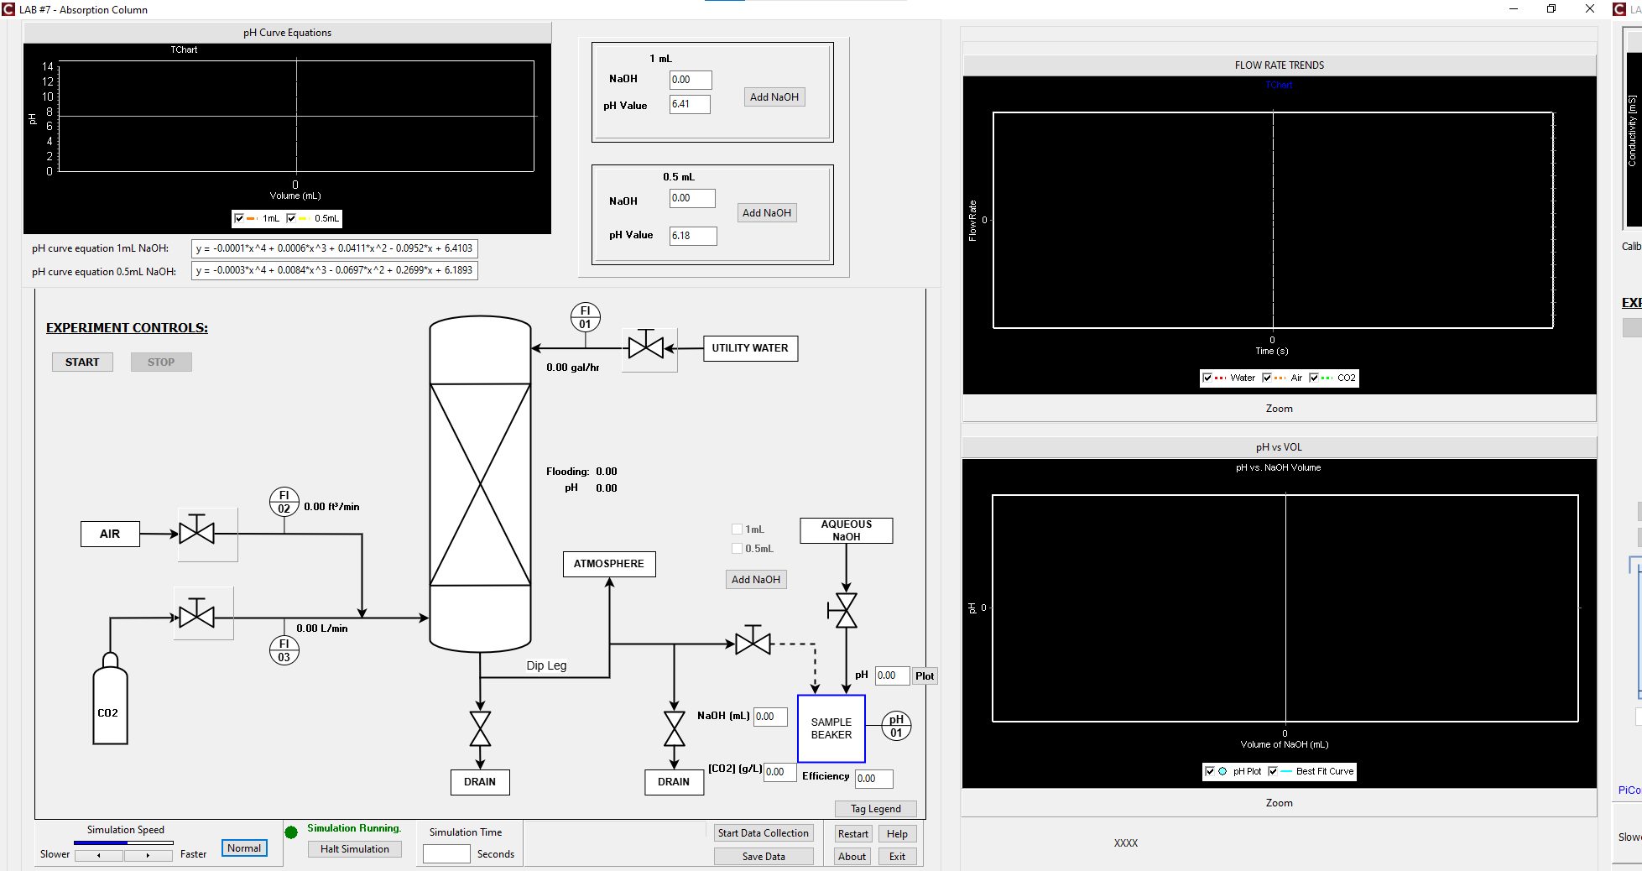

## 5.2. START-UP PROCEDURE

**Figure 3. Starting the Simulation**

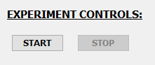

1) The first step in using the Absorption Column Simulator is to start the simulation process. On the left side of the simulator interface, just below the "EXPERIMENT CONTROLS" label, users will find the "START" button, as shown in Figure 3. Clicking this button initializes the simulation environment, activates the internal control logic, and begins the real-time dynamic behavior of the system. Once started, users can begin adjusting flow rates, monitoring system responses, and conducting the absorption and titration experiments.

**Figure 4. Valve Icon**



2) By clicking on the image **(Figure 4)** of **FI-01**, **FI-02, FI-03** for the **water, air, co2 flow line** in the Absorption Column Simulator, the user can manually change the **valve opening** using the OP (Output) field shown below/above the valve, as seen in **Figure 4.a**. This allows the user to directly specify the output signal sent to the valve (e.g., “7”), which in turn adjusts the flow rate of water entering the column. The corresponding flow rate in **gallons per hour** is displayed dynamically next to the valve. Unlike automatic control, this interface operates in manual mode only — providing a straightforward way for users to explore how different valve openings affect system behavior, such as flooding percentage and pH. This feature helps learners visualize the direct relationship between **valve position**, **flow rate**, and the **absorption process** in real time.

**Figure 4.a: Adjusting Valve Opening**

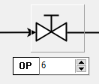

**Figure 5.** Performing the Titration Experiment

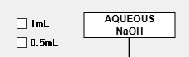

3) When the pH of the outlet stream approaches near to **6.0**, the user can begin the **titration experiment** to analyze the CO₂ concentration in the liquid sample. To initiate this, the user must first **select one of the two checkboxes** shown next to the **"AQUEOUS NaOH"** label, as seen in **Figure 5**. The checkboxes represent the **NaOH addition increment**: either **1.0 mL** or **0.5 mL** per step. The simulator will not allow the titration process to start unless **one of these checkboxes is selected**, ensuring that the type of titration is clearly defined. Once selected, the system enables the addition of NaOH in the specified volume to simulate a stepwise titration. The pH change is plotted accordingly, allowing users to generate a titration curve and analyze the resulting data.

**4)** Once one of the **NaOH volume increment checkboxes** is selected, the user begins the titration by first measuring the **initial pH of the sample beaker** at **0 mL NaOH**. The measured pH value should be **entered manually into the edit box** next to the **"pH"** label, as shown in **Figure 6**. To record this data point on the **“pH vs VOL”** chart, the user must then **click the “Plot” button**. If the user does not click the Plot button, the data point will **not appear on the chart**, and the titration curve will be incomplete — resulting in incorrect or missing results during analysis. This process is repeated for each NaOH addition step to build an accurate titration curve.

**Figure 6. pH plot**



**5**) **Building the Titration Curve and Viewing Results**

**Figure 7. NaoH addition in beaker**

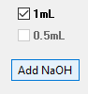

After the user measures and plots the **initial pH at 0 mL of NaOH**, they can begin the titration process by clicking the **"Add NaOH"** button located beneath the selected checkbox, as shown in **Figure 7**. This action adds the corresponding volume of NaOH (either **1 mL** or **0.5 mL**) to the **sample beaker**. The user should then **measure the new pH** of the sample, **enter it manually**, and **click the “Plot” button** to add that data point to the **“pH vs VOL”** chart. This process is **repeated after each addition of NaOH**, allowing the user to build the titration curve step by step. Once **at least 10 data points** have been plotted, the simulator automatically calculates and displays the **CO₂ concentration**, **absorption efficiency**, the **best-fit polynomial curve**, and the **corresponding curve equation** — providing a complete analysis of the titration results.

6) Viewing Reference pH Curve Equations from the Lab Manual

**Figure 8.pH Curve equation**  
  
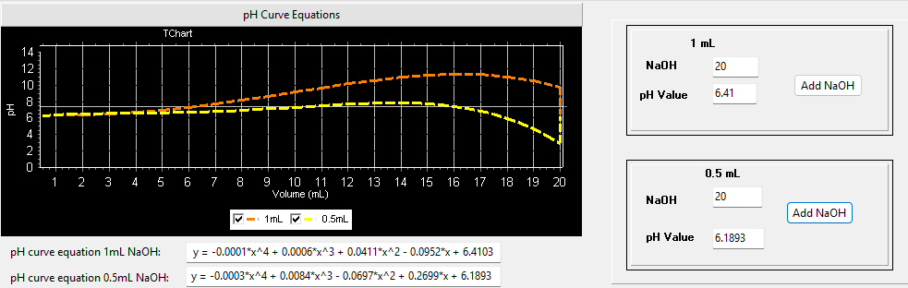

At the **top left section** of the Absorption Column Simulator, users will find a dedicated chart titled **"pH Curve Equations"**, as shown in **Figure 8**. This chart visually plots the **reference titration curves** from the Lab Manual for both titration processes: **1 mL** and **0.5 mL** NaOH increments. These curves are drawn based on predefined polynomial equations provided in the manual, allowing students to **visually compare their experimental titration data with the theoretical results**.

To generate these reference curves, users can interact with the two boxes located on the **right side** of the chart — one for **1 mL** and the other for **0.5 mL** titration. Each box contains:

* A **NaOH volume field** (automatically incremented),
* A **pH value field** (preset based on the curve equation), and
* An **“Add NaOH”** button.

By repeatedly clicking the **"Add NaOH"** button in either box, the simulator will simulate each titration step and progressively plot the corresponding point on the reference curve. This can be done independently for both 1 mL and 0.5 mL increments, enabling side-by-side comparison of both theoretical curves on the same chart. This feature helps students validate their experimental titration curves by contrasting them against the standard Lab Manual results.  
  
Below the **pH Curve Equations** chart, there are **two checkboxes** labeled **0.5 mL** and **1 mL**. These checkboxes allow the user to **toggle the visibility** of the corresponding Lab Manual titration curves. If the user **unchecks** a checkbox, the associated curve (either for 1 mL or 0.5 mL increments) will be **hidden** from the chart. Checking the box again will **redisplay the curve**, making it visible for comparison. This feature provides flexibility for the user to focus on a specific titration curve or to view both curves side-by-side when comparing experimental results with Lab Manual data.

# 6 OTHER SIMULATION FEATURES

## 6.1 FLOW RATE TRENDS

At the top right section of the Absorption Column Simulator, users will find the FLOW RATE TRENDS chart, as shown in Figure 9. This chart displays the real-time flow rates of the three key streams entering the column: water, air, and CO₂. These flow rates are directly influenced by the corresponding valve openings set by the user. The chart dynamically updates as the simulation progresses, allowing the user to observe how each flow responds to changes over time.

* Below the chart, there are **three checkboxes** labeled **Water**, **Air**, and **CO₂**. These checkboxes allow users to **toggle the visibility** of each individual flow rate curve. Unchecking a box will hide that flow rate from the chart, and checking it again will make it reappear. This helps users isolate and focus on specific streams when analyzing system behavior.
* At the very bottom of the chart area, there is a **"Zoom" button**. Clicking this button opens a zoomed-in version of the chart, making it easier to closely examine flow trends and interactions over time. Once finished, the user can close the zoomed chart to return to the original view and continue working with the main simulator layout.

**Figure 9. Monitoring Flow Rate Trends**

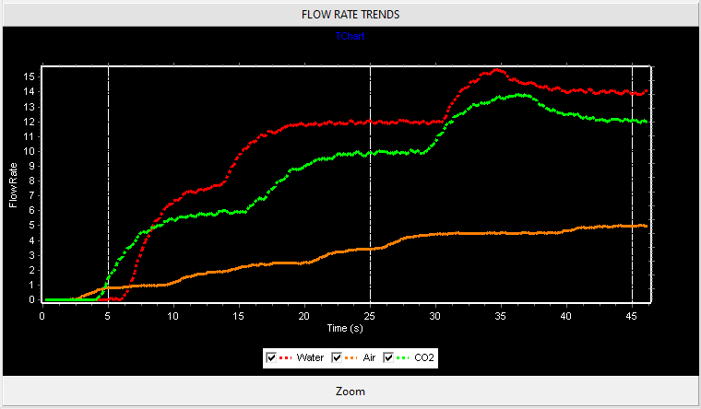

## 6.2 PLOTTING EXPERIMENTAL PH VS VOLUME AND ANALYZING THE CURVE

At the **bottom right section** of the Absorption Column Simulator, users will find the **pH vs VOL** chart, as shown in **Figure 10**. This chart is designed for manually plotting **experimental pH values against the volume of NaOH added** during the titration process. Users manually input the pH after each NaOH addition and click the “Plot” button to add that point to the chart. These points are **connected by dotted lines**, allowing users to observe the trend of the experimental data.

Once the number of plotted points reaches **10 or more**, the simulator automatically generates and displays the **best-fit polynomial curve** based on the experimental data. This curve helps users analyse the overall behaviour of the titration process and compare it visually with their manually entered points to verify if the curve accurately captures the trend.

At the bottom of the chart, there are **two checkboxes** labelled **pH Plot** and **Best Fit Curve**, which allow users to **toggle the visibility** of the experimental points and the best-fit curve independently. This enables focused analysis or comparison. Below these checkboxes is a **Zoom button**, which opens a larger version of the chart for more precise examination. Users can close the zoomed view to return to the standard simulator layout.

Finally, at the very bottom, the **equation of the best-fit curve** is displayed. This equation is used to determine the **inflection point volume**, which is critical for calculating the amount of CO₂ absorbed and the **efficiency of the absorption column**. This feature links experimental data analysis directly to the core learning objectives of the simulator.

**Figure 10. Experimental pH vs NaOH Volume Trends**

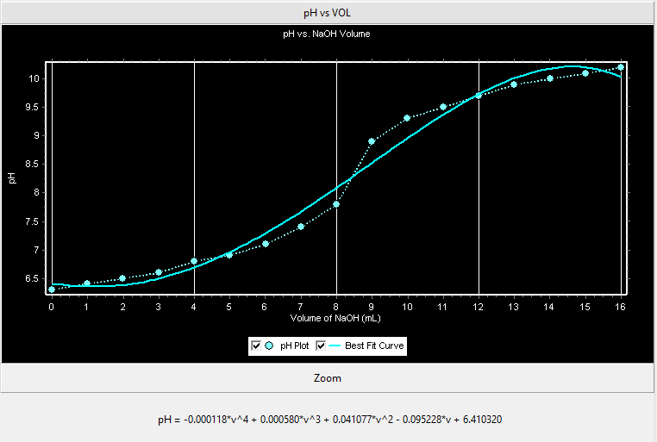

## 6.3 SIMULATION SPEED

Lab#7.2 provides a Simulation Speed option to adjust the simulation speed to match the real plant behavior. It is possible to adjust the speed as needed to accelerate or decelerate the simulation using the Simulation Speed controls as shown in **Figure 11**, in order to give an impression as if the simulation is done on existing DCS in the control room. Building such simulations quickly and easily is great for practice and exposure. Below the “Simulation speed” label, three buttons - Slower, Faster and Normal are displayed. Clicking on Slower slows down the simulation speed. Clicking on Normal resets the speed to the default medium speed. Clicking on the Faster button speeds up the simulation speed to the maximum speed. A horizontal blue bar indicates the level of simulation speed. The longer the blue bar, the faster the simulation speed.

**Figure 11. Simulation Speed Adjustment**



The Simulation Speed control is located near the bottom left corner of the screen. Clicking on Slower slows down the simulation by one increment. Clicking on Faster speeds up the simulation for one increment. Clicking on Normal runs real-time simulation speed. When the simulation speed progress bar is fully blue, this means the simulation speed is the fastest. When the simulation speed progress bar is fully white, this means the simulation speed is the slowest.

## 6.4 START / HALT SIMULATION

Click on the Start Simulation or Halt Simulation button starts or pauses the real-time simulation. If the Lab#7.2simulation is running, this button will display Halt Simulation, as shown on **Figure 12**.

**Figure 12. Start / Halt Simulation Adjustment**

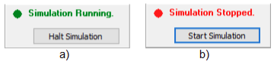

Clicking on the Start Simulation will start the program execution and change the button label to Simulation Running, as shown on **Figure 12.a)**. Clicking on the Halt Simulation will pause the program execution and change the button label to Simulation Stopped, as shown on **Figure 12.b)**.

## 6.5 START / STOP DATA COLLECTION / SAVE DATA

These buttons allow you to create CSV files containing the data generated by the simulation – Simulation Time, Water Flow, Air Flow, CO2 Flow, Actual CO2 Conc, Efficiency, NaOH Vol Added, Timestamp.

When Start Data Collection is clicked, the data is stored in the memory for the time of running the simulation. Same button changes the name to Stop Data Collection. When Stop Data Collection is clicked, then the collection is stopped. Then after clicking Save Data, a file with the data is saved to the Output directory. While data is collected a message “Data collection on…” is printed to the left of the button Stop Data Collection, as shown in **Figure 13**:

**Figure 13. Start / Stop Data Collection and Save Data**



Multiple parts of data can be appended if the Start Data Collection/Stop Data Collection buttons are clicked several times without clicking on Save Data. Then finally when the Save Data button is clicked, the file is saved.

Here is a more detailed data collection explanation:

1. Click Start Data Collection: Data collection begins.
2. Click Save Data: Data is saved to a file and flushed from memory.  Simulation halts.
3. Click Start Simulation: Simulation starts from the beginning.
4. Click Start Data Collection: Data collection begins.
5. Click Halt Simulation: Simulation halts. Collected Data is still in the memory.
6. At this moment changes in Lab#7.2 process parameters are allowed. Click on Start Simulation resumes the Data collection and Data is appended to data collected so far.
7. Steps 5 and 6 are repeatable.
8. Finally, click Save Data. Complete Data is saved to file and flushed from memory. Simulation halts.
9. Whenever Save Data button is clicked, Data is saved to file and flushed from the memory. If Save Data is clicked and there is no data collected, then Lab#7.2 reports “*No data to save*” message.

When the Save Data button is clicked, data file is saved in

“C:\Users\xxx\Documents\LAB7-AbsorptionColumn\Output” folder.

The Output folder is automatically created by Lab#7.2.

* ***AbsorptionColumn_mm-dd-yy_hh-mm-ss.csv*** (this file is in CSV format).

## 6.6 EXIT PRACTICE

Anytime during the Execution of the Absorption Column simulation, user can exit it. This button is labeled as Exit. Click on the Exit button to return to the Lab#7 menu screen. If there was unsaved data, a pop-up window will alert the user to either save or exit without saving.

## 6.7 SIMULATION TIME

This specifies the time span of the simulation, as shown in **Figure 14**. Typical values range from 200 to 1000. For good viewing, 200-500 is the recommended range. Low limit value for simulation time is 100 and high limit value is 3000. Confirmation of desired Simulation Time is being done by clicking Enter.

**Figure 14. Simulation Time Box**

Slika na kojoj se prikazuje tekst, snimka zaslona, Font, crta

Opis je automatski generiran

Simulation Time should be set longer for slow processes in order to observe the complete dynamics after a change in process.

## 6.8 RESTART

The Restart function deletes all current simulation states and restarts the complete simulation from the beginning. All valve positions are reset to 0%.

## 6.9 HELP

Click on the Help icon in the toolbar or on the main menu screen to open the Lab#7 User Manual.

## 6.10 ABOUT

Click on the About icon in the toolbar or on the main menu screen to see the version number and Lab#7 product information.

## 6.11 TAG LEGEND

Click on the Tag Legend button to get a complete list and explanation and engineering units of each tag represented in Lab#7.

## 6.12 CONTACT SUPPORT

For questions or clarifications, contact PiControl Solutions LLC by sending an email to [info@picontrolsolutions.com](mailto:info@picontrolsolutions.com).