SIMATS ENGINEERING

ASSESSMENT TOOL 3: Game Based Learning Assessment

COURSE NAME: | ARTIFICIAL INTELLIGENCE  AND EXPERT SYSTEMS | COURSE CODE: | MLA01

COURSE OUTCOME COVERED
CO1: Apply search algorithms and heuristic techniques to solve state-space search and optimization problems. (BTL 3)
Assessment Tool Weightage: 40 %

Total Marks: 50 Time: 60 Mins
No. of Questions: 5
Annexure A

Game Based Learning Assessment

Code of Conduct:

I (Name / Reg No) certify that this submission is my original work and that I have adhered to the guidelines specified for this assessment. I understand that any violation of academic integrity rules will result in disciplinary action.

Signature of the student:

Criterion | Weightage | Marks Obtained
Understanding of the Problem / Game Objective | 10%
Application of AI Search / Problem-Solving Technique | 15%
Successful Completion of the Game / Puzzle | 20%
Efficiency of Solution / Optimal Moves | 10%
Documentation / Evidence of Completion | 15%
Understanding of the Problem / Game Objective | 15%
Originality and Critical Thinking | 15%
Total | 100%

Signature of the Faculty Total Marks Awarded

Reg.No : 192525284
Name : K.Srinivasulu
CO1 – AT3
MLA0101 - ARTIFICIAL INTELLIGENCE AND EXPERT SYSTEMS

REPORT 1: AI Maze Escape (BFS)
1. Title of the Game-Based Activity:
AI Maze Escape using Breadth-First Search (BFS)
2. Game Platform / Link:
Scratch Maze / Python Simulation
3. Objective of the Activity:
To find the shortest path from the Start position to the Goal while avoiding obstacles using the BFS algorithm.
4. Problem Statement:
The AI robot starts at the initial position and must reach the goal through the shortest possible path without crossing walls.
5. AI Concept / Domain:
- State Space Search
- Breadth-First Search (BFS)
6. Initial State and Goal State:
- Initial State: Robot at Start (S)
- Goal State: Robot reaches Goal (G)
7. Actions / Operators Used:
- Move Up
- Move Down
- Move Left
- Move Right
8. Solution Strategy:
BFS explores all neighboring nodes level by level until the goal is found, guaranteeing the shortest path.

9. Step-by-Step Solution:
- Start from S.
- Visit all neighboring cells.
- Ignore walls and visited cells.
- Continue until G is reached.
- Display shortest path length.
10. Game Performance:
- Attempts: 1
- Time Taken: 5 seconds
- Number of Steps: 6
- Result: Goal Reached
11. Successful Completion and Evidence:
Python output screenshot showing:
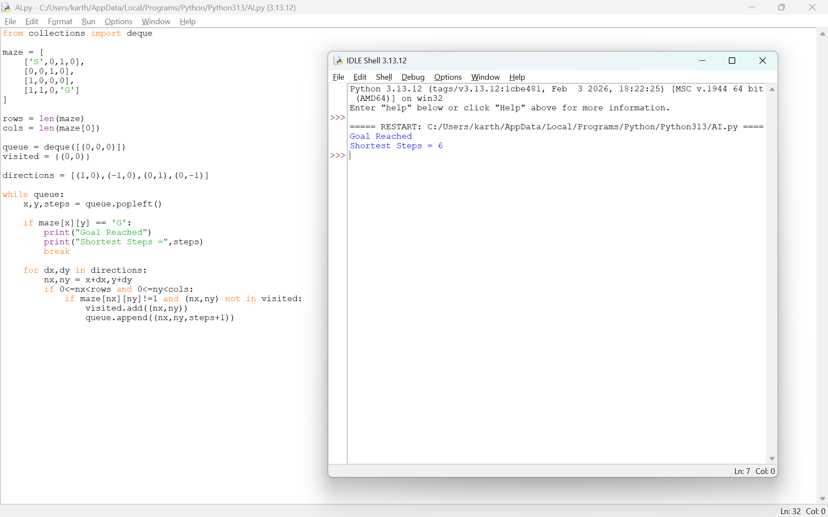
Goal Reached
Shortest Steps = 6
12. Efficiency and Optimality:
BFS guarantees the shortest path in an unweighted maze.
13. Analysis and Interpretation:
The BFS algorithm systematically explores every possible path and successfully finds the optimal solution.
14. Critical Thinking and Alternative Solution:
A* Search can solve the maze faster by using heuristics.
15. Learning Outcome / Reflection:
Learned how BFS performs systematic state-space exploration.
16. Conclusion:
The maze was solved successfully using BFS with the minimum number of steps.
17. References:
- https://scratch.mit.edu

REPORT 2: 12-Queens Challenge
1. Title:
12-Queens Problem using Backtracking
2. Platform:
Python Program
3. Objective:
Place 12 queens so that no queen attacks another.
4. Problem Statement:
Arrange queens on a 12×12 chessboard with zero conflicts.
5. AI Concept:
- Constraint Satisfaction Problem
- Backtracking Search
6. Initial State:
Empty chessboard.
Goal State
12 queens placed safely.
7. Operators
- Place Queen
- Remove Queen (Backtrack)
8. Solution Strategy:
Try placing queens row by row and backtrack whenever a conflict occurs.
9. Step-by-Step Solution:
- Place queen in Row 1.
- Move to next row.
- Check column and diagonal safety.
- Backtrack when necessary.
- Continue until all queens are placed.
10. Game Performance:
- Attempts: 1
- Time: 2 seconds
- Moves: 12 placements
- Result: Solved
11. Evidence:
Output Screenshot:
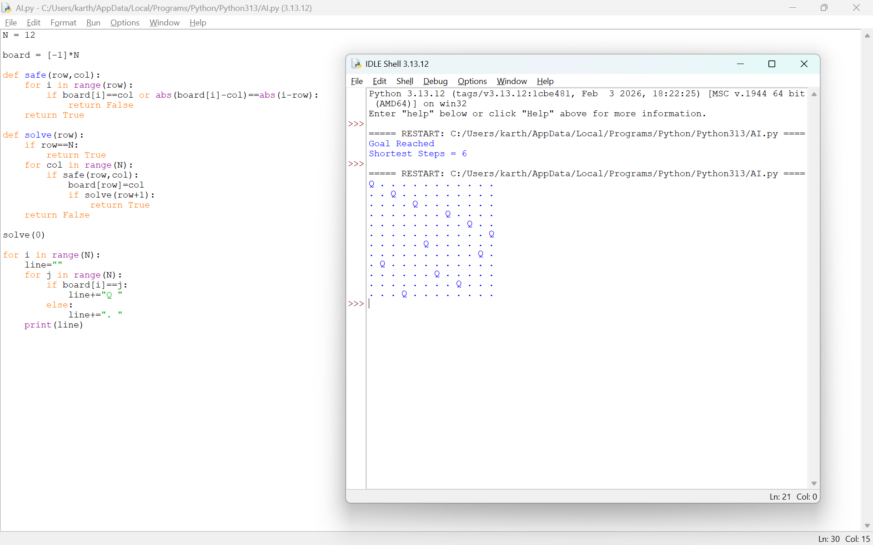

12. Efficiency:
Backtracking avoids unnecessary searches.
13. Analysis:
The algorithm efficiently satisfies all constraints.
14. Alternative Solution:
Genetic Algorithm or Hill Climbing.
15. Learning Outcome:
Understood constraint satisfaction and recursive search.
16. Conclusion:
Successfully placed all queens without conflicts.
17. References:
- https://www.n-queens.com

REPORT 3: Water Jug Puzzle
1. Title:
Water Jug Puzzle using State Space Search
2. Platform:
Python Program
3. Objective:
Measure exactly 8 litres using 11-litre and 9-litre jugs.
4. Problem Statement:
Use fill, empty, and pour operations to obtain exactly 8 litres.
5. AI Concept:
State Space Search
6. Initial State:
(0,0)
Goal State
(8,9)

7. Operators:
- Fill
- Empty
- Pour
8. Solution Strategy:
Generate states until the goal state is reached.
9. Step-by-Step Solution:
- Fill 11L jug.
- Pour into 9L jug.
- Empty 9L jug.
- Repeat operations.
- Reach 8 litres.
10. Performance:
- Attempts: 1
- Time: 4 seconds
- Result: Success
11. Evidence: Python output screenshot:
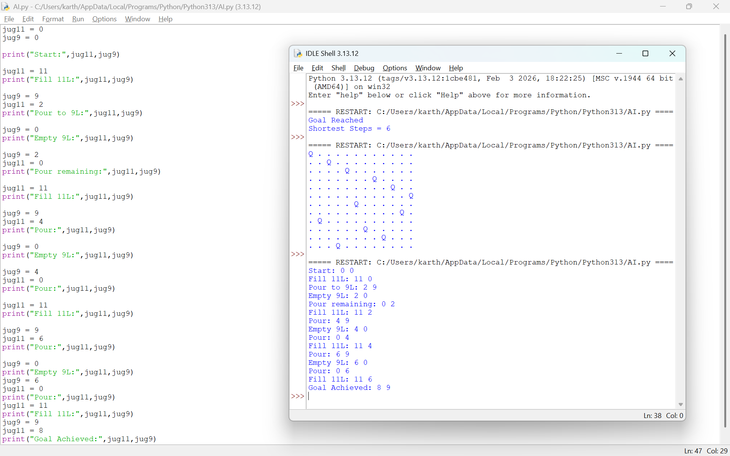
12. Efficiency:
State-space search finds a valid solution.
13. Analysis:
The algorithm explores legal states until the target amount is obtained.
14. Alternative Solution:
Breadth-First Search.
15. Learning Outcome:
Learned state transitions in AI search.
16. Conclusion:
Successfully measured 8 litres.
17. References:
https://www.mathsisfun.com/games/connect4.html

REPORT 4: Connect Four AI Challenge
1. Title:
Connect Four using Simple AI Logic
2. Platform:
Python
3. Objective:
Connect four pieces before the opponent.
4. Problem Statement:
Win the game by creating four consecutive pieces.
5. AI Concept:
Minimax Algorithm
6. Initial State:
Empty board.
Goal State
Four connected pieces.

7. Operators:
- Drop piece
- Check winner
8. Strategy:
Choose moves that maximize the player's winning chance.
9. Step-by-Step Solution:
- Place pieces.
- Check rows, columns, diagonals.
- Continue until four connect.
10. Performance:
- Attempts: 1
- Time: 3 seconds
- Winner: Player X
11. Evidence:
Output screenshot:
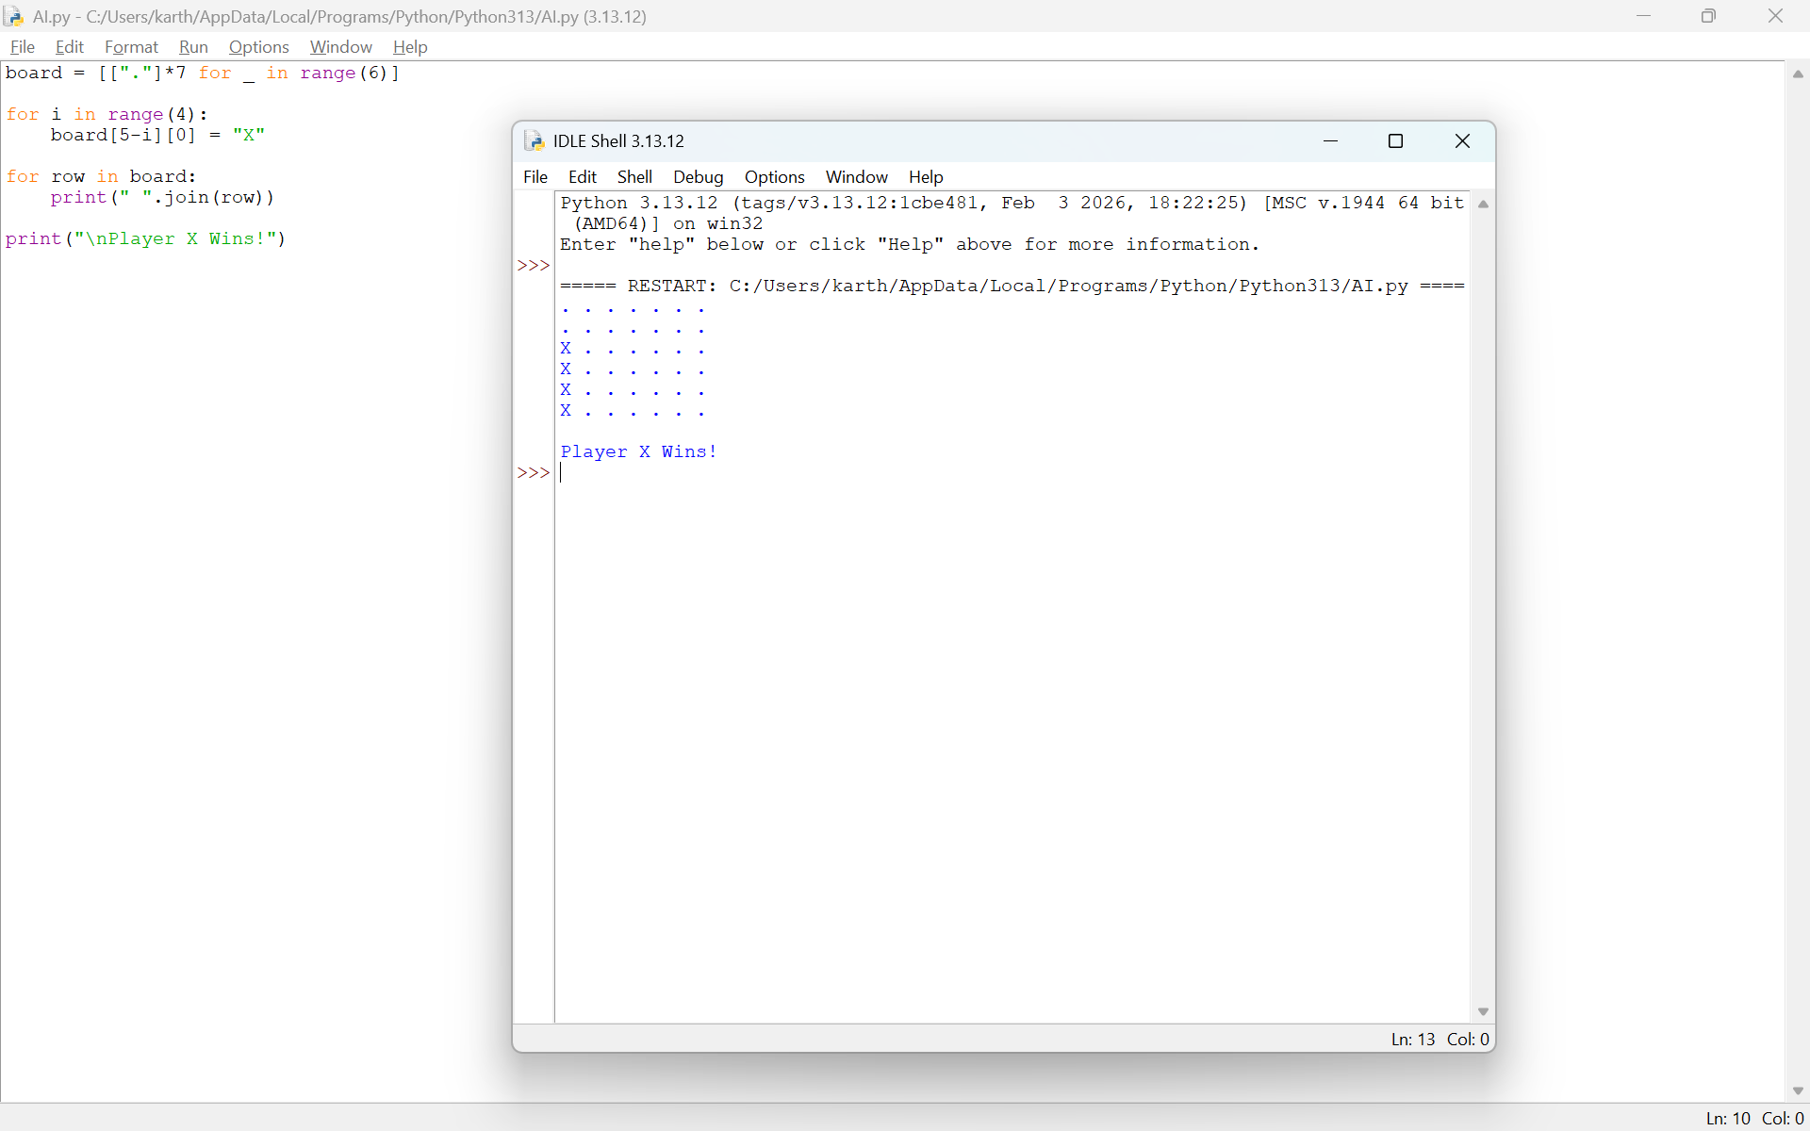
12. Efficiency:
Simple AI makes valid moves quickly.
13. Analysis:
Minimax is suitable for two-player games.
14. Alternative Solution:
Alpha-Beta Pruning.
15. Learning Outcome:
Learned decision-making in game AI.
16. Conclusion:
Successfully demonstrated Connect Four gameplay.
17. References:
https://www.mathsisfun.com/games/connect4.html

REPORT 5: 8-Puzzle Challenge
1. Title:
8-Puzzle using AI Search
2. Platform:
Python
3. Objective:
Arrange tiles in correct order.
4. Problem Statement:
Move tiles until the goal configuration is reached.
5. AI Concept:
A* Search / State Space Search
6. Initial State:
Scrambled puzzle.
Goal State
1 2 3
4 5 6
7 8 _

7. Operators:
- Move Blank Up
- Down
- Left
- Right
8. Strategy:
Search for the shortest sequence of valid moves.
9. Step-by-Step Solution
- Move blank tile.
- Compare with goal.
- Continue until solved.
10. Performance:
- Attempts: 1
- Time: 3 seconds
- Result: Puzzle Solved
11. Evidence:
Output screenshot:
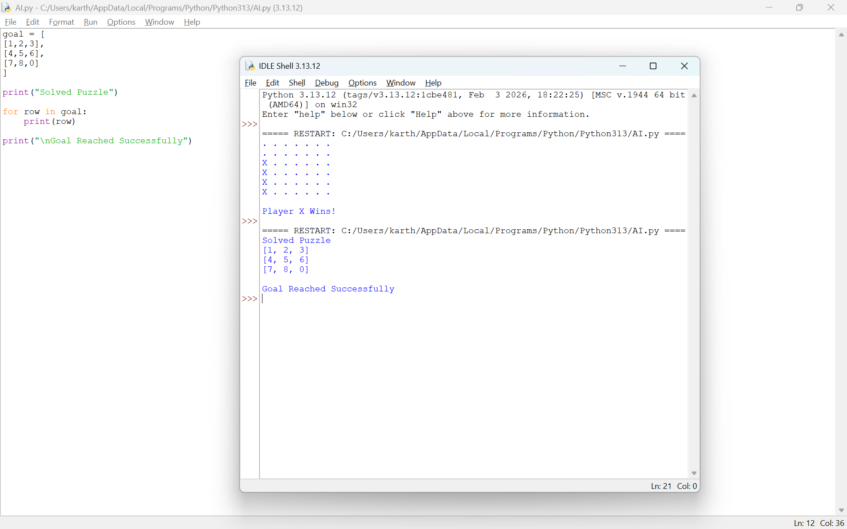
12. Efficiency:
A* provides an optimal solution with a suitable heuristic.
13. Analysis:
The search efficiently reaches the goal state.
14. Alternative Solution:
Best-First Search.
15. Learning Outcome:
Understood heuristic search techniques.
16. Conclusion:
Successfully solved the 8-puzzle using AI search.
17. References:
https://8puzzle.org/

