
Department of Computer Science and Engineering
2026-2027
Odd Semester
DATA STRUCTURES AND ALGORITHMS-3
(25CS2103E)
MATRIX CHAIN MULTIPLICATION OPTIMIZATION USING DYNAMIC PROGRAMMING
Gopireddy Susmitha – 2520030201
U. Varshitha – 2520030206
Challa Sreeja – 2520030219
COURSE INSTRUCTOR
Ms.D. Swathi

Department of Computer Science and Engineering

1. Abstract
Matrix Chain Multiplication is a fundamental optimisation problem in Data Structures and Algorithms that focuses on finding the most efficient order for multiplying a sequence of matrices. Although the final product is the same whatever the order of multiplication, different parenthesizations can require very different numbers of scalar multiplications. This project presents MatrixMind, a Java-based optimisation tool that uses Dynamic Programming, specifically Interval Dynamic Programming, to determine the optimal multiplication order for a given chain of matrices.
The system accepts matrix dimensions as input, builds a DP cost table and a split table, and calculates the minimum number of scalar multiplications required. It also identifies and displays the optimal parenthesization of the chain. To show the effectiveness of the optimisation, the tool compares the Dynamic Programming result with a naïve left-to-right strategy and reports the reduction in computational cost. The solution has a time complexity of O(n³) and a space complexity of O(n²) for a chain of n matrices, and it is presented through an interactive Java Swing interface that visualises the tables, the cost comparison and the algorithm.

2. Introduction
Matrix Chain Multiplication deals with finding the best order in which to multiply a chain of matrices. Matrix multiplication is associative, so the chain can be parenthesized in many different ways without changing the final result. However, the number of scalar multiplications needed depends strongly on the chosen order. For a chain of four matrices, for example, one parenthesization may need almost twice as many operations as another.
Trying every possible parenthesization is not practical because their number grows exponentially with the length of the chain, and a plain recursive solution solves the same sub-chains again and again. Dynamic Programming avoids this repetition: the cost of every sub-chain is computed once, stored in a table and reused. The proposed system uses this idea in a bottom-up Interval DP, and also records the split position that gave each minimum so that the optimal parenthesization can be rebuilt. The result is shown to the user together with the cost of the naïve left-to-right order, which makes the benefit of the optimisation easy to see.

3. Problem Statement
Given a sequence of n matrices A1, A2, …, An, where matrix Ai has dimensions p[i-1] × p[i], find the order of multiplication (parenthesization) that minimises the total number of scalar multiplications.
- Different multiplication orders can differ greatly in cost, although the result is identical.
- Checking all possible parenthesizations is exponential and therefore impractical for long chains.
- A fixed order such as left-to-right may perform many unnecessary operations.
- Users need a simple way to see the minimum cost, the optimal order and how much is saved compared with a naïve strategy.

4. Objectives
- To accept the dimensions of a matrix chain as input and validate them.
- To construct Dynamic Programming tables (cost table and split table) for the sub-problems.
- To calculate the minimum number of scalar multiplications using Interval DP.
- To identify and display the optimal parenthesization of the chain.
- To compare the Dynamic Programming approach with a naïve left-to-right strategy.
- To demonstrate the reduction in computational cost through an interactive Java interface.

5. Literature Survey
The matrix chain ordering problem is a classical example used to introduce Dynamic Programming. A traditional approach multiplies the matrices in a fixed order, usually from left to right, which can perform unnecessary operations. A recursive approach tries every split point but repeatedly solves the same sub-problems, so its running time grows exponentially. A bottom-up Dynamic Programming approach stores the optimal cost of every sub-chain and therefore avoids redundant calculations, reducing the work to cubic time.
Approach | Technique | Observation
Traditional approach | Fixed multiplication order | May perform unnecessary operations
Recursive approach | Recursion | Repeatedly solves the same sub-problems
Dynamic Programming | Bottom-up DP | Avoids redundant calculations
Proposed system | Interval DP + comparison | Finds the optimal order and compares its cost with the naïve order

A practical tool that combines optimal parenthesization, cost analysis and comparison with a naïve strategy gives a clearer demonstration of the benefits of Dynamic Programming than the algorithm alone, and this is the gap the proposed system addresses.

6. Case Study: Multiplying a Chain of Four Matrices
Consider the chain A1 × A2 × A3 × A4 with the dimension array p = [10, 30, 5, 60, 20]. This is the input loaded by the DEMO button of the application. The four matrices have the following sizes.
Matrix | Dimensions | Meaning
A1 | 10 × 30 | p[0] × p[1]
A2 | 30 × 5 | p[1] × p[2]
A3 | 5 × 60 | p[2] × p[3]
A4 | 60 × 20 | p[3] × p[4]

6.1 Naïve left-to-right strategy
The naïve strategy always multiplies from the left: ((A1 × A2) × A3) × A4. The cost of each step is the product of the three relevant dimensions.
Step | Calculation | Cost
A1 × A2 | 10 × 30 × 5 | 1,500
(A1A2) × A3 | 10 × 5 × 60 | 3,000
(A1A2A3) × A4 | 10 × 60 × 20 | 12,000
Total (naïve cost) |  | 16,500

6.2 Dynamic Programming strategy
The recurrence DP[i][j] = min over i ≤ k < j of { DP[i][k] + DP[k+1][j] + p[i-1] × p[k] × p[j] } is evaluated for chains of increasing length. For the full chain DP[1][4] the three possible split positions give the following costs.
Split k | DP[1][k] + DP[k+1][4] + p[0] × p[k] × p[4] | Total cost
k = 1 | 0 + 9,000 + 10 × 30 × 20 (6,000) | 15,000
k = 2 | 1,500 + 6,000 + 10 × 5 × 20 (1,000) | 8,500 (minimum)
k = 3 | 4,500 + 0 + 10 × 60 × 20 (12,000) | 16,500

The minimum is obtained at k = 2, so split[1][4] = 2 and the optimal parenthesization is ((A1 × A2) × (A3 × A4)). The cost is 1,500 for A1A2, 6,000 for A3A4 and 1,000 for the final product, a total of 8,500 scalar multiplications.

6.3 Comparison
Measure | Value | Remark
Minimum cost (DP) | 8,500 | scalar multiplications
Naïve cost (left-to-right) | 16,500 | scalar multiplications
Cost saving | 8,000 | 48.48 % reduction
Optimal order | ((A1 X A2) X (A3 X A4)) | from the split table

6.4 Further test inputs
The tool was also run on a second input, 20 30 40 50 (three matrices). Here the naïve order is already optimal, so the DP cost and the naïve cost are both 64,000 and the saving is 0 (0.00 %); the tool correctly reports ((A1 X A2) X A3). This shows that the program does not claim a saving when none exists. For a third input, 40 20 30 10 30, the same recurrence gives a minimum of 26,000 against a naïve 48,000, a saving of 22,000 (45.83 %), with optimal order ((A1 X (A2 X A3)) X A4).

7. System Modules and Course Outcome Mapping
Module | Technique | Used in the project for
Input module | String parsing and validation | Reads the dimension list and rejects empty, non-numeric or non-positive input
DP module | Interval Dynamic Programming (CO3) | Builds the DP cost table and split table for all sub-chains
Order module | Recursive reconstruction from the split table | Builds the optimal parenthesization string
Comparison module | Naïve left-to-right cost | Computes the baseline cost, the saving and the saving percentage
Result module | Result object (MatrixResult) | Carries tables, costs, order and complexity to the interface
Interface module | Java Swing GUI | Shows the matrix chain, result cards, tables, analysis and algorithm tabs

The core technique of the project, Interval Dynamic Programming, corresponds to CO3 of the course (dynamic programming techniques such as bitmask DP and interval DP).

8. Hardware and Software Requirements

Hardware requirements
- Computer or laptop
- Minimum 4 GB RAM
- Standard keyboard and mouse
- Minimum 500 MB free storage

Software requirements
- Operating system: Windows, Linux or macOS
- Programming language: Java (Java Development Kit)
- Java compiler or a Java IDE (for example VS Code, IntelliJ IDEA or Eclipse)
- Java standard libraries: java.awt and javax.swing for the interface
ALGORITHM / PSEUDO CODE

1. Overall Workflow
The tool works as a short pipeline in which each step feeds the next.
Step 1 – Input: the user types the dimension array p (for example 10 30 5 60 20) or presses DEMO.
Step 2 – Validate: reject empty input, fewer than two numbers, non-integers and non-positive values.
Step 3 – Initialise: create the cost table dp and the split table for n matrices, with dp[i][i] = 0.
Step 4 – Interval DP: for chain lengths 2 to n, try every split k and keep the minimum cost and its k.
Step 5 – Minimum cost: read dp[1][n] as the minimum number of scalar multiplications.
Step 6 – Naïve cost: compute the left-to-right cost for comparison.
Step 7 – Saving: saving = naïve cost – minimum cost, and the saving percentage.
Step 8 – Parenthesization: rebuild the optimal order recursively from the split table.
Step 9 – Display: show result cards, the DP cost table, the split table, the analysis and the algorithm.

2. Pseudo Code

2.1 Input validation
ALGORITHM ParseInput(text)
IF text is empty THEN ERROR "Please enter matrix dimensions."
parts <- split text on whitespace
IF |parts| < 2 THEN ERROR "Enter at least two dimensions."
FOR each part IN parts DO
IF part is not an integer THEN ERROR "Please enter only positive integer dimensions."
IF value <= 0 THEN ERROR "Matrix dimensions must be positive."
p <- the integers; n <- |p| - 1 // number of matrices
RETURN p, n

2.2 Interval DP for the optimal cost
ALGORITHM MatrixChainDP(p, n)
dp[1..n][1..n] <- 0; split[1..n][1..n] <- 0
FOR length <- 2 TO n DO
FOR i <- 1 TO n - length + 1 DO
j <- i + length - 1
dp[i][j] <- INFINITY
FOR k <- i TO j - 1 DO
cost <- dp[i][k] + dp[k+1][j] + p[i-1] * p[k] * p[j]
IF cost < dp[i][j] THEN
dp[i][j] <- cost; split[i][j] <- k
RETURN dp, split, dp[1][n] // minimum cost (0 if n <= 1)

2.3 Naïve left-to-right cost
ALGORITHM NaiveCost(p, n)
IF n <= 1 THEN RETURN 0
total <- 0; rows <- p[0]; currentCols <- p[1]
FOR i <- 2 TO n DO
total <- total + rows * currentCols * p[i]
currentCols <- p[i]
RETURN total

2.4 Cost saving
saving <- naiveCost - minimumCost
IF naiveCost > 0 THEN savingPercentage <- (saving / naiveCost) * 100
ELSE savingPercentage <- 0

2.5 Optimal parenthesization
ALGORITHM BuildParenthesization(split, i, j)
IF i = j THEN RETURN "A" + i
k <- split[i][j]
RETURN "(" + BuildParenthesization(split, i, k)
+ " X " + BuildParenthesization(split, k+1, j) + ")"

// for n = 1 the order is simply "A1"

3. Complexity Summary
Part | Complexity | Notes
Interval DP (time) | O(n³) | three nested loops over length, start index i and split k
DP and split tables (space) | O(n²) | two (n+1) × (n+1) tables
Naïve cost | O(n) | single left-to-right pass
Parenthesization | O(n) | one recursive visit per matrix and per split
Input validation | O(n) | one pass over the entered numbers

CODE

The program is written in Java and is organised into a main GUI class and a backend package. MatrixMind.java builds the Swing interface and calls the backend; the backend classes validate the input, run the Interval DP and return all results in one object. The listings below show the core backend logic (blank lines and line breaks condensed for readability).
File / class | Package | Purpose
MatrixMind.java | (default) | Swing GUI: input field, OPTIMIZE and DEMO buttons, matrix chain preview, result cards, and tabs for DP cost table, split table, analysis and algorithm (about 2,650 lines)
MatrixInput.java | backend | Parses and validates the dimension string; provides dimensions and matrix count
MatrixChainDP.java | backend | Interval DP, naïve cost, saving percentage and optimal parenthesization
MatrixResult.java | backend | Immutable result object holding tables, costs, order and complexity strings
BackendTest.java | backend | Console test that runs the backend on the input 10 30 5 60 20

MatrixInput.java
package backend;

public class MatrixInput {
private final int[] dimensions;

public MatrixInput(String input) {
if (input == null || input.trim().isEmpty())
throw new IllegalArgumentException("Please enter matrix dimensions.");
String[] parts = input.trim().split("\\s+");
if (parts.length < 2)
throw new IllegalArgumentException("Enter at least two dimensions.");
dimensions = new int[parts.length];
for (int i = 0; i < parts.length; i++) {
try { dimensions[i] = Integer.parseInt(parts[i]); }
catch (NumberFormatException e) {
throw new IllegalArgumentException(
"Please enter only positive integer dimensions.");
}
if (dimensions[i] <= 0)
throw new IllegalArgumentException("Matrix dimensions must be positive.");
}
}
public int[] getDimensions() { return dimensions.clone(); }
public int getMatrixCount() { return dimensions.length - 1; }
}

MatrixChainDP.java
package backend;

public class MatrixChainDP {

public MatrixResult optimize(String input) {
MatrixInput matrixInput = new MatrixInput(input);
int[] dimensions = matrixInput.getDimensions();
int n = matrixInput.getMatrixCount();

long[][] dp = new long[n + 1][n + 1];
int[][] split = new int[n + 1][n + 1];

// Interval dynamic programming
for (int length = 2; length <= n; length++) {
for (int i = 1; i <= n - length + 1; i++) {
int j = i + length - 1;
dp[i][j] = Long.MAX_VALUE;
for (int k = i; k < j; k++) {
long cost = dp[i][k] + dp[k + 1][j]
+ (long) dimensions[i - 1] * dimensions[k] * dimensions[j];
if (cost < dp[i][j]) {
dp[i][j] = cost;
split[i][j] = k;
}
}
}
}

long minimumCost = n <= 1 ? 0 : dp[1][n];
long naiveCost = calculateNaiveCost(dimensions);
long costSaving = naiveCost - minimumCost;
double savingPercentage = 0.0;
if (naiveCost > 0)
savingPercentage = ((double) costSaving / naiveCost) * 100.0;

String optimalOrder = (n == 1) ? "A1" : buildParenthesization(split, 1, n);

return new MatrixResult(dimensions, dp, split, minimumCost, naiveCost,
costSaving, savingPercentage, optimalOrder, "O(n^3)", "O(n^2)");
}

private long calculateNaiveCost(int[] dimensions) {
int n = dimensions.length - 1;
if (n <= 1) return 0;
long total = 0;
int rows = dimensions[0], currentCols = dimensions[1];
for (int i = 2; i <= n; i++) {
total += (long) rows * currentCols * dimensions[i];
currentCols = dimensions[i];
}
return total;
}

private String buildParenthesization(int[][] split, int i, int j) {
if (i == j) return "A" + i;
int k = split[i][j];
return "(" + buildParenthesization(split, i, k)
+ " X " + buildParenthesization(split, k + 1, j) + ")";
}
}

BackendTest.java
package backend;

public class BackendTest {
public static void main(String[] args) {
MatrixChainDP algorithm = new MatrixChainDP();
MatrixResult result = algorithm.optimize("10 30 5 60 20");
System.out.println("Minimum Cost : " + result.getMinimumCost());
System.out.println("Naive Cost : " + result.getNaiveCost());
System.out.println("Cost Saving : " + result.getCostSaving());
System.out.println("Saving % : "
+ String.format("%.2f%%", result.getSavingPercentage()));
System.out.println("Optimal Order : " + result.getOptimalOrder());
System.out.println("Time Complexity : " + result.getTimeComplexity());
System.out.println("Space Complexity: " + result.getSpaceComplexity());
}
}

MatrixMind.java (GUI) – how it connects
MatrixMind extends JFrame (title “MatrixMind - Matrix Chain Optimization”, 1300 × 850). The OPTIMIZE button calls calculate(), which passes the text field contents to MatrixChainDP.optimize() and then refreshes the matrix preview, the five result cards, the DP cost table (updateCostTable), the split table (updateSplitTable) and the highlighted optimal-cost cell (highlightOptimalCost). The DEMO button fills the field with 10 30 5 60 20 and calls calculate(). Invalid input is caught as an IllegalArgumentException and shown to the user by showError().

RESULTS

1. Observations
- The tool accepts a list of matrix dimensions and rejects invalid input with a clear message.
- The minimum number of scalar multiplications is computed correctly by Interval DP.
- The DP cost table and split table are displayed, with the optimal-cost cell dp[1][n] highlighted.
- The optimal parenthesization is displayed, for example ((A1 X A2) X (A3 X A4)).
- The DP cost is compared with the naïve left-to-right cost, and the saving is shown in absolute terms and as a percentage.
- When the naïve order is already optimal, the saving is correctly shown as 0 (0.00 %).
- The analysis tab states the time complexity O(n^3) and the space complexity O(n^2).

2. Output Produced by the Program
The interface shows one card for each key result and four tabs for the detailed output.
Output element | What it reports
Minimum cost card | Minimum number of scalar multiplications found by DP
Optimal order card | Optimal parenthesization of the chain
Naïve cost card | Cost of the left-to-right strategy
Cost saving card | Saving in scalar multiplications and in percent
Matrices card | Number of matrices in the chain
DP COST TABLE tab | Minimum cost of every sub-chain Ai … Aj
SPLIT TABLE tab | Optimal split position k for every sub-chain
ANALYSIS tab | DP cost, naïve cost, saving and the time and space complexity
ALGORITHM tab | The recurrence DP[i][j] = min { DP[i][k] + DP[k+1][j] + p[i-1] × p[k] × p[j] }, i ≤ k < j

3. Results on the Test Inputs
Input | DP minimum cost | Naïve cost | Saving | Optimal order
10 30 5 60 20 (DEMO) | 8,500 | 16,500 | 8,000 (48.48 %) | ((A1 X A2) X (A3 X A4))
20 30 40 50 | 64,000 | 64,000 | 0 (0.00 %) | ((A1 X A2) X A3)

For the DEMO input the DP cost table and the split table produced by the program are:
DP cost | A1 | A2 | A3 | A4
A1 | 0 | 1,500 | 4,500 | 8,500
A2 | — | 0 | 9,000 | 9,000
A3 | — | — | 0 | 6,000
A4 | — | — | — | 0

Split k | A1 | A2 | A3 | A4
A1 | — | k = 1 | k = 2 | k = 2
A2 | — | — | k = 2 | k = 2
A3 | — | — | — | k = 3
A4 | — | — | — | —

4. Screenshots
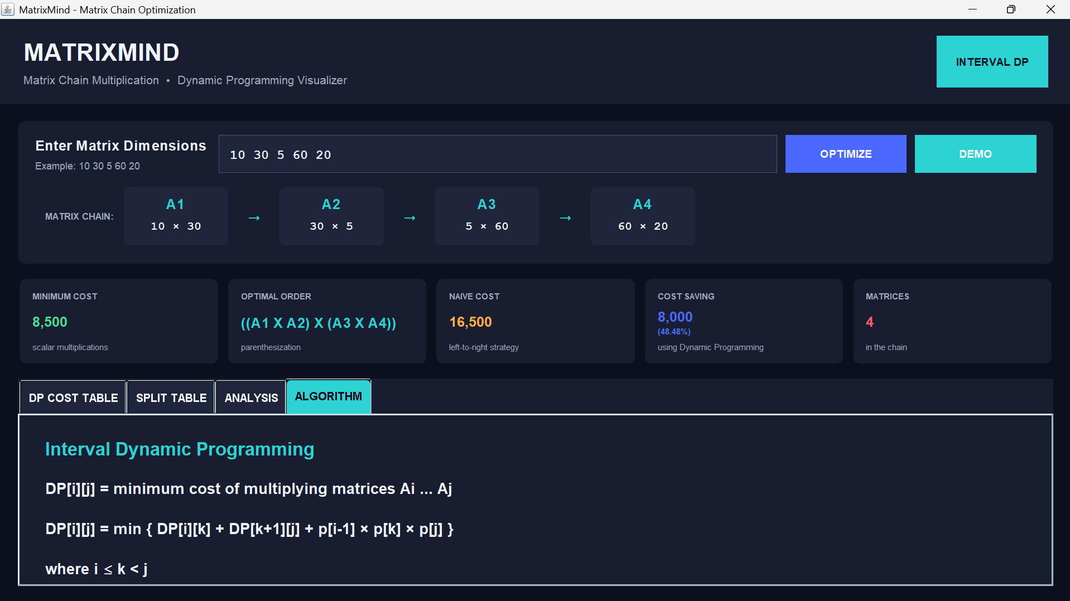
Fig. 1: MatrixMind main window for the DEMO input 10 30 5 60 20 – matrix chain preview, result cards and the Algorithm tab.
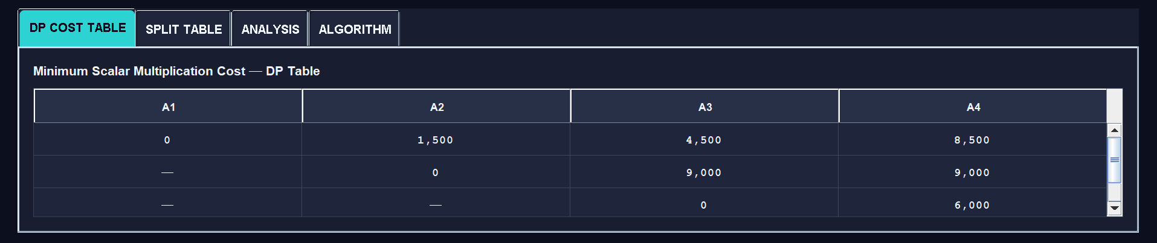
Fig. 2: DP cost table for the DEMO input (dp[1][4] = 8,500).
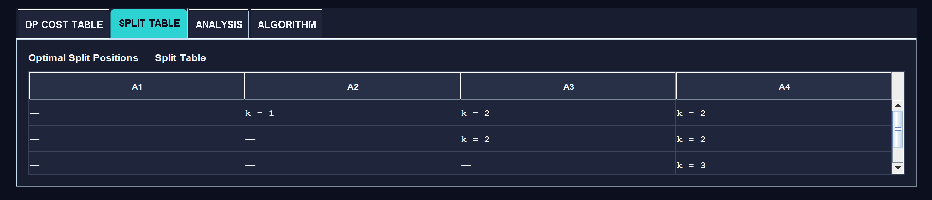
Fig. 3: Split table for the DEMO input (split[1][4] = 2).
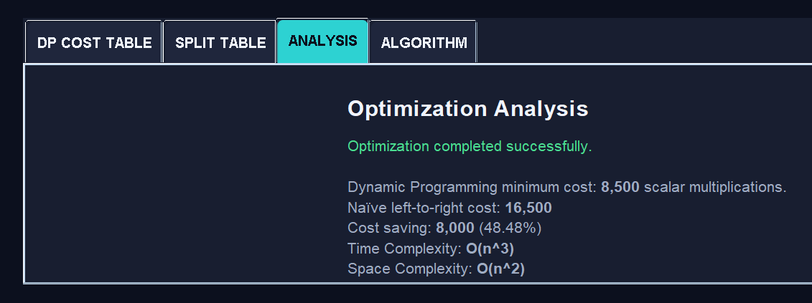
Fig. 4: Analysis tab for the DEMO input – minimum cost 8,500, naïve cost 16,500, saving 8,000 (48.48 %), O(n^3) time and O(n^2) space.
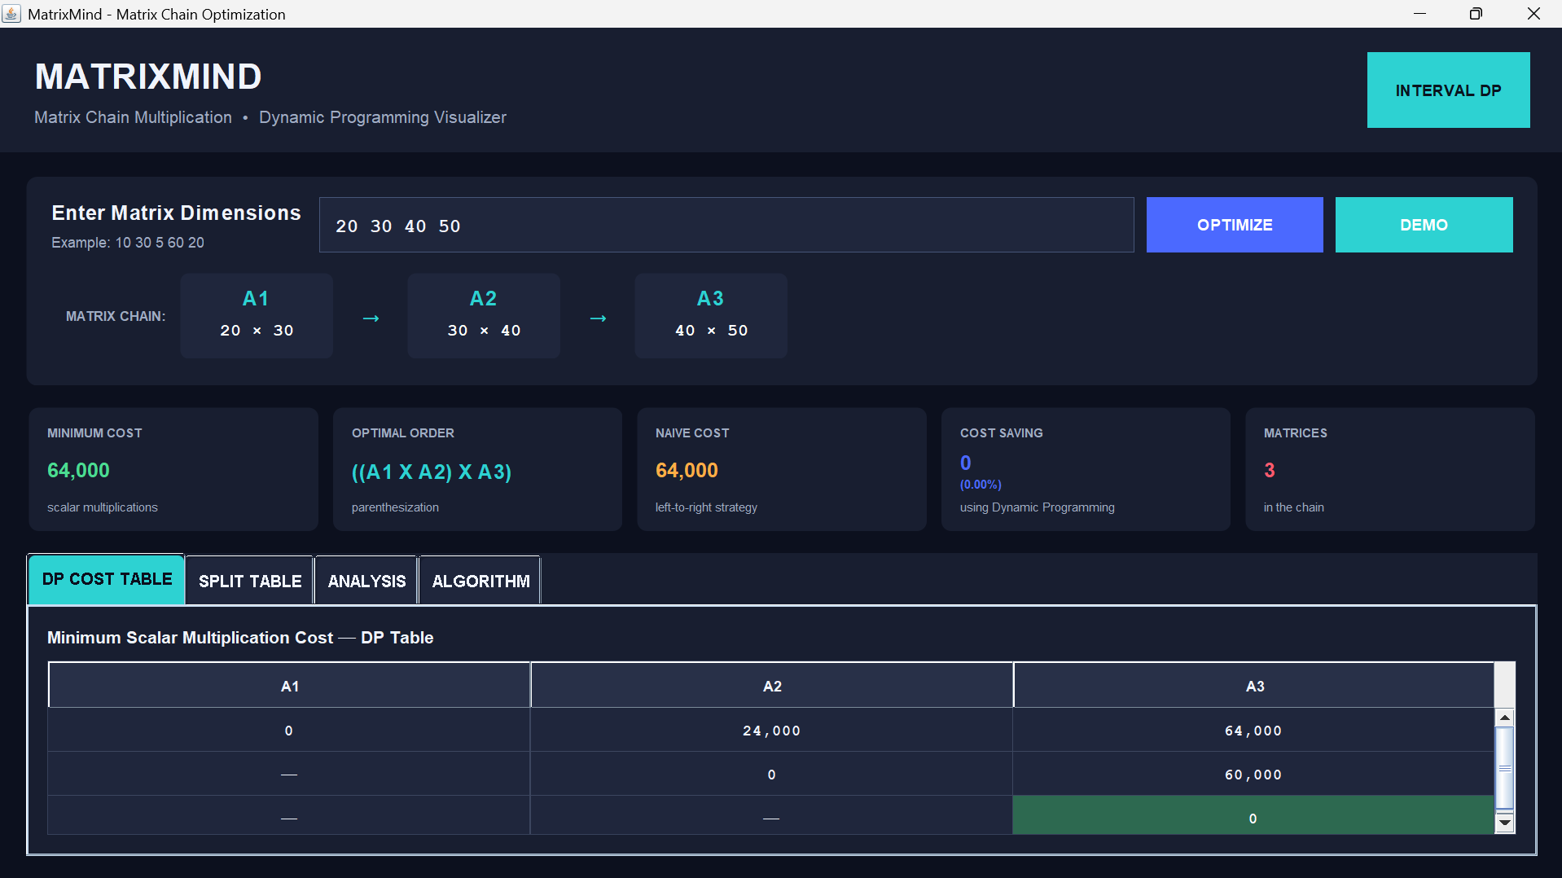
Fig. 5: Main window and DP cost table for the input 20 30 40 50 (minimum cost 64,000, no saving).
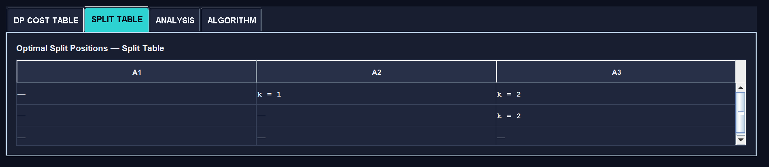
Fig. 6: Split table for the input 20 30 40 50.
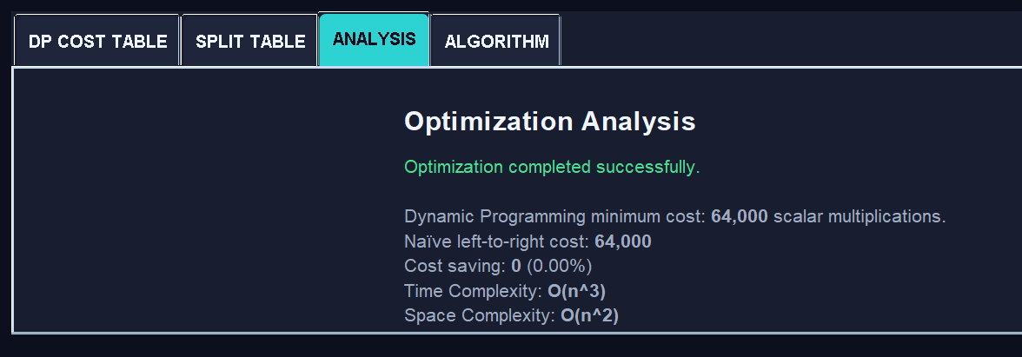
Fig. 7: Analysis tab for the input 20 30 40 50 – DP and naïve costs are both 64,000, saving 0 (0.00 %).
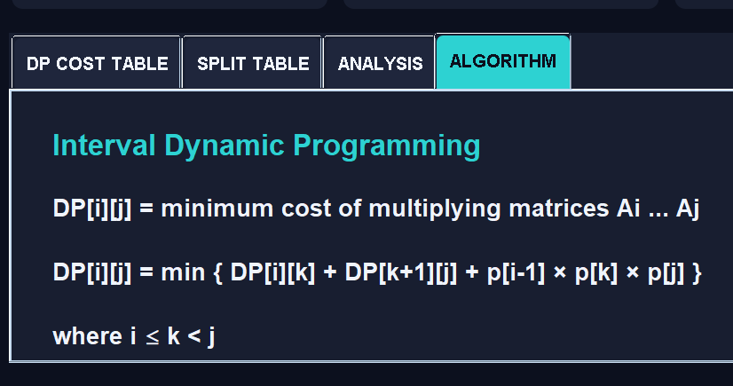
Fig. 8: Algorithm tab showing the Interval DP recurrence.

5. Conclusion
MatrixMind demonstrates how the order of operations affects computational cost in a chain of matrix multiplications. The project uses Interval Dynamic Programming to find the minimum number of scalar multiplications efficiently, in O(n³) time and O(n²) space, and the split table allows the optimal parenthesization to be reconstructed exactly. Comparison with the naïve left-to-right strategy shows the benefit of the optimisation – for the demo chain 10 30 5 60 20 the cost falls from 16,500 to 8,500, a saving of 48.48 % – while inputs such as 20 30 40 50 correctly show that no saving is possible. The interactive Java interface makes the DP tables, the optimal order and the cost comparison easy to understand, and the project gives a practical application of Dynamic Programming to an optimisation problem.

6. Future Scope
- Step-by-step animation of how the DP table is filled, cell by cell.
- Support for larger matrix chains and more detailed performance comparisons, including running-time measurements.
- Comparison with the recursive and memoised approaches as well as the naïve strategy.
- Visualising the optimal parenthesization as an expression tree.
- Exporting the tables and results to a file or report.
- Extending the tool to demonstrate other Dynamic Programming optimisation problems.
- Entering matrices with actual values and performing the multiplication in the optimal order.

7. Geo tag photos

