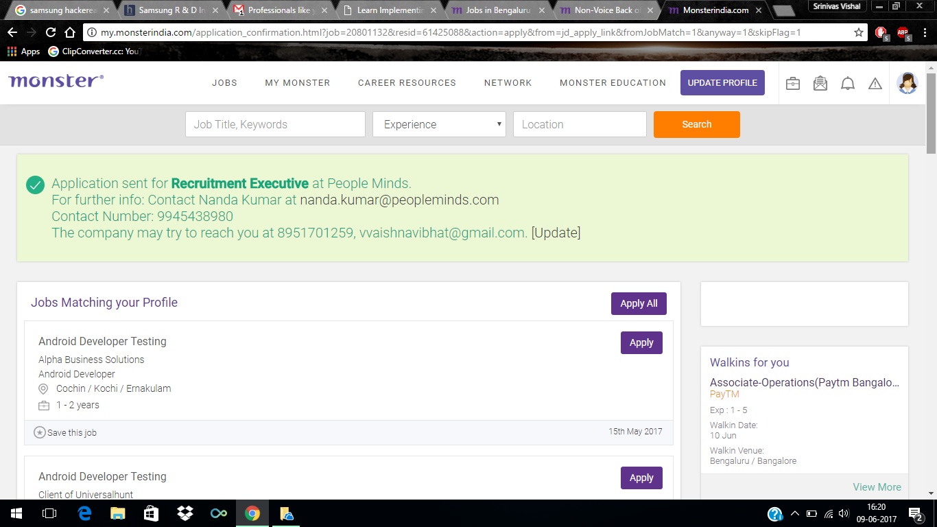

System India

An ISO 9001:2008 Certified Company  
Time:10.00 to 5.00 pm  
Address :-  
System India   
No. 107, Glassic Business Center  
14/1 M.G road, Anil kumbale circle  
opp to Corporation bank above Arya bhavan sweet  
Banglore   
**HR**  
S**hr**ikant  
09886459177  
080 65650017

Email Us At - [Career@marutisolutionsltd.com](mailto:Career@marutisolutionsltd.com) - HR Executive

Venue:  
  
SixSigma Soft solutions Pvt Ltd   
No. 42, Sama Towers, First Floor, Church Street,Bangalore - 560 001.  
Landmark: near to Anil kumble circle  
Contact person-Ms.Udhaya-9884834539

Salary:INR 1,50,000 - 1,75,000 P.A.

Industry:[Recruitment](https://www.naukri.com/recruitment-jobs) / [Staffing](https://www.naukri.com/staffing-jobs)

Functional Area:[**HR**](https://www.naukri.com/hr-jobs), [Recruitment](https://www.naukri.com/recruitment-jobs), [Administration](https://www.naukri.com/administration-jobs), [IR](https://www.naukri.com/ir-jobs)

Role Category:**HR**/ Recruitment / IR

Role:Recruitment **Executive**