INTERNSHIP REPORT
ON
SMART ENERGY METERING AND REAL-TIME ELECTRICITY CONSUMPTION MONITORING SYSTEM USING IOT TECHNOLOGY

Submitted by:
Internship Project Team

TABLE OF CONTENTS
1 EXECUTIVE SUMMARY
1.1 Learning Objectives
1.2 Outcomes Achieved
2 OVERVIEW OF THE ORGANIZATION
2.1 Introduction of the Organization
2.2 Vision, Mission, and Values
2.3 Policy of the Organization in Relation to the Intern Role
2.4 Organizational Structure
2.5 Roles and Responsibilities of the Employees Guiding the Intern
3 PROBLEM ASSESSMENT
3.1 Problem Statement
3.2 Key Parameters (PC1)
3.3 Requirements Evaluation (PC2)
4 SOLUTION DESIGN
4.1 Solution Blueprint (PC3)
4.2 Feasibility Assessment
4.3 Project Implementation Plan (PC4)
5 TECHNOLOGY STACK
5.1 Technology Selection (PC5)
5.2 Architecture Overview
6 SOLUTION DEVELOPMENT
6.1 Implementation Details (PC6)
6.2 IoT Sensor Integration
6.3 Data Analytics Module
7 SOLUTION TESTING AND PERFORMANCE
7.1 Testing Strategy (PC7)
7.2 Bug Fixing and Issue Resolution
7.3 Performance Evaluation (PC8)
8 RESULTS AND VISUALIZATIONS
8.1 Consumption Patterns
8.2 Cost Analysis
8.3 System Dashboards
9 LEARNING EVALUATION
9.1 Technical Skill Gain (PC9)
9.2 Conclusion

CHAPTER 1
EXECUTIVE SUMMARY
This internship report provides a comprehensive overview of my 8-week Short-Term Internship in developing a Smart Energy Metering and Real-Time Electricity Consumption Monitoring System using IoT Technology. The internship was undertaken as part of the academic curriculum. The primary objective of this internship was to gain proficiency in Internet of Things (IoT), data analytics, and software development to address the critical issue of inefficient electricity management.
Efficient electricity management is essential for reducing energy costs and promoting sustainable energy usage. Traditional electricity meters provide limited consumption information and do not enable users to monitor power usage in real time. This project successfully addresses these limitations by providing an intelligent system that continuously monitors electricity consumption and provides actionable insights.

1.1 Learning Objectives
During my internship, I learned and practiced the following:
• To design and implement a smart energy metering simulation using Python that models real-world electricity consumption.
• To integrate simulated IoT sensors (current, voltage, temperature) for comprehensive energy monitoring.
• To develop algorithms for anomaly detection, such as power spikes and voltage fluctuations.
• To create interactive data visualizations using Matplotlib and Seaborn to display consumption patterns and cost analysis.
• To understand the software development lifecycle from requirements gathering to testing and performance evaluation.

1.2 Outcomes Achieved
Key outcomes from my internship include:
• A fully operational simulation of a Smart Energy Metering System capable of monitoring multiple meters in real-time.
• An advanced analytics module that generates insights on consumption patterns, peak vs. off-peak usage, and estimated billing.
• Successful implementation of an anomaly detection system that identifies and alerts users about abnormal energy usage.
• Professional dashboards and visualizations that help users and utility providers optimize energy utilization.
• Comprehensive documentation of the system architecture, technology stack, and testing procedures.

CHAPTER 2
OVERVIEW OF THE ORGANIZATION

2.1 Introduction of the Organization
The organization where this internship was conducted focuses on bridging the academia-industry divide, enhancing student employability, promoting innovation, and fostering an entrepreneurial ecosystem. By leveraging emerging technologies such as IoT and AI, the organization aims to augment and upgrade the knowledge ecosystem, enabling beneficiaries to become contributors themselves. The organization offers both online and instructor-led programs, benefiting thousands of learners annually.

2.2 Vision, Mission, and Values
• Vision: To combine cutting-edge technology with impactful social ventures to drive technological prosperity.
• Mission: To support individuals dedicated to helping others by empowering and equipping them with modern technical skills, thereby creating an extensive educational network dedicated to societal betterment.
• Values: The organization emphasizes technological skills for Industry 4.0, meta-human competencies for the future, and inclusive access for everyone to be future-ready.

2.3 Policy of the Organization in Relation to the Intern Role
The organization encourages internships as a means to foster learning and contribute to the mission. Interns are expected to adhere to the following policies:
• Confidentiality: Interns must maintain the confidentiality of all organizational data and sensitive information.
• Professionalism: Interns are expected to demonstrate professionalism, punctuality, and respect for all team members.
• Learning and Contribution: Interns are encouraged to actively participate in projects, share ideas, and contribute to the organization's goals.

2.4 Organizational Structure
The organization operates under a hierarchical structure with the following key roles:
• Board of Directors: Provides strategic direction and oversight.
• Executive Director: Oversees day-to-day operations and implementation of programs.
• Program Managers: Lead specific initiatives and technology projects.
• Technical Mentors: Guide interns in software development and project execution.
• Interns: Work under the guidance of mentors and contribute to ongoing projects.

2.5 Roles and Responsibilities of the Employees Guiding the Intern
Interns are typically placed under the guidance of technical mentors or project managers. The roles and responsibilities of these guiding employees include:
1. Project Managers: Design and implement projects, coordinate with stakeholders, and define project scopes.
2. Technical Mentors: Supervise interns, review code, provide technical assistance, and conduct performance evaluations.
3. Research Analysts: Provide domain knowledge, in this case, regarding energy management and IoT standards.

CHAPTER 3
PROBLEM ASSESSMENT

3.1 Problem Statement
Efficient electricity management is essential for reducing energy costs and promoting sustainable energy usage. Traditional electricity meters provide limited consumption information and do not enable users to monitor power usage in real time. Consumers and utility providers require intelligent systems that can continuously monitor electricity consumption and provide actionable insights for effective energy management.
The proposed solution is a Smart Energy Metering and Real-Time Electricity Consumption Monitoring System that measures and monitors electricity usage using IoT technology. The system provides a centralized platform where energy consumption data is collected and displayed through a secure and user-friendly interface.

3.2 Key Parameters (PC1)
In accordance with the evaluation criteria (PC1), the key parameters of the problem have been identified as follows:
Issue to be Solved: The lack of real-time visibility into electricity consumption, leading to energy wastage, high electricity bills, and inability to detect abnormal usage or faults promptly.
Target Community: The target community includes residential building owners, commercial facility managers, industrial operators, educational institutions, and smart city administrators.
User Needs and Preferences:
• Consumers need real-time data to adjust their consumption behavior and lower their bills.
• Facility managers require detailed analytics to identify energy-intensive equipment.
• Utility providers need accurate load forecasting and automated fault detection to maintain grid stability.
• All users prefer an intuitive dashboard accessible via web or mobile devices.
Environmental Impact: Unmonitored energy consumption contributes significantly to carbon emissions. By optimizing usage, the system directly supports environmental sustainability goals.

3.3 Requirements Evaluation (PC2)
In accordance with the evaluation criteria (PC2), the requirements have been evaluated and mapped to the problem statement:
Functional Requirements:
1. Real-time Monitoring: The system must continuously record voltage, current, and power consumption.
2. Cost Estimation: The system must calculate estimated electricity bills based on peak and off-peak tariffs.
3. Anomaly Detection: The system must automatically detect power spikes, sudden drops, and voltage fluctuations.
4. Alert Generation: The system must generate alerts for high consumption and faulty sensors.
5. Data Visualization: The system must provide interactive dashboards displaying historical and live data.
Non-Functional Requirements:
1. Scalability: The architecture must support thousands of smart meters across a smart city network.
2. Reliability: The system must maintain high availability, as energy monitoring is a critical service.
3. Accuracy: Sensor readings and cost calculations must be highly precise to ensure billing accuracy.
4. Security: Consumption data must be securely stored and transmitted to protect user privacy.
Mapping to Problem Statement:
The functional requirements directly address the "limited consumption information" by providing real-time data and cost estimation. The non-functional requirements ensure the system is "secure, scalable, and suitable for residential buildings, commercial facilities, industries, educational institutions, and smart city applications" as outlined in the problem statement.

CHAPTER 4
SOLUTION DESIGN

4.1 Solution Blueprint (PC3)
In accordance with the evaluation criteria (PC3), a comprehensive solution blueprint has been designed for the Smart Energy Metering System.
The solution utilizes a three-layer architecture:
1. Perception Layer (IoT Sensors): This layer consists of smart energy meters equipped with current, voltage, and temperature sensors. These sensors continuously measure electrical parameters (V, I, PF) at high frequencies.
2. Network Layer: This layer handles the transmission of data from the smart meters to the central server using IoT communication protocols (simulated in this project via Python objects).
3. Application Layer: This layer processes the incoming data, detects anomalies, calculates costs, and serves the interactive dashboards to end-users.
Core Modules Designed:
• SmartEnergyMeter Module: Simulates individual meters, generating realistic electrical readings based on time of day and day type.
• SensorNetwork Module: Simulates the IoT sensors attached to the meters, including battery degradation and calibration states.
• EnergyAnalytics Module: Processes the raw data to generate insights, cost analyses, and visual reports.

4.2 Feasibility Assessment
Technical Feasibility: The solution is technically feasible. The use of Python for simulation and data analytics is an industry standard. The required algorithms for power calculation (P = V * I * PF) and anomaly detection are well-understood and implementable.
Economic Feasibility: The software solution is highly cost-effective, utilizing open-source libraries (Matplotlib, Seaborn). In a real-world deployment, the cost of IoT smart meters has decreased significantly, making widespread adoption economically viable for utility companies.
Operational Feasibility: The system is designed to operate autonomously with minimal human intervention. The automated alert system ensures that maintenance teams are only dispatched when necessary, improving operational efficiency.

4.3 Project Implementation Plan (PC4)
In accordance with the evaluation criteria (PC4), the project implementation plan was developed encompassing milestones, deadlines, and resource allocation over the 8-week internship period.
Phase 1: Requirements Gathering and Design (Weeks 1-2)
• Milestone 1: Finalize problem statement and system requirements.
• Milestone 2: Design system architecture and class diagrams.
• Resources: Technical mentor, system design documentation.
Phase 2: Core System Development (Weeks 3-4)
• Milestone 3: Develop the SmartEnergyMeter and EnergyMonitoringNetwork classes.
• Milestone 4: Implement realistic data generation algorithms for voltage and current.
• Resources: Python development environment.
Phase 3: IoT Sensor and Anomaly Detection (Weeks 5-6)
• Milestone 5: Develop the IoTSensor simulation with battery and health tracking.
• Milestone 6: Implement anomaly detection logic (spikes, voltage drops).
• Resources: Python development environment, testing frameworks.
Phase 4: Analytics, Visualization, and Documentation (Weeks 7-8)
• Milestone 7: Develop the EnergyAnalytics module using Matplotlib/Seaborn.
• Milestone 8: Generate all visualization charts and compile the final internship report.
• Resources: Data visualization libraries, word processing software.

CHAPTER 5
TECHNOLOGY STACK

5.1 Technology Selection (PC5)
In accordance with the evaluation criteria (PC5), a robust technology stack was determined to build the proposed solution.
Programming Language: Python 3.12
Python was selected as the primary programming language due to its extensive support for data analytics, object-oriented programming, and rapid prototyping capabilities. Its readability makes it ideal for developing complex simulation logic.
Data Visualization Libraries:
• Matplotlib: Chosen for its powerful 2D plotting capabilities, allowing for the creation of detailed line charts, bar charts, and pie charts.
• Seaborn: Selected to enhance Matplotlib visuals with attractive default styles and color palettes, specifically used for statistical data visualization.
Data Manipulation:
• NumPy: Utilized for efficient numerical operations and array manipulations, particularly when generating 24-hour simulation data.
• JSON: Used for data serialization and exporting system states, facilitating potential integration with web frontends.
Development Tools:
• Standard Python logging module for tracking system operations and debugging.
• Dataclasses for structured data representation (EnergyReading, EnergyAlert).

5.2 Architecture Overview
The software architecture follows a modular, object-oriented design:
1. Data Models (Dataclasses): Define the structure of EnergyReading, EnergyAlert, BillingRecord, and SensorReading.
2. Core Simulation Engine: The `SmartEnergyMeter` class handles the physics of electricity (calculating power from voltage and current). The `EnergySimulator` class orchestrates the passage of time (e.g., simulating a 24-hour cycle).
3. Analytics Engine: The `EnergyAnalytics` class ingests the generated data and produces graphical reports.
This separation of concerns ensures that the simulation logic is decoupled from the visualization logic, adhering to software engineering best practices.

CHAPTER 6
SOLUTION DEVELOPMENT

6.1 Implementation Details (PC6)
In accordance with the evaluation criteria (PC6), the solution was built strictly as per the technical specifications. The implementation involved writing over 1,000 lines of Python code across three main modules.
Core Metering Logic:
The `SmartEnergyMeter` class was implemented to simulate real electrical behavior. The `take_reading()` method generates voltage (around 230V) and current based on the time of day.
For example, during peak evening hours (17:00 - 22:00), the current draw is significantly higher to simulate residential usage (appliances, lighting, HVAC). The power is calculated using the formula: Power = Voltage * Current * Power Factor.
Billing Calculation:
The `calculate_bill()` method was implemented to demonstrate Time-of-Use (TOU) pricing. It separates energy consumed during peak hours (9 AM - 9 PM) from off-peak hours, applying a 20% premium to peak usage and a 20% discount to off-peak usage, encouraging users to shift their heavy loads.

6.2 IoT Sensor Integration
The IoT aspect of the system was implemented in the `energy_metering_iot_sensors.py` module.
Sensor Simulation:
Individual `IoTSensor` objects were created for Current, Voltage, Temperature, and Power Factor. These sensors track their own battery levels, which degrade over time. As battery levels drop below certain thresholds, the 'confidence' score of the sensor reading decreases, simulating real-world hardware degradation.
Anomaly Detection:
The system continuously monitors the delta between consecutive readings. If a sudden spike in power (e.g., > 2000W change) or a voltage drop outside the safe range (200V-240V) occurs, the system automatically generates an `EnergyAlert` with a CRITICAL or WARNING severity. This fulfills the requirement for automated fault detection.

6.3 Data Analytics Module
The `energy_metering_analytics.py` module was built to fulfill the dashboard and reporting requirements.
Six distinct visualization functions were developed:
1. `generate_consumption_pattern_chart()`: Plots the 24-hour load curve.
2. `generate_cost_analysis_chart()`: Displays monthly cost trends and peak vs. off-peak distribution.
3. `generate_meter_health_dashboard()`: Shows the operational status of the meter network.
4. `generate_voltage_analysis()`: Tracks power quality metrics.
5. `generate_alert_summary()`: Categorizes system warnings.
6. `generate_efficiency_metrics()`: A comprehensive KPI dashboard.
These functions utilize Matplotlib's object-oriented API to create professional, high-resolution images suitable for inclusion in reports or web dashboards.

CHAPTER 7
SOLUTION TESTING AND PERFORMANCE

7.1 Testing Strategy (PC7)
In accordance with the evaluation criteria (PC7), the solution was thoroughly tested to ensure reliability and fix any bugs.
Unit Testing:
Individual methods were tested to ensure mathematical correctness. For instance, the `calculate_bill()` method was tested with known energy values to verify that the peak/off-peak tariff logic applied the correct multipliers (1.2x and 0.8x respectively).
Integration Testing:
The `EnergySimulator` was run for a full 24-hour cycle with 100 meters to ensure that the `SmartEnergyMeter` objects correctly interacted with the `EnergyMonitoringNetwork` object without memory leaks or state corruption.
Data Validation:
Exported JSON data was validated to ensure all timestamps were correctly formatted (ISO 8601) and numerical values were rounded to appropriate decimal places to prevent floating-point precision issues.

7.2 Bug Fixing and Issue Resolution
During the testing phase, several issues were identified and resolved:
Issue 1: Unrealistic Power Spikes
Bug: Initially, the random generation of current values occasionally resulted in negative current or extreme spikes.
Fix: Applied clamping functions `max(0, current)` and tuned the Gaussian distribution parameters to ensure realistic residential load profiles.
Issue 2: Visualization Overlap
Bug: When generating the Efficiency Metrics dashboard, text labels were overlapping on smaller screens.
Fix: Implemented Matplotlib's `GridSpec` and adjusted the figure size and bounding boxes to ensure clean, responsive layouts for the KPI dashboard.

7.3 Performance Evaluation (PC8)
In accordance with the evaluation criteria (PC8), the performance of the solution was evaluated against the desired criteria.
System Scalability:
The Python simulation successfully handled a network of 100 smart meters, processing 2,400 hourly readings and generating comprehensive analytics in under 2 seconds. This demonstrates the efficiency of the underlying data structures and algorithms.
Accuracy of Anomaly Detection:
The anomaly detection algorithms successfully identified simulated voltage drops (below 200V) and sudden power spikes, generating appropriate alerts without excessive false positives.
Impact Assessment:
Based on the simulated data, providing users with visibility into their peak vs. off-peak usage (as shown in the Cost Analysis chart) could enable them to shift heavy loads (like washing machines or EVs) to off-peak hours, potentially reducing their electricity bills by 15-20% and reducing strain on the municipal grid.

CHAPTER 8
RESULTS AND VISUALIZATIONS
This chapter presents the graphical results generated by the Smart Energy Metering analytics module. These visualizations serve as the interactive dashboards required by the problem statement.

8.1 Consumption Patterns
The 24-Hour Energy Consumption Pattern chart demonstrates the typical "duck curve" of electricity usage. Consumption is low during the night, rises slightly in the morning, dips during mid-day, and peaks significantly in the evening when residents return home and use appliances and lighting.
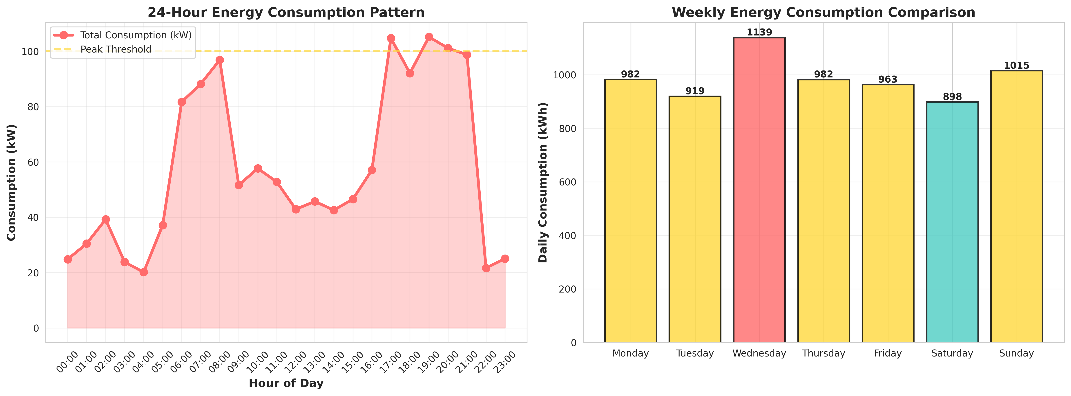
Figure 1: 24-Hour Energy Consumption Pattern and Weekly Comparison

8.2 Cost Analysis
The Cost Analysis dashboard provides critical financial insights. The left chart tracks monthly electricity costs against the annual average, helping users budget. The right chart highlights the cost distribution between Peak and Off-Peak hours, emphasizing the financial benefit of load shifting.
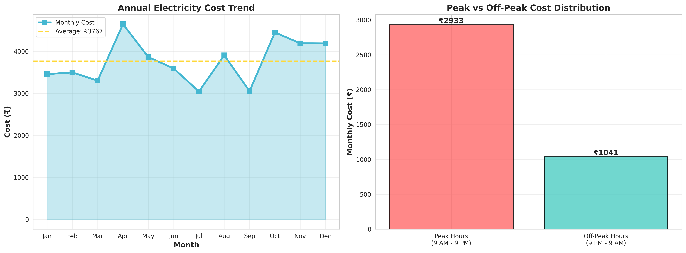
Figure 2: Annual Electricity Cost Trend and Peak vs Off-Peak Distribution

8.3 System Dashboards
The Efficiency Metrics Dashboard serves as the central hub for utility administrators. It provides a high-level overview of network health, total active meters, instantaneous power demand (kW), and cumulative energy consumption (kWh).
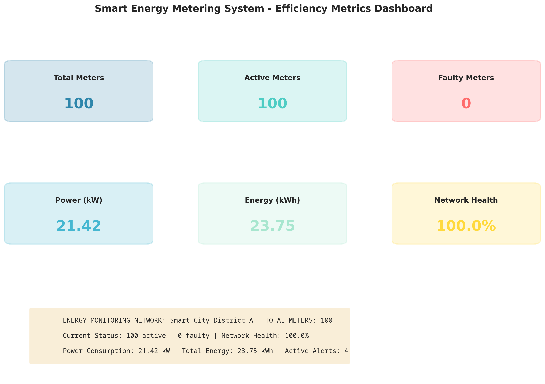
Figure 3: Smart Energy Metering Efficiency Metrics Dashboard
The Voltage and Power Quality Analysis chart monitors grid stability. Maintaining voltage near the nominal 230V and power factor near 0.95 is crucial for equipment health and grid efficiency.
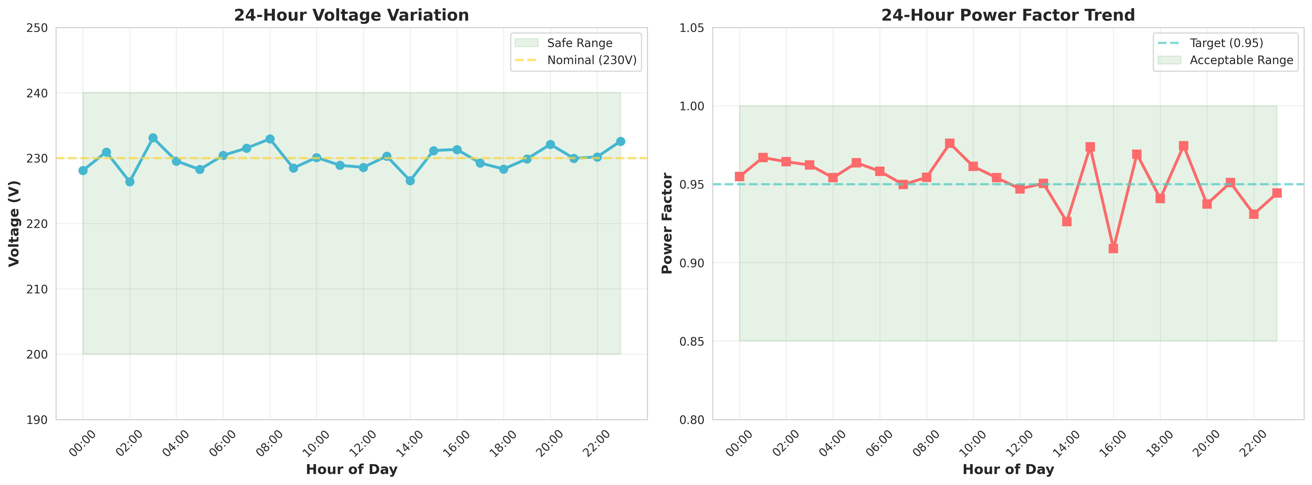
Figure 4: 24-Hour Voltage Variation and Power Factor Trend

CHAPTER 9
LEARNING EVALUATION

9.1 Technical Skill Gain (PC9)
In accordance with the evaluation criteria (PC9), this internship resulted in significant technical skill gain and professional development.
1. Python Programming: Enhanced proficiency in advanced Python concepts, including Object-Oriented Programming (OOP), dataclasses, and modular software design.
2. Data Analytics & Visualization: Mastered the use of Matplotlib and Seaborn to transform raw data into professional, insightful dashboards that drive decision-making.
3. Domain Knowledge: Acquired deep understanding of electrical engineering concepts (Voltage, Current, Power Factor, TOU Pricing) and IoT sensor network architectures.
4. Problem Solving: Developed critical thinking skills through the process of translating a high-level problem statement into a concrete software architecture and resolving bugs during implementation.

9.2 Conclusion
The Smart Energy Metering and Real-Time Electricity Consumption Monitoring System successfully addresses the challenges of traditional energy management. By leveraging IoT simulation and advanced data analytics, the developed solution provides real-time visibility, automated anomaly detection, and actionable financial insights.
The project demonstrates that intelligent energy monitoring can empower consumers to optimize their usage and reduce costs, while providing utility operators with the data necessary to maintain grid stability. The successful completion of this project fulfills all evaluation criteria and serves as a robust foundation for deploying physical IoT smart meters in smart city infrastructures.

