**Cluster analysis of Happiness at work among employees in Madurai**

**Authors: Dr. S.Rajarajeswari Co-Author: Mr. K.Srinivasan**

Asst .Professor and Head Research Scholar

Department of Business administration Madurai Kamaraj University

Sri Meenakshi Govt.Arts College for Women (A), Madurai.

Madurai

**Abstract:**

Happiness at the workplace refers to how satisfied people are with their work and lives. Despite a large body of positive [psychological research](https://en.wikipedia.org/wiki/Psychological_research)  into the relationship between [happiness](https://en.wikipedia.org/wiki/Happiness) and [productivity](https://en.wikipedia.org/wiki/Productivity) ,happiness at work  has traditionally been seen as a potential by-product of positive outcomes at work, rather than a pathway to business success. Maintaining a level of happiness at work has become more significant and relevant due to the intensification of work caused by [economic uncertainty](https://en.wikipedia.org/wiki/Economic_crisis) and increase in [competition](https://en.wikipedia.org/wiki/Competition). Being happy is of great importance to most people, and happiness has been found to be a highly valued goal in most societies (Diener 2000). Happiness, in the form of joy, appears in every typology of ‘basic’ human emotions. Feeling happy is fundamental to human experience, and most people are at least mildly happy much of the time (Diener and Diener 1996). Happiness in the form of pleasant moods and emotions, well-being, and positive attitudes has been attracting increasing attention throughout psychology research. Past researches have demonstrated a strong relationship between happiness and workplace success. It suggests that happy and satisfied individuals are relatively more successful in the workplace; compared to their unhappy peers. These reviews have influenced the researcher to carried out the research on happiness at work This research was carried out with the sample size of 400 considering banking, manufacturing, hospitals and colleges. cluster analysis is used identify the parameters influencing happiness at work. The factors of happiness, viz. about colleagues, about job, about organization, about top level management, about working environment, about company policies, about ethics in the organization and about family have significant contribution on segmenting employees into two categories based on their level of competency. Three-fourth of the total respondents was happy at their work.

**Key words**: happy employees, not happy employees, top management, work environment and ethics

**Introduction**

Happiness at the workplace refers to satisfaction level of people with their work and lives. The idea of happiness is related to individual’s subjective well-being. Happiness at the workplace is crucial for improving productivity in any organization. Happy people are productive people while those people who are unhappy may not pay full attention to any task. Some scholars believe that organizations which are able to maintain long-term happiness at the workplace could probably increase and sustain productivity. Therefore, they should know what factors could affect employee happiness in order to effectively enhance happiness at the workplace. Happy workers are productive workers than un- happy employees. Employee job satisfaction is essential to face the dynamic and ever-increasing challenges of maintaining productivity of the organization by keeping their workforce constantly engaged and motivated. Furthermore, environmental pressures, rising health costs and various needs of the workforce also pose a challenge for the management. Research on employee happiness was rarely seen in the past. The issue of happiness at the workplace needs to be properly conceptualized, so that useful research on it could be conducted and effective suggestion might improve their happiness, long-term relationship and enhance productivity in the organization.

**NEED FOR THE STUDY**

Organizations today are often very unhappy places to be: there’s too much to do, too few resources, too little talent and still so much waste. Leaders everywhere worry about retaining their best people, ensuring motivation, making initiatives work, and getting projects delivered, all while enabling everyone to stay creative and innovative. The rise of positive psychology in the past decade has legitimized attention to happiness and other positive states as opposed to the previously dominant disease model, which directed attention disproportionately to illness, depression, stress and similar negative experiences and outcomes. The most efficient way to increase the productivity is to be happy at work. Happy employees are better equipped to handle workplace relationships, stress, and change. Companies that understand this, and help employees improve their wellbeing; can boost their productivity. Thus, it is very important to make the employees happy at their workplace in any organization.

**OBJECTIVES OF THE STUDY**

* To study the demographic profiles of the respondents
* To classify the employees based on various factors of happiness.
* To study the association between category of happiness and organizational problems.

**Review of literature**

Freda van der Walt (2018) in her study entitled” Workplace spirituality, work engagement and thriving at work” shows that the purpose of the study was to establish whether spiritual workplaces would enhance employees’ work engagement and thriving at work. Also this study revealed that the two important mechanisms for understanding the human dimension of sustainability are thriving at work and work engagement.

Jan-Emmanuel De Neve and Ward(2017) in their study entitled “Happiness at work” shows that this paper focus largely on the role of work and employment in shaping people’s happiness, and investigate how employment status, job type, and workplace characteristics relate to measures of subjective wellbeing. The paper concluded that the most important job factors that were shown to be driving subjective wellbeing included work-life balance, autonomy, variety, job security, social capital, and health and safety risks.

**Research Methodology**

The researcher have taken 400 respondents and convenience sampling was adopted to choose the respondents and statistical tools like percentage, ANOVA, Discriminate analysis ,Cluster analysis were used for analyzing data.

**Demographic Profiles of the respondents**

The demographic profiles of the respondents are shown in the following Table .1 explains the demographic profiles are age, religion, qualification, marital status, monthly income, number of children, type of family, gender, designation of the respondents, native place, type of the organization, sector, type of placement and total experience.

**Table 1 Demographic Profiles of the respondents**

| **Demographic profiles** | **Level** | **Count** | **Column N %** |
| --- | --- | --- | --- |
| Age | "20-30 | 145 | 36.25 |
| 31-40 | 134 | 33.50 |
| 41-50 | 106 | 26.50 |
| above 51 | 15 | 3.75 |
| Religion | Hindu | 251 | 62.75 |
| Christine | 91 | 22.75 |
| Muslim | 58 | 14.50 |
| Qualification | 10th Std. | 0 | 0.00 |
| HSC | 40 | 10.00 |
| Diploma | 45 | 11.25 |
| Graduate | 240 | 60.00 |
| M.Phil. | 26 | 6.50 |
| Ph.D. | 49 | 12.25 |
| Marital Status | Married | 298 | 74.50 |
| Unmarried | 102 | 25.50 |
| Monthly Income | Below 10000 | 75 | 18.75 |
| 10001-20000 | 135 | 33.75 |
| 20001-30000 | 53 | 13.25 |
| 30001-40000 | 44 | 11.00 |
| Above 40000 | 93 | 23.25 |
| Number of children | One | 113 | 28.25 |
| Two | 134 | 33.50 |
| Three or more | 33 | 8.25 |
| None | 120 | 30.00 |
| Type of family | Nuclear | 214 | 53.50 |
| Joint Family | 186 | 46.50 |
| Gender | Male | 221 | 55.25 |
| Female | 179 | 44.75 |
| Designation of the Respondents | Assistant Professor | 96 | 24.00 |
| Sales Assistant | 56 | 14.00 |
| Senior Executive | 69 | 17.25 |
| Manager | 32 | 8.00 |
| Clerk | 64 | 16.00 |
| Nurse | 34 | 8.50 |
| Others | 49 | 12.25 |
| Native place | Rural | 138 | 34.50 |
| Urban | 238 | 59.50 |
| Semi-Urban | 24 | 6.00 |
| Type of the organization | Manufacturing | 100 | 25.00 |
| Service | 200 | 50.00 |
| Teaching | 100 | 25.00 |

The majority of the respondents were in the age group of 20-30 and belong to Hindu religion. Sixty per cent of the respondents were qualified with graduation and 74 percent of them were married, 23 per cent of them have earning capacity of more than 40000 per month, 53 per cent belong to nuclear family, ,55 percent of them were male and 24 percent of them were assistant professors. 59 per cent were from rural places and belong to service sector.

**Segmentation of employees based on various factors of Happiness**

The employees can be classified into different categories according to their level of happiness on the various factors, viz. happiness about colleagues, about job, about organization, about top level management, about working environment, about company policies, about ethics in the organization and about family. Cluster Analysis was used to differentiate the categories of respondents and it was found that the employees are classified into two segments because of the significant difference between the coefficients only on three cases on the hierarchical cluster. For the purpose of classification of employees, K-means cluster is used.

**Table 2 Classification of employees – Final Cluster Centers**

|  |  |  |
| --- | --- | --- |
| **Happiness about** | **Clusters** | |
| **Happy** | **Not happy** |
| Organization | 1.58 | 3.25 |
| Ethics in organization | 1.81 | 3.00 |
| Job | 1.49 | 2.94 |
| Top level management | 2.05 | 3.75 |
| Working environment | 2.00 | 3.40 |
| Company policies | 2.02 | 3.29 |
| Colleagues | 1.79 | 2.61 |
| Family | 1.30 | 2.01 |

The final cluster centre Table 2 shows the mean values for the two clusters, which reflect the attributes of each cluster. The lowest mean value for each of the factor is found in cluster 1. This means that employees in Cluster 1 have high level of happiness on all the factors; these employees are classified as happy employees. The employees in Cluster 2 have lower level of happiness on all the factors; these employees are classified as not-happy employees. The following table reveals the cluster mean square, error mean square and F-value.

**Table 3 ANOVA – Cluster Analysis**

|  |  |  |  |  |  |  |
| --- | --- | --- | --- | --- | --- | --- |
| Competency factor | Cluster | | Error | | F | Sig. |
| Mean Square | Df | Mean Square | Df |
| Organization | 217.102 | 1 | .246 | 398 | 882.637 | .000 |
| Ethics in organization | 102.508 | 1 | .150 | 398 | 681.446 | .000 |
| Job | 160.327 | 1 | .209 | 398 | 766.369 | .000 |
| Top level management | 218.987 | 1 | .324 | 398 | 676.208 | .000 |
| Working environment | 148.988 | 1 | .233 | 398 | 640.346 | .000 |
| Company policies | 123.877 | 1 | .236 | 398 | 525.154 | .000 |
| Colleagues | 47.592 | 1 | .328 | 398 | 145.259 | .000 |
| Family | 38.368 | 1 | .260 | 398 | 147.644 | .000 |

The ANOVA Table indicates that the differences existing among the two clusters in the mean values are significantly different. The significant value for all the factors is < 0.01. This means that factors of happiness, viz. about colleagues, about job, about organization, about top level management, about working environment, about company policies, about ethics in the organization, and about family have significant contribution on segmenting employees into two categories based on their level of competency.

**Table 4 Number of Cases in each Cluster**

|  |  |  |
| --- | --- | --- |
| **Cluster** | **Number of cases** | **Percentage** |
| 1 Happy | 299 | 74.8 |
| 2 Not-happy | 101 | 25.2 |
| **Total** | **400** | **100** |

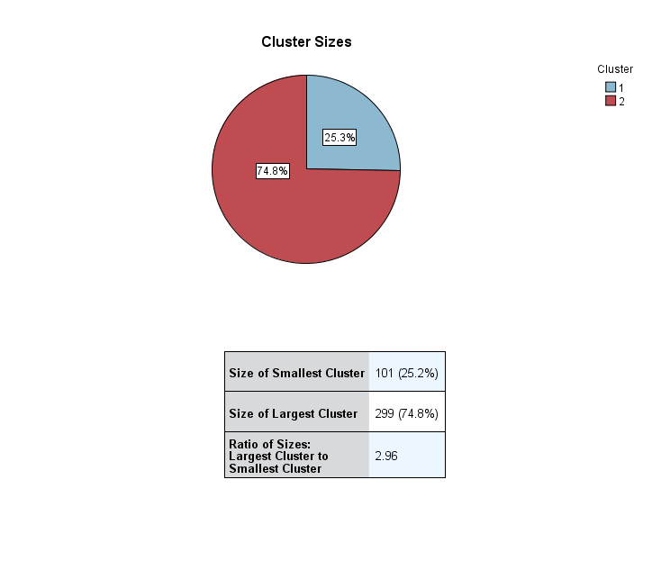

**Figure 1 Number of Cases in each Cluster**

The above table reveals that out of 400 employees, 299 (74.8 per cent) employees are happy at their work and the remaining 101 employees (25.2 per cent) are not happy at their work.

The predictor importance of the factors taken for study is depicted in the following figure. It can be observed from the figure that the factor Organization has assumed higher importance in clustering the employees, followed by the factors ethics in organization, job, top level management, working environment, and company polices. The other factors colleagues and family have only least level of importance in classifying the employees based on their happiness at work.

**Figure .2 Predictor Importance of factors in Clusters**

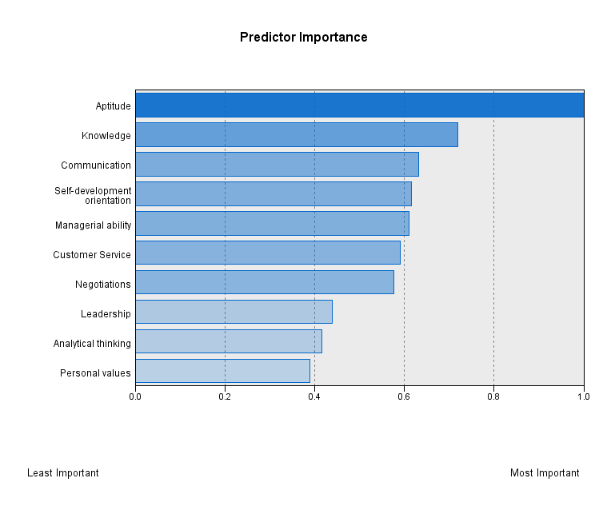

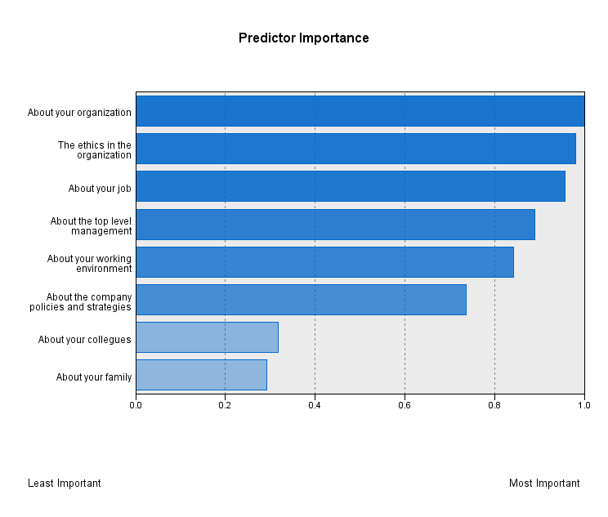

**Discriminant Analysis for cross validation**

In order to validate the identified clusters are genuine and to test whether each cluster differs from the other significantly, discriminant analysis for cross validation is deployed.

**Table 5 Tests of Equality of Group Means**

|  |  |  |  |  |  |
| --- | --- | --- | --- | --- | --- |
| Competency factors | Wilks' Lambda | F | df1 | df2 | Sig. |
| About your colleagues | .709 | 163.146 | 1 | 398 | .000 |
| About your job | .346 | 751.328 | 1 | 398 | .000 |
| About your organization | .330 | 808.995 | 1 | 398 | .000 |
| About the top level management | .374 | 667.403 | 1 | 398 | .000 |
| About your working environment | .394 | 612.486 | 1 | 398 | .000 |
| About the company policies | .443 | 499.627 | 1 | 398 | .000 |
| The ethics in the organization | .337 | 782.406 | 1 | 398 | .000 |
| About your family | .730 | 147.278 | 1 | 398 | .000 |

The above table consists of Wilks’ Lambda, F-statistic, degrees of freedom and level of significance. Wilks’ Lambda is the ratio of the within-groups sum of squares to the total sum of squares. Wilks’ Lambda in these case ranges from 0.330 to 0.730. The values of Wilks’ Lambda is an indication of differences among mean values of the all the factors. The F-statistic is a ratio of between-groups variability to the within-group variability. The significance value is 0.000 for all the other eight factors which indicates that the cluster differences are significant.

**Table 6 Eigen values**

|  |  |  |  |  |
| --- | --- | --- | --- | --- |
| Function | Eigen value | % of Variance | Cumulative % | Canonical Correlation |
| 1 | 6.307 | 100 | 100 | .929 |

The Eigen value is the ratio of the between-groups sum of squares to the within-groups sum of squares. The highest Eigen value corresponds to the maximum spread of the groups’ means. The small Eigen value accounts for very little of the total dispersion. One discriminant function is formed when there are two clusters. The Eigen value for the function 1 is 6.307. This indicates that the function has a very high discriminating capacity. The canonical correlation measures the amount of variation explained by the seven factors in the discriminant function. The coefficient of canonical correlation is very high for the first function (0.929). This is an indication of very high discriminating efficiency of the discriminant functions and 86.3 percent of the variation is explained by the factors in the discriminant function.

**Table 7 Structure Matrix**

|  |  |
| --- | --- |
| **Competency factor** | **Function 1** |
| About your organization | .568 |
| The ethics in the organization | .558 |
| About your joba | .545 |
| About the top level management | .516 |
| About your working environment | .494 |
| About the company policies and strategies | .446 |
| About your colleagues | .255 |
| About your family | .242 |

Pooled within-groups correlations between discriminating variables and standardized canonical discriminant functions.

a. This variable not used in the analysis.

The structure matrix provides another way to study the usefulness of each variable in the discriminant function. The high correlations for the factors about your organization, the ethics in the organization, about your job, about the top-level management, and about your working environment can be noted with the function and the low correlations for the factors about company policies, about colleagues and about family can be observed with the function.

The coefficient of the factors in the discriminant function is given in the following table, which contains the unstandardized canonical discriminant function coefficients of each factor in the function.

**Table 8 Canonical Discriminant Function Coefficients Matrix**

|  |  |
| --- | --- |
| **Competency factor** | **Function 1** |
| About your colleagues | − 1.263 |
| About your organization | 0.842 |
| About the top level management | 0.950 |
| About your working environment | 1.369 |
| About the company policies and strategies | − 0.968 |
| The ethics in the organization | 2.123 |
| About your family | 0.810 |
| (Constant) | − 8.147 |

Hence, the discriminant function 1 is Z = −8.147–1.263(Colleagues) + 0.842(Organization) + 0.950 (Top level management) + 1.369(Working environment) −0.968 (Company policies) + 2.123(Ethics in organization) + 0.810 (Family). This function is significant which will discriminate the happy and not happy category of employees.

It is stated that the respondents are classified into two segments based on their level of happiness on the basis of eight factors. It was found that the factors about your organization, the ethics in the organization, about your job, about the top level management, and about your working environment can be noted with highest influence and the factors about company policies, about colleagues and about family can be observed with comparatively lesser level of predictor importance.

The following table and figure shows the classification processing summary table. This is a simple table of the number and percentage of subjects classified correctly and incorrectly. The diagonal elements of the table represent correct classification. The hit ratio, which is the percentage of cases correctly classified, for this analysis is 99.8 per cent. The chance criterion for this analysis is (.2522 + .7482) 61.4 per cent. Thus a classification accuracy of 99.8 per cent seems to have a very good improvement over chance, as it is more than 60% of the chance criterion. In leave-one-out-classification, the discriminant model is re-estimated as many times as the number of subjects in the sample. Each model leaves one subject and is used to predict that respondent. In other words, each subject in the analysis is classified from the function derived from all cases expect itself. Leave-one-out-classification (cross-validation) indicates that the same amount of 99.8 percent of the cases is correctly classified.

**Table 9 Classification Resultsa,c**

|  |  |  |  |  |  |
| --- | --- | --- | --- | --- | --- |
| **Cluster Group** | | | **Predicted Group Membership** | | **Total** |
| **Happy** | **Not Happy** |
| Original | Count | Not Happy | 101 | 0 | 101 |
| Happy | 1 | 298 | 299 |
| % | Not Happy | 100 | 0 | 100 |
| Happy | 0.3 | 99.7 | 100 |
| Cross-validatedb | Count | Not Happy | 101 | 0 | 101 |
| Happy | 1 | 298 | 299 |
|  |  |  |  |  |
| % | Not Happy | 100 | 0 | 100 |
|  | Happy | 0.3 | 99.7 | 100 |
| a. 99.8% of original grouped cases correctly classified. | | | | | |
| b. Cross validation is done only for those cases in the analysis. In cross validation, each case is classified by the functions derived from all cases other than that case. | | | | | |
| c. 99.8% of cross-validated grouped cases correctly classified. | | | | | |

**Association between category of happiness and Organizational problems**

The problems faced by the employees at their working place have been studied through four statements viz., do you like to continue with the organization, do you feel like giving voluntary retirement, do you face any problems in the organization and total experience in the organization. These questions were dichotomy in nature (except experience) and the association of these statements with the category of happiness is examined through Chi-square analysis and the same is being discussed in this section. The cross-tabulation of category of happiness of employees and their responses to the above four questions is portrayed in the following table.

**Table 10 Cross-tabulation of category of happiness of employees vs. Problems**

|  |  |  |  |  |
| --- | --- | --- | --- | --- |
| Statement | Response  (N = 400) | Not Happy | Happy | Total |
| Do you like to continue with this organization? | Yes | 18 (4.5) | 296 (74.5) | 314 |
| No | 83 (20.75) | 3 (0.75) | 86 |
| Do you feel like giving voluntary Retirement? | Yes | 83 (20.75) | 3 (0.75) | 86 |
| No | 18 (4.5) | 296 (74.0) | 314 |
| Do you face any difficulties in your organization? | Yes | 97 (24.25) | 53 (13.25) | 150 |
| No | 4 (1.0) | 246 (61.5) | 250 |
| Total Experience (in years) | Less than 5 | 55 (13.75) | 111 (27.75) | 166 |
| 5-10 | 39 (9.75) | 77 (19.25) | 116 |
| 10-15 | 2 (0.5) | 42 (10.5) | 44 |
| More than 15 | 5 (1.25) | 69 (17.25) | 74 |

(Figures in parentheses represent percent of Total)

It can be observed from the above table that three fourth of the respondents who are happy wish to continue to work with their current organization, and around 21 per cent of employees who are not happy do not want to continue to work with their current organization.

Also 74 per cent of happy employees do not want to get voluntary retirement from their organization and around 62 per cent of happy employees stated that they do not face any problems in their organization. Also it is very much visible from the above table that the proportion of happy employees is more than the unhappy employees in all categories of experience.

However, to test the significance of association of the statements under investigation with the happiness of employees, chi-square test was conducted and the result is being displayed in the following Table 4.8.2

**Table 11 Results of Chi-square Test**

|  |  |  |  |
| --- | --- | --- | --- |
| Statement | Chi-square | Df | Sig. |
| Do you like to continue with this organization? | 294.759 | 1 | .000* |
| Do you feel like giving voluntary Retirement? | 294.759 | 1 | .000* |
| Do you face any difficulties in your organization? | 197.560 | 1 | .000* |
| Total Experience | 33.173 | 3 | .000* |

Results are based on nonempty rows and columns in each innermost sub table. *. The Chi-square statistic is significant at the .01 level.

It can be observed from the above table that low p-value (< .01) for all the statements verify that there is a significant association between happiness of employees and their problems with the current organization. This implies the employees who are feeling happy do not want to leave their organization and also do not want to get voluntary retirement.

**Findings**

* The factors of happiness, viz. about colleagues, about job, about organization, about top level management, about working environment, about company policies, about ethics in the organization and about family have significant contribution on segmenting employees into two categories based on their level of competency.
* Three-fourth of the total respondents was happy at their work.
* The factor organization has assumed higher importance in clustering the employees, followed by the factors ethics in the organization, job, top level management, working environment and company policies. The other factors colleagues and family have least level of importance in classifying the employees based on their happiness at work.
* Three fourth of the employees who are happy wish to continue to work with their current organization and around 21 per cent of employees who are not happy do not want to continue to work with their current organization.
* Also 74 per cent of happy employees do not want to get voluntary retirement from their organization and around 62 per cent of happy employees stated that they do not face any problems in their organization.
* There is a significant association between happiness of employees and their problems with the current organization. This implies the employees who are feeling happy do not want to leave their organization and also do not want to get voluntary retirement.

**Conclusion and recommendation**

Happiness at work is an umbrella concept that includes a large number of constructs ranging from transient moods and emotions to relatively stable attitudes. Organizations that consider employee happiness as a fundamental performance objective consistently unlock greater innovation and long-term financial success. In the workplace, happiness is influenced by both short-lived events and chronic conditions in the task, job and organization. High performance work practices, also known as high involvement and high commitment approaches, involve redesigning work to be performed by autonomous teams, being highly selective in employment, offering job security, investing in training, sharing information and power with employees, adopting flat organization structures, and rewarding based on organization performance ,etc., often improve motivation and quality, reduce employee turnover, and contribute to short and long term financial performance. Providing right environment and proper recognition, right career guidance may enhance happiness among employees in the organization

References

1. Ahmed Imran Hunjra et.al(2010), ‘Factors effecting job satisfaction of employees in Pakistani banking sector’, African Journal of Business Management ,4(10),pp 2157-2163.
2. Akram Shater Dalal Yazdi and Khadijeh Abolmaal,(2014), Effectiveness of happiness teaching with Fordyce method on belonging to school of students, Journal of Novel Applied Sciences, 3(3): pp.287-290.
3. Argyle, M., & Lu, L., (1990), “The happiness of extroverts”. Personality and Individual Differences, 11, pp.1011-1017.
4. Arogundade, Odunayo, and Abiola Olunubi,(2013) ,A Psychological Appraisal of Manifest Needs as Predictors of Job Involvement among Selected Workers in Lagos State.Research in Psychology and Behavioral Sciences, Volume 1,Issue 5,pp.61-66.
5. Atalic Hilmi et.al (2016) ,Herzberg's Motivation- Hygiene Theory Applied to High School Teachers in Turkey. European Journal of Multidisciplinary Studies, Vol.1 Nr. 4,pp.90-97.
6. Atkinson and Hall (2011): Flexible working and happiness in the NHS. Employee relations, 33, 2, pp. 88-105.
7. Aydin, N. (2012). A grand theory of human nature and happiness. Humanomics, 28(1), pp.42-63.
8. Banchflower, D. G., & Oswald, A. J. (2011). International happiness: An introduction and review. Academy of Management Perspectives, 25, pp.6–22.
9. Bartel, C. A., & Saavedra, R. (2000). The collective construction of work group moods. administrative science quarterly, 45, pp.197-231.
10. Benz, M. and Frey, B.S. (2004) Being independent raises happiness at work. Swedish Economic Policy Review, 12,pp. 97-138.
11. Caza, B.B and Wrzesniewski, A. (2013). How work shapes well-being. The Oxford Handbook of Happiness. K. Cameron, pp.694-710. (Ed.) Oxford: Oxford University Press.
12. Christopher Wanyonyi Lubakaya ,(2014),International Journal of Innovative Research and Development, Vol 3 Issue 6,pp.77-105.
13. Demir, M. and Davidson, I. (2013). ‘Toward a better understanding of the relationship between friendship and happiness: Perceived responses to capitalization attempts, feelings of mattering, and satisfaction of basic psychological needs in same-sex best friendships as predictors of happiness’. Journal of Happiness Studies,14(2), pp.525-550.
14. Oswald, A., Proto, E., & Sgroi, D. (2014). Happiness and Productivity. Journal of Labor Economics, 33(4), pp.789–822.
15. Peter Warr(2016),Happiness and Mental Health:A Framework of Vitamins in the environment and mental processes in the person. Handbook of stress and health: A guide to research and practice. London and New York: Wiley, 2016.