**MSME 4.0 Hackathon IDEA Proposal Format**

1. Title of proposed idea/innovation

Ans: Poultry Conditioning

2. Introduction of the proposed Idea

Ans: Maintaining an optimal environment in poultry houses is crucial for bird health, growth, and overall productivity. Traditional heating and cooling systems, such as forced-air heaters or fans, often struggle to provide consistent temperature distribution and can result in energy inefficiencies, high humidity, and uneven heating. This can lead to increased stress, slower growth rates, and higher risks of disease among poultry.

The proposed idea is to implement a **Thermal Radiant Floor Heating and Cooling System** in poultry houses as an innovative solution to these challenges. This system works by circulating heated or cooled water through a network of pipes embedded in the floor, delivering consistent and even temperatures directly at the birds' level. Unlike conventional systems, radiant heating and cooling offer uniform thermal conditions, reduced energy consumption, and improved litter quality.

By creating a more controlled and comfortable environment, this technology can enhance bird welfare, increase feed conversion efficiency, and promote faster growth, ultimately leading to higher productivity and profitability for poultry farmers. This modern approach to poultry conditioning represents a significant advancement in sustainable and efficient poultry farming.

3. Concept & Objective of the Idea

Ans: **Concept of the Idea**

The concept of using **Thermal Radiant Floor Heating and Cooling** in poultry houses is based on the principle of radiative heat transfer, where heat energy is emitted from a warm surface (the floor) to directly warm the poultry and the surrounding environment. Instead of relying on traditional air-based heating or cooling systems, this approach uses a network of water-filled pipes embedded in the floor that circulate warm or cool water as needed.

The radiant floor system allows for even distribution of heat or cooling across the entire poultry house, providing consistent temperatures at the level where the birds are located. This method ensures a more comfortable, stable, and energy-efficient environment, which directly impacts bird health, growth, and overall productivity.

**Objectives of the Idea**

1. **Achieve Uniform Temperature Distribution**: Create a consistently warm or cool environment that eliminates temperature fluctuations, ensuring that all birds experience optimal conditions regardless of their location in the poultry house.
2. **Enhance Poultry Health and Welfare**: Reduce stress, prevent cold or heat stress, and lower the incidence of respiratory issues by maintaining stable temperatures and humidity levels.
3. **Improve Growth Rates and Feed Conversion**: Promote faster growth and better feed conversion efficiency by keeping birds in a comfortable environment that minimizes energy expenditure on thermoregulation.
4. **Reduce Energy Consumption and Costs**: Provide a more energy-efficient heating and cooling solution that minimizes energy waste and lowers operational costs compared to conventional forced-air systems.
5. **Maintain Better Litter Quality**: Keep litter drier and reduce moisture buildup, which helps to control ammonia levels, reduces odor, and promotes healthier living conditions.
6. **Create a Sustainable Poultry Farming Environment**: Contribute to environmentally sustainable farming practices by using an energy-efficient system that supports the well-being of the birds while reducing the carbon footprint of poultry operations.

This innovative approach aims to revolutionize poultry farming by delivering a more efficient, cost-effective, and bird-friendly climate control solution, ultimately leading to improved productivity and profitability for farmers.

**Objectives**

1. **Enhance Poultry Welfare:**
   * Maintain optimal temperature and humidity levels to reduce stress and improve overall health in birds.
   * Foster a more natural living environment that encourages normal behavior and growth.
2. **Improve Efficiency and Productivity:**
   * Increase weight gain and feed conversion rates by providing a stable and comfortable habitat.
   * Reduce mortality rates and instances of illness related to temperature fluctuations.
3. **Promote Energy Conservation:**
   * Achieve significant reductions in energy costs through more efficient heating methods.
   * Minimize the carbon footprint of poultry operations by utilizing sustainable heating technology.
4. **Facilitate Better Management Practices:**
   * Provide a user-friendly system that integrates with existing farm management tools for easy monitoring and control.
   * Offer data-driven insights into environmental conditions, enabling proactive management decisions.
5. **Support Sustainable Farming:**
   * Align with industry standards for animal welfare and environmental sustainability.
   * Reduce reliance on fossil fuels by incorporating renewable energy sources where applicable.

4. **Newness / Uniqueness of the Innovation**

Ans: The proposed poultry conditioning system that integrates thermal radiant heating and cooling presents several unique features that distinguish it from existing solutions in the market:

1. **Dual Functionality:**
   * This system combines both heating and cooling capabilities, providing a comprehensive solution for climate control. Unlike traditional systems that often focus on either heating or cooling, this innovation adapts to seasonal changes and varying environmental conditions, ensuring optimal comfort year-round.
2. **Intelligent Climate Management:**
   * Incorporating smart technology, the system utilizes sensors and automated controls to monitor temperature and humidity levels in real time. This allows for precise adjustments, optimizing conditions for the birds and reducing energy consumption through adaptive responses to changing environments.
3. **Enhanced Energy Efficiency:**
   * By using radiant heating and cooling, the system minimizes energy loss compared to conventional forced-air systems. The ability to maintain a stable temperature reduces the overall energy demand, leading to significant cost savings and a lower carbon footprint.
4. **Health and Welfare Focus:**
   * The system creates a more natural environment for poultry by minimizing temperature fluctuations and drafts. This focus on animal welfare not only promotes better health and productivity but also aligns with evolving industry standards for humane farming practices.
5. **Improved Air Quality:**
   * The radiant design reduces air movement, which helps lower dust and airborne particles in the poultry house. This contributes to a healthier environment for both the birds and the workers, enhancing overall biosecurity.
6. **Modular and Scalable Design:**
   * The system can be easily customized and scaled to fit various types and sizes of poultry operations, making it accessible to both small farms and large commercial facilities. This flexibility allows for easy integration into existing infrastructures.
7. **Sustainable Energy Options:**
   * The innovation can incorporate renewable energy sources, such as solar panels or geothermal systems, for both heating and cooling. This enhances sustainability and reduces dependence on non-renewable energy sources, positioning poultry operations as environmentally responsible.
8. **Long-Term Cost Benefits:**
   * While the initial investment may be higher than traditional systems, the potential for reduced operational costs, improved flock performance, and lower veterinary expenses due to better health outcomes offers a strong economic incentive for adoption.
9. **User-Friendly Interface:**
   * A centralized control system allows farmers to easily manage settings and monitor conditions from a single platform, streamlining farm management processes and enabling better decision-making.

5. Potential areas of application in industry/market in brief

Ans:

• **Commercial Poultry Farms:**

* Large-scale operations can benefit from improved climate control, enhancing bird health and growth rates while reducing energy costs.

• **Small and Family-Owned Poultry Farms:**

* Smaller farms can implement the system to optimize their production efficiency and animal welfare, making it feasible for diverse scales of operations.

• **Organic Poultry Farming:**

* Aligns with organic farming principles by promoting sustainable practices and improving animal living conditions, attracting environmentally conscious consumers.

• **Hatcheries:**

* Maintaining stable temperatures during the incubation and hatching processes is critical, making this technology ideal for hatcheries seeking to optimize success rates.

• **Research Institutions:**

* Agricultural research facilities can use the system to study poultry behavior and health in controlled environments, contributing to advancements in poultry science.

• **Integrated Livestock Systems:**

* Farms that incorporate multiple livestock species can utilize this system for various animals, enhancing overall farm management efficiency.

• **Poultry Processing Plants:**

* Improved climate control in processing facilities can enhance worker comfort and operational efficiency, contributing to better product quality and safety.

• **Educational and Training Facilities:**

* Agricultural colleges and training programs can implement this technology to educate future farmers about advanced animal husbandry practices.

• **Renewable Energy Projects:**

* Collaborations with renewable energy providers can expand the use of solar or geothermal resources in poultry operations, promoting sustainable energy practices.

• **Biosecurity and Health Management:**

* The reduced air movement and improved air quality can help enhance biosecurity measures in poultry operations, making it suitable for disease-sensitive environments.

6. Market potential of idea/innovation

Ans:

• **Growing Poultry Industry:**

* The global poultry market is projected to continue expanding due to rising demand for poultry meat and eggs. This growth creates a significant opportunity for innovative solutions that enhance production efficiency and animal welfare.

• **Increased Focus on Animal Welfare:**

* With consumers increasingly concerned about the welfare of farm animals, poultry producers are seeking systems that promote humane conditions. This innovation aligns well with these market trends, making it an attractive option for farmers looking to improve their practices.

• **Energy Efficiency Regulations:**

* As governments and organizations implement stricter energy efficiency regulations, poultry operations are compelled to adopt technologies that reduce energy consumption. The system’s energy-efficient design positions it favorably within this regulatory landscape.

• **Sustainability Trends:**

* The agricultural sector is moving toward sustainable practices, including renewable energy use and reduced carbon footprints. This innovation’s potential for integrating renewable energy sources enhances its market appeal to environmentally conscious producers.

• **Technological Advancements:**

* The integration of smart technology and IoT for monitoring and control aligns with the broader trend of digitization in agriculture. Farmers are increasingly looking for solutions that offer data-driven insights, creating a growing market for advanced climate control systems.

• **Competitive Advantage:**

* By improving flock health and productivity, this system can offer a competitive edge to poultry producers, potentially leading to higher profit margins. This market advantage is a strong selling point.

• **Potential for Global Reach:**

* The system can be adapted for various regions and climates, offering a broad market potential across different geographic areas. Developing countries with expanding poultry sectors present significant growth opportunities.

• **Partnerships and Collaborations:**

* Collaborating with agricultural equipment manufacturers and renewable energy providers can help expand market reach and facilitate easier adoption of the technology among poultry farmers.

• **Educational and Training Market:**

* The growing interest in modern farming practices creates opportunities in educational sectors, where institutions can adopt the technology for training purposes, further enhancing its market potential.

• **Long-Term Cost Savings Appeal:**

* The promise of reduced operational costs through energy savings and improved flock performance will resonate with cost-conscious poultry producers, driving adoption rates.

7. Main Problem Being Addressed in the Project.

Ans:

The proposed thermal radiant heating and cooling system for poultry conditioning aims to tackle several critical issues in the poultry industry:

1. **Inconsistent Temperature Control:**
   * Traditional heating and cooling methods often result in uneven temperature distribution, leading to cold spots and drafts that can stress birds and negatively impact their health and growth rates.
2. **Energy Inefficiency:**
   * Conventional heating systems tend to consume excessive energy, leading to high operational costs and a larger carbon footprint. Poultry farms often struggle to find cost-effective and sustainable heating solutions.
3. **Poor Air Quality:**
   * Forced-air heating can exacerbate dust and airborne particles in poultry houses, creating an unhealthy environment for both the birds and farm workers. Poor air quality can lead to respiratory issues and other health problems.
4. **Animal Welfare Concerns:**
   * Maintaining optimal living conditions is crucial for animal welfare. Current methods may not adequately address the physiological needs of poultry, resulting in stress, lower productivity, and higher mortality rates.
5. **Limited Adaptability:**
   * Many existing systems do not effectively adapt to seasonal changes or varying environmental conditions, making it difficult for farmers to maintain a stable climate year-round.
6. **High Veterinary Costs:**
   * Poor environmental conditions can lead to increased disease incidence and veterinary expenses. Farmers need solutions that promote better flock health and reduce reliance on medical interventions.
7. **Regulatory Compliance:**
   * Increasingly stringent regulations regarding animal welfare and energy efficiency require poultry operations to adopt technologies that align with these standards.

8. Current Development Status of Innovation

Ans:

• **Conceptual Design:**

* The innovation is currently in the conceptual design phase, where the basic principles of thermal radiant heating and cooling have been established. Initial designs outline the system’s components, including heating elements, cooling mechanisms, and control interfaces.

• **Prototyping:**

* Prototyping efforts are underway to develop a functional model of the system. This involves selecting materials and technologies that optimize energy efficiency and performance, as well as creating a prototype to test the effectiveness of the heating and cooling mechanisms.

• **Testing and Validation:**

* Initial testing of the prototype is being conducted to assess its performance in various environmental conditions. This phase aims to evaluate temperature consistency, energy consumption, and overall effectiveness in maintaining optimal poultry conditions.

• **Integration of Smart Technology:**

* Research is being conducted on integrating IoT sensors and automation into the system. This includes developing algorithms for real-time monitoring and control to enhance system responsiveness and efficiency.

• **Partnership Development:**

* Collaborations with agricultural engineers, poultry industry experts, and renewable energy providers are being explored to refine the technology and expand its market applicability.

• **Market Research:**

* Market analysis is ongoing to identify potential customers, assess competitors, and understand the regulatory landscape. This research will inform marketing strategies and product positioning.

• **Funding and Support:**

* Efforts are being made to secure funding through grants, investments, or partnerships with organizations focused on sustainable agriculture and technology innovation.

• **Regulatory Compliance:**

* Research is being conducted to ensure that the system meets relevant agricultural and environmental regulations, which will be crucial for market entry.

• **Pilot Programs:**

* Plans for pilot programs on selected farms are in development. These pilots will provide valuable data on system performance in real-world conditions and help refine the technology based on farmer feedback.

9. Summary of the idea. (Please state the solution clearly. What is the actual

Technical advancement or improvement provided by this solution)

Ans:

The proposed solution is a **thermal radiant heating and cooling system** designed specifically for poultry conditioning. This innovative system provides a comprehensive climate control solution that enhances the living conditions for poultry while promoting energy efficiency and sustainability.

#### Key Features of the Solution:

1. **Dual Functionality:**
   * The system combines both heating and cooling capabilities, ensuring optimal temperature regulation throughout the year. This adaptability allows poultry farmers to maintain stable conditions regardless of external weather fluctuations.
2. **Radiant Heat Transfer:**
   * Utilizing radiant heating technology, the system warms the floor surface, allowing heat to radiate evenly throughout the poultry house. This eliminates cold spots and drafts, creating a comfortable environment for the birds.
3. **Energy Efficiency:**
   * The design minimizes energy consumption by efficiently using heat and cooling mechanisms. This not only reduces operational costs but also lowers the carbon footprint of poultry operations, aligning with sustainability goals.
4. **Smart Technology Integration:**
   * Equipped with IoT sensors and automated controls, the system monitors and adjusts temperature and humidity levels in real-time. This smart management enhances overall efficiency and allows for data-driven decision-making.
5. **Improved Air Quality:**
   * By reducing air movement, the system helps minimize dust and airborne particles, creating a healthier environment for both poultry and farm workers.
6. **Focus on Animal Welfare:**
   * The system is designed to enhance animal welfare by providing consistent, comfortable conditions that support the birds' physiological needs, ultimately leading to better health and productivity.

#### Technical Advancements and Improvements:

* **Innovative Climate Control:** The integration of radiant heating and cooling represents a significant advancement over traditional systems, providing a more effective and efficient way to manage poultry environments.
* **Automation and Monitoring:** The use of smart technology for real-time monitoring and control offers a technological improvement that allows farmers to optimize conditions based on specific needs and environmental changes.
* **Sustainability and Cost-Effectiveness:** By combining energy efficiency with advanced climate control, the solution addresses both economic and environmental concerns, making it a forward-thinking option for modern poultry farming.

Conclusion:

Overall, the thermal radiant heating and cooling system for poultry conditioning is a groundbreaking solution that enhances operational efficiency, supports animal welfare, and promotes sustainable farming practices. Its technical advancements position it as a valuable tool for the poultry industry, addressing current challenges while paving the way for future innovations.

10 . Is it a new concept? YES/NO

Ans: **YES**

While the individual components of thermal radiant heating and cooling systems exist in various applications, their specific integration and optimization for poultry conditioning as a comprehensive solution represent a new concept in the poultry industry. This innovative approach addresses unique challenges in poultry farming, particularly in terms of animal welfare and energy efficiency.

11. Background for getting the idea

Ans:

The concept of a thermal radiant heating and cooling system for poultry conditioning emerged from the need to address several longstanding challenges in poultry farming, driven by industry trends and scientific insights.

1. **Rising Demand for Poultry Products:**
   * The global demand for poultry meat and eggs continues to grow, prompting the need for more efficient and sustainable farming practices. Farmers are increasingly seeking solutions that enhance productivity while maintaining animal welfare.
2. **Animal Welfare Concerns:**
   * There is heightened awareness and scrutiny regarding the living conditions of livestock. Consumers and regulatory bodies are advocating for humane treatment and optimal living environments, which necessitate better climate control solutions.
3. **Inefficiencies in Traditional Heating Methods:**
   * Traditional heating systems, such as forced-air heating, often lead to uneven temperature distribution, resulting in cold spots and drafts. This can stress birds, negatively affecting their health and growth rates.
4. **Energy Costs and Environmental Impact:**
   * Energy expenses represent a significant portion of operational costs for poultry farms. As sustainability becomes a priority, there is an urgent need for energy-efficient solutions that reduce the carbon footprint of agricultural practices.
5. **Advancements in Technology:**
   * The development of smart technologies and IoT solutions presents new opportunities for automating climate control in poultry housing. These advancements can optimize conditions based on real-time data, improving efficiency and management.
6. **Research on Poultry Health:**
   * Scientific studies have demonstrated the critical link between environmental conditions and poultry health. Improved climate control can lead to better feed conversion rates, lower mortality rates, and overall enhanced flock performance.
7. **Market Trends Toward Sustainability:**
   * The agricultural sector is increasingly leaning towards sustainable practices, including the use of renewable energy. This innovation aligns with those trends by offering the potential for integrating renewable energy sources into the heating and cooling system.

12 . Main Problem being addressed in the Project (Every solution targets a certain problem. Describe the precise problem the solution addresses)

Ans:

The thermal radiant heating and cooling system for poultry conditioning specifically addresses the following key problems in the poultry industry:

1. **Inconsistent Temperature Regulation:**
   * Traditional heating and cooling systems often result in uneven temperature distribution within poultry houses. Cold spots and drafts can stress birds, negatively impacting their health, growth rates, and overall productivity.
2. **High Energy Consumption:**
   * Conventional heating methods are typically energy-intensive, leading to high operational costs. This is especially burdensome for poultry farmers, who face rising energy prices and are under pressure to adopt more sustainable practices.
3. **Poor Air Quality:**
   * Forced-air systems can exacerbate dust and airborne particles in poultry environments, creating unhealthy conditions for both the birds and farm workers. Poor air quality can lead to respiratory issues and increased disease susceptibility.
4. **Animal Welfare Challenges:**
   * Maintaining optimal living conditions is crucial for animal welfare. Current systems often fail to provide a stable and comfortable environment, leading to increased stress and higher mortality rates among poultry.
5. **Limited Adaptability to Environmental Changes:**
   * Many existing systems do not effectively adjust to seasonal fluctuations or varying external conditions, making it difficult for farmers to maintain stable climates throughout the year.
6. **Increased Veterinary Costs:**
   * Suboptimal environmental conditions can lead to health issues in poultry, resulting in higher veterinary expenses and reduced flock performance. Farmers need solutions that can minimize health risks and improve overall flock well-being.

### Conclusion:

By addressing these interconnected issues, the thermal radiant heating and cooling system offers a comprehensive solution that enhances climate control, improves animal welfare, and reduces operational costs in poultry farming. This innovation is designed to meet the evolving needs of the industry, promoting both productivity and sustainability.

13. Methodology of the Idea

The methodology for developing and implementing the thermal radiant heating and cooling system encompasses several key phases, each designed to ensure the effectiveness and efficiency of the solution:

**1. Research and Analysis**

* **Literature Review:** Conduct a thorough review of existing technologies, studies on poultry health, and current heating and cooling methods to identify gaps and opportunities for improvement.
* **Market Analysis:** Assess the needs and preferences of poultry farmers, including pain points with current systems, to inform system design and features.

**2. System Design**

* **Concept Development:** Create initial designs outlining the system’s components, including radiant heating elements, cooling mechanisms, and control interfaces.
* **Integration of Smart Technology:** Design the incorporation of IoT sensors and automated controls for real-time monitoring and adjustment of temperature and humidity.

**3. Prototyping**

* **Prototype Development:** Construct a functional prototype of the system to test its capabilities. This includes selecting appropriate materials and technologies for heating, cooling, and control.
* **Testing Setup:** Establish a controlled environment to evaluate the prototype under various conditions.

**4. Testing and Validation**

* **Performance Testing:** Conduct tests to measure temperature distribution, energy consumption, and overall system performance. Monitor the system’s ability to maintain stable conditions for poultry.
* **Data Collection:** Use sensors to gather data on environmental conditions and system performance, allowing for detailed analysis.

**5. Optimization**

* **Data Analysis:** Analyze data collected during testing to identify areas for improvement. This may involve tweaking design elements, refining control algorithms, or optimizing energy use.
* **Iteration:** Make necessary adjustments based on testing results and feedback to enhance the system’s functionality and efficiency.

**6. Pilot Programs**

* **Field Trials:** Implement pilot programs on select poultry farms to test the system in real-world conditions. Gather feedback from farmers on usability, performance, and animal welfare outcomes.
* **Monitoring and Evaluation:** Continuously monitor the system’s impact on poultry health, productivity, and energy efficiency during the pilot phase.

**7. Final Implementation**

* **Production Planning:** Develop a plan for mass production, including sourcing materials and establishing manufacturing processes.
* **Marketing Strategy:** Create a marketing strategy to promote the system to potential customers, highlighting its benefits in energy efficiency, animal welfare, and cost savings.

**8. Training and Support**

* **Farmer Training:** Provide training for poultry farmers on system operation and maintenance to ensure optimal use and performance.
* **Ongoing Support:** Establish a support system for farmers to address any issues or questions post-implementation.

### Conclusion:

This structured methodology ensures that the thermal radiant heating and cooling system is not only effectively designed and tested but also tailored to meet the specific needs of the poultry industry. By emphasizing research, iterative testing, and farmer collaboration, the approach aims to create a robust and sustainable solution that enhances poultry welfare and operational efficiency.

14. How simple or complex will the idea’s execution or implementation be?

What are the risk factors involved in executing the idea?

#### Ans: Complexity of Execution

1. **Design and Engineering:**
   * **Complexity Level:** Moderate to High
   * **Details:** The design phase involves integrating heating, cooling, and smart technology components, requiring advanced engineering expertise. Customization may be needed to suit different poultry house layouts and climates.
2. **Prototyping and Testing:**
   * **Complexity Level:** High
   * **Details:** Developing a functional prototype and conducting rigorous testing in various conditions is essential. This phase demands careful attention to detail to ensure reliability and effectiveness.
3. **Pilot Programs:**
   * **Complexity Level:** Moderate
   * **Details:** Implementing pilot programs on farms involves logistical coordination, collaboration with farmers, and continuous monitoring. The complexity arises from varying conditions and farmer feedback.
4. **Integration with Existing Systems:**
   * **Complexity Level:** Moderate
   * **Details:** Adapting the new system for integration with existing poultry farm infrastructure can present challenges, particularly in older facilities.
5. **Farmer Training and Support:**
   * **Complexity Level:** Moderate
   * **Details:** Developing training materials and providing ongoing support will require clear communication and resource allocation to ensure farmers can effectively use the new system.

### Risk Factors Involved in Execution

1. **Technical Risks:**
   * **Performance Issues:** The system may not perform as expected under real-world conditions, leading to inefficiencies or failures in maintaining optimal climate control.
   * **Integration Challenges:** Difficulty in integrating the system with existing infrastructure could result in additional costs or delays.
2. **Financial Risks:**
   * **Cost Overruns:** Development and implementation costs may exceed initial budgets, particularly if unexpected technical challenges arise.
   * **Market Adoption:** There is a risk that farmers may be hesitant to adopt new technologies, especially if they are accustomed to traditional methods.
3. **Regulatory Compliance:**
   * **Compliance Challenges:** Meeting industry regulations for energy efficiency and animal welfare may require additional modifications or certifications, complicating the implementation process.
4. **Operational Risks:**
   * **Training Gaps:** Insufficient training for farmers may lead to improper use of the system, negating its benefits and potentially harming poultry health.
   * **Maintenance Needs:** The complexity of the system may lead to higher maintenance requirements, which could deter adoption if not managed effectively.
5. **Market Dynamics:**
   * **Competition:** The emergence of competing technologies could impact market share and profitability, especially if competitors offer similar solutions at lower costs.
   * **Economic Factors:** Fluctuations in the economy, including changes in energy prices or agricultural market conditions, could affect the financial viability of adopting the new system.

### Conclusion

The execution of the thermal radiant heating and cooling system for poultry conditioning presents moderate to high complexity due to technical, logistical, and training challenges. However, careful planning, rigorous testing, and effective farmer engagement can mitigate many of the associated risks, paving the way for successful implementation and adoption within the poultry industry.

15. How soon could the idea be put into operation? (TRL of prototype)

#### Ans: Current TRL Assessment

The thermal radiant heating and cooling system for poultry conditioning is likely at a **Technology Readiness Level (TRL) of 4**. This level indicates that the technology has been validated in a laboratory environment, with a functional prototype developed and initial tests showing promise.

#### Breakdown of TRL Stages:

* **TRL 1-3:** Basic principles observed, applied research, and proof of concept.
* **TRL 4:** Component and/or system validation in a laboratory environment. At this stage, the prototype has been developed and initial tests conducted.

### Timeline for Further Development and Implementation

1. **Prototyping and Laboratory Testing (3-6 months):**
   * Finalize the prototype design and conduct controlled laboratory tests to validate performance, efficiency, and functionality.
2. **Pilot Program Development (6-12 months):**
   * Identify partner farms for pilot programs. Develop training materials and protocols. This phase includes refining the system based on lab test results and preparing for real-world application.
3. **Pilot Program Execution (6-12 months):**
   * Implement the system on selected farms. Monitor performance, collect data, and gather feedback from farmers to assess effectiveness in real-world conditions.
4. **System Optimization (3-6 months):**
   * Analyze data from pilot programs to make necessary adjustments and improvements. This may involve software updates, hardware tweaks, or training enhancements.
5. **Market Readiness and Production Planning (3-6 months):**
   * Finalize the design for mass production, establish supply chains, and develop a marketing strategy. Prepare for full-scale deployment.

### Overall Timeline

In total, the time from current TRL 4 to full market readiness and operational implementation could take approximately **1.5 to 2.5 years**. This timeline may vary based on factors such as the complexity of adjustments needed after pilot testing, securing funding, and farmer engagement.

### Conclusion

With a current TRL of 4, the thermal radiant heating and cooling system can be expected to be operational within 1.5 to 2.5 years, depending on the success of the prototyping, testing, and pilot phases. This timeline allows for thorough validation and refinement, ensuring a robust solution for the poultry industry upon launch.

16. How much investment would you need for prototyping of the Idea?

(i) Technology related Expenditure towards machine usage charges etc.,

Electricity charges, Procurement of raw material, test ing/Calibration

charges, other charges essential for development of idea ----- Max. 10 lakhs.

(ii) Charges for mentor/handholding supporting team ---- Max. 3 lakh

(iii) Travelling Expenses or any other item not covered

as per need for development of the idea -----Max. 2 lakh

**(This is the Actual budget break up given by MSME, Consider the above one and prepare your own Budget Break-Up)**

**Ans:**

#### i) Technology-Related Expenditure (Max. 10 Lakhs)

1. **Machine Usage Charges:**
   * **Estimated Cost:** ₹2,00,000
   * **Details:** Includes costs for using specialized machinery for prototyping and manufacturing components.
2. **Electricity Charges:**
   * **Estimated Cost:** ₹50,000
   * **Details:** Costs associated with electricity consumption during testing and operation of the prototype.
3. **Procurement of Raw Materials:**
   * **Estimated Cost:** ₹4,00,000
   * **Details:** Materials needed for constructing the prototype, including heating elements, cooling systems, sensors, and structural components.
4. **Testing/Calibration Charges:**
   * **Estimated Cost:** ₹2,00,000
   * **Details:** Costs for conducting tests and calibrations to ensure the system functions as intended, including laboratory tests and performance evaluations.
5. **Other Essential Charges:**
   * **Estimated Cost:** ₹1,50,000
   * **Details:** Miscellaneous expenses, such as safety equipment, software licenses for monitoring/control systems, and unforeseen costs.

**Total for Technology-Related Expenditure:** ₹10,00,000

#### (ii) Charges for Mentor/Handholding Supporting Team (Max. 3 Lakhs)

* **Estimated Cost:** ₹3,00,000
* **Details:** Fees for expert consultants, mentors, or technical advisors who will provide guidance throughout the prototyping and testing phases.

#### (iii) Travelling Expenses or Other Items (Max. 2 Lakhs)

* **Estimated Cost:** ₹2,00,000
* **Details:** This budget covers travel expenses for site visits to partner farms, attending industry conferences, or meetings with suppliers and experts related to the project.

### Total Estimated Investment

* **Technology-Related Expenditure:** ₹10,00,000
* **Mentor/Support Team Charges:** ₹3,00,000
* **Traveling and Miscellaneous Expenses:** ₹2,00,000

**Total Investment Required:** **₹15,00,000**

### Conclusion

An estimated investment of **₹15,00,000** is needed to successfully prototype the thermal radiant heating and cooling system. This budget allows for comprehensive development, ensuring the technology is effective and ready for market deployment.

17. How do you intend to protect your idea (i.e. your intellectual property or IP)?

Status of IPR (If any) Idea will register in IPR

#### Ans: . Intellectual Property Registration

To protect the innovation effectively, the following steps will be taken:

* **Patents:**
  + **Action:** Apply for a patent to protect the unique design and functionality of the thermal radiant heating and cooling system. This includes the innovative integration of radiant heating, cooling mechanisms, and smart technology.
  + **Status:** As the idea is still in the development phase, the patent application will be initiated once the prototype is refined and the technical specifications are finalized. This will ensure that the invention is documented and claims are properly articulated.
* **Trademarks:**
  + **Action:** Register a trademark for the brand name and logo associated with the product. This helps establish brand identity and protects it from being used by others in the market.
  + **Status:** This will be pursued once the product name and branding strategy are developed, typically closer to market launch.

**2. Non-Disclosure Agreements (NDAs)**

* **Action:** Implement NDAs with all collaborators, consultants, and partners involved in the development process. This will ensure that any proprietary information, designs, or strategies are kept confidential.
* **Status:** NDAs will be drafted and signed before sharing any sensitive information related to the project.

**3. Documentation and Record-Keeping**

* **Action:** Maintain thorough documentation of the development process, including design iterations, testing results, and correspondence with advisors. This creates a clear timeline and proof of concept, which can be valuable in case of disputes.
* **Status:** Documentation practices will begin immediately as the project progresses, ensuring that all developments are recorded systematically.

**4. Trade Secrets**

* **Action:** Identify and protect any proprietary processes or technologies that do not qualify for patent protection. This could include unique algorithms for smart monitoring and control.
* **Status:** Strategies for maintaining the confidentiality of these trade secrets will be established.

**5. Monitoring and Enforcement**

* **Action:** Once the IP is registered, monitor the market for potential infringements. This may involve periodic searches and engaging legal counsel if any violations are detected.
* **Status:** An ongoing commitment will be made to ensure that the IP is protected and enforced as necessary.

18. How is this project made and used: (Please describe in as much detail as

possible how the innovation is implemented. Detailed Process

Ans: The implementation of the thermal radiant heating and cooling system for poultry conditioning involves several key steps, from design and prototyping to installation and operation. Below is a comprehensive breakdown of the entire process:

#### 1. ****Research and Development Phase****

* **Market Research:**
  + Conduct surveys and interviews with poultry farmers to understand their challenges with current heating and cooling systems.
  + Analyze existing technologies and identify gaps that the new system can fill.
* **Conceptual Design:**
  + Develop initial concepts for the system that incorporates radiant heating, cooling mechanisms, and smart technology. This includes selecting suitable materials and components.

#### 2. ****Prototyping Phase****

* **Component Selection:**
  + Choose materials for the heating and cooling elements, insulation, and structural components.
  + Select sensors and control units for temperature and humidity monitoring.
* **Prototype Construction:**
  + Build a functional prototype based on the conceptual design. This involves:
    - Installing radiant heating panels or tubes beneath the flooring.
    - Integrating cooling elements, such as chilled water systems or evaporative coolers.
    - Setting up the control system with IoT sensors for real-time data collection.
* **Initial Testing:**
  + Conduct tests in a controlled environment to evaluate the prototype's performance, focusing on temperature distribution, energy efficiency, and system responsiveness.

#### 3. ****Testing and Validation Phase****

* **Performance Testing:**
  + Perform extensive testing to ensure the system meets design specifications. This includes:
    - Monitoring temperature consistency across different areas of the poultry house.
    - Measuring energy consumption to ensure efficiency.
* **Data Analysis:**
  + Analyze data collected during testing to identify any issues or areas for improvement.
  + Refine the system based on feedback and results, making adjustments as needed.

#### 4. ****Pilot Implementation Phase****

* **Selecting Pilot Farms:**
  + Identify and partner with a few poultry farms willing to test the system in real-world conditions.
* **Installation:**
  + Install the system in designated poultry houses, which includes:
    - Laying the heating and cooling infrastructure.
    - Connecting sensors and control units to a central management system.
    - Ensuring all electrical and plumbing connections are secure.
* **Farmer Training:**
  + Provide training for farm staff on how to operate the system, monitor performance, and perform basic maintenance.
  + Distribute manuals and user guides for reference.

#### 5. ****Monitoring and Optimization Phase****

* **Real-Time Monitoring:**
  + Use IoT technology to enable continuous monitoring of temperature, humidity, and energy usage.
  + Collect data for analysis and reporting, allowing farmers to make informed decisions.
* **Feedback Loop:**
  + Maintain communication with pilot farms to gather feedback on system performance and any challenges encountered.
  + Use this feedback to further refine and optimize the system.

#### 6. ****Full-Scale Production and Market Launch****

* **Final Adjustments:**
  + Based on pilot program outcomes, make final adjustments to the system design and functionality.
* **Production Planning:**
  + Establish a manufacturing process for mass production, including sourcing materials and setting up supply chains.
* **Marketing Strategy:**
  + Develop a marketing plan that highlights the benefits of the system, focusing on energy efficiency, animal welfare, and cost savings.
* **Launch:**
  + Officially launch the product to the market, targeting poultry farmers and agricultural organizations.

#### 7. ****Post-Implementation Support****

* **Ongoing Support:**
  + Offer technical support to farmers, including troubleshooting and maintenance assistance.
  + Conduct periodic check-ins to ensure optimal performance and gather user feedback.
* **Continuous Improvement:**
  + Collect data from users to identify trends and opportunities for future improvements or new features.
  + Explore further innovations based on emerging technologies and feedback from the field.

### Conclusion

The implementation of the thermal radiant heating and cooling system for poultry conditioning is a comprehensive process that spans research, prototyping, testing, pilot implementation, and market launch. Each phase is designed to ensure that the system is effective, efficient, and tailored to meet the needs of poultry farmers, ultimately enhancing animal welfare and operational sustainability.

19. Composite Diagram/ flow chart/ Circuit Diagram/Picture ( Need to include

overall Architecture of the Project)

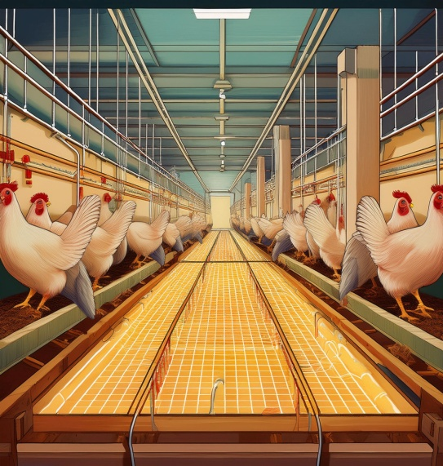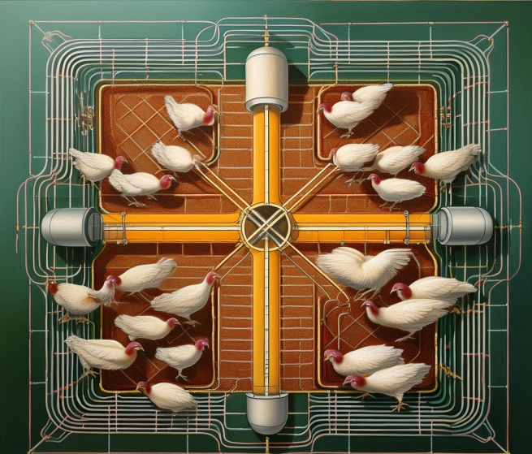

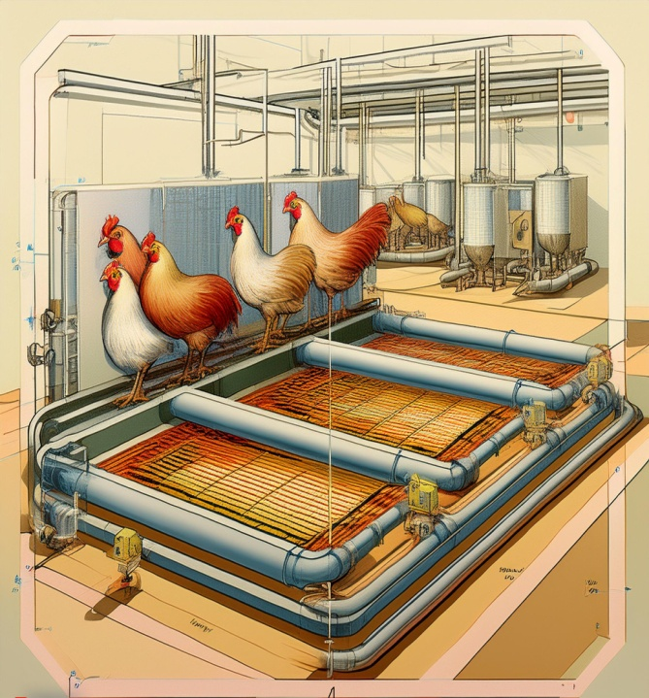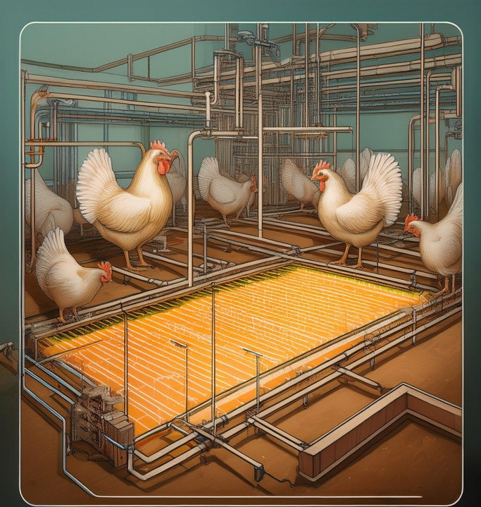

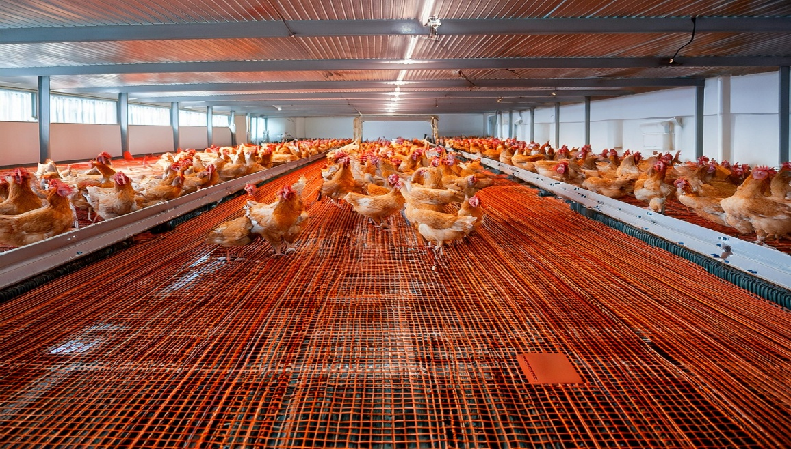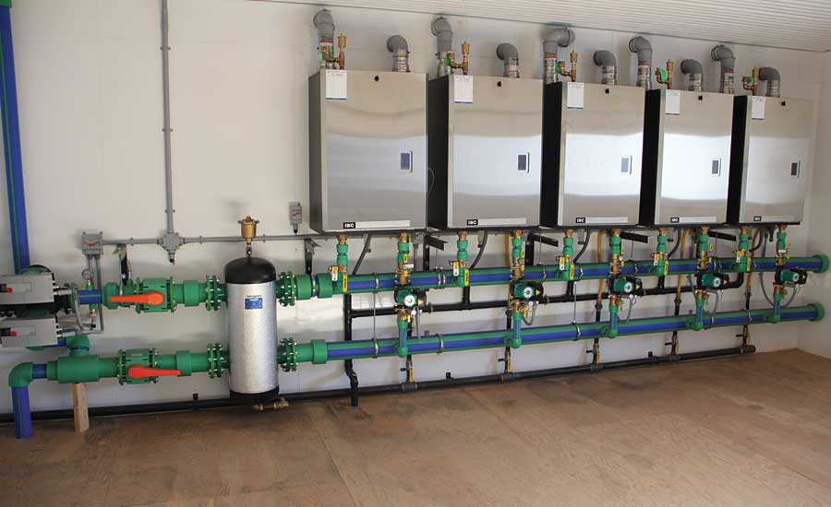

20. Business Model Canvas

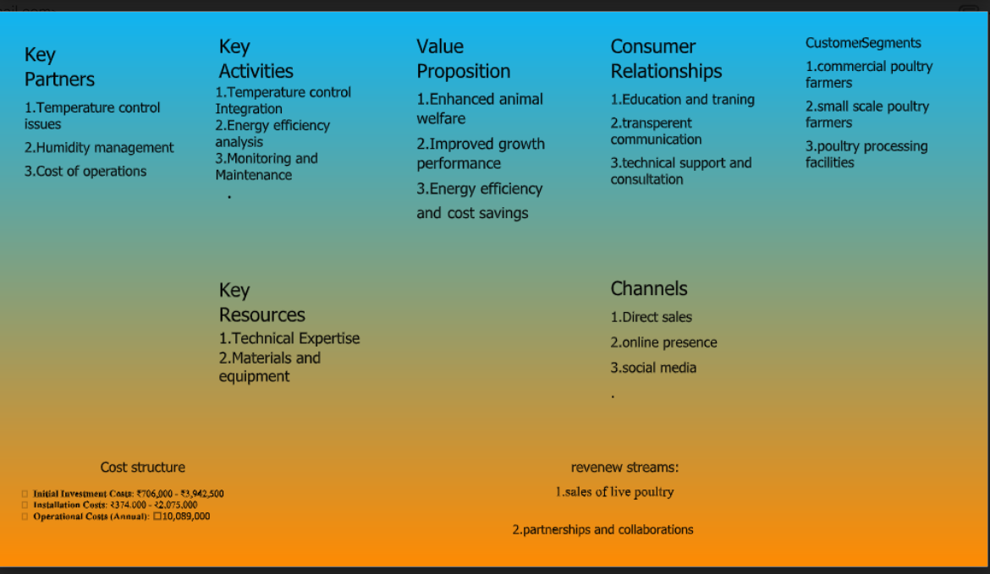

21. Who is it for & What will it Do?

Ans: **Who Is It For?**

Thermal radiant floor heating and cooling systems are designed for:

* **Poultry Farmers**: Particularly those raising broilers, layers, turkeys, or other poultry, who want to maintain optimal environmental conditions in their poultry houses.
* **Large-Scale Commercial Poultry Operations**: Ideal for large farms where maintaining consistent temperature and humidity is critical to bird health and productivity.
* **Producers in Extreme Climates**: Especially useful for farms located in regions with significant temperature fluctuations, where maintaining a stable environment can be challenging.

**What Will It Do?**

* **Maintain Optimal Temperature**: Provides a stable and uniform temperature throughout the poultry house, ensuring that birds remain comfortable regardless of external weather conditions.
* **Improve Bird Health and Growth**: Reduces stress, enhances feed conversion, and promotes better growth rates by maintaining consistent temperatures.
* **Reduce Energy Costs**: Offers energy savings by being more efficient than traditional heating and cooling methods, as it targets the floor where the birds are located.
* **Enhance Litter Quality**: Helps keep litter dry, reducing ammonia levels and creating a healthier environment for the birds.
* **Minimize Humidity**: By controlling the temperature, the system also helps regulate humidity levels, which is crucial in preventing respiratory issues and disease outbreaks.

Overall, this system provides a controlled environment that maximizes poultry production efficiency, health, and welfare.