**Hackathon Project Phases Template** for the **Personolised Ai Mentor** project.

# **Hackathon Project Phases Template**

## **Project Title:**

**StudBud: AI Study Planner**

## **Team Name:**

LEARN TO LEAD

## **Team Members:**

* P. Srinu
* G. Lokesh
* E. Uday
* M. Shiva Sai

## **Phase-1: Brainstorming & Ideation**

### **Objective:**

The goal of this phase is to generate creative, innovative ideas that shape the AI-Powered Personalized Learning Assistant. It focuses on identifying core features, understanding user needs, exploring solutions, and defining key goals to ensure the assistant delivers value. The ideation process will also outline how the AI system can adapt to diverse learning environments and boost user engagement.

### **Key Points:**

1. **Problem Statement:**
   * Traditional learning methods follow a one-size-fits-all approach, making it difficult for students to grasp concepts at their own pace. Many learners struggle with understanding complex topics, staying motivated, and getting real-time assistance for their doubts. Additionally, tracking progress and identifying weak areas is a challenge, leading to inefficient learning.
2. **Proposed Solution:**
   * An AI-powered personalized learning assistant that adapts to each learner’s pace, preferences, and strengths. This assistant will provide:
   * Personalized Learning Paths – AI suggests lessons based on user progress.
   * AI Chatbot Tutor – Uses NLP to answer doubts and explain concepts in real time.
   * Adaptive Quizzes & Assessments – AI-generated quizzes targeting weak areas.
   * Progress Tracking & Insights – Visual dashboards for tracking performance.
   * Multi-Modal Learning – Text, video, and interactive content for different learning styles.
   * Gamification & Motivation – Badges, leaderboards, and rewards to keep learners engaged.
3. **Target Users:**
   * Students (School & College) – Struggling with subjects and needing personalized guidance.
   * Self-Learners – People learning new skills (e.g., coding, languages, business).
   * Competitive Exam Aspirants – Students preparing for exams (SAT, GRE, JEE, etc.).
   * Professionals Upskilling – Employees learning new industry-relevant skills.
4. **Expected Outcome:**
   * Enhanced Learning Experience – AI-driven recommendations improve knowledge retention.
   * Higher Engagement & Motivation – Gamification keeps users actively learning.
   * Faster Concept Mastery – Personalized feedback helps learners focus on weak areas.
   * Efficient Study Plans – AI optimizes study schedules for better productivity.
   * Real-Time Assistance – Instant AI-powered responses reduce dependency on external tutors.

## 

## **Phase-2: Requirement Analysis**

### **Objective:**

The objective of the requirement analysis phase is to define, evaluate, and document the key requirements necessary to develop the AI-Powered Personalized Learning Assistant. This ensures that the system is technically feasible, functionally robust, and aligned with user needs while identifying potential constraints and challenges.

### **Key Points:**

1. **Technical Requirements:**
   * Frontend: React.js/Next.js, Tailwind CSS/Material UI
   * Backend: Python (FastAPI/Flask/Django), Node.js (optional)
   * DB & Storage: PostgreSQL/MongoDB, Firebase/AWS S3
   * AI/ML: GPT-4, Llama (Chatbot), Collaborative/Content-based filtering (Recs), Google Speech API/Whisper (Speech)
   * Infra & Deployment: AWS/GCP/Azure, CI/CD pipeline
2. **Functional Requirements:**
   * User Management: Reg/auth, profile, progress tracking
   * AI Learning Assistant: Personalized recs, chatbot, voice support
   * Content & Assessments: Interactive lessons, AI quizzes, performance feedback
   * Gamification: Leaderboards, badges, reminders
   * Multilingual Support: Multi-language options
3. **Constraints & Challenges:**
   * Data Privacy: GDPR/CCPA, encrypted storage
   * AI Accuracy: Accurate answers, no bias
   * Scalability: Efficient for growing user base
   * Content Quality: High-quality learning materials
   * Internet Dependency: Offline support for limited access

## 

## **Phase-3: Project Design**

### **Objective:**

Develop the architecture and user flow of the application.

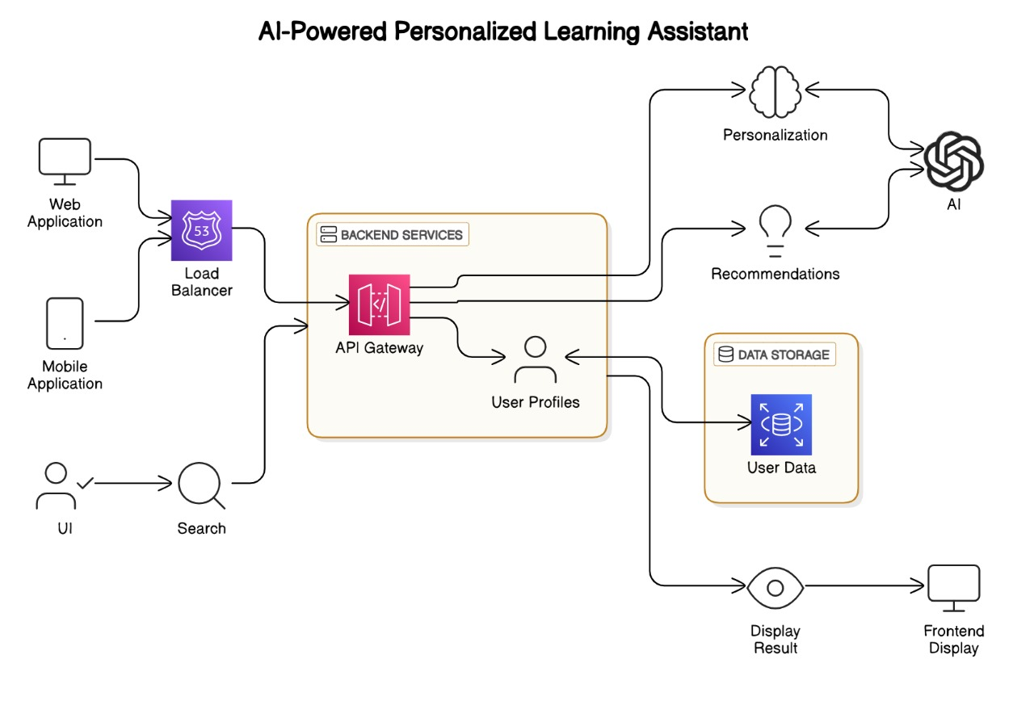

### **Key Points:**

1. **System Architecture:**
   * Frontend: Web/Mobile App, Speech Recognition (optional), Dashboard for progress.
   * Backend: AI/ML Model, Database (MongoDB/PostgreSQL), APIs (Flask/Django), Auth (JWT/OAuth).
   * Data: Educational Content, Quiz Engine.
   * Learning Algorithm: Personalized Path, Recommender System, NLP for queries.
2. **User Flow:**
   * Sign Up/Login: Profile creation, Auth (email/social media).
   * Home/Dashboard: Progress overview, personalized recs.
   * Learning Path: Dynamic path based on assessments.
   * Interaction: Q&A with AI, recs based on progress.
   * Assessments: Quizzes, instant feedback.
   * Progress Tracking: Reports, strengths/weaknesses
3. **UI/UX Considerations:**
   * Intuitive UI: Easy navigation, clear labels.
   * Personalization: Custom themes, tailored UI.
   * Interactive Design: Gamification (badges, progress bars).
   * Mobile: Responsive design for mobile access.
   * Natural Interaction: Chat/Speech features with context-based responses.
   * Accessibility: Text-to-speech, high contrast, keyboard navigation.

## 

## **Phase-4: Project Planning (Agile Methodologies)**

### **Objective:**

Break down development tasks for efficient completion.

|  |  |  |  |  |  |  |  |
| --- | --- | --- | --- | --- | --- | --- | --- |
| **Sprint** | **Task** | **Priority** | **Duration** | **Deadline** | **Assigned To** | **Dependencies** | **Expected Outcome** |
| Sprint 1 | Define Project scope and objectives | 🔴 High | 6 hours (Day 1) | End of Day 1 | Shiva sai | None | Clear Project scope,objectives,and goals defined |
| Sprint 1 | Set up development environment(libraries,frameworks,tools) | 🟡 Medium | 2 hours (Day 1) | End of Day 1 | Srinu | None | Development environment ready for tools ,libraries and frame works |
| Sprint 2 | Gather requiremwnts | 🔴 High | 3 hours (Day 2) | Mid-Day 2 | Lokesh | Sprint 1 | Comprehensive list of functional and non functional requirements for the projects |
| Sprint 2 | Design database schema | 🔴 High | 1.5 hours (Day 2) | Mid-Day 2 | Uday | Sprint 1 | Data base schema designed to store data,preferences and learning resources |
| Sprint 3 | Collect and preprocess data(course, artiles) | 🟡 Medium | 1.5 hours (Day 2) | Mid-Day 2 | Lokesh | Sprint 2 | Raw data collected and preprocessed,ready for training the recommendation system |
| Sprint 3 | Build user profiling system | 🟢 Low | 1 hour (Day 2) | End of Day 2 | Entire Team | Sprint 2 | System to understand and store user preferences and profiles |
| Sprint 4 | Implement recommendation algorithms(collabrative/content based) | 🔴 High | 1 hour  (day 2) | End of day 2 | Entire team | Sprint 3 | All recommendations engine implemented to offer presonalized learning content |
| Sprint 4 | Integrate external learning resources (API  integration, web scraping) | 🟡 Medium | 1.5 hours  (day 2) | End of day 2 | Srinu | Sprint 3 | External learning  resources  integrated into the system. |

### 

### **Sprint Planning with Priorities**

### **Sprint 1 – Setup & Integration (Day 1)**

Define Project Scope and Objectives

Priority: 🔴 High

Set Up Development Environment (Libraries, Frameworks, Tools)

Priority: 🟡 Medium

### **Sprint 2 – Core Features & Debugging (Day 2)**

Gather Requirements

Priority: 🔴 High

Design Database Schema

Priority: 🔴 High

### **Sprint 3 – Testing, Enhancements & Submission (Day 2)**

Collect and Preprocess Data (Courses, Articles)

Priority: 🟡 Medium

Build User Profiling System

Priority: 🟢 Low

**Phase-5: Project Development**

### **Objective:**

Implement core features of the AI-Powered Personalized Learning Assistant

### **Key Points:**

1. **Technology Stack Used:**
   * Frontend: React.js / Next.js, Tailwind CSS
   * Backend: FastAPI / Flask / Node.js (Express)
   * AI/ML: Python (TensorFlow, PyTorch), LangChain, OpenAI API
   * Database: PostgreSQL / MongoDB, FAISS / Pinecone for recommendations
   * Infrastructure: Docker, Kubernetes, AWS/GCP for hosting
2. **Development Process:**
   * Planning & Research – Define user needs, select tech stack
   * Data Collection & Processing – Gather and clean learning data
   * AI Model Development – Build recommendation system, chatbot
   * Backend & API – Create REST/GraphQL APIs, integrate ML models
   * Frontend – Develop UI with personalized learning features
   * Testing & Optimization – Debug, improve performance
   * Deployment & Scaling – Deploy to cloud, monitor, and refine
3. **Challenges & Fixes:**
   * Cold Start – Use hybrid recommendations, predefined personas.
   * Scalability – Optimize with async processing, caching, load balancing.
   * High Latency – Speed up with model quantization, GPU acceleration.
   * Chatbot Context – Improve with LangChain, RAG, vector databases.
   * Data Privacy – Ensure encryption, anonymization, compliance.
   * User Engagement – Boost with gamification, adaptive learning, AI quizzes.

## **Phase-6: Functional & Performance Testing**

### **Objective:**

Ensure that the AutoSage App works as expected.

**Functional & Performance Testing Plan**

|  |  |  |  |  |  |
| --- | --- | --- | --- | --- | --- |
| Test Case ID | Category | Test Scenario | Expected Outcome | Status | Tester |
| F-001 | Authentication | User sign-up with valid credentials | Account created successfully | passed | Srinu |
| F-002 | Authentication | Login with incorrect password | Show 'Invalid Credentials' error | passed | Srinu |
| F-003 | Chatbot | AI responds to user queries | Relevant and accurate responses | passed | Srinu |
| F-004 | Recommendations | Personalized course suggestions | Display relevant courses based on user behavior | passed | Lokesh |
| F-005 | Content Loading | Video and document accessibility | Videos/docs load without errors | passed | Shiva sai |
| P-001 | API Performance | API response time under load | Response time < 2s under 1000 requests | Require some more speed | Uday |
| P-002 | Scalability | System handles 5000+ users | No crashes, smooth performance | passes | Shiva Sai |
| P-003 | AI Processing | Chatbot response speed | AI replies within 1-2 seconds | passed | Srinu |
| P-004 | Database Performance | Query execution time | Queries execute in <500ms | passed | Lokesh |
| P-005 | Security | Unauthorized API access attempt | Access denied with error response | passed | Uday |