13/06/2025

Friday

**SQL**

* Strucuted Query language
* Used to store ,maniplate and retrive data in relational database like mysql, postgresql,sqlserver, oracle,sql lite

Mysql work bench

* To create new database

Create database java_training;

SQL commands:

1. DDL : Data Definition Language
2. DML : Data Manipulaion Language
3. DQL : Data Query Language
4. TCL: Transaction Commit Language

|  |  |  |  |  |
| --- | --- | --- | --- | --- |
| DDL | DML | DQL | DCL | TCL |
| Create | Insert | Select | grant | Commit |
| Alter | Update |  | revoke | rollback |
| drop | Delete |  |  |  |

create database java_training;  
create table Student(rollno int,sname varchar(20),age int);  
select * from student;  
insert into Student (rollno,sname,age) values (103,'pravin',31);  
update Student set age = 31 where rollno = 102;  
delete from student where rollno = 103;  
select * from student where age > 30;  
insert into Student (rollno,sname,age) values (105,'Salmaan',32);  
select * from student order by age desc;   
select age,count(*) as total from student group by age;  
select * from student;

JOINS

create database admin1;  
create table student(rollno int,fname varchar(20),age int,deptid int);  
select * from student;  
insert into student (rollno,fname,age,deptid) values (101,'om',35,2);  
insert into student (rollno,fname,age,deptid) values (105,'amol',33,1);  
insert into student (rollno,fname,age,deptid) values (109,'sai',32,3);  
insert into student (rollno,fname,age,deptid) values (104,'sayali',29,1);

create table dept(deptid int,dname varchar(20),cname varchar(20));  
select * from dept;  
insert into dept (deptid,dname,cname) values (1,'Computer',"GEC");  
insert into dept (deptid,dname,cname) values (2,'IT',"GEC");  
insert into dept (deptid,dname,cname) values (3,'EnTC',"GEC");

select s.rollno,s.fname,d.dname from student as s inner join dept as d on s.deptid = d.deptid;

select s.rollno,s.fname,d.dname from student as s left join dept as d on s.deptid = d.deptid;

select s.rollno,s.fname,d.dname from student as s right join dept as d on s.deptid = d.deptid;

select s.rollno,s.fname,d.dname from student as s join dept as d on s.deptid = d.deptid;

// work inner join on bank and customer tables

-- Create the database

create database bank_admin;

-- Use the created database (optional, depending on SQL tool)

use bank_admin;

-- Create Customer table

create table customer (

cust_id int,

cust_name varchar(30),

age int,

bank_id int

);

-- Insert sample data into Customer table

insert into customer (cust_id, cust_name, age, bank_id) values (1, 'Ravi', 40, 101);

insert into customer (cust_id, cust_name, age, bank_id) values (2, 'Neha', 35, 102);

insert into customer (cust_id, cust_name, age, bank_id) values (3, 'Amit', 45, 101);

insert into customer (cust_id, cust_name, age, bank_id) values (4, 'Pooja', 30, 103);

-- Create Bank table

create table bank (

bank_id int,

bank_name varchar(50),

branch_city varchar(30)

);

-- Insert sample data into Bank table

insert into bank (bank_id, bank_name, branch_city) values (101, 'SBI', 'Mumbai');

insert into bank (bank_id, bank_name, branch_city) values (102, 'HDFC', 'Pune');

insert into bank (bank_id, bank_name, branch_city) values (103, 'ICICI', 'Delhi');

-- Display data from both tables with a join

select c.cust_id, c.cust_name, b.bank_name, b.branch_city

from customer as c

inner join bank as b

on c.bank_id = b.bank_id;

-- INNER JOIN: Show customers with matching bank information

select c.cust_id, c.cust_name, b.bank_name

from customer as c

join bank as b

on c.bank_id = b.bank_id;

-- LEFT JOIN: Show all customers, with bank details if available

select c.cust_id, c.cust_name, b.bank_name

from customer as c

left join bank as b

on c.bank_id = b.bank_id;

-- RIGHT JOIN: Show all banks, with customer details if available

select c.cust_id, c.cust_name, b.bank_name

from customer as c

right join bank as b

on c.bank_id = b.bank_id;

**JDBC**:

* Java Database Connectivity
* It is an API in Java used to connect and interact with databases.

What can we do with JDBC ?

1. Connect to a database.

In STS create a new Maven project.

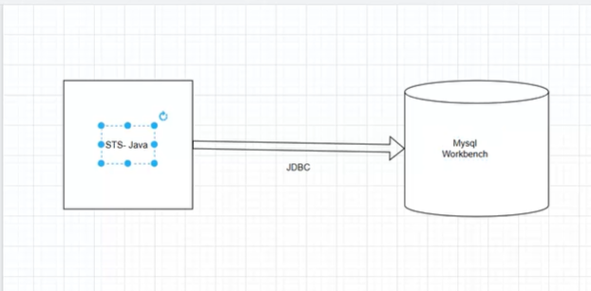

**import** java.sql.Connection;

**import** java.sql.DriverManager;

**import** java.sql.ResultSet;

**import** java.sql.Statement;

**public** **class** App

{

**public** **static** **void** main( String[] args )

    {

      String url = "jdbc:mysql://localhost:3306/admin1";

      String username = "root";

      String password = "root";

**try** {

        Class.*forName*("com.mysql.cj.jdbc.Driver");

        Connection con= DriverManager.*getConnection*(url, username, password);

        Statement stmt = con.createStatement();

        String sql = "select * from student";

        ResultSet rs = stmt.executeQuery(sql);

**while**(rs.next()) {

**int** rollno1 = rs.getInt("rollno");

          String fname1 = rs.getString("fname");

**int** age1 = rs.getInt("age");

**int** deptid1 = rs.getInt("deptid");

          System.***out***.println("Rollno : "+rollno1+",Name : "+fname1+",Age : "+age1+",Dept : "+deptid1);

        }

        rs.close();

        stmt.close();

        con.close();

      }**catch** (Exception e) {

        e.printStackTrace();

      }

    }

}