27/06/2025

Friday

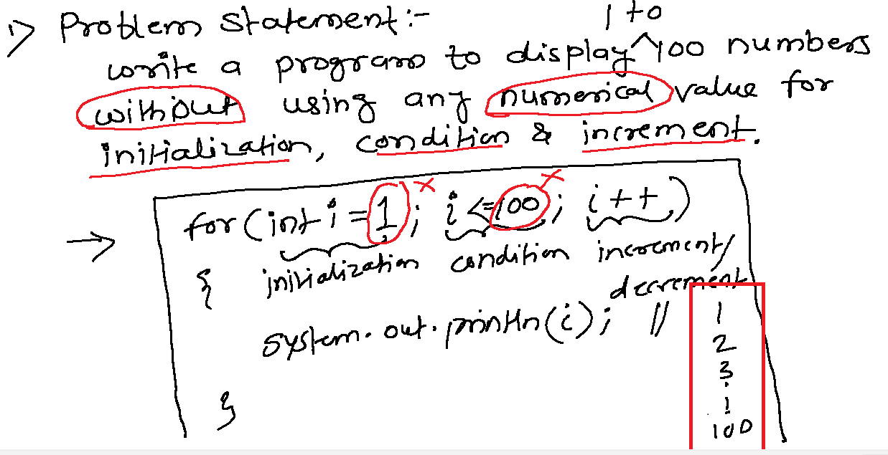

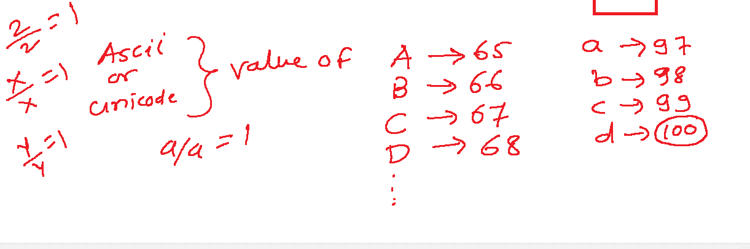

**public** **class** Test {

**public** **static** **void** main(String[] args) {

**for**(**int** i='a'/'a'; i<='d';i++) {

      System.***out***.println(i);

    }

  }

}

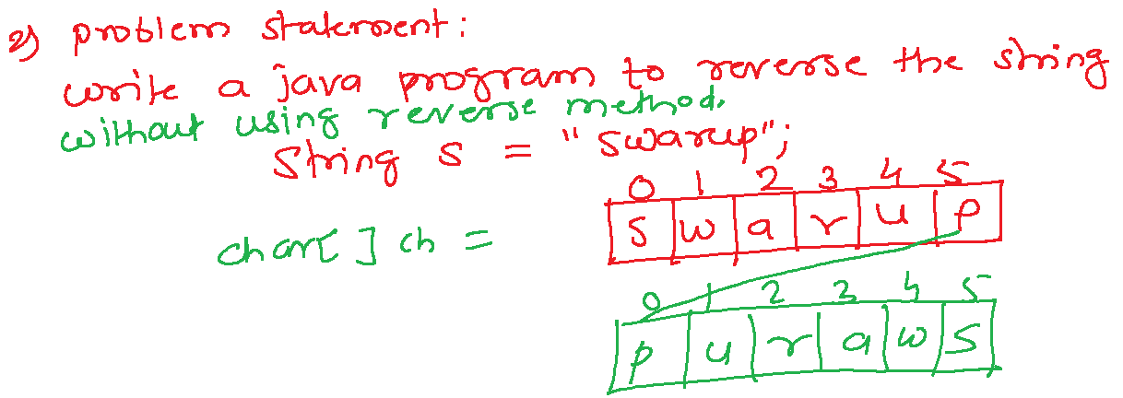

**public** **class** Test {

**public** **static** **void** main(String[] args) {

    String str = "swarup";

    String rev = "";

**for**(**int** i = str.length()-1; i>=0;i--) {

      rev= rev+str.charAt(i);

    }

    System.***out***.println("Original: "+str);

    System.***out***.println("Reversed: "+rev);

  }

}

**public** **class** Test {

**public** **static** **void** main(String[] args) {

    String str = "india";

**char**[] chars = str.toCharArray();

    String rev ="";

**for**(**int** i = chars.length-1; i>=0;i--) {

      rev= rev+chars[i];

    }

    System.***out***.println("Original: "+str);

    System.***out***.println("Reversed: "+rev);

  }

}

// by using reverse() method of StringBuffer class

**public** **class** Test {

**public** **static** **void** main(String[] args) {

    String str = "indian";

    StringBuffer sb = **new** StringBuffer(str);

    String rev = sb.reverse().toString();

    System.***out***.println("Original: "+str);

    System.***out***.println("Reversed: "+rev);

  }

}

// by using reverse() method of StringBuilder class

**public** **class** Test {

**public** **static** **void** main(String[] args) {

    String str = "Bharat";

    StringBuilder sb = **new** StringBuilder(str);

    String rev = sb.reverse().toString();

    System.***out***.println("Original: "+str);

    System.***out***.println("Reversed: "+rev);

  }

}

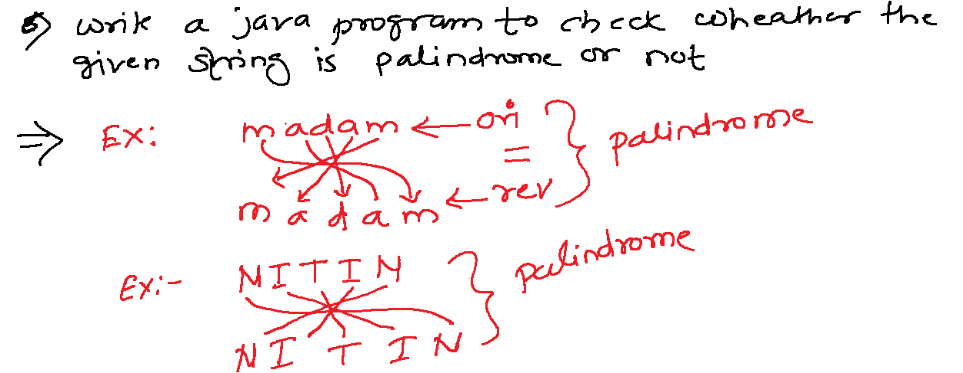

**import** java.util.Scanner;

//palindrome

**public** **class** Test {

**public** **static** **void** main(String[] args) {

    Scanner scan = **new** Scanner(System.***in***);

    System.***out***.println("Enter a String: ");

    String org = scan.nextLine();

    StringBuilder sb = **new** StringBuilder(org);

    String rev = sb.reverse().toString();

**if**(org.equals(rev)) {

      System.***out***.println("it is a palindrome.");

    }**else** {

      System.***out***.println("Not palindrome");

    }

  }

}

//swap program using 3 variables

**public** **class** SwapDemo {

**public** **static** **void** main(String[] args) {

**int** a=5,b=10;

**int** temp = a;

    a=b;

    b=temp;

    System.***out***.println("a= "+a);

    System.***out***.println("b= "+b);

  }

}

//swap program without using temp variable

**public** **class** SwapDemo {

**public** **static** **void** main(String[] args) {

**int** a=5, b= -10;

    System.***out***.println("Before swap: a= "+a+ " , b= "+b);

    a = a+b; //15

    b = a-b; // 5

    a = a-b; // 10

    System.***out***.println("After swap: a= "+a+ " , b= "+b);

  }

}

//program to check no is even or odd

**public** **class** EvenOrOdd {

**public** **static** **void** main(String[] args) {

**int** num = 10;

    System.***out***.println(num%2 == 0 ? "Even" : "Odd");

  }

}

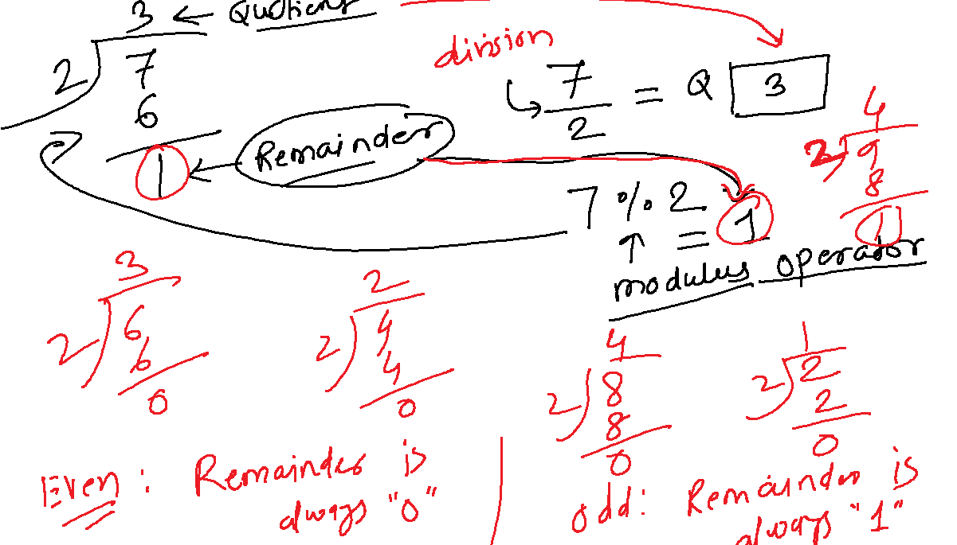

//swap program without using temp variable

**public** **class** SwapDemo {

**public** **static** **void** main(String[] args) {

**int** a=5, b= -10;

    System.***out***.println("Before swap: a= "+a+ " , b= "+b);

    a = a^b;

    b = a^b;

    a = a^b;

    System.***out***.println("After swap: a= "+a+ " , b= "+b);

  }

}

//Largest of 3 numbers

**public** **class** Largest {

**public** **static** **void** main(String[] args) {

**int** a=100,b=115,c=28;

**int** largest = (a>b) ? (a>c?a:c) : (b>c?b:c);

    System.***out***.println(largest);

  }

}

//Factorial

**public** **class** FactorialDemo {

**public** **static** **void** main(String[] args) {

**int** num = 5;

**long** fact = 1;

**for**(**int** i=1;i<=num;i++) {

      fact = fact * i;

    }

      System.***out***.println("Factorial: "+fact);

  }

}

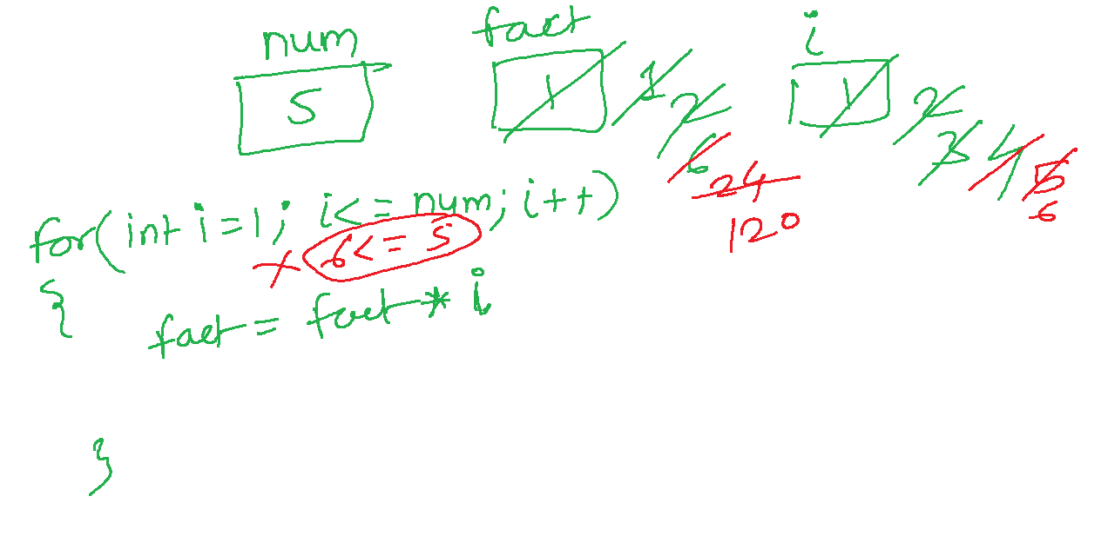

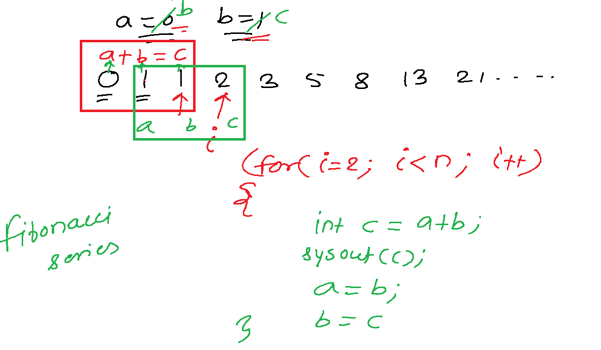

**public** **class** FibonacciSeries {

**public** **static** **void** main(String[] args) {

**int** n=10, a=0,b=1;

    System.***out***.print(a+" "+b);

**for**(**int** i=2; i<n ;i++) {

**int** c= a+b;

      System.***out***.print(" "+c);

      a=b;

      b=c;

    }

  }

}

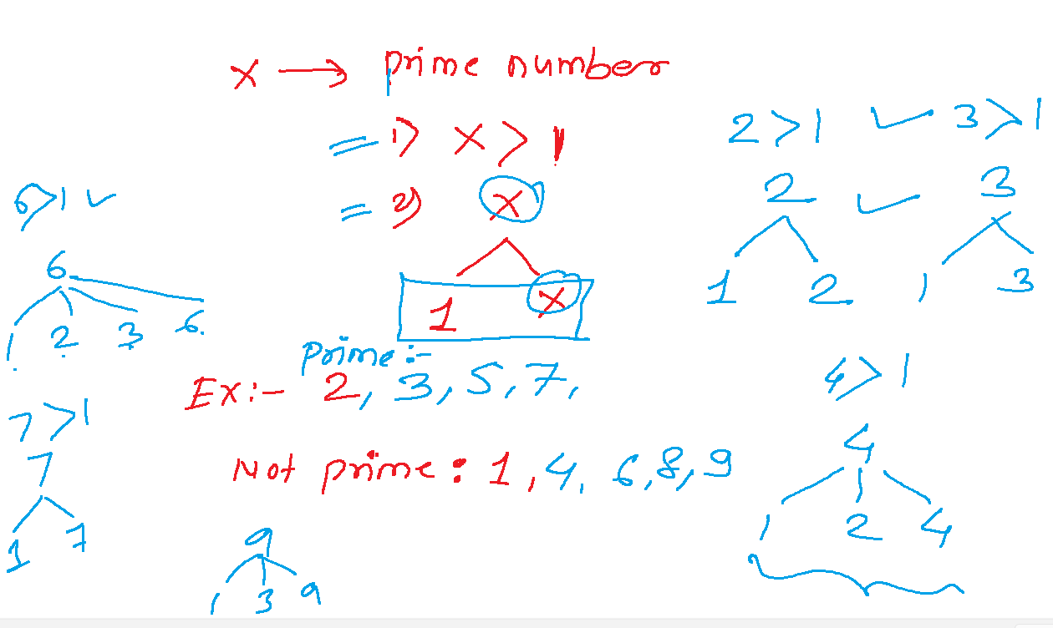

**import** java.util.Scanner;

**public** **class** PrimeCheck {

**public** **static** **void** main(String[] args) {

    Scanner scan = **new** Scanner(System.***in***);

    System.***out***.println("Enter a number: ");

**int** num = scan.nextInt();

**boolean** isPrime = **true**;

**if**(num <=1) {

      isPrime=**false**;

    }**else** {

**for**(**int** i=2; i<= Math.*sqrt*(num);i++) {

**if**(num%i==0) {

          isPrime = **false**;

**break**;

        }

      }

    }

**if**(isPrime) {

      System.***out***.println(num + " is a Prime Number.");

    }**else** {

      System.***out***.println(num + " is not a Prime Number.");

    }

  }

}