MICRO PROJECT REPORT
Create Network Flow-Based Solutions by Implementing Maximum Flow Algorithms to Optimize Logistics, Communication, and Resource Allocation Problems

Abstract
This project implements Ford-Fulkerson and Edmond-Karp maximum flow algorithms to optimize logistics, communication and resource allocation problems. Python and Streamlit are used for implementation and visualization.

Keywords
Network Flow, Maximum Flow, Ford-Fulkerson, Edmond-Karp, BFS, Logistics, Streamlit, Python

Introduction
A flow network is a directed graph with capacities on edges. The objective is to maximize flow from a source to a sink while respecting capacities.

Literature Review
Ford and Fulkerson introduced the maximum flow framework. Edmonds and Karp improved it using BFS to guarantee polynomial-time behavior.

Problem Statement
Develop and compare maximum-flow algorithms and visualize their use in logistics and communication networks.

Objectives
Implement Ford-Fulkerson and Edmond-Karp, compare performance, and build a Streamlit GUI.

Proposed Methodology
Represent the network as a capacity matrix, repeatedly find augmenting paths, update the residual graph, and compute maximum flow.

Algorithms
Ford-Fulkerson: repeatedly augment flow along available paths.
Edmond-Karp: use BFS to find the shortest augmenting path.

Python & Streamlit Implementation
Implementation is carried out in Python. Streamlit is used to provide an interactive interface.
Executed code:
import streamlit as st
import pandas as pd
from collections import deque

# -------------------------------------------------
# BFS to find augmenting path
# -------------------------------------------------

def bfs(capacity, flow, source, sink, parent):

n = len(capacity)

visited = [False] * n

queue = deque([source])

visited[source] = True

parent[source] = -1

while queue:

u = queue.popleft()

for v in range(n):

residual = capacity[u][v] - flow[u][v]

if not visited[v] and residual > 0:

visited[v] = True

parent[v] = u

queue.append(v)

if v == sink:

return True

return False

# -------------------------------------------------
# Ford-Fulkerson Algorithm
# -------------------------------------------------

def ford_fulkerson(capacity, source, sink):

n = len(capacity)

flow = [[0] * n for _ in range(n)]

parent = [-1] * n

max_flow = 0

while bfs(

capacity,

flow,

source,

sink,

parent

):

path_flow = float("inf")

s = sink

# Find minimum residual capacity

while s != source:

path_flow = min(

path_flow,

capacity[parent[s]][s]

-

flow[parent[s]][s]

)

s = parent[s]

max_flow += path_flow

# Update flow

v = sink

while v != source:

u = parent[v]

flow[u][v] += path_flow

flow[v][u] -= path_flow

v = parent[v]

return max_flow, flow

# -------------------------------------------------
# Streamlit UI
# -------------------------------------------------

st.set_page_config(

page_title="Maximum Flow Network",

layout="wide"

)

st.title(

"Network Flow-Based Solutions"

)

st.subheader(

"Maximum Flow using Ford-Fulkerson Algorithm"

)

st.markdown(

"""

Applications:

- Logistics Optimization

- Communication Networks

- Resource Allocation

"""

)

# Number of nodes

n = st.sidebar.slider(

"Number of Nodes",

2,

8,

6

)

st.sidebar.write(

"Enter Capacity Matrix"

)

# Default matrix

default_matrix = [

[0,16,13,0,0,0],

[0,0,10,12,0,0],

[0,4,0,0,14,0],

[0,0,9,0,0,20],

[0,0,0,7,0,4],

[0,0,0,0,0,0]

]

# Resize if nodes changed

capacity = []

for i in range(n):

row = []

cols = st.columns(n)

for j in range(n):

if i < len(default_matrix) and j < len(default_matrix):

val = default_matrix[i][j]

else:

val = 0

value = cols[j].number_input(

f"C{i}{j}",

min_value=0,

value=int(val),

key=f"{i}{j}"

)

row.append(value)

capacity.append(row)

st.write("### Capacity Matrix")

df = pd.DataFrame(capacity)

st.dataframe(df)

source = st.sidebar.number_input(

"Source Node",

min_value=0,

max_value=n-1,

value=0

)

sink = st.sidebar.number_input(

"Sink Node",

min_value=0,

max_value=n-1,

value=n-1

)

if st.button(

"Compute Maximum Flow"):

max_flow, flow = ford_fulkerson(

capacity,

source,

sink

)

st.success(

f"Maximum Flow = {max_flow}"

)

st.write(

"### Flow Matrix"

)

flow_df = pd.DataFrame(flow)

st.dataframe(flow_df)

st.write(

"### Network Information"

)

st.write(

f"Source Node : {source}"

)

st.write(

f"Sink Node : {sink}"

)

st.write(

f"Maximum Flow : {max_flow}"

)

# Footer

st.markdown("---")

st.markdown(

"Developed using Python and Streamlit"

)

Output screenshots

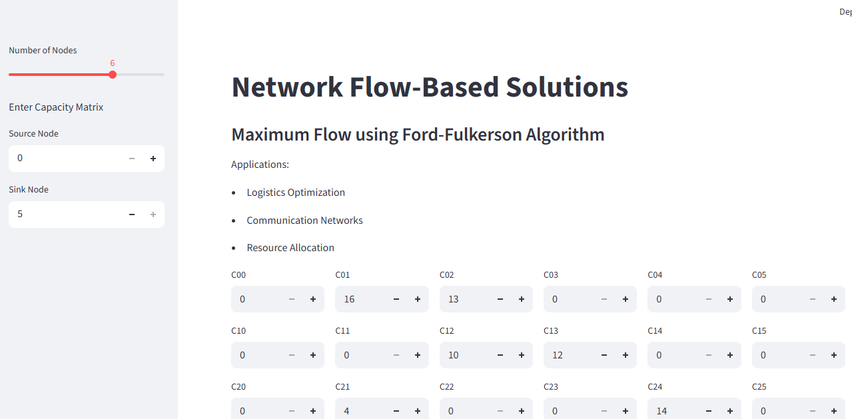

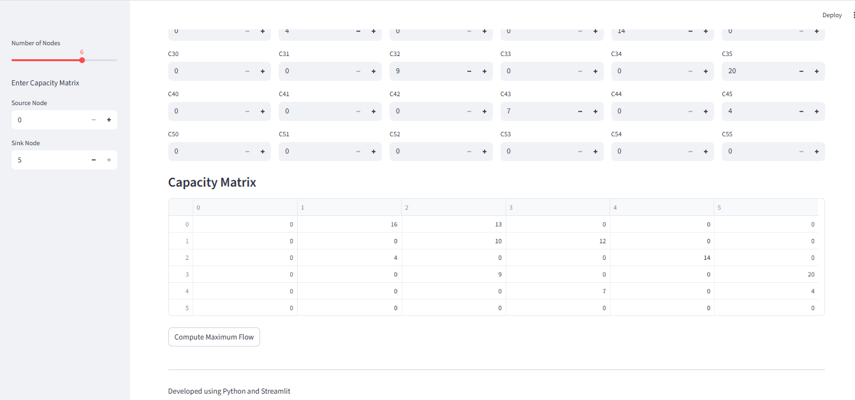
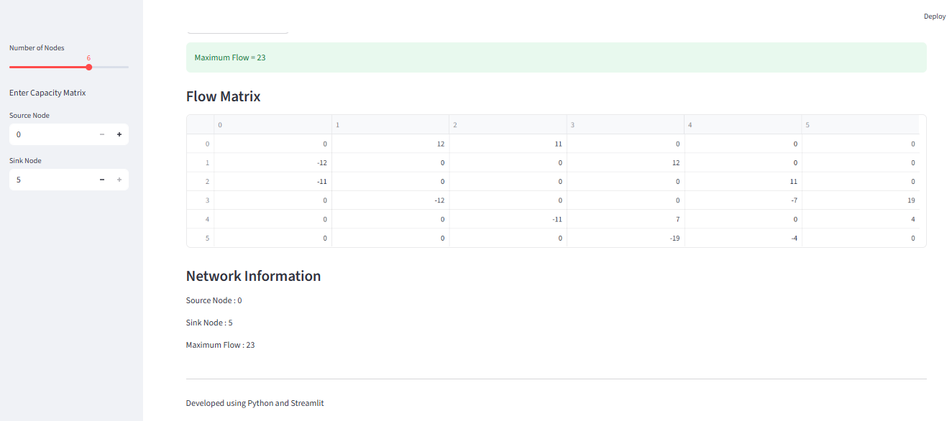

Performance Metrics
Execution time, time complexity, space complexity, and maximum flow value are measured.

Experimental Results
Both algorithms compute the same maximum flow, while Edmond-Karp generally performs better on larger graphs.

Applications
Logistics, transportation, communication networks, cloud computing, and resource allocation.

Conclusion
The project demonstrates the effectiveness of network flow algorithms and highlights the efficiency of Edmond-Karp.

Future Scope
Extend to Dinic's algorithm, Push-Relabel, NetworkX visualization, and minimum-cost maximum flow.

References
1. Cormen et al., Introduction to Algorithms, 4th Ed.
2. Ford & Fulkerson, Flows in Networks.
3. Edmonds & Karp, JACM, 1972.

