DATA VISUALIZATION AND REPORTING
Netflix Movies and TV Shows Analysis

YUVA INTERNSHIP — WEEK 3 PROJECT

Prepared using Python, Pandas, Matplotlib and Seaborn

Abstract
This project presents a data visualization study of the Netflix Movies and TV Shows dataset containing 8,807 titles and 12 columns. The objective is to transform raw catalog information into clear visualizations that communicate patterns, distributions, and relationships in the available data. Python libraries including Pandas, Matplotlib, and Seaborn were used for data preparation, statistical analysis, and visualization. The analysis includes country-wise content distribution, annual and monthly content additions, movie durations, genre frequencies, content-type proportions, and numerical correlations. The findings show that movies represent the majority of the recorded titles, International Movies is the most frequent category in the genre analysis, and movie durations are concentrated around the 91–120-minute range. The report also discusses data limitations and the importance of interpreting correlations cautiously.

1. Introduction
Data visualization is an important part of data analysis because it converts numerical and categorical information into visual representations that are easier to understand. Well-designed charts help analysts identify patterns, compare categories, observe changes over time, and communicate evidence-based findings.
This project uses Netflix catalog data to demonstrate a structured visualization workflow, from initial data exploration to chart creation, interpretation, and reporting.

2. Project Objectives
- Explore the structure and quality of the Netflix dataset.
- Identify the most frequently represented countries and genres.
- Analyze content addition patterns using time-series visualizations.
- Examine the distribution of movie durations.
- Investigate relationships between numerical variables.
- Communicate findings through clear visualizations and written explanations.

3. Dataset Description
The dataset contains 8,807 records and 12 columns. Important fields include show_id, type, title, director, cast, country, date_added, release_year, rating, duration, listed_in, and description.
The type column identifies movies and TV shows. The country column describes associated countries, date_added records the date a title was added according to the dataset, release_year indicates its release year, duration contains movie runtimes or TV show seasons, and listed_in contains genre and category labels.
The dataset is a historical snapshot rather than a complete record of Netflix's current catalog. Conclusions therefore describe the available dataset and should not automatically be generalized to Netflix's present-day content.

4. Data Exploration and Preparation
Initial inspection identified 8,807 records, 12 columns, and 0 exact duplicate rows.
The dataset contains 6,131 movies and 2,676 TV shows. Movies account for 69.62% of the titles, while TV shows account for 30.38%.
The original dataset contains 4,307 missing cells. Missing values are concentrated in fields such as director, cast, and country. Rather than removing every incomplete row, the analysis handles missing values according to the requirements of each chart.
Movie-duration analysis uses 6,128 valid duration values. The mean duration is 99.58 minutes and the median is 98.00 minutes.

Data Preparation Methods
- Loaded the CSV file using Pandas.
- Inspected data types, dimensions, missing values, and duplicates.
- Converted date_added into a datetime format for time-based analysis.
- Extracted numerical movie durations from the duration field.
- Split country and genre strings to count category appearances.
- Filtered records with missing values where required for individual analyses.

5. Visualization Strategy
Different chart types were selected according to the analytical questions. Bar charts support categorical comparisons, line charts show changes over time, scatter plots reveal relationships between numerical variables, heatmaps summarize correlations, donut charts communicate proportions, and histograms display numerical distributions.
The charts use descriptive titles, axis labels, appropriate color schemes, legends where necessary, and saved high-resolution images. Color and formatting are intended to improve readability rather than exaggerate differences.

6. Visualizations and Findings

6.1 Top 10 Countries by Netflix Content
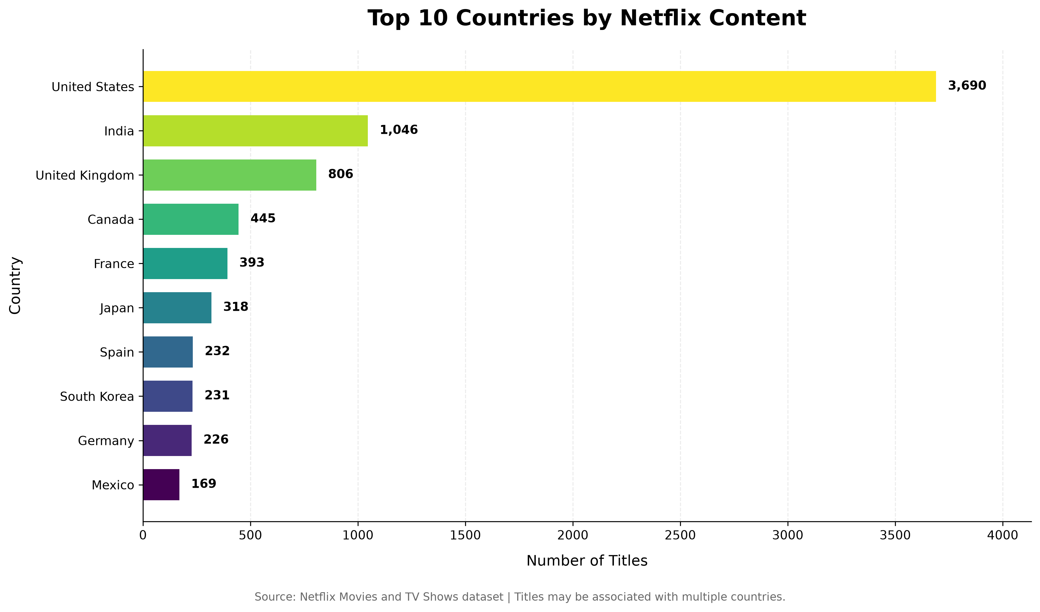
Purpose and interpretation:
A horizontal bar chart compares the number of catalog titles associated with each of the ten leading countries. Country labels were split so that titles associated with multiple countries could contribute to each relevant country count.
Key finding:
The United States leads with 3,690 country-associated title appearances, followed by India with 1,046. These counts are not mutually exclusive because some titles are associated with multiple countries.

6.2 Annual Content Addition Trends
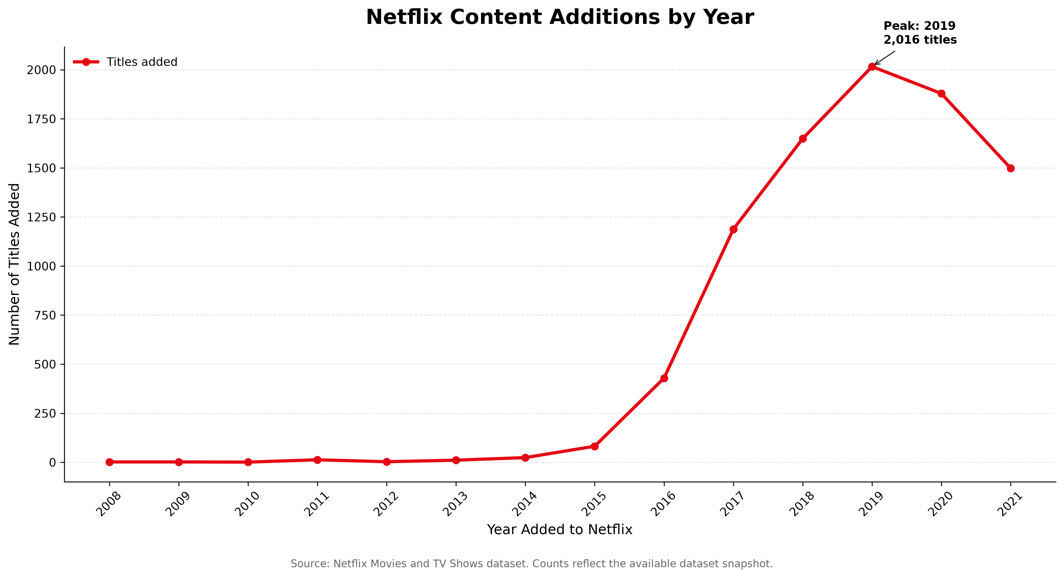
Purpose and interpretation:
A line chart displays the number of titles grouped by the year recorded in date_added. The visualization helps identify broad changes in catalog additions within the available snapshot.
Key finding:
The highest annual count in the dataset occurs in 2019, with 2,016 titles. This represents the peak in the available records, not necessarily Netflix's complete historical addition activity.

6.3 Monthly Content Addition Trends
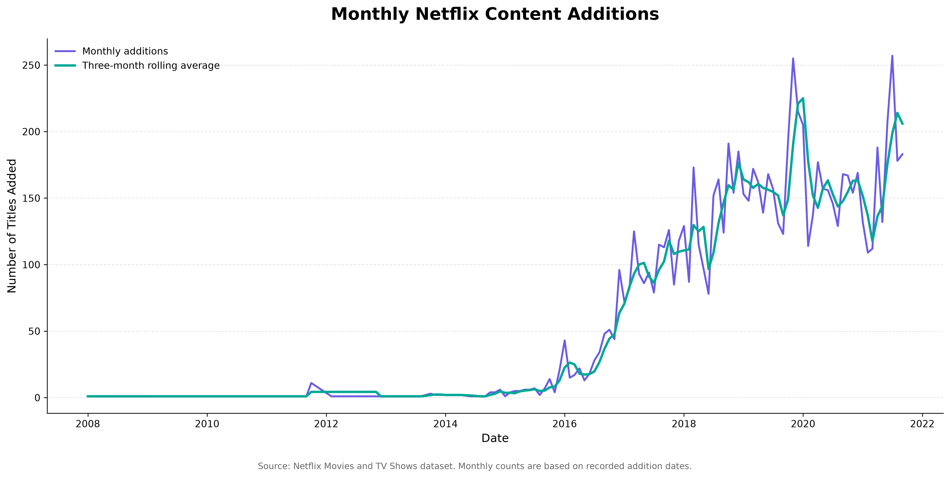
Purpose and interpretation:
Monthly counts provide a more detailed view of the recorded addition dates. A three-month rolling average helps smooth short-term fluctuations and highlight broader patterns.
Key finding:
Monthly peaks and fluctuations should be interpreted as patterns in the available records. Missing dates and the historical scope of the dataset may affect the observed pattern.

6.4 Movie Duration Versus Release Year
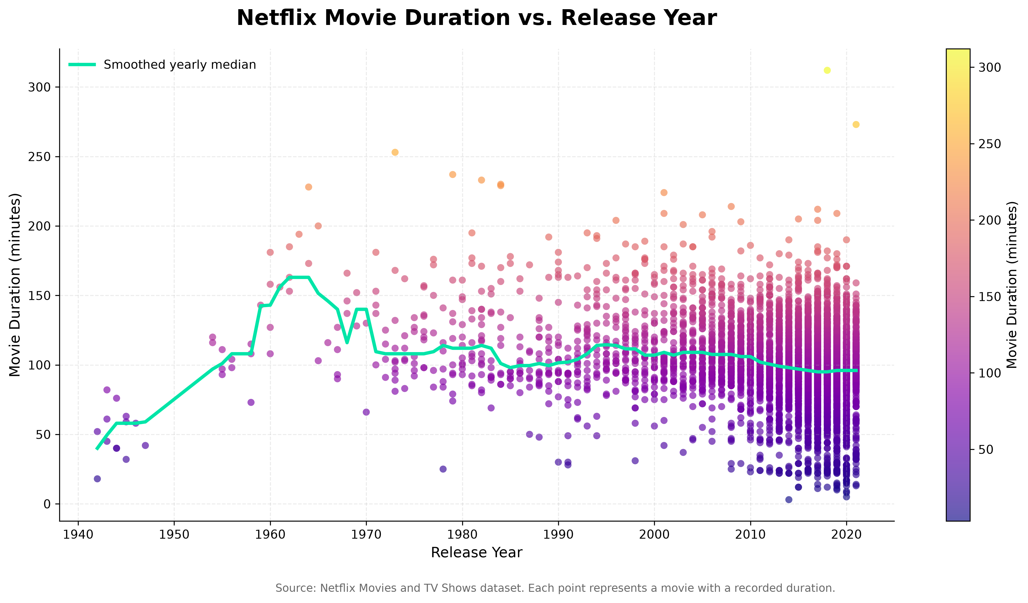
Purpose and interpretation:
Each point represents a movie, with release year on the horizontal axis and duration in minutes on the vertical axis. A smoothed yearly median line helps summarize changes across release years.
Key finding:
The visualization allows comparisons of movie runtimes across release periods. The number of titles varies by year, so patterns in years with few observations should be treated cautiously.

6.5 Movie Correlation Heatmap
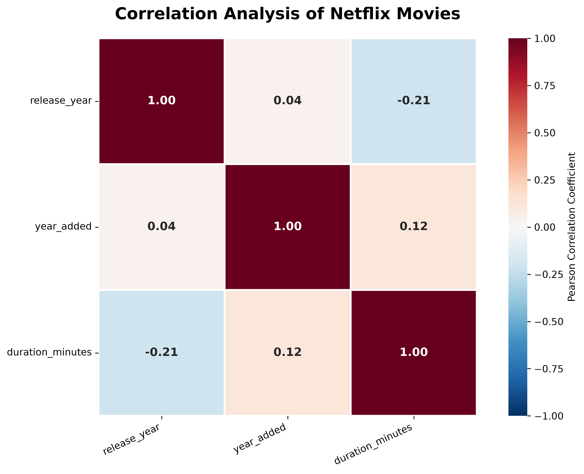
Purpose and interpretation:
The corrected heatmap uses movie records only, ensuring that the duration variable represents minutes rather than TV show seasons. Pearson correlation coefficients summarize linear relationships between release year, year added, and movie duration.
Key finding:
Release year and duration have a correlation of -0.206. Year added and duration have a correlation of 0.124. These are weak associations and do not establish causation.

6.6 Movies Versus TV Shows
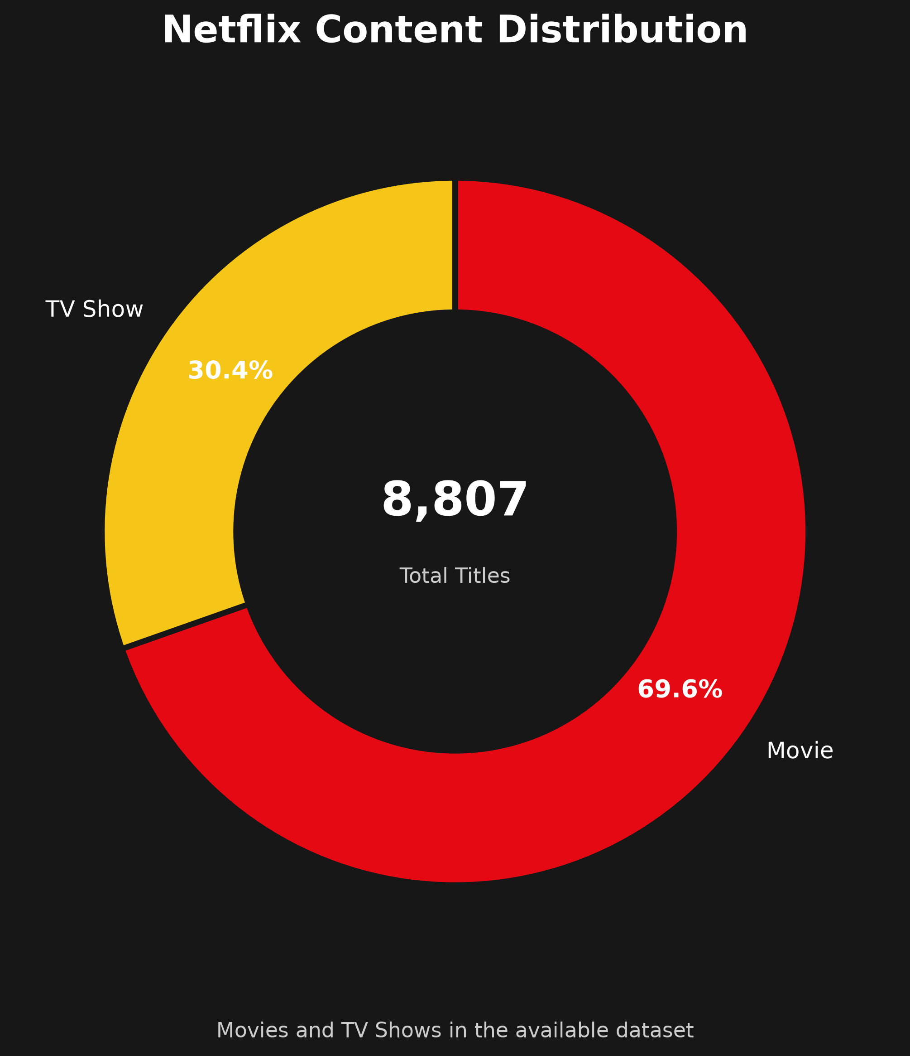
Purpose and interpretation:
A donut chart compares the proportions of movies and TV shows in the available dataset. The total number of titles is shown in the center.
Key finding:
Movies account for 69.62% of the dataset, while TV shows account for 30.38%. These figures describe title counts, not audience viewing time or popularity.

6.7 Most Frequent Genres and Categories
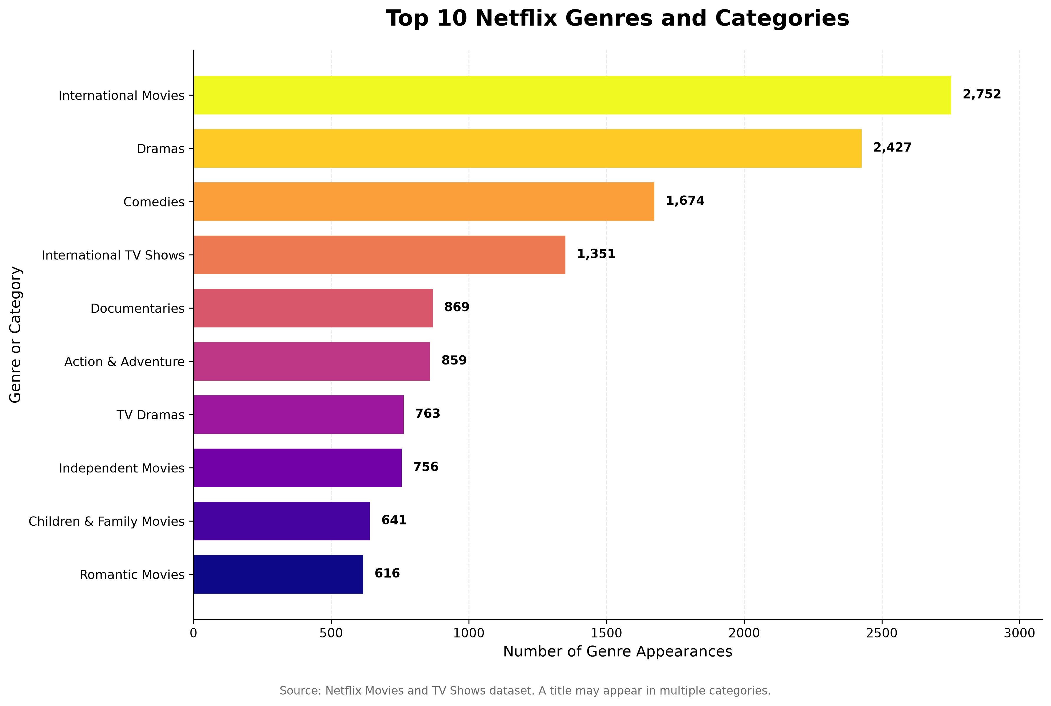
Purpose and interpretation:
A horizontal bar chart ranks the ten most frequent category labels after splitting the listed_in field. A title can belong to multiple categories, so category counts can overlap.
Key finding:
The most frequent category is International Movies, with 2,752 appearances, followed by Dramas with 2,427. These results describe category representation rather than exclusive groups of titles.

6.8 Distribution of Movie Durations
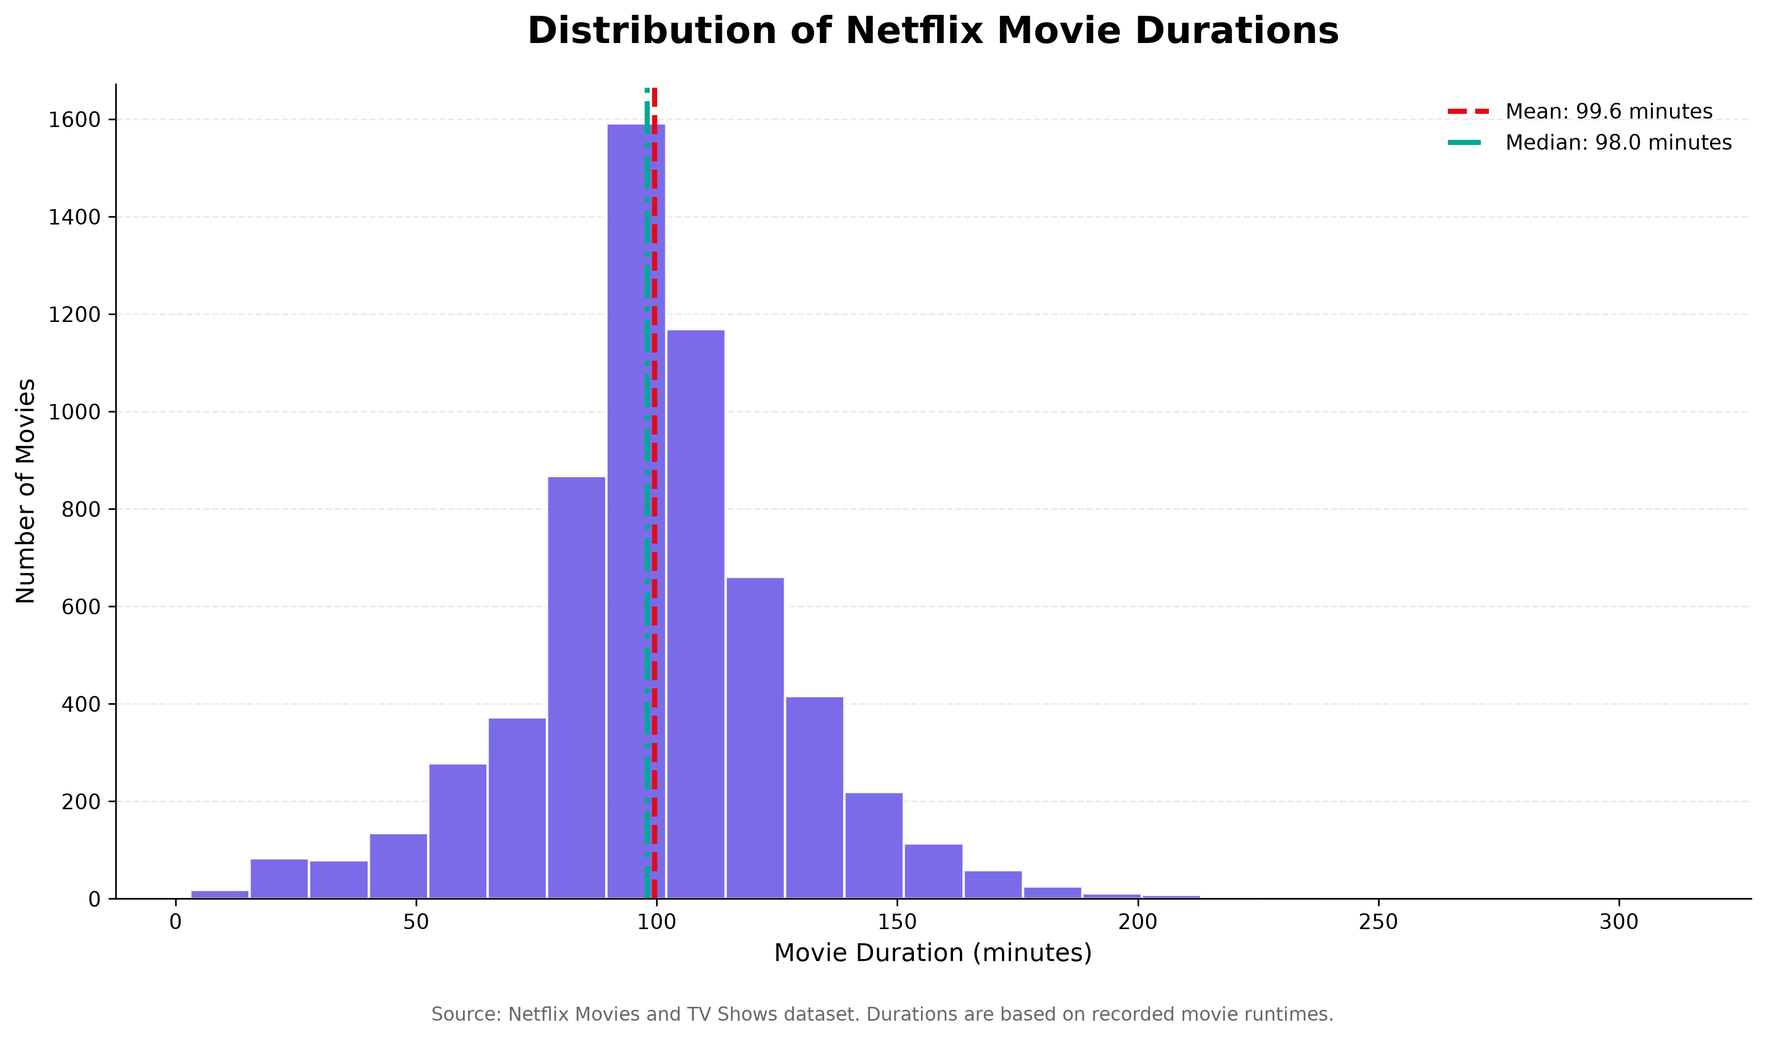
Purpose and interpretation:
A histogram groups movie runtimes into intervals. Reference lines show the mean and median, allowing the central tendency and spread of movie durations to be assessed.
Key finding:
The median runtime is 98 minutes and the average is 99.6 minutes. The largest duration category in the prepared analysis is 91–120 minutes, containing 2,996 movies.

7. Key Findings
- The dataset contains 8,807 titles, of which 6,131 are movies and 2,676 are TV shows.
- The United States has 3,690 country-associated title appearances, while India has 1,046.
- The peak year in the recorded annual addition counts is 2019, with 2,016 titles.
- The median movie duration is 98 minutes, and the average is 99.6 minutes.
- The most frequent category is International Movies, with 2,752 category appearances.
- The corrected movie-only correlation analysis indicates a weak negative association between release year and movie duration.

8. Recommendations
- Use consistent chart titles, labels, and formatting to improve readability.
- Investigate country and genre patterns further by comparing movies and TV shows separately.
- Use additional historical datasets before drawing conclusions about long-term changes in Netflix's catalog.
- Investigate unusual movie durations before deciding whether they represent errors or legitimate titles.
- Avoid interpreting correlation as evidence of causation.
- Consider interactive Plotly visualizations when users need to explore individual categories or observations.

9. Limitations
- The dataset represents a historical snapshot and does not necessarily reflect the current Netflix catalog.
- Missing values may affect country comparisons and analyses involving dates.
- Titles can be associated with multiple countries and genres, so some counts overlap.
- Correlation coefficients describe linear relationships and do not establish causation.
- The number of movies differs across release years, which can affect comparisons.
- The dataset does not directly measure viewership, audience satisfaction, or commercial success.

10. Conclusion
This project demonstrates how Python-based data visualization can transform a raw entertainment dataset into an organized analytical report. Bar charts, line charts, scatter plots, heatmaps, donut charts, and histograms were used to examine catalog composition, content addition dates, genres, and movie durations. The results highlight the importance of choosing appropriate visualizations, preparing data carefully, and interpreting results in context. The project also demonstrates that clear visual storytelling must be supported by accurate calculations, transparent limitations, and cautious conclusions.

11. Python Implementation
The analysis was implemented using separate Python scripts. Pandas was used to load, filter, group, and summarize the dataset. Matplotlib was used to customize and save charts, while Seaborn was used to create the correlation heatmap. The following representative code illustrates the approach used for correlation analysis.
correlation_matrix = numeric_df.corr(method='pearson')
The full implementation is maintained in the project's notebooks folder. The chart images are stored in outputs/charts, and this report is saved in outputs/reports.

12. References
Dataset: Netflix Movies and TV Shows dataset, distributed through Kaggle by Shivam Bansal.
Dataset URL: https://www.kaggle.com/datasets/shivamb/netflix-shows
Python documentation: https://docs.python.org/3/
Pandas documentation: https://pandas.pydata.org/docs/
Matplotlib documentation: https://matplotlib.org/stable/
Seaborn documentation: https://seaborn.pydata.org/

