Draw a UML diagram for ATM System using CASE tool. The banking system allows

a customer to access the financial transactions by ATM System, it has a step-by-step

process describe the work of this process and elaborate the what are the work can do by

customer, banking system, administrator and technicians with the ATM system.

### **Aim**

To design a UML diagram for an ATM system that illustrates the interactions and processes between the customer, banking system, administrator, and technicians, using a CASE tool.

### **Procedure**

1. **Identify Actors**:
   * **Customer**: Accesses the ATM to perform transactions.
   * **Banking System**: Manages account and transaction processes.
   * **Administrator**: Configures and maintains the ATM system.
   * **Technician**: Repairs and maintains the hardware and software of the ATM.
2. **Define Use Cases**:
   * **For Customer**: Withdraw cash, deposit funds, check balance, transfer funds, change PIN.
   * **For Banking System**: Validate transactions, update account balances, generate logs.
   * **For Administrator**: Monitor ATM logs, update software, configure settings.
   * **For Technician**: Diagnose and repair faults, maintain ATM hardware.
3. **Relationships**:
   * Map the actors to the use cases they interact with.
   * Show dependencies or extensions (e.g., "Change PIN" depends on "Authentication").
4. **Choose CASE Tool**:
   * Tools like **Lucidchart**, **StarUML**, or **Enterprise Architect** can be used.
5. **Create Diagrams**:
   * Use a **Use Case Diagram** to show interactions.
   * Use a **Class Diagram** to depict system structure.
   * Use **Sequence Diagram** for step-by-step processes.
6. **Elaborate Process**:
   * When a customer uses the ATM, the system authenticates them.
   * Based on the input, transactions like withdrawals or balance inquiries are processed by the banking system.
   * Administrators and technicians handle backend and maintenance tasks.

Usecase diagram

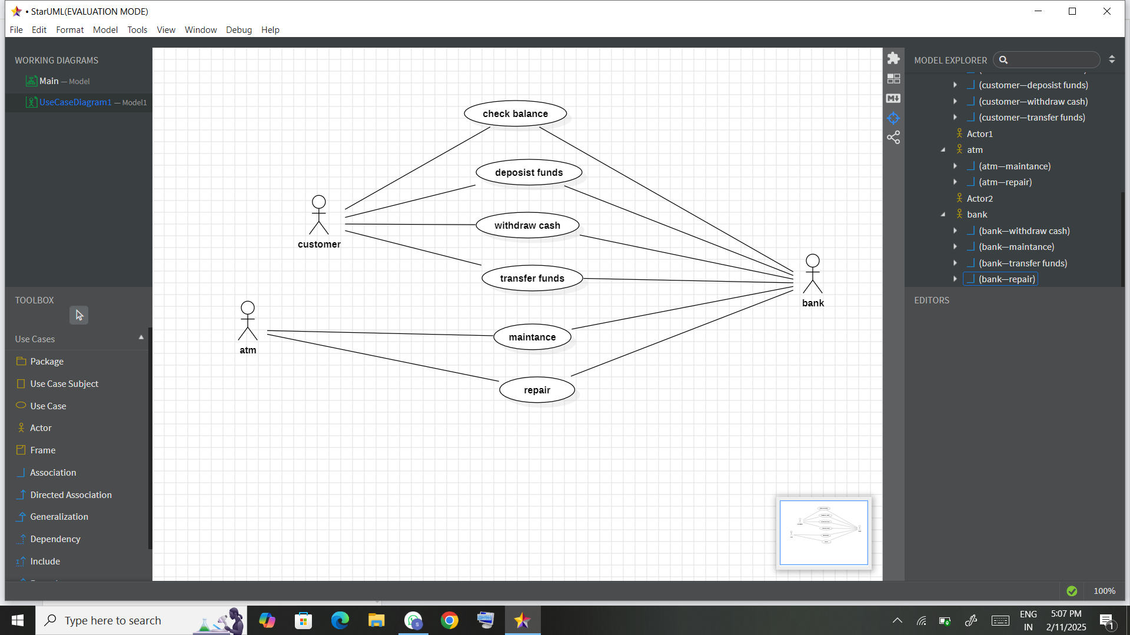

Class diagram

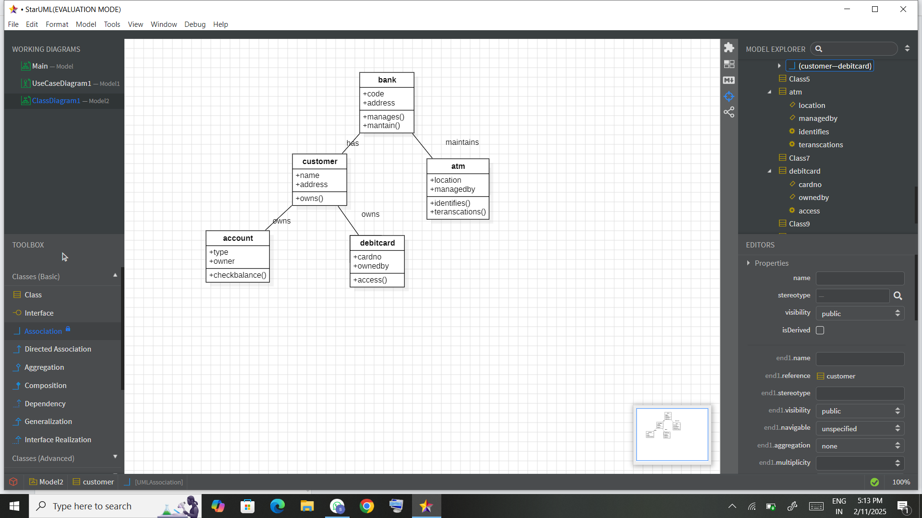

Sequence diagram

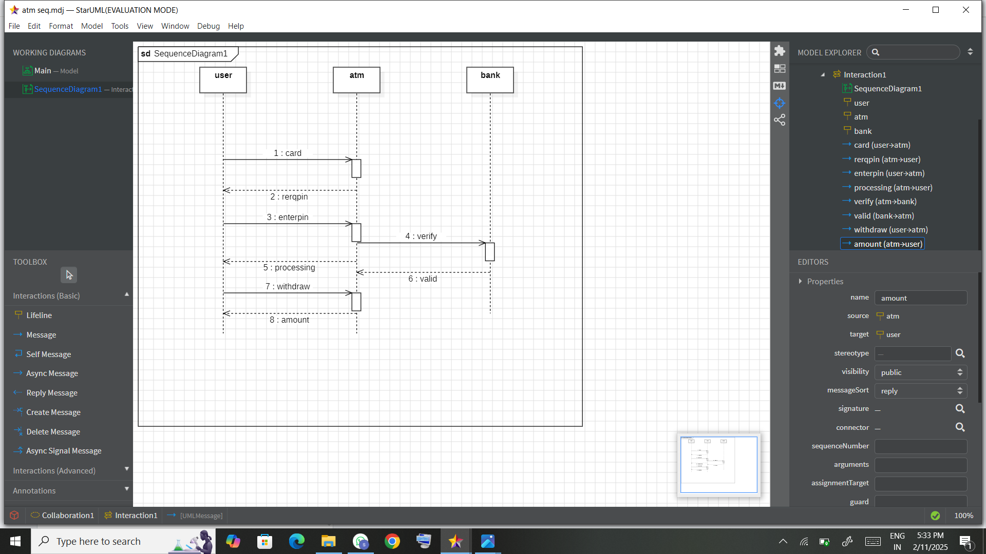

Package diagram

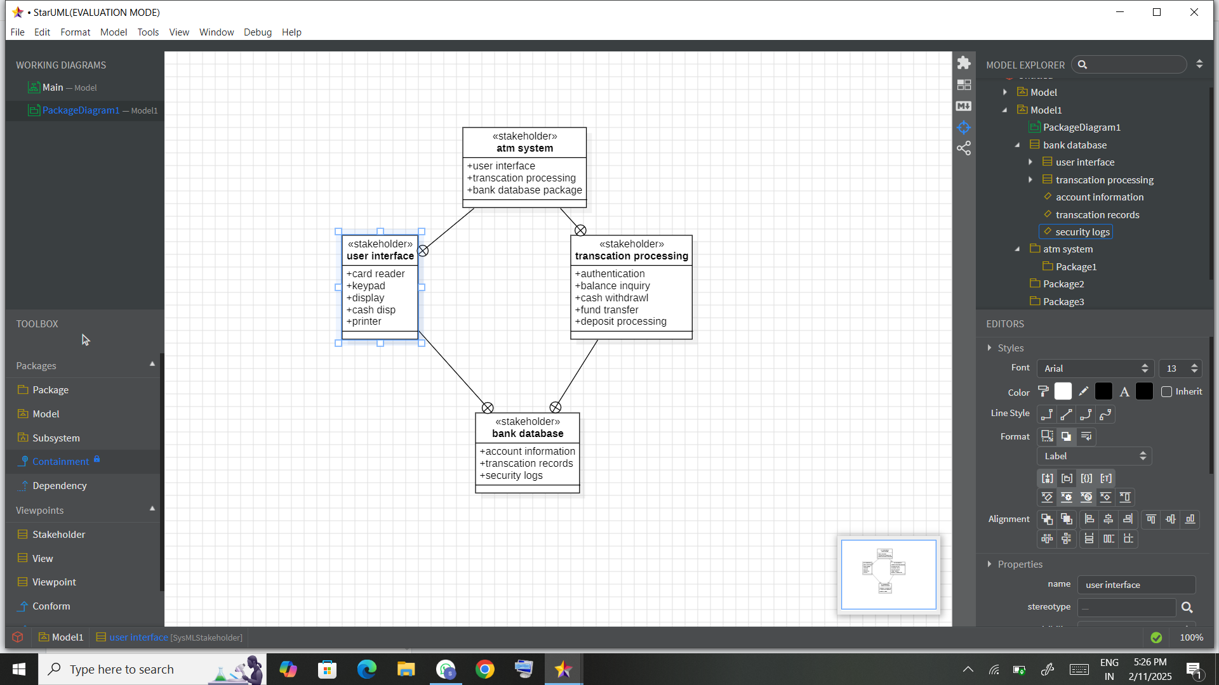

Collaboration diagram

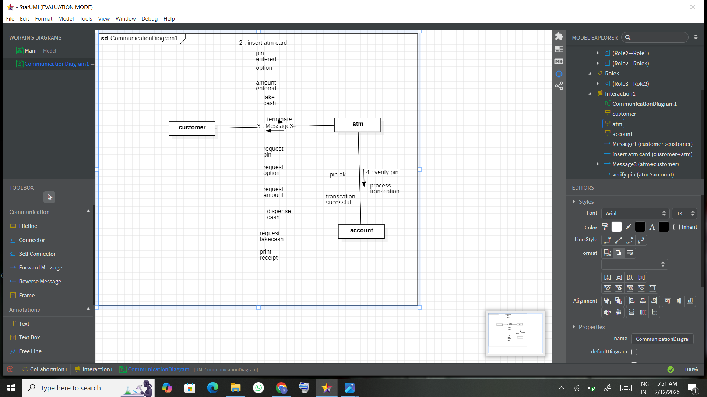

Deployment diagram

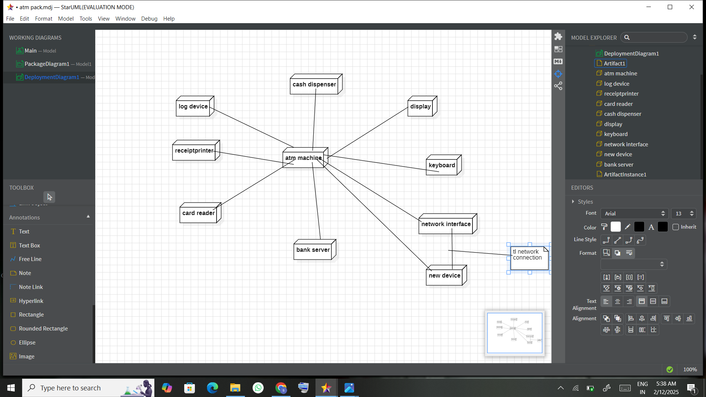

Component diagram

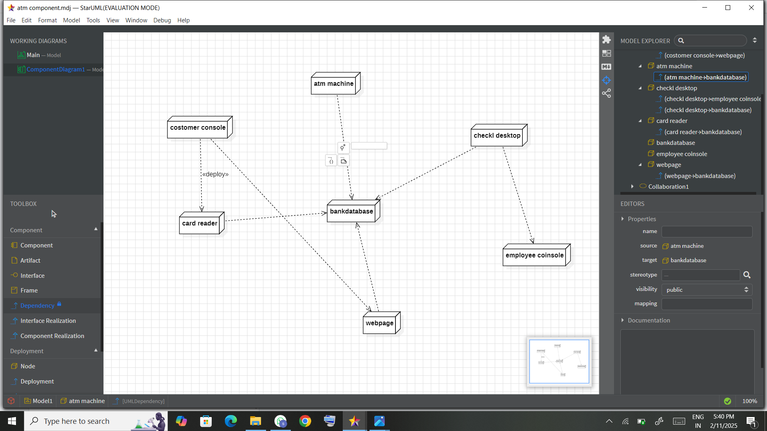

State diagram

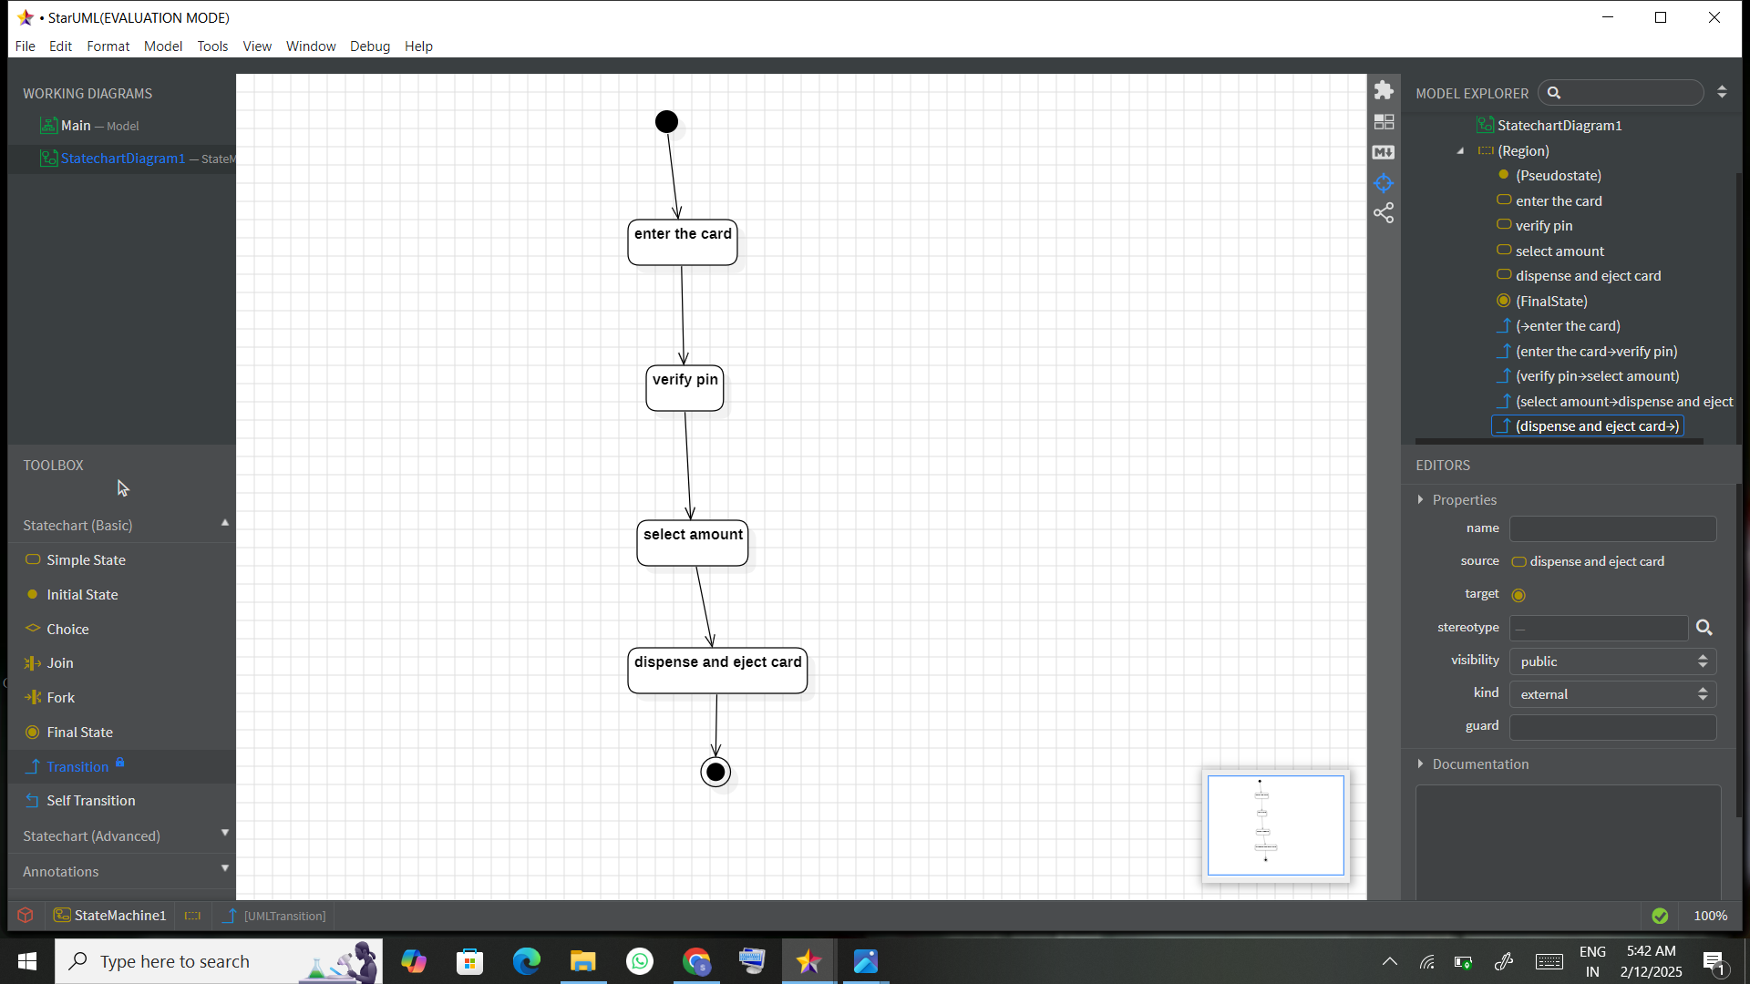

Activity diagram

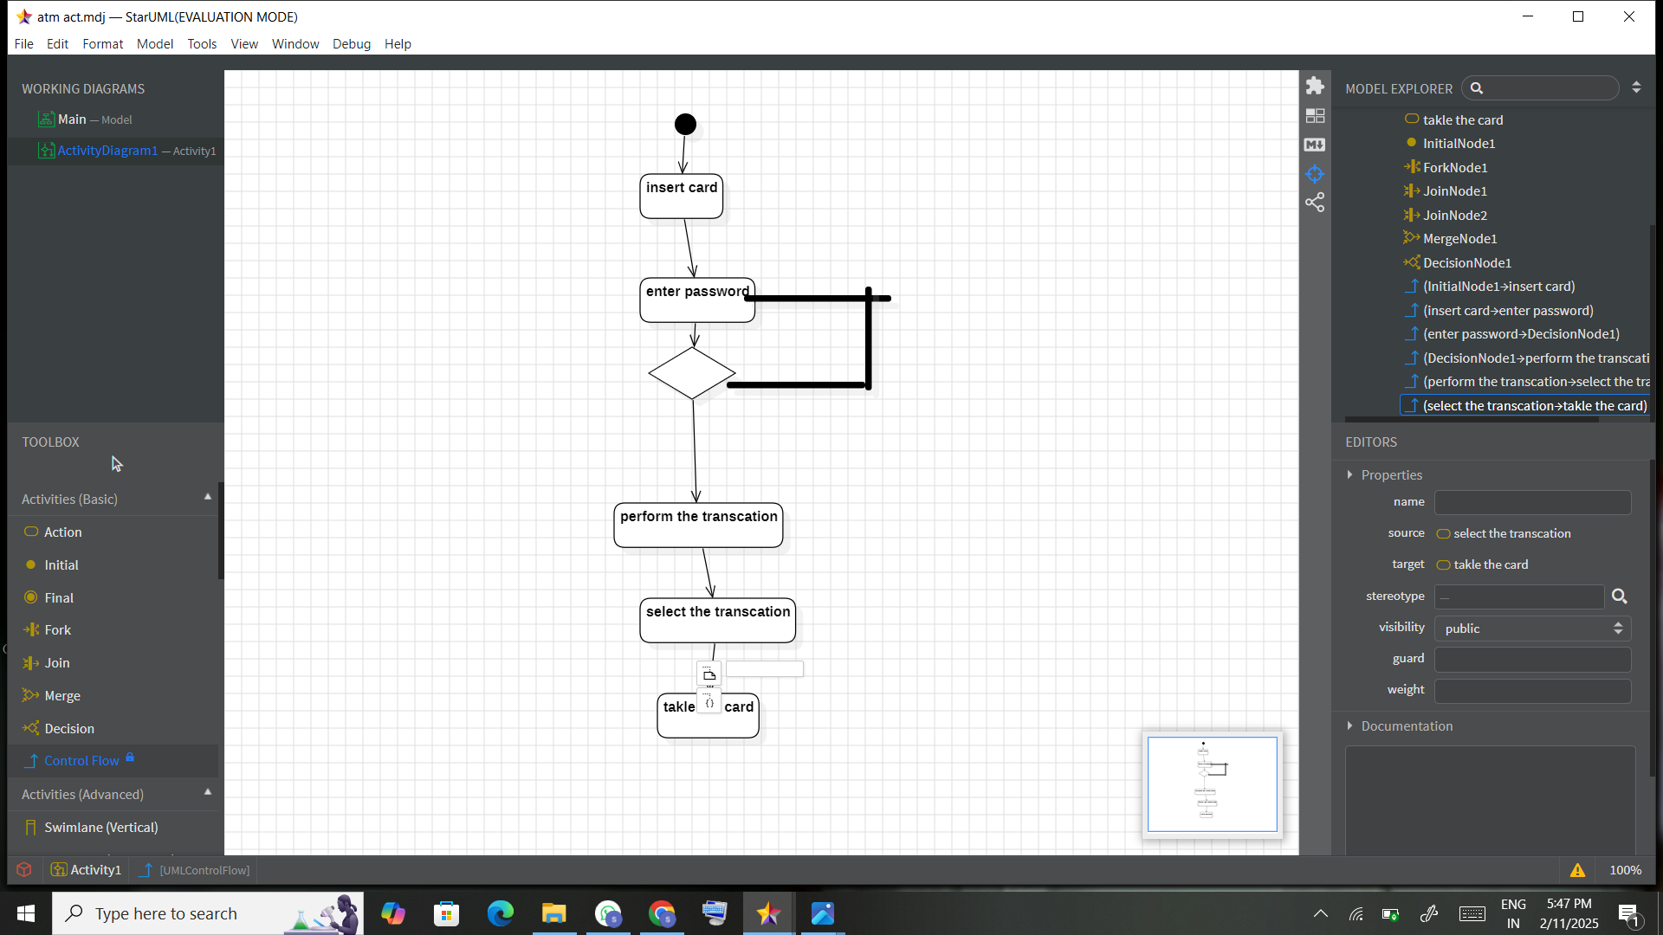

Result

The resulting UML diagram effectively illustrates the ATM System's functionalities and workflows:

* **Actors**: Customer, Banking System, Administrator, and Technician.
* **Use Cases**: Withdraw Cash, Deposit Money, Check Balance, Change PIN, Repair ATM.
* **Process Representation**:
  + Customers interact with the ATM to perform financial transactions.
  + The banking system processes these transactions and updates records.
  + Administrators and technicians handle maintenance and monitoring tasks.

This structured visualization provides a clear understanding of the ATM System's operations, aiding development, analysis, and maintenance