Draw a UML diagram for a food ordering system Systems. The activities of the food

ordering system are listed below. Receive the Customer food orders, Produce the

customer ordered food, Serve the customer with their ordered food, collect payment

from Customers, Store customer payment details, Order Raw Materials for food

products, Pay for Raw Materials and Pay for Labour.

### Aim:

To design a UML Use Case Diagram that models the functionality of a Food Ordering System, focusing on the interactions between actors and the system’s main activities.

### Procedure:

1. Identify Actors:
   * Customer: Places food orders and makes payments.
   * Chef: Prepares food based on customer orders.
   * Cashier: Collects payments from customers and stores payment details.
   * Supplier: Supplies raw materials for food preparation.
   * Restaurant Manager: Oversees payments for raw materials and labor.
2. Identify Use Cases (Activities of the System):
   * Receive Customer Food Orders
   * Produce Ordered Food
   * Serve Ordered Food
   * Collect Payment from Customers
   * Store Customer Payment Details
   * Order Raw Materials for Food Products
   * Pay for Raw Materials
   * Pay for Labour
3. Define Relationships:
   * Customer interacts with:
     + Receive Food Orders
     + Make Payment
   * Chef interacts with:
     + Produce Ordered Food
   * Cashier interacts with:
     + Collect Payment from Customers
     + Store Customer Payment Details
   * Supplier interacts with:
     + Order Raw Materials
   * Restaurant Manager interacts with:
     + Pay for Raw Material

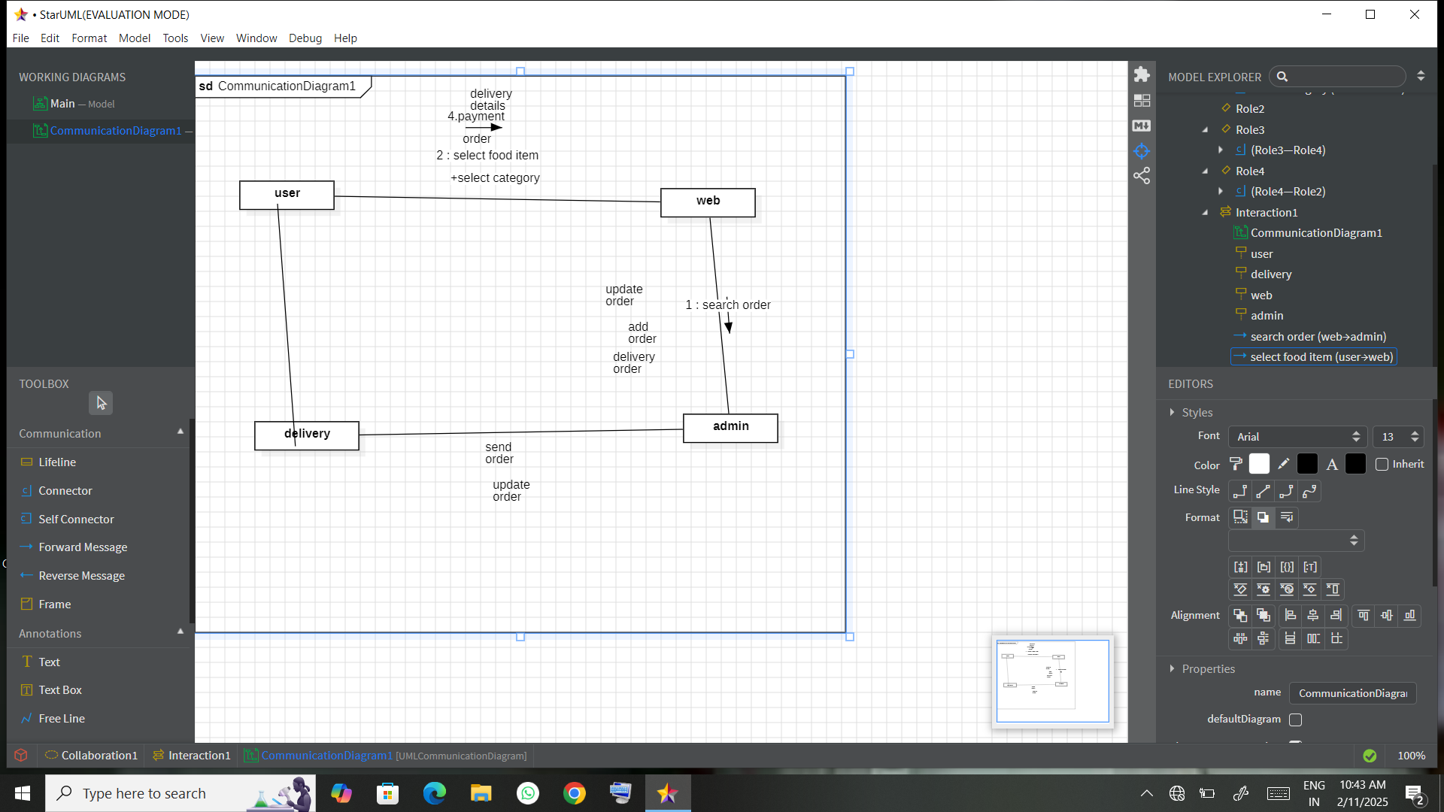

Packagedaigram

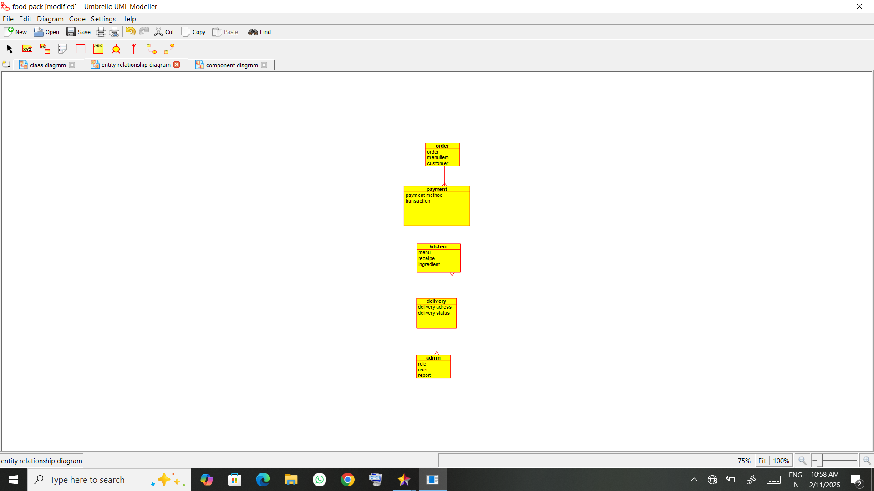

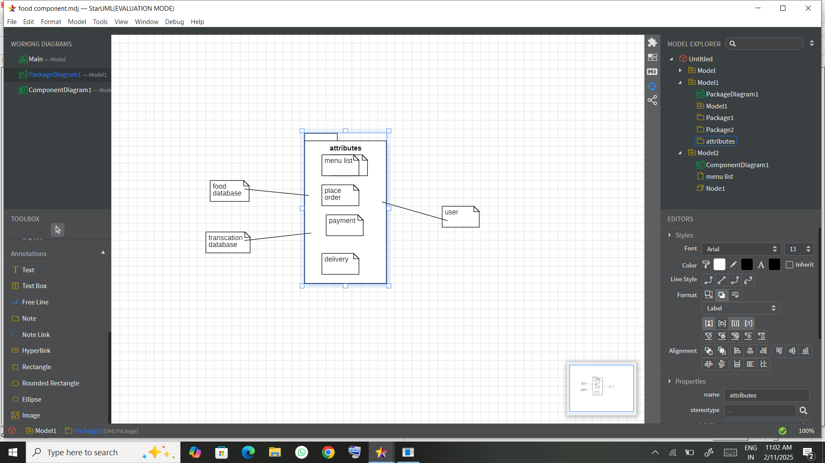

Usecase diagram

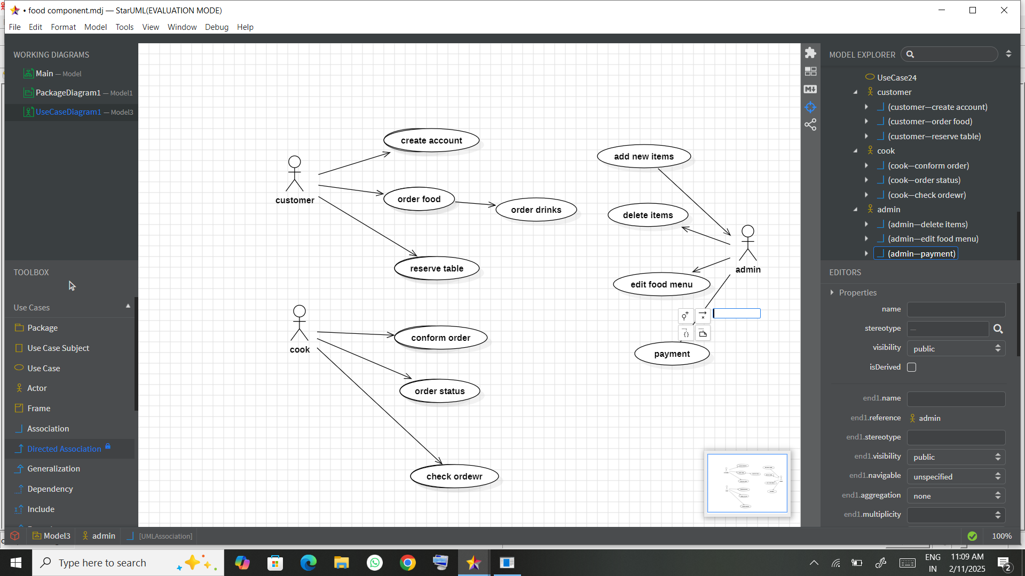

Class diagram

### Result:

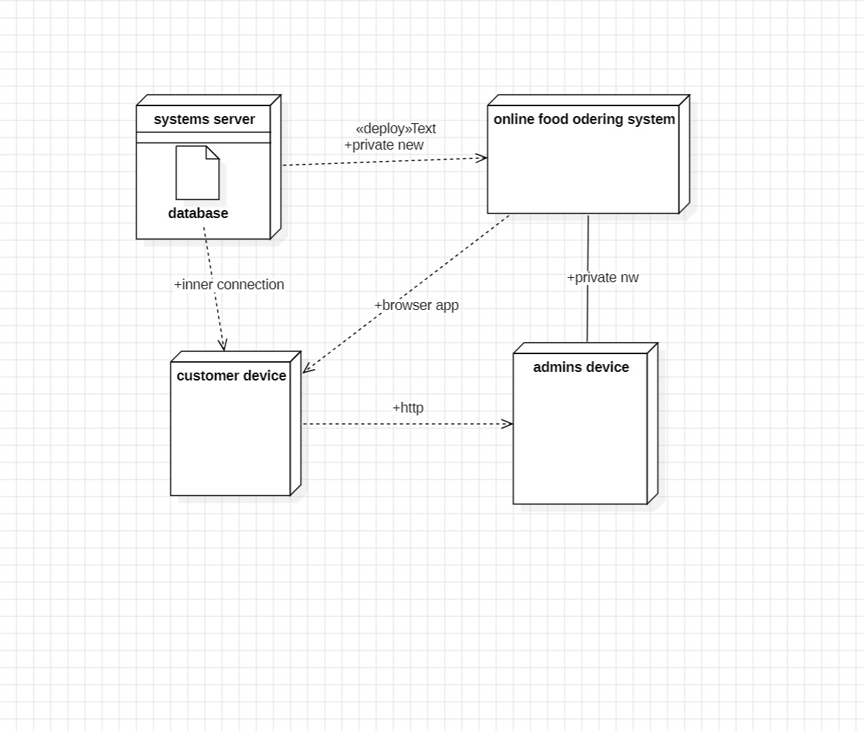

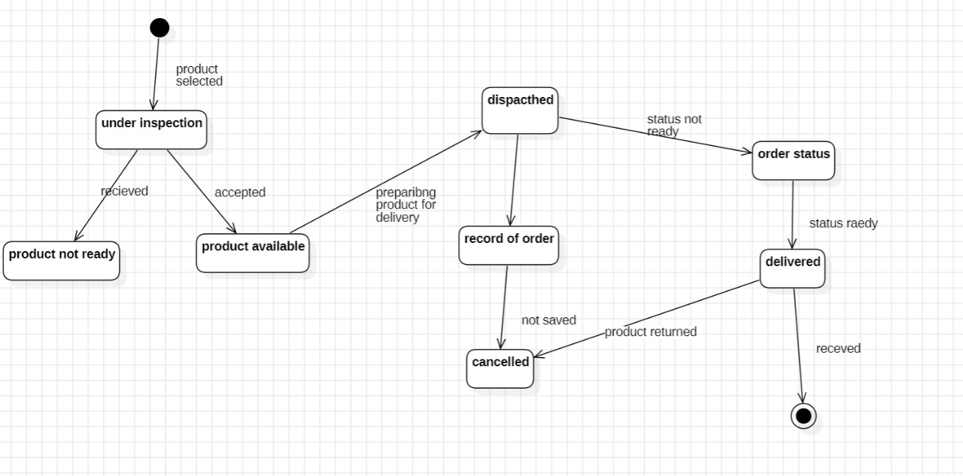

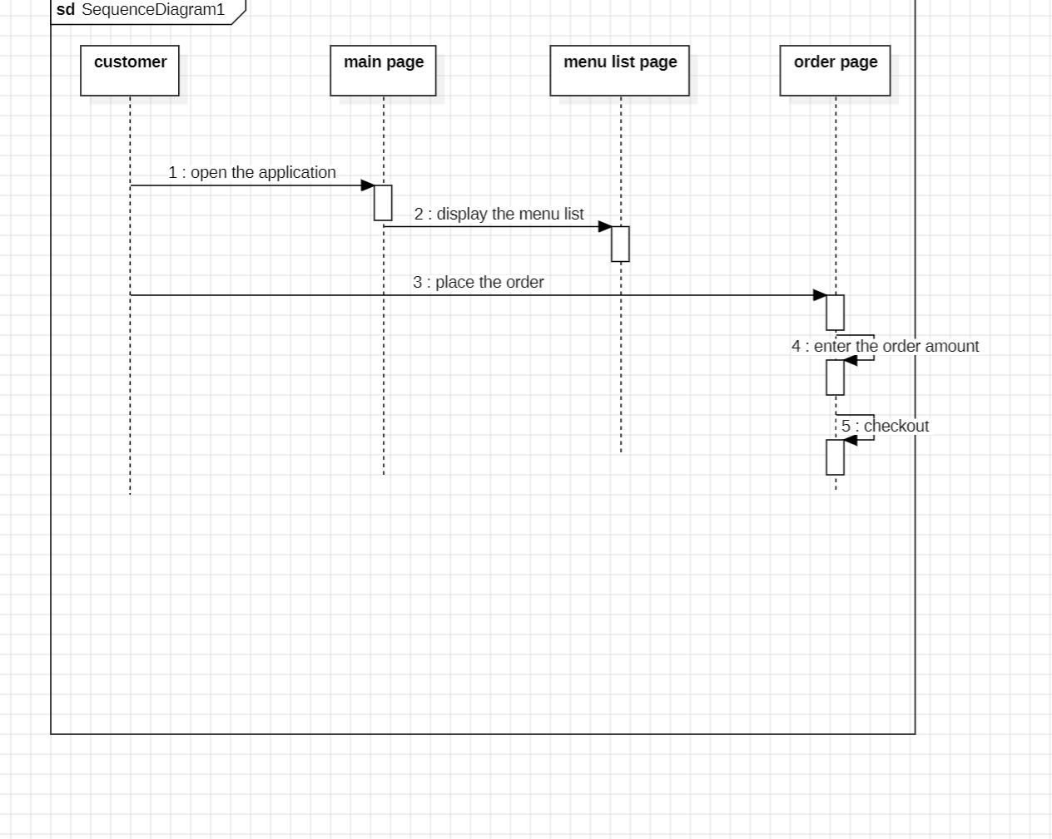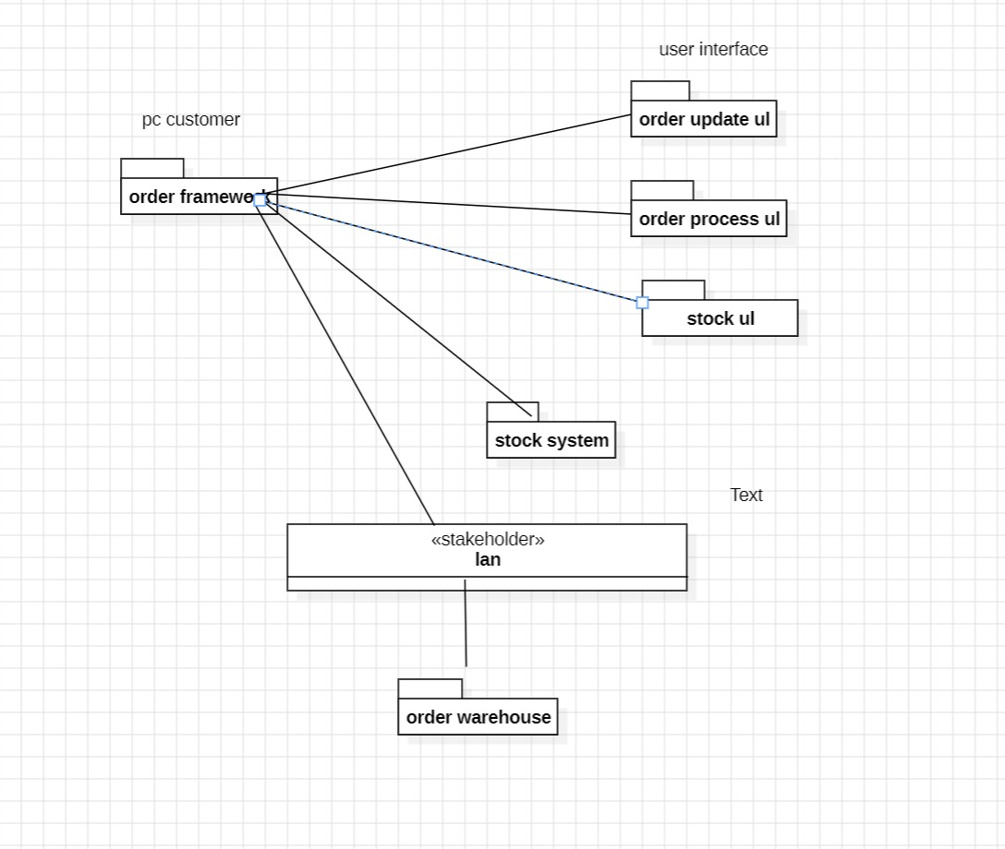

result

A UML Use Case Diagram is created to visually represent how different actors interact with the Food Ordering System.