### Draw a UML diagram for online purchasing system. Provide top level use cases for aweb customer making purchases online. Web customer actor uses some web site tomake purchases online. Top level use cases are View Items, Make Purchase and Client Register.

### Aim:

To design a UML Use Case Diagram that models the functionality of an Online Purchasing System from the perspective of a Web Customer.

### Procedure:

1. Identify Actors
   * Web Customer: A person who interacts with the online store.
   * System: The online purchasing system that handles orders, registration, and viewing items.
2. Identify Use Cases (Top-Level Functionalities)
   * View Items: The customer browses the list of available products.
   * Make Purchase: The customer selects and buys items.
   * Client Register: The customer registers on the website.
3. Define Relationships
   * The Web Customer is linked to all three use cases.
   * The Make Purchase use case may include Payment Processing and Order Confirmation (sub-use cases).

activitydaigram

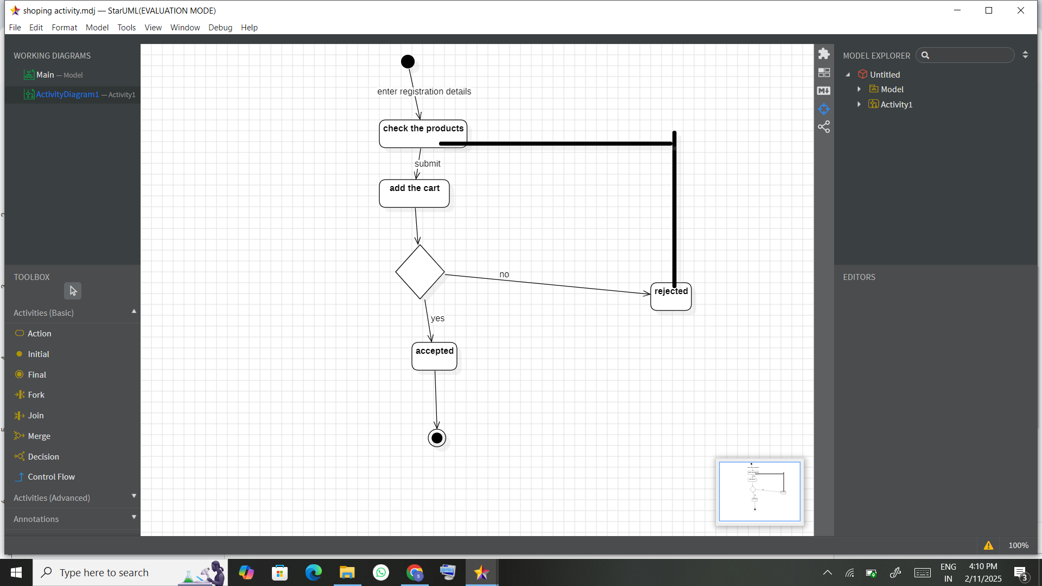

componentdiagram

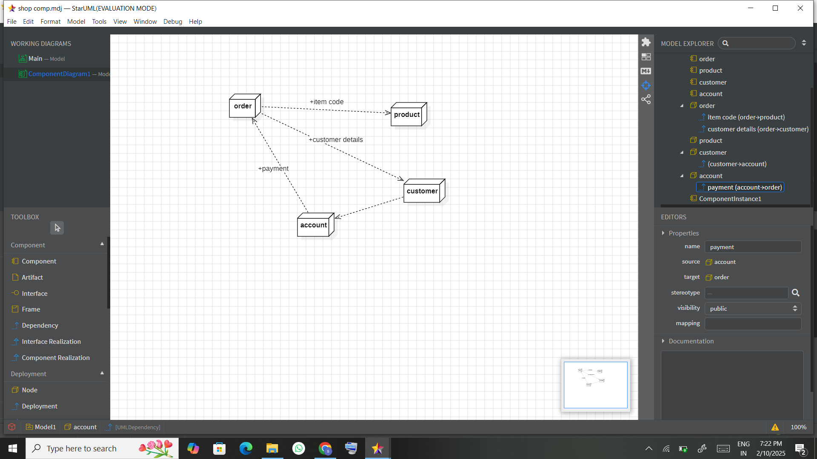

sequencediagram

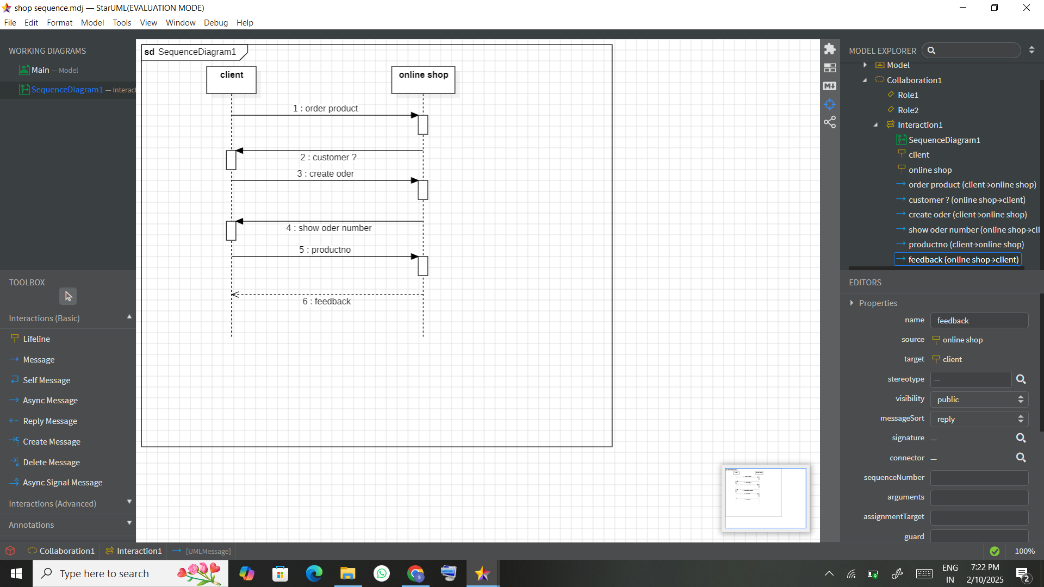

statediagram

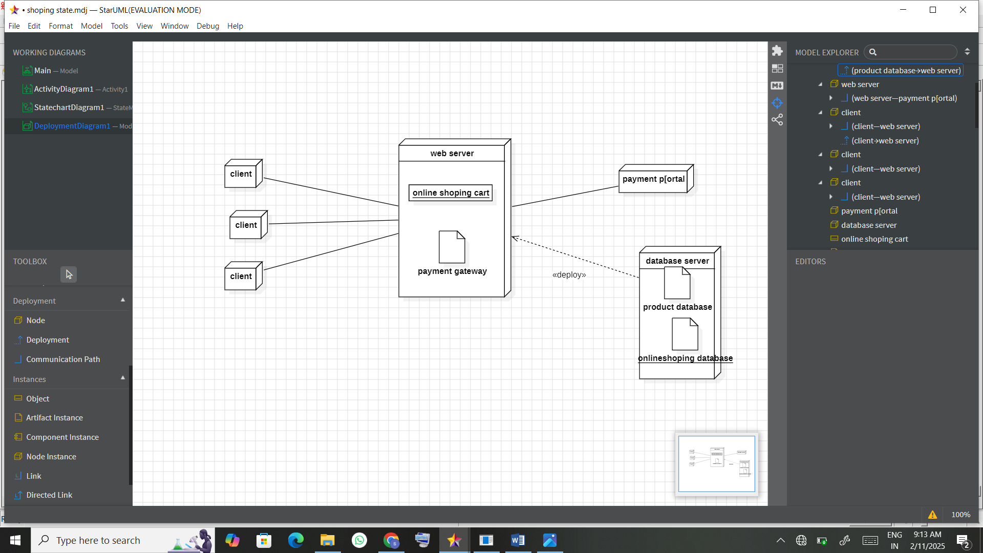

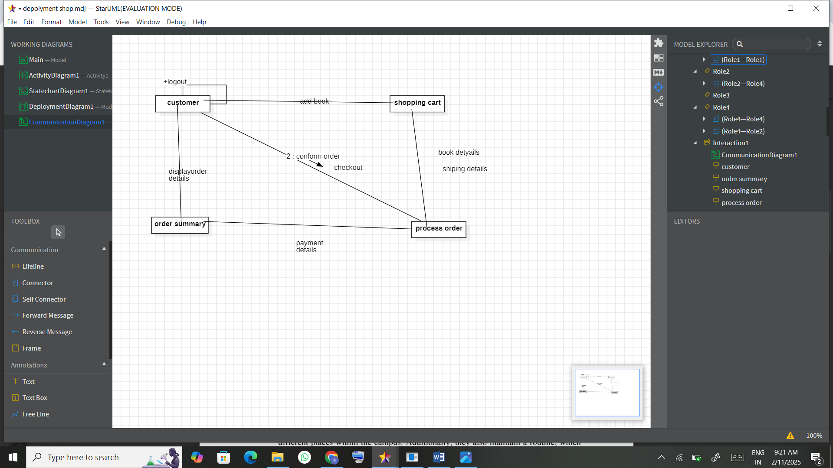

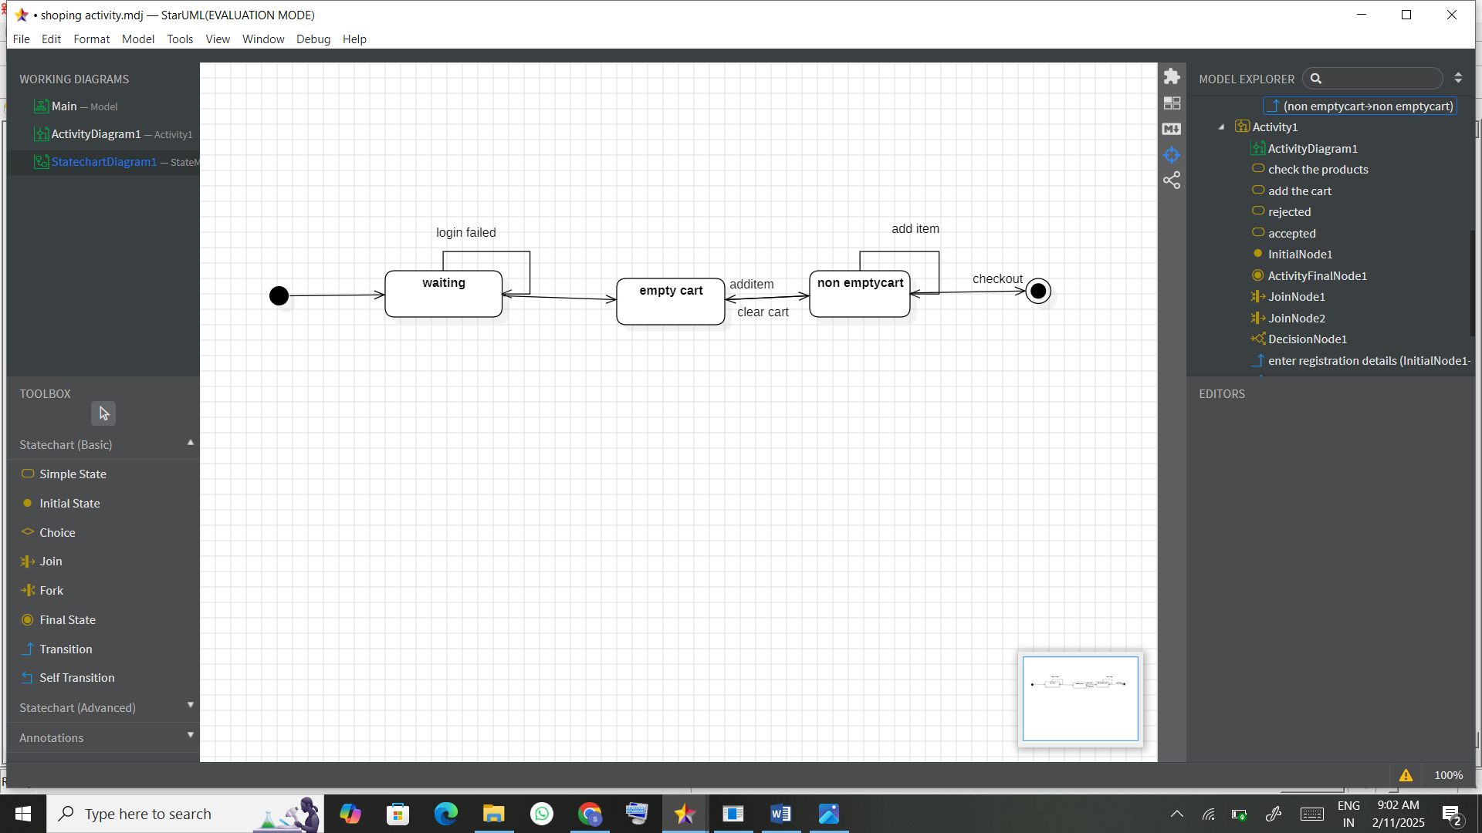

Class diagram

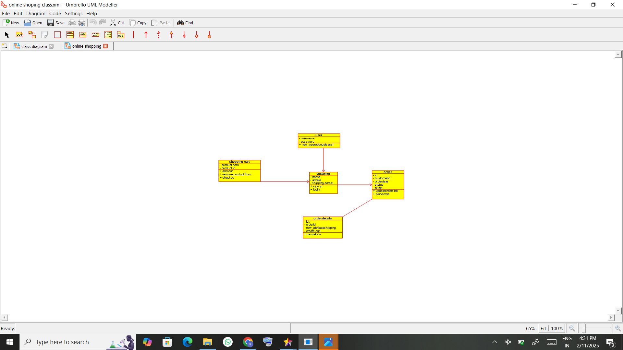

usecasediagram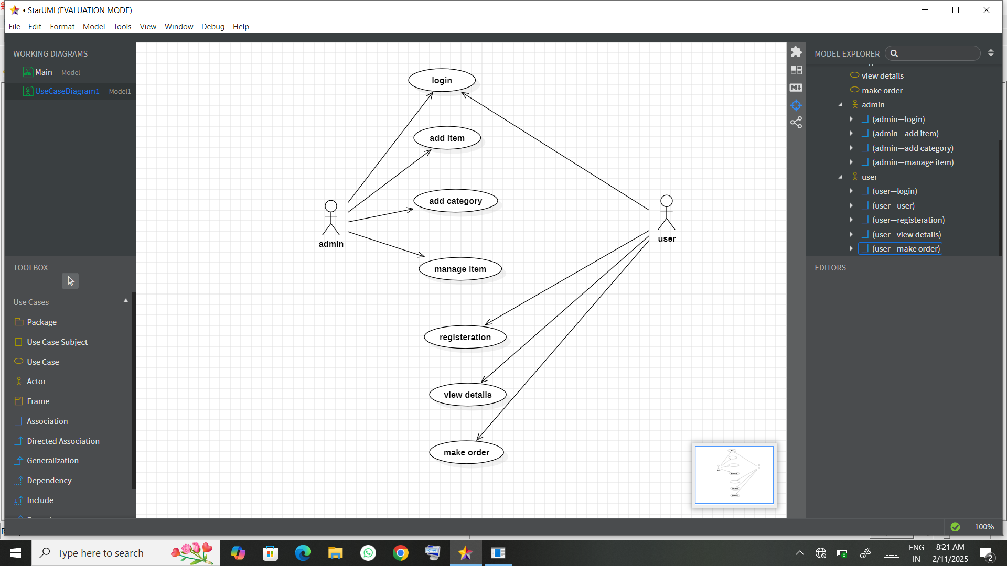

### Result:

A UML Use Case Diagram is created to visually represent the interactions between the Web Customer and the Online Purchasing System.