**Bitrate calculation exercise**

We have to follow the below steps.

* Define the data model to represent the JSON structure.
* Use a JSON library like Newtonsoft.Json to parse the JSON.
* Implement a method to calculate the bitrates based on the polling rate.

**Step1. Install Newtonsoft.Json package via NuGet.**

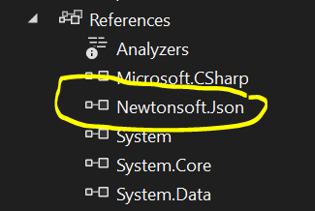

**Step2: Define the Data Model**

Create classes to represent the JSON structure:

* DeviceInfo
* NIC

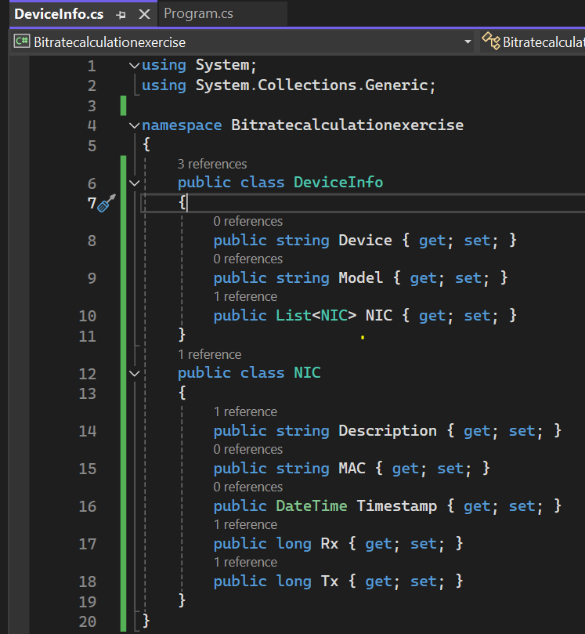

**Step3: Parse the JSON**

Use JsonConvert to parse the JSON string into a DeviceInfo object.

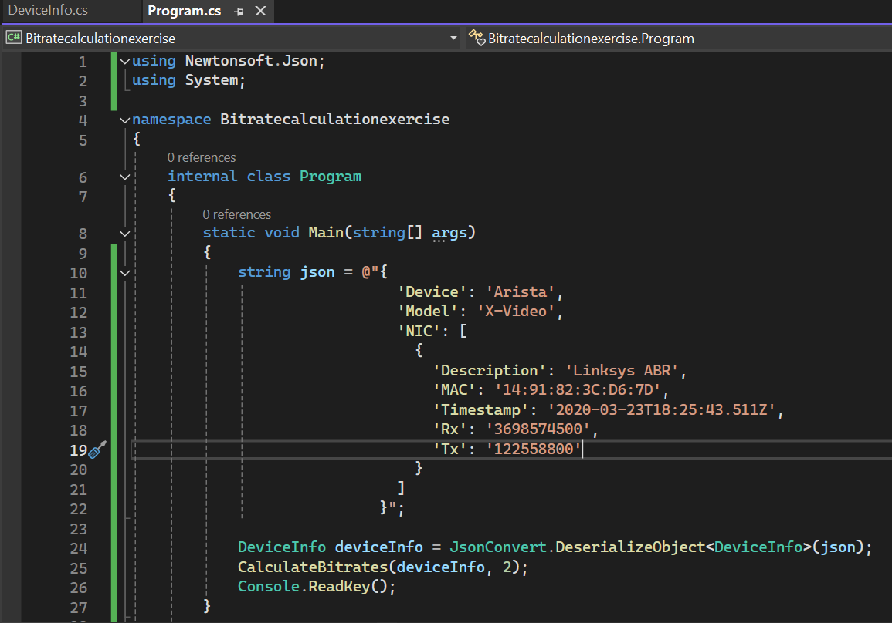

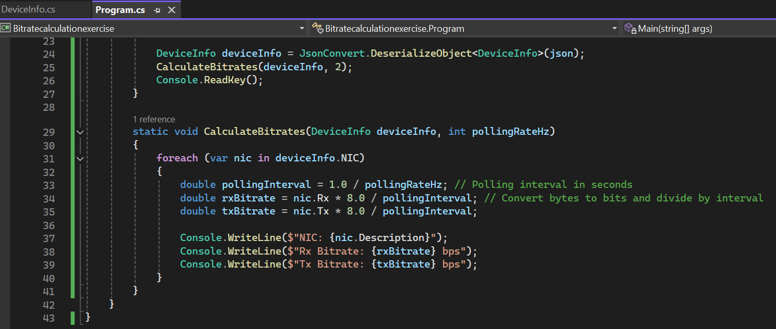

**Output:**

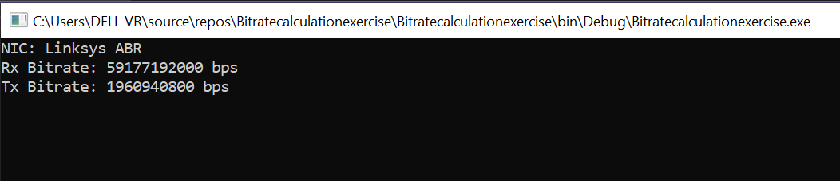

**Explanation**

* **Data Model:** The DeviceInfo and NIC classes are created to map the JSON structure
* **Parsing JSON:** The JsonConvert.DeserializeObject<T> method from Newtonsoft.Json is used to parse the JSON string into a DeviceInfo object
* **Bitrate Calculation:** 
  + The Polling rate is provided in Hz (2Hz in this case), so the polling interval is calculated as 1.0 / pollingRateHz.
  + The Rx and Tx values are given in bytes. To calculate the bitrate in bits per second (bps), the values are multiplied by 8 (To convert bytes to bits) and then divided by the polling interval.