Montel

Montel initialization

There are two different type of Montel system the ellipsoidal one and the paraboloid one, the difference consist only in the type of mirror utilized.

- Ellipsoidal Montel:
“initialize_as_montel_ellipsoid(cls, p, q, theta, bound1, bound2, angle_of_mismatch=0., fp=None, fq=None):”

p: is the distance between the source of the beam and the center of the montel system
q: is the distance between the center of montel and the image plane
bound1 and bound2: define the dimension of the two ellipsoidal mirror
angle_of_mismatch: implement the possibility the put the mirror with an angle different from 90 degree each other (the angle must be put in degree)
fp: is the object focal distance of the mirros (is initialized as p)
fq: is the image focal distance of the mirrors (is initialized as q)

INITIALIZATION

beta = (90.- angle_of_mismatch)*np.pi/180 #### angle beetween the two mirror

Angle between the two mirrors (initialized as 90 degree)

oe1 = Optical_element.initialize_as_surface_conic_ellipsoid_from_focal_distances(p=p, q=q, theta=theta, alpha=0., cylindrical=1, fp=fp, fq=fq)
oe1.set_bound(bound1)

Definition of the first mirror using SurfaceConic.py script

oe2 = oe1.duplicate()
oe2.rotation_surface_conic(beta, 'y')
oe2.set_bound(bound2)

Definition of the second mirror as the first mirror but rotated of an angle beta

distance_of_the_screen = q
ccc = np.array([0., 0., 0., 0., 0., 0., 0., 1., 0., -distance_of_the_screen])
screen = Optical_element.initialize_as_surface_conic_from_coefficients(ccc)
screen.set_parameters(p, q, 0., 0., "Surface conical mirror")
Definition of the image plane

- Parabolic Montel is, more or less, equal to the ellipsoidal one

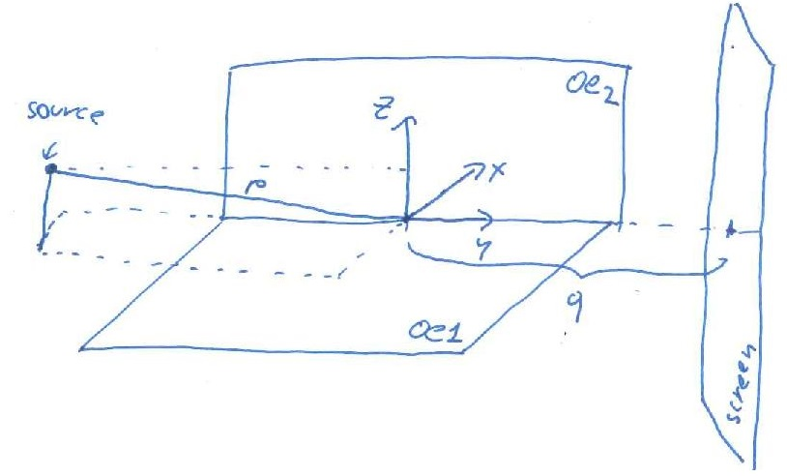
Trace Montel code
The trace code is composed by 3 main parts:
1 – Changing the reference system in the montel coordinate system (a system that is centered in the middle of the first mirror)
2 – Trace the beam ray by ray looking the travel time to reach the different element (1st mirror, 2nd mirror, image plane)
3 – Change the reference system with respect to the optical axis

1) Montel reference system
op_axis = Beam(1)
op_axis.set_point(0., 0., 0.)
op_axis.set_divergences_collimated()
beam = op_axis.merge(beam)
First of all is implanted, in the fist position of the beam, a ray that simulate the optical axis
[beam, n] = self.rotation_traslation_montel(beam)
The Montel reference system transformation is done by a first rotation around x of an angle theta to have the correct incidence with the first mirror, after there is a rotation around an axis k orthogonal to the op_axis and the x axis to obtain also the correct incidence with respect to the 2nd optical element without changing the incidence of the first mirror. After the rotation is done a translation of the correct distance, p, between the source and the Montel system
2) Tracing ray by ray
This second part consist in the evaluation of travel time to reach the different optical element ray by ray stopping the tracing of a ray when reach the image plane
3) Last reference system
One time that all the rays have reached the image plane only those reflecting two time are considered and, on those ones, is done a first translation of -q, and some rotation to fix the direction of the optical axis as the new axes [0, 1, 0].
The algorithm of the rotations are this one:
1) rotation of -theta around k(that axis created in the “Montel reference system”) , and -theta around x to be in the system of the source.
2) find the angle theta between the optical axis in the source reference system and [0,1,0]
3) find the angle fi between the projection of the optical axis in the xy-plane and [0,1,0]
4) rotation of the beam of an angle theta around k' that is a vector of the vector product between the projection of the new optical axis on the xy-plane and z axis
5) rotation of the beam of an angle fi around z

Montel for Russo
In this script there are coded the simulation for different system (ideal lens, KirkPatrickBaez, paraboloid mirror and Montel)
In the Montel the simulation are done using the two different Montel system:
- The paraboloid one
- The ellipsoidal one with one focal distance very big (equal to the one used in the “Echo Spectometer” oasys work in the Montel-Like system).
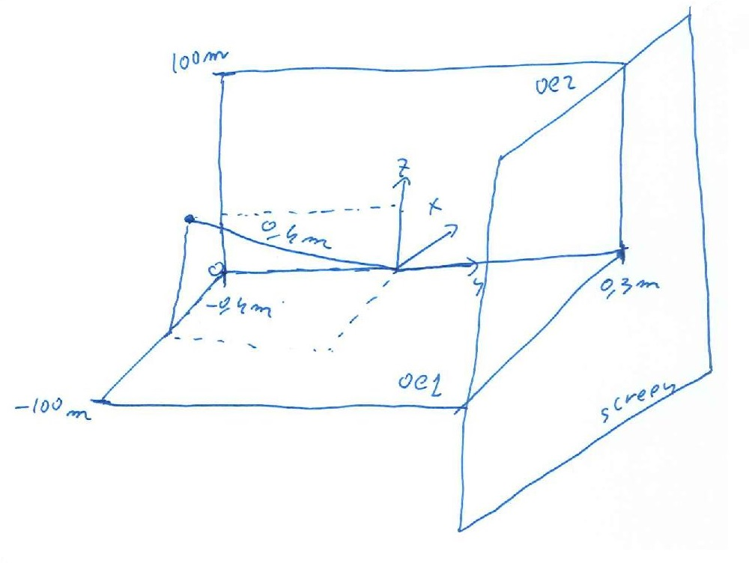
Beacause the montel script needs to define the dimension of the two mirror, to be as much similar as the oasys-job, the dimension are setted in such a way to cover all the possible space
The plot printed on the screen are (the black point is the representative ray of the optical axis):
-Figure 1: the x/z plot of the source
-Figure 2: footprint on the oe1
-Figure 3: footprint on the oe2
-Figure 4: the x/z plot of beam after the exit of the first Montel system (with change of variable)
-Figure 5: the vx/vz plot of beam after the exit of the first Montel system (with change of variable)
-Figure 6: footprint on the oe1 of the 2nd montel system in the case of focal = 0.4
-Figure 7: footprint on the oe2 of the 2nd montel system in the case of focal = 0.4
-Figure 8: the x/z plot of beam after the exit of the 2nd Montel system (with change of variable) in the case of focal = 0.4
-Figure 9: the vx/vz plot of beam after the exit of the 2nd Montel system (with change of variable) in the case of focal = 0.4
-Figure 10: footprint on the oe1 of the 2nd montel system in the case of focal = 1.471
-Figure 11: footprint on the oe2 of the 2nd montel system in the case of focal = 1.471
-Figure 12: the x/z plot of beam after the exit of the 2nd Montel system (with change of variable) in the case of focal = 1.471
-Figure 13: the vx/vz plot of beam after the exit of the 2nd Montel system (with change of variable) in the case of focal = 1.471
At the end of the simulation it is printed the width of the x-dimension of the beam, to compare with the x-dimension of the source printed too

Montel for Moretti
The first thing done it for simulate the Moretti system was that to convert the input data of the paper in the data that the Montel script manage, in other world was done some calculation to find theta. The calculation are those scripted in the function “theta():” at the top of the script, moreover sigma = FWHM/(2 sqrt(2ln(2))).

The system simulated is the propagation of a beam with:
- Gaussian divergence profile with FWHM of 25urad
- Source size spot of 1 um * 1 um
- distance source-Monel of 351 mm
- image plane at 1 m
- angle of mismatch goes from -0.02 to 0.03 degree with a step of 0.01 degree
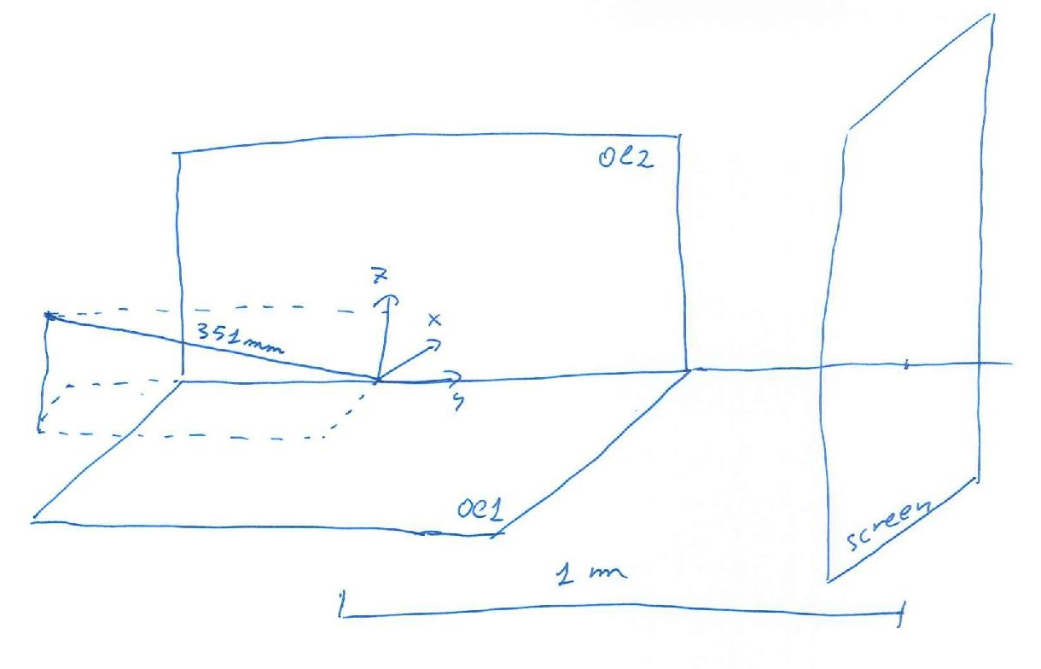
The resulted plotted are:
-Figure 7: fitting of the histogram of the vx velocity at the end of the propagation
-Figure 8: histogram of the vx velocity at the end of the propagation
-Figure 9-14: vx/vz plot for the different configuration at the end of the montel
-Figure 15-20: x/z plot for the different configuration at the end of the montel
The other Figures are the footprint of the different Montel configuration

