**Sagittal shape difference between a cylinder and a diaboloid at 2:1 demag**

H. A. Padmore 5/29/2020

**1. Introduction**

The diaboloid offers distinct advantages over a toroid for imaging the very small beams of ALS bending magnet source. However making this complex shape to the accuracy needed is going to be tough. Although planar shapes such as plane ellipses, plane hyperbola can be made to the accuracy needed (with very large foci distances, such that the slope at the end of the mirror is small, typically a few mrads or less), the complex 3D shape of the diaboloid imposes very difficult challenges. However, at the 2:1 demagnification in the horizontal direction that we use in our PX beamlines, it was recently found that the normally pseudo conical shape of the diaboloid is actually cylindrical, ie. the cone angle is zero. Further it was found that the sagittal shape (constant in the 2:1 case) is elliptical (K. Goldberg and M. Sanchez del Rio, LSBL 1440). The parabolic tangential curvature can be produced by bending. So the task of polishing this mirror before bending is to make a sagittal cross section that is elliptical, and only slightly different from a circle. This might open up new ways to make this shape. This note just documents the sagittal shape difference between the diaboloid and the circle.

**2. Method**

From LSBL 1440, the height of the elliptical sagittal shape for Type I diaboloid is given by,

 (1)

As in LSBL 1440, expanding the square root term for |x|<<q and referencing to the surface gives

 (2)

For the circular shape with respect to the surface we have



and Coddington’s equation for the sagittal direction can be rearranged and substituted for r to give,

 (3)

For the case under consideration here p=2q. The expressions in (2) and (3) can be Taylor series expanded to 2nd order and the difference of the ellipse from the circle is then given by,

 (4)

The difference in heights determined from 2) and 3), is compared to the difference obtained with (4) and it can be seen that (4) is highly accurate over the range of apertures that we typically use.

Finally a question is how aspheric is the mirror. Going back to equ. (2) and substituting d=p sin(2), we have

 (5)

This means that z is maximum when the discriminant is zero so zmax = d at x=d (3)-1/2. These are the semi-major and semi-minor axes lengths and so the distance from the center of the ellipse to a focus is c = (d2-d2/3)1/2 = 0.816d. Therefore the distance from the surface of the mirror to the center of the ellipse is zmax = p sin(2) , the distance from the surface to the first focus is zmax – c = p sin(2) – 0.816 p sin(2) = 0.184 p sin(2) and the distance between the two foci is 1.632 p sin(2). The eccentricity is c / zmax = 0.816, ie. the ellipse is highly aspheric.

**3. Results**

Calculations were done for p=20 m, q= 10 m and  = 5 mrads. The absolute height of the circle and ellipse is shown in Fig 1. The difference in heights, given by equs. (2) and (3) is shown in Fig 2 together with the simpler expression given by (4). They are virtually identical. The difference in the slopes is shown in Fig 3, and reaches 4 mrad at the edge of the +/- 0.75 mrad aperture. Fig. 4 shows the radius of curvature of the ellipse compared to the fixed radius of the circle. Fig 5 shows the full semi-circle and semi-ellipse which accentuates the fact that the ellipse has a high ellipticity. In this case, the distance from the surface to the lower focus is 0.184 x 20 x (2 x 0.005) = 36.8 mm, the distance between the surface and the center of the ellipse is 200 mm and the distance between the foci is 326.4 mm. Taking a circle rather than an ellipse, from Coddington’s equation, the radius is 66.6 mm.



**Fig. 1** Circle (black) and ellipse (red) corresponding to p=20 m, q=10 m and =5 mrads



**Fig. 2** Height difference between a circle and an ellipse for p=20 m, q=10 m, =5 mrads. The solid line is from the difference between equ. 2 and 3 (I have this result changing sign: Eq 3 – Eq 2), and the dotted line is from equ. 4.

This is my result:

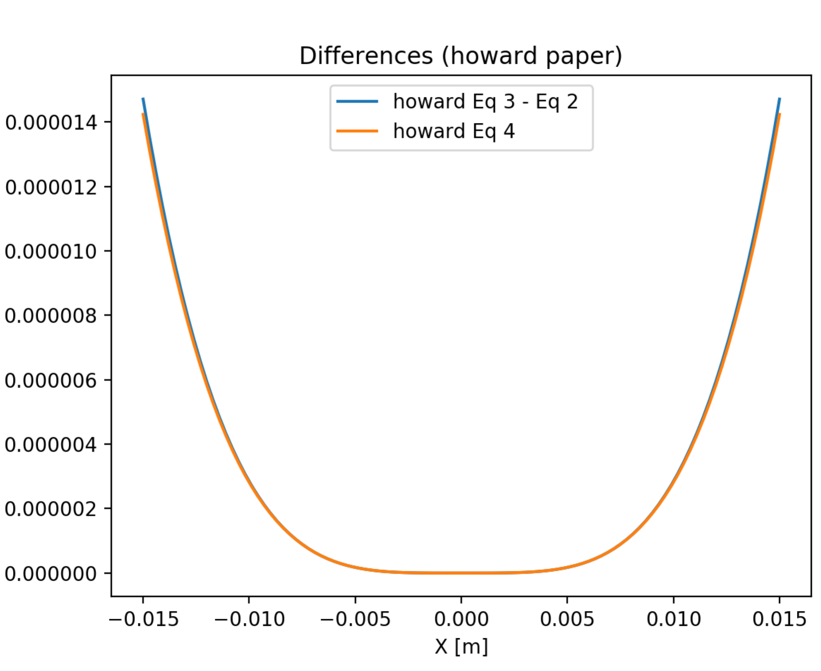



**Fig. 3** Slope difference between a circle and an ellipse for p=20 m, q=10 m, =5 mrads.



**Fig. 4** Radius of curvature of the ellipse, in comparison to the fixed value for the circle



**Fig. 5** The sagittal circle and ellipse for p=20, q=10, =5 mrads

**A. Derivation of Eq. 4**

Combining Eq. 1:



with the expansion the square root to 4th degree:



we get:

 (6)

To get z we take the negative square root of (6) and use the Taylor expansion:



we get



in the parenthesis the (1/q) term can be neglected with respect to the other term:

 (7)

Here the first term is the shift to have the mirror origin at zero, the second term is the quadratic approximation to the circle given by the Coddington eqs. and the third is the difference with the circle for diaboloid Type I (point to segment focusing) :



For diaboloid Type II (segment-to-point focus) which is the one used at the beamlines, we swap p and q:



and in the typical case of p=2q we obtain Eq. 4:



**B. Additional comments**

The Eq. 4 is a very interesting result. But note that dz is the difference from the ellipse of the diaboloid sagittal cut approximated to the fourth degree and the approximation of the circle (not the exact circle in Eq. 3).

The next figure is the full shape that I calculated (numerically in Oasys and with Ken’s equation swappinf p and q) and your equations. On the right, you find a zoom of the edge. There is a small difference.

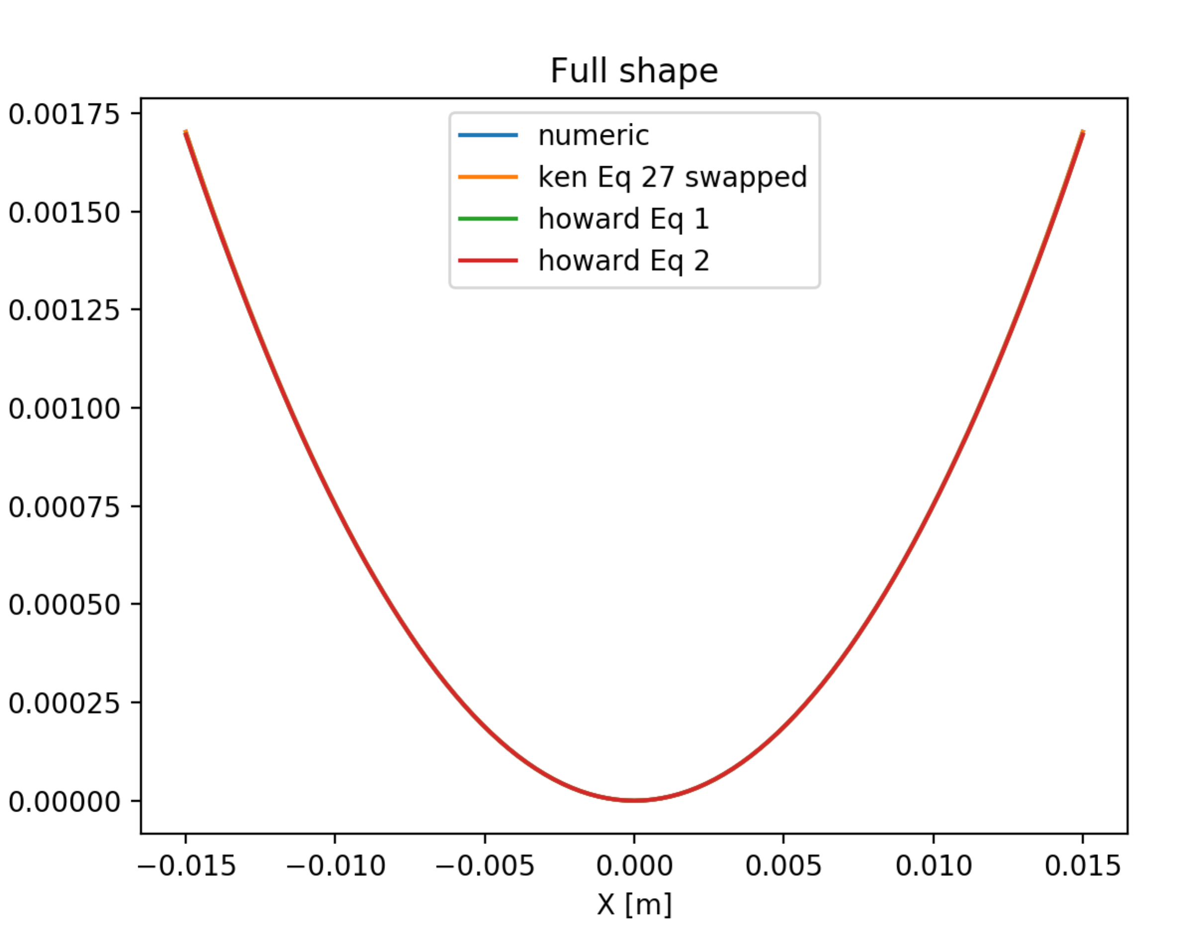 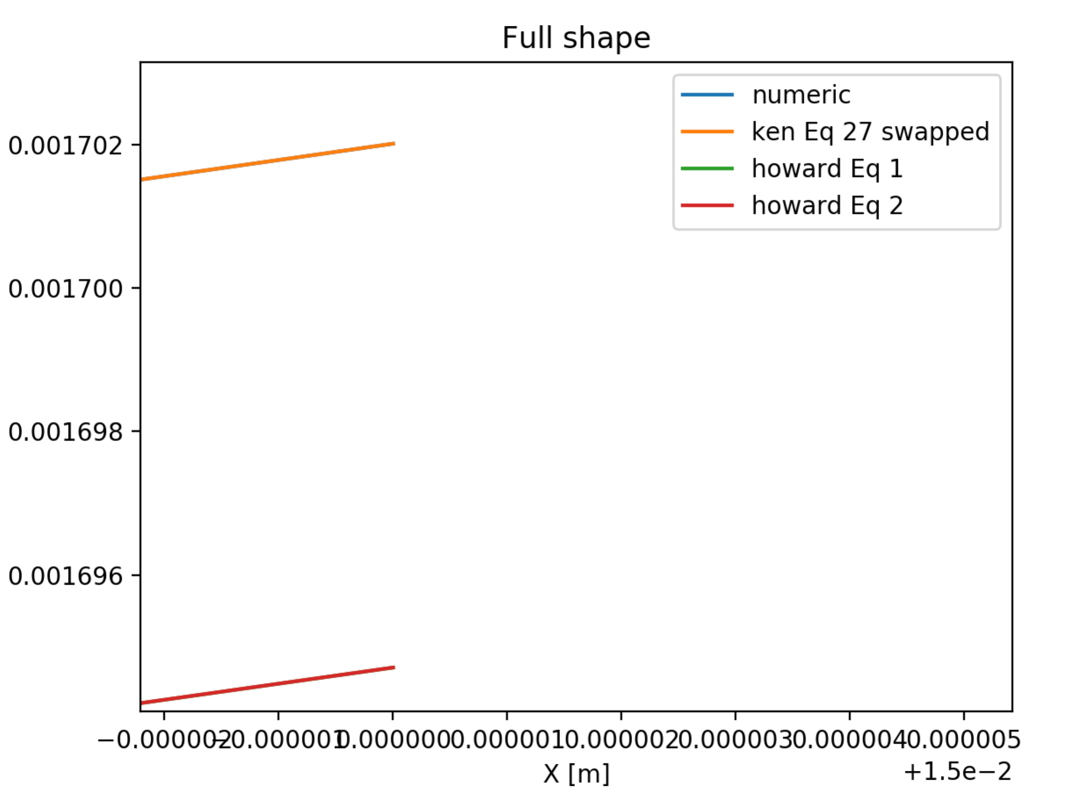

The differences with the circle approximation (p + q) / (2 * p * q * sin2t) * x**2 are:

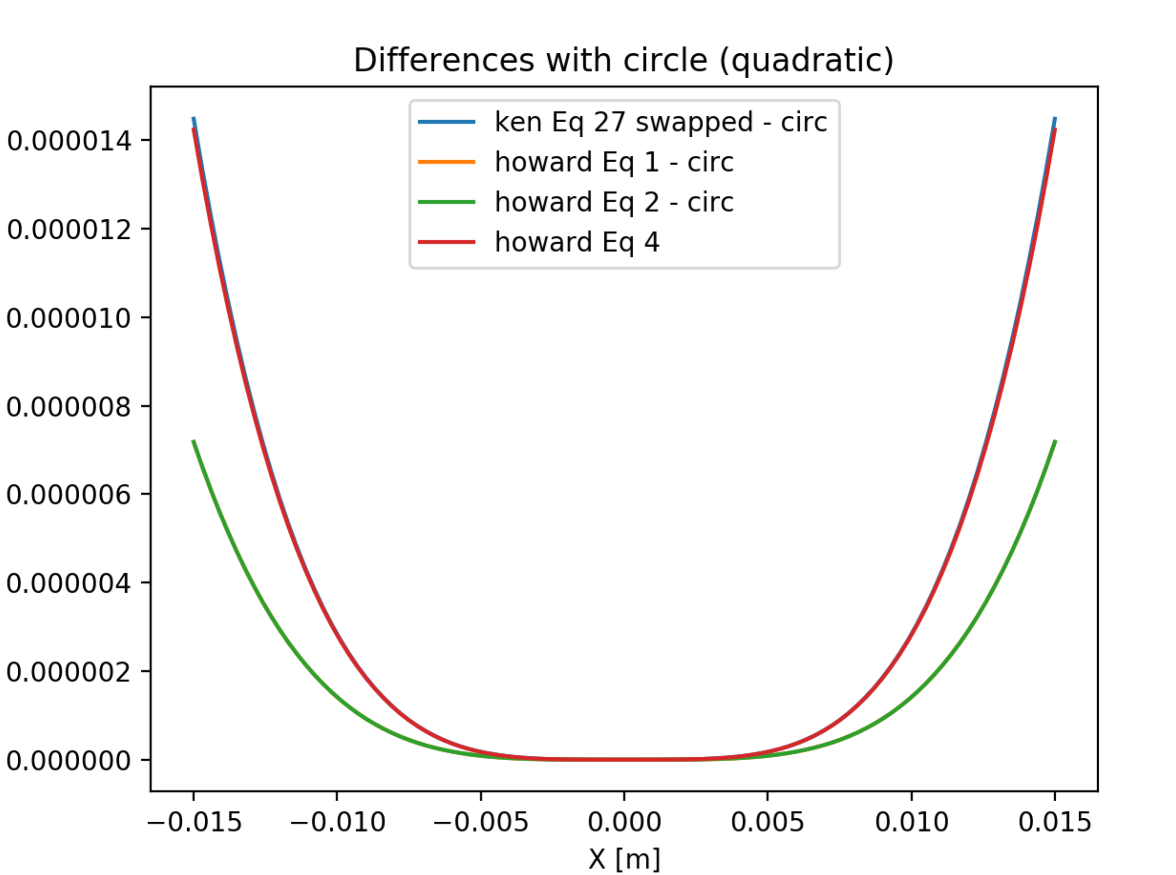

and the differences with the exact circle are:

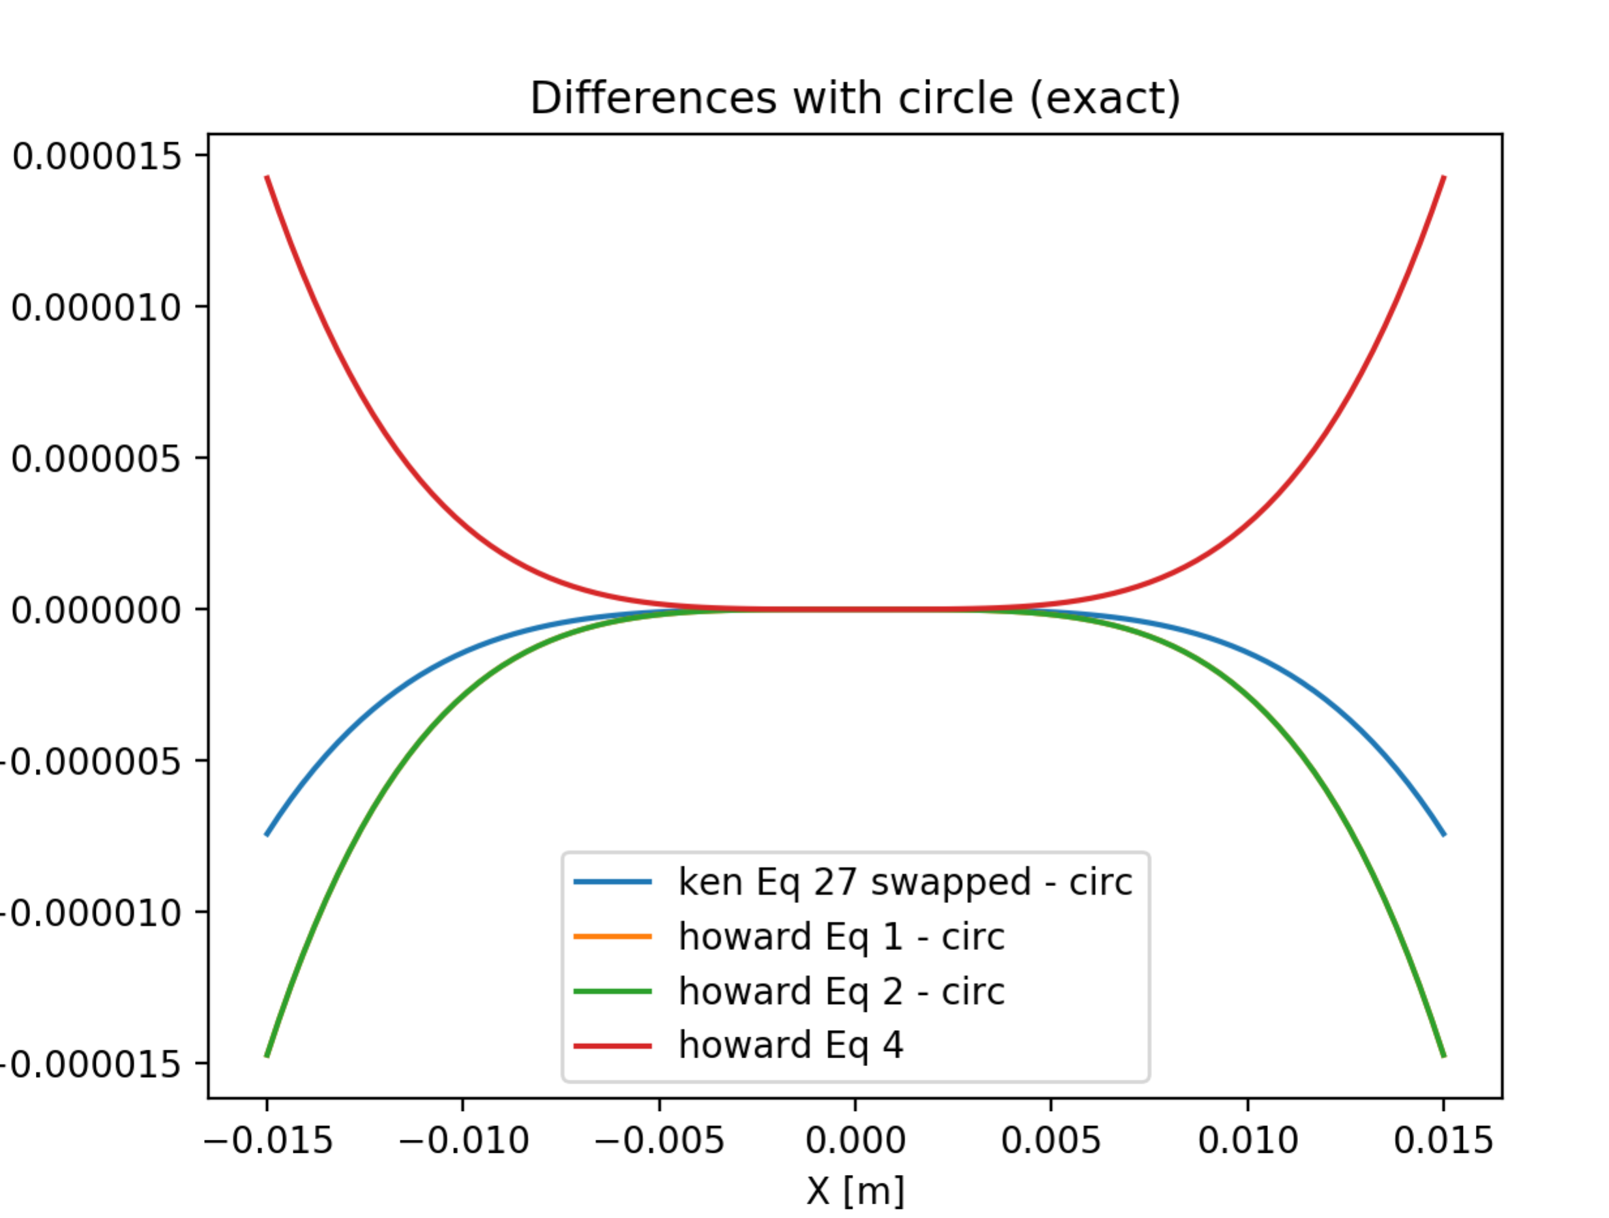

There is a funny compensation that I do not understand that makes your Fig. 2 works very well (you did not swap p and q that is necessary). You see here that if you reverse the plot (the sign I mentioned in the caption of Fig. 2) your green (and yellow below) match very well the Eq. 4. I do not know why…