SHADOW

PRIMER

(Upgraded to SHADOW3)

SHADOW
Copyright (C) 1984-2011

This program and its documentation is free software: you can redistribute it and/or modify it under the terms of the GNU General Public License as published by the Free Software Foundation, either version 3 of the License, or (at your option) any later version.

This program is distributed in the hope that it will be useful, but WITHOUT ANY WARRANTY; without even the implied warranty of MERCHANTABILITY or FITNESS FOR A PARTICULAR PURPOSE. See the GNU General Public License for more details.

You should have received a copy of the GNU General Public License along with this program. If not, see <http://www.gnu.org/licenses/>.

THE AUTHORS DISCLAIMS ALL WARRANTIES WITH REGARD TO THIS SOFTWARE, INCLUDING IMPLIED WARRANTIES OF MERCHANTIBILITY AND FITNESS. IN NO EVENT SHALL THE UNIVERSITY OF WISCONSIN BE LIABLE FOR ANY SPECIAL, INDIRECT OR CONSEQUENTIAL DAMAGES OR ANY DAMAGES WHATSOEVER RESULTING FROM LOSS OF USE, DATA OR PROFITS, WHETHER IN AN ACTION OF CONTRACT, NEGLIGENCE OR OTHER TORTIOUS ACTION, ARISING OUT OF OR IN CONNECTION WITH THE USE OR PERFORMANCE OF THIS SOFTWARE.

Authors: Franco Cerrina, Chris Welnak, G.J. Chen and M. Sanchez del Rio

Foreword to SHADOW3

SHADOW3 is the third main release of the popular ray tracing code. Born in the 80’s, SHADOW 1 was developed for VAX-VMS machines, and used much of machine-dependent code. In the 90’s it was ported to Unix workstations. At this time most of the source and optical models available in SHADOW were completed and developed. This version was used for the simulation of several third generation synchrotron sources. Since then a lot of work was focused on the development of alternative graphic tools, scripts and graphical users interfaces. Today, most SHADOW 2 users run it under the XOP/ShadowVui framework. SHADOW3 comes in a moment when SHADOW start to become old, among other things because of: i) the binaries available present problems in new machines, with some library incompatibilities, ii) the current version became quite old, being more and more difficult to recompile (note that g77 compiler, default for SHADOW 2 is not longer supported), iii) many programming limitations, inherited from the old computers, like the limited number of rays, and iv) the difficulty to add new features, due to the old structure. SHADOW3 comes with a completely new code structure, and full compatibility with the old version. The new code structure is fully compatible with new Fortran (since Fortran 90) and uses extensively the “modules” approach. This will open SHADOW to a new community: the programmers, that will be able to customize their code with full benefit of SHADOW. This will be explained in a new Programmers Guide.

Here we adapted the Primer to this new version. The Primer is an essential document for SHADOW beginners. This primer is centered on the command mode for running SHADOW. An introduction to ShadowVui is presented in Chapter 7. The present version of SHADOW3 covers all the examples described in this Primer.

SHADOW3 is prepared to challenging new methods and new algorithms that will deal with polarizing optics, coherence and partial coherence, sample simulation, and full and simplified implementation of new devices, such as CRL. This was planned to start just after the first release of SHADOW3, and has been longly discussed among us. Unfortunately, Franco passed away in the last phase of coding the new SHADOW3, and it will not be possible to follow these developments as we planned. However, its legacy is immense, and SHADOW is, even after more that 25 years of loyal services, the standard tool for synchrotron optics. I would like to keep it alive, as he would have desired, and I invite from here to all SHADOW users, software developers, and synchrotron researches and institutions to join efforts in supporting this fantastic tool that Franco gave us.

Manuel Sanchez del Rio, Grenoble, September 2010

Foreword

This book contains the Primer to SHADOW. We have tried to explain in detail all the aspects of the code that may be useful to the user in setting up his or her calculations. We have insisted on the description of the physical models rather than on the implementation of the algorithms used in the code in order not to obscure the physical aspects of the problems. SHADOW is a program in continuous evolution and development and thus some of the information contained in the manual may become obsolete rather quickly.

SHADOW is a multifaceted program and has been used to study optical systems ranging from ﬂashlights to x-ray telescopes and microscopes. Many beamlines and monochromators around the world have been designed and studied with the help of SHADOW and the list is constantly growing. It is the interaction with all our users that has helped us in extending and debugging the code; we have always been (and will be) interested in implementing new cases and in incorporating extensions developed by others. As our users know, SHADOW is released in the form of a Fortran and C library of subroutines which are largely undocumented. This is because we want to avoid the uncontrolled proliferation of versions of the code: when that happens it becomes impossible to maintain the code. What we suggest to the user that has a valuable idea or code for the extension of SHADOW is to get in touch with us and we will incorporate the extension/addition in future releases of the code for the benefit of the whole community. It will be impossible to thank here all the users that have helped us with input and criticisms in the past; we look forward to keep this interaction going in the future.

SHADOW is a public domain software and we intend to keep it that way. The only exception would be to companies or individuals using the code for commercial resale or development for others. A code of the size of SHADOW needs however resources beyond part-time student workers, so that we have sought in the past support from Federal agencies (and will continue to in the future). The development of SHADOW has been supported by several sources over the years; significant support was received from the Synchrotron Radiation Center, the Department of Energy via the Center for X-ray Optics at Berkeley,the Department of Defense URI program, the Wisconsin Alumni Research Foundation, Brookhaven National Laboratory, Los Alamos National Laboratory and, more recently, the Naval Research Laboratory.

It is also appropriate to name all the persons that have directly contributed to the development of SHADOW . Barry Lai has written and debugged extensive parts of the code; Karen Chapman has developed an important fraction of the undulator source and written the original Primer. Paul Runkle and Chris Welnak have written most of the User’s Guide for the Source and the Utilities and performed the computations described therein. Chris Welnak and Mumit Khan have ported the code to several Unix machines, and Luigi Capodieci has written the graphics interpreter for the Unix versions. Manuel Sanchez del Rio has written several extensions to the crystal model; Guan Jye Chen has written the Kumakhov lens and faceted mirror extensions.

F. Cerrina, Madison, March, 1994.

Table of Contents
Chapter 1.Introduction 7
1.1.SHADOW structure 7
1.1.1.Data files 8
1.1.2.Parameter files 9
1.1.3.Analysis files 9
1.2.Deﬁnitions and Nomenclature 9
Chapter 2.Overview 12
2.1.How to get started 12
2.2.SHADOW’s command level 12
2.2.1. ? or help 13
2.2.2. source 13
2.2.3. trace 13
2.2.4. exit 13
2.3.INPUT MODES 13
2.3.1. PROMPT mode 13
2.3.2. BATCH mode 14
2.3.3. SYSTEMFILE mode 14
2.4.PROMPT Mode Run 14
2.5.BATCH mode run 28
2.6.SYSTEMFILE mode run 30
Chapter 3.Output files 32
Chapter 4.Preliminary programs 35
4.1.bragg 35
4.2.prerefl 35
4.3.presurface 35
4.4.make_id 36
Chapter 5.Analysis programs 37
5.1.Basic 37
5.1.1. plotxy 37
5.1.2. translate 37
5.1.3.histo1 37
5.2.Advanced 38
5.2.1.ffresnel 38
5.2.2.intens 38
5.2.3.focnew 38
Chapter 6.Further Examples 39
6.1.Two Mirror Optical System 39
6.2.Diffraction Grating in Rowland Circle Mount 51
6.3.Power Density 63
6.4.Two Crystals I 75
6.5.Two Crystals II 95
Chapter 7.Graphical User Interface: ShadowVUI 104
Chapter 8.SHADOW Programming 105
Chapter 9.Web resources 106
9.1.SHADOW3 binaries and documentation 106
9.2.SHADOW3 sources 106
9.3.SHADOW2 Repositories (binaries, sources and documentation) 106
9.4.XOP and ShadowVUI 106
9.5.Documentation 106
Chapter 10.Glossary 107

Introduction

The PRIMER describes the basic features of the programs and provides the user with the first hands-on experience. It is intended for the newcomer to the programs and provides annotated examples as a ‘guided tour’. The reader should refer to the User’s Guide for more in-depth coverage of the topics. The Glossary may also be quite helpful. In order to run the examples indicated below, we will assume that SHADOW has been installed and is successfully running. In Chapter 9 there is a list of SHADOW web resources useful for downloading SHADOW binaries, sources, documentation and related programs.

In this PRIMER we will describe how to access SHADOW and some utility programs. Further examples can be found in the DEMOs included with the program, where some more advanced cases are illustrated, and in the USER’s GUIDE (hereafter UsG) where specific examples for each program are given.

This manual uses the format and examples of the original SHADOW Primer. It has been upgraded to SHADOW3. For the reader's comfort, the new parts are colored in blue.

Please report any bugs or comments to Manuel Sanchez del Rio <srio@esrf.eu>.

SHADOW structure

SHADOW is a software package that is designed to study the propagation of a photon beam through an optical system. The program is general, but is optimized for the case of X-rays and reﬂective optics such as those encountered in the XUV and in Synchrotron Radiation. The code is designed to be simple and reliable, with prompt-and batch-driven programs. SHADOW runs on the following operating systems: Linux, MacOS and Windows. SHADOW is formed by a core of main programs and by a collection of utilities used to process the output from the main programs. As shown in Fig. 1.1, there are three groups of commands falling under the conﬁnes of SHADOW. The ﬁrst group is used in the I/O session to define the characteristics of the source and of the optical system. The second is the one performing the actual calculations, i.e., generating and tracing the photon beam through the optical system. The third includes analysis programs necessary to interpret the results of the calculations performed earlier. The programs are run sequentially by the user in an interactive I/O session; they can also be run in batch mode.

Figure 1.1. SHADOW structure

SHADOW can be used from an interactive Graphical User Interface. A performant ShadowVui application is available under the XOP package, and it is recommended for driving SHADOW. This manual focuses specifically in the use of SHADOW from in command mode, although some references to the ShadowVui interface are also given in Chapter 7.

The communication between different modules is via disk ﬁles. The ﬁles are normally created in the current directory. Some ﬁles have default names (like the ones indicated above), other have names that are supplied by the user. Brieﬂy, we will encounter:

Data files

Data ﬁles are normally in binary (unformatted, non-printable) for accuracy and speed of disk. SHADOW creates these ﬁles containing the ray in a given position of the optical system (O.S.). Typical names are begin.dat for the beam at the source position, mirr.xx (where xx is a number starting from 01) standing for the beam at the optical element (O.E.), star.xx for the image of each individual O.E., and screen.xxyy for screens associates with O.E.’s. These ﬁles may be large.

Parameter files

Parameter ﬁles are typically named start.xx, and are in “g-file” format. This is an ASCII format that list the input variables. It is similar to the old used Fortran NAMELIST, but more flexible and portable. They list the values of the parameters used by SHADOW in setting up a calculation of a source or of an optical system. They can be edited (but we do not recommend it); there are modes to simply change single parameters. All data ﬁles can be regenerated from the start.xx ﬁles and, in some cases, preprocessor ﬁles.

Analysis files

Files created by the analysis programs vary widely in type and internal structure. Refer to the USER’s GUIDE – Utilities for a description of the ﬁles generated by each program.

Notice that the internal structure of the ﬁles used by SHADOW is rigid, in particular for the DATA ﬁles (binary), and cannot be modified by the user.

Deﬁnitions and Nomenclature

Here we describe the most commonly used terms in the code which are necessary in order to correctly set-up the calculations, when in doubt, look up the GLOSSARY. SHADOW operates on an OPTICAL SYSTEM, which is in turn formed by a SOURCE and by (one or more) OPTICAL ELEMENTS. Figure 1.2 illustrates an OPTICAL SYSTEM, formed by two mirrors.

The solid line represents the ‘central axis’ or ‘optical axis’; it connects the poles of the mirrors and defines the ‘backbone’ of the system.

Figure 1.2: Two-mirrors Optical System

The photon beam generated at the source is traced on the first mirror to the continuation plane, where an intermediate image is generated. This image becomes the source for the next mirror and is traced through to the final image position. SHADOW allows great flexibility in specifying the position and the type of mirrors used in the calculations. Data ﬁles are generated at each ‘critical’ position in the optical element, i.e., at the mirror and at the continuation planes; more, if some options are selected.

In this way, many OE’s can be concatenated together. The ﬁles are automatically numbered to keep track of what belongs where.

Before beginning the description of a session, it is necessary to define briefly the geometry used by the programs (more in the UsG). SHADOW works in a Cartesian reference frame, always using the full specification of the vectors. Most optical ray-tracing programs refer the rays components to the optical axis but, although cheaper in terms of storage, this solution is rigid and makes exotic geometries impossible to implement. We thus deﬁne the geometry shown in Figure 1.3. Notice that this geometry is somewhat different from other codes (in particular machine physics conventions). Notice also how for an off-center system the reference frame of the source flows in that of the mirror.

This is all that is needed for a first run of SHADOW. We will introduce other terms as needed.

Figure 1.3: Optical Element Geometry and Continuation Planes

Overview

How to get started

Part of this manual is intended to take the user through the first steps in using SHADOW. It defines how to access the programs and presents some simple cases. To this purpose we present the literal screen output, as it should appear to the user: this text will be in typewriter style. Throughout the text, we will make use of several abbreviations and symbols to indicate I/O operations. Here is a list of some of these symbols. In the program listings that follow, the answer supplied by the user to the system questions are normally colored in red.

Symbol Definition

% Represents the shell prompt from your host computer.
// Used in the examples of interactive sessions to denote comments. They are colored in green.
OE Optical Element (a mirror, grating, crystal, or lens).
OS Optical System (consists of one or more OE).
TT TT means the user’s terminal (from the old DEC’s language).
UsG User’s Guide

We assume SHADOW is installed and running on your system. For this it may be necessary include to define some logical names and commands. Refer to the installation documentation.

Since SHADOW may generate a considerable amount of disk files, we recommend that you create a new directory for each project or new variation on the project, in order to keep an orderly data structure.

At this point, all the logical names are defined and you are ready to start SHADOW itself. The directory in which you currently are will be your root directory for the rest of the session.

SHADOW’s command level

To access SHADOW programs from the system prompt level, enter shadow3. This takes you to SHADOW command level where the prompt is shadow3>. The available commands are listed by entering a question mark ? Or by entering help. They included the commands for main programs (source and trace) plus a number of pre- and post-processor. Each of these commands perform a specific function and after completion you are returned to SHADOW’s command level. We describe the function of each command below. We notice that only two of these commands, source and trace, perform actual calculations. After the user has supplied the input data (using one of the input modes described below) the calculations are performed.

? or help
Invokes the help facility at the SHADOW command level and provides some on-line description of the local commands and of their purposes.

source
Used to define the source parameters and then generate the relative model. After entering the command, you will be prompted to choose an input mode (see below) during which the source physical description is “set-up”. The source will then be generated automatically after the I/O session is completed. Chapter 5 contains several examples of this process.

trace
Used to define the optical elements and the optical system. On completion of the OS definition, trace computes the path of each ray through the OS. A source must exist before issuing the command trace.

exit
Exit from SHADOW command level to operating system command level.

INPUT MODES
There are two ways to enter parameters characterizing source and OE. They are three input modes, PROMPT, BATCH and SYSTEMFILE that are described below. Note that in SHADOW versions prior to before 3.0, the MENU mode was also available. This is not longer supported in SHADOW3 and it is replaced and enhanced by the use of ShadowVUI.

PROMPT mode
The user answers questions from SHADOW designed to cover the full specification of source or OE. The questions branch depending on the answers supplied. This is recommended as a starting point until familiarity with the minimum necessary parameters is achieved, since in this mode it is not possible to “forget” a parameter and generate surprising results. The mode is particularly useful (and safe) when setting up a new system. It is somewhat limited by the fact that it is not possible (yet) to back-track during the session to alter a single parameter without going through the process from the beginning.

BATCH mode
This method takes a parameter files start.xx generated by a previous input session and supplies it to SHADOW for a re-run. You will simply be prompted for this parameter file name.

SYSTEMFILE mode
This method runs a previously prepared session defined in parameter files ( start.00 for the source; and start.xx plus systemfile.dat for trace).

Figure 2.1: Spherical Mirror Geometry

PROMPT Mode Run
In this section we will give an example of how to run an interactive session with SHADOW. We have included a transcript of an actual session so that you should be able to duplicate the results. For the start, we will choose a very simple case, that is, a point source illuminating a spherical mirror, as illustrated in Fig. 2.1. Let’s assume that we want to study an optical system focusing a (point) source located at 30 cm before the mirror to a distance 40 cm after the mirror. The source has an aperture of ±0.1 rads in horizontal and ±0.02 in vertical. We need an angle of incidence of 20º and we do not know the radius of the mirror needed to satisfy the focal condition. We would like SHADOW to compute all the missing parameters for us. After the calculation we will have a look at the results using one of the utilities, plotxy.

In this example we will then demonstrate how:
- To generate a simple source
- To trace a simple 1-mirror optical system
- To display some of the information

It may be a good idea to create a hard-copy of your session. This is particularly useful since it allows you to cross-check answers supplied earlier during the session.

The inputs for the examples in this manual have been written into input files primer_chxxyy.inp and can be used to rerun the example by simply entering shadow3 < primer_chxxyy.inp.

In the following text, any line prefixed with " // " represents a comment to the I/O record.

Let’s assume that we have started SHADOW successfully and let’s follow this:

Chapter 2.4 run1 | To rerun: shadow3 < primer_ch24_run1.inp
%shadow3

::::::: ::: :: ::: ::::::: ::::: ::: :: ::
:::::::: ::: :: :::: :::::::: ::::::: ::: :: ::
::: ::: :: ::: : ::: ::: ::: :: ::: :: ::
::: ::: :: ::: :: ::: :: ::: :: ::: :: ::
::::::: ::::::::: ::: :: ::: :: ::: :: ::: :: ::
::::::: ::::::::: ::: :: ::: :: ::: :: ::: :: ::
:: ::: :: ::: :: ::: :: ::: :: ::: :: ::
::: ::: :: ::: :: ::: ::: ::: ::: ::: ::: :::
:::::::: ::: :: ::: :: :::::::: ::::::: :::::::::
::::::: ::: :: ::: :: ::::::: ::::: ::: :::

SHADOW v3.0Beta

/*
/*
/*
/*

// shadow3> is the prompt at this level. To begin the SOURCE procedure
// type ‘source’. If uncertain, enter a help to get a list of
// commands. The procedures could be accessed directly by entering, for
// instance,

shadow3> source
/* This procedure generates a SOURCE for SHADOW.

SOURCE selected. Begin procedure.
Select mode, enter :
prompt : prompted session
batch : file-oriented session
systemfile : file-oriented session using start.00

Select mode (prompt OR batch OR systemfile): prompt
Call to INPUT_SOURCE
--------------------------------- S H A D O W -------------------------------

Defining source :
When prompted for a yes/no answer, you may enter:
for YES answer Y*, y*, 1*
for NO answer anything else

// Questions in verbose output are asked in a more descriptive manner.
// Terse questions supply very sparse information, if any.
// Initiate characterization of source.

Do you want a verbose [ 1 ] or terse [ 0 ] output ? 1

------------- SOURCE SPECS ------------------
Options available:
Random in BOTH REAL and MOMENTUM space 0
Grid BOTH 1
Grid REAL, random MOMENTUM 2
Random REAL, grid MOMENTUM 3
Ellipses in PHASE space,random around each ellipse 4
Ellipses in PHASE space, grid around each ellipse 5
Source modelling type [ 0-5 ] ? 0
How many rays [Default=30000] ? 1000
Seed [ odd, 1000 - 1 000 000 ] ? 10001
Do you want to optimize the source ? 0

Source type : [ 0 ] regular (geometrical or bending magnet) source
[ 1 ] normal wiggler
[ 2 ] undulator
[ 3 ] elliptical wiggler
Then ? 0

The source is specified in the laboratory reference frame.
The program will then rotate the set of rays in the mirror frame.
Type of source,now.
use ( 0 ) for point source
( 1 ) for rectangular s.
( 2 ) for elliptical s.
( 3 ) for gaussian s.
( 6 ) for dense plasma s.
X-Z plane source type [ 0-3, 6 ] ? 0

Source depth. The actual source will be centered on
the no-depth position. Use
(1) for no depth,
(2) for flat depth distribution,
(3) for gaussian depth distribution,
(4) for a synchrotron source depth distr.
Then ?
Source Depth [ 1-4 ] ? 1

O.K., got it so far.
Source distribution now. We may use
( 1 ) for a flat source
( 2 ) uniform s.
( 3 ) gaussian s.
( 4 ) synchrotron
( 5 ) conical
( 6 ) exact synchrotron
Source Angle Distribution [ 1-6 ] ? 1
Horizontal half-divergence [ (+)x, rads ] ? 0.05
[ (-)x, rads ] ? 0.05
Vertical [ (+)z, rads ] ? 0.01
[ (-)z, rads ] ? 0.01
// strictly speaking, these previous values are not divergences, but director cosines along X and Z. In the case of collimates beams, like with synchrotron radiation, the sine of the divergences can be approximated by the divergences and the director cosines are directly the divergences. But this is not true for divergent sources.

Do you want a Photon energy [ Y/N ] ? 0

Do you want to store the optical paths (OPD) [Y/N] ? 0
Do you want to generate the A vectors (electric field) [Y/N] ? 0
Exit from INPUT_SOURCE
Generated 250 rays out of 1000
500
750
1000
Exit from SOURCE

Source has been successfully generated.

SOURCE procedure completed.

// SOURCE has now generated 1000 rays that have the distribution in angle,
// space and photon energy as specified by the answer to the prompts.
// We can list the newly created files. For accessing the shell commands
// from the shadow3> prompt just use the symbol $ before the command.
// We can verify that the following files have been generated:

shadow3>
shadow3>
shadow3> $ls -lt
total 8548
-rw-r--r-- 1 srio srio 4483 2010-12-26 17:52 end.00
-rw-r--r-- 1 srio srio 104020 2010-12-26 17:52 begin.dat
-rw-r--r-- 1 srio srio 4482 2010-12-26 17:52 start.00
...
shadow3>
shadow3>

// Since we now have a file with a source, we can begin to trace the
// mirror. Notice how the commands for generating the source and tracing the
// system are separate.

shadow3> trace

Ray Tracing Selected. Begin procedure.

Mode selected [prompt OR batch OR systemfile] ?prompt
Call to RESET
Exit from RESET
Mode selected is: prompt

Options: to start anew [ 0 ]
to restart from a given OE [ 1 ]

// SHADOW is inquiring if we are starting a calculation from the
// beginning of the system or we want to resume a tracing interrupted
// at an intermediate position.

Then ? 0

Call to INPUT_OE
--------------------------------- S H A D O W -------------------------------

When prompted for a yes/no answer, you may enter:
for YES answer Y*, y*, 1*
for NO answer anything else

Defining Optical Element: 1
Continue ? [ EXIT to terminate OS ] <enter>

// SHADOW inquires if it is necessary to continue tracing or if the end of the
// system has been reached.

Do you want a verbose [ 1 ] or terse [ 0 ] output ? 1
You may save disk space by not writing out the intermediate STAR or MIRR data files. In general you will notneed them unless you have specific needs (footprints, etc.)

Files to write out. Options:
All............................ [ 0 ]
Mirror only.....................[ 1 ]
Image at CP only................[ 2 ]
None............................[ 3 ]
Then ? 0

Let's define the optical or central axis of the system for this particular
optical element. By this I mean a "virtual" line that runs throughout the
optical system. Along this line are located the "continuation" planes, where
the OS is subdivided in the individual OE. This line does not have to coincide
with the true optical axis, as it is used mainly for bookkeeping the data,
but it helps greatly in the data analysis if this identity is preserved as
everything in the program is referred to it. Once established, you still have
complete freedom of "moving" around the mirrors. In the case of a grating,
you will have several choices. The program may override your specifications
for the central axis and locate the source and image at the best position.
You will be prompted later for this option. It is recommended to use CM as
units. This is not critical for most cases, but it is in the case of
diffraction elements.

//Most importantly, use the same units throughout the specification of
//source and system unless otherwise specified.
Optical Element definition:
Incidence Angle ? 20 // Degrees
Source Distance ? 20
Reflection Angle? 20 // Degrees
Image Distance ? 40
Reflector [ 0 ] or refractor [ 1 ] ? 0

A segmented mirror is formed by M by N independent mirrors
Is this a segmented mirror system? 0
Kumakhov lens are formed from tube arrays
their packing pattern are Wigner-Seitz type cell.
A capillary would be the central tube of a kumakhov lens.
Is this a Kumakhov system? 0
Compound mirrors ( or lenses) are formed
by several smaller mirrors ( facets) combined together.
A: Is this mirror faceted [Y/N] ? 0

Lets define the mirror. I may compute its parameters, like the radius or the
axes. This will not affect the rest of the calculations; all the geometrical
parameters may be modified later. Or, you may wish to specify the mirror
parameters yourself.

What kind of surface are we dealing with ?
spherical = 1
elliptical = 2
toroidal = 3
paraboloid = 4
plane = 5
Codling slit = 6
hyperbolical = 7
cone = 8
polynomial = 9

Mirror surface [ 1-9] ? 1
Do you want to specify the mirror parameters ? 0
Is the mirror Cylindrical ? 0
Is this optical element a Fresnel Zone Plate ? 0
Are we dealing with a Grating ? 0

Are we dealing with a crystal [ Y/N ] ? 0
Is the mirror convex [ Y/N ] ? 0
Reflectivity of Surface. SHADOW may solve the Fresnel equations locally.
Available options:
No reflectivity .......... 0
Full polarization dependence .......... 1
No " " .......... 2
Reflectivity mode [ 0,1,2 ] ? 0

Mirror orientation angle. Angles are measured CCW, in deg,
referring to the mirror normal. Alpha=0 is the mirror
sitting at the origin, facing up. Alpha = 90 is the
mirror standing at your right and facing left when you
look along the beam STANDING ON THE PREVIOUS MIRROR and so on.
Orientation Angle [ Alpha ] ? 0

Mirror Dimensions finite [ Y/N ] ? 0

The mirror will be computed from the optical parameters
that you supply. For example,in the case of a spherical mirror
I will compute the radius of the mirror to satisfy the equation
1/p + 1/q = 2/(R*cos(theta)) given p,q and theta.
This will NOT affect in any way the placement of the mirror in
the optical element.
Focii placed at continuation planes [ Y/N ] ? 1

It may be helpful to save the exact incidence and reflection
angles for each ray. The saved file contains the index of the
ray, the incidence angle (in degrees), and the reflection angle
for each ray hitting this element.
Save incidence and reflection angles to disk? 0
The Optical Element and the the relative mirror are now fully
defined. The mirror pole is now located at the "center" of the
optical element. It is possible to override this situation and
"move" the mirror without affecting the rest of the system.
It is also possible to move the "source" without affecting the
rest of the system.
The movements are expressed in the DEFAULT Mirror Ref. Frame.
so that if you move BOTH source and mirror the relative
movement is the vector sum of the individual ones.
A word of caution: SOURCE movements and MIRROR movements are
NOT equivalent from the point of view of the whole system.
Do you want to move the Source [ Y/N ] ? 0

--- Mirror rotations and position. ---
We define three angles, as rotations around the three axis.
These rotation are defined in the program as corrections to
the mirror nominal position; that is, they modify the mirror
position relative to the Default Mirror Reference Frame, where
all the calculations are performed. Remember that rotations
do NOT commute. I apply them in the same order of entry.
CW ROTATIONS are (+) angles.
A translation can be also applied to the mirror.
Do you want to move the mirror itself [ Y/N ] ? 0
Distorted surface [ Y/N ] ? 0
Do you want to include surface roughness [Y/N] ? 0

Any screens in this OE [ Y/N ] ? 0

Slit at continuation plane [ Y/N ] ? 0
Extra Image plates [ Y/N ] ? 0
File containing the source array [Default: begin.dat] ? begin.dat
Exit from INPUT
Tracing optical element # 1
Call to SETSOUR
Exit from SETSOUR
Call to IMREF
Exit from IMREF
Call to OPTAXIS
Exit from OPTAXIS
Call to MSETUP
Exit from MSETUP
Call to RESTART
Exit from RESTART
Call to MIRROR
Exit from MIRROR
Call to IMAGE
Exit from IMAGE
Call to DEALLOC
Exit from DEALLOC
Call to RESET
Exit from RESET

Do you want to change input mode ? 0

Call to INPUT_OE
--------------------------------- S H A D O W -------------------------------

Defining Optical Element: 2
Continue ? [ EXIT to terminate OS ] EXIT

End of session

shadow3>
//We have achieved our goal. Let us have a look at the results of the calculation.
shadow3>
shadow3> $ls -lt
total 9440
-rw-r--r-- 1 srio srio 5626 2010-12-26 17:56 end.01
-rw-r--r-- 1 srio srio 161 2010-12-26 17:56 effic.01
-rw-r--r-- 1 srio srio 104020 2010-12-26 17:56 mirr.01
-rw-r--r-- 1 srio srio 104020 2010-12-26 17:56 star.01
-rw-r--r-- 1 srio srio 645 2010-12-26 17:56 optax.01
-rw-r--r-- 1 srio srio 5620 2010-12-26 17:56 start.01
-rw-r--r-- 1 srio srio 4483 2010-12-26 17:52 end.00
-rw-r--r-- 1 srio srio 104020 2010-12-26 17:52 begin.dat
-rw-r--r-- 1 srio srio 4482 2010-12-26 17:52 start.00
…
//This is a ‘minimal’ set of files, since SHADOW may generate more if other options are selected. The large STAR and MIRR are the files containing the arrays with the 1000 rays at the image plane and mirror surface, respectively. SHADOW is a verbose program and likes to generate large amount of data; from this the usefulness of the ‘scratch’ area. We now may have a first look to the results. For that, we will make use of PLOTXY (see UsG), a graphics utility that quickly plots any projection of the beam at any position where an output file has been generated. We will look first at the STAR.01 file, the image at the continuation plane.
shadow3>
shadow3>
shadow3> plotxy
PLOT> Input file? star.01
PLOT> Options --- Enter
PLOT> 0 for excluding the losses
PLOT> 1 for including only the losses
PLOT> 2 for including all the rays.
PLOT> Then ? 0
PLOT> Comment for plot [ 80 char ] ?
*******************/*******************/*******************/*******************/
Image at continuation plane

PLOT> Found 1000 good points out of 1000
PLOT> The following columns are defined for each ray
1) the regular columns [1-12]

Col Par Minimum: Maximum: Center: St. Dev.:

1 X -0.34855 0.35216 0.14158E-01 0.20157
2 Y -0.10185E-13 0.21347E-13 0.69701E-14 0.48684E-14
3 Z 0.88248E-06 0.10937E-01 0.36807E-02 0.30755E-02
4 X' -0.16370E-01 0.16316E-01 -0.65698E-03 0.93289E-02
5 Y' 0.99985 1.0000 0.99995 0.39616E-04
6 Z' -0.49925E-02 0.50203E-02 -0.69525E-04 0.29109E-02
11 Photon Energy (eV) 0.0000 0.0000
20 Numerical Aperture 0.15143E-03 0.17062E-01
Total Intensity: 1000.0000000000000

//The former table gives some statistical information about the rays traced by SHADOW. To understand the meaning, refer to Fig. 1.3, that describes the geometry used by SHADOW. Since we are plotting a STAR file, i.e., the intercepts at the image plane, it is easily understood that Y (row 2) will be zero within the machine precision, while Y’ (Y direction of ray) will be always very close to 1.

PLOT> Options. You may plot any two rows from
the above list versus each other.
You may also plot any of them versus the
ray Numerical Aperture. N.A. -- enter 20.

PLOT> Rows to use for plot :
PLOT> for horizontal axis ? 1
PLOT> for vertical axis ? 3

PLOT> Scaling options. Enter

0 For automatic scaling
1 For cartesian scaling
2 For external limits
PLOT> Then ? 0
PLOT> Plotting options :
0 For scattered plot
1 For pixelized plot
2 For contour plot
PLOT> Then ? 0
PLOT> Ready for histograms. Enter:
-1 to skip
0 for same limits as plot
PLOT> ? 0
PLOT> Number of bins for X axis [default = 55] :<enter>
PLOT> Number of bins for Y axis [default = 55] :<enter>
File written to disk: plotxy_scatter.dat
File written to disk: plotxy_histtop.dat
File written to disk: plotxy_histside.dat
File written to disk: plotxy.gpl
shadow3>
// Three files are written containing the data to be plotted in ASCII. These files can be easily used with any plotting program. A fourth file .gpl is created, containing the instructions to make the plot with the free program gnuplot. Let us call it:
shadow3>
shadow3>
shadow3>
shadow3> $gnuplot plotxy.gpl
sh: gnuplot: not found
//gnuplot is not installed in the system. Go to gnuplot.info for downloading and installation instructions. For the linux (ubuntu) box, the installations is as siple as:
shadow3>
shadow3> $sudo aptitude install gnuplot
[sudo] password for srio:
…
//Let us try again:
shadow3> $gnuplot plotxy.gpl
// And you should get a plot like in Fig. 2.2
Press <Enter> to end graphic
shadow3>
shadow3>

This completes this first simple example. Why not try to plot out other projections of the beam? If you enter MIRR.01 and then specify 1 and 2 you will have a picture of the radiation’s footprint on the mirror. Furthermore, if you specify again STAR.01 but rows {1,4} or {3,6} instead of {1,3}, you will plot out respectively the x or z phase space. They are represented in Fig. 2.3 (X-phase space) and Fig. 2.4 (Z-phase space). These plots are very important in finding the distance from the focus; you should see that the z phase space is quite symmetric relative to the vertical axis of the plot (z'), indicating that the beam is at a waist at that position, while the x phase space should have a distinctive slant to it. The slope is indeed equal to 1/D, if D is the distance of the sagittal focus from the continuation plane: the system is quite astigmatic. Furthermore, an ideal focusing system would give a straight line in phase space: deviations from it directly indicate the existence of aberrations.

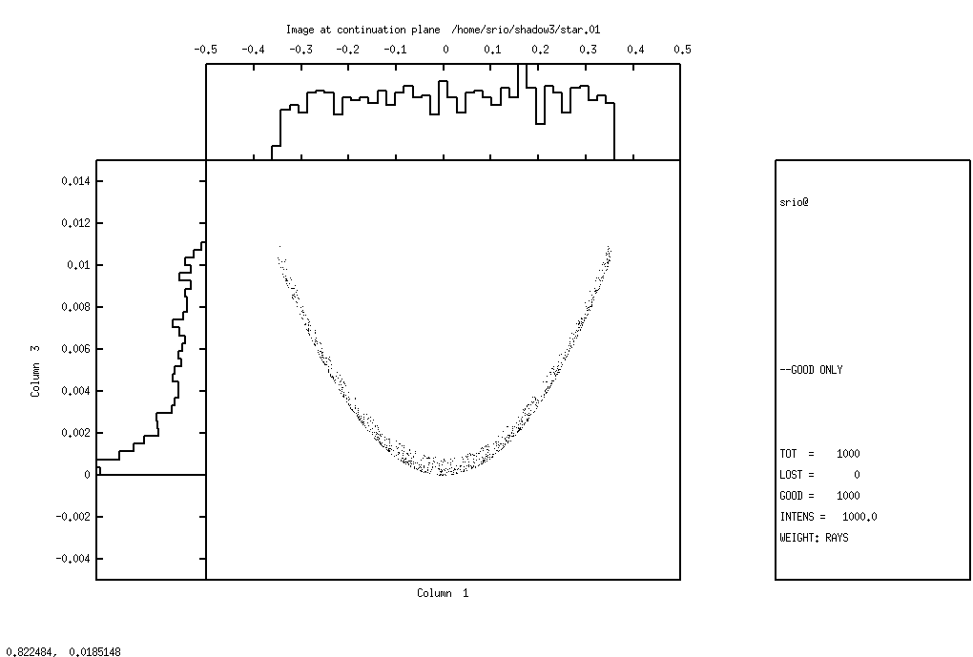
Figure 2.2: Image at continuation plane

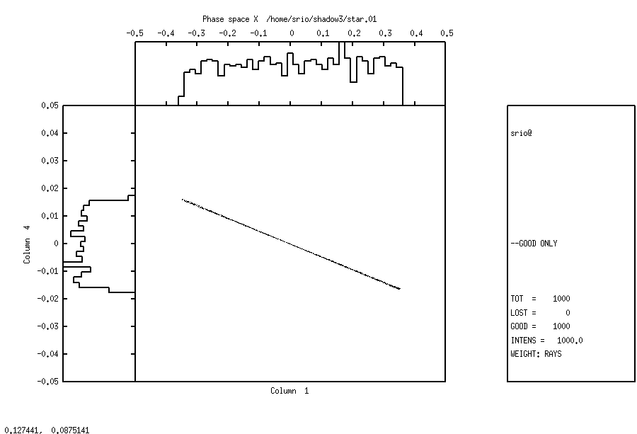

Figure 2.3: X-phase space

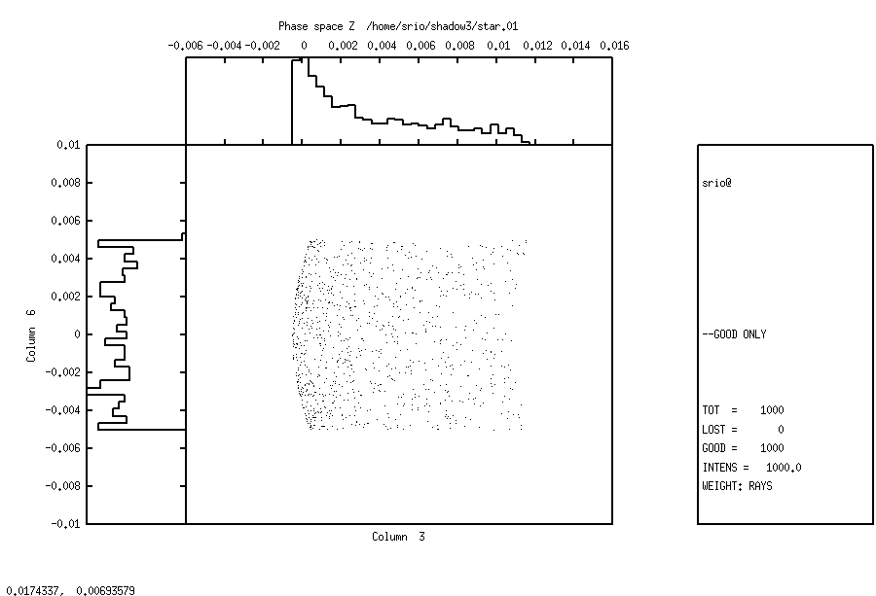
Figure 2.4: Z-phase space

Let us instead inspect in some detail the type of mirror that SHADOW has produced; for
this we will need the end.xx files.

Chapter 2.4 mirinfo | To rerun: shadow3<primer_ch24_ mirinfo.inp
shadow3> minrinfo
-------------------- M I R I N F O ----------------------

MirInfo: Mirror descriptor file. It must be an end.xx type.
MirInfo: Please input filename:
end.01
MirInfo: Title ?
PRIMER
MirInfo: Comment ?
FIRST MIRROR
MirInfo: Output file ?
mirror1.txt
shadow3> $cat mirror1.txt
++++++++++++++++++++++++++++++++++++++++++++++++++++++++++++++++++++++++++++++
******************** MIRROR DESCRIPTION ********************
++++++++++++++++++++++++++++++++++++++++++++++++++++++++++++++++++++++++++++++
PRIMER
FIRST MIRROR
++++++++++++++++++++++++++++++++++++++++++++++++++++++++++++++++++++++++++++++
Input file specified: end.01
Full file specification: /home/srio/shadow3/end.01
Creation date: 2010 12 29 17h 19min 25 s
++++++++++++++++++++++++++++++++++++++++++++++++++++++++++++++++++++++++++++++

Surface figure was defined as: SPHERICAL
Cylindrical figure NO
Element type REFLECTOR
Reflectivity OFF
Mirror dimensions UNLIMITED
++++++++++++++++++++++++++++++++++++++++++++++++++++++++++++++++++++++++++++++
Central Axis parameters :
Source Plane Distance 20.000000000000000
Image Plane 40.000000000000000
Incidence Angle 20.000237754631645
Reflection/Diffraction Angle 20.000237754631645

Mirror parameters COMPUTED
Same configuration as Central Axis YES
Objective focus at 20.000000000000000
Image focus at 40.000000000000000
Incidence angle 20.000237754631645
Parameters used follow:
Spherical Radius 28.3780000
Source of this O.E. moved NO
Mirror at pole position ( no mov. ) YES
++++++++++++++++++++++++++++++++++++++++++++++++++++++++++++++++++++++++++++++
*************** E N D ***************
++++++++++++++++++++++++++++++++++++++++++++++++++++++++++++++++++++++++++++++
shadow3>

Notice how SHADOW supplies us the mirror radius satisfying the requested focal conditions. Let us have a look now at the system geometry.

Chapter 2.4 sysinfo | To rerun: shadow3<primer_ch24_ sysinfo.inp
shadow3> sysinfo
-------------------- S Y S I N F O ----------------------

SysInfo: Default filenames [ Y/N ] ? Y
SysInfo: How many OE's ? 1
SysInfo: Title ? PRIMER
SysInfo: Comment ? system description
SysInfo: Output file : system.txt
shadow3>
shadow3> $cat system.txt

++++++++++++++++++++++++++++++++++++++++++++++++++++++++++++++++++++++++++++++
************** S Y S T E M D E S C R I P T I O N **************
++++++++++++++++++++++++++++++++++++++++++++++++++++++++++++++++++++++++++++++
PRIMER
system description
++++++++++++++++++++++++++++++++++++++++++++++++++++++++++++++++++++++++++++++
++++++++++++++++++++++++++++++++++++++++++++++++++++++++++++++++++++++++++++++
# Optical Element:
1 /home/srio/shadow3/end.01
++++++++++++++++++++++++++++++++++++++++++++++++++++++++++++++++++++++++++++++

Optical Element # 1 System Number:

MIRROR SPHERICAL UNLIMITED COMPUTED REFLEC. OFF

Orientation 0.0000000000000000 deg.
Source Plane 20.000000000000000
Incidence Ang. 20.000237754631645 deg.
Reflection Ang. 20.000237754631645 deg.
Image Plane 40.000000000000000
----------------

OPTICAL SYSTEM CONFIGURATION
Laboratory Reference Frame.

OPT. Elem # X = Y = Z =

0 0.0000000000 0.0000000000 0.0000000000
1 0.0000000000 20.000000000 0.0000000000
1' -0.0000000000 -10.641780112 25.711501543

++++++++++++++++++++++++++++++++++++++++++++++++++++++++++++++++++++++++++++++
*************** E N D ***************
++++++++++++++++++++++++++++++++++++++++++++++++++++++++++++++++++++++++++++++
shadow3>

Notice how SYSINFO lists the location of all elements in the laboratory reference frame. We can plot out the beam at the SCREEN location by using PLOTXY, just like we did before for STAR (the reference frame is the same).

BATCH mode run

This section will demonstrate the use of the BATCH input mode. This mode is particularly useful when used to re-trace an OE or a system defined in an earlier session. It assumes that the start.00 file, that contains the parameters describing the source, and start.01 , with those describing the optical element no. 1, are existing.

This section will then simply describe how:

- To generate a SOURCE in BATCH
- To trace an Optical Element in BATCH

We can access directly the source by typing:

Chapter 2.5 run1 | To rerun: shadow3<primer_25_run1.inp
shadow3>
shadow3> source

SOURCE selected. Begin procedure.
Select mode, enter :
prompt : prompted session
batch : file-oriented session
systemfile : file-oriented session using start.00

Select mode (prompt OR batch OR systemfile): batch
File containing source description [ Default: start.00 ] ?:start.00
Generated 250 rays out of 1000
500
750
1000
Exit from SOURCE

Source has been successfully generated.

SOURCE procedure completed.

shadow3> trace

Ray Tracing Selected. Begin procedure.

Mode selected [prompt OR batch OR systemfile] ?batch
Call to RESET
Exit from RESET
Mode selected is: batch

Options: to start anew [ 0 ]
to restart from a given OE [ 1 ]

Then ? 0

Input file [ EXIT terminates OS ] ?start.01
Tracing optical element # 1
Call to SETSOUR
Exit from SETSOUR
Call to IMREF
Exit from IMREF
Call to OPTAXIS
Exit from OPTAXIS
Call to MSETUP
Exit from MSETUP
Call to RESTART
Exit from RESTART
Call to MIRROR
Exit from MIRROR
Call to IMAGE
Exit from IMAGE
Call to DEALLOC
Exit from DEALLOC
Call to RESET
Exit from RESET

Do you want to change input mode ? 0

Input file [ EXIT terminates OS ] ?EXIT
shadow3>

The calculation is completed. Now we could run PLOTXY as shown earlier to out about the ray’s distribution. They should be identical to those obtained in the earlier runs.

SYSTEMFILE mode run

This is a slight variant of the BATCH mode introduced in SHADOW3. For the source, it is identical, but the file that contains the parameters describing the source must be names start.00. The file systemfile.dat contains the names of the files describing the OS, in this case start.01. If there are n optical elements, this file should contain n lines, with the names of the start files, typically from start.01 to start.0n. However, systemfile.dat may contain the names of files located in other directories and not necessarily named start.xx. It is a good practice to get rid of the calculation outputs (like star, mirr, etc.) and to keep only the start files (and the optical constants, if used). SHADOW is a very efficient program and it is often better to just regenerate the output rather than storing large amount of data. In any event, tree-structured directories are very helpful in keeping things straight. Meaningful names are also very helpful. This section will then simply describe how:

- To generate a SOURCE in SYSTEMFILE.
- To trace an Optical Element in SYSTEMFILE.

We can access directly the source by typing:

Chapter 2.6 run1 | To rerun: shadow3<primer_26_run1.inp
shadow3>
// make sure that the needed files exist
shadow3> $ls start.*
start.00 start.01
shadow3> $cat systemfile.dat
cat: systemfile.dat: No such file or directory
//OK, systemfile.dat does not exist, let us create it:
shadow3> $echo "start.01" > systemfile.dat
shadow3> $cat systemfile.dat
start.01
shadow3> source

SOURCE selected. Begin procedure.
Select mode, enter :
prompt : prompted session
batch : file-oriented session
systemfile : file-oriented session using start.00

Select mode (prompt OR batch OR systemfile): systemfile
Generated 250 rays out of 1000
500
750
1000
Exit from SOURCE

Source has been successfully generated.

SOURCE procedure completed.

shadow3> trace

Ray Tracing Selected. Begin procedure.

Mode selected [prompt OR batch OR systemfile] ?systemfile
Call to RESET
Exit from RESET
Mode selected is: systemfile

Options: to start anew [ 0 ]
to restart from a given OE [ 1 ]

Then ? 0

Tracing optical element # 1
Call to SETSOUR
Exit from SETSOUR
Call to IMREF
Exit from IMREF
Call to OPTAXIS
Exit from OPTAXIS
Call to MSETUP
Exit from MSETUP
Call to RESTART
Exit from RESTART
Call to MIRROR
Exit from MIRROR
Call to IMAGE
Exit from IMAGE
Call to DEALLOC
Exit from DEALLOC
Call to RESET
Exit from RESET
shadow3>

Output files

The disk files used by SHADOW have different purposes depending on their type. We notice that the name structure of the output files is fixed, while the input ones can be named at the user’s pleasure (with the exception of systemfile.dat). The only output files that may play any role on input are the star's (and maybe screen's). In particular, end files should never be used as input files instead of start's. After a run of SHADOW through a single OE you will typically find the following files.

ls -lt
%ls -lt
-rw-r--r-- 1 srio srio 5626 2010-12-29 17:51 end.01
-rw-r--r-- 1 srio srio 161 2010-12-29 17:51 effic.01
-rw-r--r-- 1 srio srio 104020 2010-12-29 17:51 mirr.01
-rw-r--r-- 1 srio srio 104020 2010-12-29 17:51 star.01
-rw-r--r-- 1 srio srio 645 2010-12-29 17:51 optax.01
-rw-r--r-- 1 srio srio 4483 2010-12-29 17:51 end.00
-rw-r--r-- 1 srio srio 104020 2010-12-29 17:51 begin.dat
-rw-r--r-- 1 srio srio 9 2010-12-29 17:51 systemfile.dat

The binary output files (double precision array) describe the collection of rays defining the beam at a particular location in the OS. Binary files generated by SHADOW are:

begin.dat
star.xx
mirr.xx
screen.xxyy

Parameter files contain the listing of the variables’ values that define a source or an OE. Examples of this type are:

start.xx
end.xx

A closer look at each file will help you find the information you need.

begin.dat
Binary file which contains an array describing the source. Generated on exit from SOURCE.

mirr.xx
Binary file storing the intercepts of the beam on a surface, OE xx, in the mirror reference frame. This file is notable for its use in plotting the illuminated area on the OE. Generated on exit from TRACE.

star.xx
Binary file storing the intercepts at an image (or continuation) plane xx. Generated on exit from TRACE.

start.xx
start.00 is a parameter file containing the data entered during SOURCE to describe the source. Similarly, start.xx contains data describing OE xx.

end.xx
end.00 is a parameter file which contains the parameters for the source (state) at the end of the SOURCE run. end.xx contains parameters for OE xx on exit from TRACE. When the actual source generation and tracing processes occur, some variables of start.xx may be modified or recalculated and stored in end.xx. end.xx files are need by:
- sysinfo --> returns information on the whole OS
- mirinfo --> on a given OE
- sourcinfo --> on the source

screen.xxyy
Binary file containing the intercepts of the beam at screen yy in OE xx. Generated on exit from TRACE.

effic.xx
This file contains information on the “optical efficiency” of OE xx. It will tell you the number of rays transmitted through a particular OE, as well as the mirror average reflectivity. Generated on exit from TRACE.

systemfile.dat
File containing the names of the start.xx files to be used in the TRACing process. It is normally generated by using an editor (PROMPT does not generate it). It is used in batch and menu mode to supply the names of the files containing OE descriptions.

SRDISTR, SRSPEC,SRANG
These files contain the universal functions for the SR bending magnet sources. Since SHADOW3, they are generated only when SHADOW cannot find them in a data directory pointed by an appropriate environment variable.

STOTxxxxx, SPARxxxxx, SPERxxxxx
These files contain the vertical distribution of an SR source, and thus are generated only when an exact SR bending magnet source is chosen. The photon energy is specified by xxxxx.

RMIR.xx
Binary file generated when the “Move Mirror” option is chosen. Contains the intercepts of the beam at the moved mirror position.

Angle.xx
ASCII file containing information about the incidence and reflection angles for each ray for a given optical element. File contains: ray number, incidence angle, reflection angle, and whether the ray is good or lost. Only created if “Save incidence angle information” option is chosen.

These files are the most important ones. Once more, we urge the user to meaningful names, to avoid endless frustration during late-night runs.

Preliminary programs

Following is a list of external files that the users may need to have before running SHADOW. They may be prepared by the user in the format SHADOW requires, or by preliminary programs available under the shadow3> prompt, described in detail in the USER’s GUIDE (UsG).

- Diffraction profile of a crystal [UsG – bragg]
- Optical constants for calculating reflection coefficient of a mirror [UsG – prerefl].
- Optical constants for calculating absorption by a screen placed along the OS [UsG – prerefl].
- Specifications of surface errors introduced on a mirror surface [UsG – presurface, or User Supplied]
- File with insertion device distribution – undulator or wiggler. [UsG – make_id].

Files of the type (1) and (2) are briefly described below, since they will be needed for the examples in Chapter 6. They both utilize the optical constant library in the file F12LIB.FULL.

bragg
This is a preliminary program which lets the users specify a crystal structure and write out the parameters in such a way that SHADOW can readily use it to compute the reflection coefficients. Dynamical diffraction calculation including crystal absorption is used following Zachariasen formalism for perfect crystals. Optional rocking curves can also be generated for immediate check (See the examples in Chapter 6 and the UsG for more information).

prerefl
This is a preliminary program that generates the complex dielectric constant for the mirror (or filter) material from the atomic scattering factor library and data supplied from the user. The (unformatted) file is read by SHADOW and used to compute the local reflectivity based on Fresnel equations, as well as the phase shifts.

presurface
The program will read from a user-supplied file a mesh describing the surface. This can be either a surface error, in the sense of a small perturbation z = z(x,y) to the ideal mirror surface or a mirror surface in its own right (although it could always be interpreted as a perturbation to a plane surface). presurface generates the coefficients of a bicubic spline to be used by SHADOW in computing the intercepts. Due to the limited precision of these interpolations, we strongly suggest that presurface be used only for surface errors and pathological surfaces.

make_id
To generate sources that are insertion devices, we must do some preliminary calculations. make_id is the utility that generates the integrated probability distribution function for the undulators, and the CDF of photon emission for the wigglers. The files are binary and read in by the SOURCE in SHADOW. There are detailed examples in the User’s Guide for the Source and for the Utilities

Analysis programs

SHADOW provides a set of programs to analyze the results of the calculations. Here are a few to get you started. In the following descriptions, BOF refers to a binary output file, i.e., a ray file generated by SHADOW. A BOF is unformatted thus unreadable by typing to the terminal whereas a formatted file is one you can type to the terminal. All programs are launched by typing the name of the program unless otherwise specified.

Basic

plotxy
Generates a scatter, connected, contour or pixelated plot using any two rows of the ray file (i.e., star.xx, mirr.xx, begin.dat) as horizontal and vertical axes. Histograms are also available.

Input: binary output file.
Output: ASCII files with data to plot, and gnuplot command file plotxy.gpl.

translate
Translates an unformatted BOF (i.e., begin.dat, mirr.xx) into a formatted file. The twelve to eighteen rows of each ray are displayed in the output file as shown:

X Y Z Spatial coordinate
X’ Y’ Z’ Direction
Asx Asy Asz EM vector (s-)
FF q kk Flag, wavenumber, ray index
opd Fs Fp optical path length, phases
Apx Apy Apz EM vector (p-)

Input: binary output file.
Output: terminal or user-named formatted file.

histo1
Creates the histogram describing the distribution of the rays within the limits specified by the user. The histogram can be displayed using gnuplot or the file can be written and later supplied to gnuplot or exported to any other program. The histogram will exhibit the real intensity if the absorption of the OE has been taken into account, or will exhibit the geometrical image if the absorption has not been accounted for.

Input: a binary output file.
Output: ASCII file with data to plot, and gnuplot command file histo1.gpl.

Advanced

ffresnel
Takes a BOF (star.xx or screen.xxyy) and creates a file containing the diffracted image of this aperture. You must keep polarization and phase information (i.e., answer YES to POLARIZED source)

Input: a binary output file.
Output: a formatted file FFPAR storing the responses to the input session needed to define the image. A formatted, two-column file FFRESNEL.

intens
Generates a plottable file containing the locally absorbed or transmitted radiation across an OE from BOF (i.e., mirr.xx).

Input: a binary ray file and "input IO file"
Output: a user-named, formatted, two-column file.

focnew
Searches a BOF (i.e., mirr.xx, star.xx) for a minimum in the waist (i.e., the best Gaussian focus of the beam for both sagittal and tangential directions), and returns the optimum focal distance measured relative to the original image file. You have the option to generate a two-column plottable file of the waist size vs. position along the direction of propagation.

Input: a binary input file.
Output: a formatted file focus, plus a user-named, formatted, two column file.

Suggestions: To plot the beam variance file, use Y log-scale. This creates a better plot.

Further Examples

Two Mirror Optical System
As a simple example of the use of SHADOW with a realistic synchrotron source, let us consider the case of a two-mirror system to be installed at a SR machine to relay the radiation to the input slit of a monochromator. A pair of elliptical mirrors has been selected, with the goal of achieving an overall demagnification of a factor of 8. The parameters are as indicated in Fig. 1.2. These, together with the source specification, are the only input we need in order to trace the system. We will use, for brevity, the TERSE mode. If you are not sure of the question’s meaning, compare with the VERBOSE example(s) of the former chapter. In this section we will then show how to:

- To define a Synchrotron Radiation source
- To trace an optical system formed by two optical elements
- To use plotxy to look at the results by scatter plots and by contour plots

Let us then begin by specifying the source; we select the case of a Synchrotron source .

Chapter 6.1 run1 | To rerun: shadow3<primer_ch61_run1.inp
shadow3> source

SOURCE selected. Begin procedure.
Select mode, enter :
prompt : prompted session
batch : file-oriented session
systemfile : file-oriented session using start.00

Select mode (prompt OR batch OR systemfile): prompt
Call to INPUT_SOURCE
--------------------------------- S H A D O W -------------------------------

Defining source :
When prompted for a yes/no answer, you may enter:
for YES answer Y*, y*, 1*
for NO answer anything else

Do you want a verbose [ 1 ] or terse [ 0 ] output ? 0

------------- SOURCE SPECS ------------------
Source modelling type [ 0-5 ] ? 0
How many rays [Default=30000] ? 1000
Seed [ odd, 1000 - 1 000 000 ] ? 1111111
Do you want to optimize the source ? 0

Source type : [ 0 ] regular (geometrical or bending magnet) source
[ 1 ] normal wiggler
[ 2 ] undulator
[ 3 ] elliptical wiggler
Then ? 0

X-Z plane source type [ 0-3, 6 ] ? 3
Sigma along X ? 1
Z ? .2

Source Depth [ 1-4 ] ? 4

Source Angle Distribution [ 1-6 ] ? 4
Horizontal half-divergence [ (+)x, rads ] ? .005
[ (-)x, rads ] ? .005
Vertical [ (+)z, rads ] ? .0025
[ (-)z, rads ] ? .0025

// NOTE: SHADOW calculates the correct vertical divergence for a synchrotron source if the user places a larger value here. Otherwise SHADOW cuts the vertical distribution to the selected values.

Magnetic Radius [ m ] ? 2
Notice: the ORBIT radius MUST be in the same units as the rest of the optical system.
Use negative ORBIT radius argument for CCW storage ring.
Orbit Radius [ same as other units ] ? 2000
Do you want to include electron beam emittances [ Y/N ] ? 0
Electron Beam Energy [ GeV ] ? 1
Polarization Selected [ 1-3 ] ? 3
Distribution type [0,1] ? 0
Energy distribution [ 1-4 ] ? 1
Photon Energy [ 0 ] or Angstroms [ 1 ] ? 0
Energy [ eV ] ? 500

Do you want to store the optical paths (OPD) [Y/N] ? 0
Do you want to generate the A vectors (electric field) [Y/N] ? 0
Exit from INPUT_SOURCE
File SRSPEC not found: Creating it!
File written to disk: SRDISTR
File written to disk: SRSPEC
File written to disk: SRANG
//Note that SHADOW3 created these files with SR distributions.

Generated 250 rays out of 1000
500
750
1000
Exit from SOURCE

Source has been successfully generated.

SOURCE procedure completed.

//The source has now been generated. We define and trace the Optical system.
shadow3> trace

Ray Tracing Selected. Begin procedure.

Mode selected [prompt OR batch OR systemfile] ?prompt
Call to RESET
Exit from RESET
Mode selected is: prompt

Options: to start anew [ 0 ]
to restart from a given OE [ 1 ]

Then ? 0

Call to INPUT_OE
--------------------------------- S H A D O W -------------------------------

When prompted for a yes/no answer, you may enter:
for YES answer Y*, y*, 1*
for NO answer anything else

Defining Optical Element: 1
Continue ? [ EXIT to terminate OS ] <enter>

Do you want a verbose [ 1 ] or terse [ 0 ] output ? 0

Files to write out. Options:
All............................ [ 0 ]
Mirror only.....................[ 1 ]
Image at CP only................[ 2 ]
None............................[ 3 ]
Then ? 0

Optical Element definition:
Incidence Angle ? 88
Source Distance ? 2000
Reflection Angle? 88
Image Distance ? 500
Reflector [ 0 ] or refractor [ 1 ] ? 0

Is this a segmented mirror system? 0
Is this a Kumakhov system? 0
A: Is this mirror faceted [Y/N] ? 0
Mirror surface [ 1-9] ? 2
Do you want to specify the mirror parameters ? 0
Is the mirror Cylindrical ? 0
Is this optical element a Fresnel Zone Plate ? 0
Are we dealing with a Grating ? 0

Are we dealing with a crystal [ Y/N ] ? 0
Is the mirror convex [ Y/N ] ? 0
Reflectivity mode [ 0,1,2 ] ? 0

Orientation Angle [ Alpha ] ? 0

Mirror Dimensions finite [ Y/N ] ? 0

Focii placed at continuation planes [ Y/N ] ? 1

Save incidence and reflection angles to disk? 0
Do you want to move the Source [ Y/N ] ? 0
Do you want to move the mirror itself [ Y/N ] ? 0
Distorted surface [ Y/N ] ? 0
Do you want to include surface roughness [Y/N] ? 0

Any screens in this OE [ Y/N ] ? 0

Slit at continuation plane [ Y/N ] ? 0
Extra Image plates [ Y/N ] ? 0
File containing the source array [Default: begin.dat] ? begin.dat
Exit from INPUT
Tracing optical element # 1
Call to SETSOUR
…
//We have abbreviated the process of ray tracing as shown.
Exit from RESET

//The first element completed, SHADOW begins with the definition of the second one. Before beginning, the program checks if the user wants to change input mode. This is useful if an optical system has already been run once, so that START files are available and the user wants to modify only a given OE. In the present case we will stay in PROMPT mode.
Do you want to change input mode ? 0

Call to INPUT_OE
--------------------------------- S H A D O W -------------------------------

Defining Optical Element: 2
Continue ? [ EXIT to terminate OS ] <enter>

Do you want a verbose [ 1 ] or terse [ 0 ] output ? 0

Files to write out. Options:
All............................ [ 0 ]
Mirror only.....................[ 1 ]
Image at CP only................[ 2 ]
None............................[ 3 ]
Then ? 0

Optical Element definition:
Incidence Angle ? 88
Source Distance ? 1000
Reflection Angle? 88
Image Distance ? 500
Reflector [ 0 ] or refractor [ 1 ] ? 0

Is this a segmented mirror system? 0
Is this a Kumakhov system? 0
A: Is this mirror faceted [Y/N] ? 0
Mirror surface [ 1-9] ? 2
Do you want to specify the mirror parameters ? 0
Is the mirror Cylindrical ? 0
Is this optical element a Fresnel Zone Plate ? 0
Are we dealing with a Grating ? 0

Are we dealing with a crystal [ Y/N ] ? 0
Is the mirror convex [ Y/N ] ? 0
Reflectivity mode [ 0,1,2 ] ? 0

Orientation Angle [ Alpha ] ? 180

Mirror Dimensions finite [ Y/N ] ? 0

Focii placed at continuation planes [ Y/N ] ? 1

Save incidence and reflection angles to disk? 0
Do you want to move the Source [ Y/N ] ? 0
Do you want to move the mirror itself [ Y/N ] ? 0
Distorted surface [ Y/N ] ? 0
Do you want to include surface roughness [Y/N] ? 0

Any screens in this OE [ Y/N ] ? 0

Slit at continuation plane [ Y/N ] ? 0
Extra Image plates [ Y/N ] ? 0
Exit from INPUT
...
Exit from RESET

Do you want to change input mode ? 0

Call to INPUT_OE
--------------------------------- S H A D O W -------------------------------

Defining Optical Element: 3
Continue ? [ EXIT to terminate OS ] EXIT

End of session

shadow3>
shadow3>

The tracing has been completed and it is now time to have a look at the results. For this we will use plotxy, a general-purpose plotting program. We are interested in finding out the area of each mirror which is illuminated and the final and intermediate image. We start with a scatter plot of the radiation “footprint” on the mirrors. The image plots are generated in the same way. Notice how we use row (1,2) for the mirrors and rows (1,3) for the images.

Chapter 6.1 plotxy | (included in shadow3<primer_ch61_run1.inp)
shadow3> plotxy
PLOT> Input file? mirr.01
PLOT> Options --- Enter
PLOT> 0 for excluding the losses
PLOT> 1 for including only the losses
PLOT> 2 for including all the rays.
PLOT> Then ? 0
PLOT> Comment for plot [ 80 char ] ?
*******************/*******************/*******************/*******************/
Footprint on Mirror 1

PLOT> Found 1000 good points out of 1000
PLOT> The following columns are defined for each ray
1) the regular columns [1-12]

Col Par Minimum: Maximum: Center: St. Dev.:

1 X -11.523 11.018 0.22264 5.8004
2 Y -107.07 56.911 -18.107 29.237
3 Z 0.18644E-03 2.4657 0.62679 0.55680
4 X' -0.22408E-01 0.20863E-01 -0.43927E-03 0.11018E-01
5 Y' 0.99921 0.99955 0.99940 0.60499E-04
6 Z' 0.24733E-01 0.39190E-01 0.32580E-01 0.26252E-02
11 Photon Energy (eV) 500.00 500.00
20 Numerical Aperture 0.30067E-01 0.39671E-01
Total Intensity: 1000.0000000000000

PLOT> Options. You may plot any two rows from
the above list versus each other.
You may also plot any of them versus the
ray Numerical Aperture. N.A. -- enter 20.

PLOT> Rows to use for plot :
PLOT> for horizontal axis ? 1
PLOT> for vertical axis ? 2

PLOT> Scaling options. Enter

0 For automatic scaling
1 For cartesian scaling
2 For external limits
PLOT> Then ? 0
PLOT> Plotting options :
0 For scattered plot
1 For pixelized plot
2 For contour plot
PLOT> Then ? 0
PLOT> Ready for histograms. Enter:
-1 to skip
0 for same limits as plot
PLOT> ? 0
PLOT> Number of bins for X axis [default = 55] : 55
PLOT> Number of bins for Y axis [default = 55] : 55
File written to disk: plotxy_scatter.dat
File written to disk: plotxy_histtop.dat
File written to disk: plotxy_histside.dat
File written to disk: plotxy.gpl
shadow3>
shadow3>
shadow3> $gnuplot plotxy.gpl
// This creates the plot in Fig 6.1
Press <Enter> to end graphic
shadow3>
shadow3>
shadow3>
shadow3>
// idem for mirror 2 (file mirr.02). Results are in Fig. 6.2

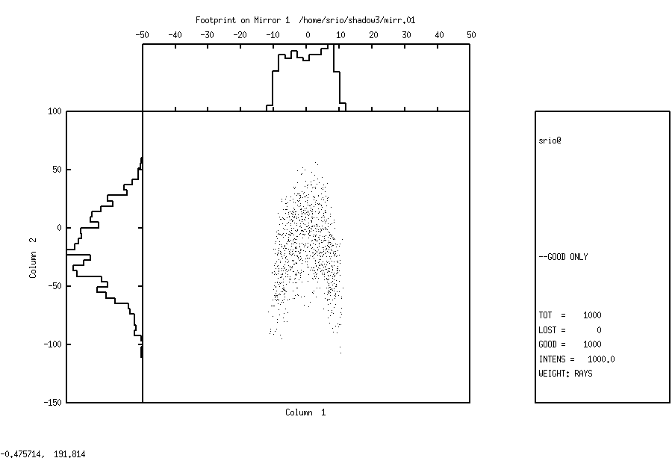
Figure 6.1: Footprint on mirror 1

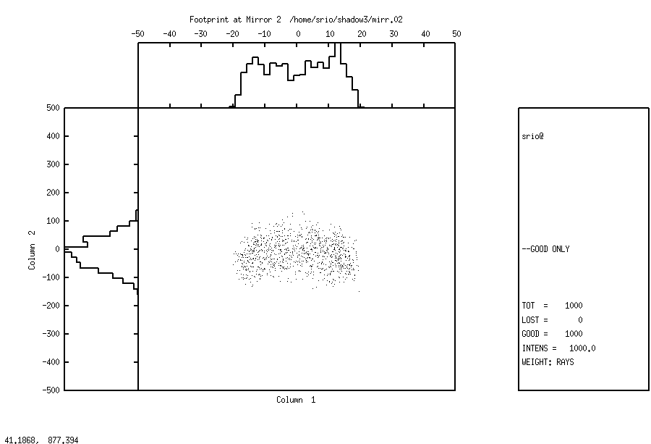
Figure 6.2: Footprint on mirror 2

The following next plots include the plot on the intermediate plane between the two mirrors (file star.01) and the final image (file star.02). We profit these examples to demonstrate the use of contour curves for the intermediate image, and pixelized image (for the final image).

Chapter 6.1 contour | To rerun: shadow3<primer_ch61_contour.inp
shadow3> plotxy
PLOT> Input file? star.01
PLOT> Options --- Enter
PLOT> 0 for excluding the losses
PLOT> 1 for including only the losses
PLOT> 2 for including all the rays.
PLOT> Then ? 0
PLOT> Comment for plot [ 80 char ] ?
*******************/*******************/*******************/*******************/
Intermediate Image

PLOT> Found 1000 good points out of 1000
PLOT> The following columns are defined for each ray
1) the regular columns [1-12]

Col Par Minimum: Maximum: Center: St. Dev.:

1 X -0.89219 0.83959 -0.97934E-03 0.23750
2 Y -0.13880E-12 0.22968E-12 0.46339E-13 0.57910E-13
3 Z -0.54263 0.29230 -0.14634E-01 0.11410
4 X' -0.22408E-01 0.20863E-01 -0.43927E-03 0.11018E-01
5 Y' 0.99973 1.0000 0.99993 0.58878E-04
6 Z' -0.10165E-01 0.42939E-02 -0.23186E-02 0.26253E-02
11 Photon Energy (eV) 500.00 500.00
20 Numerical Aperture 0.21798E-03 0.23108E-01
Total Intensity: 1000.0000000000000

PLOT> Options. You may plot any two rows from
the above list versus each other.
You may also plot any of them versus the
ray Numerical Aperture. N.A. -- enter 20.

PLOT> Rows to use for plot :
PLOT> for horizontal axis ? 1
PLOT> for vertical axis ? 3

PLOT> Scaling options. Enter

0 For automatic scaling
1 For cartesian scaling
2 For external limits
PLOT> Then ? 0
PLOT> Plotting options :
0 For scattered plot
1 For pixelized plot
2 For contour plot
PLOT> Then ? 2
PLOT> Number of bins [Nx by Ny] to prepare the grids.
PLOT> Nx [Default=101]: 21
PLOT> Ny [Default=101]: 21
PLOT> Number of contours [Default=10] : 11
PLOT> Included reflectivity ? 0
Smoothing [ Y/N ] ? 0
PLOT> Ready for histograms. Enter:
-1 to skip
0 for same limits as plot
PLOT> ? 0
File written to disk: plotxy_grid.dat
File written to disk: plotxy_histtop.dat
File written to disk: plotxy_histside.dat
File written to disk: plotxy.gpl
shadow3>
shadow3> $gnuplot plotxy.gpl
// Result in Fig. 6.3
Press <Enter> to end graphic
shadow3>

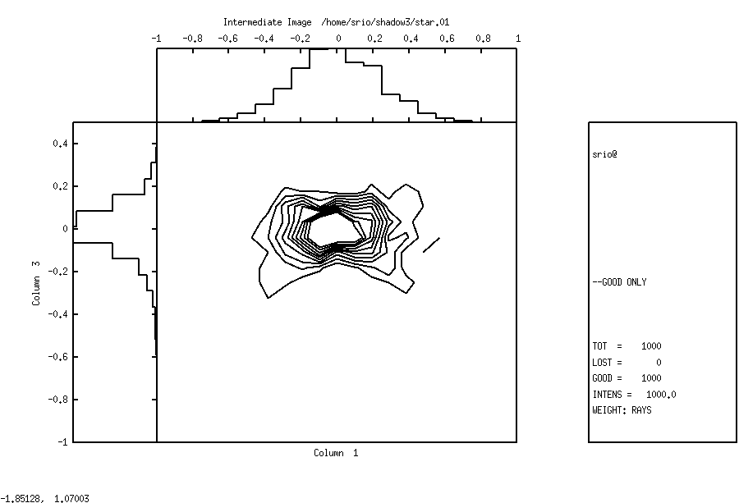

Figure 6.3: Contour plot of intermediate image

And now the final image.

Run 6.1 pixelized | To rerun: shadow3<primer_ch61_pixelized.inp
shadow3> plotxy
PLOT> Input file? star.02
PLOT> Options --- Enter
PLOT> 0 for excluding the losses
PLOT> 1 for including only the losses
PLOT> 2 for including all the rays.
PLOT> Then ? 0
PLOT> Comment for plot [ 80 char ] ?
*******************/*******************/*******************/*******************/
Final Image

PLOT> Found 1000 good points out of 1000
PLOT> The following columns are defined for each ray
1) the regular columns [1-12]

Col Par Minimum: Maximum: Center: St. Dev.:

1 X -0.33550 0.39833 0.75203E-04 0.11157
2 Y -0.16061E-12 0.24525E-12 0.48731E-13 0.54842E-13
3 Z -0.36404 0.17837 -0.19043E-01 0.78524E-01
4 X' -0.40058E-01 0.38649E-01 -0.78828E-03 0.20759E-01
5 Y' 0.99900 1.0000 0.99975 0.21972E-03
6 Z' -0.24326E-01 0.11192E-01 -0.60488E-02 0.62859E-02
11 Photon Energy (eV) 500.00 500.00
20 Numerical Aperture 0.31540E-03 0.44843E-01
Total Intensity: 1000.0000000000000

PLOT> Options. You may plot any two rows from
the above list versus each other.
You may also plot any of them versus the
ray Numerical Aperture. N.A. -- enter 20.

PLOT> Rows to use for plot :
PLOT> for horizontal axis ? 1
PLOT> for vertical axis ? 3

PLOT> Scaling options. Enter

0 For automatic scaling
1 For cartesian scaling
2 For external limits
PLOT> Then ? 0
PLOT> Plotting options :
0 For scattered plot
1 For pixelized plot
2 For contour plot
PLOT> Then ? 1
PLOT> Number of bins [Nx by Ny] to prepare the grids.^M
PLOT> Nx [Default=101]: 101
PLOT> Ny [Default=101]: 101
PLOT> Included reflectivity ? 0
Smoothing [ Y/N ] ? 0
PLOT> Plotting options :
0 For scattered plot
1 For pixelized plot
2 For contour plot
PLOT> Then ? 0
PLOT> Ready for histograms. Enter:
-1 to skip
0 for same limits as plot
PLOT> ? 0
File written to disk: plotxy_grid.dat
File written to disk: plotxy_histtop.dat
File written to disk: plotxy_histside.dat
File written to disk: plotxy.gpl
shadow3>
shadow3>
shadow3> $gnuplot plotxy.gpl
//See result in Fig. 6.4. For comparison purposes, the scatter plot is shown in Fig. 6.5, but there is no log shown.
Press <Enter> to end graphic
shadow3>

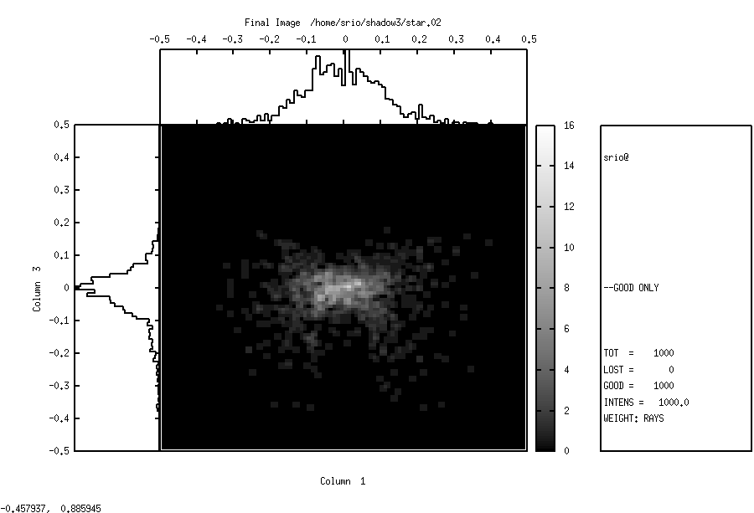
Figure 6.4: Pixelized plot of Final Image

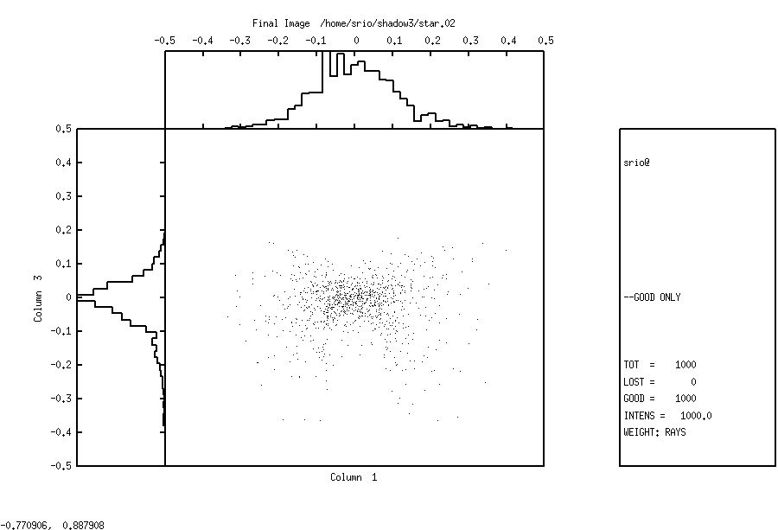
Figure 6.5: Scatter plot of Final Image

Diffraction Grating in Rowland Circle Mount

The purpose of this section is to familiarize the user with the treatment of diffraction cases. The analysis of diffraction gratings is one of the central features of SHADOW. There are many different types of gratings and monochromator mounts. Here we will introduce the study of diffraction by having a look to the simple case of a spherical grating in the Rowland mount. We recall that a slit located on the Rowland circle will be imaged on the same circle, at unit magnification, at a position dependent on the wavelength. We will start with the case of a monochromatic rectangular source (slit) and then proceed to study the resolution of the grating by using a source with three different wavelengths. The procedure to be followed is typical of other systems.

One of the nice features of SHADOW is the capability of the program to figure out by itself the parameters of a mirror and/or diffraction grating. This extends to the calculation of the system geometry, since it is always annoying to have to compute the incidence and diffraction angles, etc. It is enough to request that SHADOW sets up the grating’s angles to satisfy the particular mount geometrical conditions for a given wavelength. In this section we will then discuss how:

- to define an OE containing diffraction grating.
- to use the AUTOTUNE switch of SHADOW
- to use recolor
- to use plotxy to study the resolution.

Let’s assume that we want to study the behavior of a grazing angle 2m spherical grating, with a line density of 1200 lines/mm, to be used at 88º angle of incidence (typical Grasshopper) as shown in Fig. 6.6. The entrance slit is modeled by a rectangular source, 20 mm high and 2 mm wide, at a photon energy of 200 eV. At this energy, we have the geometry specified in the first run of TRACE.

In the second, we simply tell SHADOW that the mount is a Rowland one, fixed angle of incidence, and let the program compute the angles.

Figure 6.6: Rowland Circle Geometry

Chapter 6.2 run1 | To rerun: shadow3<primer_ch62_run1.inp
shadow3> source

SOURCE selected. Begin procedure.
Select mode, enter :
prompt : prompted session
batch : file-oriented session
systemfile : file-oriented session using start.00

Select mode (prompt OR batch OR systemfile): prompt
Call to INPUT_SOURCE
--------------------------------- S H A D O W -------------------------------

Defining source :
When prompted for a yes/no answer, you may enter:
for YES answer Y*, y*, 1*
for NO answer anything else

Do you want a verbose [ 1 ] or terse [ 0 ] output ? 0

------------- SOURCE SPECS ------------------
Source modelling type [ 0-5 ] ? 0
How many rays [Default=30000] ? 2000
Seed [ odd, 1000 - 1 000 000 ] ? 1000111
Do you want to optimize the source ? 0

Source type : [ 0 ] regular (geometrical or bending magnet) source
[ 1 ] normal wiggler
[ 2 ] undulator
[ 3 ] elliptical wiggler
Then ? 0

X-Z plane source type [ 0-3, 6 ] ? 1
Source Width [ x ] ? 2
Height [ z ] ? .02

Source Depth [ 1-4 ] ? 1

Source Angle Distribution [ 1-6 ] ? 1
Horizontal half-divergence [ (+)x, rads ] ? .005
[ (-)x, rads ] ? .005
Vertical [ (+)z, rads ] ? .005
[ (-)z, rads ] ? .005
Do you want a Photon energy [ Y/N ] ? 1
Energy distribution [ 1-4 ] ? 1
Photon Energy [ 0 ] or Angstroms [ 1 ] ? 0
Energy [ eV ] ? 200

Do you want to store the optical paths (OPD) [Y/N] ? 0
Do you want to generate the A vectors (electric field) [Y/N] ? 0
Exit from INPUT_SOURCE
Generated 250 rays out of 2000
500
750
1000
1250
1500
1750
2000
Exit from SOURCE

Source has been successfully generated.

SOURCE procedure completed.

shadow3>
shadow3>
shadow3> trace

Ray Tracing Selected. Begin procedure.

Mode selected [prompt OR batch OR systemfile] ?prompt
Call to RESET
Exit from RESET
Mode selected is: prompt

Options: to start anew [ 0 ]
to restart from a given OE [ 1 ]

Then ? 0

Call to INPUT_OE
--------------------------------- S H A D O W -------------------------------

When prompted for a yes/no answer, you may enter:
for YES answer Y*, y*, 1*
for NO answer anything else

Defining Optical Element: 1
Continue ? [ EXIT to terminate OS ] <enter>

Do you want a verbose [ 1 ] or terse [ 0 ] output ? 0

Files to write out. Options:
All............................ [ 0 ]
Mirror only.....................[ 1 ]
Image at CP only................[ 2 ]
None............................[ 3 ]
Then ? 0

Optical Element definition:
Incidence Angle ? 88
Source Distance ? 69.798
Reflection Angle? 82.726
Image Distance ? 253.233
Reflector [ 0 ] or refractor [ 1 ] ? 0

Is this a segmented mirror system? 0
Is this a Kumakhov system? 0
A: Is this mirror faceted [Y/N] ? 0
Mirror surface [ 1-9] ? 1
Do you want to specify the mirror parameters ? 1
//Notice how we tell SHADOW that the mirror is fully user specified.
Is the mirror Cylindrical ? 0
Is this optical element a Fresnel Zone Plate ? 0
Are we dealing with a Grating ? 1

Type of ruling.
0 ruling density constant on the X-Y plane
1 for ruling density constant onto the mirror surface.
2 for an holographic grating.
3 for an oriental-fan type
4 reserved
5 polynomial line density
Then: 0
Lines per CM ? 12000
Diffraction Order ? -1
Auto Tuning of Grating [ Y/N ] ? 0
// SHADOW knows that we are dealing with a grating and offers to ’align’ it at the right wavelength. For now, we decline.

Is the mirror convex [ Y/N ] ? 0
Reflectivity mode [ 0,1,2 ] ? 0

Orientation Angle [ Alpha ] ? 0

Mirror Dimensions finite [ Y/N ] ? 0

Spherical Mirror Radius ? 2000
// Had we not elected to specify the mirror/grating parameters, SHADOW would not have asked this question.

Save incidence and reflection angles to disk? 0
Do you want to move the Source [ Y/N ] ? 0
Do you want to move the mirror itself [ Y/N ] ? 0
Distorted surface [ Y/N ] ? 0
Do you want to include surface roughness [Y/N] ? 0

Any screens in this OE [ Y/N ] ? 0

Slit at continuation plane [ Y/N ] ? 0
Extra Image plates [ Y/N ] ? 0
File containing the source array [Default: begin.dat] ? begin.dat
Exit from INPUT
Tracing optical element # 1
Call to SETSOUR
...
Exit from DEALLOC
Call to RESET
Exit from RESET

Do you want to change input mode ? 0

Call to INPUT_OE
--------------------------------- S H A D O W -------------------------------

Defining Optical Element: 2
Continue ? [ EXIT to terminate OS ] EXIT

End of session

shadow3>
//Let’s have a look at the image quality.
shadow3> plotxy
PLOT> Input file? star.01
PLOT> Options --- Enter
PLOT> 0 for excluding the losses
PLOT> 1 for including only the losses
PLOT> 2 for including all the rays.
PLOT> Then ? 0
PLOT> Comment for plot [ 80 char ] ?
*******************/*******************/*******************/*******************/
Final image for a single beam energy

PLOT> Found 2000 good points out of 2000
PLOT> The following columns are defined for each ray
1) the regular columns [1-12]

Col Par Minimum: Maximum: Center: St. Dev.:

1 X -2.5131 2.5619 0.68732E-01 1.1026
2 Y -0.11165E-12 0.10935E-12 -0.37338E-14 0.28581E-13
3 Z -0.11207E-01 0.15941E-01 0.53315E-03 0.60637E-02
4 X' -0.49968E-02 0.50273E-02 0.19377E-03 0.28232E-02
5 Y' 0.99997 1.0000 0.99999 0.52573E-05
6 Z' -0.46486E-02 0.55630E-02 0.70524E-04 0.29298E-02
11 Photon Energy (eV) 200.00 200.00
20 Numerical Aperture 0.12445E-03 0.73475E-02
Total Intensity: 2000.0000000000000

PLOT> Options. You may plot any two rows from
the above list versus each other.
You may also plot any of them versus the
ray Numerical Aperture. N.A. -- enter 20.

PLOT> Rows to use for plot :
PLOT> for horizontal axis ? 1
PLOT> for vertical axis ? 3

PLOT> Scaling options. Enter

0 For automatic scaling
1 For cartesian scaling
2 For external limits
PLOT> Then ? 0
PLOT> Plotting options :
0 For scattered plot
1 For pixelized plot
2 For contour plot
PLOT> Then ? 0
PLOT> Ready for histograms. Enter:
-1 to skip
0 for same limits as plot
PLOT> ? 0
PLOT> Number of bins for X axis [default = 55] : <enter>
PLOT> Number of bins for Y axis [default = 55] : <enter>
File written to disk: plotxy_scatter.dat
File written to disk: plotxy_histtop.dat
File written to disk: plotxy_histside.dat
File written to disk: plotxy.gpl
shadow3>
shadow3> $gnuplot plotxy.gpl
// See plot in Fig. 6.7
Press <Enter> to end graphic
shadow3>

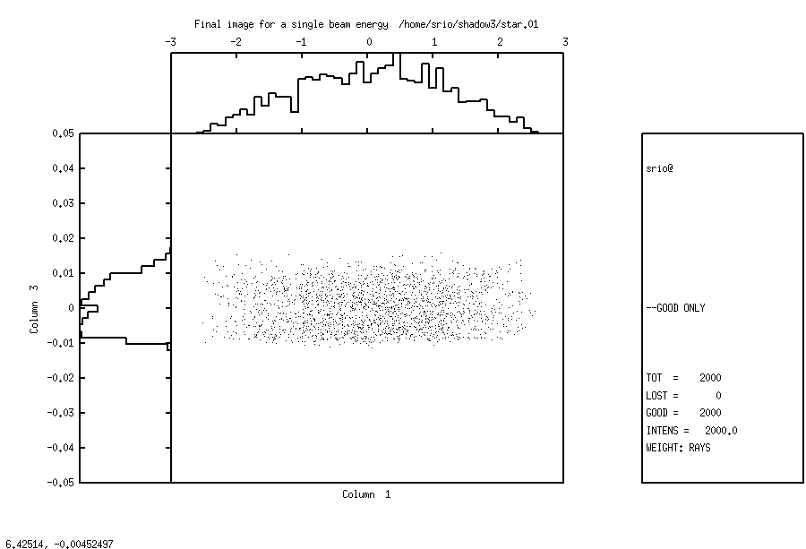
Figure 6.7: Final Image for a single beam energy

After this first example, let us proceed to a more complex one. A monochromator is designed to separate wavelengths, so let us verify the resolution of this mount. We will now use recolor to create a new source file with three different photon energies.

Chapter 6.2 recolor | To rerun: shadow3<primer_ch62_recolor.inp
shadow3>
shadow3> recolor
File for input ?
begin.dat
and for output ?
begin.new
Data ready. Read 2000 points.
Are you going to specify energies in eV [ 0 ] or wavelengths in angstroms [ 1 ] ?
0
Available options :
1 single line
2 multi lines
3 box distribution
Then ?
2
How many lines ?
3
Line n. 1 . Then ?
199
Line n. 2 . Then ?
200
Line n. 3 . Then ?
200.5
Enter seed for random number generator :
1000113
All done.
shadow3>

We will now run trace using begin.new as source file to generate a new image file. In this case we will select the autotuning feature, and let SHADOW worry about figuring out diffraction angles. Since we are interested in a fairly simple case, we will keep the incidence angle constant and let SHADOW compute the “outgoing” diffracted beam angle. This corresponds to the case 2 in the “mount type” question. SHADOW recognizes several types of grating configurations (mounts).

Starting from the grating equation:

the mount used is specified by the relation between α, β. For instance, in the SEYA/TGM case the angle between incoming and outgoing central axis (α + β) is fixed so that SHADOW will figure out incidence and reflection angles that satisfy the grating equation at that particular wavelength. The user needs to specify only the included angle (this is done by using the zero order angles as the OE parameters angles) and SHADOW will rotate the grating by the correct amount. For the case of constant incidence angle (α fixed, β variable) SHADOW will simply compute the diffraction angle β that satisfies the grating equation, while keeping constant the incidence angle specified in the OE geometry. This is the case that we will be using.

Chapter 6.2 run2 | To rerun: shadow<primer_ch62_run2.inp
shadow3>
shadow3> trace

Ray Tracing Selected. Begin procedure.

Mode selected [prompt OR batch OR systemfile] ?prompt
Call to RESET
Exit from RESET
Mode selected is: prompt

Options: to start anew [ 0 ]
to restart from a given OE [ 1 ]

Then ? 0

Call to INPUT_OE
--------------------------------- S H A D O W -------------------------------

When prompted for a yes/no answer, you may enter:
for YES answer Y*, y*, 1*
for NO answer anything else

Defining Optical Element: 1
Continue ? [ EXIT to terminate OS ] <enter>

Do you want a verbose [ 1 ] or terse [ 0 ] output ? 0

Files to write out. Options:
All............................ [ 0 ]
Mirror only.....................[ 1 ]
Image at CP only................[ 2 ]
None............................[ 3 ]
Then ? 0

Optical Element definition:
Incidence Angle ? 88.0
Source Distance ? 69.789
Reflection Angle? 10.00
// Notice that the Reflection Angle will be computed by SHADOW, so that we do not need to specify it.
Image Distance ? 253.233
Reflector [ 0 ] or refractor [ 1 ] ? 0

Is this a segmented mirror system? 0
Is this a Kumakhov system? 0
A: Is this mirror faceted [Y/N] ? 0
Mirror surface [ 1-9] ? 1
Do you want to specify the mirror parameters ? 1
Is the mirror Cylindrical ? 0
Is this optical element a Fresnel Zone Plate ? 0
Are we dealing with a Grating ? 1

Type of ruling.
0 ruling density constant on the X-Y plane
1 for ruling density constant onto the mirror surface.
2 for an holographic grating.
3 for an oriental-fan type
4 reserved
5 polynomial line density
Then: 0
Lines per CM ? 12000
Diffraction Order ? -1
// We will now instruct SHADOW to tune the grating to a photon energy of 200 eV; notice that there is no explicit relation between the energy tuning and the one used in specifying the source. Sometimes it may indeed be useful to have them different, for example when studying resolving power.
Auto Tuning of Grating [ Y/N ] ? 1
Energy, in eV, [ 0 ] or wavelength, in Angs., [ 1 ] ? 0
Photon Energy ? 200
TGM/SEYA 0
ERG 1
Con Inc Ang 2
Con Dif Ang 3
Hunter 4
Mount type ? 2

Is the mirror convex [ Y/N ] ? 0
Reflectivity mode [ 0,1,2 ] ? 0

Orientation Angle [ Alpha ] ? 0

Mirror Dimensions finite [ Y/N ] ? 0

Spherical Mirror Radius ? 2000

Save incidence and reflection angles to disk? 0
Do you want to move the Source [ Y/N ] ? 0
Do you want to move the mirror itself [ Y/N ] ? 0
Distorted surface [ Y/N ] ? 0
Do you want to include surface roughness [Y/N] ? 0

Any screens in this OE [ Y/N ] ? 0

Slit at continuation plane [ Y/N ] ? 0
Extra Image plates [ Y/N ] ? 0
// use the source after running recolor:
File containing the source array [Default: begin.dat] ? begin.new
Exit from INPUT
Tracing optical element # 1
Call to SETSOUR
...
Exit from RESET

Do you want to change input mode ? 0

Call to INPUT_OE
--------------------------------- S H A D O W -------------------------------

Defining Optical Element: 2
Continue ? [ EXIT to terminate OS ] EXIT

End of session

shadow3>
// The tracing is completed and let’s examine the result. Since we have used a source with three different wavelengths, we should observe three bands in the image plane
shadow3> plotxy
PLOT> Input file? star.01
PLOT> Options --- Enter
PLOT> 0 for excluding the losses
PLOT> 1 for including only the losses
PLOT> 2 for including all the rays.
PLOT> Then ? 0
PLOT> Comment for plot [ 80 char ] ?
*******************/*******************/*******************/*******************/
Final image for 3 beam energies

PLOT> Found 2000 good points out of 2000
PLOT> The following columns are defined for each ray
1) the regular columns [1-12]

Col Par Minimum: Maximum: Center: St. Dev.:

1 X -2.5131 2.5618 0.68730E-01 1.1026
2 Y -0.10946E-12 0.10057E-12 -0.87967E-14 0.27983E-13
3 Z -0.47983E-01 0.90795E-01 0.11428E-01 0.46877E-01
4 X' -0.49968E-02 0.50273E-02 0.19377E-03 0.28232E-02
5 Y' 0.99997 1.0000 0.99999 0.53174E-05
6 Z' -0.47688E-02 0.58235E-02 0.11363E-03 0.29380E-02
11 Photon Energy (eV) 199.00 200.50
20 Numerical Aperture 0.12290E-03 0.75673E-02
Total Intensity: 2000.0000000000000

PLOT> Options. You may plot any two rows from
the above list versus each other.
You may also plot any of them versus the
ray Numerical Aperture. N.A. -- enter 20.

PLOT> Rows to use for plot :
PLOT> for horizontal axis ? 1
PLOT> for vertical axis ? 3

PLOT> Scaling options. Enter

0 For automatic scaling
1 For cartesian scaling
2 For external limits
PLOT> Then ? 0
PLOT> Plotting options :
0 For scattered plot
1 For pixelized plot
2 For contour plot
PLOT> Then ? 0
PLOT> Ready for histograms. Enter:
-1 to skip
0 for same limits as plot
PLOT> ? 0
PLOT> Number of bins for X axis [default = 55] : <enter>
PLOT> Number of bins for Y axis [default = 55] : <enter>
File written to disk: plotxy_scatter.dat
File written to disk: plotxy_histtop.dat
File written to disk: plotxy_histside.dat
File written to disk: plotxy.gpl
shadow3>
shadow3> $gnuplot plotxy.gpl
// See plot in Fig. 6.8
Press <Enter> to end graphic
shadow3>

Notice how the three wavelengths are well resolved. The box indicates the possible location of an exit slit. You may try to run again SHADOW using closer photon energies, e.g., 200.1 and 199.8 and see if they are still resolved. Another interesting exercise is to select a continuous source in recolor, for example between 199 and 201 eV, rerun SHADOW and then plotxy. This time, select the 3 and 11 row to plot. You will have then a plot of the position at the exit slit plane versus the photon energy. The slope of that band of points is the grating dispersion; it is easy to obtain directly the photon energy bandpass transmitted by a given slit (Dz), just by drawing the lines corresponding to the slit down on the photon energy axis. For a more complete discussion, see the UG.

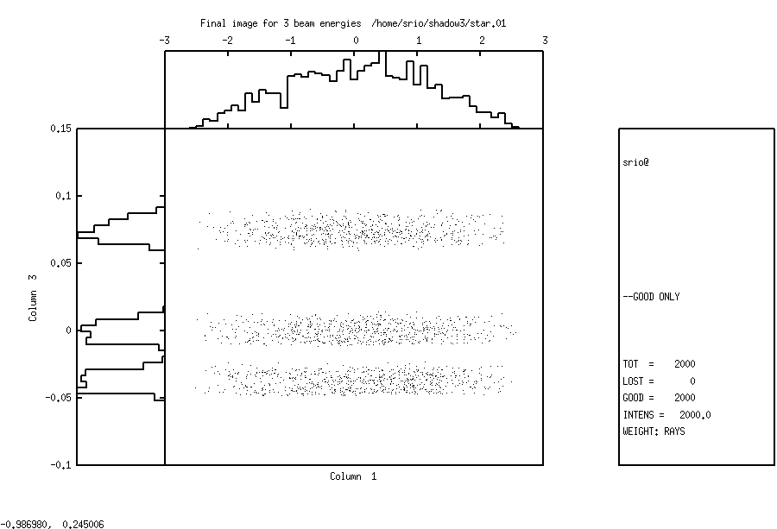
Figure 6.8: Final Image for three beam energies

Power Density
One of the most important problems in synchrotron x-ray optics is that of the power loading of mirrors and other elements. SHADOW can help in heat load calculations. For that one should know the spectrum of the source. SHADOW samples rays following this spectrum, and traces them through the optical elements. It is then possible to know the photon flux distribution over the optical elements and normalize it using the total power to calculate the local power density. This information can be used by external Finite Elements Methods (FEM) programs to compute the cooling required to minimize the thermal deformation, and evaluate it. The deformed surface calculated by FEM can be reinserted into SHADOW (using the presurface facility) to evaluate the deterioration of the focal conditions because of the heat load. For these calculations, the user should pay attention to these facts:
- SHADOW usually works with rays sampling flux distributions (and not power distributions)
- The 'filters' in SHADOW do not take into account the attenuation due to inelastic effects (Compton), important for low Z and high energies. Therefore SHADOW filters attenuate the beam slightly less that what it should be.
- In old versions of SHADOW, the the plotting facilities histo1 and plotxy had the possibility to normalize the intensity to power. As this normalization require external data (source characteristics) it has been removed from SHADOW3, which only allows unnormalized histograms.

In this section we will show how to deal with this problem and what insights can be obtained. We will demonstrate then how:

- To generate a Synchrotron source
- To use the program PREREFL
- To use the REFLECTIVITY switch in SHADOW
- To use PLOTXY to compute absorbed power density

We will consider the case of a gold mirror on a machine similar to Aladdin. See figure 6.12. We stress that NO approximations are made within SHADOW, and that both the source and the reflectivities are computed exactly. The source will cover the range 200-6000 eV, more than enough to model the system.

Chapter 6.3 run1 | To rerun: shadow3 < primer_ch63_run1.inp
shadow3> source

SOURCE selected. Begin procedure.
Select mode, enter :
prompt : prompted session
batch : file-oriented session
systemfile : file-oriented session using start.00

Select mode (prompt OR batch OR systemfile): prompt
Call to INPUT_SOURCE
--------------------------------- S H A D O W -------------------------------

Defining source :
When prompted for a yes/no answer, you may enter:
for YES answer Y*, y*, 1*
for NO answer anything else

Do you want a verbose [ 1 ] or terse [ 0 ] output ?0

------------- SOURCE SPECS ------------------
Source modelling type [ 0-5 ] ? 0
How many rays [Default=30000] ? 1000
Seed [ odd, 1000 - 1 000 000 ] ? 10111
Do you want to optimize the source ? 0

Source type : [ 0 ] regular (geometrical or bending magnet) source
[ 1 ] normal wiggler
[ 2 ] undulator
[ 3 ] elliptical wiggler
Then ? 0

X-Z plane source type [ 0-3, 6 ] ? 3
Sigma along X ? 1
Z ? .2

Source Depth [ 1-4 ] ? 4

Source Angle Distribution [ 1-6 ] ? 4
Horizontal half-divergence [ (+)x, rads ] ? .01
[ (-)x, rads ] ? .01
Vertical [ (+)z, rads ] ? .005
[ (-)z, rads ] ? .005
Magnetic Radius [ m ] ? 2.0833
Notice: the ORBIT radius MUST be in the same units as the rest of the optical system.
Use negative ORBIT radius argument for CCW storage ring.
Orbit Radius [ same as other units ] ?2083.3
Do you want to include electron beam emittances [ Y/N ] ? 0
Electron Beam Energy [ GeV ] ? 1
Polarization Selected [ 1-3 ] ? 0
Distribution type [0,1] ? 0
Energy distribution [ 1-4 ] ? 3
Photon Energy [ 0 ] or Angstroms [ 1 ] ? 0
From photon energy or wavelength ...
? 200
... to photon energy or wavelength :
? 6000

Do you want to store the optical paths (OPD) [Y/N] ? 1
Do you want to generate the A vectors (electric field) [Y/N] ?1
//This step is essential. It directs SHADOW to generate and store the vectors describing the amplitude of each ray’s vector potential A. Normally SHADOW does not generate this information, for space economy.

Exit from INPUT_SOURCE
Generated 250 rays out of 1000
500
750
1000
Exit from SOURCE

Source has been successfully generated.

SOURCE procedure completed.

shadow3>
shadow3>
// The source is now ready, but before we can run SHADOW we have to generate a file containing information about the optical properties of the material of the mirror surface. This is the purpose of prerefl, that computes the complex dielectric function of the material. We recall that we cover all the elements in the range 30 – 100,000 eV.
shadow3> prerefl
Element [0] or compound [1] ? 0
Density [ g/cm3 ] ?19.3
Enter atomic symbol (capitalized) : AU
Enter starting photon energy,end and step
200
6000
100
Output file : AUF1F2.OPT
shadow3>
shadow3>
shadow3>
shadow3>
// All set to go. We can now trace the system.
shadow3>
shadow3> trace

Ray Tracing Selected. Begin procedure.

Mode selected [prompt OR batch OR systemfile] ?prompt
Call to RESET
Exit from RESET
Mode selected is: prompt

Options: to start anew [ 0 ]
to restart from a given OE [ 1 ]

Then ? 0

Call to INPUT_OE
--------------------------------- S H A D O W -------------------------------

When prompted for a yes/no answer, you may enter:
for YES answer Y*, y*, 1*
for NO answer anything else

Defining Optical Element: 1
Continue ? [ EXIT to terminate OS ] <enter>

Do you want a verbose [ 1 ] or terse [ 0 ] output ?0

Files to write out. Options:
All............................ [ 0 ]
Mirror only.....................[ 1 ]
Image at CP only................[ 2 ]
None............................[ 3 ]
Then ? 0

Optical Element definition:
Incidence Angle ? 88
Source Distance ? 5000
Reflection Angle? 88
Image Distance ? 5000
Reflector [ 0 ] or refractor [ 1 ] ? 0

Is this a segmented mirror system?0
Is this a Kumakhov system?0
A: Is this mirror faceted [Y/N] ?0
Mirror surface [ 1-9] ? 3
Toroidal Selected.
Enter 0, if mirror pole is at the lower outer torus (usual case)
1, lower inner
2, upper inner
3, upper outer
Mirror pole location ? 0
Do you want to specify the mirror parameters ?0
Is the mirror Cylindrical ? 0
Is this optical element a Fresnel Zone Plate ? 0
Are we dealing with a Grating ? 0

Are we dealing with a crystal [ Y/N ] ? 0
Is the mirror convex [ Y/N ] ? 0
Reflectivity mode [ 0,1,2 ] ?

Optical Constant Source: [file=0,tt:=1], multilayer [2] ?
File with optical constants ?
AUF1F2.OPT

Orientation Angle [ Alpha ] ? 0

Mirror Dimensions finite [ Y/N ] ?0

Focii placed at continuation planes [ Y/N ] ? 1

Save incidence and reflection angles to disk? 0
Do you want to move the Source [ Y/N ] ? 0
Do you want to move the mirror itself [ Y/N ] ? 0
Distorted surface [ Y/N ] ? 0
Do you want to include surface roughness [Y/N] ? 0

Any screens in this OE [ Y/N ] ? 0

Slit at continuation plane [ Y/N ] ? 0
Extra Image plates [ Y/N ] ? 0
File containing the source array [Default: begin.dat] ? begin.dat
Exit from INPUT
Tracing optical element # 1
Call to SETSOUR
…
Exit from RESET

Do you want to change input mode ? 0

Call to INPUT_OE
--------------------------------- S H A D O W -------------------------------

Defining Optical Element: 2
Continue ? [ EXIT to terminate OS ] EXIT

End of session

shadow3>
shadow3> $cat effic.01
Of a total of 1000 rays, of which 1000 formed the input set
0 were out of the mirror N. 1
The mirror collects 1.0000 of the incoming flux.
The average reflectivities are :
S-pol 0.56842
P-pol 0.56499
Total 0.56670
The overall efficiency of the mirror is : 0.56670
shadow3>

And now the contour plot:

Chapter 6.3 contour | To rerun: shadow3<primer_ch63_contour.inp
. shadow3> plotxy
PLOT> Input file? mirr.01
PLOT> Options --- Enter
PLOT> 0 for excluding the losses
PLOT> 1 for including only the losses
PLOT> 2 for including all the rays.
PLOT> Then ? 0
PLOT> Comment for plot [ 80 char ] ?
*******************/*******************/*******************/*******************/
Flux on mirror

PLOT> Found 1000 good points out of 1000
PLOT> The following columns are defined for each ray
1) the regular columns [1-12]
2) optical path [13]
3) phase angle of As[14], Ap[15], and the Ap vector [16-18]

Col Par Minimum: Maximum: Center: St. Dev.:

1 X -49.195 50.172 0.85939 27.984
2 Y -304.36 133.10 -65.994 79.655
3 Z 0.75300E-03 7.4041 2.3097 2.0409
4 X' -0.10149E-01 0.98337E-02 -0.16230E-03 0.54830E-02
5 Y' 0.99936 0.99946 0.99941 0.18240E-04
6 Z' 0.31714E-01 0.35835E-01 0.34021E-01 0.84658E-03
11 Photon Energy (eV) 200.02 5914.5
20 Numerical Aperture 0.32979E-01 0.35894E-01
Total Intensity: 567.8016178230669

PLOT> Options. You may plot any two rows from
the above list versus each other.
You may also plot any of them versus the
ray Numerical Aperture. N.A. -- enter 20.

PLOT> Rows to use for plot :
PLOT> for horizontal axis ? 1
PLOT> for vertical axis ? 2

PLOT> Scaling options. Enter

0 For automatic scaling
1 For cartesian scaling
2 For external limits
PLOT> Then ? 0
PLOT> Plotting options :
0 For scattered plot
1 For pixelized plot
2 For contour plot
PLOT> Then ? 2
PLOT> Number of bins [Nx by Ny] to prepare the grids.
PLOT> Nx [Default=101]: 15
PLOT> Ny [Default=101]: 15
PLOT> Number of contours [Default=10] : 7
PLOT> Included reflectivity ? 1
Smoothing [ Y/N ] ? 1
PLOT> Ready for histograms. Enter:
-1 to skip
0 for same limits as plot
PLOT> ? 0
File written to disk: plotxy_grid.dat
File written to disk: plotxy_histtop.dat
File written to disk: plotxy_histside.dat
File written to disk: plotxy.gpl
shadow3>
shadow3> $gnuplot plotxy.gpl
// see result in Fig.6.9
shadow3>

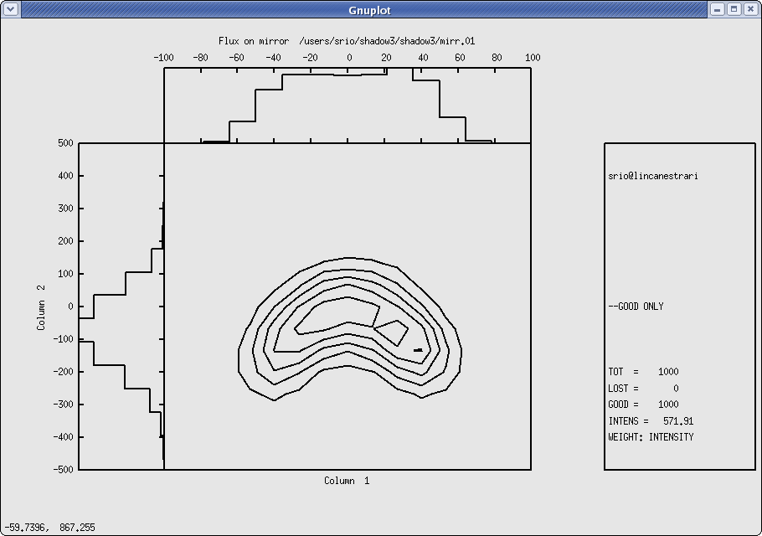
Figure 6.9: Contour plot of flux, incident on the first mirror

Mirror-Filter Combination

In this case we will examine the effect on the spectrum of the radiation of a filter and of a mirror together. We will trace a beamline with a beryllium filter in front of a gold mirror. We could plot as done above the power density at the filter and at the mirror, but we will leave that to the reader. Let us begin by generating the file with the constants of Be.

Chapter 6.3 run2 | shadow3 < primer_ch63_run2.inp
shadow3> prerefl
Element [0] or compound [1] ? 0
Density [ g/cm3 ] ?1.845
Enter atomic symbol (capitalized) : BE
Enter starting photon energy,end and step
200,6000,100
Output file : BEF1F2.OPT
shadow3>
// Since the source already exists, we can proceed directly with the calculations.

shadow3> trace

Ray Tracing Selected. Begin procedure.

Mode selected [prompt OR batch OR systemfile] ?prompt
Call to RESET
Exit from RESET
Mode selected is: prompt

Options: to start anew [ 0 ]
to restart from a given OE [ 1 ]

Then ? 0

Call to INPUT_OE
--------------------------------- S H A D O W -------------------------------

When prompted for a yes/no answer, you may enter:
for YES answer Y*, y*, 1*
for NO answer anything else

Defining Optical Element: 1
Continue ? [ EXIT to terminate OS ] <enter>

Do you want a verbose [ 1 ] or terse [ 0 ] output ?0

Files to write out. Options:
All............................ [ 0 ]
Mirror only.....................[ 1 ]
Image at CP only................[ 2 ]
None............................[ 3 ]
Then ? 0

Optical Element definition:
Incidence Angle ? 88
Source Distance ? 5000
Reflection Angle? 88
Image Distance ? 5000
Reflector [ 0 ] or refractor [ 1 ] ? 0

Is this a segmented mirror system?0
Is this a Kumakhov system?0
A: Is this mirror faceted [Y/N] ?0
Mirror surface [ 1-9] ? 3
Toroidal Selected.
Enter 0, if mirror pole is at the lower outer torus (usual case)
1, lower inner
2, upper inner
3, upper outer
Mirror pole location ? 0
Do you want to specify the mirror parameters ?0
Is the mirror Cylindrical ? 0
Is this optical element a Fresnel Zone Plate ? 0
Are we dealing with a Grating ? 0

Are we dealing with a crystal [ Y/N ] ? 0
Is the mirror convex [ Y/N ] ? 0
Reflectivity mode [ 0,1,2 ] ? 1

Optical Constant Source: [file=0,tt:=1], multilayer [2] ?0
File with optical constants ?
AUF1F2.OPT

Orientation Angle [ Alpha ] ? 0

Mirror Dimensions finite [ Y/N ] ?0

Focii placed at continuation planes [ Y/N ] ? 1

Save incidence and reflection angles to disk? 0
Do you want to move the Source [ Y/N ] ? 0
Do you want to move the mirror itself [ Y/N ] ? 0
Distorted surface [ Y/N ] ? 0
Do you want to include surface roughness [Y/N] ? 0

Any screens in this OE [ Y/N ] ? 1
How many in this OE [ total ] ? 1
Screen N. 1
Is this screen before mirror [ Y/N ] ? 1
Distance from mirror [ absolute ] ? 2500
Is Screen Carrying an Aperture Stop [ Y/N ] ? 0
Include absorption [ Y/N ] ? 1
File with optical constants ?
BEF1F2.OPT
Thickness of film [ cm ] ? 2.0e-4
// This is a 2 microns BE filter.

Slit at continuation plane [ Y/N ] ? 0
Extra Image plates [ Y/N ] ? 0
File containing the source array [Default: begin.dat] ? begin.dat
Exit from INPUT
Tracing optical element # 1
Call to SETSOUR
...
Exit from RESET

Do you want to change input mode ? 0

Call to INPUT_OE
--------------------------------- S H A D O W -------------------------------

Defining Optical Element: 2
Continue ? [ EXIT to terminate OS ] EXIT

End of session

shadow3>
//The data have been generated. In order to analyze the output, we will need to know the power per eV in the spectrum. This can be achieved by using histo1 on the files begin.dat, screen.0101, mirr.01. They represent the source, the beam after the filter and after the mirror. By computing the transmitted flux at each one, we can follow the progression of the spectrum along the beamline.

shadow3> histo1
File for analysis ?
begin.dat
Column to analyze ? 11
//11 is the position where the photon energy of the ray is stored. We want then to perform a binning operation based on it.
Options : [0] Angstroms
: [1] eV
: [2] cm-1
<?> 1
Read : 1000 rays
Maximum : 5914.514707798465
Minimum : 200.02375341123158
Distribution center ? 2750
width ? 5500
Number of bins (odd, please) ? 31
Flag checks. Enter :
0 to exclude lost rays
1 to include lost rays too
2 to use only lost rays
<?> 0
Normalization kind. Enter :
0 for no normalization
1 to normalize to 1
2 area normalized to 1
<?> 0
Include reflectivity (|A|**2 as weighing factor)? 1
File (data) written to disk: histo1.dat
File (gnuplot script) written to disk: histo1.gpl
shadow3>
shadow3>
//copy or rename the histo1.dat’s for final overplot. Otherwise they will be overwritten by subsequent runs.
shadow3> $cp histo1.dat histo1_begin.dat
shadow3>
//OK. Here we go for the same histo1 on the other two files.
shadow3> histo1
File for analysis ?
screen.0101
Column to analyze ? 11
Options : [0] Angstroms
: [1] eV
: [2] cm-1
<?> 1
Read : 1000 rays
Maximum : 5914.514707798465
Minimum : 200.02375341123158
Distribution center ? 2750
width ? 5500
Number of bins (odd, please) ? 31
Flag checks. Enter :
0 to exclude lost rays
1 to include lost rays too
2 to use only lost rays
<?> 0
Normalization kind. Enter :
0 for no normalization
1 to normalize to 1
2 area normalized to 1
<?> 0
Include reflectivity (|A|**2 as weighing factor)? 1
File (data) written to disk: histo1.dat
File (gnuplot script) written to disk: histo1.gpl
shadow3>
shadow3>
shadow3> $cp histo1.dat histo1_screen.dat
shadow3>
shadow3>
shadow3> histo1
File for analysis ?
mirr.01
Column to analyze ? 11
Options : [0] Angstroms
: [1] eV
: [2] cm-1
<?> 1
Read : 1000 rays
Maximum : 5914.514707798465
Minimum : 200.02375341123158
Distribution center ? 2750
width ? 5500
Number of bins (odd, please) ? 31
Flag checks. Enter :
0 to exclude lost rays
1 to include lost rays too
2 to use only lost rays
<?> 0
Normalization kind. Enter :
0 for no normalization
1 to normalize to 1
2 area normalized to 1
<?> 0
Include reflectivity (|A|**2 as weighing factor)? 1
File (data) written to disk: histo1.dat
File (gnuplot script) written to disk: histo1.gpl
shadow3>
shadow3>
shadow3> $cp histo1.dat histo1_mirr.dat
shadow3>

The three histograms can be plotted together using gnuplot. The command file can be easily created using as template histo1.gpl. The new histo1mod.gpl is shown and plotted is follows:

Chapter 6.3 histograms | To rerun: shadow3<primer_ch63_results2.inp
% cat histo1mod.gpl
#
# Gnuplot script for shadow3
# Created by histo1
#
set terminal x11
plot 'histo1_begin.dat' using 1:2 with boxes, 'histo1_screen.dat' using 1:2 with boxes , 'histo1_mirr.dat' using 1:2 with boxes
pause -1 'Press <Enter> to end graphic '
%
% gnuplot histo1mod.gpl
//see plot in Fig. 6.10
Press <Enter> to end graphic
%

Notice how the Be filter cuts the low energies, while the Au mirror cuts the high ones.

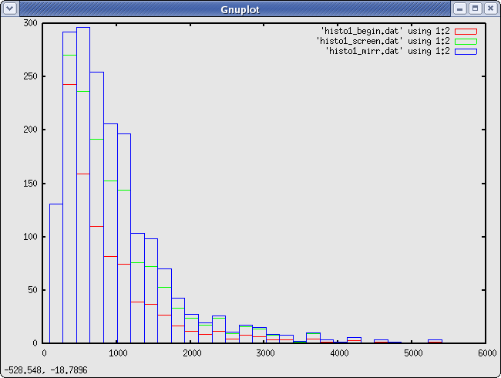
Figure 6.10: Overlay of histograms after source, filter, and mirror

Two Crystals I

The main purpose of this section is to demonstrate how to ray-trace a crystal monochromator. SHADOW needs a data file prepared by bragg to ray trace a crystal. In addition, bragg may allow the user to visualize the diffraction patterns or rocking curves of the crystal in consideration.

SHADOW deals with crystals in both reflection (Bragg) and transmission (Laue) mounting.
Two crystal models are allowed in SHADOW: perfect crystals (i.e. Silicon, Diamond) and mosaic crystals, where the crystal block is made by an agglutination of small microcrystals (i.e. graphite, beryllium). Perfect crystals may be symmetric (the Bragg planes are parallel to the crystal surface in Bragg mounting, and perpendicular in Laue mounting) and asymmetric, when the crystal planes form an arbitrary angle alfa with the crystal surface. Mosaic crystals can only be symmetrical in SHADOW. Ground-bent crystals (the so-called Johansson geometry) for perfect crystals are also allowed in SHADOW. We remind the reader that a symmetric perfect crystal in Bragg mounting is essentially a mirror with a very narrow bandwidth in energy or angle, determined by its rocking curve or diffraction pattern. An asymmetric crystal does not act as a mirror, but as a grating, where the ”grating ruling” is provided by the intersection lines between the Bragg planes and crystal surface. In addition,the rocking curve (strictly speaking: diffraction profile) determines the energy or angular acceptance, as in symmetric crystals. In all the crystal cases of three-dimensional Bragg scattering, only the rays close to the Bragg condition will be diffracted; the other ones will be absorbed by the crystal. For this reason, to only look at the scatter plot of the reflected (outgoing) beam, like we did in the case of the grating, is not enough. This is because of the way SHADOW carries the intensity information; to each ray is associated the vector potential A that contains, in its modulus, the intensity (and polarization) information. For this reason a simple scatter plot does not convey any information on the intensity of the rays; it is necessary then to use either the facilities provided by plotxy in the contour mode (two dimensional case) using the intensity flag.

- To use bragg in generating the files needed by SHADOW to perform the calculations.
- To run SHADOW for the CRYSTAL case
- To run SHADOW by restarting from an Optical Element instead of from a source
- To use PREPLOT in order to analyze the results

The case that we will consider is that of a two-crystal monochromator in a parallel configuration. After considering the ideal case, we will introduce some rotational misalignement and study its effect on the transmitted spectrum. See figure 6.11 below. In order to do that, we will restart the calculations at the second OE, since the first one will have been left unchanged. The source that we will be using will be a point source of single wavelength. The BRAGG condition

(6.2)

will change along the crystal surface, since θ will be changing and rays hitting at different positions will be attenuated by different amounts. Another section will describe the complementary case of a collimated broad-band source. Notice that for a real source, i.e., both diverging and with a continuous distribution, the diffraction profile (using plotxy on column 25) will not be a “nice” curve but instead a band of values.

Figure 6.11: Two crystals monochromator with diverging radiation and antiparallel configuration: a) ideal case, b) misaligned second crystal.

In order to prepare bragg it is necessary to have a table of the real part of the atomic scattering coefficients in function of sin(θ)/λ. An exhaustive table can be found in the International Tables of X-Ray Crystallography, Vol.III, Sect.2.2, Table 2.2A, p.72. A shorter version can be found in X-ray Diffraction, by B.E. Warren, Addison-Wesley, 1969. bragg will prompt about the coefficients. bragg is the program that generates the crystal parameters in a format suitable for input to SHADOW. Let us use the GaAs (111) plane, with incident energy of 11160 eV.

Chapter 6.4 bragg | To rerun: shadow3 < primer_ch64_bragg.inp
shadow3> bragg
All crystal structures are refered to a cubic unit cell.
Bravais lattice type :
0 for ZincBlende
1 for Rocksalt
2 for simple FCC
3 for CsCl structure
hexagonal Bravais lattice type:
4 for Hexagonal Close-Packed structure
5 for Hexagonal Graphite structure
Then ? 0
Lattice constant (Angs) ? 5.65
Index of crystal plane of reflection H,K,L :
1,1,1
***********************************************************
The ZINCBLENDE structure is defined by atom A located at
(0,0,0) and atom B at (1/4,1/4,1/4) of the fcc lattice.
***********************************************************
Enter atomic symbol (capitalized) for atom A : GA
Enter atomic symbol (capitalized) for atom B : AS
***********************************************************
Atomic scattering factor is defined by fo + f' + if", where
fo = fo(SIN(theta)/Lambda) is the non-dispersive part
fp, fpp (Lambda) are the dispersive part.
***********************************************************
We need fo at 3 different values of SIN(theta)/Lambda, which
should cover the range of interest and center around :
SIN(theta)/Lambda = 0.15327883252821919 ratio.
***********************************************************
Please enter 1) SIN(theta)/Lambda, 2) fo ,
// At this point, take the International Tables or the ones from Warren, and find the values tabulated for Ga and As at values of Sin(theta)/lambda bracketing the one quoted above. BRAGG will automatically interpolate.
For atom A, first set :
0.14,27.162
, second set :
0.15,26.783
, third set :
0.16,26.406
For atom B, first set :
0.14,28.742
, second set :
0.15,28.307
, third set :
0.16,27.877
***********************************************************
f', f" is furnished from optical constant library within …
//The other part of the atomic scattering factors is read from the library. Enter the photon energy range, keeping it reasonably narrow.
minimum photon energy (eV) : 11100
maximum photon energy (eV) : 11200
energy step (eV) : 10
Do you want to include crystal absorption [1/0] ? 1
Temperature (Debye-Waller) factor : 0.979
//This is the value of the Debye-Waller coefficient, exp(-(1/3)(G u)^2) where G is the scattering vector and u the rms atomic displacement. If in doubt, enter 1.0. This will ignore then DW effects.
Output file name (for SHADOW) : GAAS.PAR
Do you want to generate a rocking curve [1/0] ? 1
What do you want to calculate ?:
[1] Diffracted beam in Transmission (Laue) geometry
[2] Diffracted beam in Reflection (Bragg) geometry
[3] like [2] using thick crystal approximation
<?> 3
... at what energy (eV) ? 11160

So far, we are working with:
Lambda = 1.1109784946236561 Angstroms
Theta (graz) = 9.8046508411997557 degrees
Bragg angle = 9.8071538814150880 degrees
Structure factor = ( 142.68220618199777 , 11.036236715533464 )
Refraction index = 1 - delta - i*beta :
delta = 7.32877800968534387E-006
beta = 4.83801824737804214E-007
Absorption coeff = 547.23228784171613 cm-1

Do you want to calculate a mosaic crystal ? 0
Asymmetric cut angle (deg) between face and bragg planes (CW)=
0
1/2 width of Rock Curve s-pol = : 25.548911600910561 microradians
1/2 width of Rock Curve p-pol = : 24.067150901971125 microradians

// Ss and Sp represent the width of the Bragg peak, and will be used as ’reduced units’ in some of the plots, so that the peak will extend from -1 to +1.
+/- how many microradians : 60
How many points : 200
Do you want to use sec [1/0] ? 0
// we use radiants
Do you want the R.C. centered [1/0] ? 0
Do you want to try another energy [1/0] ? 0
shadow3>
shadow3> $ls -lt
total 12720
-rw-r--r-- 1 srio srio 10600 2011-01-03 10:36 rock_curve.p
-rw-r--r-- 1 srio srio 1398 2011-01-03 10:36 rock_curve.par
-rw-r--r-- 1 srio srio 10600 2011-01-03 10:36 rock_curve.s
...
shadow3>
shadow3>
// GAAS.PAR will be the input parameter file to SHADOW. At the end of the file GAAS.PAR is a table of:
eV f'(Ga) f”(Ga) f'(As) f”(As)
which form the optical constant library. The user can edit this file if more accurate values are available, especially near an absorption edge. The user can also use or create alternative programs to create this file required by SHADOW.
shadow3> $cat GAAS.PAR
0 1562378464.9909172 3.26202902092138591E-008
31 33 0.97899999999999998
( 4.0000000000000000 ,-7.34763812293426355E-016)
( 4.0000000000000000 , 7.34763812293426355E-016)
(-1.46952762458685271E-015, -4.0000000000000000 )
(-1.46952762458685271E-015, 4.0000000000000000 )
32.677999999999429 -40.799999999988358 9.9999999999708962
35.356999999999971 -50.749999999992724 25.000000000000000
11
11100.000000000000 -1.8899823284296602 3.4146693197174036
-2.4318328841752788 0.56066060479244639
11110.000000000000 -1.8746976414382885 3.4098429795897109
-2.4439498939035253 0.55974017817707888
11120.000000000000 -1.8594129544469169 3.4050166394620187
-2.4560669036317755 0.55881975156171138
11130.000000000000 -1.8441282674555453 3.4001902993343260
-2.4681839133600221 0.55789932494634387
11140.000000000000 -1.8288435804641701 3.3953639592066338
-2.4803009230882722 0.55697889833097636
11150.000000000000 -1.8135588934727984 3.3905376190789411
-2.4924179328165188 0.55605847171560885
11160.000000000000 -1.7982742064814268 3.3857112789512489
-2.5045349425447689 0.55513804510024123
11170.000000000000 -1.7829895194900551 3.3808849388235562
-2.5166519522730155 0.55421761848487372
11180.000000000000 -1.7677048324986835 3.3760585986958640
-2.5287689620012657 0.55329719186950621
11190.000000000000 -1.7524201455073083 3.3712322585681713
-2.5408859717295122 0.55237676525413870
11200.000000000000 -1.7371354585159366 3.3664059184404787
-2.5530029814577624 0.55145633863877119
shadow3>
//ROCK CURVE.PAR lists the parameters used to generate the rocking curve at 11160 eV, which are a function of the real part of Ss and Sp (for the S- and P-polarization). For this case, Ss = 25.549 and Sp = 24.067 microradians.

shadow3> $cat rock_curve.par
ZincBlende structure :
For atom A, fo + f' + if" = ( 24.860893431379896 , 3.3857112789512489 )
B, = ( 25.660924319179539 , 0.55513804510024123 )
Lattice constant = 5.6500000000000004 Angstroms
crystal thickness = 0.0000000000000000 cm
d-spacing = 3.2620290209213860 Angstroms
Photon energy = 11160.000000000000 eV
Lambda = 1.1109784946236561 Angstroms
SIN(theta)/Lambda = 0.15327883252821919 ratio.
Refraction index = 1 - delta - i*beta :
delta = 7.32877800968534387E-006
beta = 4.83801824737804214E-007
Absorption coeff = 547.23228784171613 cm-1
Temperature factor = 0.97899999999999998
Structure factor F(000) = ( 238.78876340389522 , 15.763397296205961 )
Structure factor F(hkl) = ( 142.68220618199777 , 11.036236715533464 )
Asymmetric factor b= : -1.0000000000000000
lenght primary extinction (s-pol) = 6.94437738105059084E-306 microns
lenght primary extinction (p-pol) = 1.48219693752373963E-319 microns
The width of the Rock Curve is
1/2 width for s-pol = : 25.548911600910561 microradians
1/2 width for p-pol = : 24.067150901971125 microradians
Theta (graz) = 9.8046508411997557 degrees
Bragg angle(corr) = 9.8071538814150880 degrees
shadow3>
shadow3>
//Plot out the rocking curve for S-polarization. For that, we use gnuplot. We created a small command file for that:
shadow3> $cat bragg.gpl
set terminal x11 size 900,600
set xlabel "Rock angle (microrads)"
set ylabel "Reflectivity"
plot "rock_curve.s" u 1:2 w lines, "rock_curve.p" u 1:2 w lines
pause -1 'Press <Enter> to end graphic '
shadow3>
shadow3> $gnuplot bragg.gpl
// See plot at Fig. 6.12
Press <Enter> to end graphic
shadow3>

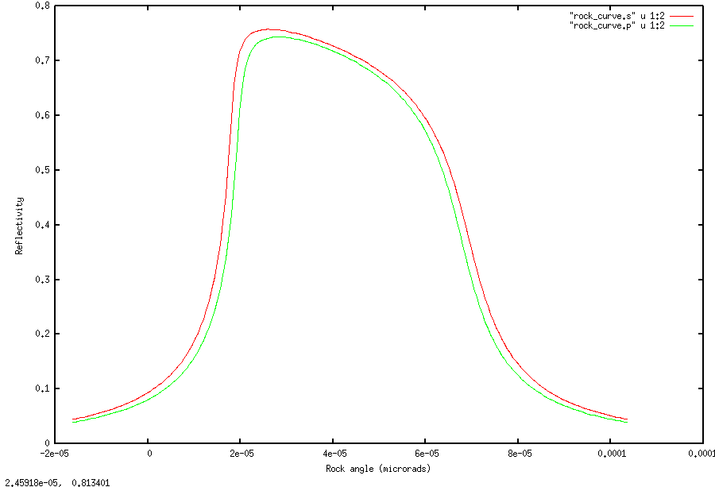

Figure 6.12: Rocking curve for S-polarization (red) and P-polarisation (green).

Things seem to be reasonable, so we can run SHADOW (finally). To check things out, let us use a monochromatic source with only vertical divergence.

Chapter 6.4 source | To rerun: shadow3<primer_ch64_source.inp
shadow3> source

SOURCE selected. Begin procedure.
Select mode, enter :
prompt : prompted session
batch : file-oriented session
systemfile : file-oriented session using start.00

Select mode (prompt OR batch OR systemfile): prompt
Call to INPUT_SOURCE
--------------------------------- S H A D O W -------------------------------

Defining source :
When prompted for a yes/no answer, you may enter:
for YES answer Y*, y*, 1*
for NO answer anything else

Do you want a verbose [ 1 ] or terse [ 0 ] output ?0

------------- SOURCE SPECS ------------------
Source modelling type [ 0-5 ] ? 0
How many rays [Default=30000] ? 1000
Seed [ odd, 1000 - 1 000 000 ] ? 12345
Do you want to optimize the source ? 0

Source type : [ 0 ] regular (geometrical or bending magnet) source
[ 1 ] normal wiggler
[ 2 ] undulator
[ 3 ] elliptical wiggler
Then ? 0

X-Z plane source type [ 0-3, 6 ] ? 0

Source Depth [ 1-4 ] ? 1

Source Angle Distribution [ 1-6 ] ? 2
Horizontal half-divergence [ (+)x, rads ] ? 0
[ (-)x, rads ] ? 0
Vertical [ (+)z, rads ] ? 60e-6
[ (-)z, rads ] ? 60e-6
Do you want a Photon energy [ Y/N ] ? 1
Energy distribution [ 1-4 ] ? 1
Photon Energy [ 0 ] or Angstroms [ 1 ] ? 0
Energy [ eV ] ? 11160

Do you want to store the optical paths (OPD) [Y/N] ? 1
//This is important, as crystal reflectivity accounts for s and p polarisation
Do you want to generate the A vectors (electric field) [Y/N] ?1
Phase difference ?0
Degree of polarization ?1
Incoherent [0] or coherent [1] ?0
Exit from INPUT_SOURCE
Generated 250 rays out of 1000
500
750
1000
Exit from SOURCE

Source has been successfully generated.

SOURCE procedure completed.

Let us run trace and post-processors.

Chapter 6.4 run1 | shadow3 < primer_run64_run1.inp
shadow3> trace

Ray Tracing Selected. Begin procedure.

Mode selected [prompt OR batch OR systemfile] ?prompt
Call to RESET
Exit from RESET
Mode selected is: prompt

Options: to start anew [ 0 ]
to restart from a given OE [ 1 ]

Then ? 0

Call to INPUT_OE
--------------------------------- S H A D O W -------------------------------

When prompted for a yes/no answer, you may enter:
for YES answer Y*, y*, 1*
for NO answer anything else

Defining Optical Element: 1
Continue ? [ EXIT to terminate OS ] <enter>

Do you want a verbose [ 1 ] or terse [ 0 ] output ?0

Files to write out. Options:
All............................ [ 0 ]
Mirror only.....................[ 1 ]
Image at CP only................[ 2 ]
None............................[ 3 ]
Then ? 0

Optical Element definition:
Incidence Angle ? 10
Source Distance ? 5000
Reflection Angle? 10
Image Distance ? 150
//The angles here do not matter, as they will be replaced by the exact Bragg angle when you choose autotuning of the crystal and neither do distances.
Reflector [ 0 ] or refractor [ 1 ] ? 0

Is this a segmented mirror system?0
Is this a Kumakhov system?0
A: Is this mirror faceted [Y/N] ?0
Mirror surface [ 1-9] ? 5
Is the mirror Cylindrical ? 0
Is this optical element a Fresnel Zone Plate ? 0
Are we dealing with a Grating ? 0

Are we dealing with a crystal [ Y/N ] ? 1
//After we specify the mirror 9strictly speaking: oe) to be a crystal, SHADOW asks further questions to define the problem. We will tell the program that we want the crystal to be automatically set at the photon energy of 11160 eV.
File containing crystal parameters ?
GAAS.PAR
Is it a mosaic crystal [ Y/N ] ? 0
Is the crystal asymmetric [ Y/N ] ? 0
Are we working in Johansson geometry [Y/N] ? 0
Automatic Tuning of Crystal [ Y/N ] ?1
Energy, in eV, [ 0 ] or wavelength, in Angs., [ 1 ] ? 0
Photon Energy ? 11160
Is the mirror convex [ Y/N ] ? 0
Reflectivity mode [ 0,1,2 ] ? 0

Orientation Angle [ Alpha ] ? 0

Mirror Dimensions finite [ Y/N ] ?0

Save incidence and reflection angles to disk? 0
Do you want to move the Source [ Y/N ] ? 0
Do you want to move the mirror itself [ Y/N ] ? 0
Distorted surface [ Y/N ] ? 0
Do you want to include surface roughness [Y/N] ? 0

Any screens in this OE [ Y/N ] ? 0

Slit at continuation plane [ Y/N ] ? 0
Extra Image plates [ Y/N ] ? 0
File containing the source array [Default: begin.dat] ? begin.dat
Exit from INPUT
Tracing optical element # 1
Call to SETSOUR
…
Exit from RESET

Do you want to change input mode ? 0

Call to INPUT_OE
--------------------------------- S H A D O W -------------------------------

Defining Optical Element: 2
Continue ? [ EXIT to terminate OS ]

Do you want a verbose [ 1 ] or terse [ 0 ] output ?0

Files to write out. Options:
All............................ [ 0 ]
Mirror only.....................[ 1 ]
Image at CP only................[ 2 ]
None............................[ 3 ]
Then ? 0

Optical Element definition:
Incidence Angle ? 10
Source Distance ? 150
Reflection Angle? 10
Image Distance ? 5000
Reflector [ 0 ] or refractor [ 1 ] ? 0

Is this a segmented mirror system?0
Is this a Kumakhov system?0
A: Is this mirror faceted [Y/N] ?0
Mirror surface [ 1-9] ? 5
Is the mirror Cylindrical ? 0
Is this optical element a Fresnel Zone Plate ? 0
Are we dealing with a Grating ? 0

Are we dealing with a crystal [ Y/N ] ? 1
File containing crystal parameters ?
GAAS.PAR
Is it a mosaic crystal [ Y/N ] ? 0
Is the crystal asymmetric [ Y/N ] ? 0
Are we working in Johansson geometry [Y/N] ? 0
Automatic Tuning of Crystal [ Y/N ] ?1
Energy, in eV, [ 0 ] or wavelength, in Angs., [ 1 ] ? 0
Photon Energy ? 11160
Is the mirror convex [ Y/N ] ? 0
Reflectivity mode [ 0,1,2 ] ? 0

//the second crystal will be parallel to the first one, then in (+,-) [or non-dispersive) configuration
Orientation Angle [ Alpha ] ? 180

Mirror Dimensions finite [ Y/N ] ?0

Save incidence and reflection angles to disk? 0
Do you want to move the Source [ Y/N ] ? 0
Do you want to move the mirror itself [ Y/N ] ? 0
Distorted surface [ Y/N ] ? 0
Do you want to include surface roughness [Y/N] ? 0

Any screens in this OE [ Y/N ] ? 0

Slit at continuation plane [ Y/N ] ? 0
Extra Image plates [ Y/N ] ? 0
Exit from INPUT
Tracing optical element # 2
Call to SETSOUR
…
Exit from RESET

Do you want to change input mode ? 0

Call to INPUT_OE
--------------------------------- S H A D O W -------------------------------

Defining Optical Element: 3
Continue ? [ EXIT to terminate OS ] EXIT

End of session

shadow3>

Let us have a look to the results.

6.4 results1 | To rerun: shadow3 < primer_ch64_results1.inp
shadow3>
shadow3>
// Note the P-polarization has smaller average reflectivity, because of narrower width of the rocking curve (smaller value of Sp relative to Ss).
shadow3> $cat effic.01
Of a total of 1000 rays, of which 1000 formed the input set
0 were out of the mirror N. 1
The mirror collects 1.0000 of the incoming flux.
The average reflectivities are :
S-pol 0.37799
P-pol 0.35457
Total 0.36628
The overall efficiency of the mirror is : 0.36628
shadow3>
shadow3>
// We know that SHADOW must have changed the optical system angles, in order to satisfy Bragg’s equation. To check the new values, let us run MIRINFO
shadow3> mirinfo
-------------------- M I R I N F O ----------------------

MirInfo: Mirror descriptor file. It must be an end.xx type.
MirInfo: Please input filename:
end.01
MirInfo: Title ?
plane crystal diffraction
MirInfo: Comment ?
test shadow diffraction profile
MirInfo: Output file ?
mirror1.txt

shadow3>
// Notice the incident and reflected angle have been replaced by the Bragg angle.
shadow3> $cat mirror1.txt
++++++++++++++++++++++++++++++++++++++++++++++++++++++++++++++++++++++++++++++
******************** MIRROR DESCRIPTION ********************
++++++++++++++++++++++++++++++++++++++++++++++++++++++++++++++++++++++++++++++
plane crystal diffraction
test shadow diffraction profile
++++++++++++++++++++++++++++++++++++++++++++++++++++++++++++++++++++++++++++++
Input file specified: end.01
Full file specification: /mntdirect/_scisoft/users/srio/GIT/PRIMER/end.01
Creation date: 2011 01 05 11h 28min 59 s
++++++++++++++++++++++++++++++++++++++++++++++++++++++++++++++++++++++++++++++

Surface figure was defined as: PLANE
Cylindrical figure NO
Element type REFLECTOR
Element type CRYSTAL
Lattice Spacing 3.262E-8
Bragg Reflection from GAAS.PAR
Reflectivity ON coefficients from: GAAS.PAR
Polarization dependence YES
Mirror dimensions UNLIMITED
+++++++++++++++++++++++++++++++++++++++++++++++++++++++++++++++++++++++++++++++
Central Axis parameters :
Source Plane Distance 5000.
Image Plane 150.
Incidence Angle 80.19117300651001
Reflection/Diffraction Angle 80.19117300651001

Mirror parameters COMPUTED
Same configuration as Central Axis NO
Objective focus at 0.
Image focus at 0.
Incidence angle 0.
Parameters used follow:
Plane mirror
Source of this O.E. moved NO
Mirror at pole position ( no mov. ) YES
++++++++++++++++++++++++++++++++++++++++++++++++++++++++++++++++++++++++++++++
*************** E N D ***************
++++++++++++++++++++++++++++++++++++++++++++++++++++++++++++++++++++++++++++++
shadow3>
shadow3>
shadow3>
// Now let us verify that SHADOW also computes the same diffraction profile. Since the source we used was a point source, the incidence angle changes continuously along the mirror surface, accordingly to the aperture of the ray from the central axis. If we then plot the ray intensity versus z', i.e., the sine of the aperture at the image plane, we should obtain a curve that duplicates exactly the Bragg diffraction profile. Let’s compare the following plot with that done earlier using rock_curve.s. We use plotxy with extended column numbers added in SHADOW3 to display the diffraction profile and store the generated plottable file.
shadow3> plotxy
PLOT> Input file? star.01
PLOT> Options --- Enter
PLOT> 0 for excluding the losses
PLOT> 1 for including only the losses
PLOT> 2 for including all the rays.
PLOT> Then ? 0
PLOT> Comment for plot [ 80 char ] ?
*******************/*******************/*******************/*******************/
diffraction profile on crystal 1

PLOT> Found 1000 good points out of 1000
PLOT> The following columns are defined for each ray
1) the regular columns [1-12]
2) optical path [13]
3) phase angle of As[14], Ap[15], and the Ap vector [16-18]

Col Par Minimum: Maximum: Center: St. Dev.:

1 X -0.56730E-16 0.18862E-16 -0.93109E-17 0.22092E-16
2 Y -0.29702E-13 0.58991E-13 0.12836E-13 0.14871E-13
3 Z -0.30805 0.30884 0.56944E-03 0.17484
4 X' -0.11016E-19 0.36625E-20 -0.18079E-20 0.42898E-20
5 Y' 1.0000 1.0000 1.0000 0.0000
6 Z' -0.59810E-04 0.59974E-04 0.11591E-06 0.33949E-04
11 Photon Energy (eV) 11160. 11160.
20 Numerical Aperture 0.53071E-08 0.59974E-04
21 R=SQRT(X**2+Y**2+Z**2) 0.54809E-04 0.30884
22 angle [rad] from Y-axis 0.14901E-07 0.59974E-04
23 Intensity-s 0.21119 0.87039
24 Intensity-p 0.95901E-25 0.46815E-21
25 Intensity 0.21119 0.87039
Total Intensity: 377.9923358923218

PLOT> Options. You may plot any two rows from
the above list versus each other.
You may also plot any of them versus the
ray Numerical Aperture. N.A. -- enter 20.

PLOT> Rows to use for plot :
PLOT> for horizontal axis ? 6
PLOT> for vertical axis ? 25

PLOT> Scaling options. Enter

0 For automatic scaling
1 For cartesian scaling
2 For external limits
PLOT> The-n ? 0
PLOT> Plotting options :
0 For scattered plot
1 For pixelized plot
2 For contour plot
PLOT> Then ? 0
PLOT> Ready for histograms. Enter:
-1 to skip
0 for same limits as plot
PLOT> ? -1
File written to disk: plotxy_scatter.dat
File written to disk: plotxy_histtop.dat
File written to disk: plotxy_histside.dat
File written to disk: plotxy.gpl
shadow3>
shadow3>
// Let us sane the numerical data of this plot for further plots.
shadow3> $cp plotxy_scatter.dat star01.dat
shadow3>
shadow3>
// We will now create a plottable file of the intensity after the second crystal, but we will be plotting it out later. If you are interested, plot it now just as we did for the first crystal. The Bragg curve should be sharper.

shadow3> plotxy
PLOT> Input file? star.02
PLOT> Options --- Enter
PLOT> 0 for excluding the losses
PLOT> 1 for including only the losses
PLOT> 2 for including all the rays.
PLOT> Then ? 0
PLOT> Comment for plot [ 80 char ] ?
*******************/*******************/*******************/*******************/
diffraction after second crystal

PLOT> Found 1000 good points out of 1000
PLOT> The following columns are defined for each ray
1) the regular columns [1-12]
2) optical path [13]
3) phase angle of As[14], Ap[15], and the Ap vector [16-18]

Col Par Minimum: Maximum: Center: St. Dev.:

1 X -0.14993E-07 0.15032E-07 0.28384E-10 0.85097E-08
2 Y -0.11457E-11 0.16553E-11 0.17123E-12 0.47722E-12
3 Z -0.61605 0.61773 0.11938E-02 0.34968
4 X' -0.14555E-11 0.14595E-11 0.28207E-14 0.82619E-12
5 Y' 1.0000 1.0000 1.0000 0.0000
6 Z' -0.59805E-04 0.59979E-04 0.12140E-06 0.33949E-04
11 Photon Energy (eV) 11160. 11160.
20 Numerical Aperture 0.18846E-09 0.59979E-04
21 R=SQRT(X**2+Y**2+Z**2) 0.54663E-04 0.61773
22 angle [rad] from Y-axis 0.0000 0.59979E-04
23 Intensity-s 0.44597E-01 0.75758
24 Intensity-p 0.10166E-08 0.18259E-07
25 Intensity 0.44597E-01 0.75758
Total Intensity: 223.26485482434333

PLOT> Options. You may plot any two rows from
the above list versus each other.
You may also plot any of them versus the
ray Numerical Aperture. N.A. -- enter 20.

PLOT> Rows to use for plot :
PLOT> for horizontal axis ? 6
PLOT> for vertical axis ? 25

PLOT> Scaling options. Enter

0 For automatic scaling
1 For cartesian scaling
2 For external limits
PLOT> Then ? 0
PLOT> Plotting options :
0 For scattered plot
1 For pixelized plot
2 For contour plot
PLOT> Then ? 0
PLOT> Ready for histograms. Enter:
-1 to skip
0 for same limits as plot
PLOT> ? -1
File written to disk: plotxy_scatter.dat
File written to disk: plotxy_histtop.dat
File written to disk: plotxy_histside.dat
File written to disk: plotxy.gpl
// See results (gnuplot plotxy.gpl) in Fig. 6.13
shadow3>
shadow3> $cp plotxy_scatter.dat star02.dat
shadow3>

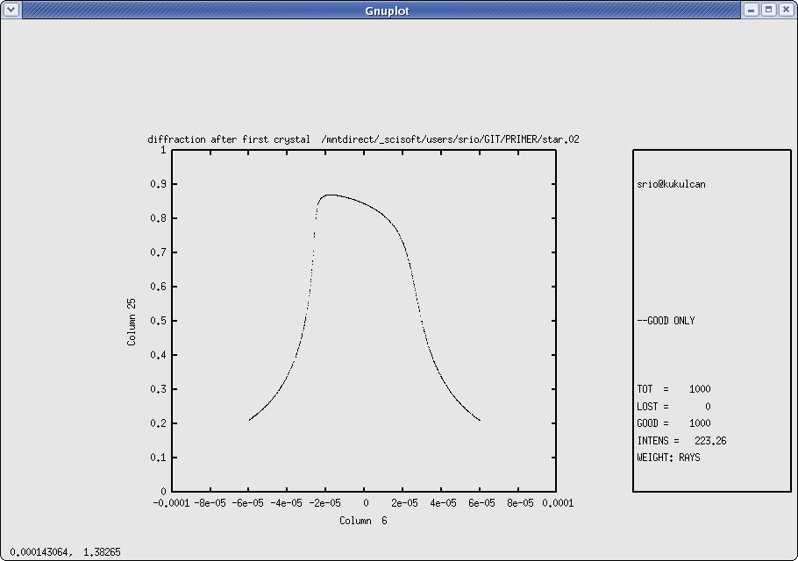
Figure 6.17: Plane Crystal Reflection

To illustrate the case of Bragg diffraction, we will now offset slightly the second crystal from its ideal position. At first, we will be setting directly (no autotuning or other features) the second crystal to the “wrong” angle, i.e., 2.777E-3 degrees away from the nominal Bragg angle (that we know exactly from the run of mirinfo).

6.4 Chapter 6.4 run 2 | To rerun: shadow3 < primer_ch64run2.inp
shadow3> trace

Ray Tracing Selected. Begin procedure.

Mode selected [prompt OR batch OR systemfile] ?prompt
Call to RESET
Exit from RESET
Mode selected is: prompt

Options: to start anew [ 0 ]
to restart from a given OE [ 1 ]

Then ? 1

Previous element number: 1
Image file of the previous OE ? star.01

Do you want to change input mode ? 0

Call to INPUT_OE
--------------------------------- S H A D O W -------------------------------

Defining Optical Element: 2
Continue ? [ EXIT to terminate OS ]

Do you want a verbose [ 1 ] or terse [ 0 ] output ?0

Files to write out. Options:
All............................ [ 0 ]
Mirror only.....................[ 1 ]
Image at CP only................[ 2 ]
None............................[ 3 ]
Then ? 0

Optical Element definition:
Incidence Angle ? 80.1956244
Source Distance ? 150
Reflection Angle? 80.1956244
Image Distance ? 5000
Reflector [ 0 ] or refractor [ 1 ] ? 0

Is this a segmented mirror system?0
Is this a Kumakhov system?0
A: Is this mirror faceted [Y/N] ?0
Mirror surface [ 1-9] ? 5
Is the mirror Cylindrical ? 0
Is this optical element a Fresnel Zone Plate ? 0
Are we dealing with a Grating ? 0

Are we dealing with a crystal [ Y/N ] ? 1
File containing crystal parameters ?
GAAS.PAR
Is it a mosaic crystal [ Y/N ] ? 0
Is the crystal asymmetric [ Y/N ] ? 0
Are we working in Johansson geometry [Y/N] ? 0
Automatic Tuning of Crystal [ Y/N ] ?0
Is the mirror convex [ Y/N ] ? 0
Reflectivity mode [ 0,1,2 ] ? 0

Orientation Angle [ Alpha ] ? 180

Mirror Dimensions finite [ Y/N ] ?0

Save incidence and reflection angles to disk? 0
Do you want to move the Source [ Y/N ] ? 0
Do you want to move the mirror itself [ Y/N ] ? 0
Distorted surface [ Y/N ] ? 0
Do you want to include surface roughness [Y/N] ? 0

Any screens in this OE [ Y/N ] ? 0

Slit at continuation plane [ Y/N ] ? 0
Extra Image plates [ Y/N ] ? 0
Exit from INPUT
Tracing optical element # 2
Call to SETSOUR
...
Exit from RESET

Do you want to change input mode ? 0

Call to INPUT_OE
--------------------------------- S H A D O W -------------------------------

Defining Optical Element: 3
Continue ? [ EXIT to terminate OS ] EXIT

End of session
// The tracing has been completed. Notice how easy it is to restart from any given point along the optical system. We now generate another plottable file, similarly to what we did before.
shadow3>
shadow3> plotxy
PLOT> Input file? star.02
PLOT> Options --- Enter
PLOT> 0 for excluding the losses
PLOT> 1 for including only the losses
PLOT> 2 for including all the rays.
PLOT> Then ? 0
PLOT> Comment for plot [ 80 char ] ?
*******************/*******************/*******************/*******************/
second crystal misaligned

PLOT> Found 1000 good points out of 1000
PLOT> The following columns are defined for each ray
1) the regular columns [1-12]
2) optical path [13]
3) phase angle of As[14], Ap[15], and the Ap vector [16-18]

Col Par Minimum: Maximum: Center: St. Dev.:

1 X -0.14993E-07 0.15032E-07 0.28384E-10 0.85097E-08
2 Y -0.15246E-11 0.12892E-11 -0.20269E-12 0.47104E-12
3 Z -0.61607 0.61770 0.11663E-02 0.34968
4 X' -0.14555E-11 0.14595E-11 0.28207E-14 0.82619E-12
5 Y' 1.0000 1.0000 1.0000 0.0000
6 Z' -0.59810E-04 0.59974E-04 0.11591E-06 0.33949E-04
11 Photon Energy (eV) 11160. 11160.
20 Numerical Aperture 0.53071E-08 0.59974E-04
21 R=SQRT(X**2+Y**2+Z**2) 0.82141E-04 0.61770
22 angle [rad] from Y-axis 0.14901E-07 0.59974E-04
23 Intensity-s 0.24074E-01 0.54646
24 Intensity-p 0.55101E-09 0.12312E-07
25 Intensity 0.24074E-01 0.54646
Total Intensity: 65.05779059464037

PLOT> Options. You may plot any two rows from
the above list versus each other.
You may also plot any of them versus the
ray Numerical Aperture. N.A. -- enter 20.

PLOT> Rows to use for plot :
PLOT> for horizontal axis ? 6
PLOT> for vertical axis ? 25

PLOT> Scaling options. Enter

0 For automatic scaling
1 For cartesian scaling
2 For external limits
PLOT> Then ? 0
PLOT> Plotting options :
0 For scattered plot
1 For pixelized plot
2 For contour plot
PLOT> Then ? 0
PLOT> Ready for histograms. Enter:
-1 to skip
0 for same limits as plot
PLOT> ? -1
File written to disk: plotxy_scatter.dat
File written to disk: plotxy_histtop.dat
File written to disk: plotxy_histside.dat
File written to disk: plotxy.gpl
shadow3>
shadow3>
shadow3> $cp plotxy_scatter.dat star02misaligned.dat
shadow3>

We will now plot out the two cases, offset and not, together. This is a typical mode of using
SHADOW, in order to appreciate the changes induced by small variations in the OS. Since we are plotting the intensity versus the angle, the offset of the second crystal will cause the third plot to be out of bounds (try it). We created the command file bragg2.gpl to plot the three images on the same graph (Fig. 6.18) using the command: gnuplot bragg2.gpl.

Chapter 6.4 intensities | To rerun: shadow3<primer_ch64_results2.inp
%cat bragg2.gpl
set terminal x11 size 900,600
set xlabel "Zp (rads)"
set ylabel "Normalized Intensity"
plot "star01.dat" u 1:2 w points, "star02.dat" u 1:2 w points, "star02misaligned.dat" u 1:2 w points
pause -1 'Press <Enter> to end graphic '

%gnuplot bragg2.gpl
//see plot in Fig. 6.18

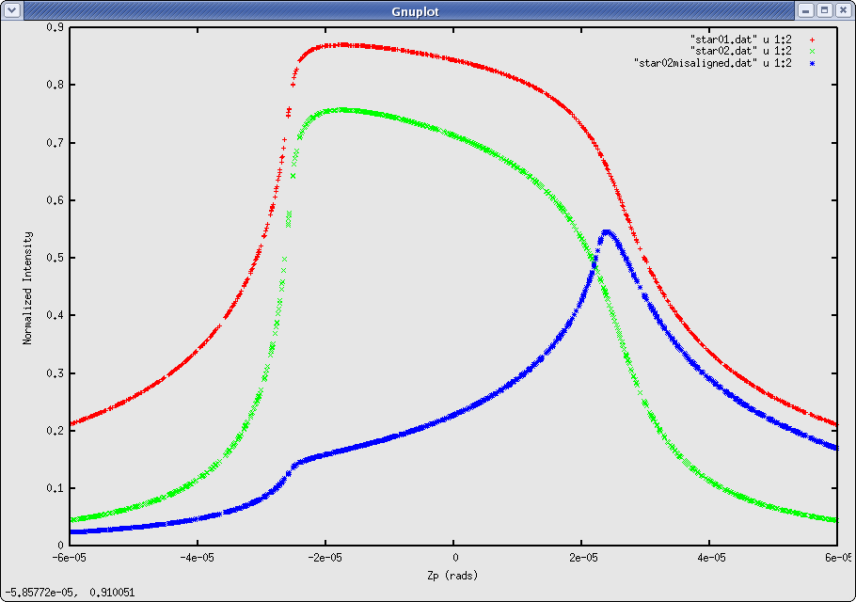
Figure 6.18: Comparison of BRAGG reflectors: offset and exact conditions

Several interesting observations can be drawn from this plot. Notice the three curves. The highest one represents the intensity transmitted at each wavelength by the first crystal; notice that it is essentially identical with the rocking curve and is centered around zero. The second (lower) curve centered around zero represents the intensity transmitted by the two crystals; it is, in this case, equal to the square of the original intensity. The sides are thus more sharply defined, while the “bandpass” is not changed substantially. However, the fact that the sides are sharper means that the transmitted intensity is a better approximation to a rectangle, i.e., to an ideal monochromator. The third and smallest curve is clearly offset to the side. This is due to the rotation imparted to the second crystal, that displaces the diffraction profiles of the two crystals relative to each other, thus giving the typical “spike”. A careful observation will reveal the onset of the two different diffraction profiles. This is highlighted by the added traces.

Figure 6.19: Two crystals monochromator in parallel radiation.

Two Crystals II

In this section of the primer we will reconsider the case of the two crystals, but with a different type of source. We will be using a collimated source with a continuous energy distribution. The crystals will be set at the same conditions as for the former case. In the case of the point source the change of angle across the face of the crystal produced the change in reflectivity and thus in intensity. In the present case it will be the change in wavelength that will give rise to a different reflectivity. Besides this, the run is exactly like the former one, so we will not repeat the full description.

Chapter 6.5 source | Shadow3 < primer_ch65_source.inp
shadow3> source

SOURCE selected. Begin procedure.
Select mode, enter :
prompt : prompted session
batch : file-oriented session
systemfile : file-oriented session using start.00

Select mode (prompt OR batch OR systemfile): prompt
Call to INPUT_SOURCE
--------------------------------- S H A D O W -------------------------------

Defining source :
When prompted for a yes/no answer, you may enter:
for YES answer Y*, y*, 1*
for NO answer anything else

Do you want a verbose [ 1 ] or terse [ 0 ] output ?0

------------- SOURCE SPECS ------------------
Source modelling type [ 0-5 ] ? 0
How many rays [Default=30000] ? 1000
Seed [ odd, 1000 - 1 000 000 ] ? 12345
Do you want to optimize the source ? 0

Source type : [ 0 ] regular (geometrical or bending magnet) source
[ 1 ] normal wiggler
[ 2 ] undulator
[ 3 ] elliptical wiggler
Then ? 0

X-Z plane source type [ 0-3, 6 ] ? 1
Source Width [ x ] ? 1
Height [ z ] ? 1

Source Depth [ 1-4 ] ? 1

Source Angle Distribution [ 1-6 ] ? 1
Horizontal half-divergence [ (+)x, rads ] ? 0
[ (-)x, rads ] ? 0
Vertical [ (+)z, rads ] ? 0
[ (-)z, rads ] ? 0
Do you want a Photon energy [ Y/N ] ? 1
Energy distribution [ 1-4 ] ? 3
Photon Energy [ 0 ] or Angstroms [ 1 ] ? 0
From photon energy or wavelength ...
? 11156
... to photon energy or wavelength :
? 11165

Do you want to store the optical paths (OPD) [Y/N] ? 1
Do you want to generate the A vectors (electric field) [Y/N] ?1
Phase difference ?0
Degree of polarization ?1
Incoherent [0] or coherent [1] ?0
Exit from INPUT_SOURCE
Generated 250 rays out of 1000
500
750
1000
Exit from SOURCE

Source has been successfully generated.

SOURCE procedure completed.
shadow3>

Now we proceed running trace, exactly the same as done in the previous chapter (you can rerun using shadow3<primer_ch64_run1.inp).

Then, we run plotxy on the files start.01 and star.02, but plotting intensity (column 25) versus energy (column 11), and rename the plotxy_scatter.dat file into star01.dat and star02.dat, respectively. Then, we run again trace for the second crystal misaligned. We will use a new feature, the “mirror movement” that allows to misalign the oe without changing the optical axes. This option is useful for studying tolerances to small displacement and rotations of the elements. Finally, we run plotxy again and rename the file with points to star02misaligned.dat. This is the run:

Chapter 6.5  Crystal 2 misalignment | shadow3 < primer_ch65_run2.inp
shadow3> plotxy
PLOT> Input file? star.01
PLOT> Options --- Enter
PLOT> 0 for excluding the losses
PLOT> 1 for including only the losses
PLOT> 2 for including all the rays.
PLOT> Then ? 0
PLOT> Comment for plot [ 80 char ] ?
*******************/*******************/*******************/*******************/
xtal1

PLOT> Found 1000 good points out of 1000
PLOT> The following columns are defined for each ray
1) the regular columns [1-12]
2) optical path [13]
3) phase angle of As[14], Ap[15], and the Ap vector [16-18]

Col Par Minimum: Maximum: Center: St. Dev.:

1 X -0.49975 0.49793 -0.72861E-02 0.29168
2 Y -0.16208E-13 0.37947E-13 0.11299E-13 0.11157E-13
3 Z -0.49941 0.49911 -0.42044E-02 0.29778
4 X' 0.0000 0.0000 0.0000 0.0000
5 Y' 1.0000 1.0000 1.0000 0.0000
6 Z' 0.54956E-08 0.54956E-08 0.54956E-08 0.48996E-15
11 Photon Energy (eV) 11156. 11165.
20 Numerical Aperture 0.54956E-08 0.54956E-08
21 R=SQRT(X**2+Y**2+Z**2) 0.11457E-01 0.69535
22 angle [rad] from Y-axis 0.0000 0.0000
23 Intensity-s 0.16054 0.87037
24 Intensity-p 0.0000 0.0000
25 Intensity 0.16054 0.87037
Total Intensity: 332.79629190884214

PLOT> Options. You may plot any two rows from
the above list versus each other.
You may also plot any of them versus the
ray Numerical Aperture. N.A. -- enter 20.

PLOT> Rows to use for plot :
PLOT> for horizontal axis ? 11
PLOT> for vertical axis ? 25
PLOT> Units for plot:
0 For cm-1
1 For eV
2 For Angs
PLOT> Then ? 1

PLOT> Scaling options. Enter

0 For automatic scaling
1 For cartesian scaling
2 For external limits
PLOT> Then ? 0
PLOT> Plotting options :
0 For scattered plot
1 For pixelized plot
2 For contour plot
PLOT> Then ? 0
PLOT> Ready for histograms. Enter:
-1 to skip
0 for same limits as plot
PLOT> ? -1
File written to disk: plotxy_scatter.dat
File written to disk: plotxy_histtop.dat
File written to disk: plotxy_histside.dat
File written to disk: plotxy.gpl
shadow3> $cp plotxy_scatter.dat star01.dat
shadow3> plotxy
PLOT> Input file? star.02
PLOT> Options --- Enter
PLOT> 0 for excluding the losses
PLOT> 1 for including only the losses
PLOT> 2 for including all the rays.
PLOT> Then ? 0
PLOT> Comment for plot [ 80 char ] ?
*******************/*******************/*******************/*******************/
xtal2

PLOT> Found 1000 good points out of 1000
PLOT> The following columns are defined for each ray
1) the regular columns [1-12]
2) optical path [13]
3) phase angle of As[14], Ap[15], and the Ap vector [16-18]

Col Par Minimum: Maximum: Center: St. Dev.:

1 X -0.49793 0.49975 0.72861E-02 0.29168
2 Y -0.21388E-12 0.14809E-11 0.62215E-12 0.36911E-12
3 Z -0.49935 0.49916 -0.41486E-02 0.29778
4 X' 0.13374E-15 0.13374E-15 0.13374E-15 0.0000
5 Y' 1.0000 1.0000 1.0000 0.10410E-07
6 Z' 0.10991E-07 0.10991E-07 0.10991E-07 0.0000
11 Photon Energy (eV) 11156. 11165.
20 Numerical Aperture 0.10991E-07 0.10991E-07
21 R=SQRT(X**2+Y**2+Z**2) 0.11434E-01 0.69539
22 angle [rad] from Y-axis 0.14901E-07 0.14901E-07
23 Intensity-s 0.25771E-01 0.75754
24 Intensity-p 0.58886E-09 0.18258E-07
25 Intensity 0.25771E-01 0.75754
Total Intensity: 193.64991085642197

PLOT> Options. You may plot any two rows from
the above list versus each other.
You may also plot any of them versus the
ray Numerical Aperture. N.A. -- enter 20.

PLOT> Rows to use for plot :
PLOT> for horizontal axis ? 11
PLOT> for vertical axis ? 25
PLOT> Units for plot:
0 For cm-1
1 For eV
2 For Angs
PLOT> Then ? 1

PLOT> Scaling options. Enter

0 For automatic scaling
1 For cartesian scaling
2 For external limits
PLOT> Then ? 0
PLOT> Plotting options :
0 For scattered plot
1 For pixelized plot
2 For contour plot
PLOT> Then ? 0
PLOT> Ready for histograms. Enter:
-1 to skip
0 for same limits as plot
PLOT> ? -1
File written to disk: plotxy_scatter.dat
File written to disk: plotxy_histtop.dat
File written to disk: plotxy_histside.dat
File written to disk: plotxy.gpl
shadow3>
shadow3> $cp plotxy_scatter.dat star02.dat
Exit shadow3
shadow3> trace

Ray Tracing Selected. Begin procedure.

Mode selected [prompt OR batch OR systemfile] ?prompt
Call to RESET
Exit from RESET
Mode selected is: prompt

Options: to start anew [ 0 ]
to restart from a given OE [ 1 ]

Then ? 1

Previous element number: 1
Image file of the previous OE ? star.01

Do you want to change input mode ? 0

Call to INPUT_OE
--------------------------------- S H A D O W -------------------------------

Defining Optical Element: 2
Continue ? [ EXIT to terminate OS ]

Do you want a verbose [ 1 ] or terse [ 0 ] output ?0

Files to write out. Options:
All............................ [ 0 ]
Mirror only.....................[ 1 ]
Image at CP only................[ 2 ]
None............................[ 3 ]
Then ? 0

Optical Element definition:
Incidence Angle ? 10
Source Distance ? 150
Reflection Angle? 10
Image Distance ? 5000
Reflector [ 0 ] or refractor [ 1 ] ? 0

Is this a segmented mirror system?0
Is this a Kumakhov system?0
A: Is this mirror faceted [Y/N] ?0
Mirror surface [ 1-9] ? 5
Is the mirror Cylindrical ? 0
Is this optical element a Fresnel Zone Plate ? 0
Are we dealing with a Grating ? 0

Are we dealing with a crystal [ Y/N ] ? 1
File containing crystal parameters ?
GAAS.PAR
Is it a mosaic crystal [ Y/N ] ? 0
Is the crystal asymmetric [ Y/N ] ? 0
Are we working in Johansson geometry [Y/N] ? 0
Automatic Tuning of Crystal [ Y/N ] ?1
Energy, in eV, [ 0 ] or wavelength, in Angs., [ 1 ] ? 0
Photon Energy ? 11160
Is the mirror convex [ Y/N ] ? 0
Reflectivity mode [ 0,1,2 ] ? 0

Orientation Angle [ Alpha ] ? 180

Mirror Dimensions finite [ Y/N ] ?0

Save incidence and reflection angles to disk? 0
Do you want to move the Source [ Y/N ] ? 0
Do you want to move the mirror itself [ Y/N ] ? 1
Rotation around X axis [ degrees ] ? 2.777e-3
Y ? <enter>
Z ? <enter>
Mirror Offset. In X ? <enter>
Y ? <enter>
Z ? <enter>
Distorted surface [ Y/N ] ? 0
Do you want to include surface roughness [Y/N] ? 0

Any screens in this OE [ Y/N ] ? 0

Slit at continuation plane [ Y/N ] ? 0
Extra Image plates [ Y/N ] ? 0
Exit from INPUT
Tracing optical element # 2
Call to SETSOUR
...
Exit from RESET

Do you want to change input mode ? 0

Call to INPUT_OE
--------------------------------- S H A D O W -------------------------------

Defining Optical Element: 3
Continue ? [ EXIT to terminate OS ] EXIT

End of session

shadow3>
shadow3> plotxy
PLOT> Input file? star.02
PLOT> Options --- Enter
PLOT> 0 for excluding the losses
PLOT> 1 for including only the losses
PLOT> 2 for including all the rays.
PLOT> Then ? 0
PLOT> Comment for plot [ 80 char ] ?
*******************/*******************/*******************/*******************/
xtal2 misaligned

PLOT> Found 1000 good points out of 1000
PLOT> The following columns are defined for each ray
1) the regular columns [1-12]
2) optical path [13]
3) phase angle of As[14], Ap[15], and the Ap vector [16-18]

Col Par Minimum: Maximum: Center: St. Dev.:

1 X -0.49793 0.49975 0.72861E-02 0.29168
2 Y -0.11592E-11 0.12762E-11 0.82664E-13 0.42798E-12
3 Z -0.98403 0.14483E-01 -0.48883 0.29778
4 X' 0.13374E-15 0.13374E-15 0.13374E-15 0.0000
5 Y' 1.0000 1.0000 1.0000 0.54800E-07
6 Z' -0.96925E-04 -0.96925E-04 -0.96925E-04 0.20850E-10
11 Photon Energy (eV) 11156. 11165.
20 Numerical Aperture 0.96925E-04 0.96925E-04
21 R=SQRT(X**2+Y**2+Z**2) 0.92778E-02 1.0763
22 angle [rad] from Y-axis 0.96925E-04 0.96925E-04
23 Intensity-s 0.22834E-01 0.54691
24 Intensity-p 0.52263E-09 0.12322E-07
25 Intensity 0.22834E-01 0.54691
Total Intensity: 58.33070545387576

PLOT> Options. You may plot any two rows from
the above list versus each other.
You may also plot any of them versus the
ray Numerical Aperture. N.A. -- enter 20.

PLOT> Rows to use for plot :
PLOT> for horizontal axis ? 11
PLOT> for vertical axis ? 25
PLOT> Units for plot:
0 For cm-1
1 For eV
2 For Angs
PLOT> Then ? 1

PLOT> Scaling options. Enter

0 For automatic scaling
1 For cartesian scaling
2 For external limits
PLOT> Then ? 0
PLOT> Plotting options :
0 For scattered plot
1 For pixelized plot
2 For contour plot
PLOT> Then ? 0
PLOT> Ready for histograms. Enter:
-1 to skip
0 for same limits as plot
PLOT> ? -1
File written to disk: plotxy_scatter.dat
File written to disk: plotxy_histtop.dat
File written to disk: plotxy_histside.dat
File written to disk: plotxy.gpl
shadow3> $cp plotxy_scatter.dat star02misaligned.dat
shadow3>

Now, we want to plot the reflectivity as a function of the photon energy, instead of angle. For that, as done in the last chapter, we create a gnuplot command file bragg2.gpl and launch the plot with the command gnuplot bragg2.gpl. You may reuse the command shadow3<primer_ch64_results2.inp. The result is shown in Fig. 6.20.

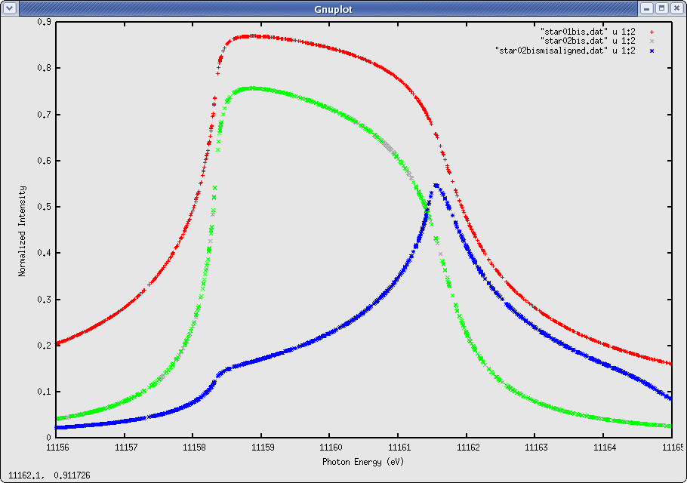
Figure 6.20: Comparison of BRAGG reflectors for continuous energy

Note that in section Two Crystals I we calculated the intensity versus angle for a monochromatic divergent beam and obtained the typical diffraction profile. In this section we used a white source, but a collimated (no divergence) beam, and obtained a similar profile, but as a function of energy. In a more general case with white and divergent beam, and probably extended source size, the intensity plot is not a well defined curve, but a band, and the intensity response is better obtained using histo1 on column 11 with the reflectivity switch on.

Graphical User Interface: ShadowVUI

The goal of this manual is to getting starting with SHADOW, and to give examples of running it. We have always used the SHADOW command mode, that directly used the “shadow3” program, which contains the SHADOW kernel and basic pre- and post-processors. However, it is possible to use SHADOW3 within a Graphical Use Interface, that helps in preparing the start.xx files and give more sophisticated graphics than gnuplot. This is the case of ShadowVUI, a complete user interface written in IDL and freely available under the XOP package. It allows to run SHADOW in a multi-window environment, helping the user to modify the optical system, rerun SHADOW with modified inputs, and quickly refresh all the screens showing interesting information for the user, as XY plots, histograms, automatic calculation of Full Width at Half Maximum, fits, etc. Another powerful feature in ShadowVUI is the availability of macros, that permit to run SHADOW in a loop, to perform powerful post-precessing, make parametric calculations, and compute a posteriori some basic operations (tracing in vacuum, vignetting, etc.). The full description of the ShadowVUI is out of the scope of this Primer, but we strongly recommend it for users wanting to run SHADOW intensively. For getting started with ShadowVUI, we provide the workspace files for all the examples in this Primer, and a tutorial on XOP and SHADOW under ShadowVUI is also available. Fig. 7.1 shows some screenshots of ShadowVUI.
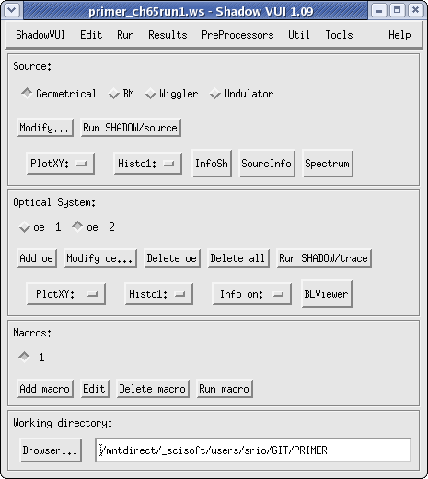
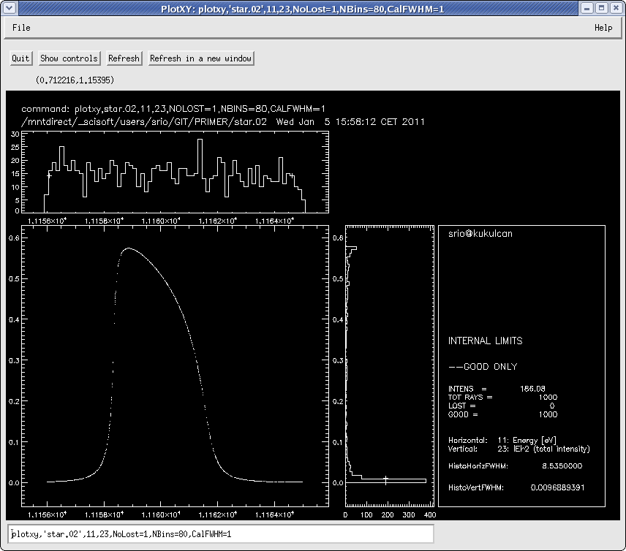
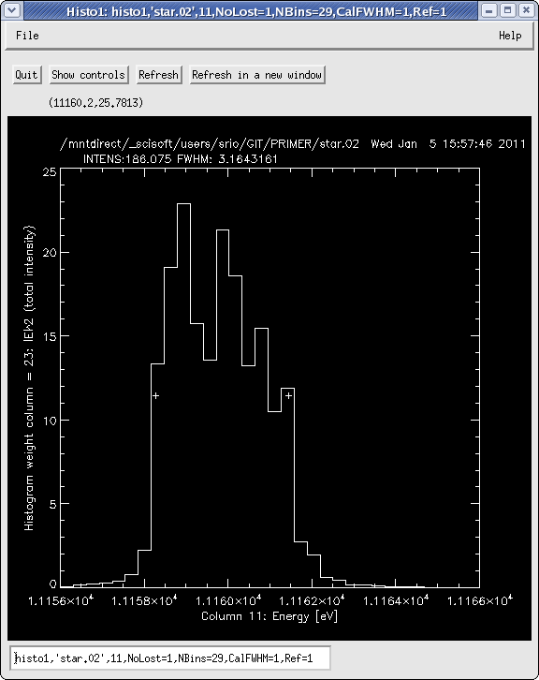

Figure 7.1: Screenshots of ShadowVUI

SHADOW Programming

SHADOW code has been completely restructured and cleaning in version 3. It allows now
SHADOW users to become programmers. It is easy to make Fortran main programs that call the different routines of the SHADOW library. Moreover, using the newly designed SHADOW3 API, it is possible to call SHADOW from programs written in C, C++, Python and IDL. It is possible to run SHADOW in loops, without writing files, thus accelerating the calculation. Scripts, macros and programs can be written to deal with optical system optimization, image simulation, and low transmission calculations requiring a large number of rays (>10⁶).

Please refer to the documentation and examples distributed with the SHADOW sources.

Web resources
This chapter list the web addresses from where it is possible to obtain SHADOW and related material.

SHADOW3 binaries and documentation
- http://ftp.esrf.eu/pub/scisoft/shadow3/

SHADOW3 sources
- git://git.epn-campus.eu

SHADOW2 Repositories (binaries, sources and documentation)
- http://ftp.esrf.eu/pub/scisoft/shadow/
- http://ftp.esrf.eu/pub/scisoft/shadow/

XOP and ShadowVUI
- http://www.esrf.fr/UsersAndScience/Experiments/TBS/SciSoft/xop2.3
- http://ftp.esrf.eu/pub/scisoft/xop2.3/

Documentation

All manuals are available under the HELP menu in ShadowVUI.

For direct access, you may use these links:
- SHADOW3 Primer (this document):
http://ftp.esrf.eu/pub/scisoft/shadow3/Shadow3Primer.pdf
- SHADOW2 Primer:
http://ftp.esrf.eu/pub/scisoft/shadow/documentation/Primer.pdf
- SHADOW2 Users Guide – Sources:
http://ftp.esrf.eu/pub/scisoft/shadow/documentation/shadow-source.pdf
- SHADOW2 Users Guide – Trace:
http://ftp.esrf.eu/pub/scisoft/shadow/documentation/shadow-trace.pdf
- SHADOW2 Users Guide – Utils:
http://ftp.esrf.eu/pub/scisoft/shadow/documentation/userguide.pdf
- XOP and ShadowVUI Tutorial: http://ftp.esrf.eu/pub/scisoft/xop2.0/XopTutorial/exercises_xop+shadow.pdf

Glossary

Active Surface A surface where the rays are reflected/refracted.

Aligned System An optical system where nothing has been ‘moved’ when running SHADOW.

Aperture A slit or hole at a screen that limits the latitude of the beam.

batch mode Input mode that takes parameter files ( start.xx ) generated by a previous input session and supplies them to SHADOW for a re-run. You will simply be prompted for these parameter file names.

Beam A collection of rays, pretty much like in flashlight beam. The rays can be random or ordered (grid). The beam is stored in the BOF at different locations.

Beamline The hardware implementation of an optical system used to relay with or without monochromatization the beam from source to sample.

Bins Divisions of a histogram that determine the resolution of ray statistics; A greater number of bins yields higher resolution but less reliable statistics, i.e. a smaller signal/noise ratio.

Blaze The blaze condition proper applies only to triangular grooves, when the light is incident and diffraction angles, relative to the grating normal, are such that the ray is exactly ’reflected’ by the facet. In other words, the incoming ray forms with the facet normal the same angle as the diffracted beam. It is the condition of maximum efficiency of the grating. Lamellar and sinusoidal gratings have both high-efficiency angles, but for other reasons (see Gratings).

BOF Binary Output File – the large binary files generated by the run of SHADOW. They contain the full beam description at some location along the optical system. Use translate to type/print them.

Central Ray The ray generate by SOURCE with x = y = z = 0, x' = z' = 0, and
y' = 1. It is the ray propagating exactly along the source Y axis. It coincides with the optical axis, in the case of an aligned system.

Collimated The condition of a beam in which all rays are parallel, i.e., the object/image is at infinity.

Continuation Plane An intermediate plane perpendicular to the Y axis that acts as a delimiter between two optical elements, or as the image plane at the end of the optical system. Continuation planes may or may not coincide with the beam focus. The beam information for the XXth continuation plane is located in the B.O.F. Star.XX.

Cylindrical Figure A figure originated by the translation of a plane curve perpendicular to the plane. If the plane curve is an ellipse, we speak of elliptical cylinder; if it is a circle, of circular cylinder; etc.

Diffraction Grating An element whose surface produces a strongly peaked autocorrelation power series. The relative height of the first, second, etc. peak represent the relative efficiency of the first, second, ... diffraction order. As the ACF depends on the coherent spacing for the peak position, the diffraction angles are determined solely by the grating pitch. The height of the peaks represents the Fourier components of the surface at each groove, so that the efficiency depends on the shape of the grooves. The condition of blaze is usually the most efficient.

Diffraction Limit The observed width of a (geometrically) point-like image. It is due to the finite wavelength of the radiation used to reconstruct the image and to the finite convergence angle. Typically: δ = λ 2N.A.

Diffraction Limited Optics An optical system where the dimensions of the image are larger than those of the geometrical image and defined by the radiation employed. For a focusing system, the diffraction limited focus is given by λ/2N.A. , N.A. being the numerical aperture of the system. Aberrations and figure errors mainly modify the intensity distribution within the limits predicted by the diffraction limit.

Diffraction Order See Order.

Element The part of an optical system that encloses an active surface.

ERF Exit Record File - Contains information about a source or optical element after the rays have been traced through the system. Information such as computed parameters, and positions in the X,Y,Z and Laboratory Reference Frames are given. SHADOW gives the ERFs the default name end.xx.

exit Exit from SHADOW command level to Operating System level.

External Pertaining to the definition of an optical element; the parameters are supplied by the user rather than being computed by SHADOW.

Figure The mathematical function describing the surface of a mirror or of a lens. We speak of elliptical figure, etc.

Figure Limited Optics Optical systems where the dimensions of the image are dominated by the figure errors. At grazing angle, slope errors are the most serious. Common problems with high brightness sources (small dimensions).

Flag Tags a ray if it was not transmitted through an OE or screen. The Flag is 1 if the ray passed and 0 if it was lost. The Flag is the tenth column in the BOFs; it may assume other values as well.

Footprint The intensity pattern of a beam on the surface of an optical element

Fresnel Equations Determine the reflectivity of a medium for the two polarization
directions as a function of incident and transmitted angles.

Geometrical Optics The study of an optical system purely on the basis of geometrical relations between rays and surfaces.

G-file Text file that contains the input parameters for the source or optical system. These files (named by SHADOW as start.xx) are the only files that are needed, besides the files created by the preprocessors, to regenerate the beam data for the entire system. They inherited the structure of the Fortran NAMELIST.

Grating Horizon The wavelength such that, for a particular incidence angle, the diffracted first order would be at -90ë, i.e., diffracted back and tangent to the surface. Longer wavelengths would be diffracted ’inside’ the surface, so that the grating behaves like a normal mirror for wavelengths beyond the horizon.

Grating Mount The particular optical system configuration chosen to implement an instrument. A mount is specified by the geometry of the grating element and by focal conditions. Also used, more loosely, to indicate a type of scanning action, like in “TGM mount”: this simply means a mount with constant included angle and rotation achieved by simple rotation of the grating.

Grazing Angle An Incidence or Reflection angle in which the rays are nearly parallel to the optical surface.

Groove Shape Refers to a grating’s grooves. They can be generally divided in lamellar, triangular or sinusoidal.

Image Distance The distance along the Y axis from an optical element to the next continuation plane, which may or may not be the location of a real image.

Incidence Angle The angle that an incident ray makes with respect to the normal of the optical surface in question.

Input Modes Means to enter the parameters characterizing source and OE. The three input modes are prompt, batch and systemfile.

help Evokes the help facility at the SHADOW command level and provides some on-line description of the local commands and their purposes.

Marginal Rays The rays on the periphery (margin) of the beam. They are normally the ones suffering the most aberration.

Momentum Space The “space” which is occupied by the angles that the rays make with respect to the Y axis. The angles are expressed by their components in the X and Z directions, thus for any ray: x'2 + y'2 + z'2 = 1. The coordinates in momentum space for a ray are in columns 4, 5, and 6 in any B.O.F.

Monochromator An optical instrument capable of transmitting a very narrow bandpass of a white spectrum. Normally consisting of one or more gratings/crystals in a particular mount.

Namelist From Fortran, ASCII file with a list of variables. See G-file.

Normal A vector which is perpendicular to the surface in question. Usually located at the geometric center of an optical surface.

Numerical Aperture The sine of the angle formed by a ray with the optical axis.

Optical Axis The ray connecting the poles of the optical elements. It connects the origin points of the consecutive OE’s. Notice that even when the mirror are ‘moved’, the optical axis remains the same. Same as central ray, if the source has not been ‘moved’ in SHADOW.

Optical Efficiency The ratio of the number of photons departing to the number incident
on an optical element (or system).

Optical Element or O.E. The part of the optical system encompassing an active surface. It is delimited by two planes (source/object and image, respectively) located along the optical axis at some convenient location.

Optical Path The optical path of a ray is given by the integral of the refraction index as a function of position n(s) over ds, from a to b, being a and b are the initial and terminal points of the ray. The focal condition states that all the optical paths are the same, independent of angle.

Optical system The collection of optical elements under study.

Orders The labels tagged to a beam when diffracted from a grating. The European convention defines negative the orders diffracted inside (inside order) the zero-order reflection beam, positive those laying outside. The American convention is the opposite. Most XUV systems work in the first order and the XUV community follows the European convention.

Phase Space The union of Real and Momentum spaces. Phase space projections may aid in interpreting the character of the beam at a given point in the system by determining the correlation between two of the components such as X and X¢.

Physical Optics The study of an optical system that explicitly includes physical aspects, such as reflectivity, diffractions, etc.

Preprocessor Any utility that generates data that is used for SOURCE generation or defining an element of the optical system, e.g., PREREFL is used to determine the reflection and transmission coefficients for a given Atomic Number.

prompt mode Input mode in SHADOW that asks the user for parameters to cover the full specification of a source or OE. Useful when setting up a new system.

Ray The path described by a single photon. It is specified by 12,13, or 18 double precision real numbers. They are described by a starting point, a direction, an electric field, a phase, a polarization degree, an energy, a status flag.

Ray Index Index used to number the rays in order of their generation: the first ray is given Ray Index 1, the second 2, etc... The Ray index is the 12th column in the BOFs.

Real Space The ordinary geometrical space. The real space coordinates for a ray are in columns 1, 2, and 3 in the BOFs.

Reflection Angle The angle that a reflected or refracted ray that is coincident with the Y axis makes with respect to the normal of the optical surface in question.

Roughness The random errors left on a surface by machining or coating. Included in SHADOW using the Power Spectral Density function mapped onto the surface of the element. See Demo for more details.

Seed An odd eight-digit number used as input to a pseudo-random number generator for creating source photon distributions or other random processes.

Shape The shape of the mirror outline or contour: a spherical mirror can be round or rectangular. The same is true for any mirror figure. Same as Profile.

Sigma Usually refers to the standard deviation of the distribution function in question.

SOURCE Used to define the source parameters and generate the source rays. After entering the command the user will be prompted to choose an input mode during which the physical description is set up.

Source Depth The distribution of the source points in the Y direction.

Source Distance The distance along the Y axis from the source or previous continuation plane to the next optical element in the system.

Source Limited Optics An optical system where the dimensions of the image are dominated by the aberrations caused by the large extent of the source, either in plane or in angle. Diffraction and figure errors have a small effect.

systemfile mode Input mode that takes parameter files ( start.xx, systemfile.dat ) generated by a previous input session and supplies them to SHADOW for a re-run. You will simply be prompted for these parameter file names.

TRACE Used to define the optical elements and the optical system. On completion of the OS definition, TRACE computes the path of each ray through the OS. A source must exist before issuing the command TRACE.

Virtual Image Rays emerging from an OE or OS in image space are diverging, so image appears to exist in object space.

Virtual Object Rays entering an OE or OS from object space are converging, so
object appears to exist in image space.

Wavenumber The wavenumber for a photon is given by K = 2π/λ , where λ is the
wavelength.

Zero order The beam reflected by a grating without scattering, whereby it acts like a simple mirror.

Theory of X-Ray Diffraction in Crystals, William H. Zachariasen, Dover
M. Sanchez del Rio, et. al, Review of Scientific Instruments 63(1), 1992

