Same-Day Perishables Clearance
v3 Architecture & Design
J24 Store Platform · Theta Direct Innovations · builds on the shipped v2 repo
Summary. v3 keeps every hard call v2 got right — Temporal per-batch ownership, a pure deterministic price engine, a strict activity/workflow I/O boundary — and fixes the two things that actually block trustworthy live pricing: the projection model and the data-acquisition topology. It adds a testing harness that exercises the whole loop before any real integration lands. Every change is additive and ships behind a config flag.

Contents

1. The three decisions
# | Question | Decision & why
1 | Poll into a DB and have a separate workflow act, or one workflow? | Decisions stay in ONE workflow per batch; only data acquisition is decoupled into a shared per-facility poller + read-model. Splitting the actor out re-creates the coordination Temporal removes; splitting the reader out is pure upside — it protects the slow OUTWARDED endpoint and kills N× duplicated scans.
2 | Simulate with a Postman mock? | Yes for contract testing (shape, retry, headers — the repo is already env-flag driven). Add a stateful mock for trajectory testing: static responses don't move, so the ladder never walks; a time-moving fake makes the price actually step.
3 | Is sell-through logic fine, or use the hourly forecast? | Combine them. Observed sell-through supplies the LEVEL; the hourly profile supplies the SHAPE. v2's flat rate×remaining_h understates the evening peak for greens and over-marks-down at the 4pm trough. The hourly pipeline you already built produces exactly the shape needed.

2. Target architecture
One poller per facility batch-refreshes a sell-through snapshot; every markdown workflow reads the snapshot (≈1 ms) instead of scanning Bolt itself. Decisions never live in the poller — correlation of a price change to its trigger, and the replay-based audit trail, are preserved.
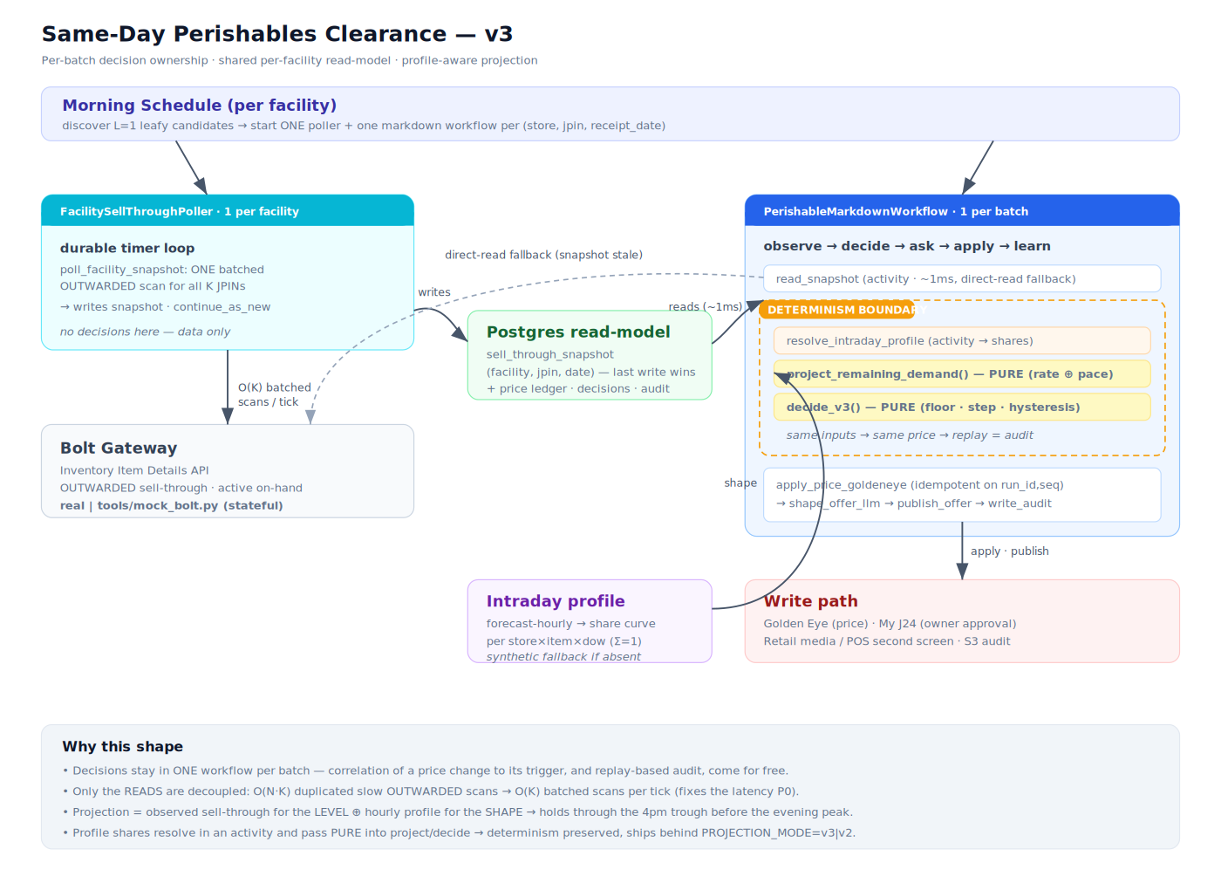
Figure 1 — v3 topology: per-batch decision ownership, shared per-facility read-model, profile-aware projection.
Read path (the change): for K candidate JPINs and N batches this turns O(N·K) slow OUTWARDED scans per tick into O(K) batched scans — the concrete fix for the OUTWARDED-latency P0.

3. The projection model (the core fix)
v2 projected end-of-day clearance with a flat extrapolation:
proj = units_sold + recent_rate × remaining_h # assumes the rate holds flat
That is wrong for greens in a way that costs margin: demand is evening-peaked, so a 4 pm midday rate understates what's coming and the agent marks down right before the rush. v3 blends two estimators of the units that will sell from now to close:
- RATE — recent_rate × remaining_h. Robust at open, blind to the day's shape.
- PACE — infer today's level from what has sold, project the remainder by the profile's shape:
D_hat = units_sold / cum_share_to_now
remaining_pace = D_hat × remaining_share # carries the evening peak
They blend by a weight w that grows with both how much of the day's demand has elapsed and how many units have been observed — so v3 leans on RATE at open and PACE from mid-morning:
w = min( clip(cum_share/share_ref), clip(units_sold/units_ref) )
remaining_demand = w × remaining_pace + (1−w) × remaining_rate

Worked example — the leafy-greens trap (from the unit tests)
Coriander, Q0 = 60, sold 27 by 16:00, midday rate 3/hr, 5 h nominally left.
- v2 flat: 27 + 3×5 = 42 of 60 → behind → marks down before the rush.
- v3 pace: profile says 45% of the day has happened, 55% ahead. D_hat = 27/0.45 = 60, remaining = 33, proj = 60 of 60 → HOLD, margin protected.
Guardrail: a genuine laggard (8 of 60 by 4 pm) still steps — the profile can't clear it even with the peak. v3 stops over-discounting; it never stops discounting real slow movers. It uses only the profile's shape, never the daily point-forecast level, so it stays robust to a stale forecast.

4. Determinism is preserved
Both new inputs arrive as plain parameters computed off the workflow's own deterministic clock and resolved in activities. resolve_intraday_profile (activity) reads the artifact; project_remaining_demand and decide_v3 are pure — no clock, no I/O, no randomness. Same inputs → same price → replay is the audit record. A unit test asserts exactly this.

5. Testing strategy
Layer | Tool | What it proves
Unit (pure) | tests/test_projection.py | evening-peak HOLD vs flat STEP, laggard still steps, early-day leans on rate, determinism
Contract | Postman static mock → BOLT_BASE_URL | headers, createdTimeAfter, 5xx retry/backoff, JSON shape
Trajectory | tools/mock_bolt.py (stateful) | sell-through rises through the day, projection updates, ladder actually walks, poller + snapshot read wired
Run the full loop with no real creds: start the mock, bring up the compose stack, point the app at the mock, start a run (a 13 h day replays in ~30 s). Flip PROJECTION_MODE=v2 on the same JPIN to watch the flat model mark down earlier through the afternoon trough. See docs/V3-TESTING.md for exact commands.

6. File manifest

New
- pricing/projection.py — pure profile-aware projector (project_remaining_demand, DayProjection).
- activities/profile.py + adapters/profile.py — resolve intraday shares; evening-peaked synthetic fallback.
- activities/snapshot.py — batched facility poll + fast read_snapshot (direct-read fallback).
- workflows/facility_poller.py — FacilitySellThroughPoller (one per facility, continue_as_new).
- tools/mock_bolt.py — stateful Bolt mock for trajectory testing.
- start_poller.py — CLI to launch the poller. tests/test_projection.py — v3 unit tests (passing).

Changed (additive, non-breaking)
- pricing/decision_engine.py — added decide_v3 (projection-driven; decide_v2 untouched).
- pricing/ladder.py — env-driven PROJECTION_MODE / READ_FROM_SNAPSHOT defaults (activity-side).
- workflows/markdown.py — v3 read + profile + decide branch, behind config flags.
- worker.py — registers the poller + new activities.
- shared/models.py, db/models.py, db/repo.py — IntradayProfile, AddJpinsRequest, sell_through_snapshot read-model.

7. Rollout
- Step 1. Shadow v3 next to v2 — log both decisions, no writes; confirm v3 holds through the trough v2 marks down.
- Step 2. Stand up the snapshot poller; keep batches reading Bolt directly. De-risks the read-model independently.
- Step 3. Flip batches to read_snapshot; the staleness fallback protects against poller lag.
- Step 4. Enable v3 pricing for a subset of JPINs, then the facility, once the profile artifact is published daily.
Each step is independently reversible via a config flag; none requires a migration beyond the additive sell_through_snapshot table (auto-created by init_db()).

