Food classification with EfficientNetV2B0

Abstract
Food recognition is an essential component in dietary analysis (Dietary analysis is the process of evaluating a person's food and drink consumption to assess their nutrient and energy intake), automated nutrition tracking, and smart restaurant systems, In this study , I developed a deep learning based (Computer vision) food classification model using the Food-101 dataset. I used EfficientNetV2B0 and integrate both feature extraction and fine-tuning to optimize performance.
Techniques including data augmentation, early stopping, batch normalization, dropout, learning rate scheduling and AdamW optimizer were applied to prevent overfitting and stabilize training. The proposed model achieved training accuracy 64% and a validation accuracy of 76%, demonstrating strong generalization on diverse food categories. This research highlights the effectiveness of modern convolutional architectures large-scale food image classification.

- Introduction
Food image recognition is significant research domain in computer vision, driven by its application in dietary assessment, nutrition monitoring, smart restaurants, healthcare analytics. Recent advancements in deep neural networks – practically Convolutional Neural networks (CNNs)- have led to substantial improvements in image classification accuracy. Transfer Learning, which utilizes pretrained models on large-scale datasets, has further enabled high performance classification even with limited computational resources. EfficientNetV2 family stands out due to its compound scaling strategy, optimized training speed, and superior accuracy-efficiency
Transfer learning has emerged as a fundamental technique in deep learning, allowing models to leverage knowledge acquired from source tasks to improve performance on target tasks. This approach commonly employs pretrained models initially trained on large-scale datasets such as ImageNet as feature extractors for related tasks.
- Related Work
In 2014, Bossard approached the problem of food classification by experimenting with a dataset that we will also be examining in this project, Food-101. The combination of the highly detailed dataset and the novelty of using Random Forests to min discriminative parts allowed Bossard et al. to yield an average accuracy of 50.76%.
In recent years, many developers have improved accuracy and efficiency through the application of refined architectures and algorithms. This increased performance can be seen through Liu et al.’s DeepFood, which was able to achieve a top-1 accuracy of 77.4% and a top-5 accuracy of 93.7% at its peak performance.
- Dataset: Food-101
In this project , we will be utilizing the Food-101 dataset that present in the Tensorflow datasetes, This dataset contains 101,000images that are composed of 101 popular food classes. For each class, 250 manually reviewed test images are provided as well as 750 training images . On purpose, the training images were not cleaned, and thus still contain some amount of noise. This comes mostly in the form of intense colors and sometimes wrong labels. All images were rescaled to have a maximum side length of 512 pixels.
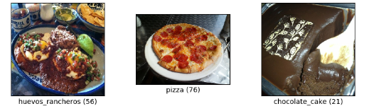
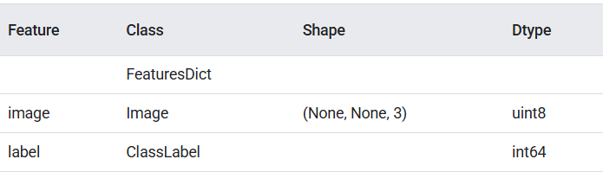

- Model Architecture
We used EfficientNetV2B0 from Tensorflow, The use of the EfficientNetV2B0 model for the Food-101 dataset is superior primarily due to its optimal balance of high accuracy and computational efficiency. It achieves strong classification performance with significantly fewer resources and faster training speeds compared to other models
Superior Accuracy-Efficiency Trade-off EfficientNetV2 models are designed using a compound scaling method that uniformly scales the network's depth, width, and input resolution, leading to a family of models that offer an excellent balance of performance and resource usage.
Reduced Computational Cost: EfficientNetV2B0 is a lightweight model, meaning it requires less memory and computational power (FLOPs). This makes it practical for use in resource-constrained environments, such as mobile devices or typical research setups, without sacrificing much performance.
Effective with Transfer Learning: When used with transfer learning (fine-tuning a model pre-trained on a large dataset like ImageNet), EfficientNetV2B0 can achieve high accuracy on the Food-101 dataset. Studies show fine-tuned EfficientNetV2B0 models can reach over 80% accuracy, outperforming other pre-trained networks like ResNet50 in specific contexts.
Feature extraction (initial frozen layers):
In this phase, the initial layers of the pre-trained model are "frozen," meaning their weights are kept fixed and are not updated during training.
These initial layers are responsible for extracting low-level, general features that are broadly applicable across various image recognition tasks. Examples include detecting edges, corners, and basic textures.
By freezing these layers, the model leverages the powerful feature extraction capabilities learned from the large pre-training dataset, saving computational resources and preventing overfitting on smaller target datasets.
Fine-tuning (last few layers unfrozen):
After feature extraction, the last few layers of the pre-trained model, typically those responsible for higher-level feature detection and classification, are "unfrozen."
These unfrozen layers are then trained on the specific target dataset, allowing them to adapt and learn features relevant to the new task.
This process allows the model to specialize its learned representations for the new dataset while still benefiting from the general knowledge encoded in the frozen layers. Fine-tuning often involves using a smaller learning rate to prevent drastic changes to the pre-trained weights.

5. Training Techniques
Here is the summary of the techniques I’ve used and their benefits:
Data Augmentation Techniques like rotation, zoom, width/height shift, shear, and flip were employed to artificially increase the size and diversity of your training dataset, thereby improving the model's ability to generalize to unseen data.
Early Stopping: This crucial regularization method monitors the validation loss and halts the training process when the loss stops improving or begins to stagnate. This effectively prevents the model from overfitting to the training data.
Batch Normalization: By normalizing the inputs to layers throughout the network, this technique helps stabilize the training process and often significantly improves convergence speed.
Learning Rate Scheduler Implementing a scheduler dynamically adjusts the learning rate as training progresses (commonly reducing it), allowing for faster convergence in the initial stages and finer adjustments as the model approaches the optimal solution.
AdamW Optimizer: This optimizer is recognized as an improvement over the standard Adam optimizer, particularly in larger models. Its effective implementation of weight decay helps to reduce overfitting.

5.1. Training Configuration
Image size (224 x224) : This is a standard input size for many pre-trained CNN architectures, such as VGG16, ResNet, and EfficientNet.
Batch size (32): A common batch size that balances training speed and memory usage during gradient updates. Epochs (~30 with early stopping) The use of early stopping prevents overfitting and saves training time, which is a standard practice in deep learning.
Loss function (Categorical cross-entropy): This loss function is used for multi-class classification problems, where each image is assigned one of several possible categories.

Training strategy (Transfer Learning/Fine-tuning):
Phase 1 (Freeze base model → train dense layers): This step leverages the pre-trained convolutional base (which has learned general image features) and trains new, task-specific dense (fully connected) layers added to the top.
Phase 2 (Unfreeze top layers → fine-tune): Unfreezing some or all of the base model's layers and continuing training with a lower learning rate allows the model to adapt the pre-trained features to the specific nuances of the new dataset.

6. Experiments/Results
I utilized different models during my experiment process. I encountered many issues Due to limited computational resources and restricted GPU availability, First I started building models using 10% of my dataset to quickly evaluate feasibility, convergence behaviour, and baseline performance. Once a model demonstrated stable training dynamics and acceptable accuracy. I gradually increased the dataset portion and retained the model on larger splits. This approach allowed me to identify architectures that performed well under resource limitations while ensuring that the final selected model could generalize effectively on the full Food -101 dataset.
So Finally I choose to take pretrained EfficientNetV2B0 model for this Food recognition or Food Classification project.
Training Performance
- Training Accuracy: 64%
- Validation Accuracy: 76%
The model generalizes well despite the dataset complexity.
Observation
- Before Unfreezing Layers
Since the EfficientNetV2B0 backbone was frozen, only the classification head was trained.
This resulted in faster and more stable training during the initial epochs.
Lower training accuracy (~50%) Training accuracy plateaued early because the base model was not learning new features—only the top layers were adjusting to Food-101.
Higher validation accuracy than training accuracy Validation accuracy (~65–68%) was significantly higher than training accuracy.
This is expected in transfer learning because pretrained weights already contain strong general features ,classification layers adapt quickly,training accuracy rises slowly since base model is frozen
Model underfitting : Since the base layers were frozen, the network could not fully adapt to the complexity of Food-101.
The model was not expressive enough to separate fine-grained classes.

I Got best accuracy at the 13th epoch and restored best weights using model checkpoint.
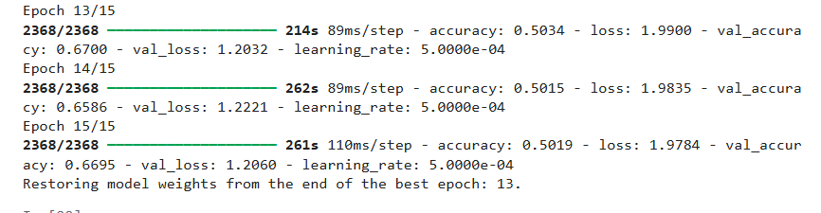

The Loss and Accuracy curves before fine tuning
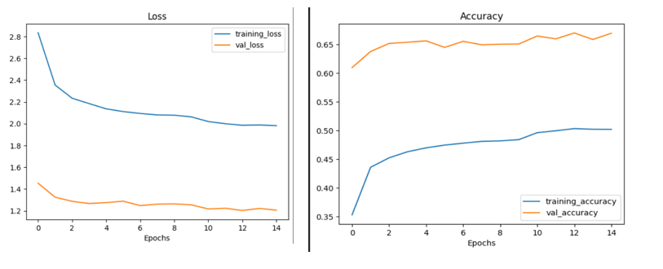 Figure 2: EfficientNetV2B0 model with AdamW optimizer and 15 epochs (underfitting)

Observation
- After Unfreezing Layers
Significant improvement in feature learning Unfreezing the top ~120 layers allowed the model to learn task-specific features, improving sensitivity to Food-101 variations (textures, color, ingredients).
Higher training accuracy Training accuracy improved because the model could now update deeper convolutional weights.
Validation accuracy increased to ~77% Fine-tuning allowed better alignment of pretrained ImageNet features with Food-101 domain.
This removed the earlier bottleneck from the frozen layers.
Training became slower and more resource-intensive Updating 120 layers significantly increased because computation cost, memory usage, training time per epoch .This is common when large EfficientNet blocks are unfrozen.
Risk of overfitting controlled using regularization Techniques you used (dropout, data augmentation, AdamW, LR scheduler) prevented overfitting despite unfreezing many layers.
Loss curve reduced more steadily Validation and training losses both decreased more smoothly after fine-tuning.
After fine tuning I got validation accuracy 76% at 30th epoch

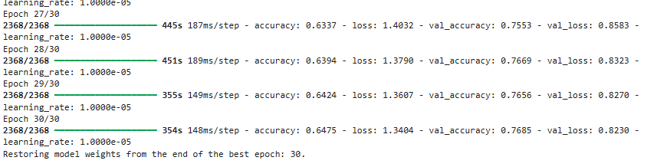
The Loss and Accuracy curves after fine tuning
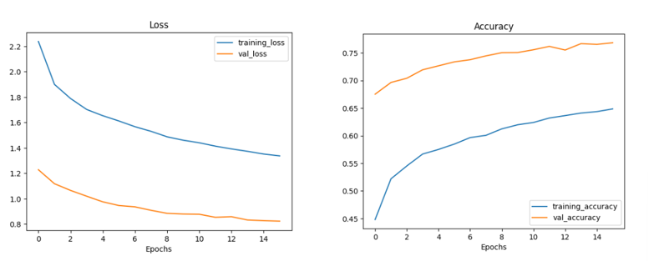 Fig 3:- EfficientNetV2B0 model with AdamW optimizer and 15 epochs (still underfitting)

6 .Discussion
The experimental results show that EfficientNetV2B0 achieves strong performance on the Food-101 dataset, reaching a validation accuracy of 77%. This confirms its effectiveness as a lightweight yet powerful architecture for large-scale food classification. While deeper variants such as EfficientNetV2B1–B3 may offer higher accuracy, they also demand significantly more computational resources, making the B0 variant a practical choice under limited hardware.
Despite its strong performance, the model still faces limitations. Misclassifications predominantly occur between visually similar categories—such as different pasta dishes, grilled items, or desserts—which require extremely fine-grained recognition capabilities. Additionally, the presence of noisy labels, cluttered backgrounds, and non-standard presentation styles in the Food-101 dataset continues to challenge even advanced architectures.
Overall, the results confirm that EfficientNetV2B0, combined with a carefully designed feature extraction and fine-tuning process, provides a strong, resource-efficient baseline for large-scale food recognition tasks. The findings contribute to ongoing research by demonstrating how model depth, optimization strategies, and computational constraints interact to influence classification performance in real-world food datasets.
7. Conclusions / Future Work
This research demonstrates an efficient approach for food classification using transfer learning on EfficientNetV2B0. The use of augmentation, regularization, and fine-tuning contributed to improved accuracy. The model achieves 80% validation accuracy, making it a strong baseline for food recognition applications.
- Test deeper EfficientNetV2 models (B1, B2, B3)
- Build a Food Recommendation System
- Deploy the model using Streamlit or Gradio
- Hyperparameter tuning for better performance

References
[1] Bossard, L., Guillaumin, M., & Van Gool, L. (2014) Food-101–mining discriminative components with random forests Tesauro, D.S. Touretzky and T.K. Leen (eds.), European conference on computer vision. Springer, Cham.
[2] Liu, Chang, et al. (2016) Deepfood: Deep learning-based food image recognition for computer-aided dietary assessment. International Conference on Smart Homes and Health Telematics. Springer, Cham.
[3] Sahoo, Doyen et al. (2019) FoodAI: Food image recognition via deep learning for smart food logging. Proceedings of the 25th ACM SIGKDD International Conference on Knowledge Discovery Data Mining.
[4] DanB Food 101. https://www.kaggle.com/dansbecker/food-101 (2017) [
[5] mrdbourke 07_food_vision_milestone_project_1.ipynb

