Open1722 CAN Latency Tester
Linux vs. Zephyr IEEE-1722 Gateway
Project Specification Document v 0.2

1. Team

Name | Role | Date | Signature
Sripiranavan Yogarajah | Developer | April 7, 2026
Sebastian Schildt | Client
Ulrich Straus | Client

2. Motivation
In modern automotive and industrial systems, CAN data often must be transported over Ethernet backbones using time-sensitive networking protocols. The IEEE-1722 (AVTP) standard defines how to encapsulate CAN frames into Ethernet packets. Open1722 is an open-source implementation of IEEE-1722 that runs on both Linux and Zephyr OS, making it an ideal candidate for comparison.
Every gateway introduces latency and — critically — jitter, which can destabilise time-sensitive control loops. This project builds a measurement framework to quantify and compare the end-to-end latency and jitter of CAN forwarding through an IEEE-1722 bridge on both a Linux host (Raspberry Pi) and a Zephyr (STM32F439ZI) node, providing a real-world performance delta between a general-purpose OS and an RTOS.

3. Goals
Phase 1: Linux Gateway Performance Characterization
- Deploy Open1722 gateway on two Raspberry Pi nodes to bridge CAN frames over Ethernet using IEEE-1722 AVTP.
- Implement round-trip latency measurement on STM32F439ZI by timestamping CAN1 TX and CAN2 RX.
- Achieve sub-millisecond performance with mean latency <1 ms and jitter < 200 µs for the complete CAN → Ethernet → CAN path.
- Collect 10000+ latency samples to establish statistical baseline with mean, standard deviation, min, max and 95th / 99th percentile.
- Test under varying CAN bus loads at 10%, 50% and 80% utilization to characterize gateway scalability.
- Identify jitter sources by profiling Linux OS scheduling, SocketCAN driver delays, and network stack overhead.
- Validate IEEE-1722 protocol compliance by capturing AVTP frames with Wireshark and verifying correct CAN encapsulation.
- Optimize Linux gateway performance using real-time scheduling, CPU pinning and memory locking.
- Generate latency distribution plots including histograms, cumulative distribution functions and time-series jitter analysis.
- Document reproducible test methodology with automated scripts for data collection analysis and future Zephyr comparison baseline.
Phase 2: Zephyr Gateway Comparison(Extended Goal)
Upon successful completion of Phase 1, implement Zephyr based Open1722 gateway on STM32 to quantify performance differences between Linux and Zephyr under identical test conditions, focusing on latency reduction, jitter improvement, and determinism under load.

4. System Architecture
The system uses a five-node round-trip pipeline. The STM32F439ZI acts as both the CAN frame source and the latency measurement node. Two Raspberry Pi units act as IEEE-1722 gateways.

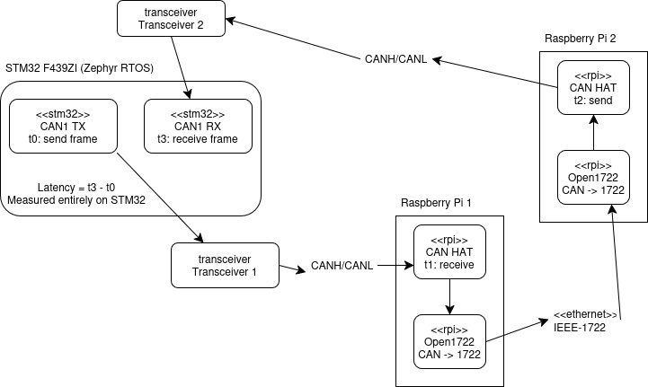

5. Solution Approach
The system implements a five-node round-trip pipeline as described in Section 4. The key design decisions are:

- Direct Ethernet cable between RPi1 and RPi2 to minimize network jitter and isolate the Open1722 forwarding latency from switch-induced variability.
- STM32F439ZI as exclusive measurement node by computing latency entirely on-device (t₃ - t₀), no PTP or external clock synchronization is required.
- Two independent CAN buses – CAN Bus A connect STM32 CAN1 to RPi1; CAN Bus B connects RPi2 to STM32 CAN2. Both CAN interfaces operate in normal mode with 120Ω termination resistors at each end.
- Identical test conditions for reproducibility – all measurements use the same CAN bitrate (250kbps), frame rate, and payload to enable fair comparison between configurations.
- Jitter as primary metric – standard deviation of latency reveals scheduling non-determinism more clearly than mean latency alone, making it critical for evaluating real time performance.

6. Roadmap

Task | Start | End | Status
Hardware Setup & CAN Bus Verification | March 30, 2026 | March 31, 2026 | Done
CAN TX/RX on Linux and Zephyr | April 1, 2026 | April 3, 2026 | Done
Open1722 Integration – Linux Gateway (RPi1 + RPi2) | April 4, 2026 | April 15, 2026 | In Progress
Timestamp & Latency Measurement Framework. | April 16, 2026 | April 20, 2026 | Pending
Review 1: Basic IEEE-1722 Forwarding | April 21, 2026 | April 21, 2026 | Milestone
Data Collection & Load Testing | April 22, 2026 | May 5, 2026 | Pending
Jitter Analysis & Linux Optimization | May 6, 2026 | May 15, 2026 | Pending
Protocol Validation & Documentation | May 16, 2026 | May 25, 2026 | Pending
Review 2: Linux Gateway Performance Report | May 26, 2026 | May 26, 2026 | Milestone
Open1722 Integration – Zephyr Gateway | May 28, 2026 | June 9, 2026 | Pending
Linux vs Zephyr Comparison Analysis | June 10, 2026 | June 16, 2026 | Pending
Final Documentation & Presentation | June 17, 2026 | June 30, 2026 | Pending

7. Continuation plan
This project establishes a baseline measurement framework that can be extended to evaluate additional gateway architectures and protocol combinations.
- STM32 to STM32 Full Zephyr Pipeline
- Hybrid STM32 – Raspberry Pi Configuration
- Wireless IEEE 1722 over WiFi 6E / 5G
The relevant diagrams are in the Github repository under <git>/docs/diagrams directory

