**REAL-TIME FACE RECOGNITION SYSTEM USING EXACT LEGENDRE MOMENTS AND SUPPORT VECTOR MACHINE**

Dr.Ch.Srinivasa Rao1, Sri Pooja Ravipati1, Chaitanya Valluru1

1.Department of Electronics and Communication Engineering, JNTUK Univeristy College of Engineering, Vizianagaram – 535 001

Email: [chsrao.ece@jntukucev.ac.in](mailto:chsrao.ece@jntukucev.ac.in), [sripooja.ravipati257@gmail.com](mailto:sripooja.ravipati257@gmail.com), [chaitanyavalluru404@gmail.com](mailto:chaitanyavalluru404@gmail.com)

**Abstract:** Face recognition is an active field of research with varied applications. This paper discusses about the implementation of a real time face recognition system using invariant image moments. Feature extraction and classification are two key steps for face recognition. We compared three automated methods for face recognition using invariant image moments for feature extraction. For classification, SVM (Support Vector Machine) and k-Nearest Neighbors were used. The experiments were implemented on three face databases, The ATT Face database and the Georgia Tech Database and MIT CBCL database. The developed model is implemented for a real-time face recognition system using Exact Legendre Moments and Support Vector Machine and k-Nearest Neighbors.

**1*.* Introduction**

Face recognition is prominent area of research; there are multitude of algorithms and techniques available in literature to perform face recognition. Feature extraction and classification are two key steps in face recognition. Feature extraction can be defined as the procedure of extracting relevant information from a face image. This can be done in two steps. One is face detection and the other is extracting the features from the detected face. For face-detection Viola-Jones algorithm is used. For feature extraction, Moment functions are used.

The face detection system is most clearly distinguished from previous approaches in its ability to detect faces extremely rapidly using Viola-Jones face detection algorithm [3]. There are three main contributions of this Viola Jones object detection framework. These contributions are evaluated to obtain the feature from the image using the process of integral image followed by cascading classifier and adaboost training to eliminate the weak features.

Moment functions of the two-dimensional image intensity distribution are used in a variety of applications like visual pattern recognition, object classification, template matching, edge detection, pose estimation, robotic vision and data compression. Image moments that are invariant with respect to the transformations of scale, translation and rotation find applications in areas such as pattern recognition, object identification and template matching. Orthogonal moments have additional properties of being robust in the presence of image noise and have a near zero redundancy measure in a feature set [1]. The Legendre moments are invariant to scaling. In general Face Recognition (FR) system suffers with inefficient feature extraction and classification [2]. The success of FR system depends upon either on the feature extraction approach or on the classifier design. The Legendre moments are scale invariant and orthogonal which are found to be suitable for representing the holistic features of the face images in the database [2]. The obtained features from the input images are recognized using K-Nearest-Neighbor (kNN) classifier using the Manhattan distance and Multiclass Support Vector Machine (SVM) classifier.

The outline of the paper is as follows: Section 2 feature extraction In Section 3 classification.  Section 4 contains experimental results and real-time implementation Section 5 concludes the paper.

**2. Feature Extraction**

In feature extraction process there are two steps: face detection and extracting features from the detected face. For face detection process, Viola-Jones Algorithm is used. For feature extraction Legendre moments Zeroth Order [11] Approximation and Exact Legendre Moments [1] are used.

**2.1Viola-Jones Algorithm**

The Viola-Jones algorithm is a widely used mechanism for object detection. The main property of this algorithm is that training is slow, but detection is fast. This algorithm uses Haar basis feature filters, so it does not use multiplications. The efficiency of the Viola-Jones algorithm can be significantly increased by first generating the integral image. Detection happens inside a detection window.  A minimum and maximum window size is chosen, and for each size a sliding step size is chosen.  Then the detection window is moved across the image.  Each face recognition filter (from the set of N filters) contains a set of cascade-connected classifiers. Each classifier looks at a rectangular subset of the detection window and determines if it looks like a face. If it does, the next classifier is applied. If all classifiers give a positive answer, the filter gives a positive answer and the face is recognized. Otherwise the next filter in the set of N filters is run. Each classifier is composed of Haar feature extractors (weak classifiers). Each Haar feature is the weighted sum of 2-D integrals of small rectangular areas attached to each other. The weights may take values ±1. Haar feature extractors are scaled with respect to the detection window size. The cascade architecture is very efficient because the classifiers with the fewest features are placed at the beginning of the cascade, minimizing the total required computation. The most popular algorithm for features training is AdaBoost training which removes the weak classifiers and creates a set of strong classifiers for detection purpose [3].

**2.2 Image Moments**

**2.2.1 Legendre Moments**

Legendre Moments (LM) are continuous and orthogonal moments, they can be used to represent an image with minimum amount of information redundancy. The Legendre moments are scale invariant and orthogonal which are found to be suitable for representing the holistic features of the face images in the database. The obtained features from the input images are used for recognition purpose [1].Legendre moments of order g = ( p + q) for an image with intensity function f (x, y) are defined as

$Lpq=\frac{(2q+1)(2q+1)}{4}\int_{-1}^{1}{\int_{-1}^{1}{Pp(x)Pq(y)f (x, y) dx dy}}$----- (1)

where, Pp (x) is the pth order Legendre polynomial defined as

$\text{Pp}\left(\text{x}\right)\text{=}\sum_{\text{k=0}}^{\text{p}}{a_{k}\text{, }}\text{= }\frac{\text{1}}{2^{p}\text{p}\text{!}}{\left(\frac{d}{dx}\right)}^{P}\left[{\left(x^{2}-1\right)}^{p}\right]$----- (2)

Where *x* ∈ [−1*,* 1], and the Legendre polynomial *Pp(x)* obeys the following recursive relation:

$Pp\left(x\right)= \frac{\left(2p + 1\right)}{\left(p + 1\right)}xPp\left(x\right)-\frac{p}{\left(p + 1\right)} Pp-1(x)$----- (3)

With *P*0*(x)* = 1, *P*1*(x)* = *x* and *p>*1. The set of Legendre polynomials {*Pp(x)*} forms a complete orthogonal basis set on the interval [−1*,* 1]. The orthogonality property is defined [1] as

$\int_{-1}^{1}{Pp\left(x\right)Pq\left(x\right)dx =\left\{\begin{aligned}0, &p≠q \\ \frac{2}{\left(2p + 1\right)}, &p=q\end{aligned}\right.}$----- (4)

A digital image of size *M* ×*N* is an array of pixels. Centers of these pixels are the points $\left(x_{i},y_{j}\right)$, where the image intensity function is defined only for this discrete set of points $\left(x_{i},y_{j}\right)$ ∈ [−1*,* 1]X[−1*,* 1]. $Δx_{i}= x_{i+1}- x_{i}$, $Δy_{j}= y_{j+1}- y_{j}$ are sampling intervals in the *x*- and *y*-directions, respectively. In the literature of digital image processing, the intervals ${∆x}_{i}$ and ${∆y}_{j}$ are fixed at constant values $Δx_{j}= 2/M$, and $Δy_{j}= 2/N$, respectively [1]. Therefore, the points $\left(x_{i},y_{j}\right)$ will be defined as follows:

$x_{i}=-1 +\left(i - \frac{1}{2}\right)∆x$----- (5.1)

$y_{j}=-1 +\left(j – \frac{1}{2}\right)∆y$----- (5.2)

With *i*=1*,* 2*,* 3*. . . M* and *j* =1*,* 2*,* 3*. . . N*. For the discrete space version of the image, Eq. (1) is usually approximated by

$\tilde{L}pq=\frac{\left(2p + 1\right)\left(2q + 1\right)}{MN}\sum_{i=1}^{M}{\sum_{j=1}^{N}{Pp\left(x_{i}\right)Pq\left(y_{j} \right)f \left(x_{i},y_{j} \right)}}$----- (6)

Eq. (5) is so-called direct method for Legendre moments computations, which is the approximated version using zeroth-order approximation (ZOA). As indicated by Liao and Pawlak [11], Eq. (5) is not a very accurate approximation of Eq. (1). To improve the accuracy, they propose to use the following [1].

Approximated form: $Lpq=\frac{\left(2p + 1\right)\left(2q + 1\right)}{4}\sum_{i=1}^{M}{\sum_{j=1}^{N}{hpq\left(xi, yj \right)f \left(xi, yj \right)}}$----- (7)

Where $hpq\left(xi, yj \right)=\int_{xi-\left(\frac{∆xi}{2}\right)}^{xi+\left(\frac{∆xi}{2}\right)}{\int_{yj-\left(∆yj\frac{}{2}\right)}^{yj+\left(∆yj\frac{}{2}\right)}{Pp\left(xi\right)Pq\left(yj \right)dx dy}}$----- (8)

Liao and Pawlak propose (AESR) method to evaluate the double integral defined by Eq. (6), and then they use it to calculate the Legendre moments defined by Eq. (7).

**2.2.2 Exact Legendre Moments**

Many algorithms are developed for the computation of LM [6, 7, 8], but these methods focus mainly on 2D geometric moments. When they are applied to a digital image, a numerical approximation is necessary. The difficulty in the use of Legendre moments is due to their high computational complexity, especially when a higher order of moments is used. Error due to approximation increases as the order of the moment increases. An accurate method for computing the Exact Legendre Moments (ELM) proposed by Hosney [1] is as follows [2]

The set of Legendre polynomials {Pp(x)} forms a complete orthogonal basis set on the interval [-1, 1]. A digital image of size NxN is an array of pixels. Centers of these pixels are the points (xi, yj). To improve accuracy, it is proposed to use the following approximated form. One of the special results involving Legendre polynomial is that [1],

$\int{Pp\left(x\right)dx= \frac{P_{p+1}(x) -P_{p-1}(x)}{2p + 1}}$----- (9)

Where *p* =1. For simplicity, upper and lower limits of the integration in Eq. (8) will be expressed as follows:

$U_{i+1}= x_{i}+ \frac{{∆x}_{i}}{2}= -1+i∆x$----- (10.1)

$U_{i}= x_{i}- \frac{{∆x}_{i}}{2}= -1+(i-1)∆x$----- (10.2)

Similarly, $V_{j+1}= x_{j}+ \frac{{∆y}_{j}}{2}= -1+j∆y$----- (11.1)

${ V}_{j}= x_{j}- \frac{{∆y}_{j}}{2}= -1+\left(j-1\right)∆y$----- (11.2)

Using Equations. (10.1), (10.2), (10.3) and (10.4) the integral parts will be written as follows:

$\int_{U_{i}}^{U_{i+1}}{Pp\left(x\right)dx = {\left[\frac{P_{p+1}\left(x\right)–P_{p-1}\left(x\right)}{2p + 1}\right]}_{U_{i}}^{U_{i+1}}}$----- (12)

$\int_{V_{j}}^{V_{j+1}}{Pq\left(y\right)dy = {\left[\frac{P_{q+1}\left(y\right)–P_{q-1}\left(y\right)}{2q + 1}\right]}_{j}^{V_{j+1}}}$----- (13)

$\int_{U_{i}}^{U_{i+1}}{Pp\left(x\right)dx = {\frac{1}{\left(p + 1\right)}\left[xPp\left(x\right)-P_{p-1}\left(x\right)\right]}_{U_{i}}^{U_{i+1}}}$----- (14)

$\int_{V_{i}}^{V_{i+1}}{Pq\left(y\right)dx = {\frac{1}{\left(q + 1\right)}\left[xPq\left(y\right)-P_{q-1}\left(y\right)\right]}_{V_{j}}^{V_{j+1}}}$----- (15)

The set of Legendre moment can thus be computed exactly [1] by

${\hat{ L}}_{pq}= \sum_{i=1}^{M}{\sum_{j=1}^{N}{I_{p}\left(x_{i}\right)I_{q}\left(y_{j}\right)f \left(x_{i}, y_{j}\right)}}$----- (16)

Where

$I_{p}\left(x_{i}\right)= {\frac{\left(2p + 1\right)}{\left(2p + 2\right)}\left[xPp\left(x\right)-P_{p-1}\left(x\right)\right]}_{U_{i}}^{U_{i+1}}$----- (17)

$I_{q}\left(y_{i}\right)= {\frac{\left(2q + 1\right)}{\left(2q + 2\right)}\left[xPq\left(y\right)-P_{q-1}\left(y\right)\right]}_{V_{i}}^{V_{i+1}}$----- (18)

Eq. (3.6.17) is valid only for *p*≥1, and *q*≥1

The moment kernel of exact 2D Legendre moments is defined by Eq. (17). This kernel is independent of the image. Therefore, this kernel can be pre-computed, stored, recalled whenever it is needed to avoid repetitive computation.

**3. Classification**

**3.1 Support Vector Machine**

Support Vector Machines (SVMs) are supervised learning methods used for image classification. It views the given image database as two sets of vectors in an ‘ n ’ dimensional space and constructs a separating hyper plane that maximizes the margin between the images relevant to query and the images not relevant to the query [10]. SVM is a kernel method and the kernel function used in SVM is very crucial in determining the performance. The aim of SVM classification method is to find an optimal hyper plane separating relevant and irrelevant vectors by maximizing the size of the margin (between both classes). This is due to the fact if the separating plane has the largest distance to the nearest training data points of any class, it lowers the generalization error of the overall classifier.

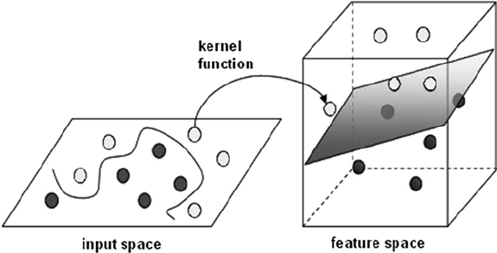

Fig1. SVM Kernel function mapping from a non-linear pattern to a linear plane [10]

**3.2 K-Nearest Neighbors**

The k-nearest neighbor algorithm [12] is a method for classifying objects based on closest training examples in the feature space. It is among the simplest of all machine learning algorithms. Training process for this algorithm only consists of storing feature vectors and labels of the training images. In the classification process, the unlabelled query point is simply assigned to the label of its k nearest neighbors. Typically the object is classified based on the labels of its k nearest neighbors by majority vote. If k=1, the object is simply classified as the class of the object nearest to it. When there are only two classes, k must be an odd integer [12]. However, there can still be ties when k is an odd integer when performing multiclass classification. After we convert each image to a vector of fixed-length with real numbers, the distance function for KNN which is Manhattan distance.

d(x,y) = $\sum_{i=1}^{n}{|Xi -Yi|}$

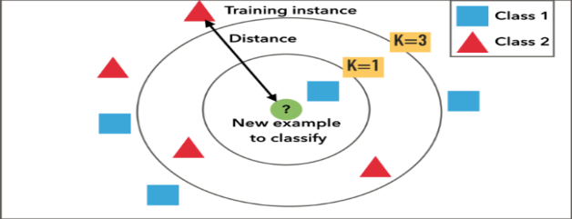

Fig2: Example of k-NN classification.[14] The test sample (inside circle) should be classified either to the first class of blue squares or to the second class of red triangles. If k = 3 (outside circle) it is assigned to the second class because there are 2 triangles and only 1 square inside the inner circle. If, for example k = 5 it is assigned to the first class (3 squares vs. 2 triangles outside the outer circle).

**4. Experimental Results**

**4.1 Databases**

Our experiments were performed on three face databases, and later a real-time database was created to implement a practical face recognition system.

The AT&T database consists of 40 subjects each having 10 different variations comprising of 400 images. These images are captured with the dark background under different illumination conditions with varying facial expressions. The image resolution is 92x112 pixels. The AT&T database contains images with very small changes in orientation of images for each subject involved which includes frontal and slight tilt of the head and is in gray-scale in PGM format.

The Georgia Tech database contains total 750 images, 15 images each for 50 individuals. The images are in JPEG format and all are of different sizes. The images in the database show variations in illumination conditions, facial expression, and appearance. The images show frontal and/or tilted faces with different facial expressions, lighting conditions and scale. each image for each subject is oriented in a different angle compared to the other.

The MIT-CBCL face recognition database contains face images of 10 subjects. The training set contains High resolution pictures, including frontal, half-profile and profile view of the person. The test set consists of 200 images per subject. The illumination, pose (up to about 30 degrees of rotation in depth) and the background is varied and the images are in 19x19 grayscale PGM format images.

We have mainly used MATLAB version 16.0 and the PC web camera for the experimentation purpose. The accuracy of the face recognition is measured which yields the efficiency of retrieval of the image from the database.

$$Accuracy=\frac{No.of images detected right in the database}{Total no.of images present in the database}$$

**4.2 Real time face database creation:**

In this process, we have taken 5 subjects and captured 15 facial gestures for each subject thereby comprising of 75 images in the database. These images are captured under same background with different facial expressions under bright illumination conditions. The images thus taken were performed segmentation using Viola-Jones algorithm and later the images were resized to remove the background effects on the image. Then these images were trained to create a real-time face database. After creation of the database we have tested the working in two conditions by taking an input image from the PC and second by taking the live input using the camera and verified the precision in recognition process.

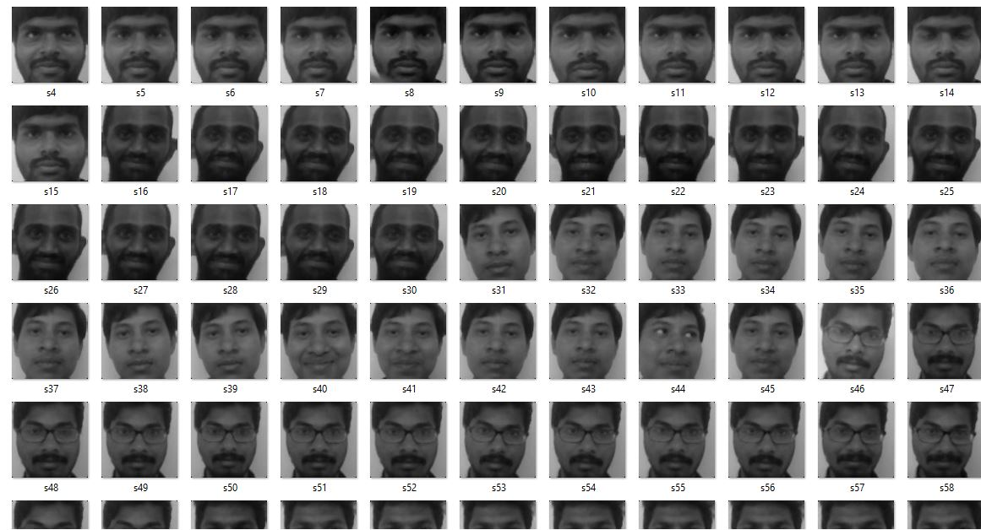

Fig 3: Real time face database with different orientation of people in gray scale

Using Viola Jones algorithm faces are detected and extracted. All the detected faces from the video are compared one by one with the face database. If any face is recognized based on the moment feature extracted from the input face with that of the faces in the database and then the matched image and name of the image is displayed.

**4.3 Results for K-Nearest Neighbor classifier**

The AT&T database, Georgia Tech database and MIT CBCL database are considered and the faces are detected using Viola Jones algorithm and features are extracted using Legendre moments ZOA and Exact Legendre Moments for different orders varying from 2 to 10. The order that yields the better accuracy is considered. The extracted features are classified using the k-Nearest-Neighbor classifier for different values of k. Manhattan distance is used as the distance parameter to calculate distance between the train and test images and the k value is chosen such that which yields good results. The comparison table for Legendre Moments and Exact Legendre Moments using K-Nearest-Neighbor classifier for the AT&T database, Georgia Tech database and MIT CBCL database are given below:

|  |  |  |  |
| --- | --- | --- | --- |
|  | AAT&T database | Georgia Tech database | MIT CBCL face database |
| Legendre Moments ZOA | 98.5% | 84.26% | 98.5% |
| Exact Legendre Moments | 98.75% | 82.8% | 100% |

**4.4 Results for Support Vector machine classifier**

The AT&T database, Georgia Tech database and MIT CBCL database are considered and the faces are detected using Viola-Jones algorithm and features are extracted using Legendre moments ZOA and Exact Legendre Moments for different orders varying from 2 to 10. The order that yields the better accuracy is considered. The extracted features are classified using the Multi-class SVM classifier, which compares the faces based on the classes they belong to and classifies them to particular class based on their location on the hyper plane. The comparison table for Legendre Moments and Exact Legendre Moments using SVM classifier for the AT&T database, Georgia Tech database and MIT CBCL database are given below:

|  |  |  |  |
| --- | --- | --- | --- |
|  | AAT&T database | Georgia Tech database | MIT CBCL face database |
| Legendre Moments ZOA | 98.5% | 87.56% | 99% |
| Exact Legendre Moments | 99% | 89.75% | 100% |

**4.5 Results for Real-time database**

The real-time face database is taken such that the algorithm is written in such a way that the camera continuously senses the location and whenever there is a person it detects the face using the Viola-Jones algorithm. The detected face is cropped and resized to eliminate the affects of backgrounds for extracting features. From the detected face moment features are extracted using Legendre Moments and Exact Legendre Moments.

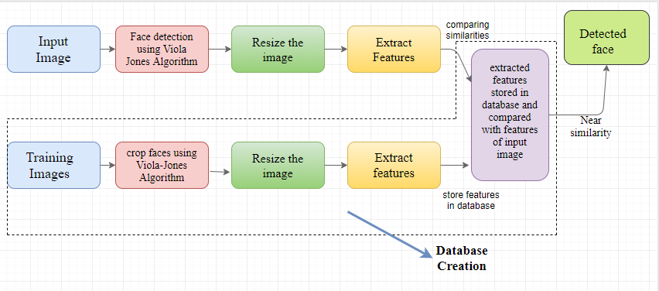

Fig 4: Process of Real-time Face Recognition system

The features extracted are stored in a database and whenever there is a new person the image is captured and the corresponding features are matched with those created in the database. The classification metric is used to choose the required one from the database and the retrieved image is displayed as the detected face as shown in Figure 4. The features are mapped using the K-Nearest-Neighbor classifier and the SVM classifier. We have used Manhattan distance for the distance metric with varying k and set the results for k=3. From this we have evaluated the precision and accuracy for the datasets. In case of SVM, we have taken multi-class SVM which groups according to the class and the accuracy is calculated. This system can be used for security purpose

|  |  |  |
| --- | --- | --- |
|  | NN CLASSIFIER | SVM CLASSIFIER |
| Legendre Moments ZOA | 73/75  (97.33%) | 75/75  (100%) |
| Exact Legendre Moments | 74/75  (98.66%) | 75/75  (100%) |

**5. Conclusions**

In this work, we implemented to different frameworks for face recognition process. One is combination of Exact Legendre Moments with k-Nearest Neighbors and the other is combination of Exact Legendre Moments with Support Vector Machine. The purpose of using Image Invariant Moments is due to their robustness to Rotation, Translation and Scaling Invariance. The Latency involved in computation of features using general techniques is reduced to 10% almost (1.25 to 2 seconds) using these moments. The other point is that the moment features are statistical and doesn’t affect with the experiment conditions. Once computed the moment feature values can be stored in the database and can be retrieved for further use which reduces the complexity in computing the features.

Here the Legendre moments are computed initially using zeroth order approximation. The performance of LM is good however as the order of the moment increases there is an error in computing the moments, which decreases the accuracy. To overcome this problem in real-time implementation we have taken Exact Legendre Moments which eliminates the errors in computation. The efficiency of Exact Legendre Moments is good and slightly improved when compared to Legendre Moments using both classification algorithms.

The combination of Exact Legendre Moments with Support Vector Machine and the combination of Exact Legendre Moments with k-Nearest Neighbors had the same performance while evaluating the AT&T database, Georgia Tech database and MIT CBCL database.

In real-time database, the combination of Support Vector Machine and Exact Legendre Moments outperformed the combination of K-Nearest Neighbors and the Exact Legendre Moments yielding 100% accuracy under bright illumination conditions. The model designed can be used for continuous tracking, surveillance and security systems.

**6. Acknowledgements**

We would like to thank Dr. Ch. Srinivasa Rao, Research Instructor and Professor, Department of Electronics and Communication Engineering, JNTUK UCEV.

**References**:

[1] Khalid M. Hosny “Exact Legendre Moments computation for gray level images” Journal of Pattern Recognition 40 (3597–3605) by Science Direct, 2007.

[2] Ch. Srinivasa Rao, S.Srinivas Kumar and B.Chandra Mohan “Content based image retrieval using Exact Legendre Moments and Support Vector Machine” International Journal of Multimedia and its Applications (IJMA), vol.2, No.2, May 2010.

[3] Viola,P, M..Jones “Robust Real-Time Face Detection” International Journal of computer vision 57(2), 2004.

[4] S.Annadurai and A.Saradha “Face recognition using Legendre Moments”  ICVGIP 2004, Proceedings of the Fourth Indian Conference on Computer Vision, Graphics & Image Processing, Kolkata, India, December 16-18, 2004

[5] Corinna Cortes, Vladimir Vapnik “Support Vector Networks” Machine Learning, 20, 273-297(1995)

[6]Altman, N. S. (1992). "An introduction to kernel and nearest-neighbor nonparametric regression". *The American Statistician*. **46** (3): 175–185.

[7]AT&T Laboratories Cambridge, “The database of faces,” at: http://www.cl.cam.ac.uk/research/dtg/attarchive/face database.html

[8] Georgia Tech face database, http://www.anefian.com/research/face_reco.htm

[9]MIT CBCL Face Recognition Database, cbcl.mit.edu/software-datasets/heisele/facerecognition-database.html

[10] https://medium.com/@LSchultebraucks/introduction-to-support-vector-machines-9f8161ae2fcb

[11] S. X. Liao and M. Pawlak, On image analysis by moments, IEEE Trans. Pattern Anal. Mach. Intell. 18, 1996, 254–266

[12] Bremner D, Demaine E, Erickson J, Iacono J, Langerman S, Morin P, Toussaint G, Outputsensitive algorithms for computing nearestneighbor decision boundaries, Discrete and Computational Geometry, 2005, pp. 593–604. [13] Cover, T., Hart, P. , Nearest-neighbor pattern classification, Information Theory, IEEE Transactions on, Jan. 1967, pp. 21-27.

[13] <http://www.csd.uwo.ca/~olga/Courses/CS434a_541a/Lecture11.pdf>

[14] <https://medium.com/@adi.bronshtein/a-quick-introduction-to-k-nearest-neighbors-algorithm-62214cea29c7>

[15] <http://www.wseas.us/e-library/conferences/2012/CambridgeUSA/MATHCC/MATHCC-18.pdf>

[16] S.Annadurai and A.Saradha “Face recognition using Legendre Moments”  ICVGIP 2004, Proceedings of the Fourth Indian Conference on Computer Vision, Graphics & Image Processing, Kolkata, India, December 16-18, 2004

[17] Rajiv Kapoor and Pallavi Mathur “Face recognition using Moments and Wavelets” International Journal of Engineering Research and Applications (IJERA), Vol. 3, Issue 4, Jul-Aug 2013

[18] Shu Chang, Ding Xiaaoqing, Fang Chi “Histogram of Oriented Gradient for face recognition” Tsinghua Science And Technology, Volume 16, Number 2, April 2011

[19] Pallavi D. Wadkar, Megha Wankhade, “AFace recognition using Discrete wavelet Transforms”, International Journal of Advanced Engineering Technology IJAET/Vol.III/ Issue I/January-March, 2012

[20] Farooq Bhat and M.Arif wani, “Elastic Bunch graph matching based face recognition under varying lighting, pose and expression conditions.”

[21] Milan Tuba, Romana Capor-Hrosik, and Mirjana Vukovic, “Face detection based on invariant moments classified by neural network”, International Journal Of Circuits, Systems And Signal Processing, Vol.8, 2014

[22] A.Nabatchian, E.Abdel-Raheem, M.Ahmadi, “Human Face Recognition using Different Moment Invariants-A comparative study” IEEE transaction on Image and Signal Processing,2008

[23] <https://www.mathworks.com/products/computer-vision.html>

[24] https://www.mathworks.com/products/image.html