**PROCEDURE**

**Prerequisites**

1: Apache NetBeans: Download Apache-NetBeans-13-bin-windows-x64. You can download it from netbeans.apache.org.

2: Java Development Kit (JDK): Download JDK if not already installed. You can download it from the official Oracle website.

* Java Development Kit (JDK): NetBeans requires a JDK to be installed

3. Integrated Development Environment (IDE): This is optional but tools like Eclipse, IntelliJ IDEA, or NetBeans can simplify your coding and deployment.

**Step 1:** Install JDK (jdk-8u144-windows-x64).

**Step 2:** Install Apache-NetBeans-13-bin-windows-x64.

**Step 3:** After installation launch Apache NetBeans

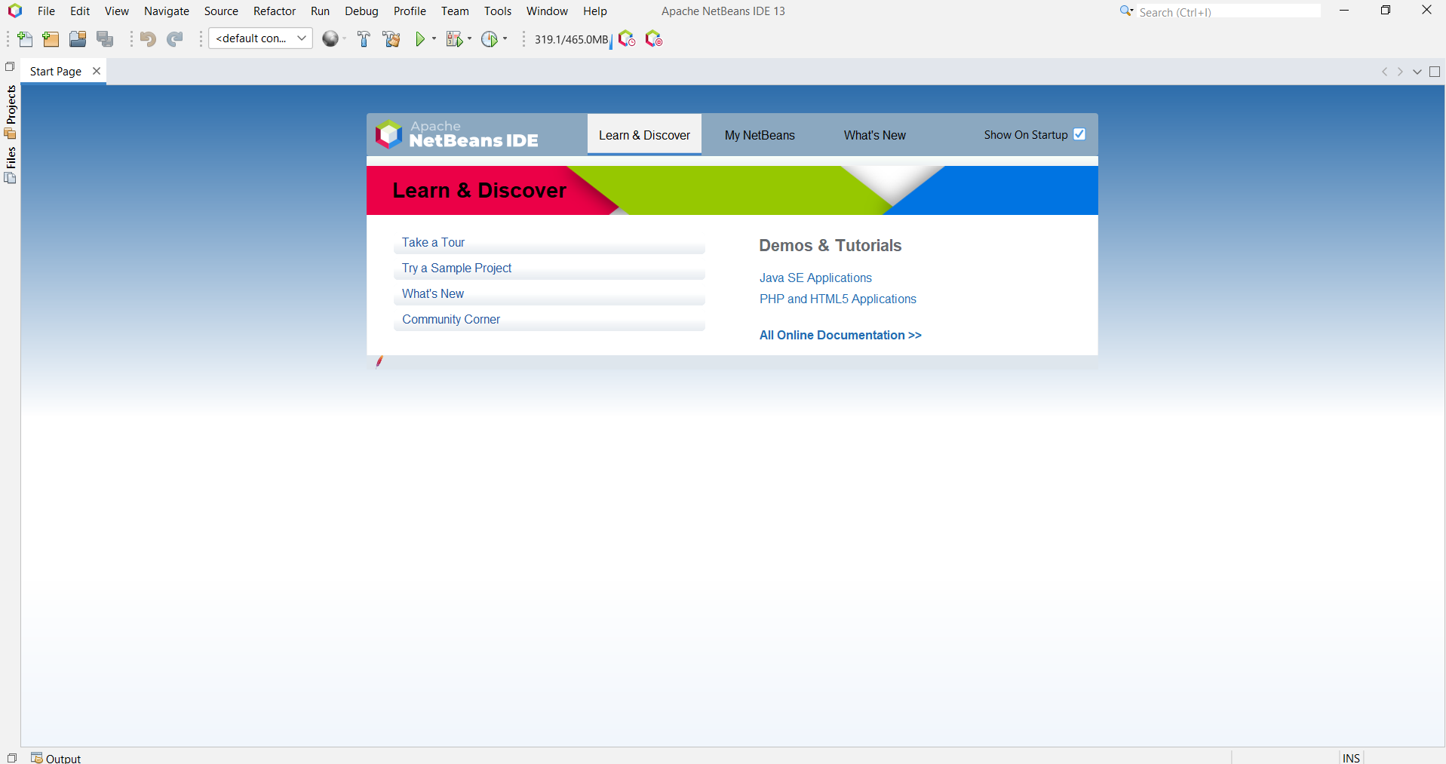

**Step 4:** Click the file menu then ->click the open project option ->select the ML.main folder.

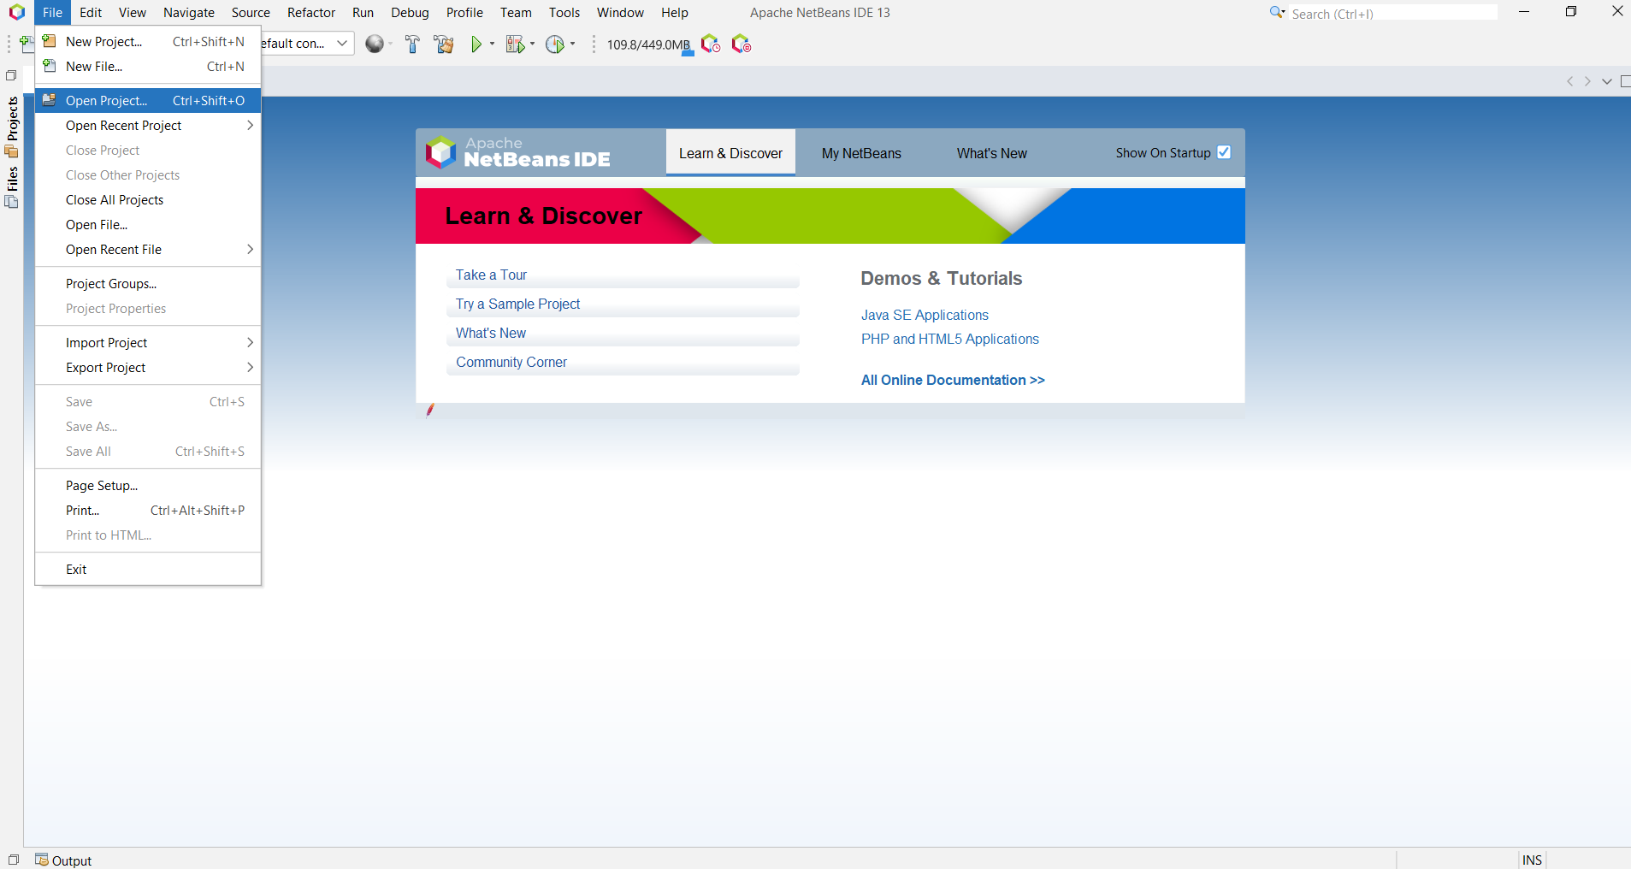

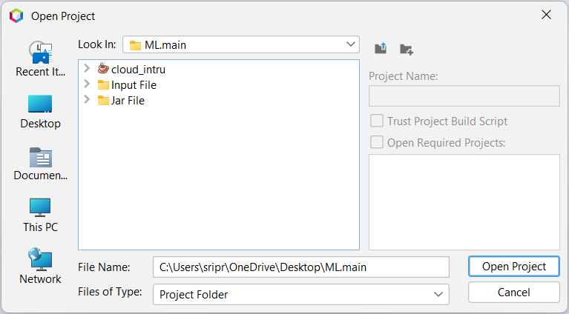

**Step 5**: **package installation:** To add a package using the library option, right click on “library” and then select “ADD JAR/FOLDER” from the menu

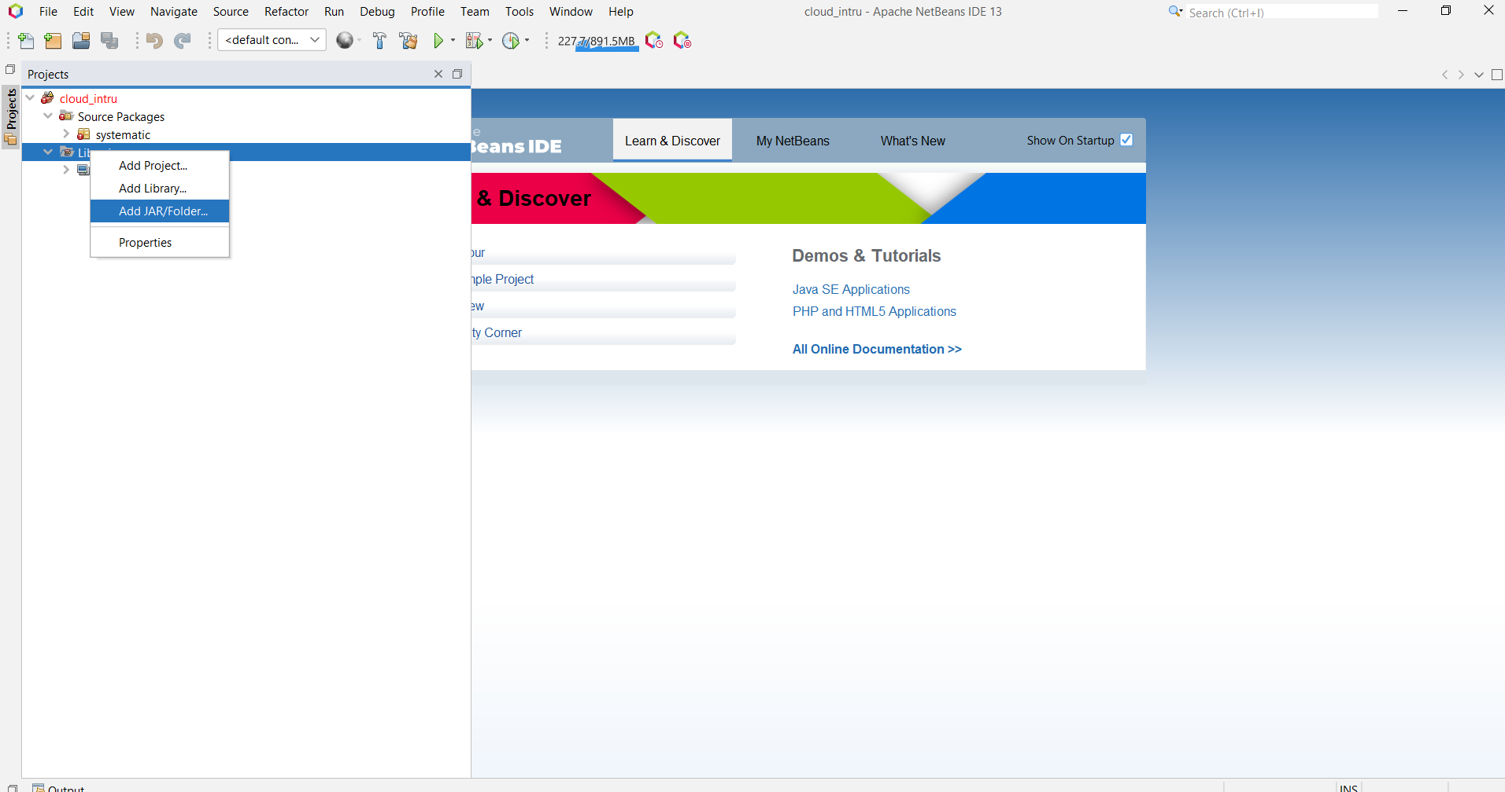

**Step 6:** select the ML.main folder ->jar file ->Weka-stable-3.6.10

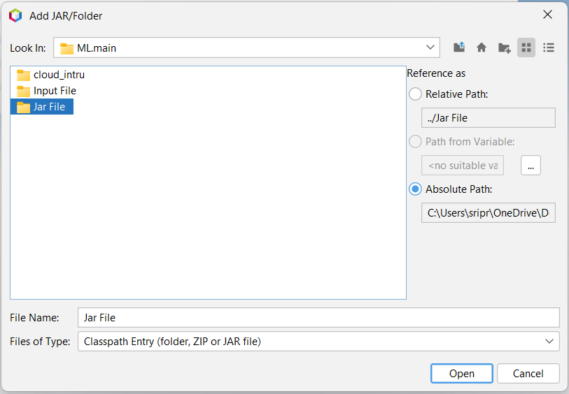

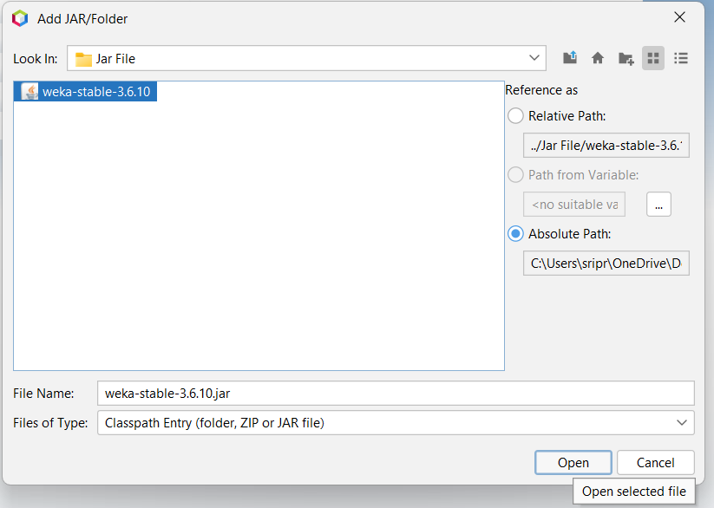

**Step 7:** After installing the Weka-stable-3.6.10 package, click on “cloud_intru” and then press the “run” button to run the program

**Step 8:** click browse button to select a directory

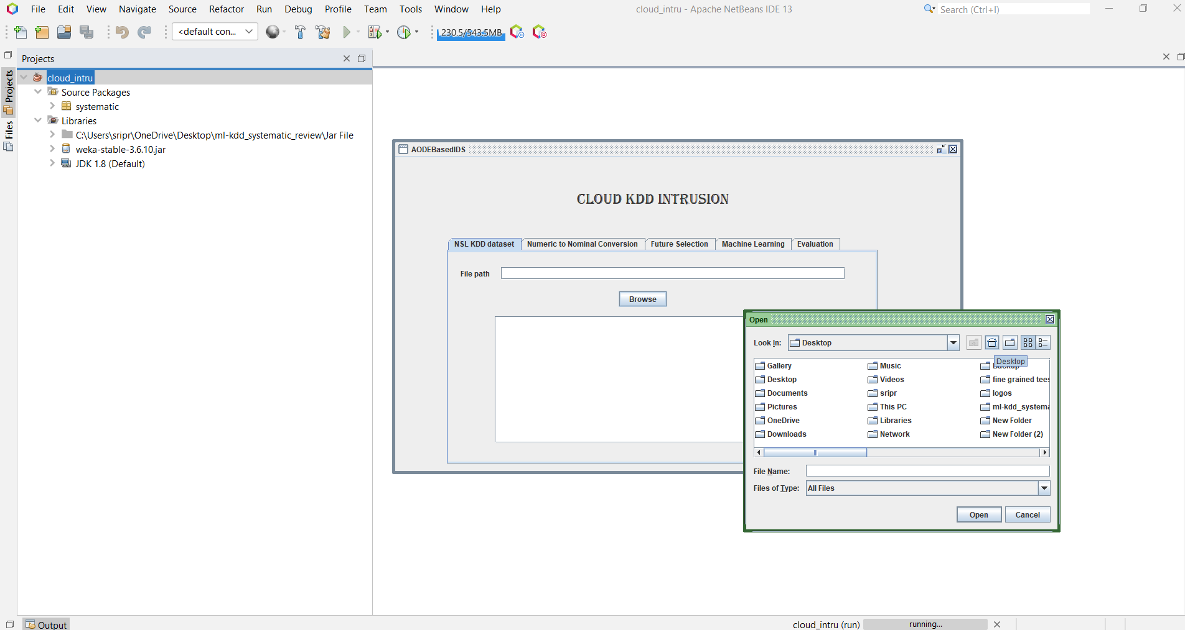

**Step 9:** press desktop->ML.main->input file->NSLKDDdataset.csv

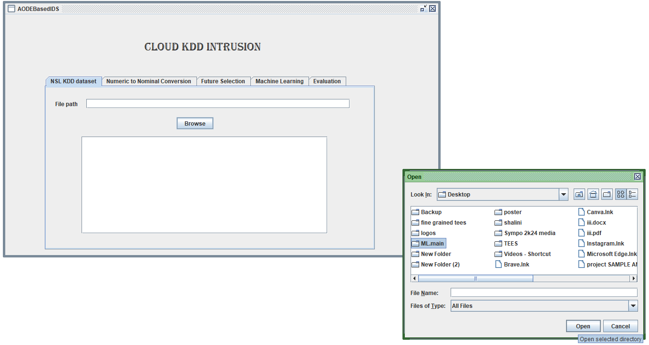

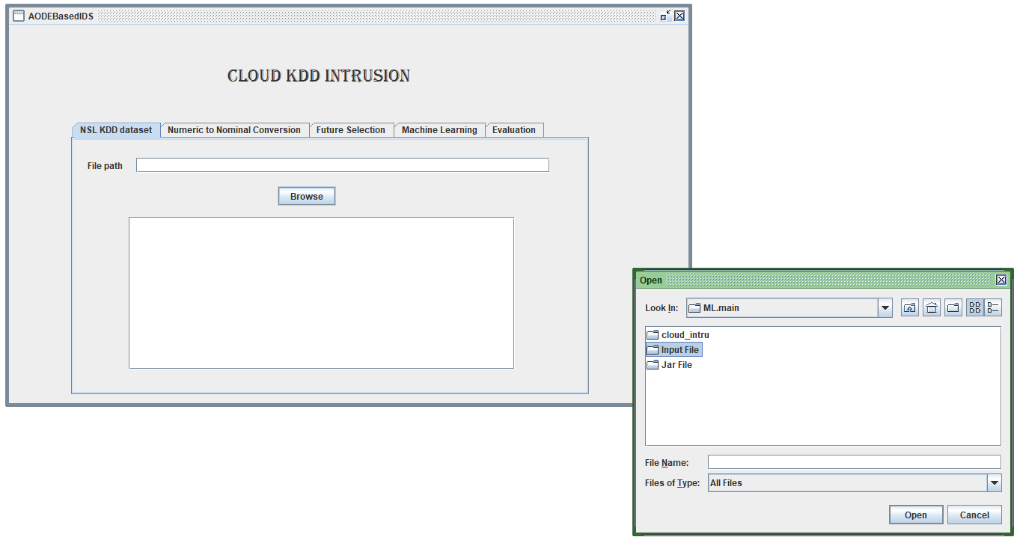

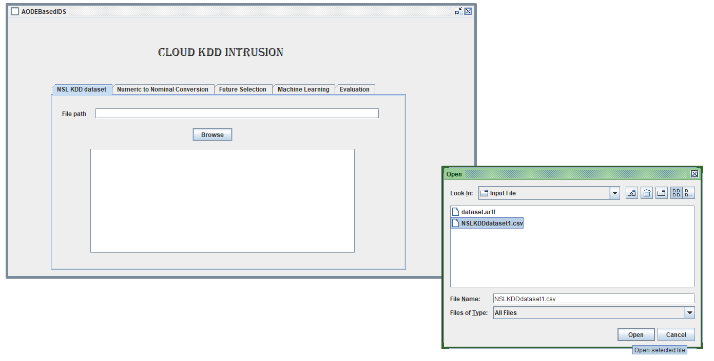

**Step 10**: open the file

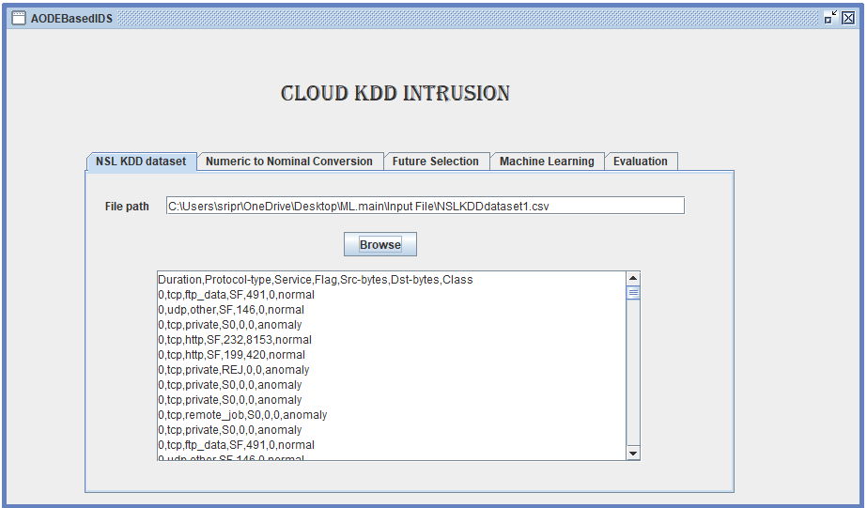

**Step 11:** Convert numeric data to nominal data

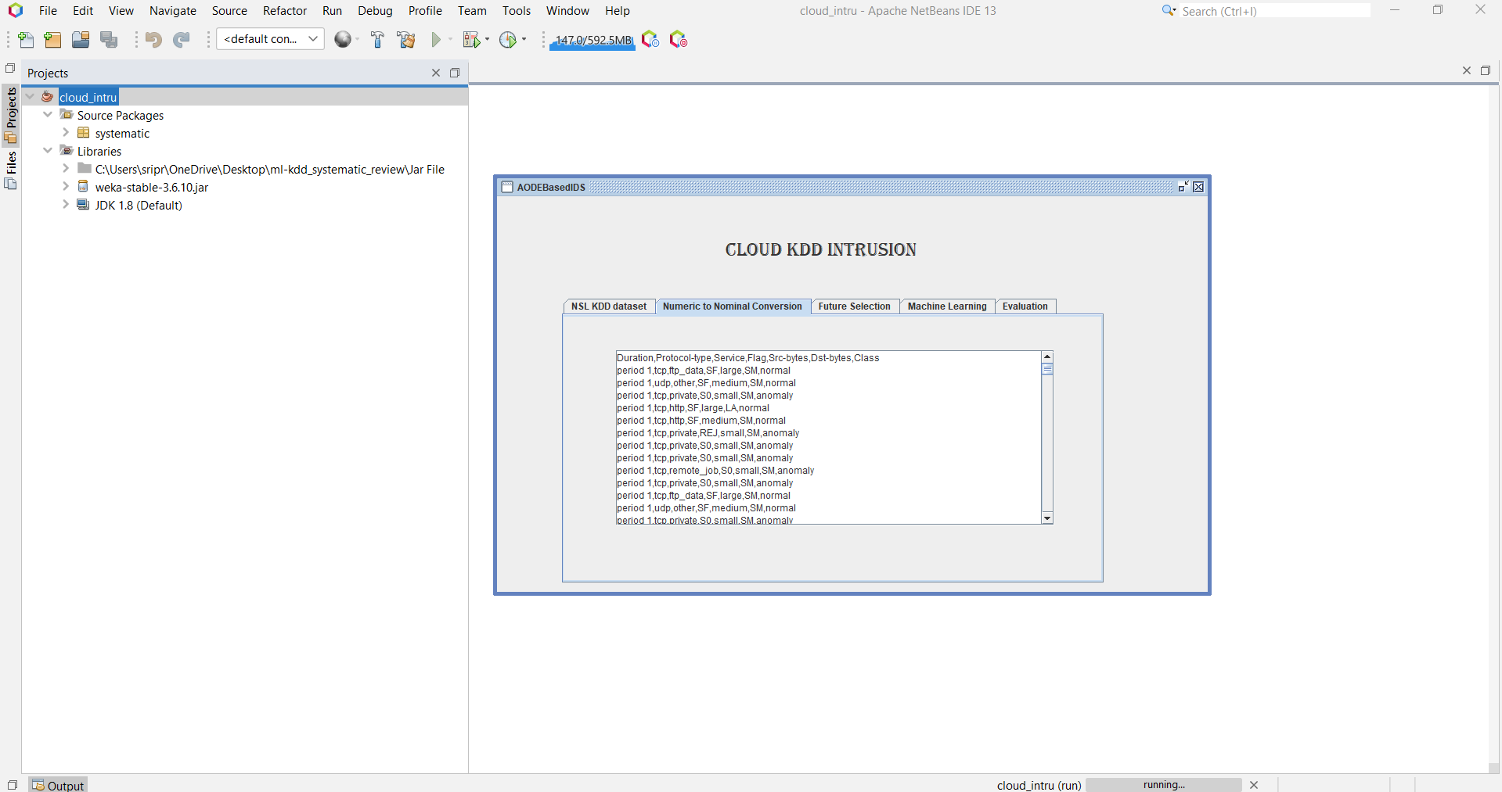

**Step 12:** Check the information gain ratio of the data

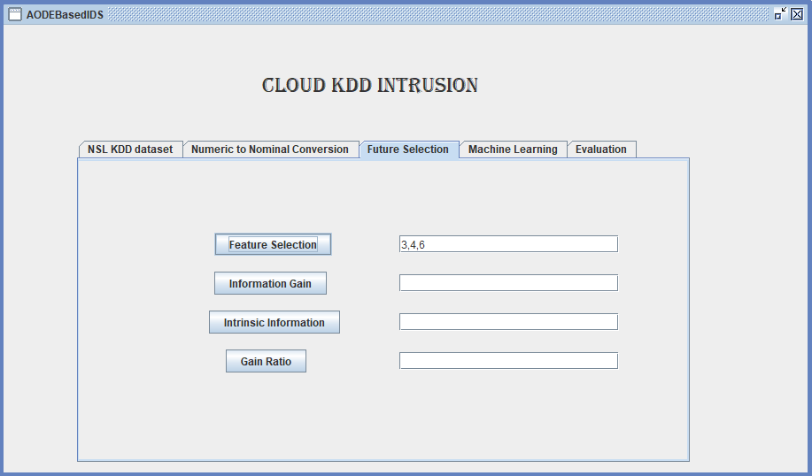

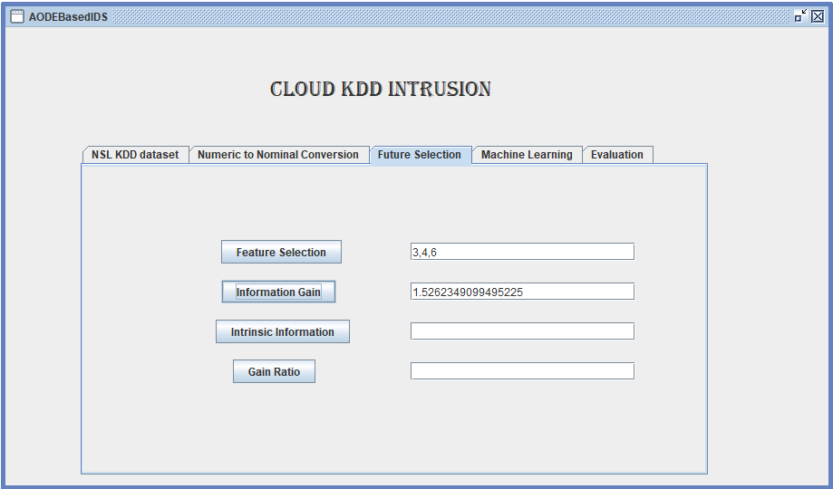

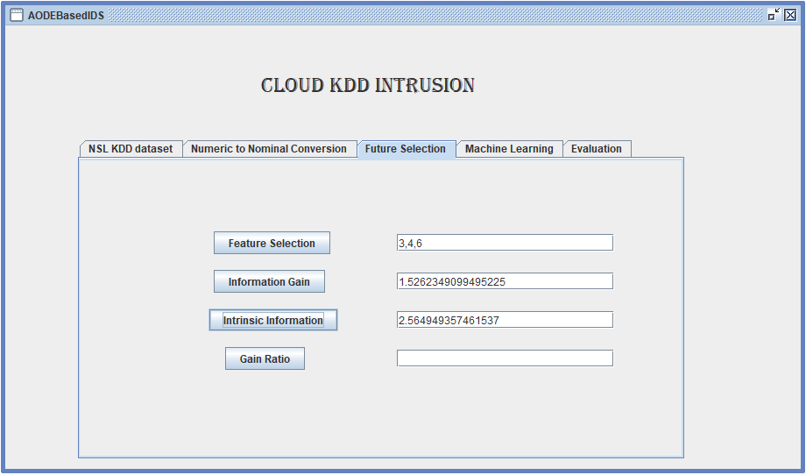

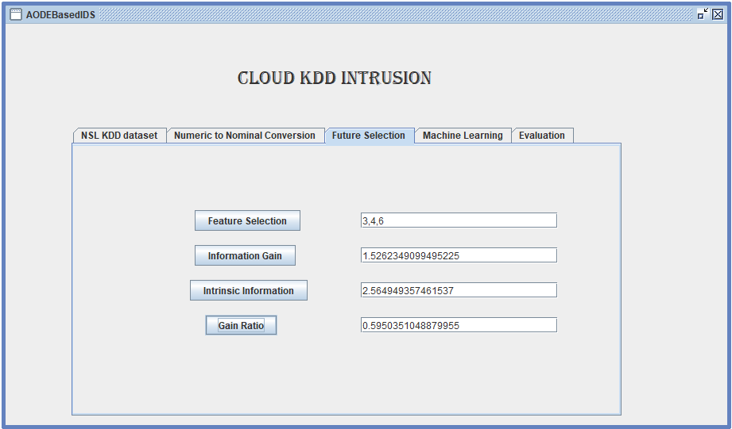

**Step 13:** Open the dataset.arff to display the average one dependence estimator classifier

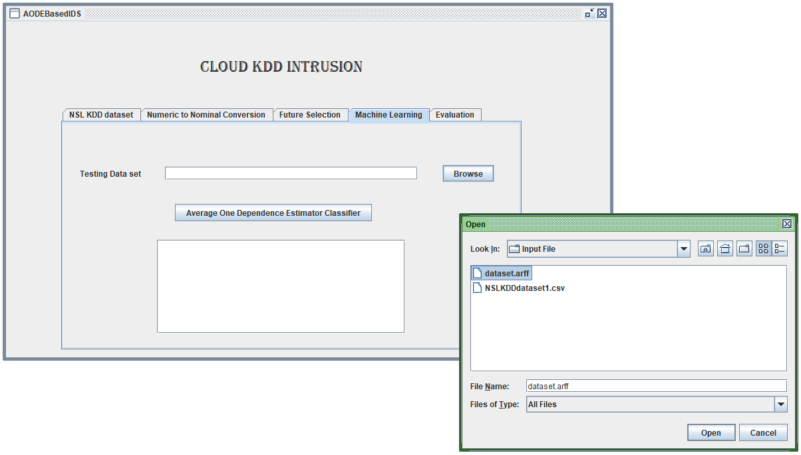

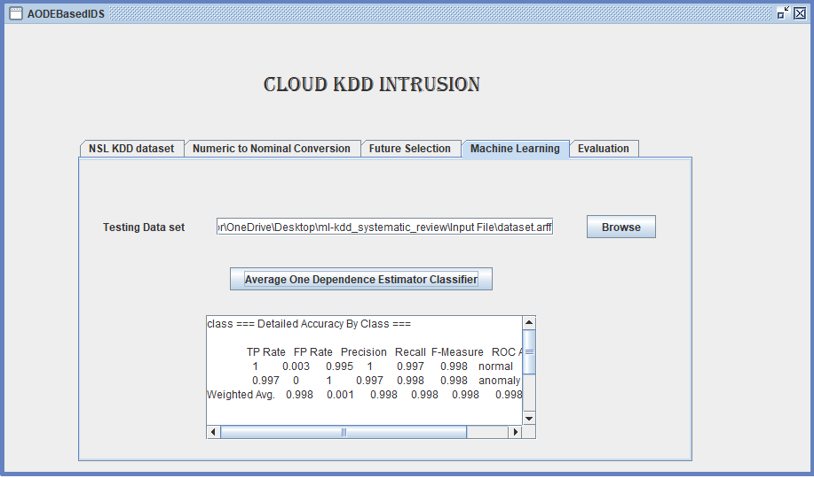

**Step 14:** Click on “Evaluation” to check the accuracy of machine learning techniques

