### California Housing Dataset prediction using Linear Regression

Lokeshwari, Sriprasath

February 9, 2020

<https://www.kaggle.com/camnugent/california-housing-prices>

library(tidyverse)

## -- Attaching packages --------------------------------------- tidyverse 1.3.0 --

## v ggplot2 3.2.1 v purrr 0.3.3  
## v tibble 2.1.3 v dplyr 0.8.3  
## v tidyr 1.0.2 v stringr 1.4.0  
## v readr 1.3.1 v forcats 0.4.0

## -- Conflicts ------------------------------------------ tidyverse_conflicts() --  
## x dplyr::filter() masks stats::filter()  
## x dplyr::lag() masks stats::lag()

require(tidyverse)  
California <- read.csv("https://personal.utdallas.edu/~sxg180154/housing.csv")

### Analysing the Dataset - California

##### View the california Dataset, getting summary of the Dataset (California) and dimension of the California Dataset

View(California)  
summary(California)

## longitude latitude housing_median_age total_rooms   
## Min. :-124.3 Min. :32.54 Min. : 1.00 Min. : 2   
## 1st Qu.:-121.8 1st Qu.:33.93 1st Qu.:18.00 1st Qu.: 1448   
## Median :-118.5 Median :34.26 Median :29.00 Median : 2127   
## Mean :-119.6 Mean :35.63 Mean :28.64 Mean : 2636   
## 3rd Qu.:-118.0 3rd Qu.:37.71 3rd Qu.:37.00 3rd Qu.: 3148   
## Max. :-114.3 Max. :41.95 Max. :52.00 Max. :39320   
##   
## total_bedrooms population households median_income   
## Min. : 1.0 Min. : 3 Min. : 1.0 Min. : 0.4999   
## 1st Qu.: 296.0 1st Qu.: 787 1st Qu.: 280.0 1st Qu.: 2.5634   
## Median : 435.0 Median : 1166 Median : 409.0 Median : 3.5348   
## Mean : 537.9 Mean : 1425 Mean : 499.5 Mean : 3.8707   
## 3rd Qu.: 647.0 3rd Qu.: 1725 3rd Qu.: 605.0 3rd Qu.: 4.7432   
## Max. :6445.0 Max. :35682 Max. :6082.0 Max. :15.0001   
## NA's :207   
## median_house_value ocean_proximity  
## Min. : 14999 <1H OCEAN :9136   
## 1st Qu.:119600 INLAND :6551   
## Median :179700 ISLAND : 5   
## Mean :206856 NEAR BAY :2290   
## 3rd Qu.:264725 NEAR OCEAN:2658   
## Max. :500001   
##

dim(California)

## [1] 20640 10

#### Finding the percentage of Null values in each column to eliminate if there are more than 50% NULL values in a column

for(i in 1:ncol(California)) {  
 colName <- colnames(California[i])  
 pctNull <- sum(is.na(California[,i]))/length(California[,i])  
 print(paste("Column ", colName, " has ", round(pctNull*100, 3), "% of nulls"))  
}

## [1] "Column longitude has 0 % of nulls"  
## [1] "Column latitude has 0 % of nulls"  
## [1] "Column housing_median_age has 0 % of nulls"  
## [1] "Column total_rooms has 0 % of nulls"  
## [1] "Column total_bedrooms has 1.003 % of nulls"  
## [1] "Column population has 0 % of nulls"  
## [1] "Column households has 0 % of nulls"  
## [1] "Column median_income has 0 % of nulls"  
## [1] "Column median_house_value has 0 % of nulls"  
## [1] "Column ocean_proximity has 0 % of nulls"

##### Cleaning all the NULL values in each row using exclude() function

##### From the dimension of the original California data and the cleaned data we can conclude that 207 rows with NULL values are eliminated

cali_clean <- na.exclude(California)  
dim(cali_clean)

## [1] 20433 10

##### Getting a correlation plot for visuaization using corrplot()

library(corrplot)

## corrplot 0.84 loaded

require(corrplot)  
Mat <- cor(cali_clean[sapply(cali_clean, is.numeric)])  
corrplot(Mat)

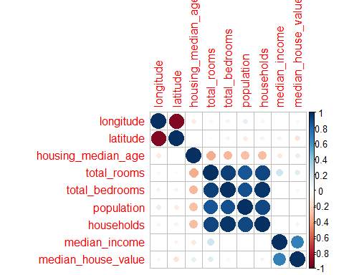

### Visual Representation and correlation of the Dataset - California

##### From the graph we can estimate that the correlation betweeen

##### Total_rooms - Households

##### Population - Total_rooms

##### Population - Households

##### Median_Income - Median_House_value are highly correlated

##### Getting the correlation values for each predictors and the output value(median_house_value)

##### Features having highest correlation among the predictors

cor(cali_clean$total_rooms, cali_clean$households)

## [1] 0.9189915

cor(cali_clean$population,cali_clean$total_rooms)

## [1] 0.8572813

cor(cali_clean$population,cali_clean$households)

## [1] 0.9071859

##### => Correlation between the output value(median_house_value) and all other predictors

cor(cali_clean$median_income,cali_clean$median_house_value)

## [1] 0.6883555

cor(cali_clean$longitude,cali_clean$median_house_value)

## [1] -0.04539822

cor(cali_clean$latitude,cali_clean$median_house_value)

## [1] -0.1446382

cor(cali_clean$housing_median_age,cali_clean$median_house_value)

## [1] 0.106432

cor(cali_clean$total_rooms,cali_clean$median_house_value)

## [1] 0.1332941

cor(cali_clean$total_bedrooms,cali_clean$median_house_value)

## [1] 0.04968618

cor(cali_clean$population,cali_clean$median_house_value)

## [1] -0.02529973

cor(cali_clean$households,cali_clean$median_house_value)

## [1] 0.06489355

#### Plotting the housing_value based on the latitude, longitude and population

##### This plot shows that the region with the highest population has high housing value

ggplot(data = cali_clean,mapping = aes(cali_clean$latitude,y=cali_clean$longitude, color = cali_clean$median_house_value, size = cali_clean$population/100))+geom_point()

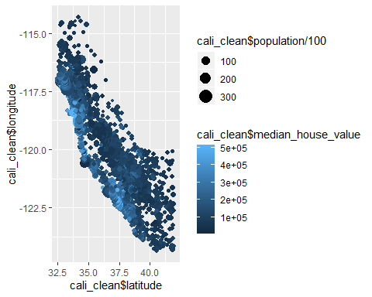

##### => Plotting the point ggplot of all predictors vs the housing value

ggplot(data = cali_clean,mapping= aes(cali_clean$longitude, cali_clean$median_house_value))+geom_point(color = "light green")

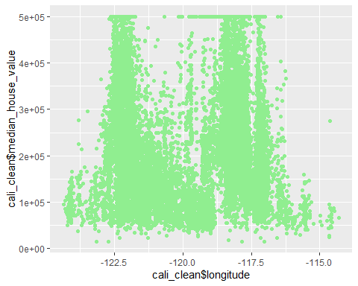

##### This graph concludes that the median_house_value is higher from -122.5 to -117.5 longitude. And the number of houses are more with median_house_value around 1e+05 to 3e+05 and longitude from -122.4 to -117.5

ggplot(data = cali_clean,mapping= aes(cali_clean$latitude, cali_clean$median_house_value))+geom_point(color = "light blue")

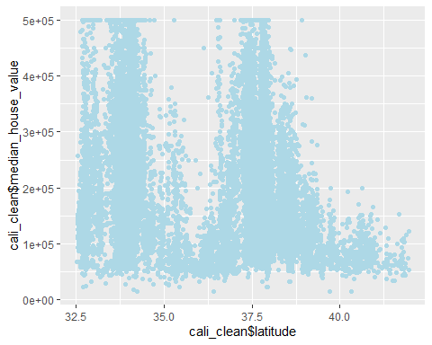

##### This graph concludes that the median_house_value is higher at latitude 32.5 and 37.5. The number of houses are more with the median_house_value around 1e+05 to 4e+05 and laitude from 32.5 to 40.0

ggplot(data = cali_clean,mapping= aes(cali_clean$housing_median_age, cali_clean$median_house_value))+geom_point(color = "light pink")

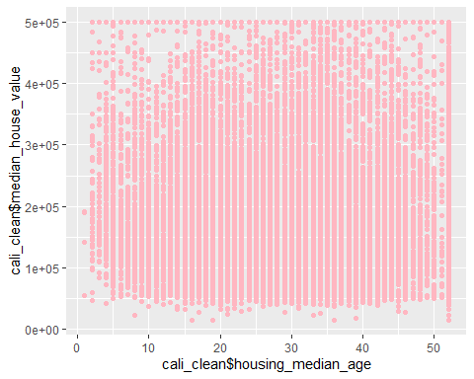

##### This graph shows that the median_house_value is same for all ages of houses. The houses are spread over all values of the houses and different age

ggplot(data = cali_clean,mapping= aes(cali_clean$total_rooms, cali_clean$median_house_value))+geom_point(color = "grey")

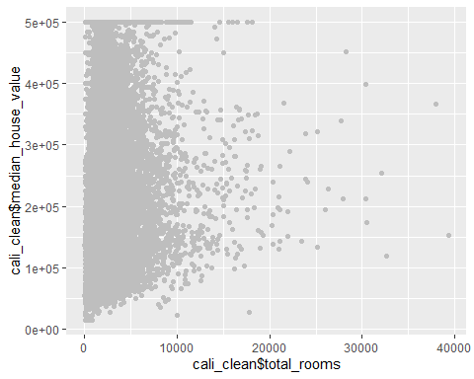

##### Almost 90% of the house area have 0 to 5000 rooms in a particular area. The median_house_value is evenly distributed for the area with total_rooms from 0 to 5000.

ggplot(data = cali_clean,mapping= aes(cali_clean$total_bedrooms, cali_clean$median_house_value))+geom_point(color = "cyan")

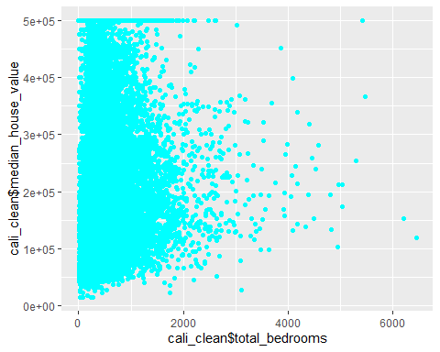

##### Almost 80% of the house area have 0 to 1000 bedrooms in a particular area. The median_house_value is evenly distributed for the area with total_bedrooms from 0 to 1000.

ggplot(data = cali_clean,mapping= aes(cali_clean$population, cali_clean$median_house_value))+geom_point(color = "purple")

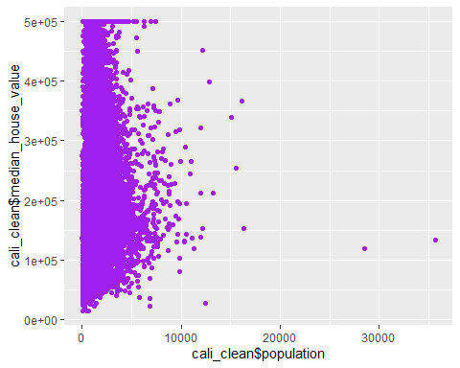

##### Almost 92% of the house area have 0 to 5000 population count in a particular area. The median_house_value is evenly distributed for the area with population count from 0 to 5000

ggplot(data = cali_clean,mapping= aes(cali_clean$households, cali_clean$median_house_value))+geom_point(color = "dark red")

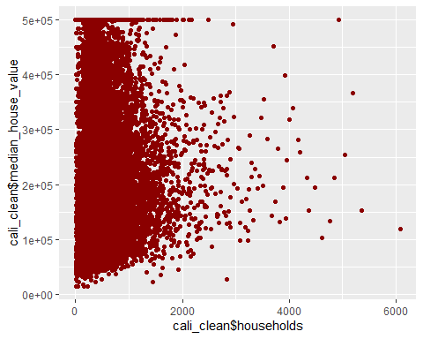

##### Almost 90% of the house area have 0 to 1000 households in a particular area. The median_house_value is evenly distributed for the area with households from 0 to 1000.

ggplot(data = cali_clean,mapping= aes(cali_clean$median_income, cali_clean$median_house_value))+geom_point(color = "light yellow")

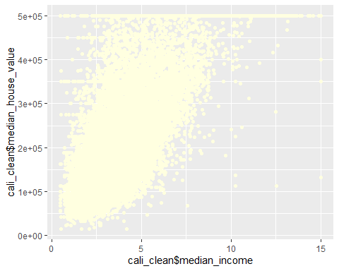

##### The graph is linear for the house_value and median_income. The people who gets high income have bought houses with high house_value. The median_house_value gradually increases with increase in house_value.

ggplot(data = cali_clean,mapping= aes(cali_clean$ocean_proximity, cali_clean$median_house_value))+geom_point(color = "pink")

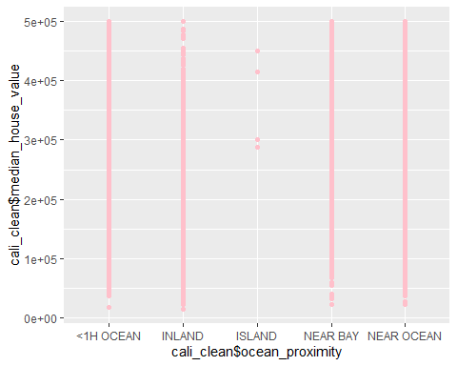

##### We can conclude that the there are less number of houses in near ocean and near bay and exactly 5 houses in island. The house_value is more in other area compared to Island.

#### => Finding the concentration of house values based on the ocean proximity

ggplot(data = cali_clean,mapping = aes(x = cali_clean$ocean_proximity, y= cali_clean$median_house_value))+geom_boxplot()

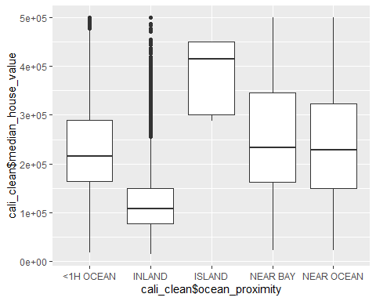

##### We can conclude that the there are less number of houses in near ocean and near bay and exactly 5 houses in island

##### But the Median_house_value increases for the houses near ocean and near bay than the houses in the <1HOcean and Inland

#### => Number of houses in each category of ocean proximity

group_ocean = cali_clean %>% group_by(ocean_proximity) %>% summarise(Number = n()) %>% arrange(desc(Number))  
group_ocean

## # A tibble: 5 x 2  
## ocean_proximity Number  
## <fct> <int>  
## 1 <1H OCEAN 9034  
## 2 INLAND 6496  
## 3 NEAR OCEAN 2628  
## 4 NEAR BAY 2270  
## 5 ISLAND 5

##### We can conclude that there are less houses near the ocean and bay and exactly 5 houses in the island

#### => Top 10 costliest houses in the california housing data

cost = cali_clean %>% filter(!is.na(median_house_value)) %>% arrange(desc(median_house_value)) %>% head(10)  
cost

## longitude latitude housing_median_age total_rooms total_bedrooms population  
## 1 -122.27 37.80 52 249 78 396  
## 2 -122.25 37.87 52 609 236 1349  
## 3 -122.24 37.86 52 1668 225 517  
## 4 -122.24 37.85 52 3726 474 1366  
## 5 -122.23 37.83 52 2990 379 947  
## 6 -122.22 37.82 39 2492 310 808  
## 7 -122.22 37.82 42 2991 335 1018  
## 8 -122.23 37.82 52 3242 366 1001  
## 9 -122.23 37.82 52 3494 396 1192  
## 10 -122.23 37.82 52 1611 203 556  
## households median_income median_house_value ocean_proximity  
## 1 85 1.2434 500001 NEAR BAY  
## 2 250 1.1696 500001 NEAR BAY  
## 3 214 7.8521 500001 NEAR BAY  
## 4 496 9.3959 500001 NEAR BAY  
## 5 361 7.8772 500001 NEAR BAY  
## 6 315 11.8603 500001 NEAR BAY  
## 7 335 13.4990 500001 NEAR BAY  
## 8 352 12.2138 500001 NEAR BAY  
## 9 383 12.3804 500001 NEAR BAY  
## 10 179 8.7477 500001 NEAR BAY

#### => Splitting rooms_per_household, bedrooms_per_household, population_per_household

rooms = trunc(cali_clean$total_rooms/cali_clean$households)  
bedrooms = trunc(cali_clean$total_bedrooms/cali_clean$total_rooms)  
popu_per_house = trunc(cali_clean$population/cali_clean$households)

##### Adding the additional columns(rooms_per_household, bedrooms_per_room, population_per_husehold) in the cali_full dataframe

##### Splitting the data into the smaller dataset with respect to every household and population

cali_full = cali_clean %>% add_column(rooms = rooms,bedrooms = bedrooms, pop_per_house = popu_per_house)

##### => Again finding the correlation between the predcitors and the newly added columns

##### This correlation is also similar to the original data where we obtained the derived dataset i.e. rooms_per_household, bedrooms_per_room and

matrix <- cor(cali_full[sapply(cali_full, is.numeric)])  
corrplot(matrix)

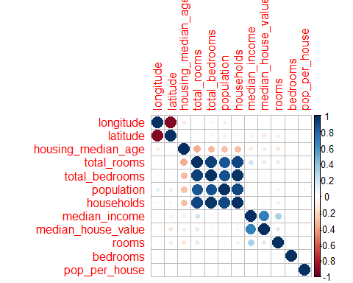

cor(matrix)

## longitude latitude housing_median_age total_rooms  
## longitude 1.0000000000 -0.98144232 -0.18560762 0.14161045  
## latitude -0.9814423246 1.00000000 0.10672804 -0.12179737  
## housing_median_age -0.1856076195 0.10672804 1.00000000 -0.75046065  
## total_rooms 0.1416104506 -0.12179737 -0.75046065 1.00000000  
## total_bedrooms 0.1658263736 -0.14011352 -0.69693145 0.98650546  
## population 0.2035423324 -0.17615988 -0.68441755 0.97013502  
## households 0.1615291972 -0.14274025 -0.67889602 0.98285046  
## median_income -0.0006528726 -0.10613198 -0.14303440 -0.02771175  
## median_house_value 0.0012360285 -0.15879449 0.09101670 -0.08072260  
## rooms -0.1234104348 0.16565900 -0.21599125 -0.10244660  
## bedrooms -0.0065163600 0.01934191 0.04322066 -0.23655525  
## pop_per_house -0.0062305844 0.02071009 0.06267989 -0.23979760  
## total_bedrooms population households median_income  
## longitude 0.1658264 0.2035423 0.1615292 -0.0006528726  
## latitude -0.1401135 -0.1761599 -0.1427403 -0.1061319837  
## housing_median_age -0.6969314 -0.6844175 -0.6788960 -0.1430343952  
## total_rooms 0.9865055 0.9701350 0.9828505 -0.0277117515  
## total_bedrooms 1.0000000 0.9886538 0.9982912 -0.1702024466  
## population 0.9886538 1.0000000 0.9911631 -0.2011689005  
## households 0.9982912 0.9911631 1.0000000 -0.1653555078  
## median_income -0.1702024 -0.2011689 -0.1653555 1.0000000000  
## median_house_value -0.1803002 -0.2248021 -0.1664323 0.8852253895  
## rooms -0.2177188 -0.2756743 -0.2615215 0.4801820119  
## bedrooms -0.2087264 -0.2040689 -0.2056358 -0.1715180939  
## pop_per_house -0.2155424 -0.1370039 -0.2101102 -0.1422231415  
## median_house_value rooms bedrooms pop_per_house  
## longitude 0.001236029 -0.1234104 -0.00651636 -0.006230584  
## latitude -0.158794486 0.1656590 0.01934191 0.020710093  
## housing_median_age 0.091016699 -0.2159912 0.04322066 0.062679886  
## total_rooms -0.080722599 -0.1024466 -0.23655525 -0.239797598  
## total_bedrooms -0.180300241 -0.2177188 -0.20872643 -0.215542353  
## population -0.224802122 -0.2756743 -0.20406894 -0.137003899  
## households -0.166432318 -0.2615215 -0.20563575 -0.210110176  
## median_income 0.885225389 0.4801820 -0.17151809 -0.142223141  
## median_house_value 1.000000000 0.2535645 -0.16161228 -0.193169329  
## rooms 0.253564468 1.0000000 -0.14655978 -0.128032759  
## bedrooms -0.161612276 -0.1465598 1.00000000 -0.069676508  
## pop_per_house -0.193169329 -0.1280328 -0.06967651 1.000000000

##### The Median_house_value is more correlated to the median_house_value

##### From the correlation matrix we get the value of correlation between the each predictor and the output value(median_house_value)

##### => Plotting the graph between the median_house_value, median_income , total_rooms and housing _median_age

plot(cali_full[,c("median_house_value","median_income","total_rooms","housing_median_age")])

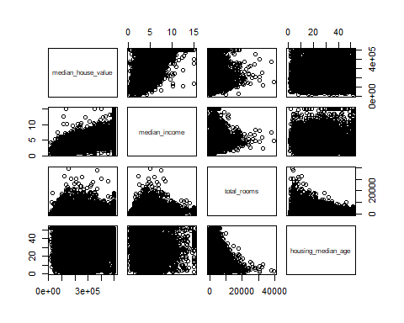

##### This plot shows the distribution of median_house_value , median_income , total_rooms and median_housing_age among each other predictor.

boxplot(cali_full$median_house_value)

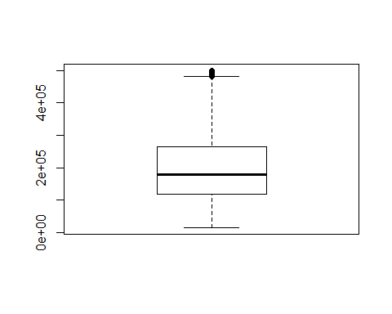

##### => The quantile range of median_house_value is plotted using box_plot. From this we can conclude that the min house_value is from 1e+05 to 5e+05 with some outliers. And the median value of the house_value is 2e+00

hist(cali_full$median_house_value,col = "dark green", border = 2)

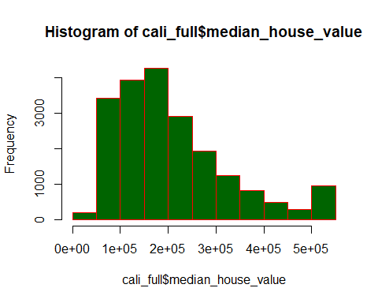

##### => From the histogram we can conclude that the distribution is normal with Gaussian curve. The curve peaks at 2e+05 median_house_value and gradually reduces.

#### => ggplot for the derived features from the original dataset

ggplot(cali_full, aes(x = rooms)) + geom_histogram(fill = "yellow", color = "black", binwidth = 1)

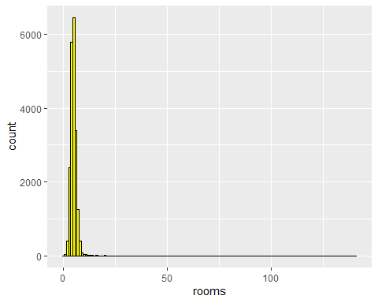

ggplot(cali_full, aes(bedrooms)) + geom_histogram(color = "black", fill = "navy blue", binwidth = 1)

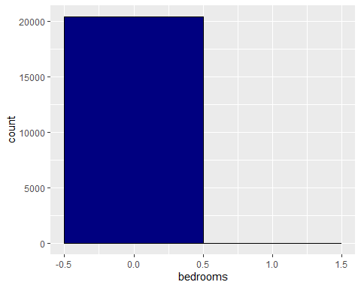

ggplot(cali_full, aes(x = pop_per_house)) + geom_histogram(fill = " orange", color = "black", binwidth = 100)

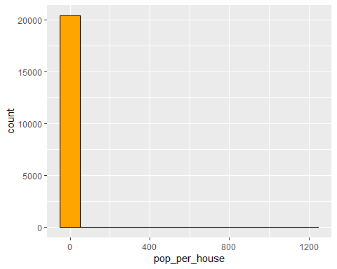

##### The ggplot shows the histogram of rooms_per_household, bedroom_per_room and population_per_household. SO the rooms per house ranges from 0 to 10, bedrooms per room differs from 0 to 2 and population per household ranges from 0 to 100.

### Developing a model using linear regression method

##### => Creating model for each features of the dataset to find out the f stat and R^2 value

##### To find out the importance of each feature

fit1 <- lm(median_house_value ~ longitude,cali_clean)  
summary(fit1)

##   
## Call:  
## lm(formula = median_house_value ~ longitude, data = cali_clean)  
##   
## Residuals:  
## Min 1Q Median 3Q Max   
## -201280 -86579 -26354 56598 301351   
##   
## Coefficients:  
## Estimate Std. Error t value Pr(>|t|)   
## (Intercept) -105885.6 48153.4 -2.199 0.0279 *   
## longitude -2615.6 402.7 -6.496 8.45e-11 ***  
## ---  
## Signif. codes: 0 '***' 0.001 '**' 0.01 '*' 0.05 '.' 0.1 ' ' 1  
##   
## Residual standard error: 115300 on 20431 degrees of freedom  
## Multiple R-squared: 0.002061, Adjusted R-squared: 0.002012   
## F-statistic: 42.2 on 1 and 20431 DF, p-value: 8.45e-11

fit2 <- lm(median_house_value ~ latitude , cali_clean)  
summary(fit2)

##   
## Call:  
## lm(formula = median_house_value ~ latitude, data = cali_clean)  
##   
## Residuals:  
## Min 1Q Median 3Q Max   
## -207211 -84082 -30082 57066 318746   
##   
## Coefficients:  
## Estimate Std. Error t value Pr(>|t|)   
## (Intercept) 485352.2 13352.6 36.35 <2e-16 ***  
## latitude -7815.4 374.1 -20.89 <2e-16 ***  
## ---  
## Signif. codes: 0 '***' 0.001 '**' 0.01 '*' 0.05 '.' 0.1 ' ' 1  
##   
## Residual standard error: 114200 on 20431 degrees of freedom  
## Multiple R-squared: 0.02092, Adjusted R-squared: 0.02087   
## F-statistic: 436.6 on 1 and 20431 DF, p-value: < 2.2e-16

fit3 <- lm(median_house_value ~ housing_median_age, cali_clean)  
summary(fit3)

##   
## Call:  
## lm(formula = median_house_value ~ housing_median_age, data = cali_clean)  
##   
## Residuals:  
## Min 1Q Median 3Q Max   
## -214665 -85114 -25771 58290 319123   
##   
## Coefficients:  
## Estimate Std. Error t value Pr(>|t|)   
## (Intercept) 178926.58 1994.76 89.7 <2e-16 ***  
## housing_median_age 975.72 63.77 15.3 <2e-16 ***  
## ---  
## Signif. codes: 0 '***' 0.001 '**' 0.01 '*' 0.05 '.' 0.1 ' ' 1  
##   
## Residual standard error: 114800 on 20431 degrees of freedom  
## Multiple R-squared: 0.01133, Adjusted R-squared: 0.01128   
## F-statistic: 234.1 on 1 and 20431 DF, p-value: < 2.2e-16

fit4 <- lm(median_house_value ~ total_rooms, cali_clean)  
summary(fit4)

##   
## Call:  
## lm(formula = median_house_value ~ total_rooms, data = cali_clean)  
##   
## Residuals:  
## Min 1Q Median 3Q Max   
## -311460 -86505 -26706 55721 311644   
##   
## Coefficients:  
## Estimate Std. Error t value Pr(>|t|)   
## (Intercept) 1.883e+05 1.254e+03 150.13 <2e-16 ***  
## total_rooms 7.041e+00 3.663e-01 19.22 <2e-16 ***  
## ---  
## Signif. codes: 0 '***' 0.001 '**' 0.01 '*' 0.05 '.' 0.1 ' ' 1  
##   
## Residual standard error: 114400 on 20431 degrees of freedom  
## Multiple R-squared: 0.01777, Adjusted R-squared: 0.01772   
## F-statistic: 369.6 on 1 and 20431 DF, p-value: < 2.2e-16

fit5 <- lm(median_house_value ~ total_bedrooms, cali_clean)  
summary(fit5)

##   
## Call:  
## lm(formula = median_house_value ~ total_bedrooms, data = cali_clean)  
##   
## Residuals:  
## Min 1Q Median 3Q Max   
## -213629 -87479 -27730 57317 300444   
##   
## Coefficients:  
## Estimate Std. Error t value Pr(>|t|)   
## (Intercept) 1.995e+05 1.308e+03 152.568 < 2e-16 ***  
## total_bedrooms 1.361e+01 1.914e+00 7.111 1.19e-12 ***  
## ---  
## Signif. codes: 0 '***' 0.001 '**' 0.01 '*' 0.05 '.' 0.1 ' ' 1  
##   
## Residual standard error: 115300 on 20431 degrees of freedom  
## Multiple R-squared: 0.002469, Adjusted R-squared: 0.00242   
## F-statistic: 50.56 on 1 and 20431 DF, p-value: 1.192e-12

fit6 <- lm(median_house_value ~ population, cali_clean)  
summary(fit6)

##   
## Call:  
## lm(formula = median_house_value ~ population, data = cali_clean)  
##   
## Residuals:  
## Min 1Q Median 3Q Max   
## -195491 -86980 -26885 58117 308615   
##   
## Coefficients:  
## Estimate Std. Error t value Pr(>|t|)   
## (Intercept) 2.105e+05 1.297e+03 162.318 < 2e-16 ***  
## population -2.577e+00 7.124e-01 -3.617 0.000298 ***  
## ---  
## Signif. codes: 0 '***' 0.001 '**' 0.01 '*' 0.05 '.' 0.1 ' ' 1  
##   
## Residual standard error: 115400 on 20431 degrees of freedom  
## Multiple R-squared: 0.0006401, Adjusted R-squared: 0.0005912   
## F-statistic: 13.09 on 1 and 20431 DF, p-value: 0.0002983

fit7 <- lm(median_house_value ~ households, cali_clean)  
summary(fit7)

##   
## Call:  
## lm(formula = median_house_value ~ households, data = cali_clean)  
##   
## Residuals:  
## Min 1Q Median 3Q Max   
## -224153 -86962 -27933 56931 302903   
##   
## Coefficients:  
## Estimate Std. Error t value Pr(>|t|)   
## (Intercept) 1.971e+05 1.326e+03 148.644 <2e-16 ***  
## households 1.959e+01 2.108e+00 9.295 <2e-16 ***  
## ---  
## Signif. codes: 0 '***' 0.001 '**' 0.01 '*' 0.05 '.' 0.1 ' ' 1  
##   
## Residual standard error: 115200 on 20431 degrees of freedom  
## Multiple R-squared: 0.004211, Adjusted R-squared: 0.004162   
## F-statistic: 86.4 on 1 and 20431 DF, p-value: < 2.2e-16

fit8 <- lm(median_house_value ~ median_income, cali_clean)  
summary(fit8)

##   
## Call:  
## lm(formula = median_house_value ~ median_income, data = cali_clean)  
##   
## Residuals:  
## Min 1Q Median 3Q Max   
## -541167 -55858 -16955 36895 434180   
##   
## Coefficients:  
## Estimate Std. Error t value Pr(>|t|)   
## (Intercept) 44906.4 1330.0 33.77 <2e-16 ***  
## median_income 41837.1 308.4 135.64 <2e-16 ***  
## ---  
## Signif. codes: 0 '***' 0.001 '**' 0.01 '*' 0.05 '.' 0.1 ' ' 1  
##   
## Residual standard error: 83740 on 20431 degrees of freedom  
## Multiple R-squared: 0.4738, Adjusted R-squared: 0.4738   
## F-statistic: 1.84e+04 on 1 and 20431 DF, p-value: < 2.2e-16

##### From all these model we can conclude that the Latitude, Housing_median_age, Total_rooms and Median_income has high F-statistic and R^2 value. Since the correlation between median_income and median_house_value is higher we consider it for the creating the first model.

model1 <- lm(median_house_value ~ median_income, cali_full)  
summary(model1)

##   
## Call:  
## lm(formula = median_house_value ~ median_income, data = cali_full)  
##   
## Residuals:  
## Min 1Q Median 3Q Max   
## -541167 -55858 -16955 36895 434180   
##   
## Coefficients:  
## Estimate Std. Error t value Pr(>|t|)   
## (Intercept) 44906.4 1330.0 33.77 <2e-16 ***  
## median_income 41837.1 308.4 135.64 <2e-16 ***  
## ---  
## Signif. codes: 0 '***' 0.001 '**' 0.01 '*' 0.05 '.' 0.1 ' ' 1  
##   
## Residual standard error: 83740 on 20431 degrees of freedom  
## Multiple R-squared: 0.4738, Adjusted R-squared: 0.4738   
## F-statistic: 1.84e+04 on 1 and 20431 DF, p-value: < 2.2e-16

##### Standard_error in this model is 83740 but the r^2 value and the f statistic value are higher which suits for a best model.

### Consideration of Categorical data

##### Since there is only one categorical data and it is correlated with the median_house_value

##### We have to consider the ocean proximity by converting it into quantitative variable.

##### => Converting the categorical variable into integer values which eases the method to find the correlation between the predictor and the output value.

cali_full$ocean_proximity =factor(cali_full$ocean_proximity, level = c("<1H OCEAN","INLAND","ISLAND","NEAR BAY","NEAR OCEAN"), labels = c(1,2,3,4,5))

##### => Model with all the features of cali_full dataset including the Categorical variable and derived features

model2 <- lm(median_house_value ~ ., cali_full)  
summary(model2)

##   
## Call:  
## lm(formula = median_house_value ~ ., data = cali_full)  
##   
## Residuals:  
## Min 1Q Median 3Q Max   
## -554800 -42684 -10402 28926 779971   
##   
## Coefficients:  
## Estimate Std. Error t value Pr(>|t|)   
## (Intercept) -2.351e+06 8.870e+04 -26.507 < 2e-16 ***  
## longitude -2.775e+04 1.027e+03 -27.007 < 2e-16 ***  
## latitude -2.653e+04 1.015e+03 -26.139 < 2e-16 ***  
## housing_median_age 1.079e+03 4.386e+01 24.610 < 2e-16 ***  
## total_rooms -7.308e+00 8.120e-01 -9.000 < 2e-16 ***  
## total_bedrooms 8.545e+01 7.201e+00 11.866 < 2e-16 ***  
## population -3.847e+01 1.108e+00 -34.707 < 2e-16 ***  
## households 7.406e+01 8.239e+00 8.989 < 2e-16 ***  
## median_income 3.862e+04 3.503e+02 110.251 < 2e-16 ***  
## ocean_proximity2 -3.905e+04 1.743e+03 -22.407 < 2e-16 ***  
## ocean_proximity3 1.523e+05 3.071e+04 4.959 7.15e-07 ***  
## ocean_proximity4 -3.975e+03 1.911e+03 -2.080 0.0376 *   
## ocean_proximity5 3.932e+03 1.569e+03 2.507 0.0122 *   
## rooms 1.670e+03 2.447e+02 6.823 9.18e-12 ***  
## bedrooms 7.508e+04 3.962e+04 1.895 0.0581 .   
## pop_per_house 6.488e+01 4.741e+01 1.368 0.1712   
## ---  
## Signif. codes: 0 '***' 0.001 '**' 0.01 '*' 0.05 '.' 0.1 ' ' 1  
##   
## Residual standard error: 68580 on 20417 degrees of freedom  
## Multiple R-squared: 0.6473, Adjusted R-squared: 0.6471   
## F-statistic: 2499 on 15 and 20417 DF, p-value: < 2.2e-16

##### This model concludes with F-statistic - 2499 and R^2 - 0.6473 values and relatively with a lesser Standard error of 68580. Hence this model is comparitively a good fit than other models.This model includes the categorical variables and the derived features.

#### => The model with longitude and latitude features.

model3 <- lm(median_house_value ~ longitude+latitude, cali_full)  
summary(model3)

##   
## Call:  
## lm(formula = median_house_value ~ longitude + latitude, data = cali_full)  
##   
## Residuals:  
## Min 1Q Median 3Q Max   
## -315933 -67617 -22892 46127 483223   
##   
## Coefficients:  
## Estimate Std. Error t value Pr(>|t|)   
## (Intercept) -5822326.7 82532.4 -70.55 <2e-16 ***  
## longitude -71135.6 921.3 -77.21 <2e-16 ***  
## latitude -69500.8 864.0 -80.44 <2e-16 ***  
## ---  
## Signif. codes: 0 '***' 0.001 '**' 0.01 '*' 0.05 '.' 0.1 ' ' 1  
##   
## Residual standard error: 100500 on 20430 degrees of freedom  
## Multiple R-squared: 0.2421, Adjusted R-squared: 0.242   
## F-statistic: 3263 on 2 and 20430 DF, p-value: < 2.2e-16

##### This model includes just the logitude and latitude feature of the dataset. The F-statistic increase from 2499 to 3263 but the R^2 value is reduced from 0.6473 to 0.2421.. And the Standard error rate is also increased to 100500.

#### => The model with all the features except longitude and latitude and derived features.

model4 <- lm(median_house_value ~ housing_median_age+households+total_rooms+population+total_bedrooms, cali_full)  
summary(model4)

##   
## Call:  
## lm(formula = median_house_value ~ housing_median_age + households +   
## total_rooms + population + total_bedrooms, data = cali_full)  
##   
## Residuals:  
## Min 1Q Median 3Q Max   
## -455244 -78410 -15962 54588 1177669   
##   
## Coefficients:  
## Estimate Std. Error t value Pr(>|t|)   
## (Intercept) 1.475e+05 2.462e+03 59.90 <2e-16 ***  
## housing_median_age 1.603e+03 6.337e+01 25.29 <2e-16 ***  
## households 2.848e+02 1.115e+01 25.54 <2e-16 ***  
## total_rooms 4.592e+01 9.658e-01 47.55 <2e-16 ***  
## population -6.490e+01 1.604e+00 -40.47 <2e-16 ***  
## total_bedrooms -2.926e+02 9.700e+00 -30.16 <2e-16 ***  
## ---  
## Signif. codes: 0 '***' 0.001 '**' 0.01 '*' 0.05 '.' 0.1 ' ' 1  
##   
## Residual standard error: 105900 on 20427 degrees of freedom  
## Multiple R-squared: 0.1588, Adjusted R-squared: 0.1586   
## F-statistic: 771 on 5 and 20427 DF, p-value: < 2.2e-16

##### This model includes all other features except the logitude and latitude feature of the data set. The F-statistic has reduced to 771 and the R^2 value is also reduced to 0.1588. This model is not a good fit for linear regression. Hence some features needed to be altered.

#### => The model with all features except derived features.

model5<- lm(median_house_value ~ longitude+latitude+housing_median_age+total_rooms+population+median_income+ocean_proximity, cali_full)  
summary(model5)

##   
## Call:  
## lm(formula = median_house_value ~ longitude + latitude + housing_median_age +   
## total_rooms + population + median_income + ocean_proximity,   
## data = cali_full)  
##   
## Residuals:  
## Min 1Q Median 3Q Max   
## -500858 -45222 -11829 30045 506447   
##   
## Coefficients:  
## Estimate Std. Error t value Pr(>|t|)   
## (Intercept) -2.340e+06 8.965e+04 -26.105 < 2e-16 ***  
## longitude -2.812e+04 1.040e+03 -27.041 < 2e-16 ***  
## latitude -2.702e+04 1.028e+03 -26.292 < 2e-16 ***  
## housing_median_age 1.004e+03 4.511e+01 22.245 < 2e-16 ***  
## total_rooms 1.522e+01 4.969e-01 30.639 < 2e-16 ***  
## population -2.565e+01 9.327e-01 -27.504 < 2e-16 ***  
## median_income 3.363e+04 3.011e+02 111.695 < 2e-16 ***  
## ocean_proximity2 -4.688e+04 1.782e+03 -26.307 < 2e-16 ***  
## ocean_proximity3 1.526e+05 3.165e+04 4.822 1.43e-06 ***  
## ocean_proximity4 -1.390e+03 1.969e+03 -0.706 0.4802   
## ocean_proximity5 3.935e+03 1.616e+03 2.435 0.0149 *   
## ---  
## Signif. codes: 0 '***' 0.001 '**' 0.01 '*' 0.05 '.' 0.1 ' ' 1  
##   
## Residual standard error: 70710 on 20422 degrees of freedom  
## Multiple R-squared: 0.625, Adjusted R-squared: 0.6248   
## F-statistic: 3403 on 10 and 20422 DF, p-value: < 2.2e-16

##### Including all the features except the features we splitted - rooms_per_house, bedrooms_per_room, population_per_house. The f-statistics is 3403 and R^2 value is 0.625. The std error is 70710. The F-statistic and R^2 values are higher which can prove this to be a best model. But the Standard error is comapritively higher at 70710.

##### When compared the R^2 ans F-statistic we can conclude that the both is higher if we consider all the features including the feaures we extracted from the existing predictors

##### i.e. model2 has comparitively higher F-statistic and R^2 value and lesser Standard error.

### => Forward and Backward selection for creating a model.

##### => Extracting features for forward and backward selection

long <- cali_full$longitude  
lat <- cali_full$latitude  
age <- cali_full$housing_median_age  
rooms <- cali_full$total_rooms  
bed <- cali_full$total_bedrooms  
pop <- cali_full$population  
house <- cali_full$households  
inc <- cali_full$median_income  
ocean <- cali_full$ocean_proximity

### => Forward selection based on AIC.

fit.forward <- step(lm(cali_full$median_house_value ~ 1),  
 scope = list(upper = ~ long + lat + age + rooms + bed + pop + house +inc+ocean),direction = "forward")

## Start: AIC=476354.2  
## cali_full$median_house_value ~ 1  
##   
## Df Sum of Sq RSS AIC  
## + inc 1 1.2901e+14 1.4326e+14 463235  
## + ocean 4 6.4787e+13 2.0748e+14 470810  
## + lat 1 5.6958e+12 2.6657e+14 475924  
## + rooms 1 4.8374e+12 2.6743e+14 475990  
## + age 1 3.0842e+12 2.6918e+14 476123  
## + house 1 1.1466e+12 2.7112e+14 476270  
## + bed 1 6.7214e+11 2.7159e+14 476306  
## + long 1 5.6114e+11 2.7170e+14 476314  
## + pop 1 1.7427e+11 2.7209e+14 476343  
## <none> 2.7226e+14 476354  
##   
## Step: AIC=463235.5  
## cali_full$median_house_value ~ inc  
##   
## Df Sum of Sq RSS AIC  
## + ocean 4 3.1118e+13 1.1214e+14 458239  
## + age 1 9.7438e+12 1.3351e+14 461798  
## + lat 1 2.2109e+12 1.4105e+14 462920  
## + house 1 8.4322e+11 1.4241e+14 463117  
## + bed 1 8.2372e+11 1.4243e+14 463120  
## + long 1 3.2780e+11 1.4293e+14 463191  
## + pop 1 2.2585e+11 1.4303e+14 463205  
## <none> 1.4326e+14 463235  
## + rooms 1 2.4139e+09 1.4325e+14 463237  
##   
## Step: AIC=458239.3  
## cali_full$median_house_value ~ inc + ocean  
##   
## Df Sum of Sq RSS AIC  
## + age 1 2.4385e+12 1.0970e+14 457792  
## + bed 1 7.8257e+11 1.1136e+14 458098  
## + house 1 5.6530e+11 1.1157e+14 458138  
## + long 1 3.0098e+11 1.1184e+14 458186  
## + pop 1 2.3972e+11 1.1190e+14 458198  
## + rooms 1 1.4979e+11 1.1199e+14 458214  
## <none> 1.1214e+14 458239  
## + lat 1 1.0523e+09 1.1214e+14 458241  
##   
## Step: AIC=457792.1  
## cali_full$median_house_value ~ inc + ocean + age  
##   
## Df Sum of Sq RSS AIC  
## + bed 1 2.2820e+12 1.0742e+14 457365  
## + house 1 1.7976e+12 1.0790e+14 457456  
## + rooms 1 9.6652e+11 1.0873e+14 457613  
## + long 1 2.4961e+11 1.0945e+14 457748  
## <none> 1.0970e+14 457792  
## + lat 1 7.5363e+08 1.0970e+14 457794  
## + pop 1 7.1702e+07 1.0970e+14 457794  
##   
## Step: AIC=457364.5  
## cali_full$median_house_value ~ inc + ocean + age + bed  
##   
## Df Sum of Sq RSS AIC  
## + pop 1 6.9098e+12 1.0051e+14 456008  
## + rooms 1 2.0006e+12 1.0542e+14 456982  
## + house 1 4.2757e+11 1.0699e+14 457285  
## + long 1 3.4912e+11 1.0707e+14 457300  
## + lat 1 1.7758e+10 1.0740e+14 457363  
## <none> 1.0742e+14 457365  
##   
## Step: AIC=456008  
## cali_full$median_house_value ~ inc + ocean + age + bed + pop  
##   
## Df Sum of Sq RSS AIC  
## + house 1 5.6424e+11 9.9944e+13 455895  
## + rooms 1 4.7980e+11 1.0003e+14 455912  
## + long 1 2.6979e+11 1.0024e+14 455955  
## <none> 1.0051e+14 456008  
## + lat 1 3.2783e+08 1.0051e+14 456010  
##   
## Step: AIC=455895  
## cali_full$median_house_value ~ inc + ocean + age + bed + pop +   
## house  
##   
## Df Sum of Sq RSS AIC  
## + rooms 1 4.2825e+11 9.9515e+13 455809  
## + long 1 1.9564e+11 9.9748e+13 455857  
## <none> 9.9944e+13 455895  
## + lat 1 4.9236e+09 9.9939e+13 455896  
##   
## Step: AIC=455809.2  
## cali_full$median_house_value ~ inc + ocean + age + bed + pop +   
## house + rooms  
##   
## Df Sum of Sq RSS AIC  
## + long 1 2.2779e+11 9.9288e+13 455764  
## <none> 9.9515e+13 455809  
## + lat 1 5.2044e+08 9.9515e+13 455811  
##   
## Step: AIC=455764.4  
## cali_full$median_house_value ~ inc + ocean + age + bed + pop +   
## house + rooms + long  
##   
## Df Sum of Sq RSS AIC  
## + lat 1 3.0323e+12 9.6255e+13 455133  
## <none> 9.9288e+13 455764  
##   
## Step: AIC=455132.6  
## cali_full$median_house_value ~ inc + ocean + age + bed + pop +   
## house + rooms + long + lat

summary(fit.forward)

##   
## Call:  
## lm(formula = cali_full$median_house_value ~ inc + ocean + age +   
## bed + pop + house + rooms + long + lat)  
##   
## Residuals:  
## Min 1Q Median 3Q Max   
## -556980 -42683 -10497 28765 779052   
##   
## Coefficients:  
## Estimate Std. Error t value Pr(>|t|)   
## (Intercept) -2.270e+06 8.801e+04 -25.791 < 2e-16 ***  
## inc 3.926e+04 3.380e+02 116.151 < 2e-16 ***  
## ocean2 -3.928e+04 1.744e+03 -22.522 < 2e-16 ***  
## ocean3 1.529e+05 3.074e+04 4.974 6.62e-07 ***  
## ocean4 -3.954e+03 1.913e+03 -2.067 0.03879 *   
## ocean5 4.278e+03 1.570e+03 2.726 0.00642 **   
## age 1.073e+03 4.389e+01 24.439 < 2e-16 ***  
## bed 1.006e+02 6.869e+00 14.640 < 2e-16 ***  
## pop -3.797e+01 1.076e+00 -35.282 < 2e-16 ***  
## house 4.962e+01 7.451e+00 6.659 2.83e-11 ***  
## rooms -6.193e+00 7.915e-01 -7.825 5.32e-15 ***  
## long -2.681e+04 1.020e+03 -26.296 < 2e-16 ***  
## lat -2.548e+04 1.005e+03 -25.363 < 2e-16 ***  
## ---  
## Signif. codes: 0 '***' 0.001 '**' 0.01 '*' 0.05 '.' 0.1 ' ' 1  
##   
## Residual standard error: 68660 on 20420 degrees of freedom  
## Multiple R-squared: 0.6465, Adjusted R-squared: 0.6463   
## F-statistic: 3112 on 12 and 20420 DF, p-value: < 2.2e-16

### => Backward elimination based on AIC.

fit.backward <-step(lm(cali_full$median_house_value ~ long + lat + age + rooms + bed + pop + house +inc+ocean),  
 scope = list(lower = ~1),direction = "backward")

## Start: AIC=455132.6  
## cali_full$median_house_value ~ long + lat + age + rooms + bed +   
## pop + house + inc + ocean  
##   
## Df Sum of Sq RSS AIC  
## <none> 9.6255e+13 455133  
## - house 1 2.0901e+11 9.6464e+13 455175  
## - rooms 1 2.8863e+11 9.6544e+13 455192  
## - bed 1 1.0103e+12 9.7266e+13 455344  
## - ocean 4 2.6007e+12 9.8856e+13 455669  
## - age 1 2.8154e+12 9.9071e+13 455720  
## - lat 1 3.0323e+12 9.9288e+13 455764  
## - long 1 3.2595e+12 9.9515e+13 455811  
## - pop 1 5.8679e+12 1.0212e+14 456340  
## - inc 1 6.3594e+13 1.5985e+14 465495

summary(fit.backward)

##   
## Call:  
## lm(formula = cali_full$median_house_value ~ long + lat + age +   
## rooms + bed + pop + house + inc + ocean)  
##   
## Residuals:  
## Min 1Q Median 3Q Max   
## -556980 -42683 -10497 28765 779052   
##   
## Coefficients:  
## Estimate Std. Error t value Pr(>|t|)   
## (Intercept) -2.270e+06 8.801e+04 -25.791 < 2e-16 ***  
## long -2.681e+04 1.020e+03 -26.296 < 2e-16 ***  
## lat -2.548e+04 1.005e+03 -25.363 < 2e-16 ***  
## age 1.073e+03 4.389e+01 24.439 < 2e-16 ***  
## rooms -6.193e+00 7.915e-01 -7.825 5.32e-15 ***  
## bed 1.006e+02 6.869e+00 14.640 < 2e-16 ***  
## pop -3.797e+01 1.076e+00 -35.282 < 2e-16 ***  
## house 4.962e+01 7.451e+00 6.659 2.83e-11 ***  
## inc 3.926e+04 3.380e+02 116.151 < 2e-16 ***  
## ocean2 -3.928e+04 1.744e+03 -22.522 < 2e-16 ***  
## ocean3 1.529e+05 3.074e+04 4.974 6.62e-07 ***  
## ocean4 -3.954e+03 1.913e+03 -2.067 0.03879 *   
## ocean5 4.278e+03 1.570e+03 2.726 0.00642 **   
## ---  
## Signif. codes: 0 '***' 0.001 '**' 0.01 '*' 0.05 '.' 0.1 ' ' 1  
##   
## Residual standard error: 68660 on 20420 degrees of freedom  
## Multiple R-squared: 0.6465, Adjusted R-squared: 0.6463   
## F-statistic: 3112 on 12 and 20420 DF, p-value: < 2.2e-16

### => Both forward/backward selection based on AIC.

fit.both <-step(lm(cali_full$median_house_value ~ 1),  
 scope = list(lower = ~1,  
 upper = ~ long + lat + age + rooms + bed + pop + house +inc+ocean),  
 direction = "both")

## Start: AIC=476354.2  
## cali_full$median_house_value ~ 1  
##   
## Df Sum of Sq RSS AIC  
## + inc 1 1.2901e+14 1.4326e+14 463235  
## + ocean 4 6.4787e+13 2.0748e+14 470810  
## + lat 1 5.6958e+12 2.6657e+14 475924  
## + rooms 1 4.8374e+12 2.6743e+14 475990  
## + age 1 3.0842e+12 2.6918e+14 476123  
## + house 1 1.1466e+12 2.7112e+14 476270  
## + bed 1 6.7214e+11 2.7159e+14 476306  
## + long 1 5.6114e+11 2.7170e+14 476314  
## + pop 1 1.7427e+11 2.7209e+14 476343  
## <none> 2.7226e+14 476354  
##   
## Step: AIC=463235.5  
## cali_full$median_house_value ~ inc  
##   
## Df Sum of Sq RSS AIC  
## + ocean 4 3.1118e+13 1.1214e+14 458239  
## + age 1 9.7438e+12 1.3351e+14 461798  
## + lat 1 2.2109e+12 1.4105e+14 462920  
## + house 1 8.4322e+11 1.4241e+14 463117  
## + bed 1 8.2372e+11 1.4243e+14 463120  
## + long 1 3.2780e+11 1.4293e+14 463191  
## + pop 1 2.2585e+11 1.4303e+14 463205  
## <none> 1.4326e+14 463235  
## + rooms 1 2.4139e+09 1.4325e+14 463237  
## - inc 1 1.2901e+14 2.7226e+14 476354  
##   
## Step: AIC=458239.3  
## cali_full$median_house_value ~ inc + ocean  
##   
## Df Sum of Sq RSS AIC  
## + age 1 2.4385e+12 1.0970e+14 457792  
## + bed 1 7.8257e+11 1.1136e+14 458098  
## + house 1 5.6530e+11 1.1157e+14 458138  
## + long 1 3.0098e+11 1.1184e+14 458186  
## + pop 1 2.3972e+11 1.1190e+14 458198  
## + rooms 1 1.4979e+11 1.1199e+14 458214  
## <none> 1.1214e+14 458239  
## + lat 1 1.0523e+09 1.1214e+14 458241  
## - ocean 4 3.1118e+13 1.4326e+14 463235  
## - inc 1 9.5339e+13 2.0748e+14 470810  
##   
## Step: AIC=457792.1  
## cali_full$median_house_value ~ inc + ocean + age  
##   
## Df Sum of Sq RSS AIC  
## + bed 1 2.2820e+12 1.0742e+14 457365  
## + house 1 1.7976e+12 1.0790e+14 457456  
## + rooms 1 9.6652e+11 1.0873e+14 457613  
## + long 1 2.4961e+11 1.0945e+14 457748  
## <none> 1.0970e+14 457792  
## + lat 1 7.5363e+08 1.0970e+14 457794  
## + pop 1 7.1702e+07 1.0970e+14 457794  
## - age 1 2.4385e+12 1.1214e+14 458239  
## - ocean 4 2.3813e+13 1.3351e+14 461798  
## - inc 1 9.7680e+13 2.0738e+14 470802  
##   
## Step: AIC=457364.5  
## cali_full$median_house_value ~ inc + ocean + age + bed  
##   
## Df Sum of Sq RSS AIC  
## + pop 1 6.9098e+12 1.0051e+14 456008  
## + rooms 1 2.0006e+12 1.0542e+14 456982  
## + house 1 4.2757e+11 1.0699e+14 457285  
## + long 1 3.4912e+11 1.0707e+14 457300  
## + lat 1 1.7758e+10 1.0740e+14 457363  
## <none> 1.0742e+14 457365  
## - bed 1 2.2820e+12 1.0970e+14 457792  
## - age 1 3.9379e+12 1.1136e+14 458098  
## - ocean 4 2.1987e+13 1.2940e+14 461162  
## - inc 1 9.9436e+13 2.0685e+14 470752  
##   
## Step: AIC=456008  
## cali_full$median_house_value ~ inc + ocean + age + bed + pop  
##   
## Df Sum of Sq RSS AIC  
## + house 1 5.6424e+11 9.9944e+13 455895  
## + rooms 1 4.7980e+11 1.0003e+14 455912  
## + long 1 2.6979e+11 1.0024e+14 455955  
## <none> 1.0051e+14 456008  
## + lat 1 3.2783e+08 1.0051e+14 456010  
## - age 1 3.7682e+12 1.0428e+14 456758  
## - pop 1 6.9098e+12 1.0742e+14 457365  
## - bed 1 9.1917e+12 1.0970e+14 457794  
## - ocean 4 2.2385e+13 1.2289e+14 460109  
## - inc 1 1.0002e+14 2.0053e+14 470119  
##   
## Step: AIC=455895  
## cali_full$median_house_value ~ inc + ocean + age + bed + pop +   
## house  
##   
## Df Sum of Sq RSS AIC  
## + rooms 1 4.2825e+11 9.9515e+13 455809  
## + long 1 1.9564e+11 9.9748e+13 455857  
## <none> 9.9944e+13 455895  
## + lat 1 4.9236e+09 9.9939e+13 455896  
## - bed 1 3.2220e+11 1.0027e+14 455959  
## - house 1 5.6424e+11 1.0051e+14 456008  
## - age 1 3.6169e+12 1.0356e+14 456619  
## - pop 1 7.0464e+12 1.0699e+14 457285  
## - ocean 4 2.1209e+13 1.2115e+14 459819  
## - inc 1 9.8230e+13 1.9817e+14 469880  
##   
## Step: AIC=455809.2  
## cali_full$median_house_value ~ inc + ocean + age + bed + pop +   
## house + rooms  
##   
## Df Sum of Sq RSS AIC  
## + long 1 2.2779e+11 9.9288e+13 455764  
## <none> 9.9515e+13 455809  
## + lat 1 5.2044e+08 9.9515e+13 455811  
## - rooms 1 4.2825e+11 9.9944e+13 455895  
## - house 1 5.1268e+11 1.0003e+14 455912  
## - bed 1 6.7328e+11 1.0019e+14 455945  
## - age 1 3.4718e+12 1.0299e+14 456508  
## - pop 1 5.6343e+12 1.0515e+14 456933  
## - ocean 4 1.8445e+13 1.1796e+14 459276  
## - inc 1 6.8970e+13 1.6849e+14 466566  
##   
## Step: AIC=455764.4  
## cali_full$median_house_value ~ inc + ocean + age + bed + pop +   
## house + rooms + long  
##   
## Df Sum of Sq RSS AIC  
## + lat 1 3.0323e+12 9.6255e+13 455133  
## <none> 9.9288e+13 455764  
## - long 1 2.2779e+11 9.9515e+13 455809  
## - house 1 4.3550e+11 9.9723e+13 455852  
## - rooms 1 4.6040e+11 9.9748e+13 455857  
## - bed 1 7.5484e+11 1.0004e+14 455917  
## - age 1 3.4602e+12 1.0275e+14 456462  
## - pop 1 5.3940e+12 1.0468e+14 456843  
## - ocean 4 1.8655e+13 1.1794e+14 459274  
## - inc 1 6.9023e+13 1.6831e+14 466547  
##   
## Step: AIC=455132.6  
## cali_full$median_house_value ~ inc + ocean + age + bed + pop +   
## house + rooms + long + lat  
##   
## Df Sum of Sq RSS AIC  
## <none> 9.6255e+13 455133  
## - house 1 2.0901e+11 9.6464e+13 455175  
## - rooms 1 2.8863e+11 9.6544e+13 455192  
## - bed 1 1.0103e+12 9.7266e+13 455344  
## - ocean 4 2.6007e+12 9.8856e+13 455669  
## - age 1 2.8154e+12 9.9071e+13 455720  
## - lat 1 3.0323e+12 9.9288e+13 455764  
## - long 1 3.2595e+12 9.9515e+13 455811  
## - pop 1 5.8679e+12 1.0212e+14 456340  
## - inc 1 6.3594e+13 1.5985e+14 465495

summary(fit.both)

##   
## Call:  
## lm(formula = cali_full$median_house_value ~ inc + ocean + age +   
## bed + pop + house + rooms + long + lat)  
##   
## Residuals:  
## Min 1Q Median 3Q Max   
## -556980 -42683 -10497 28765 779052   
##   
## Coefficients:  
## Estimate Std. Error t value Pr(>|t|)   
## (Intercept) -2.270e+06 8.801e+04 -25.791 < 2e-16 ***  
## inc 3.926e+04 3.380e+02 116.151 < 2e-16 ***  
## ocean2 -3.928e+04 1.744e+03 -22.522 < 2e-16 ***  
## ocean3 1.529e+05 3.074e+04 4.974 6.62e-07 ***  
## ocean4 -3.954e+03 1.913e+03 -2.067 0.03879 *   
## ocean5 4.278e+03 1.570e+03 2.726 0.00642 **   
## age 1.073e+03 4.389e+01 24.439 < 2e-16 ***  
## bed 1.006e+02 6.869e+00 14.640 < 2e-16 ***  
## pop -3.797e+01 1.076e+00 -35.282 < 2e-16 ***  
## house 4.962e+01 7.451e+00 6.659 2.83e-11 ***  
## rooms -6.193e+00 7.915e-01 -7.825 5.32e-15 ***  
## long -2.681e+04 1.020e+03 -26.296 < 2e-16 ***  
## lat -2.548e+04 1.005e+03 -25.363 < 2e-16 ***  
## ---  
## Signif. codes: 0 '***' 0.001 '**' 0.01 '*' 0.05 '.' 0.1 ' ' 1  
##   
## Residual standard error: 68660 on 20420 degrees of freedom  
## Multiple R-squared: 0.6465, Adjusted R-squared: 0.6463   
## F-statistic: 3112 on 12 and 20420 DF, p-value: < 2.2e-16

##### Since model2 is comparitively the best model, visualizing it using plot function which returns the following graphs - the Residual vs Fitted, Normal QQ plot, Scale-Location, Residuals vs leverage.

plot(model2)

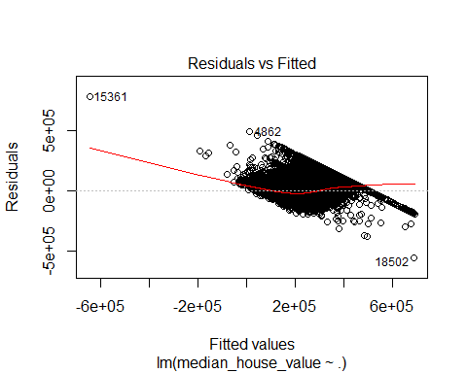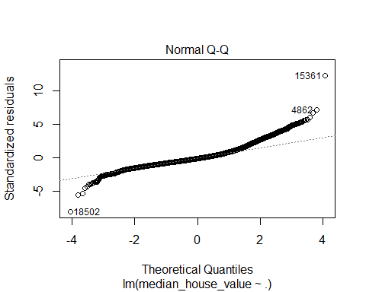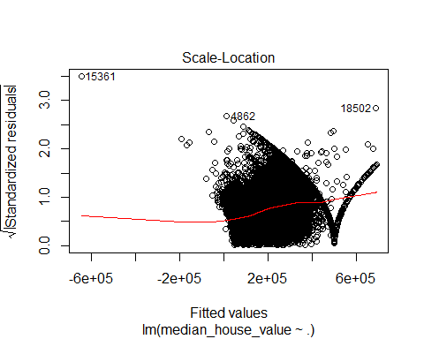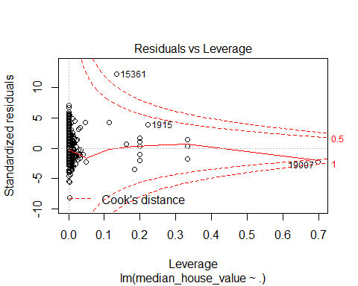

### Predicting the outcome value or Testing the model

##### Obtaining the predicted value by using one of the value of the trained data.

df <- as.data.frame(cali_full[1,])  
df

## longitude latitude housing_median_age total_rooms total_bedrooms population  
## 1 -122.23 37.88 41 880 129 322  
## households median_income median_house_value ocean_proximity rooms bedrooms  
## 1 126 8.3252 452600 4 6 0  
## pop_per_house  
## 1 2

df[,"median_house_value"] <- NULL  
df

## longitude latitude housing_median_age total_rooms total_bedrooms population  
## 1 -122.23 37.88 41 880 129 322  
## households median_income ocean_proximity rooms bedrooms pop_per_house  
## 1 126 8.3252 4 6 0 2

##### From the df variable we can see that the actual value is 452600. Then the median_house_value is eliminated and passed the data for testing the model.

predict.lm(model2,df )

## 1   
## 409162.3

##### The predicted value 409162.3 concludes that the error rate between the Actual - Predicted output is very small. Hence this model is a best fitted linear regression model.