Module 1:
Exercise 1: Implementing the Singleton Pattern
Scenario:
You need to ensure that a logging utility class in your application has only one instance throughout the application lifecycle to ensure consistent logging.
Code:
class Logger {
private static final Logger instance = new Logger();
private Logger() {
}
public static Logger getInstance() {
return instance;
}
public void log(String message) {
System.out.println("[LOG]: " + message);
}
}
class LazyLogger {
private static volatile LazyLogger instance;
private LazyLogger() {}
public static LazyLogger getInstance() {
if (instance == null) {
synchronized (LazyLogger.class) {
if (instance == null) {
instance = new LazyLogger();
}
}
}
return instance;
}
}

public class SingletonTest {
public static void main(String[] args) {
Logger logger1 = Logger.getInstance();
Logger logger2 = Logger.getInstance();
logger1.log("First message");
logger2.log("Second message");
System.out.println("Same instance? " + (logger1 == logger2));
}
}
Output:
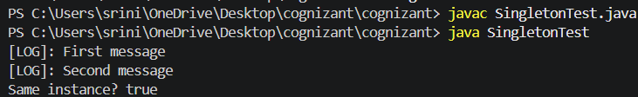

Exercise 2: Implementing the Factory Method Pattern
Scenario:
You are developing a document management system that needs to create different types of documents (e.g., Word, PDF, Excel). Use the Factory Method Pattern to achieve this.
Code:
interface Document {
void open();
}
class WordDocument implements Document {
public void open() { System.out.println("Opening Word document..."); }
}

class PdfDocument implements Document {
public void open() { System.out.println("Opening PDF document..."); }
}

class ExcelDocument implements Document {
public void open() { System.out.println("Opening Excel document..."); }
}
abstract class DocumentFactory {
public abstract Document createDocument();
}

class WordDocumentFactory extends DocumentFactory {
public Document createDocument() { return new WordDocument(); }
}

class PdfDocumentFactory extends DocumentFactory {
public Document createDocument() { return new PdfDocument(); }
}

class ExcelDocumentFactory extends DocumentFactory {
public Document createDocument() { return new ExcelDocument(); }
}

public class FactoryMethodTest {
public static void main(String[] args) {
DocumentFactory wordFactory = new WordDocumentFactory();
Document word = wordFactory.createDocument();
word.open();

DocumentFactory pdfFactory = new PdfDocumentFactory();
Document pdf = pdfFactory.createDocument();
pdf.open();

DocumentFactory excelFactory = new ExcelDocumentFactory();
Document excel = excelFactory.createDocument();
excel.open();
}
}
Output:
