**DATA VISUALIZATION FINAL PROJECT REPORT**

**SRI PRIYANKA SEELAM (39857091)**



**Evolution of Growth in Real Estate Business in Florida**

Table of Contents

**Introduction** 3

**Methodology** 4

**Analysis** 5

**Conclusion** 12

**Introduction:**

The ability to acquire and investigate data is main part in the business. Data and information are the keys to represent a visualization. Data visualization is the practice of translating information into a visual context, such as a map or graph, to make data easier for the human brain to understand and pull insights from.

Similarly, **Evolution of growth in real estate business**can also detect similar patterns, make hypothesis, and build a better independent way. There are few separate ways that they can use this information to get perfect advantage of this project.

The growth of real estate market has been incredible in the last two years. I would like to do my research starting with Florida state. And in the end, I want to compare the price of housing with the price of Apartments. As part of project, I would like to investigate what are the potential reasons that lead to an increase in price at a higher rate.

In today’s world one piece of content that has always been and will continue to be a staple for agents is the real estate. The projected revenue growth for real estate business is 312.30bn in 2022. The analysts are expecting 13.34% growth in revenue incoming four years (2022-2026). An average individual is spending about $1.34k. These are some of the statistics published in “Statista”.

I also found some remarkably interesting statistics in this real estate business area. So, I decided to investigate this segment to do visualizations. But later I got to know is getting related data for this market is difficult and we need to pay to the third parties to access their data. Finding direct data related to my project has been difficult. There are few datasets in this segment which are floating online, but they are not matching my research questions. At last, I found only one dataset in Kaggle which have many unwanted variables. So, I decided to use that dataset with only the variables I need.

My main idea behind this project is to predict and understand the trend the real estate system for the past few years. Hotel management collects the data for room availability and the total number of bookings to increase the cost of a room. To analyze the business logic behind all this I thought this would be good project to go with, unfortunately there is not much data available to public. But I found one “Real estate Florida” dataset in Kaggle. The second data set I used also holds the “Real estate” but contains different set of values inside the dataset which I got from the Economic Research Report published by US Federal.

My goal is to find some of the research questions like:

* Understanding the property cost of apartments over different months?
* Furthermore, I also like to find the housing cost over certain period.
* What is the rate of housing when compared with real estate area rate?

**Methodology:**

The Real estate Florida dataset holds details of Month of sale, Type of property, Area(ft.), Price, Country, State, it is vast data set which has 119,390 records from different countries. For this project I did data cleanup as our main goal is to focus on visualizations from combining the two datasets available.

Real estate dataset has House age, Distance to the nearest MRT station, Number of convenience stores, latitude, longitude, house price of unit area, Date, Market segment for the Florida state for the years 2018, 2019 and 2020. I have taken these three years only because I have the property details for only these years.

Variables which are used in “Real estate Florida” dataset are

|  |  |
| --- | --- |
| **Variable Name** | **Description** |
| Month of sale | Includes all months in a year |
| Type of property | Indicating Housing, Office, Apartment |
| Area(ft.) | Length of the area in Sq. ft |
| Price | Value of the property |
| Country | Selected country as USA |
| State | Selected country as Florida |
| Mortgage | A mortgage is a type of loan used to purchase or maintain a home, land, or other types of real estate. If the loan is given to borrower, then it is set as Yes in dataset else No |

Variables which are used for visualization in “Real estate”

|  |  |
| --- | --- |
| **Variable Name** | **Description** |
| Latitude | Used for the precise value |
| Longitude | Used for the precise value |
| house price of unit area | Value of the house |
| Date | Starting from Jan start date to December |
| Market segment | Purchased online, offline, corporate |

There are many variables present in the “Real estate Florida” and “Real estate” dataset which I didn’t want to use. So, I mentioned only few variables in those datasets which I used for the visualizations. But full dataset has been loaded into the tableau to create required visualizations. I have used link method to connect the two tables. I joined them with “date”, “Country” variables in Real estate Florida dataset to “date” & “Country” in Real estate.

Main dataset “Real estate Florida” is sourced from Kaggle, but it is originally from the article US Federal article.

**Analysis:**

**Visualization 1:**

**Month Wise Apartment Comparison on Property**

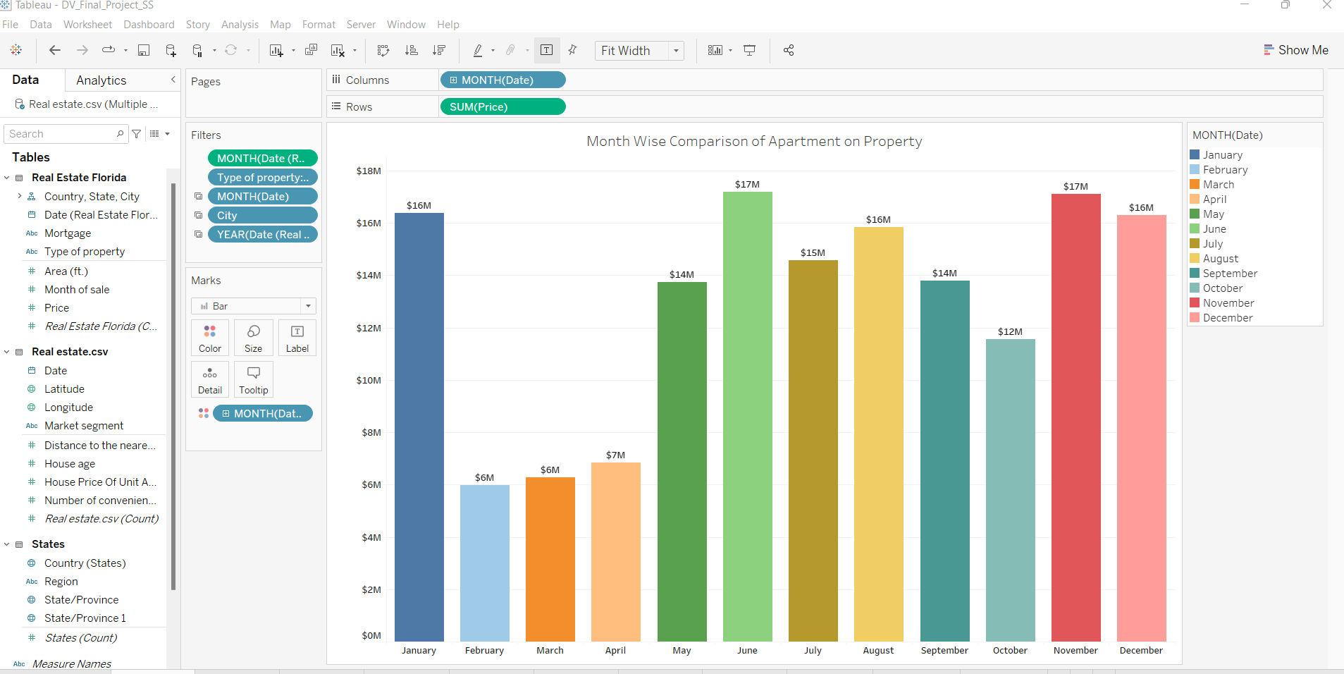

In the first visualization, I did analysis for the total amount spent for Apartments under property category by each resident. I wanted to show the amount spent only for apartments on monthly basis. As we can see June and November months has the highest value when compared with the rest of the months in a year. At the bottom of the visualization, we can also see the different months starting from January to December

In Real Estate business, we could also notice that the price has fallen in the months of February, March and April month.

**Visualization 2:**

**Year Wise House Comparison on property**

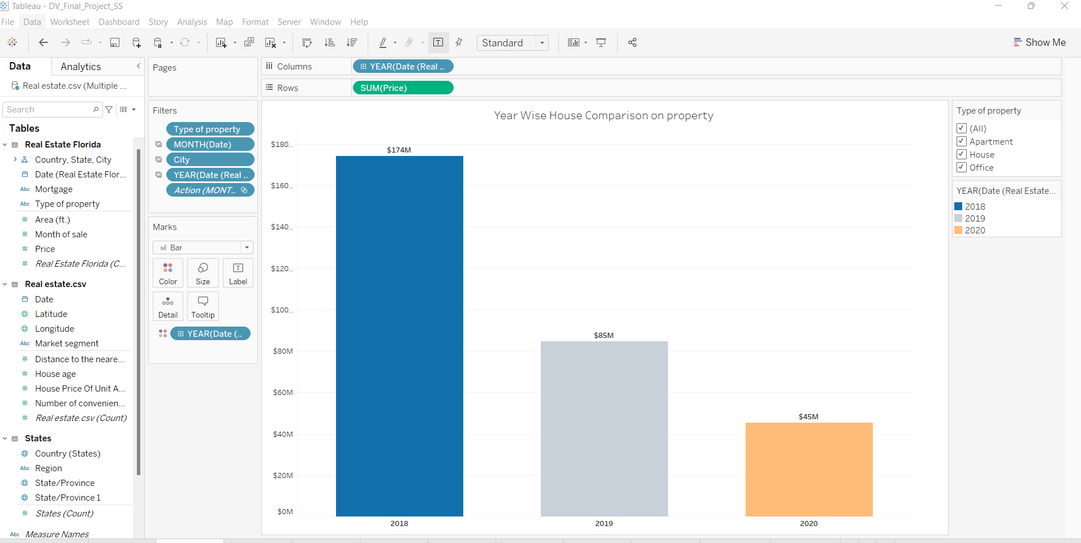

The second visualization is a simple one, yet I wanted to show the amount spent for house on yearly basis under property category. From the above visualization, we can see that most of the amount was invested in the year 2018 with a net worth of $174 M when compared to the investments made in 2019 and 2020.

The very lowest ranking was seen in 2020 with a net worth of $45 M. As we see in this there is some missing data in the left side of the graph so there is a huge drop in the graph. I have used drill down feature where I had a chance to show the bar charts in quarterly basis too as you can see from the below image.

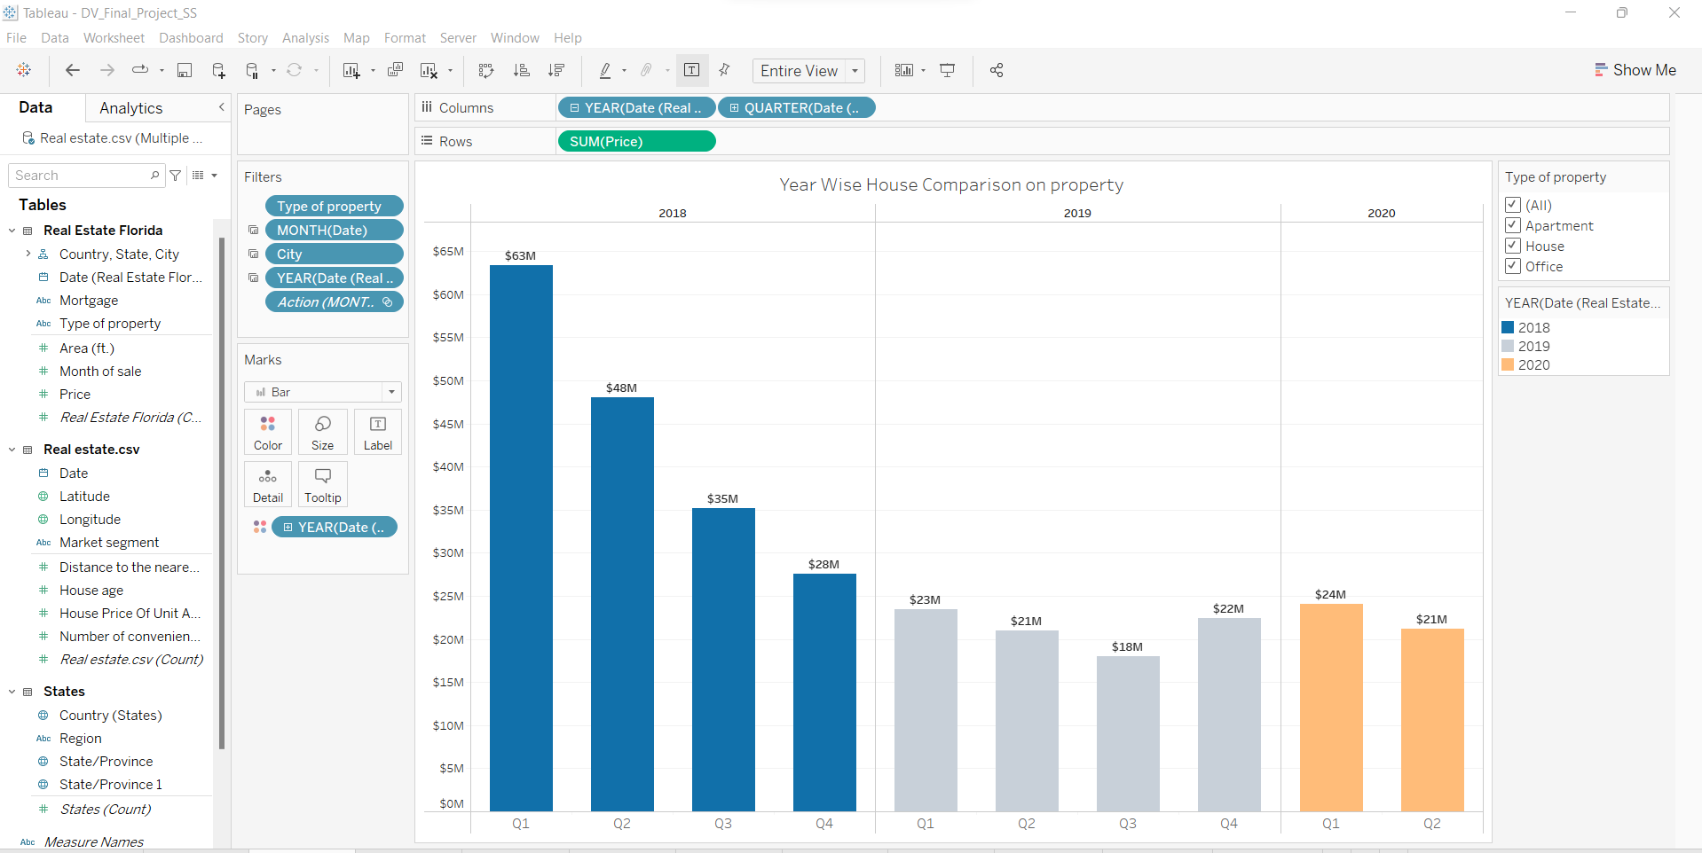

**Visualization 3:**

**House Price of each Unit according to Market Segment for each quarter**

As the trend keeps on changing the value of the land will also be changed according to certain factors like when inflammation rates are high and crimes rates are high. So, I have summed up the house price per unit area to show the quarterly price as you can see in the below visualization. I also used the filters on month and city for getting the better visualization.

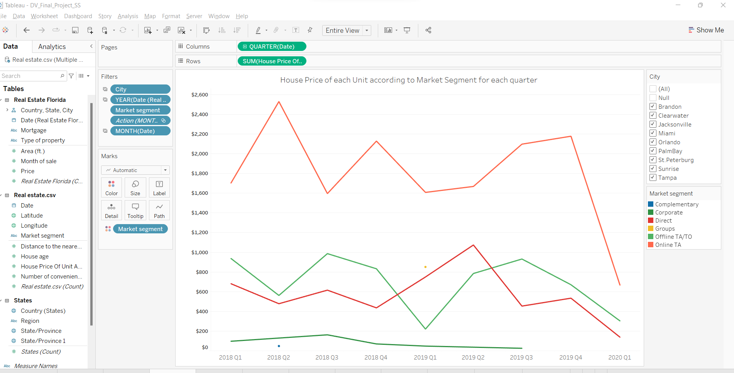

**Visualization 4:**

**Price of property in each city in Florida**

In the below geographical map, we can see it is divided into two parts based on the type of hotel. This visualization shows many states included in US however I am concentrating on Florida real estate alone, so I am highlighting the cites along with its price.

Almost all the states have different prices, where few of the states have less price compared to the population. In Florida, the highest property price was noted in the city Tampa with net worth of $65 M whereas the least prices are noted in the city PalmBay & Branden with 8 M each. We can observe this difference if we see each of these cities in this visualization.

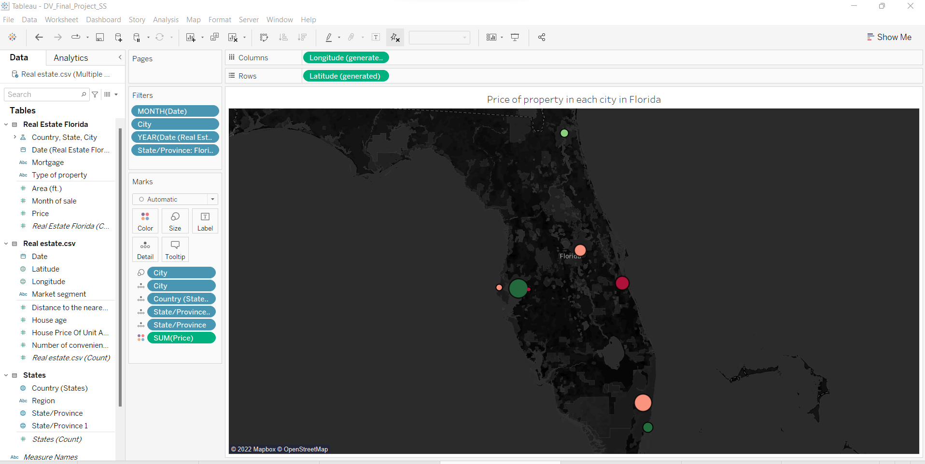

**Visualization 5:**

**Year Wise prices comparison of Property**

The main goal of this visualization is to show the complete prices for all the categories like (Apartments, House and Office) in Property field which we have in the dataset Real estate Florida. If you have a closer look at each category the value keeps on changing for year to year along with the price variations.

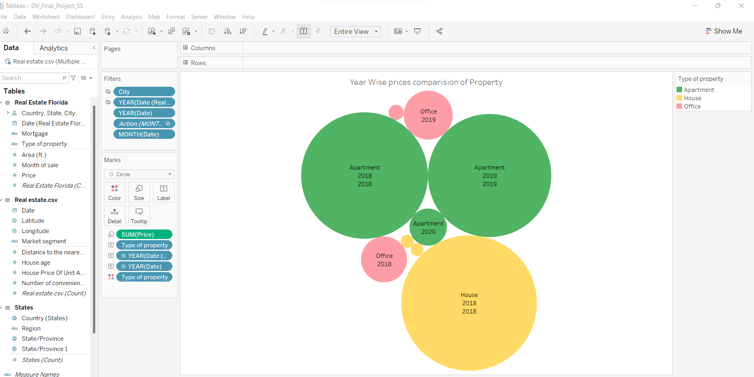

**Visualization 6:**

**Distance Wise Month Price**

Of all the visualizations this one clearly shows the distance between all the cities stated in the dataset. The pie chart is always best to show such difference mainly when dealing with numerical values like percentages, decimals and so on. I am also using calculated field on month by doing sum.

**Dashboard 1:**

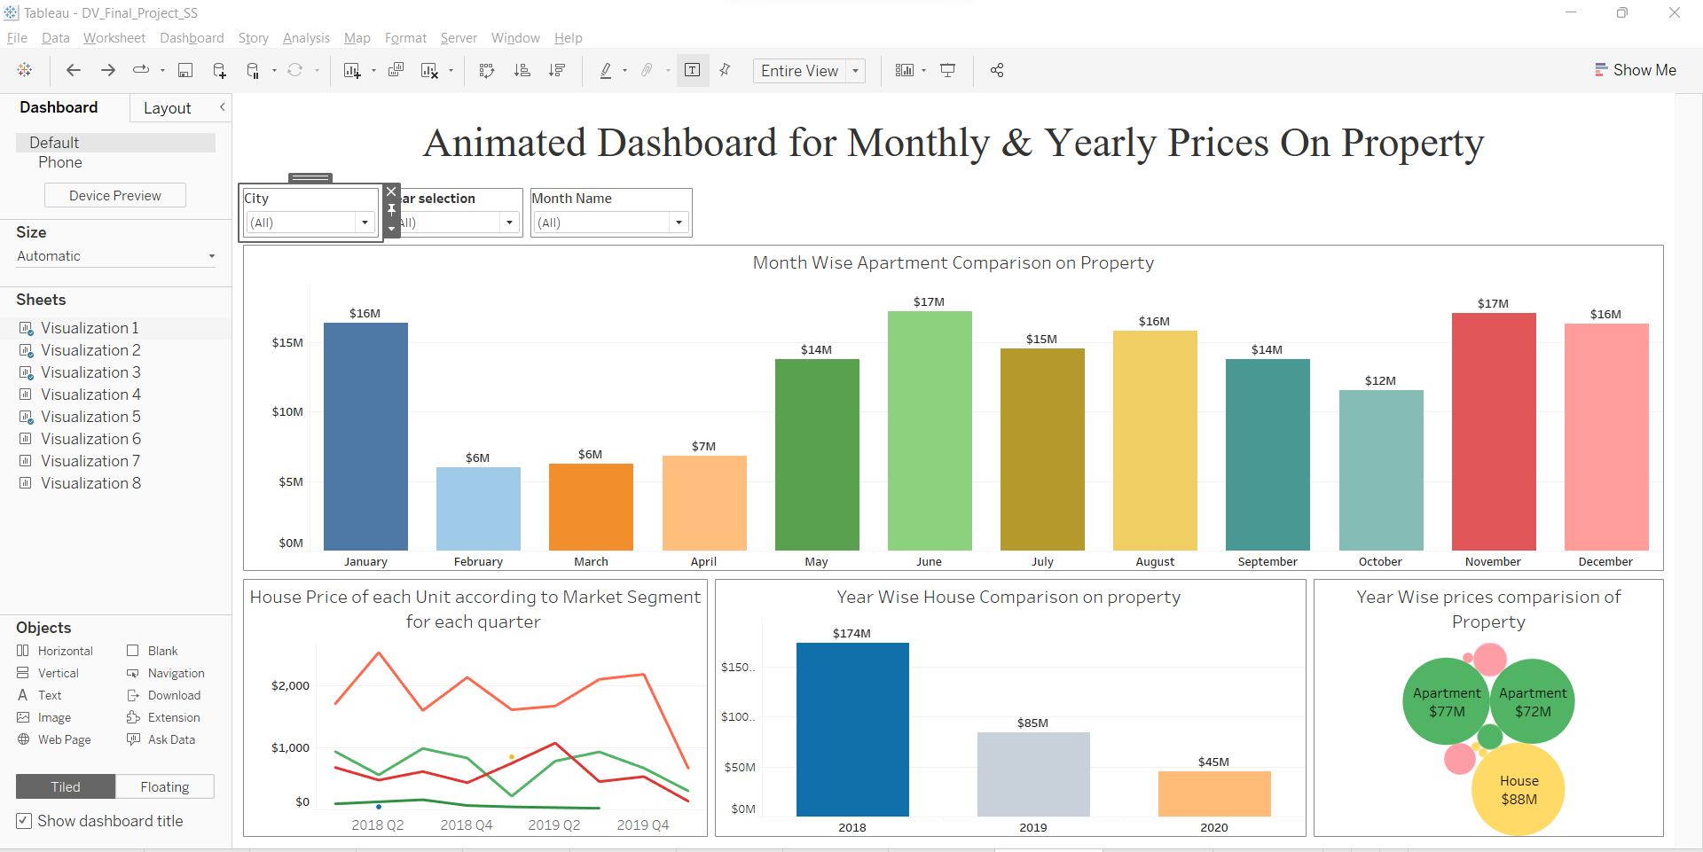

The above dashboard is an animated dashboard where you get the accurate results if you filter by month. However, I had used filter method for all the countries. This dashboard contains four visualizations related toevolution of growth in real estate business in Florida.

**Dashboard 2:** In this dashboard, we have two visualizations which has a map plot and pie chart.

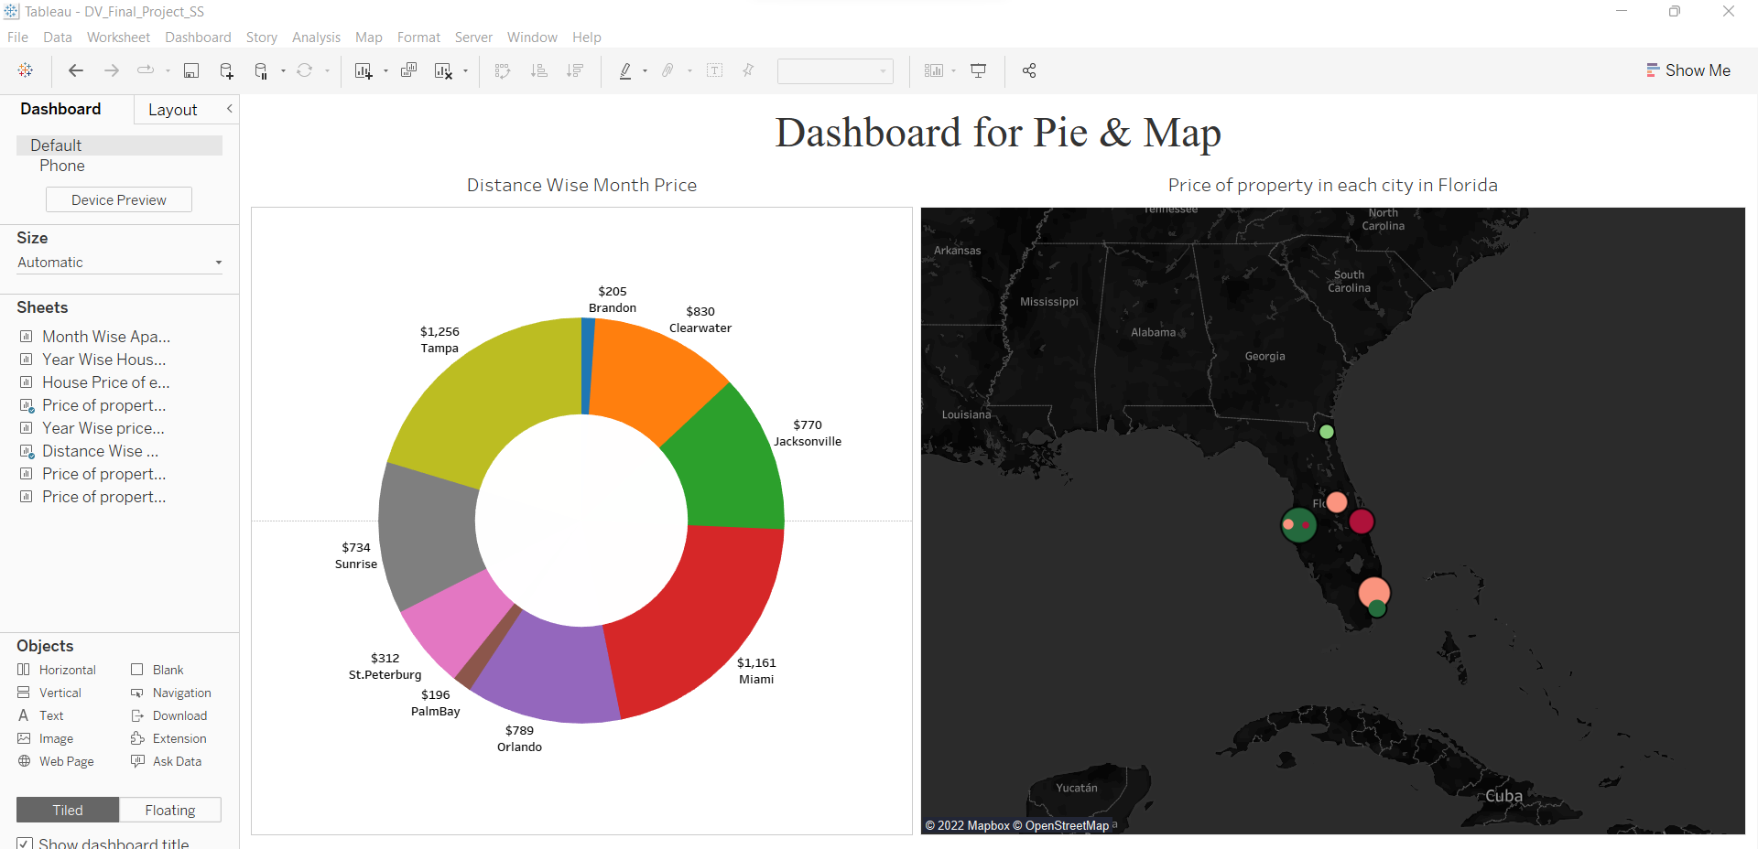

**Dashboard 3:**

To show the comparison price of each city in the year 2018 and 2020 the below dashboard is designed.

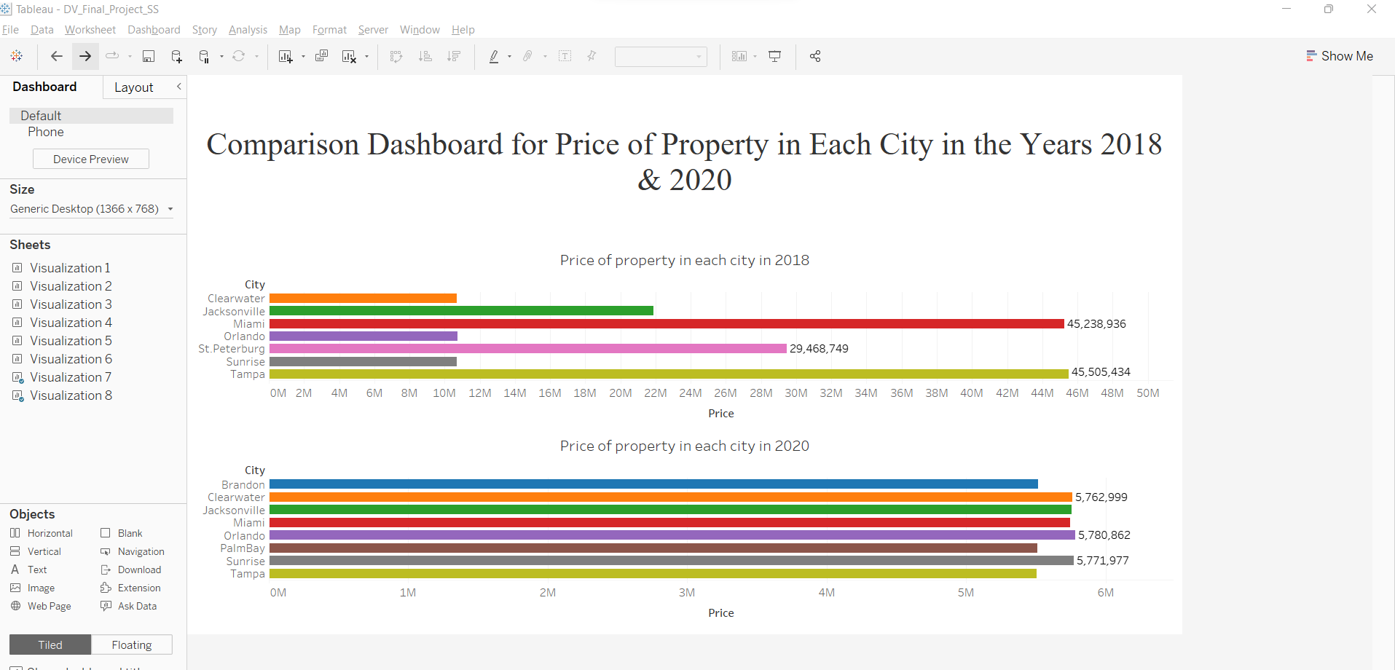

**Conclusion:**

After doing visualizations with the data I have, I tried to answer all the questions which I have mentioned in the initial project discussions. Price, City are the prime factor in my projects which lets everyone to compare it over years. We can expect this pattern will continue to dominate in the market.

We can also see a clear pattern of increase of price in Tampa and decreasing prices in rest of the cities. in the bookings for few months. January month has the highest spike in both.

**Other Research Questions:**

**Visualization 7 & 8:**

**Price of property in each city in 2018**

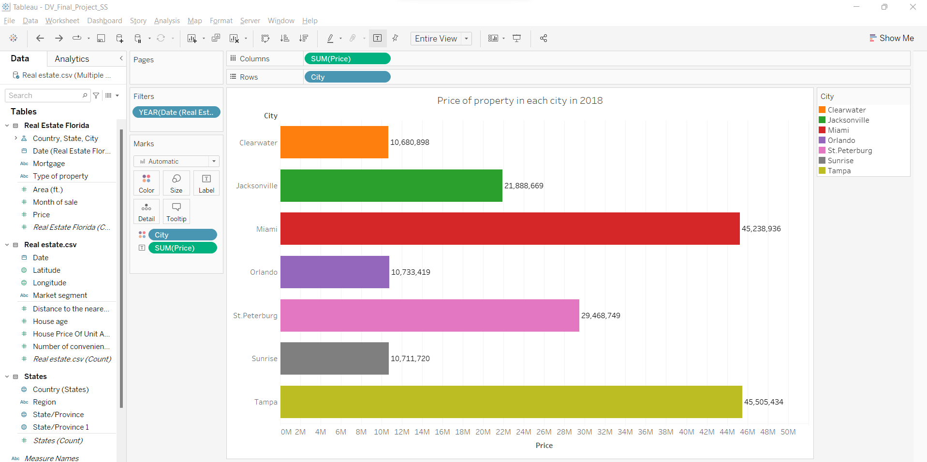

**Price of property in each city in 2020**

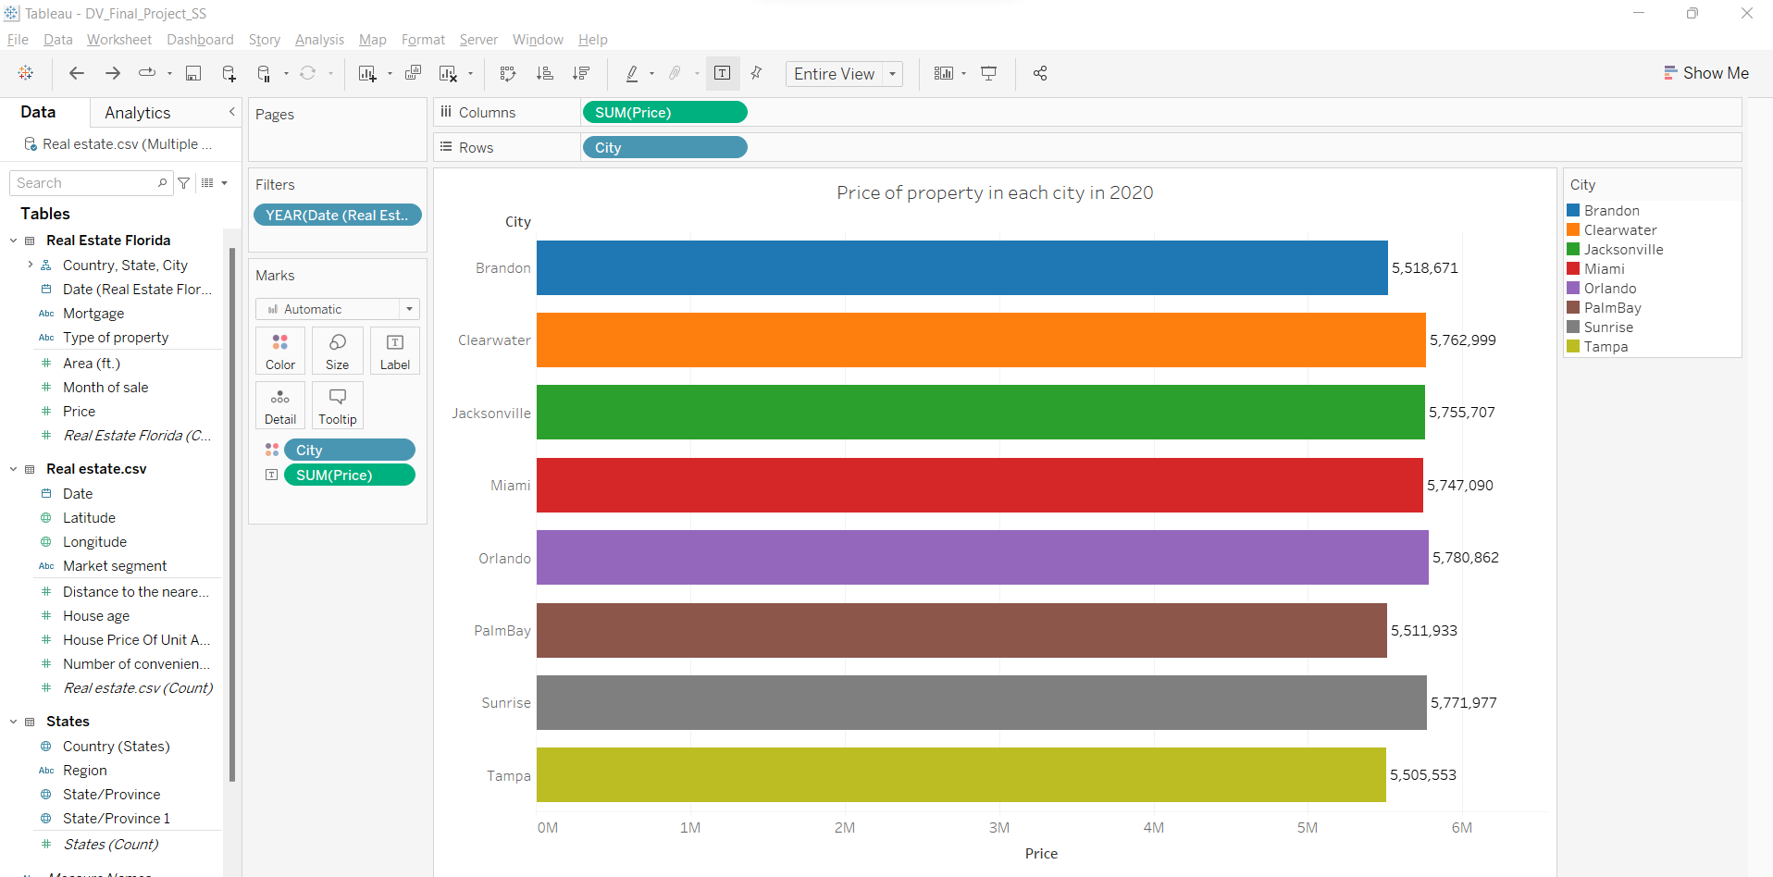

When I am surfing in web to find relevant information and datasets for my project, I found another interesting prediction that the price of housing in Florida hikes every year. To analyze this trend, I tried a check if this trend is continuing over the decade.

As we can see from the above visualization the Price value of Tampa is almost equal in both the years whereas the rest of the cities has a drastic change over the year.