**Annexure3b- Complete filing**

**INVENTION DISCLOSURE FORM**

Details of Invention for better understanding:

1. **TITLE:** AI-Powered Random Pairing Platform for Interviews and Mentorship
2. **INTERNAL INVENTOR(S)/ STUDENT(S):** All fields in this column are mandatory to be filled

|  |  |
| --- | --- |
| A. Full name | Prashant Kumar |
| Mobile Number | 6207307063 |
| Email (personal) | [1306pkumar@gmail.com](mailto:1306pkumar@gmail.com) |
| UID/Registration number | 12312739 |
| Address of Internal Inventors | Lovely Professional University, Punjab-144411, India |
| Signature (Mandatory) |  |

|  |  |
| --- | --- |
| B. Full name | Ronak Kumar Singh |
| Mobile Number | 7009097789 |
| Email (personal) | [ronakkumar20062006@gmail.com](mailto:ronakkumar20062006@gmail.com) |
| UID/Registration number | 12312741 |
| Address of Internal Inventors | Lovely Professional University, Punjab-144411, India |

|  |  |
| --- | --- |
| Signature (Mandatory) |  |

|  |  |
| --- | --- |
| C. Full name | Saksham Tiwari |
| Mobile Number | 8423852794 |
| Email (personal) | [Sakshamtiwari458@gmail.com](mailto:Sakshamtiwari458@gmail.com) |
| UID/Registration number | 12313623 |
| Address of Internal Inventors | Lovely Professional University, Punjab-144411, India |
| Signature (Mandatory) |  |

## (FOR ADDITIONAL INVENTORS, PLEASE ADD ROWS)

1. **DESCRIPTION OF THE INVENTION:** This invention proposes an AI-powered system designed to facilitate structured mock interviews and mentorship sessions through intelligent random pairing. The platform enhances interview preparation, technical skill development, and professional mentorship by leveraging AI-driven matching algorithms.

The system collects user-specific data, including skill levels, learning objectives, experience, and topic preferences. Using advanced machine learning techniques, it identifies optimal pairings for users based on their expertise, mentorship needs or learning goals. This ensures effective and relevant interactions between users engaged in coding interviews, soft skills development, or behavioral assessments.

Additionally, the system provides data-driven insights through interactive dashboards and performance analytics. Features such as structured feedback mechanisms, session reviews, and adaptive learning pathways enhance continuous improvement. By enabling real-time personalized pairing, the invention maximizes the efficiency of mock interviews and mentorship, ensuring every participant benefits from relevant and engaging sessions tailored to their individual needs.

### Motivation and Advantages

Interview preparation and mentorship often face challenges such as limited accessibility, lack of structured feedback, and ineffective pairing mechanisms. Many individuals struggle to find suitable practice partners, receive constructive insights, or connect with experienced mentors. Existing solutions focus on either automated question-based assessments or predefined mentor- mentee pairings, failing to offer real-time, human-to-human interaction. This invention addresses these limitations by introducing an AI-powered random pairing platform that ensures dynamic, intelligent matchmaking for structured mock interviews and mentorship sessions. By leveraging AI-driven algorithms, the system matches users based on their skill levels, experience, and learning objectives, facilitating relevant, real-time interactions that enhance communication, technical knowledge, and problem-solving abilities. Furthermore, structured feedback mechanisms, adaptive learning analytics, and customizable role selection allow users to refine their skills progressively. The platform seamlessly integrates mentorship support, connecting students and professionals with industry experts for guided learning. With a secure, scalable, and accessible design, this innovation democratizes interview preparation, offering an effective, data-driven, and interactive learning experience tailored to individual needs.

## TECHNICAL WORKING

The AI-powered random pairing platform for mock interviews and mentorship operates through a multi-layered AI-driven framework that integrates real-time data collection, intelligent matching algorithms, structured feedback mechanisms, and adaptive learning analytics to create an optimized and personalized interview experience.

The system follows a structured workflow comprising user data acquisition, AI-driven pairing, real-time communication, feedback generation, adaptive learning, and performance analytics to ensure an efficient, engaging, and continuously improving interview and mentorship platform.

### User Data Acquisition

The platform gathers user-specific data in real-time to enable precise and relevant pairing for interviews and mentorship sessions.

### Key Data Sources:

* + **User Profiles:**
    - Captures details such as skill level, expertise, learning goals, and topic preferences.
    - Continuous updates based on session performance and feedback.

### Behavioral & Interaction Data:

* + - Tracks user communication style, past interactions, and preferred mentorship format.
    - Help refine matchmaking and feedback mechanisms.

### Skill Assessment Data:

* + - Integrates coding challenges, soft skills evaluations, and prior interview experience.
    - Ensure users are paired with partners at appropriate difficulty levels.

### AI-Driven Matching Algorithm

The system employs advanced machine learning models to optimize pairing for mock interviews and mentorship interactions.

### AI Algorithms Used:

* + **Natural Language Processing (NLP) & Sentiment Analysis:**
    - Assesses user responses to categorize experience levels.
    - Ensures balanced pairing of interviewers and interviewees.

### Collaborative Filtering & Clustering (K-Means, DBSCAN):

* + - Groups of users with similar learning goals and experience levels.
    - Help identify skill gaps and recommend ideal interview partners.

### Real-Time Adaptive Matching:

* + - Dynamically adjusts pairings based on user history, feedback, and current session demand.

### Real-Time Interview & Mentorship Execution

Once matched, users engage in structured live interactions through an integrated communication interface.

### Key Features:

* + **Video & Chat-Based Sessions:**
    - Provides real-time conversation with interactive tools for discussions.

### Role-Based Selection:

* + - Users can choose to be interviewers, interviewees, or mentors.

### Session Recording & Transcription:

* + - Enables users to review past interactions for self-improvement.

### Structured Feedback & Adaptive Learning

Post-session feedback helps users refine their skills and enhances future pairings.

### Feedback Mechanisms:

* + **AI-Generated Feedback Reports:**
    - Evaluates performance using speech analysis, response accuracy, and engagement levels.

### User Rating System:

* + - Participants rate their session experience, contributing to continuous platform improvement.

### Adaptive Learning Recommendations:

* + - Suggest skill-specific improvements based on previous interactions.

### Performance Analytics & Insights

The platform transforms raw session data into actionable insights for users and mentors.

### Visualization Tools Used:

* + **Personalized Dashboards:**
    - Displays user performance, strengths, and improvement areas.

### AI-Based Heatmaps:

* + - Identifies frequently discussed topics and skill gaps.

### Session Trend Analysis:

* + - Provides insights into skill development over multiple interactions.

### Security, Deployment & Scalability

The platform is designed to be secure, scalable, and accessible across various user bases. Key Features:

### End-to-End Encryption:

* + - Ensures user privacy and data protection during sessions.

### Cloud-Based Architecture (AWS, Azure, GCP):

* + - Enables real-time processing and large-scale adoption.

### API Integration:

* + - Connects seamlessly with EdTech platforms, universities, and corporate training systems.

### Unique Attributes and Advantages:

* + **AI-Driven Random Pairing:** Unlike traditional mentorship platforms that rely on predefined mentor-mentee relationships, this system leverages **AI-driven dynamic pairing** for mock interviews. The platform intelligently matches users based on **skill level, expertise, and learning objectives**, ensuring that each session is highly relevant and effective.
  + **Real-Time Adaptive Matching:** The system continuously **analyzes user performance and feedback** to refine future pairings. Using **machine learning models such as clustering algorithms (K-Means, DBSCAN) and NLP-based assessment**, the platform ensures users are matched with the most appropriate interview partners and mentors.
  + **Structured Feedback and Performance Analytics:** The platform integrates **AI- generated session reviews, peer feedback, and skill assessment reports** to track user progress. By analyzing **speech patterns, response quality, and confidence levels**, the

system provides **personalized feedback and tailored learning recommendations**, enabling continuous skill improvement.

* + **Customizable Role & Topic Selection:** Unlike static interview platforms, this system allows users to **define their roles (interviewer/interviewee/mentor)** and select topics based on their specific **career aspirations and skill levels**. This ensures that each session is focused and effective.
  + **Mentorship Integration & Expert Guidance:** The platform bridges the gap between **students, job seekers, and industry professionals** by enabling **direct mentorship sessions**. Experienced mentors can **review performance, provide structured guidance, and share industry insights**, making the learning process more practical and engaging.
  + **Scalable, Secure & Privacy-Focused:** With **cloud-based deployment**, the platform is **highly scalable**, supporting thousands of users simultaneously. The system also offers **anonymous mode** for users who prefer privacy, and **end-to-end encryption** ensures data security during sessions.
  + **Continuous Learning & Adaptive AI Models:** The AI-driven analytics **track user progress over multiple sessions**, identifying strengths and weaknesses. The system then **adapts pairings, suggests new topics, and refines feedback models** to enhance user learning over time.
  + **Global Accessibility & Inclusivity:** By supporting **multiple languages, real-time translations, and API integration with EdTech platforms**, the system ensures **global access to mentorship and interview preparation**, breaking geographical and financial barriers.

## 6. PROBLEM ADDRESSED BY THE INVENTION

Traditional interview preparation and mentorship platforms lack real-time pairing, structured feedback, and intelligent matchmaking, leading to inefficient learning experiences. Many learners struggle to find the right practice partners or mentors, and existing systems fail to adapt to individual needs, making interview preparation less effective. This invention introduces an AI- driven platform that optimizes mentor-mentee pairing, skill-based matchmaking, and structured learning analytics, ensuring a highly personalized and impactful interview preparation process.

### AI-Driven Smart Pairing for Effective Practice

* + The platform analyzes user skills, experience levels, and learning objectives to match individuals with the most suitable partners.
  + Unlike traditional systems, which lack dynamic pairing, this invention ensures real-time AI-driven matchups for mock interviews, technical assessments, and soft skills coaching.
  + Users can select specific roles (interviewer/interviewee) and topics, ensuring relevant and skill-focused interactions.

### Structured Feedback for Continuous Improvement

* + The system automatically generates feedback reports, tracking response accuracy, confidence levels, and interaction quality.
  + AI-driven session analysis identifies areas for improvement, allowing users to refine their communication, problem-solving, and technical skills.
  + Mentors and interviewers provide structured feedback, ensuring continuous learning beyond a single session.

### Real-Time Mentor-Mentee Matching

* + Many learners struggle to find experienced mentors, leading to a lack of structured guidance.
  + This platform dynamically connects students, job seekers, and professionals with industry experts for real-time mentorship.
  + Unlike static mentorship programs, this system adapts based on user performance and evolving skill sets, ensuring ongoing support and relevant guidance.

### Intelligent Learning Analytics for Skill Optimization

* + The system tracks user performance over multiple sessions, using adaptive AI models to recommend personalized learning paths.
  + Interactive dashboards provide insights into strengths, weaknesses, and progress trends, helping users focus on areas needing improvement.
  + AI-powered learning trajectory analysis enables smarter decision-making, ensuring each session is tailored to maximize learning efficiency.

### Scalable and Accessible Interview Training

* + Existing platforms often restrict access to structured interview practice due to high costs and limited availability.
  + This invention ensures scalable, cost-effective access to mock interviews, mentorship sessions, and feedback tools, breaking barriers for students, job seekers, and professionals worldwide.
  + Cloud-based architecture supports large-scale deployment, making interview training accessible to users anytime, anywhere.

### Expanding Career Readiness and Professional Development

* + The platform focuses on bridging skill gaps by ensuring structured, data-driven interview preparation for individuals across industries.
  + AI-driven career mapping tools suggest relevant practice areas, mentorship sessions, and skill development plans based on industry trends.
  + Reduces hiring challenges for companies by producing better-prepared candidates, improving employability and professional growth.

## OBJECTIVE OF THE INVENTION

### AI-Driven Smart Interview Pairing

This invention enhances interview preparation by leveraging real-time AI-driven pairings to match users for mock interviews. By analyzing skill levels, learning objectives, and prior experiences, the system ensures effective and relevant interview practice sessions. Unlike traditional methods that rely on manual scheduling, this AI-powered approach optimizes pairings dynamically, helping users improve communication skills and gain confidence in technical and behavioral interviews.

### Structured Feedback for Instant Skill Assessment

The platform provides real-time session reviews with AI-generated feedback reports. By analyzing speech patterns, problem-solving approaches, and confidence levels, the system tracks user progress and offers personalized improvement recommendations. Users receive structured feedback from both AI models and interview partners, enabling continuous skill enhancement over multiple sessions.

### AI-Powered Mentorship Support

The system connects students, job seekers, and professionals with industry experts and educators for guided learning experiences. AI-driven mentor recommendations ensure that users receive personalized career advice, industry insights, and skill-specific guidance. Unlike traditional mentorship programs, this platform adapts mentor recommendations based on user progress, ensuring ongoing and relevant support.

### Smart AI Matching for Optimized Pairing

Using advanced machine learning models, the system analyzes user profiles, past session data, and skill trajectories to optimize matchmaking. The AI clusters users are based on expertise levels and learning goals, ensuring that interviewees are paired with the most suitable interviewers. This intelligent real-time pairing system increases session effectiveness, creating a structured and balanced interview practice environment.

### Continuous Learning & Adaptive Skill Enhancement

The AI-powered analytics track user performance over multiple sessions, refining pairing accuracy and suggesting targeted practice areas. Interactive dashboards provide real-time performance insights, helping users identify strengths and weaknesses. The system adjusts recommendations based on learning progress, ensuring long-term interview preparation efficiency through adaptive learning models.

1. **STATE OF THE ART/ RESEARCH GAP/NOVELTY:**

|  |  |  |  |  |
| --- | --- | --- | --- | --- |
| Sr. No. | Patent I’d | Abstract | Research Gap | Novelty |
| 1 | US20230145363A1 | Describes an intelligent mentor and expertise matching tool that utilizes AI to connect mentees with suitable mentors based on profiles and preferences. The system facilitates mentorship by analysing user data to recommend optimal pairings. | 1. Focuses on mentor-mentee matching but lacks real-time random pairing for mock interviews. 2. Does not provide structured feedback mechanisms post- interaction. 3. Lacks customization for role-specific scenarios in interview practice. 4. No integration with adaptive learning analytics for continuous improvement. | 1. AI-driven random pairing for spontaneous mock interviews. 2. Real-time structured feedback and session reviews to enhance learning. 3. ​   Customizable role and topic selection for tailored interview experiences.   1. Integration with adaptive learning analytics to   monitor and promote |

|  |  |  |  |  |
| --- | --- | --- | --- | --- |
|  |  |  |  | continuous skill development. |
| 2 | US20210312399 A1 | Introduces a system and method for conducting automated interview sessions using AI. It includes a question generator and chat bot to simulate interview scenarios, aiming to assess candidate responses effectively. | 1. Emphasizes automated interviews but lacks human-to- human interaction for realistic practice. 2. Does not incorporate mentorship or guidance from experienced professionals. 3. Absence of AI- driven pairing based on user skill levels and learning objectives. 4. Limited to predefined questions without adaptive customization based on user progress. | 1. Facilitates human-to- human mock interviews through AI- driven random pairing. 2. Connects users with mentors for personalized guidance and support. 3. Utilizes AI algorithms to match users based on experience, skills, and goals. 4. Offers adaptive session customization and feedback to align with individual learning   trajectories. |
| 3 | US20240161045 A1 | Details a system for assisting interviewers by analysing conversations using AI to ensure compliance with predetermined rules, providing real-time feedback to interviewers. | 1. Aims to assist interviewers but does not address the needs of interviewees seeking practice opportunities. 2. Lacks a platform for pairing individuals for mock interviews or mentorship. 3. Does not offer role-specific | 1. Provides a platform for interviewees to engage in mock interviews with peers or mentors. 2. AI-driven pairing system facilitates connections based on specific roles and topics. |

|  |  |  |  |  |
| --- | --- | --- | --- | --- |
|  |  |  | customization or adaptive learning features.  4. Focuses on compliance during interviews rather than skill development through practice. | 3. Incorporates adaptive learning features to tailor sessions according to user progress and feedback.  4. Enhances skill development through practical experience and  structured mentorship. |

# DETAILED DESCRIPTION:

The proposed invention is an AI-powered random pairing platform designed to enhance interview preparation and mentorship through intelligent matchmaking, structured feedback, and adaptive learning analytics. Unlike traditional mentorship or interview simulation platforms, this system dynamically pairs users based on skill levels, learning objectives, and experience, ensuring personalized and efficient learning.

### AI-Powered Matching System

The platform employs advanced AI algorithms to analyze user profiles, skill levels, and past performance, ensuring optimal pairings for mock interviews and mentorship sessions.

* + Machine learning models (K-Means clustering, NLP-based analysis) match users based on technical expertise, communication skills, and topic preferences.
  + Real-time adaptive pairing ensures that interviewees are always connected with suitable mentors or peers, maximizing the learning impact of each session.
  + Users can select specific roles (interviewer/interviewee/mentor) to tailor their experience.

### Real-Time Communication Interface

The platform provides seamless, real-time communication for mock interviews and mentorship sessions through an integrated video and chat-based interface.

* + Supports high-quality video calls and text-based interaction, allowing users to conduct interviews, share insights, and provide guidance in structured conversation formats.
  + Ensures low-latency real-time engagement, making it ideal for technical coding interviews, behavioral assessments, and industry mentorship.
  + Screen sharing and interactive whiteboard features enable live problem-solving and coding exercises.

### Structured Feedback Mechanism

A built-in structured feedback system helps users assess their performance, track progress, and refine their skills over time.

* + AI-generated performance reports analyze response accuracy, confidence levels, and interaction quality.
  + Users receive real-time feedback from mentors, interviewers, and AI-driven assessment models.
  + Session ratings and peer reviews contribute to a continuous improvement cycle, ensuring that every user benefits from detailed feedback.

### Adaptive Learning Analytics

The platform leverages AI-powered analytics to provide personalized learning recommendations and refine interview pairings over time.

* + Tracks user performance metrics, including communication effectiveness, problem- solving skills, and technical proficiency.
  + AI-driven learning pathways suggest future topics and interview scenarios, ensuring progressive skill development.
  + Predictive analytics detect patterns in user behavior, optimizing session difficulty and pairing accuracy for effective long-term learning.

### Role and Topic Customization

Users can customize their interview experience by selecting specific roles, skill levels, and interview topics.

* + Allows users to switch between roles (interviewer/interviewee/mentor) depending on their learning objectives.
  + Users can specify focus areas such as coding interviews, behavioral assessments, system design, or industry-specific mentoring.
  + Ensures that every session is tailored to user needs, increasing engagement and relevance.

### Session Recording and Analysis

To enhance self-improvement and performance tracking, the platform offers an optional session recording feature.

* + Users can review past sessions, identify communication gaps, and refine their interviewing techniques.
  + AI-powered speech and sentiment analysis extract insights from past interactions to highlight areas for improvement.
  + Transcripts and timestamped feedback summaries enable users to focus on specific moments in the session that require enhancement.

### Mentorship Integration

The platform connects users with experienced mentors and industry professionals, providing structured career guidance and skill development support.

* + AI-powered mentor recommendations ensure that users connect with the most relevant experts based on career goals.
  + One-on-one and group mentorship sessions allow users to gain insights from seasoned professionals.
  + Facilitate career-building opportunities, helping users understand industry expectations and interview strategies.

### Secure and Anonymous Mode

To ensure privacy and security, the platform offers a secure environment for users to participate in interviews and mentorship sessions confidently.

* + Anonymous pairing options allow users to practice without revealing personal information.
  + End-to-end encryption secures all communications, ensuring confidentiality and data protection.
  + AI-driven moderation and session monitoring prevent unethical behavior, ensuring a safe and professional interview environment.

# Results and Advantages of the AI-Powered Random Pairing Platform for Interviews and Mentorship

### Results Achieved:

1. **Efficient Interview Preparation:**
   * Users experience realistic mock interviews through AI-driven random pairing.
   * Real-time interactions help build confidence and improve communication skills.

### Intelligent Matching System:

* + AI algorithms ensure users are paired based on experience, expertise, and learning objectives.
  + Customization options allow selection of roles, topics, and difficulty levels for tailored sessions.

### Structured Feedback and Analytics:

* + Session reviews and AI-driven feedback help users identify strengths and areas for improvement.
  + Adaptive learning analytics track user progress and refine future pairings.

### Seamless Mentorship Integration:

* + Connect students with experienced mentors and industry professionals.
  + Facilitates knowledge sharing and skill development through guided mentorship sessions.

### Secure and Scalable Platform:

* + Supports anonymous mode for user privacy.
  + Scalable infrastructure allows broad accessibility for individuals, educational institutions, and corporations.

### Advantages Over Existing Prior Art:

|  |  |  |
| --- | --- | --- |
| **Feature** | **Existing Systems** | **AI-Powered Random Pairing Platform** |
| **Pairing Mechanism** | Predefined mentor-mentee pairing or automated question- based interviews | AI-driven random pairing for dynamic mock interviews |
| **Feedback Mechanism** | Limited or no structured feedback | Real-time structured feedback and session reviews |
| **Customization** | Static interview formats | Customizable roles, topics, and difficulty levels |
| **Mentorship Integration** | Focuses on automation or mentorship separately | Combines real-time human-to- human mock interviews with mentorship |
| **Adaptive Learning** | No continuous improvement tracking | AI-driven analytics to track user progress and enhance session quality |
| **Scalability & Accessibility** | Restricted to specific institutions or companies | Open access for students, professionals, and organizations |

**Superiority Over Prior Art:**

* **Real-time AI-Driven Pairing:** Unlike existing systems, which focus on predefined mentorship or automated question-based interviews, this platform enables real-time pairing of users for realistic practice.
* **Holistic Learning Approach:** Combines mock interviews, structured feedback, and mentorship in one solution.
* **Dynamic Customization:** Offers flexibility to tailor interview scenarios, skill levels, and roles to suit individual learning objectives.
* **Continuous Improvement:** Utilizes AI to track and refine user progress, ensuring consistent learning and skill enhancement.
* **Scalable and Commercially Viable:** Can be integrated into educational institutions, corporate training programs, and EdTech platforms.

This platform provides an innovative solution to interview preparation and mentorship, addressing key gaps in accessibility, structured feedback, and effective pairing mechanisms.

## EXPANSION:

To ensure scalability and adaptability, the proposed AI-powered random pairing platform considers multiple dynamic variables that influence interview preparation, mentorship effectiveness, and skill-based matchmaking. These variables enable the system to continuously refine pairing accuracy, enhance learning experiences, and optimize mentorship support over time.

### User Demographics and Learning Preferences

* + Skill Levels & Expertise: Categorizes users based on beginner, intermediate, and advanced proficiency levels, ensuring appropriate interview pairings.
  + Career Goals & Industry Specialization: Allows users to choose their domain (Software, Finance, Healthcare, etc.), ensuring role-specific interview practice.
  + User Engagement Patterns: Analyzes session frequency, feedback history, and learning behaviors to refine pairing strategies.

### Mentorship and Professional Guidance Variables

* + Mentor-Student Ratio: Balances mentor availability with demand, ensuring optimal resource allocation for guided learning experiences.
  + Industry Expert Insights: Matches mentees with senior professionals for career advice and industry-specific guidance.
  + Adaptive Mentor Matching: AI tracks mentor effectiveness and user feedback, adjusting recommendations dynamically.

### Real-Time Feedback and Learning Analytics

* + Structured Feedback Ratings: Uses peer and AI-generated feedback to adjust pairing accuracy and interview difficulty over time.
  + Performance Trend Analysis: Tracks speech patterns, problem-solving speed, and confidence levels to refine learning paths.
  + Session Impact Measurement: Evaluates how each interview session contributes to user improvement, ensuring progressive skill development.

### AI-Driven Adaptive Matching Models

* + Machine Learning-Based Clustering: Uses NLP and clustering algorithms (K-Means, DBSCAN) to identify ideal pairings based on skill similarity and improvement needs.
  + Dynamic Session Re-Routing: Adjusts pairing logic based on live session feedback, improving match relevance and engagement.
  + AI-Powered Role Switching: Users can transition between interviewee, interviewer, and mentor roles, enabling holistic skill development.

### Accessibility and Platform Integration Variables

* + Multilingual Support & Real-Time Translation: Ensures global accessibility, breaking language barriers in interview practice.
  + Cloud-Based Deployment & Scalability: Supports large-scale adoption, allowing universities and enterprises to integrate with their learning management systems (LMS).
  + Mobile & Web Interface Optimization: Ensures seamless user experience across devices, allowing users to participate in mock interviews from anywhere.

## WORKING PROTOTYPE/ FORMULATION/ DESIGN/COMPOSITION:

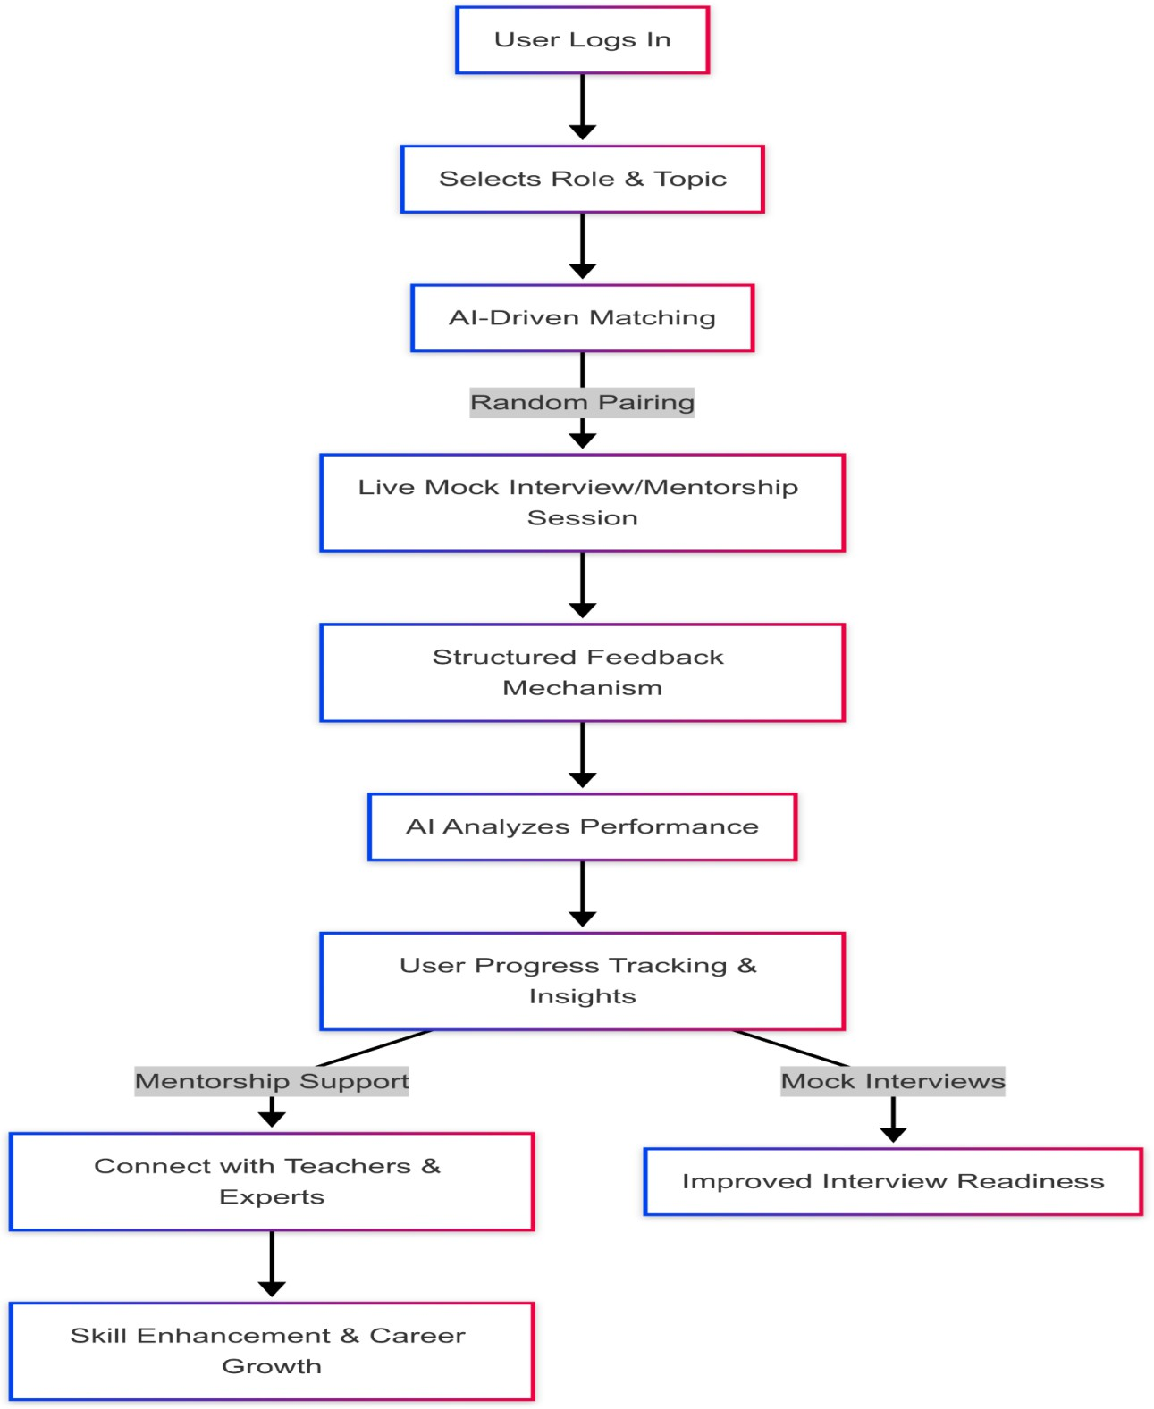

Fig 1: AI-Driven Mock Interview & Mentorship Workflow

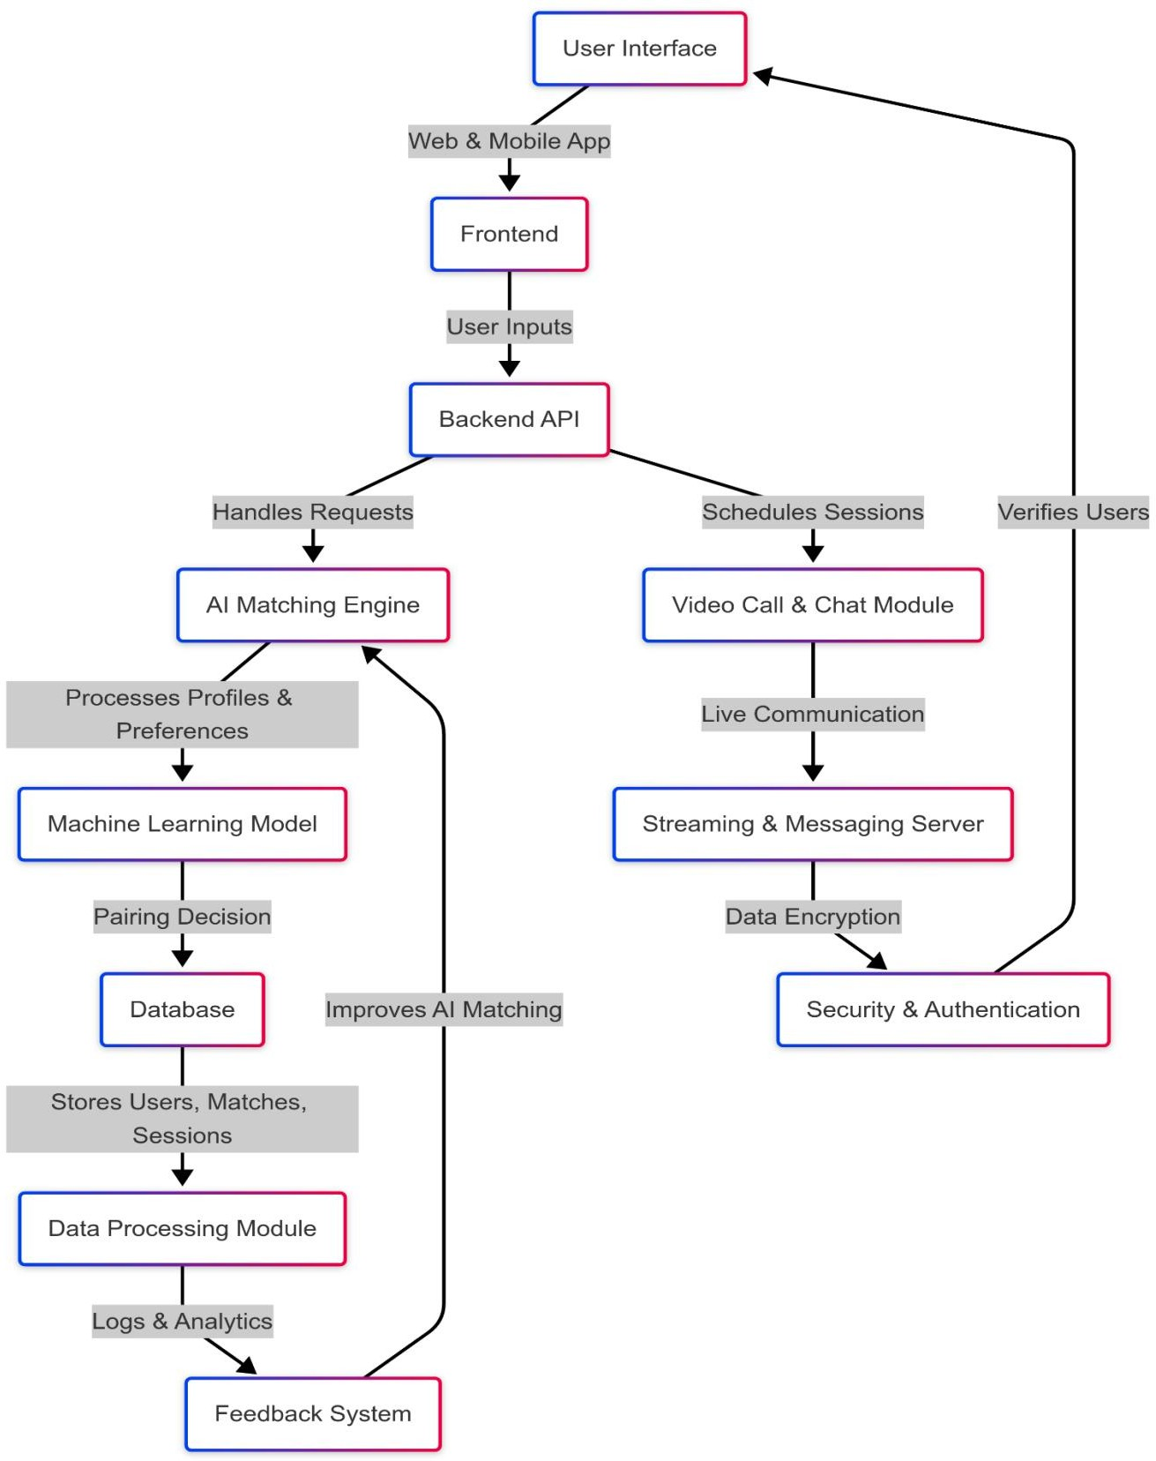

Fig 2 System Architecture for AI-Driven Matching & Communication Platform

## EXISTING DATA:

Several studies and patent filings have been analyzed to evaluate the performance of AI-driven interview preparation and mentorship platforms in comparison to traditional training methods. The following patents and research initiatives provide insights into the current state of AI-based learning, skill assessment, and interview simulation technologies:

## US20230145363A1

**Title:** *AI-Based Mentor and Expertise Matching System*

* + Describes an AI-powered mentor-mentee matching tool that connects users based on expertise and preferences.
  + Focuses on mentorship but lacks real-time random pairing for structured mock interviews.
  + Does not integrate adaptive learning analytics for skill tracking and improvement.

### Relevance to This Invention:

* + Unlike static mentorship models, our system provides AI-driven dynamic matchmaking for mock interviews and mentorship, ensuring real-time feedback and skill-based pairing.

## US20210312399A1

**Title:** *Automated AI-Based Interview Simulation System*

* + Describes an AI-driven system for conducting automated interviews using a question generator and chatbot.
  + Lacks human-to-human interaction, limiting the realism of interview practice.
  + Does not provide mentorship integration or structured feedback mechanisms.

### Relevance to This Invention:

* + Our platform facilitates real-time human-to-human interactions through AI-powered random pairing, ensuring authentic interview practice.
  + Unlike predefined chatbot-driven simulations, this invention enables role-based selection, mentor pairing, and adaptive feedback for interview readiness.

## US20240161045A1

**Title:** *AI-Based Interview Analytics and Compliance System*

* + Focuses on analyzing interviewer behavior and providing rule-based compliance feedback.
  + Does not address the needs of interviewees or provide structured interview training.
  + Lacks an AI-driven matching system for skill-based mock interview pairings.

### Relevance to This Invention:

* + Instead of focusing solely on interviewer behavior analysis, our system enhances interviewee skill development through structured mentorship and AI-driven learning pathways.
  + Unlike compliance-focused solutions, our platform prioritizes interactive mock interviews, real-time feedback, and adaptive skill tracking.

## USE AND DISCLOSURE (IMPORTANT):

|  |  |  |
| --- | --- | --- |
| A. Have you described or shown your invention/ design to anyone or in any conference? | YES ( ) | NO ( √ ) |
| B. Have you made any attempts to commercialize your invention (for example, have you approached any companies about purchasing or manufacturing your invention)? | YES ( ) | NO ( √ ) |
| C. Has your invention been described in any printed publication, or any other form of media, such as the Internet? | YES ( ) | NO ( √ ) |
| D. Do you have any collaboration with any other institute or organization on the same? Provide name and other details. | YES ( ) | NO ( √ ) |
| E. Name of Regulatory body or any other approvals if required. | YES ( ) | NO ( √ ) |

1. Provide links and dates for such actions if the information has been made public (Google, research papers, YouTube videos, etc.) before sharing with us.

Not Shared

1. Provide the terms and conditions of the MOU also if the work is done in collaboration within or outside university (Any Industry, other Universities, or any other entity).

N/A (No collaboration)

## POTENTIAL CHANCES OF COMMERCIALIZATION

The AI-powered random pairing platform has significant commercialization potential, offering scalable and adaptable solutions for interview preparation, mentorship, and skill development. The platform’s unique AI-driven approach makes it valuable for corporate training, educational institutions, and online learning platforms.

### Growing Demand for AI-Powered Interview Preparation

* + With the rise of remote work and virtual hiring, structured interview practice has become critical for job seekers and professionals.
  + Traditional interview preparation methods lack personalization, real-time feedback, and structured mentorship, creating a gap that this platform effectively fills.
  + Companies and job seekers alike seek intelligent, AI-driven solutions for technical and behavioral interview training.

### Corporate Training and Employee Development

* + Businesses are investing in AI-powered training programs to enhance their employees' communication, leadership, and problem-solving skills.
  + The platform can be integrated into corporate learning environments, offering structured mentorship and interview coaching for professionals at different career stages.
  + HR and recruitment teams can utilize the system to prepare candidates for internal promotions, leadership roles, and high-stakes interviews.

### EdTech and University Collaborations

* + Universities and educational institutions can integrate the platform into career development programs to help students prepare for job interviews, internships, and competitive exams.
  + The platform’s structured feedback mechanism and mentor integration make it a powerful tool for career counseling and interview readiness programs.
  + AI-driven pairing allows students to practice interviews with peers, industry experts, or faculty mentors, making the learning process more dynamic and effective.

### Expansion into AI and Adaptive Learning Markets

* + The AI-driven learning industry is expanding rapidly, with adaptive skill-building and mentorship platforms gaining traction.
  + This system can be positioned as an AI-powered alternative to conventional coaching, offering real-time personalized learning pathways and dynamic skill assessment.
  + Investors and technology firms focusing on EdTech, career coaching, and AI-driven assessments would find this platform a lucrative opportunity.

## REVENUE STREAMS

1. Subscription-Based Model: Monthly or yearly subscription plans for individual learners, professionals, and corporate teams.
2. Licensing AI-Powered Analytics: Companies can license the platform’s AI-driven skill assessment and feedback tools.
3. Enterprise Solutions: Customized interview preparation modules for corporate clients, universities, and HR training programs.
4. Mentorship & Coaching Services: Integration with professional coaches and industry experts for premium mentorship programs.

## TARGET PARTNERS

* + EdTech Companies & Universities: Platforms like Coursera, Udemy, LinkedIn Learning, and universities looking for structured interview preparation solutions.
  + Corporate Training Firms: Companies focused on employee development, leadership training, and recruitment coaching.
  + HR & Recruitment Platforms: Online hiring platforms that need AI-powered mock interviews and candidate readiness assessments.
  + AI & Learning Tech Firms: Organizations investing in adaptive learning, AI-based mentorship, and career growth solutions.

### List of Companies for Commercialization

The AI-powered random pairing platform for interviews and mentorship has strong commercialization potential and can be marketed to companies specializing in EdTech, corporate training, AI-driven learning platforms, and online recruitment solutions. The following companies and organizations are potential commercialization partners:

### LinkedIn Learning

* + **Overview:** Offers online professional development courses, including interview preparation and skill-building programs.
  + **Website:** [https://learning.linkedin.com](https://learning.linkedin.com/)

### Coursera

* + **Overview:** A global online learning platform that collaborates with universities and companies to offer courses in career development, interview coaching, and mentorship.
  + **Website:** [https://www.coursera.org](https://www.coursera.org/)

### Udemy

* + **Overview:** Provides on-demand courses, including mock interview training and professional skill development, making it a potential platform for commercialization.
  + **Website:** [https://www.udemy.com](https://www.udemy.com/)

### HackerRank

* + **Overview:** A technical hiring platform that allows users to practice coding interviews and take AI-assisted assessments.
  + **Website:** [https://www.hackerrank.com](https://www.hackerrank.com/)

### Google AI for Education

* + **Overview:** Provides AI-driven education and training tools, which could be leveraged for automated interview training and mentorship programs.
  + **Website:** [https://edu.google.com](https://edu.google.com/)

### IBM AI Solutions

* + **Overview:** Develops AI-driven training and mentorship solutions, making it a potential partner for corporate employee training and AI-based learning programs.
  + **Website:** <https://www.ibm.com/watson>

### Microsoft AI & Education

* + **Overview:** Offers AI-powered learning solutions that can be integrated into mock interview training and professional mentorship programs.
  + **Website:** <https://www.microsoft.com/en-us/ai/education>

### Turing

* + **Overview:** An AI-powered talent platform that connects remote developers with job opportunities, requiring structured mock interview preparation and mentorship tools.
  + **Website:** [https://www.turing.com](https://www.turing.com/)

### HireVue

* + **Overview:** Specializes in AI-driven hiring assessments and video interview solutions, making it a strong commercialization partner for structured interview preparation.
  + **Website:** [https://www.hirevue.com](https://www.hirevue.com/)

### Basic Patents and Royalty Considerations

At this stage, the system primarily builds open AI standards and well-established technologies. However, certain intellectual property rights and proprietary components might require licensing or compliance checks before commercialization.

### AI-Based Matching Algorithms:

* + - The system leverages machine learning frameworks like TensorFlow and PyTorch, which are open source. However, proprietary AI-based interview training models may require licensing agreements if patented by other firms.

### Natural Language Processing (NLP) & Sentiment Analysis Tools:

* + - The AI-driven feedback mechanism uses NLP models that analyze responses. Some commercially available speech analysis APIs (e.g., Google Cloud Speech- to-Text, IBM Watson Speech Analytics) may require royalty payments if integrated into the system.

### API & Data Integration:

* + - If the system integrates third-party APIs for job market insights, career recommendations, or industry-specific interview questions, licensing agreements may be necessary.

### EdTech Platform Compliance:

* + - Certain learning management systems (LMS) and EdTech platforms may have patented training methodologies that require legal compliance and potential royalty considerations.

1. **FILING OPTIONS:** Please indicate the level of work which can be considered for provisional/ complete/ PCT filings (Mandatory to mention).

### Keywords for Patent Search and Commercialization

To enhance the discoverability of this invention in patent databases and commercialization efforts, the following keywords are recommended:

### AI-Based Interview & Mentorship Keywords

* + AI-powered interview preparation
  + Machine learning for interview training
  + AI-based skill assessment platform
  + Adaptive learning for interview coaching
  + AI-driven mentorship system

### Corporate Training & Career Development Keywords

* + AI-based corporate training
  + Employee skill assessment AI
  + AI-driven professional coaching
  + Mentorship AI for enterprises
  + AI-powered HR interview training

### EdTech & Adaptive Learning Keywords

* + AI for student career coaching
  + AI-based university mentorship system
  + EdTech interview preparation AI
  + AI-powered mock interview platform
  + Adaptive learning for job readiness

### Natural Language Processing & AI Feedback Keywords

* + Speech analysis for interview coaching
  + NLP-based AI mentor
  + AI-driven feedback for interview preparation
  + AI-powered sentiment analysis for interviews

### AI-Powered Talent Acquisition Keywords

* + AI for talent assessment
  + AI-based HR recruitment tools
  + Machine learning for hiring processes
  + AI for technical interview training
  + AI-driven hiring assessment platform

## NO OBJECTION CERTIFICATE

This is to certify that Lovely Professional University, Phagwara (Punjab) or its associates shall have no objection if Lovely Professional University files an IPR (Patent/Copyright/Design/any other…….) entitled **" AI-Powered Random Pairing Platform for Interviews and Mentorship** " including the name(s) of, **Prashant, Ronak and Saksham** as inventors who is(are) student(s)/employee(s) studying/ working in our University/ organization.

Further Lovely Professional University, Phagwara (Punjab) shall not provide any financial assistance in respect of said IPR nor shall raise any objection later with respect to filing or commercialization of the said IPR or otherwise claim any right to the patent/invention at any stage.

(Authorised Signatory)