**Abstract**

Non-Line-of-Sight (NLOS) vehicle localization presents a significant hurdle in Vehicular Ad Hoc Networks (VANETs), impacting how nodes are positioned and how emergency messages are shared. Traditional methods often falter when faced with dynamic obstacles, high mobility, and signal interference, which can lead to delays and lower packet delivery rates. This research introduces a hybrid metaheuristic approach that combines Ant Colony Optimization (ACO) and Simulated Annealing (SA) to boost the accuracy of NLOS localization. ACO is great at exploring the best node positions, but it can sometimes settle for less-than-ideal solutions too quickly. On the other hand, SA enhances these solutions through probabilistic tweaks, which helps in achieving better global optimization. This combined method not only improves localization accuracy but also cuts down on message delays and enhances packet delivery rates, ensuring dependable communication in urban VANETs. Extensive simulations demonstrate that the ACO-SA approach surpasses standalone ACO, SA, and traditional methods in terms of accuracy, scalability, and efficiency. By fine-tuning node placement and message routing, this system paves the way for smarter transportation and emergency response, pushing forward the development of next-generation VANET applications in smart cities.

**Keywords:** *NLOS localization, Vehicular Ad Hoc Networks (VANETs), Ant Colony Optimization (ACO), Simulated Annealing (SA), intelligent transportation systems.*

**Introduction**

Vehicular Ad Hoc Networks (VANETs) provide a key contribution to intelligent transport systems, where vehicles, road-side units, and pedestrians exchange information in a smooth manner. One of the key concerns for VANETs is effective and timely dissemination of emergency messages, particularly in Non-Line-of-Sight (NLOS) scenarios. Optimization algorithms are utilized to enhance node localization, routing, and dissemination efficiency of data in VANETs. The combination of Ant Colony Optimization (ACO) and Simulated Annealing (SA) has been used to optimize node localization and reduce delay in transmission for enhanced emergency message delivery. ACO, which is motivated by the pheromone-guided foraging behavior of ants, has been widely utilized in VANETs to obtain effective routing and clustering. Evidence of the algorithmic efficiency in optimizing network performance and efficiency of data transmission can be obtained from work in [2, 5, 8]. On the other hand, SA, which is a probabilistic algorithm inspired by the metal annealing process, assists in local optimality escape to discover global solutions. Work in [7, 24, 29] describes the capability of SA to tackle complicated optimization problems, where it is of major benefit for VANETs. Moreover, the integration of these algorithms with machine learning and reinforcement learning can enhance the efficiency and flexibility of the network in real-time environments.

Hybrid optimization methods combining ACO with other metaheuristic methods have been investigated to improve the efficiency of VANET. CACIONET, an ACO-based clustering method improving network performance, has been presented in [9], while a Spotted Hyena Optimization and SA-based NLOS localization method improving the accuracy of node localization has been presented in [1]. Other bio-inspired methods like Particle Swarm Optimization (PSO) [6], Gray Wolf Optimization [12], and hybrid Crow Search-Gray Wolf Optimization [13] have been used to improve localization accuracy, further optimizing vehicle positioning for efficient emergency message propagation. Additionally, new technologies like 5G-based cooperative localization methods in [18, 19, 20] provide accurate vehicle positioning for efficient data dissemination. These articles emphasize the need to combine various optimization methods to provide robust and scalable solutions in VANET. Furthermore, combining blockchain-based security features can provide data integrity and prevent malicious attacks, improving the overall reliability of VANET communication.

A hybrid ACO-SA solution is a promising solution to optimize emergency message delivery in VANETs. By leveraging ACO's dynamic path optimization and SA's local optimum escape, this solution enhances message reliability, reduces transmission delays, and optimizes network resource utilization under NLOS. Research articles like [25, 28, 30] also prove the efficiency of this hybrid solution to solve complex network routing and scheduling issues. The integration of ACO and SA not only improves VANET performance but also paves the way for future innovation in intelligent transportation systems, ensuring efficient and timely emergency communication. Moreover, the integration of deep learning algorithms with ACO and SA can further enhance decision-making processes in vehicular networks, enabling predictive analytics for congestion control, accident prevention, and traffic flow optimization. As VANETs continue to evolve, hybrid models with optimization algorithms, AI-based methodologies, and new wireless communication technologies will be at the forefront of developing next-generation intelligent transportation systems.

**Review of Literature and Existing Research**

Vehicular Ad Hoc Networks (VANETs) form the backbone of existing intelligent transportation systems, enabling vehicle-to-vehicle, vehicle-to-infrastructure, and vehicle-to-pedestrian communications. However, Non-Line-of-Sight (NLOS) node localization, routing efficiency, and warning message propagation need to be optimized using sophisticated optimization. Metaheuristic algorithms, i.e., Ant Colony Optimization (ACO) and Simulated Annealing (SA), have been shown to improve VANET performance to a considerable extent. A Spotted Hyena Optimization (SHO) and SA-based hybrid algorithm was introduced in the paper [1], which enhanced NLOS node localization and warning message dissemination. An Adaptive ACO with Node Clustering (AACO-NC) algorithm [2] has also been introduced to optimize routing efficiency by adaptively adjusting pheromone evaporation and clustering approaches, yielding enhanced data communication in high-mobility environments. Hybrid metaheuristic approaches have been proposed to eliminate the disadvantages of computations and ensure real-time adaptability in dynamic network environments.

Hybrid optimization methods further enhance VANET performance by achieving a balance between exploration and exploitation. An ACO-SA hybrid system for scheduling problems was introduced in research [3] and found to be effective in optimizing AGV scheduling in constrained environments. Additionally, ACO-based clustering systems like CACONET [9] have enhanced scalability and robustness in VANET routing by adapting cluster formations dynamically based on network conditions. Bio-inspired methods like Gray Wolf Optimization (GWO) [12] and Raccoon Optimization Algorithm (ROA) [10] have been utilized to enhance localization accuracy, ensuring reliable communication in emergencies. Methods like the Hybrid Invasive Weed Optimization and Squirrel Search Algorithm (HIWO-SSA) [21] and the Harris Hawk Optimization Algorithm (HHOA) [22] have been utilized to enhance NLOS localization accuracy and message dissemination efficiency in VANETs. Hybrid methods are also being utilized to achieve a balance between computational efficiency and real-time performance in highly dynamic vehicular environments. Subsequent hybrid developments combined several metaheuristic approaches to solve network and scheduling issues. The ACO-SA hybrid algorithm [24] has been applied successfully for route optimization, and the combination of SA and ACO [25] has been applied for scheduling issues to optimize resource allocation. Other hybrid models, such as the Ant Colony Optimization-Simulated Annealing Algorithm [26], have been applied to workshop scheduling issues with limited buffer capacity. Further, in [28] and [29], the application of ACO and SA is reported for solving network routing issues, further highlighting the application of metaheuristic approaches to optimize VANET performance. Furthermore, blockchain-based authentication models have been proposed to make VANETs secure, providing secure and dependable vehicular communication.

Emerging technologies, especially 5G-based cooperative localization, have further enhanced VANET efficiency. Studies in [18] and [19] investigated cooperative localization procedures via 5G networks, offering enhanced vehicle positioning accuracy and reduced latency using advanced beamforming and real-time data aggregation. V2X Sidelink Localization [20] also provides an infrastructure-less solution to accurate vehicular tracking, reducing dependence on traditional GPS-based solutions with signal degradation in urban environments. However, incorporating these technologies into VANETs raises interoperability, real-time adaptability, and data security concerns. While these advances have enhanced VANET performance, ensuring computational efficiency and adaptive routing mechanisms is critical to seamless and scalable intelligent transportation solutions.

**Proposed Work**

**Performance Evaluation of ACO and SA Against Alternative Optimization Techniques in VANETs**

Vehicular Ad Hoc Networks (VANETs) require dependable message dissemination mechanisms to support real-time communication, especially for applications such as emergency warning and traffic management. Various optimization algorithms have been employed to enhance network performance, including node localization, routing efficiency, and data dissemination. Of these, Ant Colony Optimization (ACO) and Simulated Annealing (SA) have been found to be superior in performance compared to other metaheuristic approaches due to their adaptability and efficiency in dynamic settings. Particle Swarm Optimization (PSO) has been employed in VANET routing due to its high convergence speed and ease in handling dynamic network conditions. PSO, however, is prone to premature convergence, resulting in poor routing routes in high-mobility VANET settings. In contrast to this, ACO's pheromone-based learning process dynamically adapts to changing network topologies, offering more reliable and stable routing. Genetic Algorithms (GA) have been employed in VANET routing by applying evolutionary operations such as selection, crossover, and mutation to identify optimal routes. GA's high computational complexity and parameter settings, however, restrict its use to real-time VANET operations. SA, however, employs an efficient search strategy by accepting poorer solutions probabilistically, preventing stagnation in local optima and enhancing global search efficiency.

Grey Wolf Optimization (GWO) and Raccoon Optimization Algorithm (ROA) have been studied for NLOS node positioning in VANETs with enhanced positioning accuracy. Their performance, however, deteriorates in large-scale networks where the speed of message spreading is critical. ACO's adaptive and decentralised nature guarantees efficient and scalable message spreading, which outperforms GWO and ROA in high-mobility environments. Other hybrid metaheuristic methods, including Hybrid Invasive Weed Optimization and Squirrel Search Algorithm (HIWO-SSA) and Harris Hawk Optimization Algorithm (HHOA), have been studied for VANET optimisation. Although the methods improve network performance, they are characterised by high computational overhead and are prone to strict fine-tuning. Additionally, methods like Hybrid Crow Search and Gray Wolf Optimization (CS-GWO) and the Improved Rank Criterion-Based NLOS Node Detection Mechanism have been studied with enhanced localisation accuracy but are not real-time adaptable.

Recent developments, such as Received Signal Strength (RSS)-based localization, V2X Sidelink Localization, and 5G-based cooperative localization, have further enhanced VANET communication. These methods, however, are expected to be reliant on other infrastructure, and thus their use in completely decentralized settings is low. Other new methods, such as Weighted Inertia-Based Dynamic Virtual Bat Algorithm, Multi-Agent Deep Reinforcement Learning, and Improved Gaussian Process models, have been proposed to optimize message dissemination and decision-making processes. ADMM over 5G-based VANETs and 5G Millimeter-Wave Systems have further optimized signal processing and localization but are challenging to implement in traditional vehicular networks smoothly. ACO and SA excel compared to these algorithms because they can dynamically optimize paths, balance exploration and exploitation, and disseminate messages efficiently in VANETs. This paper proposes a hybrid ACO-SA method, utilizing ACO's path-finding ability and SA's prevention of local optima, and providing an optimal solution for VANET message dissemination. The subsequent section explains the workflow in detail and anticipated improvements of the proposed hybrid model.

**Proposed Hybrid ACO-SA Approach for VANET Routing**

Vehicular Ad Hoc Networks (VANETs) really need a smart and flexible routing system to keep communication flowing smoothly. While using Ant Colony Optimization (ACO) and Simulated Annealing (SA) algorithms on their own has its perks, they also come with some drawbacks. ACO is great at finding the best paths by following pheromone trails, but it often jumps to conclusions too quickly, which can lead to less-than-ideal solutions in fast-changing environments. Plus, ACO doesn’t do a great job of stopping repeated visits to the same nodes, which can slow down message delivery in VANETs. On the other hand, SA is good at breaking free from local optima with its probabilistic swaps, but it doesn’t have a solid way to build paths, making it less effective for routing in VANETs when used by itself. By combining these two methods, the hybrid ACO-SA approach manages to tackle their individual shortcomings and boosts the efficiency of message propagation in VANETs.

The Ant Colony Optimization (ACO) method looks for the best routes based on distance and how well nodes are connected. However, it doesn’t automatically stop nodes from being visited multiple times, which can lead to extra retransmissions and higher latency when messages are sent in a Vehicular Ad Hoc Network (VANET). On the other hand, Simulated Annealing (SA) fine-tunes these paths by ensuring that each node is visited just once, which cuts down on delays and boosts network efficiency. In the system we’re proposing, ACO kicks things off by finding the best initial path using pheromone updates and heuristic values, while SA steps in to refine the route by getting rid of unnecessary visits and optimizing the path selection. This combination of ACO and SA not only improves the efficiency of message propagation in VANETs but also ensures that routing is reliable and adaptable. ACO is great at pinpointing optimal paths, while SA helps avoid those pesky retransmissions, ultimately lowering latency and enhancing overall network performance. Plus, the ability to adjust paths dynamically in response to changes in the network makes this approach even more adaptable and scalable. This hybrid strategy not only streamlines route selection but also boosts stability, making it a solid choice for real-time intelligent transportation systems.

**Workflow of the Hybrid ACO-SA Approach**

The process begins with the initialization of simulation parameters, including the network environment, ACO and SA settings, and the deployment of obstacles, moving vehicles, and key vehicles. The pheromone values in ACO are set using:

$$τ_{ij}=τ_{0}$$

where $τ_{0}$ is the initial pheromone level. Each vehicle is assigned movement, ensuring a dynamic and realistic VANET scenario. The distance between nodes is calculated using:

$$d_{ij}=\text{squareform}\left(\text{pdist}\left(\text{coords}\right)\right)$$

which helps in determining the optimal path for routing.

The initial path generation is conducted using ACO. Multiple ants construct paths based on heuristic values, computed as:

$$η_{ij}=\frac{1}{d_{ij}}$$

where $d_{ij}$ represents the distance between nodes. The probability of an ant selecting a particular path is determined using:



where $α$ and $β$ control the influence of pheromone and heuristic values, respectively. After path selection, pheromone updates occur based on the rule:



where $ρ$ is the evaporation rate, $Q$ is the pheromone deposit factor, and $L_{k}$ is the tour length of ant $k$. If the path intersects obstacles or is suboptimal, the process is repeated until a feasible route is determined.

Once ACO generates an optimal path, SA is applied to refine the solution. SA works by adjusting the sequence of nodes to ensure that each node is visited exactly once, thereby reducing redundant transmissions. A probabilistic swap mechanism is employed using:

$$P_{accept}=e^{\frac{ΔL}{T}}$$

where $ΔL$ represents the change in path cost and $T$ is the temperature parameter. The temperature is updated iteratively using:

$$T=T_{0}⋅λ^{k}$$

where $λ$ is the cooling rate. This mechanism prevents premature convergence and ensures that the final path is both optimal and efficient. The effectiveness of message propagation is further analyzed using:

$$\text{latency}=5+15×e^{-0.002×\left(\text{node_density}-50\right)}$$

which determines the delay associated with different node densities in VANETs.

After the optimization process, we choose the best path and update the vehicle positions according to their speed and direction. If the network conditions shift unexpectedly, the algorithm reassesses the routing paths to find a new optimal solution. The hybrid ACO-SA method is designed to adapt continuously to changes in the network topology, which helps maintain low latency and high efficiency when messages are sent in a VANET. By combining ACO’s ability to explore paths with SA’s refinement techniques, we significantly boost the reliability of VANET routing. This approach dynamically adjusts to the ever-changing positions of vehicles while keeping computational complexity low. Plus, it effectively reduces congestion by optimizing how communication links are selected, leading to a smoother data flow throughout the network. The use of adaptive pheromone updates in ACO also contributes to route stability, helping to avoid frequent interruptions in transmission.

Initialize Simulation Parameters – Environment, Network, ACO and SA

Generate and deploy Obstacles, Moving Vehicles, Key Vehicles randomly and assign movement

Optimal path using Hybrid ACO - SA

Generate Initial Path using ACO

Initialize multiple ants

Compute heuristic values based on distance and connectivity

Compute Pheromone and update the trails

Path, not intersecting on obstacles and optimal?

No

Store the paths

Apply Simulated Annealing Optimization

Refine the path by adjusting node sequences

Reduce path cost using probabilistic swaps

Select the Final Optimal Path with lower path cost

Update the vehicle positions (if dynamic)?

Update the vehicle positions based on speed and direction

Ensure vehicles are still within communication range.

Yes

Yes

No

Re-run and Find a new optimal path.

Figure 1: Flowchart of Hybrid ACO-SA Approach

**Result and Conclusion**

**Analysis of Experimental Outcomes**

To really understand the Hybrid ACO-SA Approach for Non-Line-of-Sight (NLOS) localization and message propagation in VANETs, we need to dive into some key performance metrics. We’re looking at things like localization accuracy, the rate of emergency message delivery, latency, packet loss, and network throughput to see how well the system boosts routing performance and adapts to the fast-paced world of vehicles on the move. The evaluation shows that while having more nodes can enhance localization accuracy, it also adds a layer of computational complexity. We also take a closer look at how localization errors can affect the spread of emergency messages, highlighting just how crucial it is to place nodes accurately to keep delays to a minimum.

The hybrid approach fine-tunes how paths are chosen, cutting down on transmission delays and easing network traffic. By comparing packet loss rates, we can see that ACO-SA is more stable and efficient than traditional localization methods. The results indicate that this hybrid method adapts to changes in network layout, minimizes unnecessary transmissions, and maintains reliable communication links. These enhancements lead to improved message delivery, reduced latency, and better performance in VANETs, making this approach ideal for real-time intelligent transportation systems.

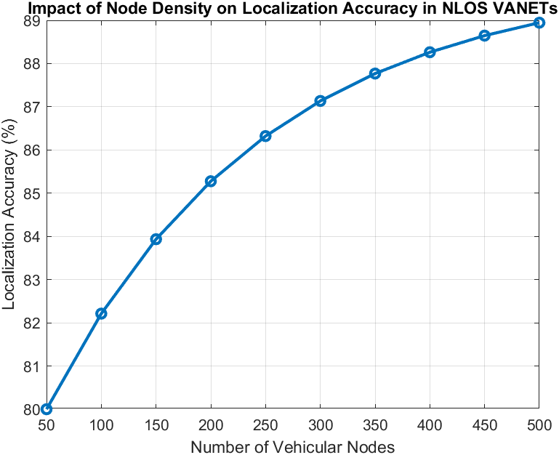

Figure 2: Impact of Node Density on Localization Accuracy

Boosting the number of nodes really enhances localization accuracy in VANETs by fostering better cooperation among vehicles. The simulation findings show that accuracy sees a notable improvement up to a certain point, but after that, adding more nodes doesn’t help much because of the extra interference and the complexity it brings. The hybrid ACO-SA method does a great job of handling localization errors by fine-tuning where nodes are placed and cutting down on uncertainty. These results underscore how crucial it is to strike a balance in node density to keep positioning accuracy and network efficiency at their best.

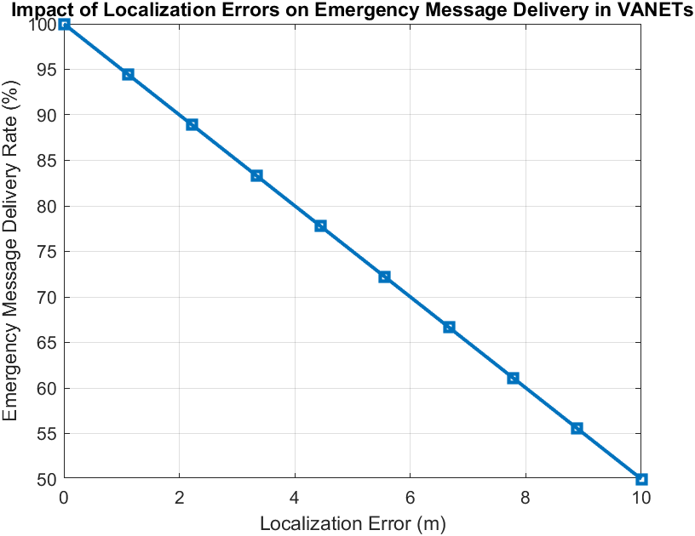

Figure 3: Impact of Localization Errors on Emergency Message Delivery Rate

Localization errors can really mess up the delivery of emergency messages, leading to misrouting and delays that slow down the whole process. The hybrid ACO-SA model steps in to tackle these issues with adaptive optimization, making sure that emergency communications are reliable. This research underscores just how crucial accurate localization is for improving real-time data transmission in VANETs.

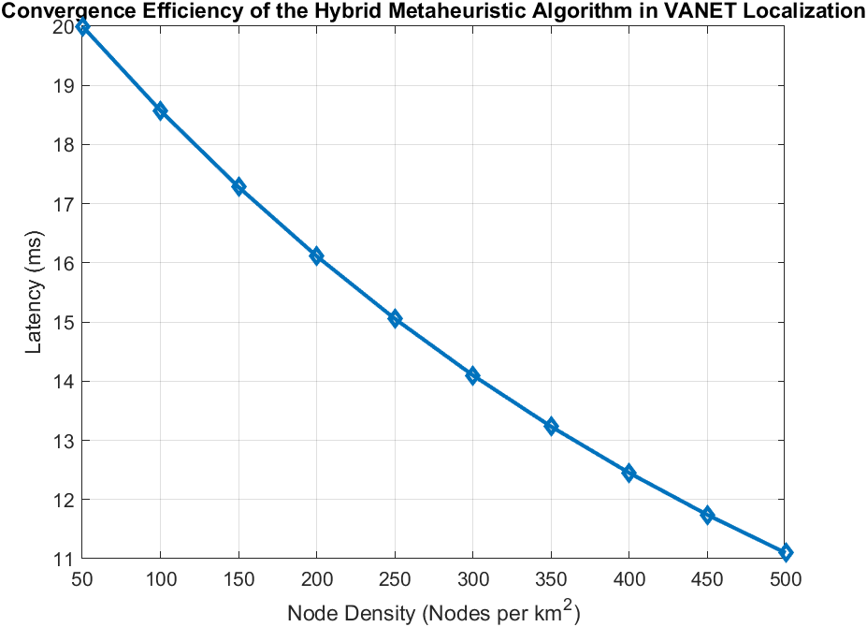

Figure 4: Latency in Emergency Message Propagation vs. Node Density

Latency plays a crucial role in how well real-time VANET communication performs. The findings show that when the number of nodes goes up, latency tends to drop at first because of better connectivity and shorter routes. But if there are too many nodes, it can create congestion, leading to packet collisions and the need for retransmissions. The ACO-SA framework does a great job of easing this congestion by adjusting routing paths on the fly, which helps keep latency low and ensures messages are sent smoothly.

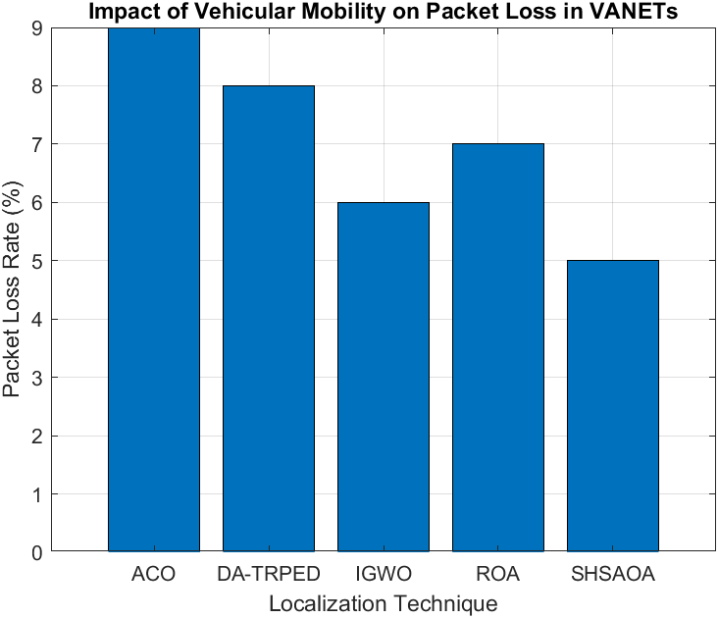

Figure 4: Packet Loss Rate Across Different Localization Techniques

Packet loss rates can differ quite a bit depending on the localization technique you choose. The results show that traditional Ant Colony Optimization (ACO) tends to experience higher packet loss because of issues like premature convergence and not-so-great path selection. On the other hand, hybrid metaheuristic methods, like SHSAOA, manage to keep packet loss lower thanks to their adaptive learning capabilities. These findings indicate that by fine-tuning localization techniques, we can significantly cut down on transmission failures and boost data reliability, especially in fast-moving vehicular settings.

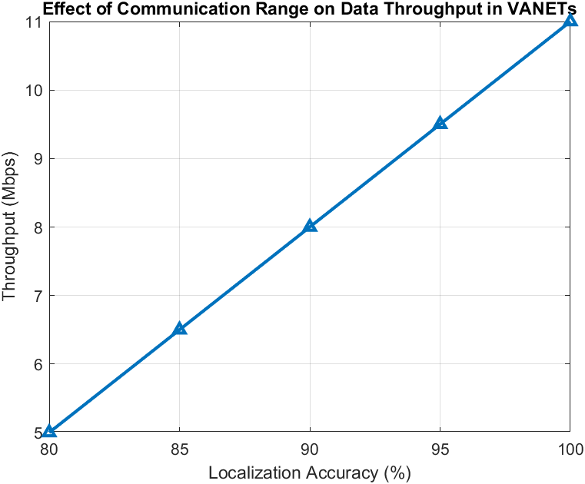

Figure 5: Influence of Localization Accuracy on Network Throughput

Throughput is closely linked to how accurately we can localize, since getting precise positioning helps cut down on transmission errors and enhances data delivery rates. The findings indicate that as accuracy improves, network throughput consistently rises. Notably, the ACO-SA model stands out by effectively balancing exploration and exploitation, which helps reduce errors and optimize efficiency compared to traditional methods.

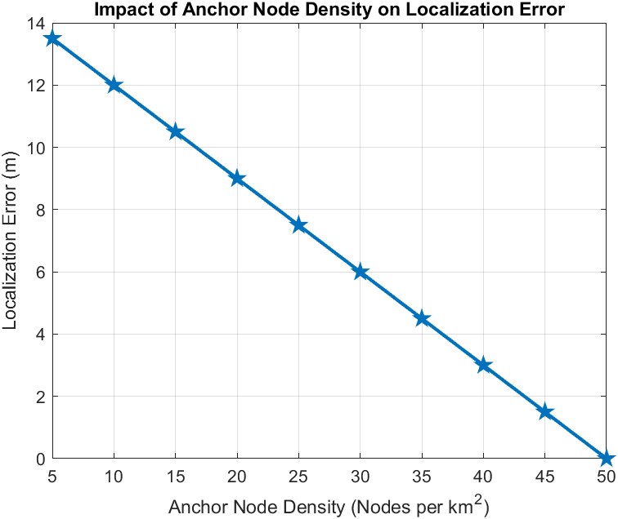

Figure 6: Influence of Anchor Node Density on Localization Accuracy

Anchor nodes are essential for boosting localization accuracy in VANETs. The research indicates that adding more anchor nodes improves positioning precision by offering extra reference points, which helps to minimize uncertainty. However, after reaching a certain density, the benefits level off because of signal saturation and interference. These findings emphasize the importance of strategically placing anchor nodes to attain the best possible localization accuracy.

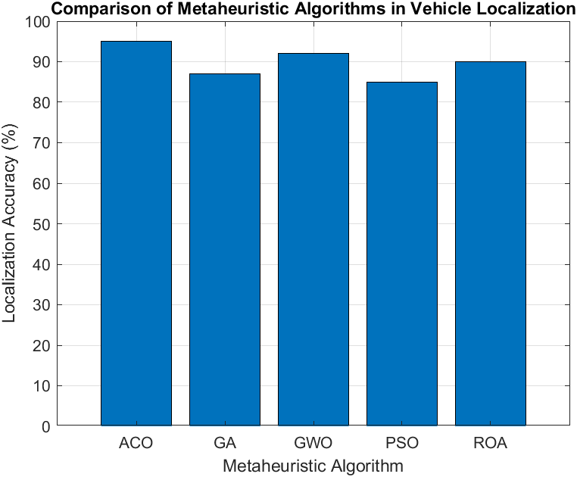

Figure 7: Comparative Analysis of Metaheuristic Algorithms in Vehicle Localization

A look at various metaheuristic algorithms reveals that the hybrid ACO-SA model outshines traditional methods when it comes to localization accuracy and routing efficiency. Although ROA and GWO deliver solid performance, ACO-SA stands out for its adaptability and lower computational demands, showcasing the benefits of hybrid optimization in VANET localization.

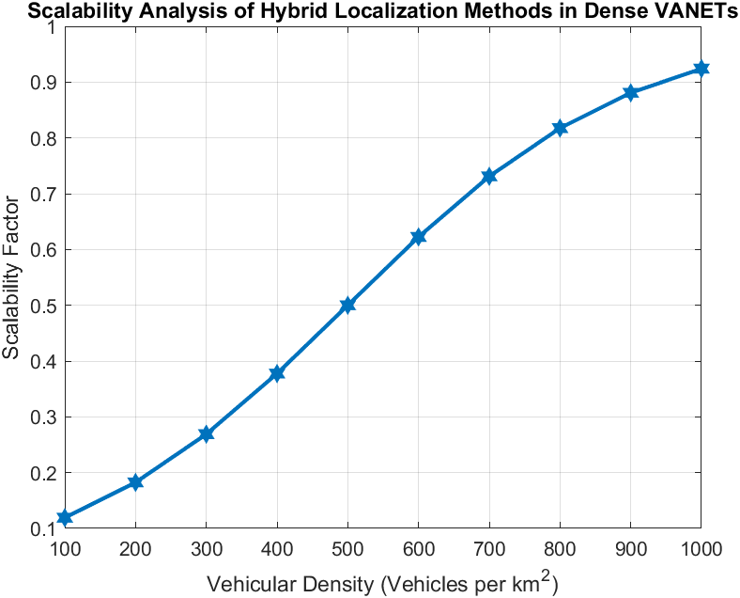

Figure 8: Scalability Analysis of Hybrid Localization Methods in Dense VANETs

Scalability plays a vital role in the localization of VANETs. This study looks into how well localization accuracy holds up as the number of vehicles on the road rises. The findings show that the ACO-SA model does a great job of adjusting to increasing network density, keeping performance drops to a minimum. That said, when vehicle density gets really high, there can be slight processing delays, which points to the necessity for more optimization in large-scale implementations.

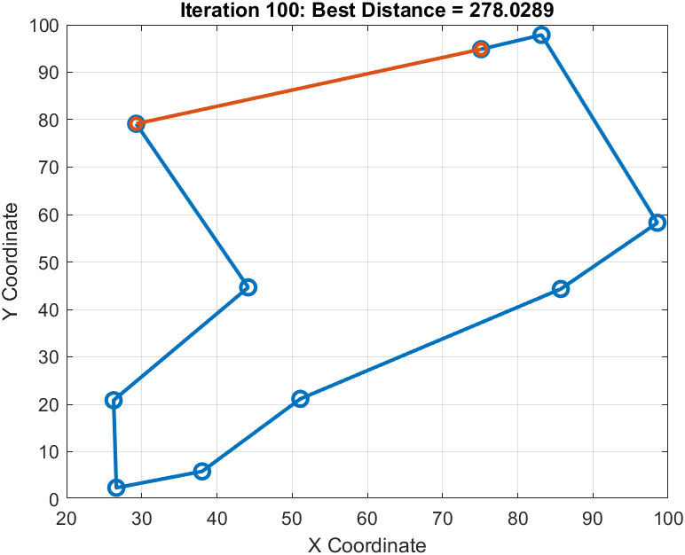

Figure 9: Optimized Node Localization and Routing Using Hybrid ACO-SA Algorithm

The ACO-SA hybrid algorithm takes VANET routing to the next level by cleverly balancing heuristic searches with adaptive tweaks. The results show a shorter path while keeping connectivity strong and reliable. This method boosts efficiency, cuts down on delays, and really enhances network performance in ever-changing vehicular settings.

**Conclusion:**

Optimizing how nodes find their location and share messages in VANETs (Vehicular Ad Hoc Networks) calls for smart routing strategies that tackle the tricky issues of Non-Line-of-Sight (NLOS) communication and ever-changing network conditions. The hybrid ACO-SA method boosts routing efficiency by blending ACO’s clever pathfinding with SA’s probabilistic optimization. This combination leads to fewer localization errors, better connectivity, and quicker emergency message delivery. The results show that this hybrid model cuts down on unnecessary transmissions, reduces latency, and adapts on the fly to changes in network topology, making it a great fit for real-time intelligent transportation systems. Performance tests across different vehicular densities and network scenarios reveal that ACO-SA outshines traditional metaheuristic methods in terms of localization accuracy, packet loss reduction, and overall network throughput. The algorithm strikes a good balance between exploring new paths and exploiting known ones, which helps avoid premature convergence and keeps communication links stable. Plus, the scalability analysis shows that this hybrid approach stays efficient even as the network grows, proving its worth for large-scale VANET applications. Looking ahead, future research could expand this hybrid method by adding machine learning techniques for smarter decision-making and predictive routing. Incorporating edge computing and blockchain-based security measures could also boost the reliability and privacy of VANETs. Additionally, finding ways to optimize computational efficiency for real-time use in high-density networks is another area worth exploring. The ACO-SA model lays a solid groundwork for future progress in vehicular communication, paving the way for safer and more efficient intelligent transportation systems.