**CTEC 22043   
 Object Oriented Programming  
 (2022/2023)**

**Srirajitha.S**

**CT/2021/047**

**LW_04**

Q1.

package Q1;  
import java.util.Scanner;  
  
  
public class Q_1 {  
 public static void main(String[] args) {  
  
 int smallest;  
  
 System.*out*.println("enter a value to a:");  
 Scanner scanner = new Scanner(System.*in*);  
 int a= scanner.nextInt();  
 System.*out*.println("enter a value to b:");  
 int b = scanner. nextInt();  
 System.*out*.println("enter a value to c:");  
 int c = scanner.nextInt();  
  
  
  
 if (a>b){  
  
 if (b>c){  
 System.*out*.println("the smallest no is: c =" + c);  
  
 }else {  
 System.*out*.println("the smallest no is: b =" + b);  
  
 }  
  
 }else {  
 if (a>c){  
 System.*out*.println("the smallest no is: c =" + c);  
  
 }else {  
 System.*out*.println("the smallest no is: a =" + a);  
 }  
 }  
 }  
}

output

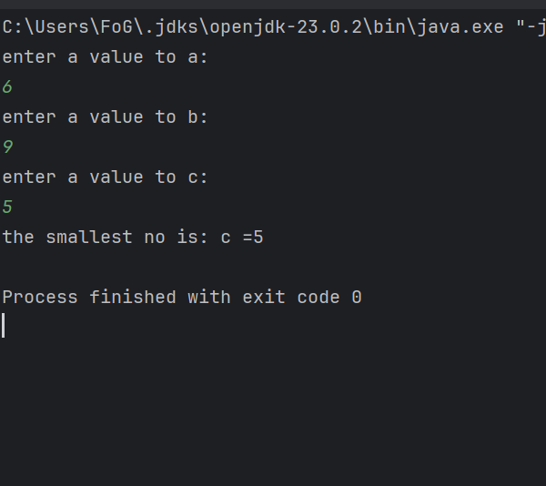

Q2.

package Q2;  
  
import java.util.Scanner;  
public class Q_2 {  
 public static void main(String[] args) {  
 Scanner scanner = new Scanner(System.*in*);  
 System.*out*.println("0.Magenta");  
 System.*out*.println("1.Cyan");  
 System.*out*.println("2.Red");  
 System.*out*.println("3.Blue");  
 System.*out*.println("4.Green");  
 System.*out*.println("Select one color from the above list:");  
 int selection = scanner.nextInt();  
 /* if (selection == 0)  
 System.out.println("You selected Magenta");  
 else if (selection == 1)  
 System.out.println("You selected Cyan");  
 else if (selection == 2)  
 System.out.println("You selected Red");  
 else if (selection == 3)  
 System.out.println("You selected Blue");  
 else if (selection == 4)  
 System.out.println("You selected Green");  
 else  
 System.out.println("Invalid selection");  
  
 */  
  
 switch ( selection){  
 case 0:  
 System.*out*.println("You selected magenta");  
 break;  
 case 1:  
 System.*out*.println("You selected cyan");  
 break;  
 case 2:  
 System.*out*.println("You selected Red");  
 break;  
 case 3:  
 System.*out*.println("You selected Blue");  
 break;  
 case 4:  
 System.*out*.println("You selected Green");  
 break;  
 default :  
 System.*out*.println("Invalid selection");  
  
 }  
 }  
}

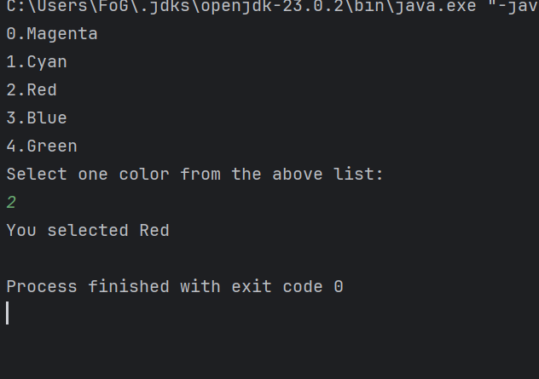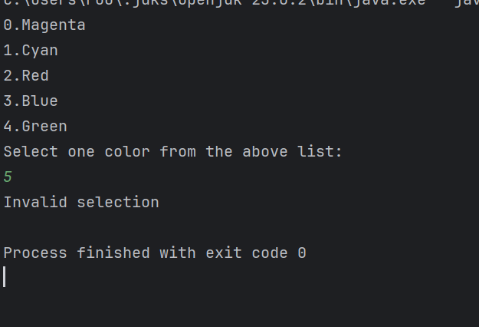output

Q3.

package Q3;  
import java.util.Scanner;  
  
  
public class Q_3 {  
 public static void main(String[] args) {  
 int power ;  
 System.*out*.println("Power of 10 number");  
 System.*out*.println("6 Million");  
 System.*out*.println("9 Billion");  
 System.*out*.println("12 Trillion");  
 System.*out*.println("15 Quadrillion");  
 System.*out*.println("18 Quintillion");  
 System.*out*.println("21 Sextillion");  
 System.*out*.println("30 Nonillion ");  
 System.*out*.println("100 Googol");  
  
 Scanner scanner = new Scanner( System.*in*);  
 System.*out*.print(" enter the power of 10 :");  
 power = scanner.nextInt();  
  
 switch (power) {  
 case 6 :  
 System.*out*.println("Million");  
 break;  
 case 9:  
 System.*out*.println("Billion");  
 break;  
 case 12:  
 System.*out*.println("Trillion");  
 break;  
 case 15:  
 System.*out*.println("Quadrillion");  
 break;  
 case 18:  
 System.*out*.println( "Quintillion");  
 break;  
 case 21:  
 System.*out*.println("Sextillion");  
 break;  
 case 30:  
 System.*out*.println("Nonillion");  
 break;  
 case 100:  
 System.*out*.println("Googol");  
 break;  
 default :  
 System.*out*.println("no any correspondence name");  
  
  
  
  
 }  
 }  
}

Output

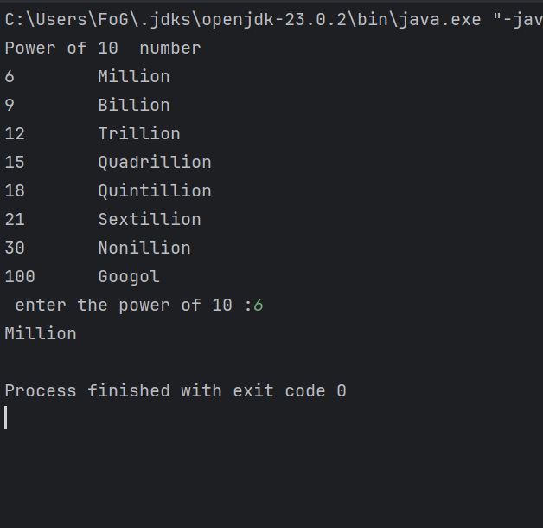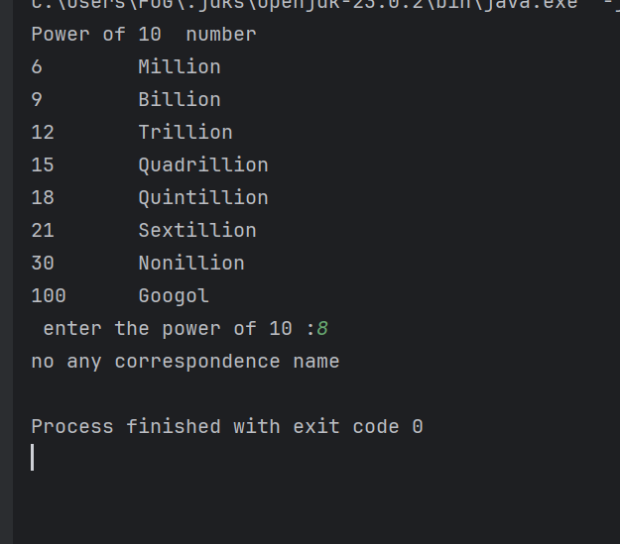

Q4

package Q4;  
import java.util.Scanner;  
  
public class Q_4 {  
 public static void main(String[] args) {  
 int year;  
  
 Scanner scanner = new Scanner (System.*in*);  
 System.*out*.println(" Enter the year : ");  
 year = scanner.nextInt();  
 scanner.close();  
  
  
 if ((year % 4==0 && year % 100!=0)|| (year % 400==0 )){  
 System.*out*.println("This is a Leap year");  
  
 }else {  
 System.*out*.println(" this is no Leap year");  
 }  
  
  
 }  
}

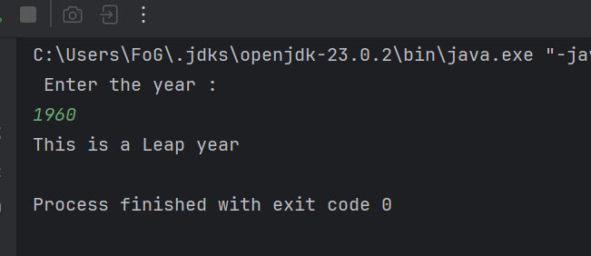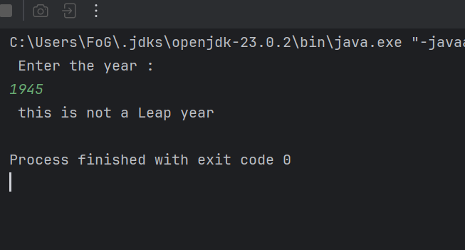

Q5

package Q5;  
  
import java.util.Scanner;  
  
public class Q_5 {  
 public static void main(String[] args) {  
  
 Scanner scanner = new Scanner(System.*in*);  
 Scanner input = new Scanner(System.*in*);  
 int EntreeSelection;  
  
  
// Display Entrée options  
 System.*out*.println("1.\nEntree:");  
 System.*out*.println("1. Tofu Burger");  
 System.*out*.println("2. Cajun Chicken");  
 System.*out*.println("3. Buffalo Wings");  
 System.*out*.println("4. Rainbow Fillet");  
  
// Display Side Dish options  
 System.*out*.println("2.\nSide Dish:");  
 System.*out*.println("1. Rice Cracker - $3.49");  
 System.*out*.println("2. No-Salt Fries - $4.59");  
 System.*out*.println("3. Zucchini - $3.99");  
 System.*out*.println("4. Brown Rice - $2.99");  
  
// Display Drink options  
 System.*out*.println("3.\nDrink:");  
 System.*out*.println("1. Cafe Mocha - $0.79");  
 System.*out*.println("2. Cafe Latte - $0.69");  
 System.*out*.println("3. Espresso - $1.09");  
 System.*out*.println("4. Oolong Tea - $0.59");  
  
  
 System.*out*.println("please enter the menu type:");  
 int menu_type = scanner.nextInt();  
  
  
  
 if (menu_type == 1 ) {  
  
 System.*out*.println("please enter the entree: (please enter the number 1-4)");  
  
 EntreeSelection = scanner.nextInt();  
  
  
  
 if (EntreeSelection == 1)  
 System.*out*.println("Entree: Tofu Burger");  
 else if (EntreeSelection == 2)  
 System.*out*.println("Entree : Cajun Chicken");  
 else if (EntreeSelection == 3)  
 System.*out*.println("Entree : Buffalo Wings");  
 else  
 System.*out*.println("Entree : Rainbow Fillet");  
 }  
  
  
  
 else if (menu_type==2) {  
 System.*out*.println("please enter the side dish: (please enter the number 1-4)");  
 int SidedishSelection = scanner.nextInt();  
  
  
 if (SidedishSelection == 1)  
 System.*out*.println("Side dish: Rice Cracker - $3.49");  
 else if (SidedishSelection == 2)  
 System.*out*.println("Side dish : No-Salt Fries - $4.59");  
 else if (SidedishSelection == 3)  
 System.*out*.println("side dish: Zucchini - $3.99");  
 else  
 System.*out*.println("side dish: Brown Rice - $2.99");  
 }  
  
  
  
 else {  
  
 System.*out*.println("please enter the entree: (please enter the number 1-4)");  
 int drinkSelection = scanner.nextInt();  
  
  
 if (drinkSelection == 1)  
 System.*out*.println("Drink : Cafe Mocha - $0.79");  
 else if (drinkSelection == 2)  
 System.*out*.println("Drink : Cafe Latte - $0.69");  
 else if (drinkSelection == 3)  
 System.*out*.println("Drink : Espresso - $1.09");  
 else  
 System.*out*.println("Drink : Oolong Tea - $0.59");  
 }  
  
  
 }  
}

Output

