CTEC 22043
Object Oriented Programming
(2022/2023)

Srirajitha.S
CT/2021/047
LW_04
Q1.

package Q1;
import java.util.Scanner;
public class Q_1 {
public static void main(String[] args) {
int smallest;
System.out.println("enter a value to a:");
Scanner scanner = new Scanner(System.in);
int a= scanner.nextInt();
System.out.println("enter a value to b:");
int b = scanner. nextInt();
System.out.println("enter a value to c:");
int c = scanner.nextInt();
if (a>b){
if (b>c){
System.out.println("the smallest no is: c =" + c);
}else {
System.out.println("the smallest no is: b =" + b);
}
}else {
if (a>c){
System.out.println("the smallest no is: c =" + c);
}else {
System.out.println("the smallest no is: a =" + a);
}
}
}
}
output
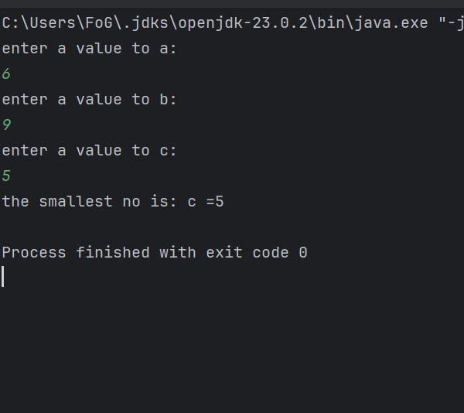
Q2.
package Q2;
import java.util.Scanner;
public class Q_2 {
public static void main(String[] args) {
Scanner scanner = new Scanner(System.in);
System.out.println("0.Magenta");
System.out.println("1.Cyan");
System.out.println("2.Red");
System.out.println("3.Blue");
System.out.println("4.Green");
System.out.println("Select one color from the above list:");
int selection = scanner.nextInt();
/* if (selection == 0)
System.out.println("You selected Magenta");
else if (selection == 1)
System.out.println("You selected Cyan");
else if (selection == 2)
System.out.println("You selected Red");
else if (selection == 3)
System.out.println("You selected Blue");
else if (selection == 4)
System.out.println("You selected Green");
else
System.out.println("Invalid selection");
*/
switch ( selection){
case 0:
System.out.println("You selected magenta");
break;
case 1:
System.out.println("You selected cyan");
break;
case 2:
System.out.println("You selected Red");
break;
case 3:
System.out.println("You selected Blue");
break;
case 4:
System.out.println("You selected Green");
break;
default :
System.out.println("Invalid selection");
}
}
}
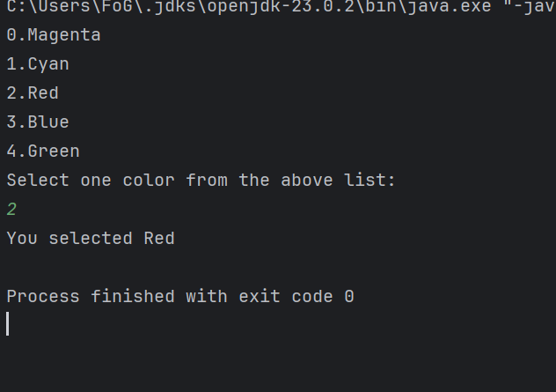
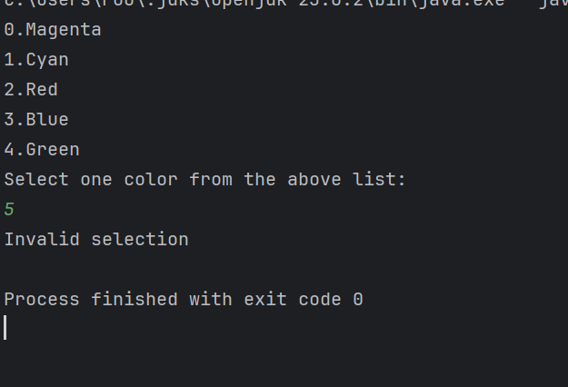
output

Q3.
package Q3;
import java.util.Scanner;
public class Q_3 {
public static void main(String[] args) {
int power ;
System.out.println("Power of 10 number");
System.out.println("6 Million");
System.out.println("9 Billion");
System.out.println("12 Trillion");
System.out.println("15 Quadrillion");
System.out.println("18 Quintillion");
System.out.println("21 Sextillion");
System.out.println("30 Nonillion ");
System.out.println("100 Googol");
Scanner scanner = new Scanner( System.in);
System.out.print(" enter the power of 10 :");
power = scanner.nextInt();
switch (power) {
case 6 :
System.out.println("Million");
break;
case 9:
System.out.println("Billion");
break;
case 12:
System.out.println("Trillion");
break;
case 15:
System.out.println("Quadrillion");
break;
case 18:
System.out.println( "Quintillion");
break;
case 21:
System.out.println("Sextillion");
break;
case 30:
System.out.println("Nonillion");
break;
case 100:
System.out.println("Googol");
break;
default :
System.out.println("no any correspondence name");
}
}
}

Output
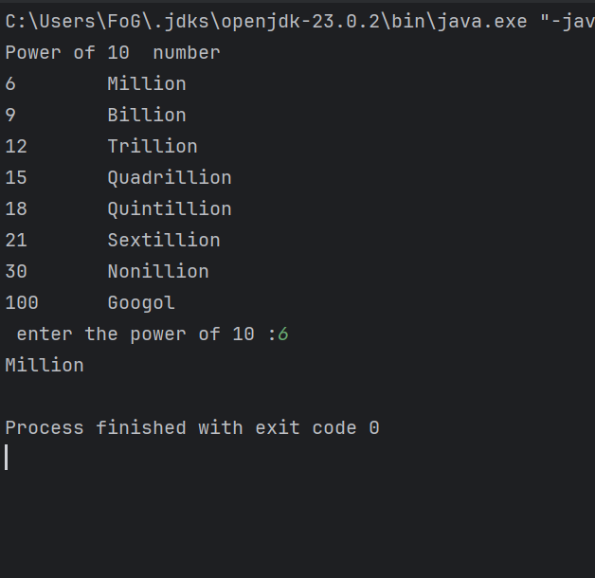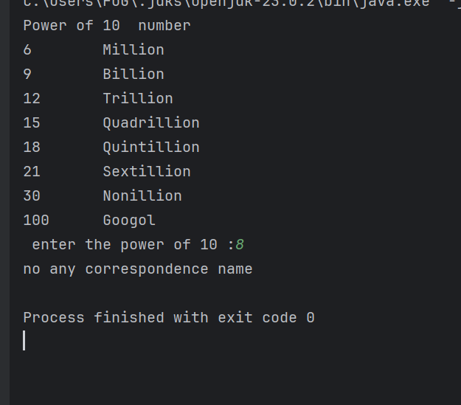

Q4
package Q4;
import java.util.Scanner;
public class Q_4 {
public static void main(String[] args) {
int year;
Scanner scanner = new Scanner (System.in);
System.out.println(" Enter the year : ");
year = scanner.nextInt();
scanner.close();
if ((year % 4==0 && year % 100!=0)|| (year % 400==0 )){
System.out.println("This is a Leap year");
}else {
System.out.println(" this is no Leap year");
}
}
}

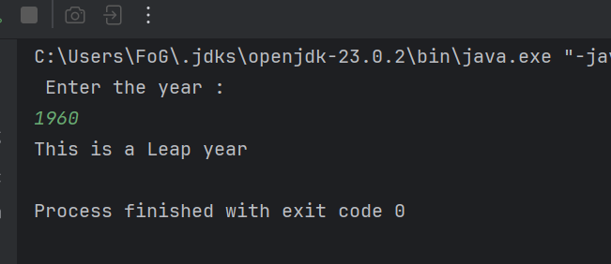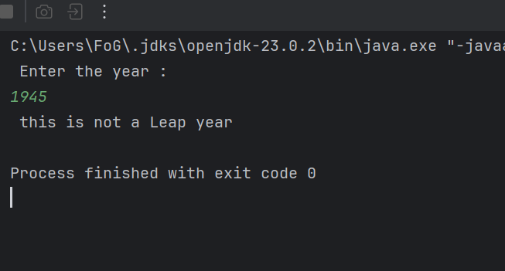

Q5
package Q5;
import java.util.Scanner;
public class Q_5 {
public static void main(String[] args) {
Scanner scanner = new Scanner(System.in);
Scanner input = new Scanner(System.in);
int EntreeSelection;
// Display Entrée options
System.out.println("1.\nEntree:");
System.out.println("1. Tofu Burger");
System.out.println("2. Cajun Chicken");
System.out.println("3. Buffalo Wings");
System.out.println("4. Rainbow Fillet");
// Display Side Dish options
System.out.println("2.\nSide Dish:");
System.out.println("1. Rice Cracker - $3.49");
System.out.println("2. No-Salt Fries - $4.59");
System.out.println("3. Zucchini - $3.99");
System.out.println("4. Brown Rice - $2.99");
// Display Drink options
System.out.println("3.\nDrink:");
System.out.println("1. Cafe Mocha - $0.79");
System.out.println("2. Cafe Latte - $0.69");
System.out.println("3. Espresso - $1.09");
System.out.println("4. Oolong Tea - $0.59");
System.out.println("please enter the menu type:");
int menu_type = scanner.nextInt();
if (menu_type == 1 ) {
System.out.println("please enter the entree: (please enter the number 1-4)");
EntreeSelection = scanner.nextInt();
if (EntreeSelection == 1)
System.out.println("Entree: Tofu Burger");
else if (EntreeSelection == 2)
System.out.println("Entree : Cajun Chicken");
else if (EntreeSelection == 3)
System.out.println("Entree : Buffalo Wings");
else
System.out.println("Entree : Rainbow Fillet");
}
else if (menu_type==2) {
System.out.println("please enter the side dish: (please enter the number 1-4)");
int SidedishSelection = scanner.nextInt();
if (SidedishSelection == 1)
System.out.println("Side dish: Rice Cracker - $3.49");
else if (SidedishSelection == 2)
System.out.println("Side dish : No-Salt Fries - $4.59");
else if (SidedishSelection == 3)
System.out.println("side dish: Zucchini - $3.99");
else
System.out.println("side dish: Brown Rice - $2.99");
}
else {
System.out.println("please enter the entree: (please enter the number 1-4)");
int drinkSelection = scanner.nextInt();
if (drinkSelection == 1)
System.out.println("Drink : Cafe Mocha - $0.79");
else if (drinkSelection == 2)
System.out.println("Drink : Cafe Latte - $0.69");
else if (drinkSelection == 3)
System.out.println("Drink : Espresso - $1.09");
else
System.out.println("Drink : Oolong Tea - $0.59");
}
}
}

Output

