CTEC 22043

Object Oriented Programming

(2022/2023)

LW_05
CT/2021/047
S.Srirajitha
Q1.
package Q_1;
public class Q1 {
public static void main(String[] args) {
int num =10;
int count =0;
do {
System.out.print(num+ " ");
num = num+1;
count =count+1;
if (count%10==0){
System.out.println();
}
}while(count<40);
}
}

output
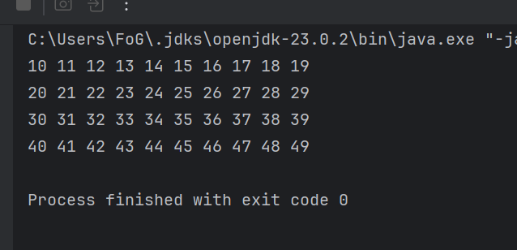

Q2.
package Q_2;
import java.util.Scanner;
public class Q2 {
public static void main(String[] args) {
Scanner scanner = new Scanner(System.in);
int num;
System.out.println("Enter a number :");
num = scanner.nextInt();
while (num >= 0) {
System.out.println(num + " has " + countDigits(num) + " digits.");
System.out.println("Enter another number :");
num = scanner.nextInt();
}
scanner.close();
System.out.println("Program terminated.");
}
// Method to count digits
public static int countDigits(int number) {
return String.valueOf(Math.abs(number)).length();
}
}

output
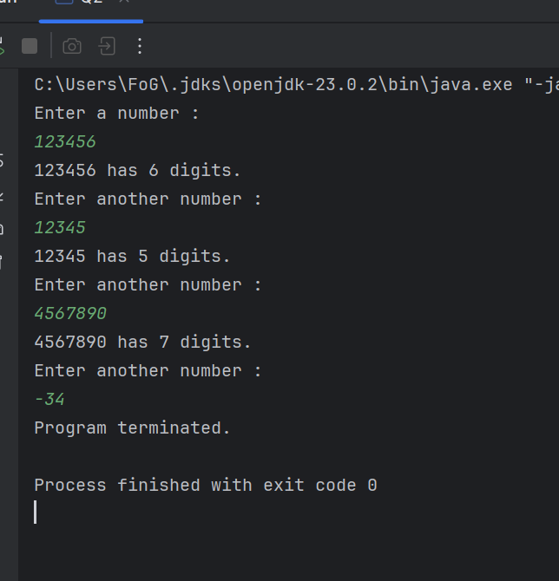

Q3.
package Q_3;
import java.util.Scanner;
public class Q3 {
public static void main(String[] args) {
int N,N1;
int num=0;
Scanner scanner=new Scanner(System.in);
System.out.println("enter the number:");
N = scanner.nextInt();
while (num<=10) {
N1 = N * num;
System.out.println(N + "*" + num + "=" + N1);
num=num+1;
}
}
}

Output
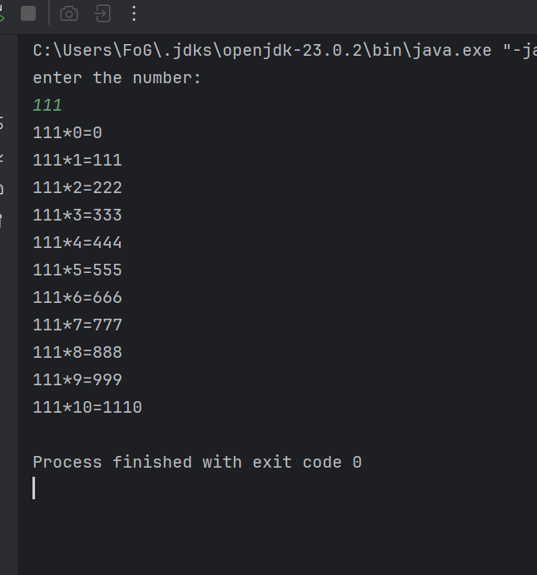

Q4.
package Q_4;
import java.util.Scanner;
public class Q4 {
public static void main(String[] args) {
int py;
int i, j;
Scanner scanner = new Scanner(System.in);
System.out.print("Enter the number of rows: ");
py = scanner.nextInt();
for (i = 1; i <= py; i++) {
for (j = 1; j <= py - i; j++) {
System.out.print(" ");
}
for (j = 1; j <= (2 * i - 1); j++) {
System.out.print("*");
}
System.out.println();
}
scanner.close();
}
}

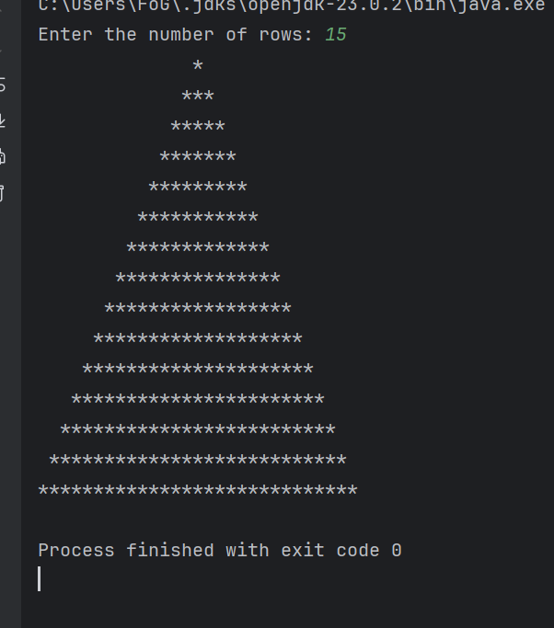

Q5. package Q_5;
import java.util.Scanner;
public class Q5 {
public static void main(String[] args) {
String word;
Scanner scanner = new Scanner(System.in);
System.out.print("Enter word or phrase: ");
word = scanner.nextLine();
if (isPalindrome(word)){
System.out.println("the word is palindrome");
}else{
System.out.println("the word is not palindrome");
}
scanner.close();
}
public static boolean isPalindrome(String word){
String reverseWord ="";
for (int i = word.length()-1; i>=0; i--){
reverseWord= reverseWord + word.charAt(i);
}
return word.equals(reverseWord);
}
}

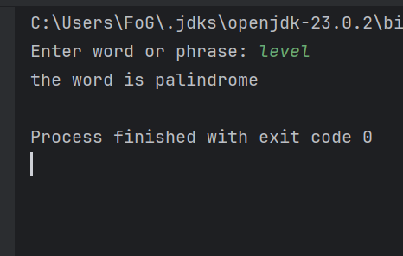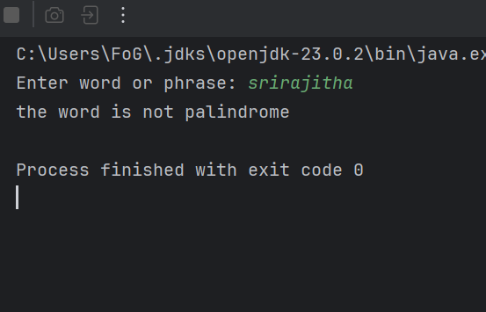

Q6.
package Q_6;
import java.util.Scanner;
import java.util.Random;
public class Q6 {
public static void main(String[] args) {
// Create a Random object to generate random numbers
Random rand = new Random();
int randomNumber = rand.nextInt(100) + 1; // random number between 1 and 100
Scanner scanner = new Scanner(System.in);
int guess = 0;
System.out.println("Welcome to the Guess the Number game!");
System.out.println("I'm thinking of a number between 1 and 100.");
while (guess != randomNumber) {
System.out.print("Enter your guess: ");
if (scanner.hasNextInt()) {
guess = scanner.nextInt();
if (guess < 1 || guess > 100) {
System.out.println("Please guess a number between 1 and 100.");
} else if (guess < randomNumber) {
System.out.println("Too low! Try a higher number.");
} else if (guess > randomNumber) {
System.out.println("Too high! Try a lower number.");
} else {
System.out.println("Congratulations! You guessed the number.");
}
} else {
System.out.println("That's not a valid number. Please enter an integer.");
scanner.next();
}
}
scanner.close();
}
}

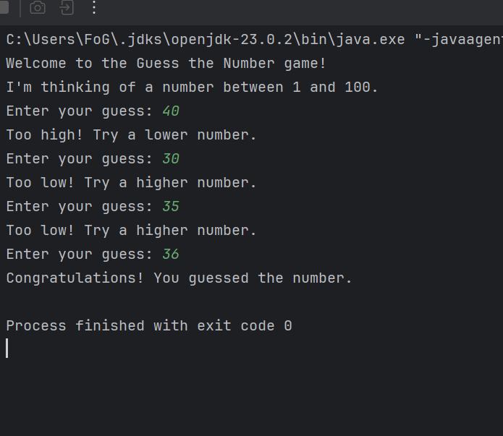

Q7.
package Q7;
import java.util.Scanner;
public class Q7 {
public static void main(String[] args) {
Scanner scanner = new Scanner(System.in);
System.out.print("Enter a sentence: ");
String sentence = scanner.nextLine();
System.out.print("Enter the word to replace: ");
String wordToReplace = scanner.nextLine();
System.out.print("Enter the replacement word: ");
String replacementWord = scanner.nextLine();
String modifiedSentence = sentence.replaceAll("\\b" + wordToReplace + "\\b", replacementWord);
System.out.println("Modified sentence: " + modifiedSentence);
scanner.close();
}
}

