**Lab Assignment 7**

*This* ***assignment*** *is submitted in partial fulfilment of*

*the requirements for the course*

*of*

**Data Warehousing**

By

Kedar Sharma

Scholar Number: **191112479**

Submitted on 6th April 2022



Submitted to:

**Prof. Mitul Ahirwal (CSE Dept.)**

**MAULANA AZAD**

**NATIONAL INSTITUTE OF TECHNOLOGY**

**BHOPAL – 462 003 (INDIA)**

**April 2022**

Contents

1. Installation: 2

**Association Mining using Apriori Algorithm with WEKA tool.**

# 1. Installation:

a. First, I have downloaded the Weka .exe file from <https://sourceforge.net/projects/weka/files/weka-3-9/3.9.6/weka-3-9-6-azul-zulu-windows.exe/download?use_mirror=onboardcloud>.

b. Then, I executed that .exe file and followed the setup steps to install the WEKA on the PC.

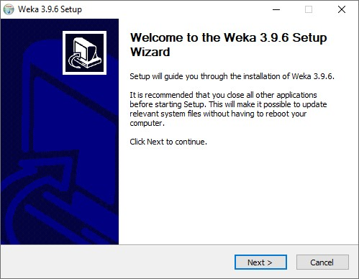

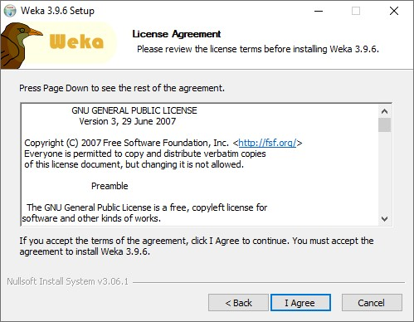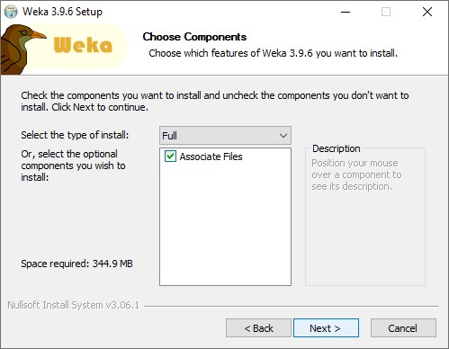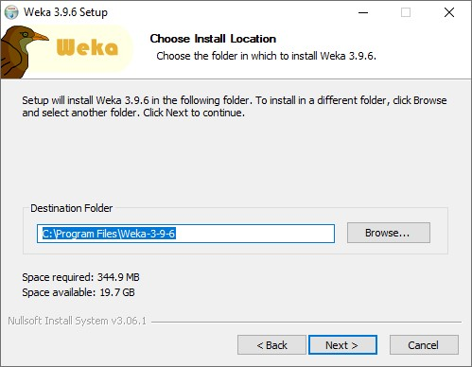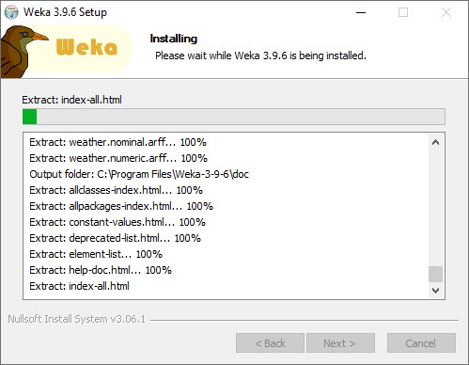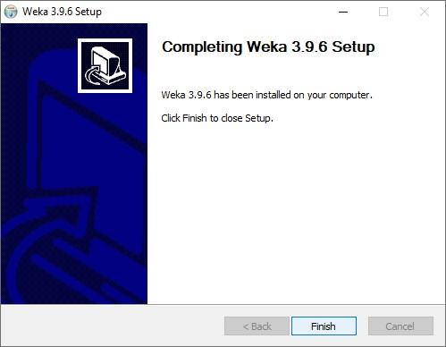

After the complete installation of the WEKA I moved to the next step of the question.

2. Then, I downloaded the dataset file which is provided.

3. Uploading the (.arff) file to the WEKA Explorer.

a. After the complete installation of the WEKA, I opened the WEKA Explored and uploaded the “relative supermarket” dataset.

b. Then, I explored the dataset.

The dataset has 4627 instances of the data and 217 attributes.

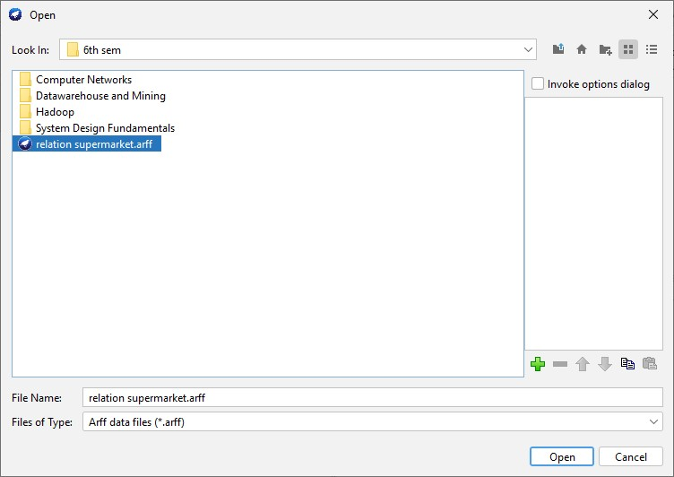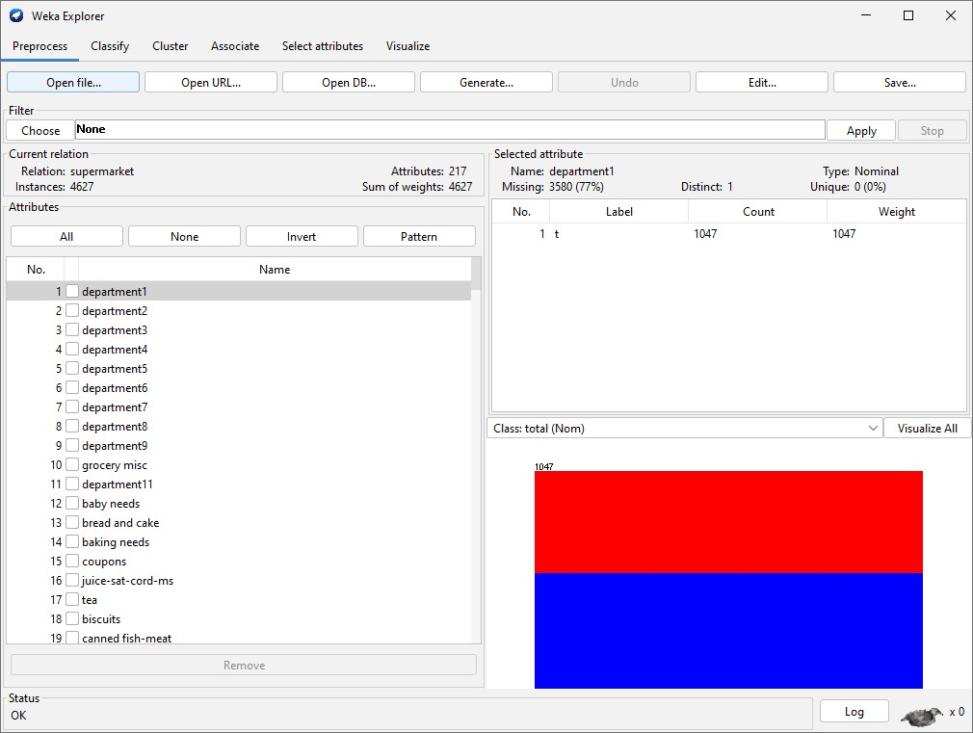

4. Applying the Apriori Algorithm on the dataset with different value of minimum support and minimum confidence and number of rules.

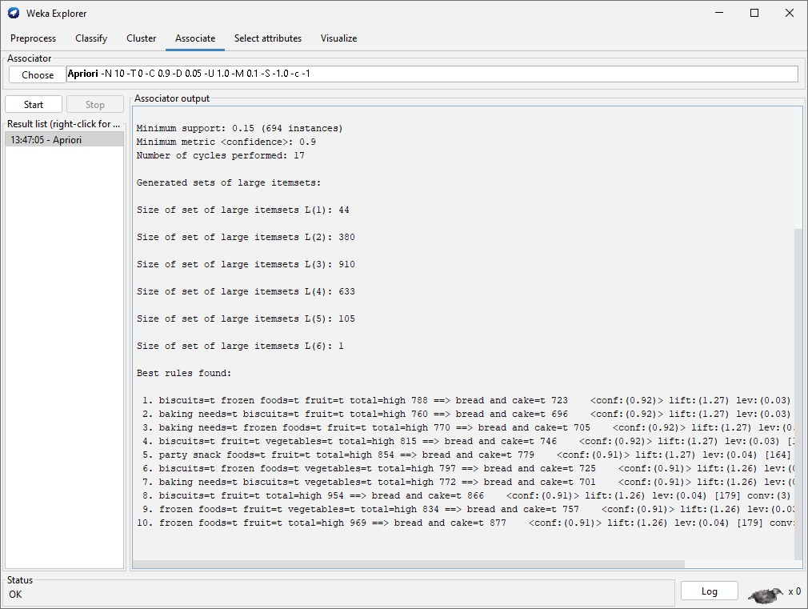

Now we change the attributes by clicking on apriori associator tab to change the minimum support and confidence value.

