Anush Sriram Ramesh

Machine Learning and Pattern Recognition EECE 5644 V30

HW 3

MLE, MAP and Cost minimization

[GitHub Link](https://github.com/sriram-0311/MLPR.git) **– Go into folder HW3 for code and results**

**Data generated is stored in “Train_10000Samples.csv”, “Train_1000Samples.csv” and “Train_100Samples.csv”.**

**Question 1.**

**1.i) Theoretically Optimal Classifier for Minimum P of Error**

From HW2, the theoretically optimal classifier for the dataset is likelihood ratio test.

Equation 1

Where, λ is the cost matrix associated with the decisions.

Let us assume [0 – 1] cost matrix for minimizing the probability of error.

|  |  |  |  |
| --- | --- | --- | --- |
|  | **ACTUAL TRUTH** | | |
| **DECISIONS** | **LABEL** | 0 | 1 |
| 0 | 0 | 1 |
| 1 | 1 | 0 |

Substituting values of λ back into the equation 1,

Data extracted from the question,

,

where, w1 = w2 = 0.5 and means, covariances parameters as per the question.

**Question 2. *Python***

**2. A. i)**

**Recover path** function implementation: Function that takes in the pred map (implemented as a dictionary), reconstructs, and returns the Astar path found.

#Recover path from start to goal using predecessor dictionary

#start : start point of the path

#goal : goal point of the path

#pred : predecessor dictionary returned from astar search function

def RecoverPath(self, start, goal, pred):

current = goal

retracedPath = []

retracedPath.append(goal)

totalCost = 0

#print("pred = ", pred)

while current in pred:

#print("current = ", current)

prevPath = pred[current]

retracedPath.append(prevPath)

current = prevPath

if current == start:

break

if current != start:

print("no path found")

for i in range(len(retracedPath) - 1):

totalCost = totalCost + distance(retracedPath[i], retracedPath[i+1])

return retracedPath, totalCost

**2.A.ii)**

**Astar search** algorithm implemented as a member function of the class Astar which has the occupancy grid G, Distance function d, weight, and heuristics (w and h) function handles.

#Astar search algorithm

#graph : occupancy grid

#start : start point of the path

#goal : goal point of the path

#Function is implemented as a member function of the class AStar

def a_star(self):

while self.Q != []:

v = heapq.heappop(self.Q)[1]

del self.Qhelper[v]

if v == self.goal:

print("goal found")

return self.RecoverPath(self.start, self.goal, self.pred)

#print("neighbors of ", v, " = ", Neighbours(self.graph, v))

for n in Neighbours(self.graph,v):

#print("n = ", n)

pvi = self.costTo[v] + distance(v, n)

if pvi < self.costTo[n]:

#The path to i through v is better than the previously-known best path to i,

# so record it as the new best path to i.

self.pred[n] = v

self.costTo[n] = pvi

self.estTotalCost[n] = pvi + distance(n, self.goal)

if n in self.Qhelper:

tmpVal = self.Qhelper[n]

self.Q.remove((tmpVal, n ))

heapq.heappush(self.Q, (self.estTotalCost[n], n))

self.Qhelper[n] = self.estTotalCost[n]

else:

heapq.heappush(self.Q, (self.estTotalCost[n], n))

self.Qhelper[n] = self.estTotalCost[n]

return []

**2.B.i)**

**N(v) : Neighbours** function implemented as a global function that takes in occupancy grid as graph and the current vertex V and returns all the free neighbors of the vertex.

#Neighbour function : takes in occupancy grid and current vertex as input and return

the list of neighbors of #the current vertex as a list of tuples. [(N1),(n2),(n3),...]

#graph : occupancy grid

#v : current vertex

def Neighbours(graph, v):

neighbors = []

for x,y in neighbor_map:

search_point = (v[0]+x,v[1]+y)

if graph[search_point] == 1:

neighbors.append(search_point)

return neighbors

**2.B.ii)**

**d(v1, v2) : Distance** between two vertices function implemented as global function that takes in two vertices and returns the Euclidean distance between the vertices.

#distance(v1,v2) : returns the distance between two vertices v1 and v2

#v1 : vertex 1

#v2 : vertex 2

def distance(v1, v2):

return math.dist(v1, v2)

**2.B.iii)**

Using the functions implemented above, Astar search is performed between Start (635,140) and Goal (350,400). The path is plotted using matplotlib superimposed on the thresholded occupancy grid map given.

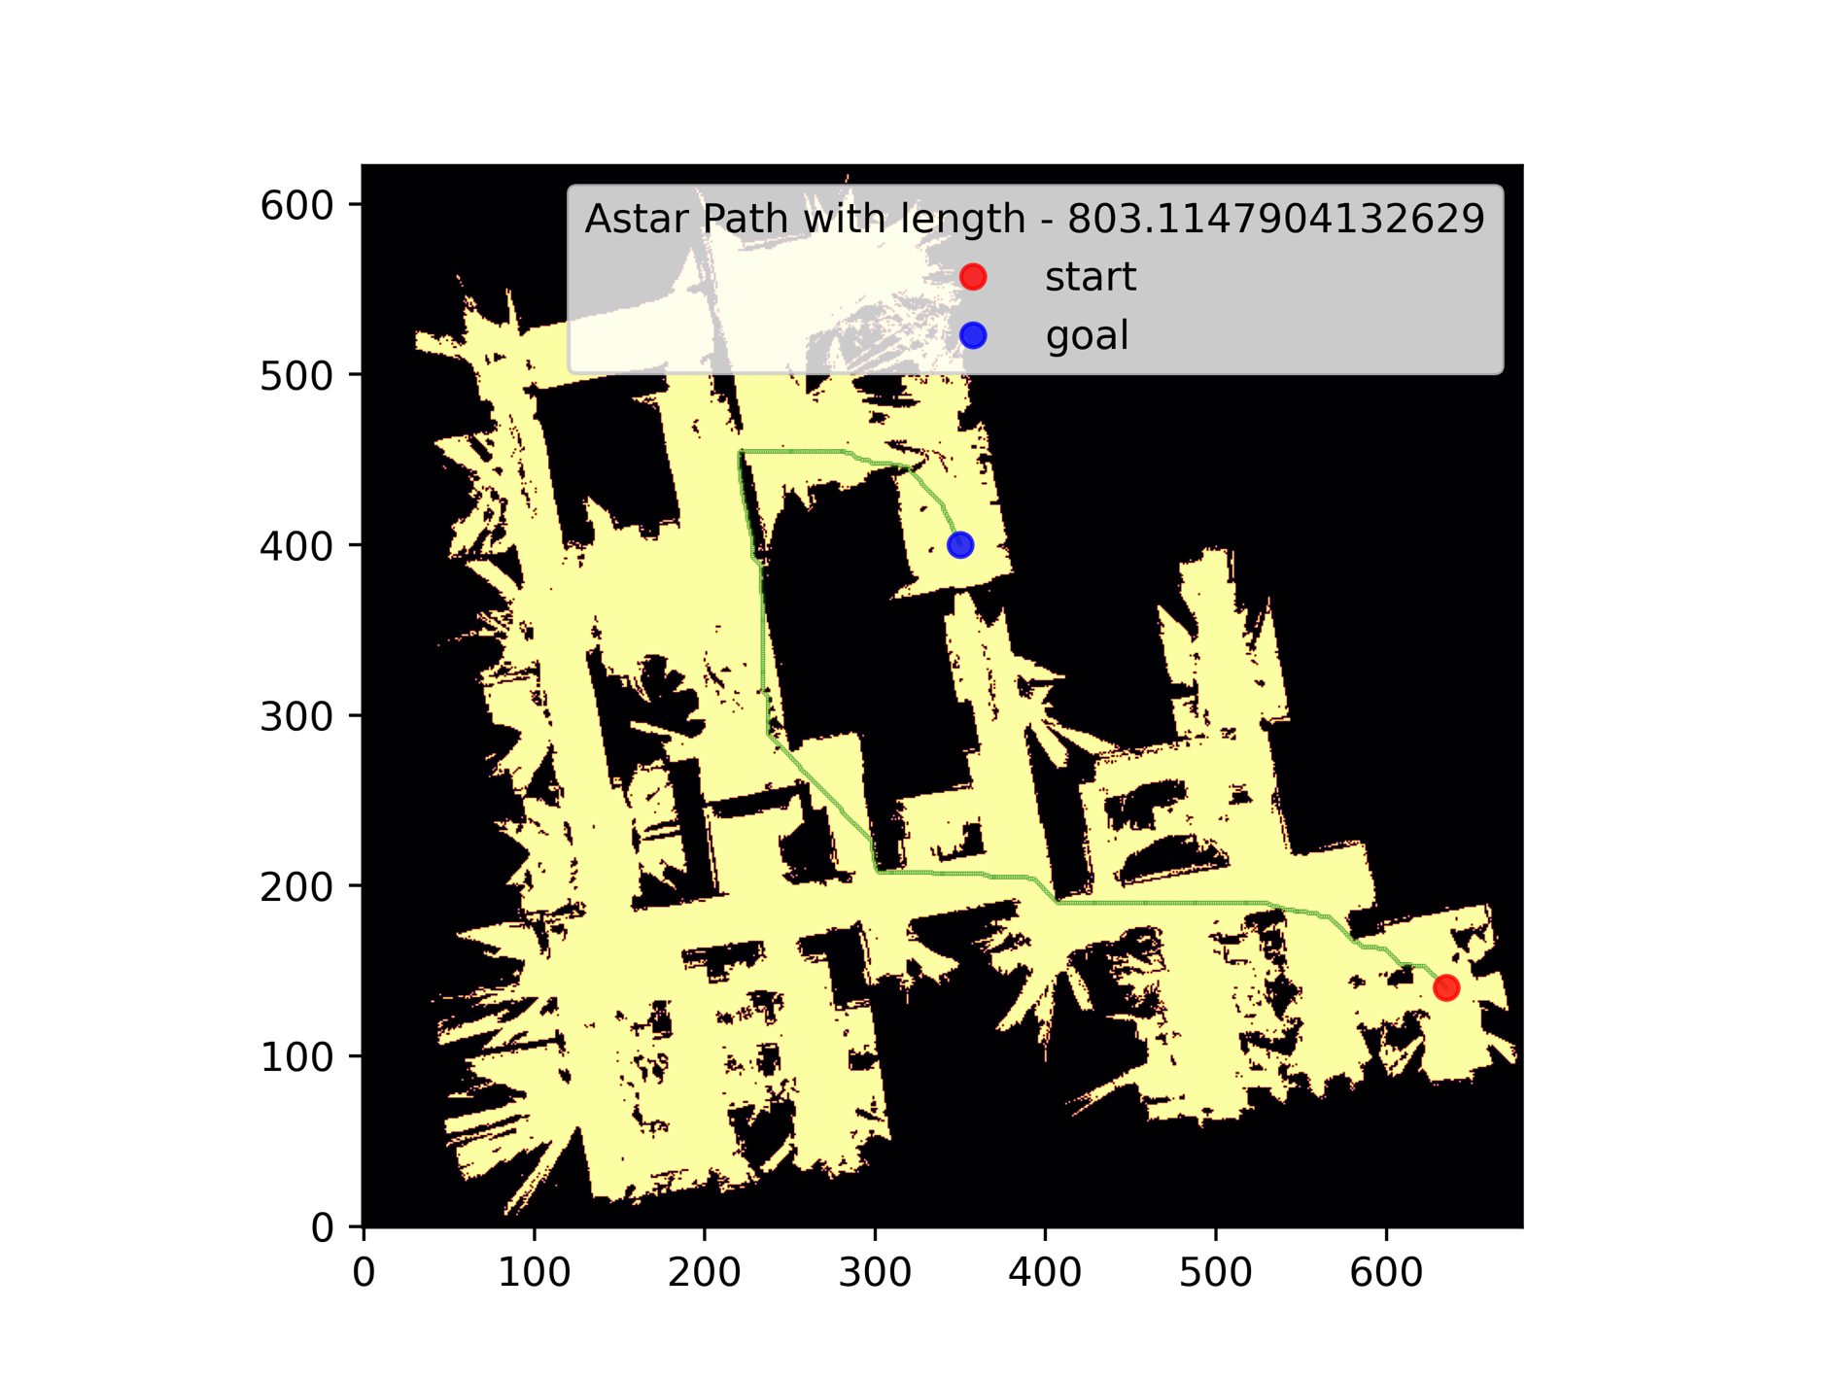

**Fig:** Astar Path calculated by the above implementation and path plotted with matplotlib. Total length of the path is 803.114

**2.C.i)**

**Rejection Samples function** – implemented as a global function that takes in a 2D NumPy array – the occupancy grid and returns one sampled vertex from the free space.

#rejectionSamples(occupancyGrid) : returns a uniformly randomly sampled point from

the free space in the occupancy grid

#occupancyGrid : 2D NumPy array of the occupancy grid

#Returns : a tuple of the form (x,y) where x and y are the coordinates of the sampled point

def rejectionSampler(occupancyGrid):

while True:

x = int(np.random.uniform(0, occupancyGrid.shape[0]))

y = int(np.random.uniform(0, occupancyGrid.shape[1]))

if occupancyGrid[x][y] > 0:

return (x,y)

else:

continue

**2.C.ii)**

**Reachability check** : implemented as a global function taking in input as occupancy grid, point 1 and point2 and returns True if there is a line of sight between the 2 points, False otherwise.

#reachabilityCheck(occupancyGrid, point1, point2) : checks if there is a line of

sight between point1 and point2

#occupancyGrid : 2D NumPy array of the occupancy grid

#point1 : tuple of the form (x,y) where x and y are the coordinates of the first point

#point2 : tuple of the form (x,y) where x and y are the coordinates of the second point

#Returns : True if there is a line of sight between point1 and point2, False otherwise

def reachabilityCheck(occupancyGrid, v1, v2):

# print("v1: ", v1)

# print("v2: ", v2)

current = v1

while current != v2:

neighbors = Neighbours(occupancyGrid, current)

current = min(neighbors, key=lambda x: math.dist(x, v2))

if occupancyGrid[current] == 0:

return False

else:

continue

return True

**2.C.iii)**

**Build PRM Graph** : Implemented as a member function that accepts the number of samples to be generated as input and builds the graph as a member variable of the class PRM.

#build_graph() : builds the PRM graph using the rejection sampling algorithm for the

given number of samples and maximum distance

#number_of_samples : number of samples to be generated

#max_distance : maximum distance between two nodes in the graph

#returns : None

#Updates the graph, vertices, and edges attributes of the class PRM

def build_graph(self, n):

for i in range(n):

sampleVertex = rejectionSampler(self.occupancy_grid)

self.addVertex(sampleVertex, i)

#addVertex(vertex, index) : adds a vertex to the graph

#vertex : tuple of the form (x,y) where x and y are the coordinates of the vertex to be added sampled from the free space

#itr : index of the vertex to be added

#returns : None

def addVertex(self, sampleVertex, itr):

self.graph.add_node(itr, pos=sampleVertex)

if itr > 1:

for v in self.graph.nodes:

if (self.graph.nodes[v]['pos'] != sampleVertex) and (math.dist(self.graph.nodes[v]['pos'], sampleVertex) <= self.maxDistance):

if (reachablity_check(self.occupancy_grid, self.graph.nodes[v]['pos'], sampleVertex)):

self.graph.add_edge(v,itr, weight=math.dist(sampleVertex, self.graph.nodes[v]['pos']))

self.vertices.append(sampleVertex)

else:

continue

else:

continue

return

else:

return

**2.C.iv)**

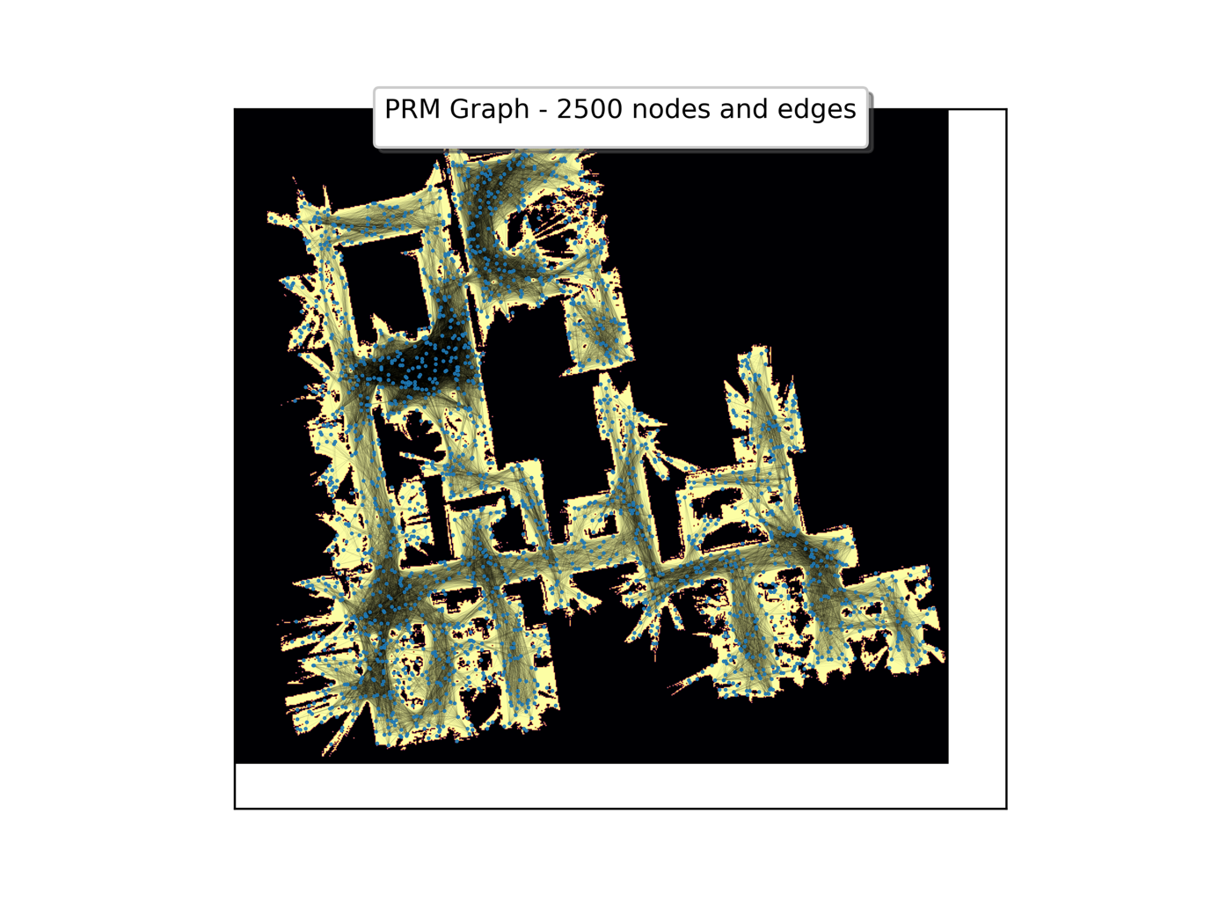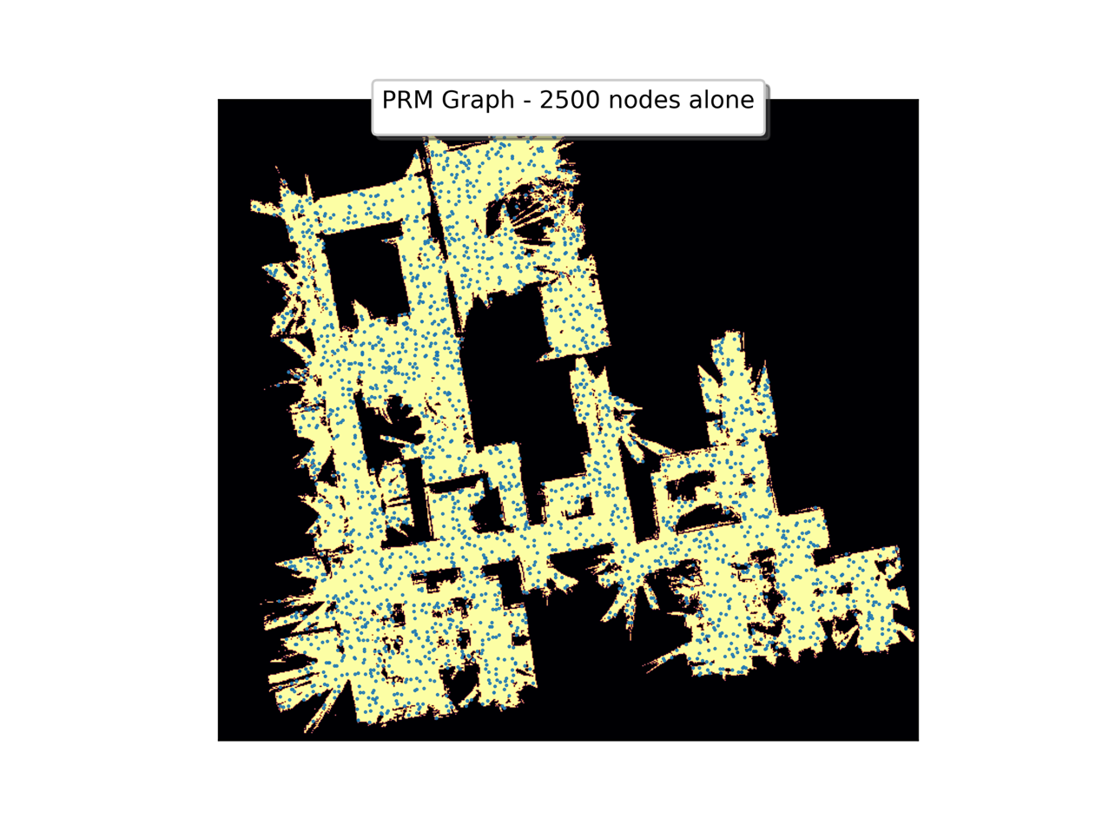PRM Graph generated for 2500 samples generated using rejection sampling. Maximum distance between two nodes is 75.

**Fig:** 2500 nodes sampled from free space in occupancy grid and added to graph. Plotted with Matplotlib.

**2.C.v)**

Astar search performed on the graph generated above between 2 points, **Start (635,140)** and **Goal (350,400)**. The path is plotted with matplotlib with the edges in the graph removed for better visibility of the path.

**Fig:** Astar path found by the networkx’s astar_search function call and plotted. Total length of the path is 819.100