Creation of Maven Java Project
Step 1. Open Eclipse IDE
└── 1.1. Launch Eclipse workspace
Step 2. Install Maven Plugin (if not installed)
└── 2.1. Go to "Help" in the top menu
└── 2.1.1. Click "Eclipse Marketplace"
└── 2.1.2. Search for "Maven Integration for Eclipse"
└── 2.1.3. Install the plugin if not already installed
Step 3. Create a New Maven Project
└── 3.1. File -> New -> Project...
└── 3.1.1. Expand "Maven"
└── 3.1.2. Select "Maven Project" and click "Next"
Step 4. Set Project Configuration
└── 4.1. Select workspace location (default or custom)
└── 4.2. Click "Next"
Step 5. Choose Maven Archetype
└── 5.1. Select an archetype(e.g "org.apache.maven.archetypes -> maven-archetype-quickstart 1.4 ")
└── 5.2. Click "Next"
Step 6. Define Project Metadata
└── 6.1. Group ID: (e.g., com.example)
└── 6.2. Artifact ID: (e.g., my-maven-project)
└── 6.3. Version: (default is usually fine)
└── 6.4. Click "Finish"
In Console, artifacts are grouped. When prompted with Y/N, type 'Y'.

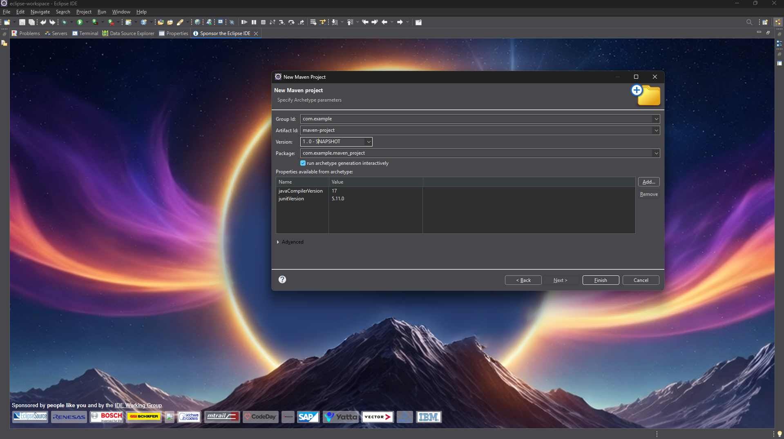
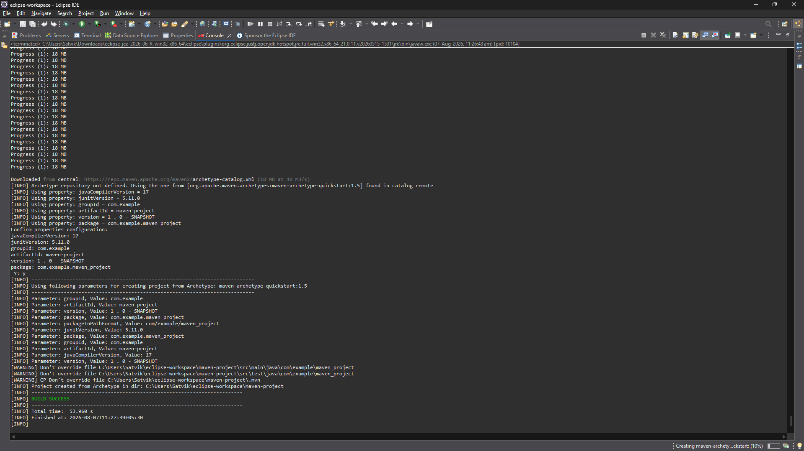
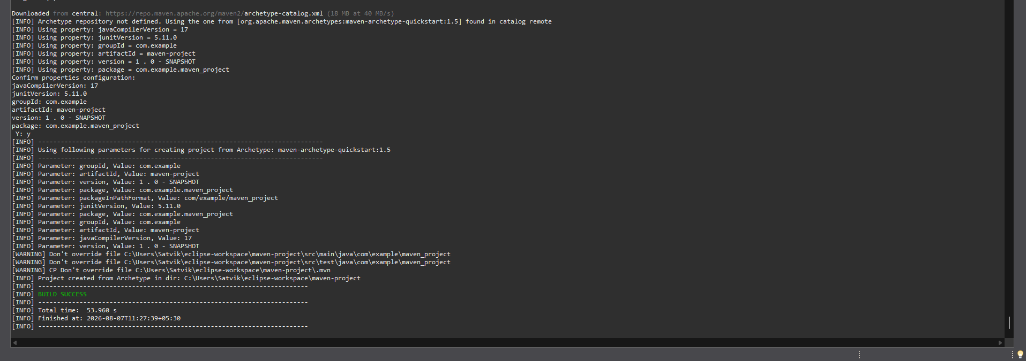

Step 7. Maven Project Created
└── 7.1. Project structure is generated with a standard Maven layout
└── 7.2. Includes:
└── src/main/java (for Java source code)
└── src/test/java (for test code)
└── pom.xml (Maven configuration file)
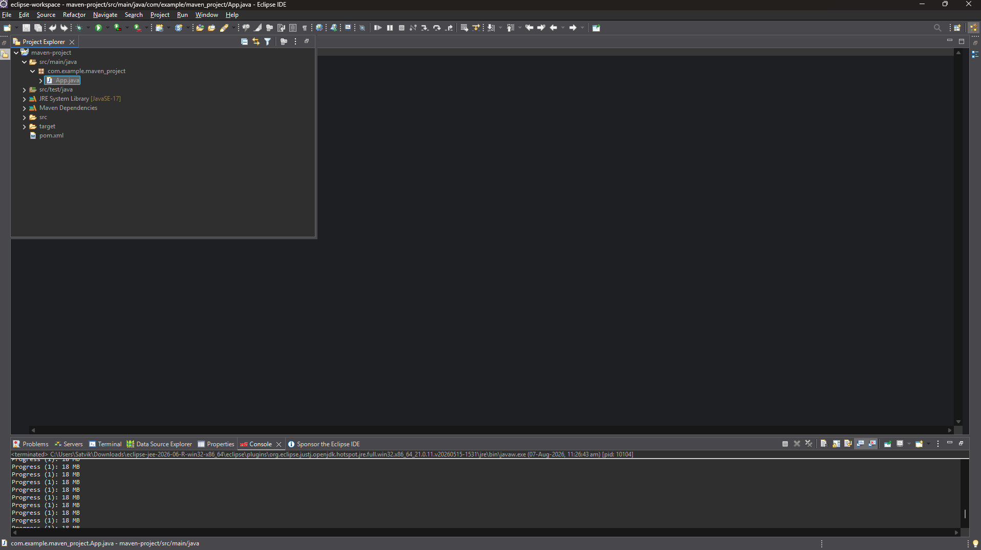
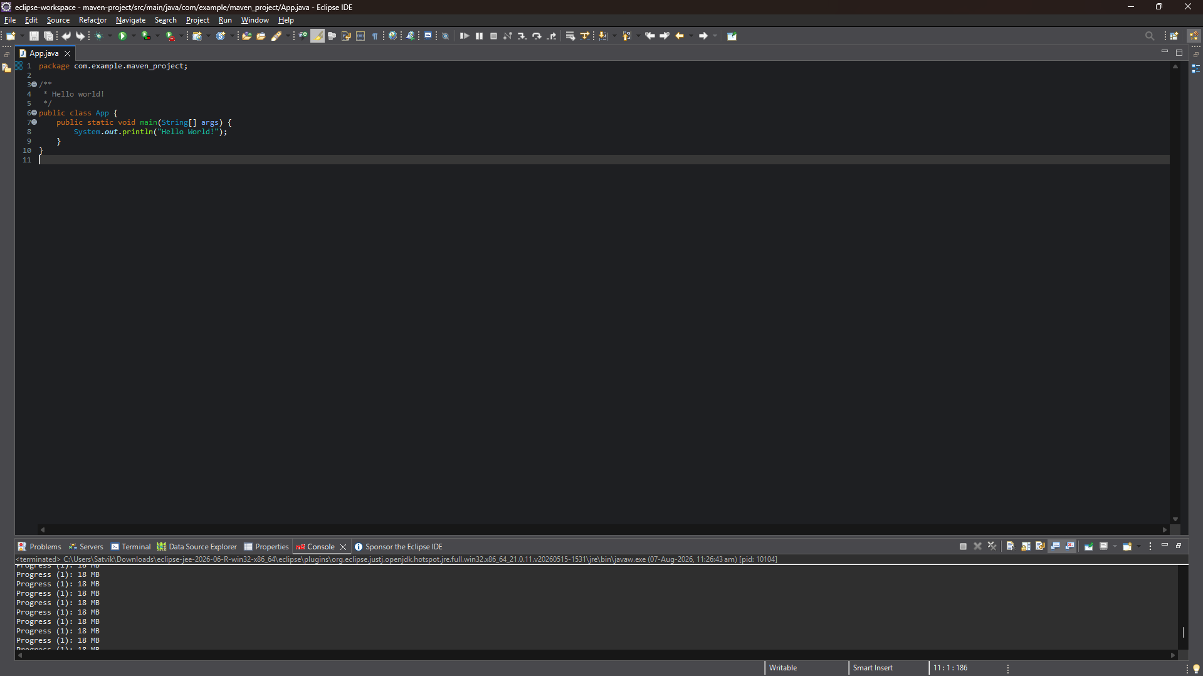

Step 8. Update Project Settings (if needed)
└── 8.1. Right-click on the project -> Maven -> Update Project...
└── 8.2. Ensure dependencies are up to date

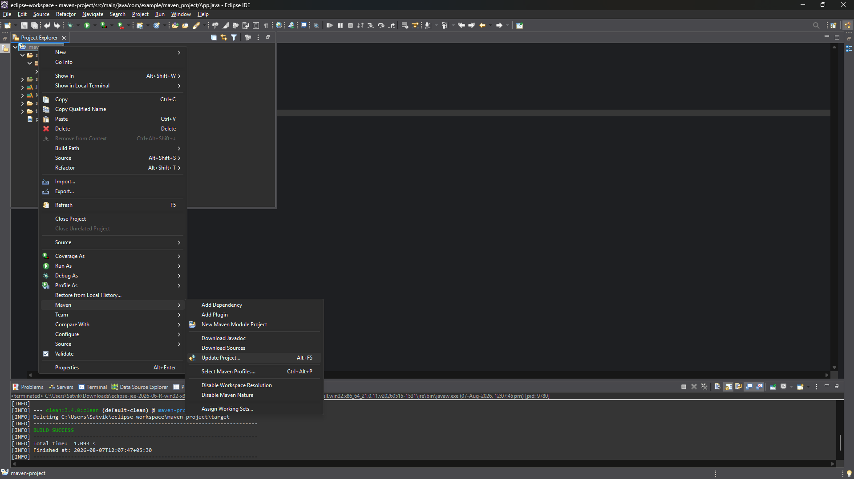
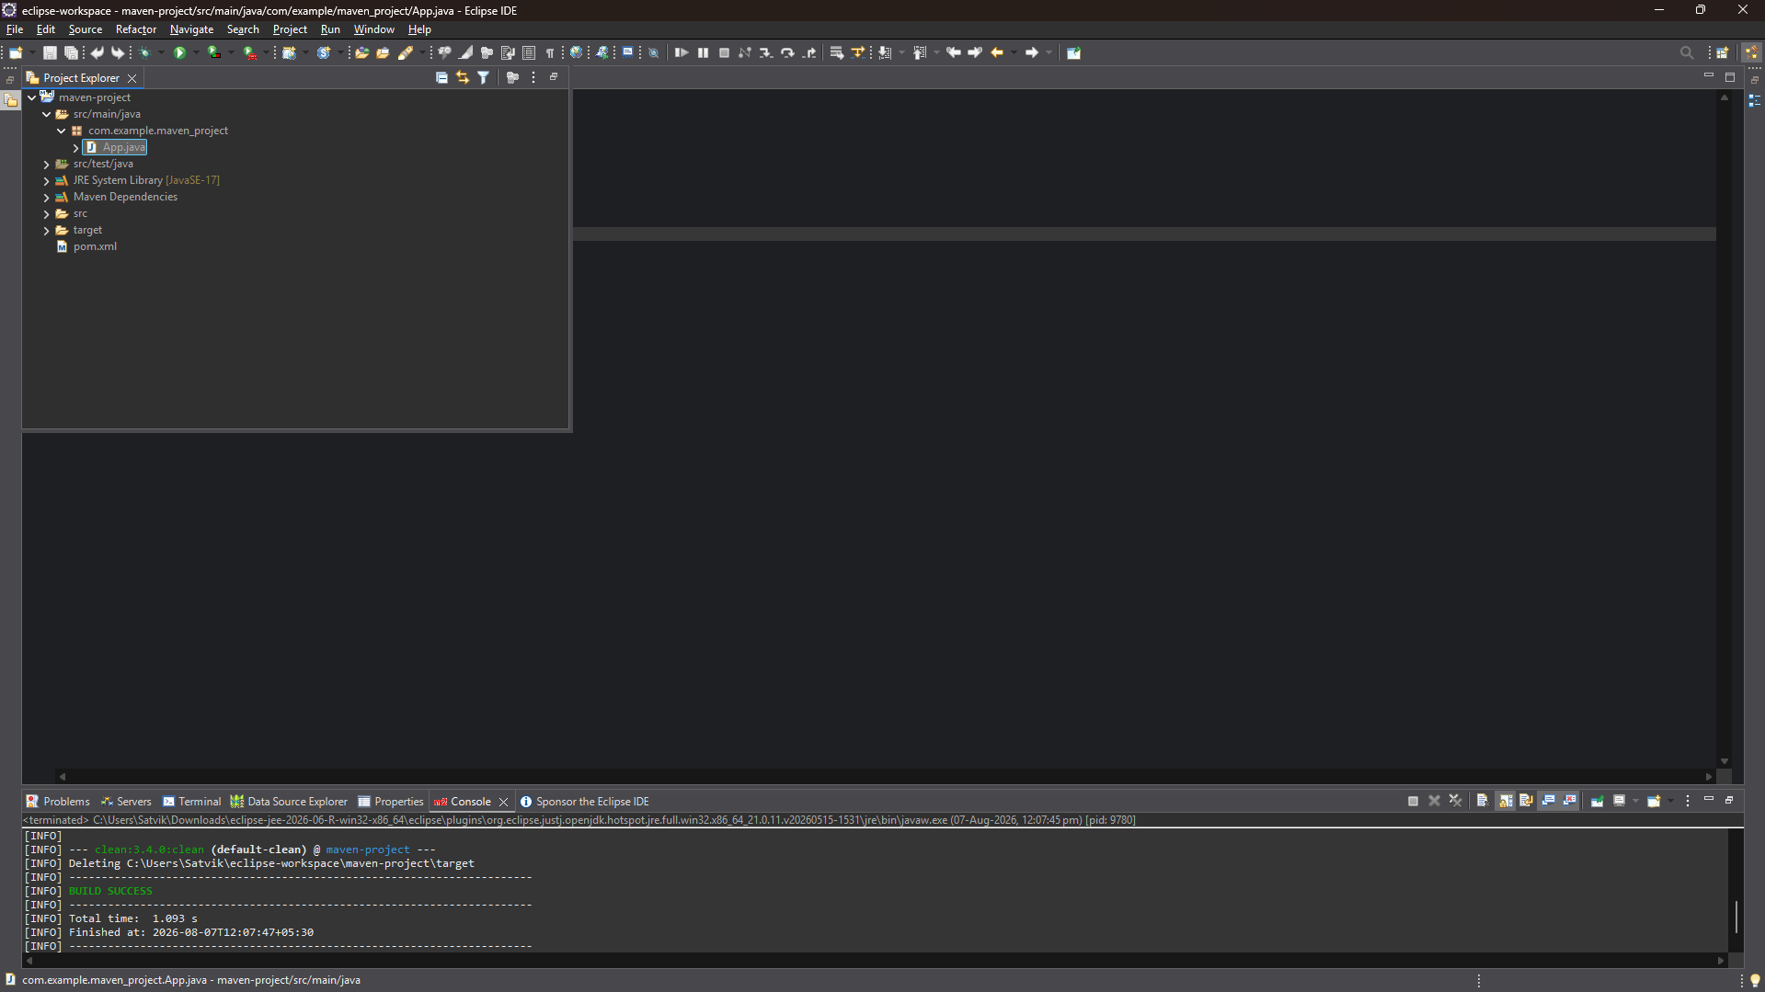

Step 9:
Run maven clean on app.java
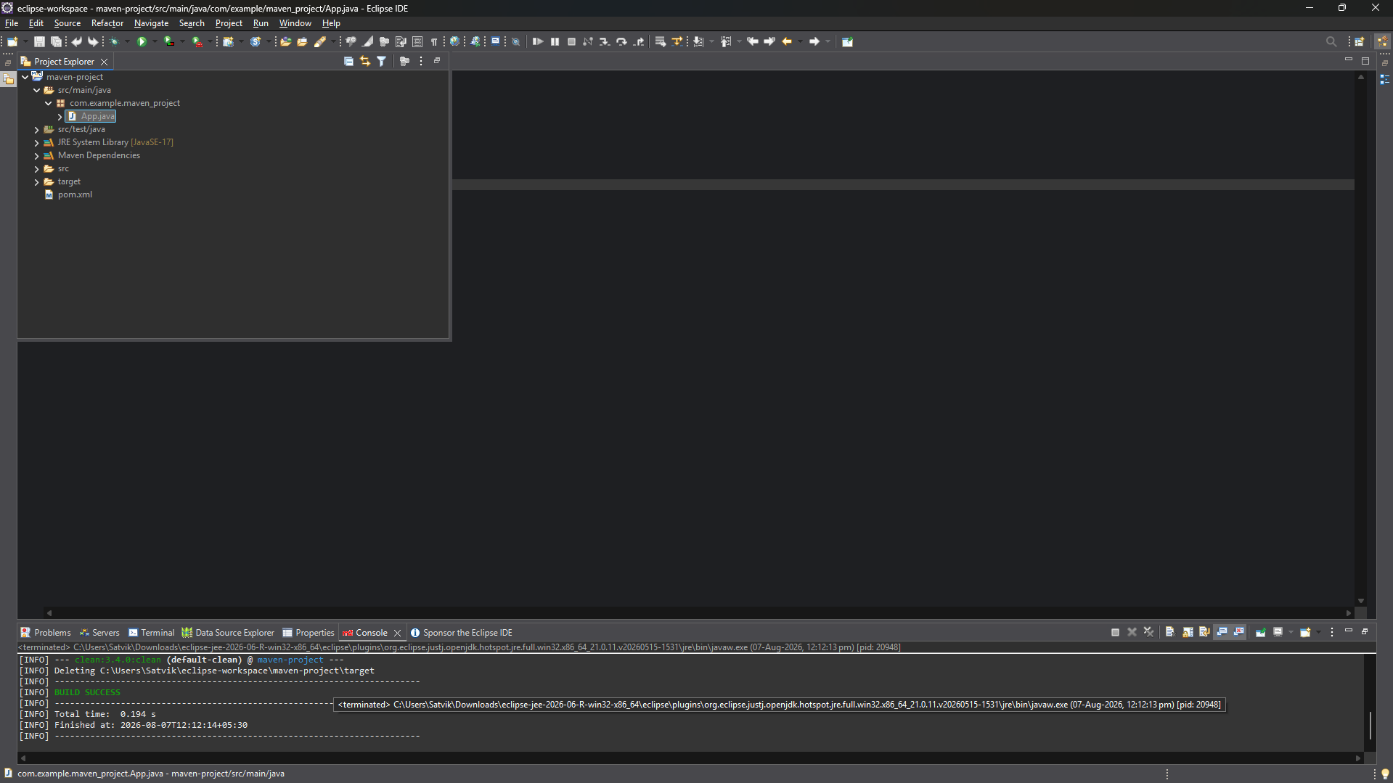
Run maven install on app.java
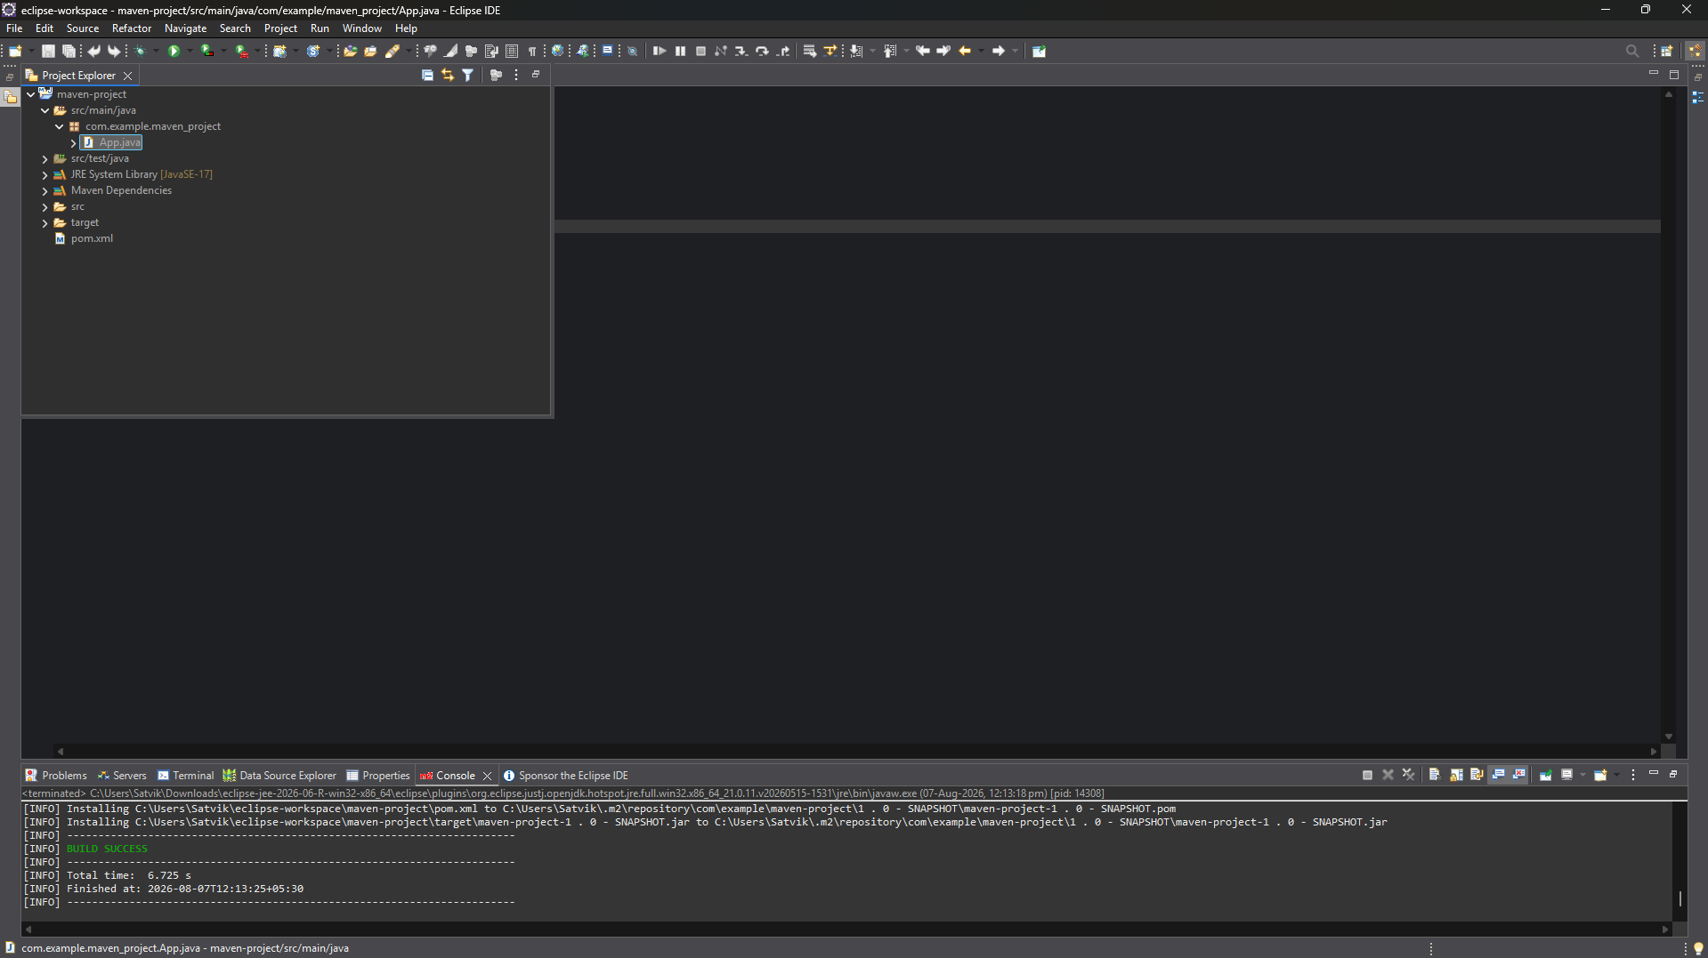

Run maven test on app.java:
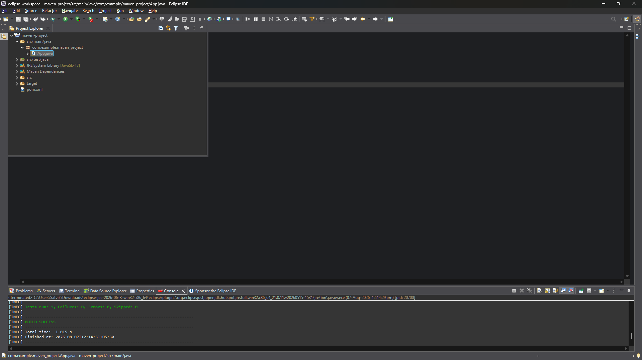
Run maven build on app.java(goals: clean install):
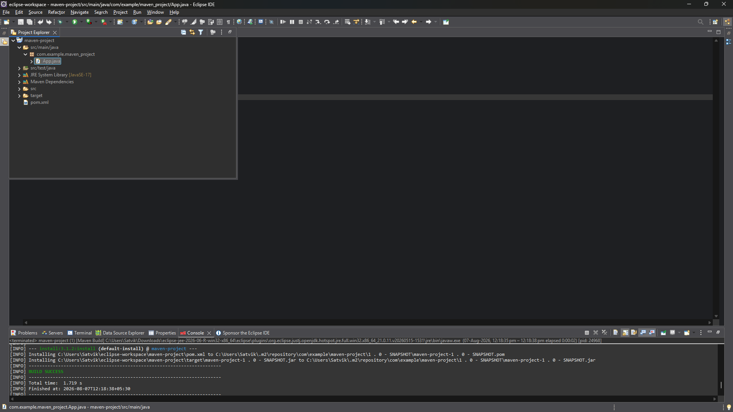

Step 10:
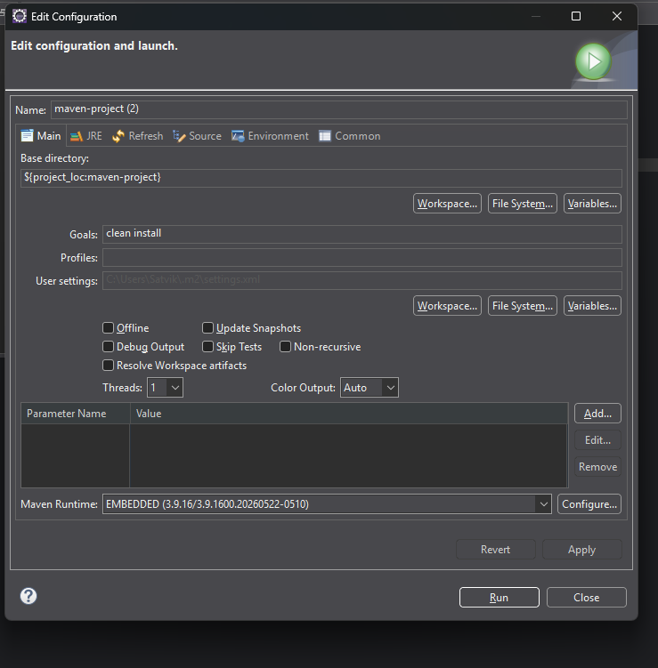
Step 11:
Step 12. Run the application:
└── Right-click on App.java -> Run As -> Java Application
└── Output: "Hello World" displayed.
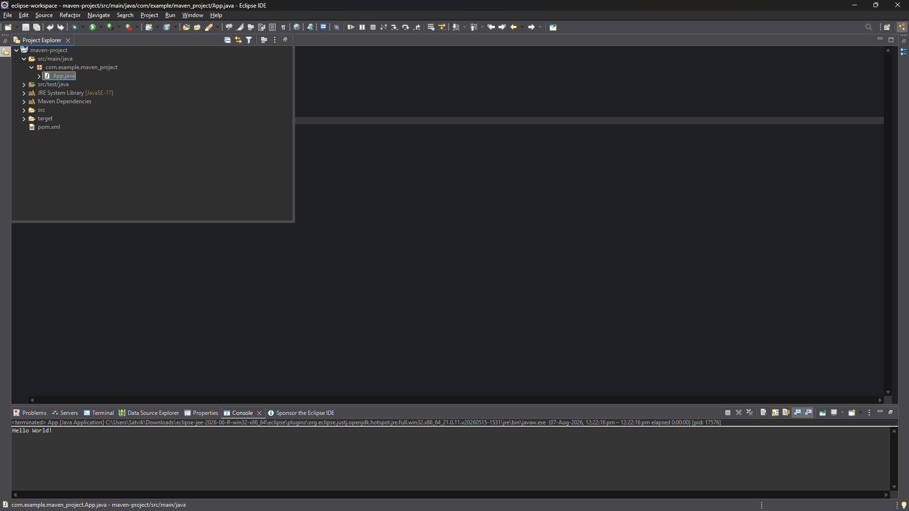
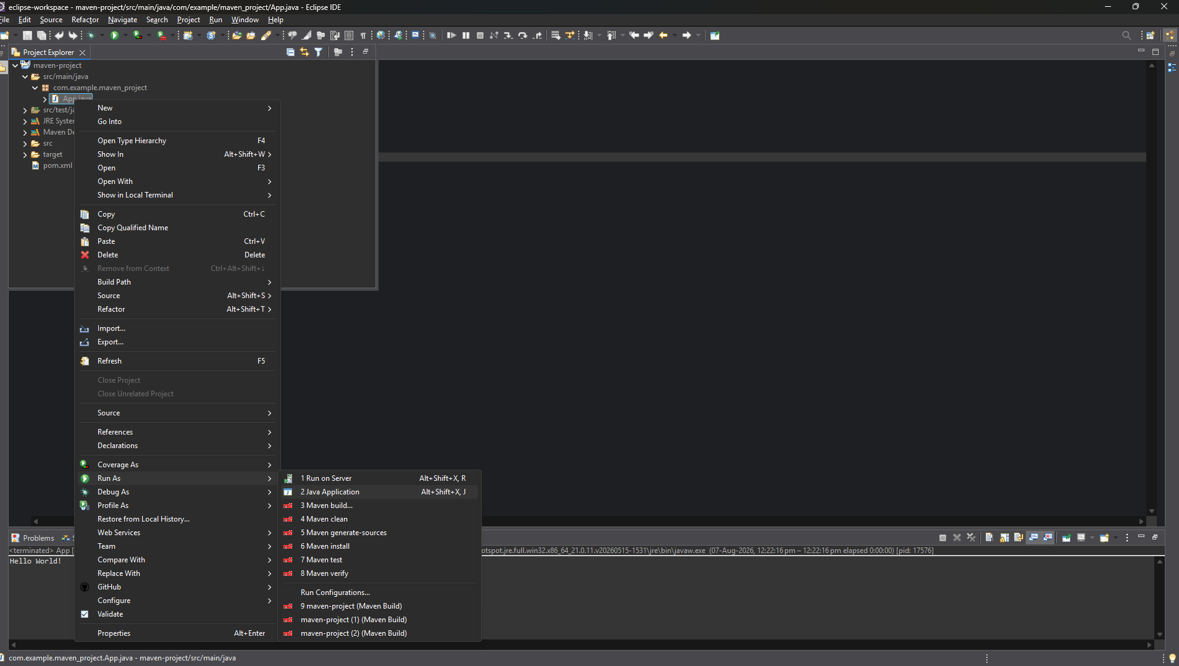

Creation of Maven web Java Project
Step 1: Open Eclipse
└── 1.1 Launch Eclipse IDE.
└── 1.2 Select or create a workspace.
Step 2: Create a New Maven Project
└── 2.1. File -> New -> Project...
└── 2.1.1. Expand "Maven"
└── 2.1.2. Select "Maven Project" and click "Next"
Step 3: Choose Maven Archetype
└── 3.1. Select an archetype(e.g "'org.apache.maven.archetypes' -> 'maven-archetype-webapp' 1.4 ")
└── 3.2. Click "Next"
Step 4: Configure the Maven Project
└── 4.1 Group Id: Enter a group ID (e.g., com.example).
└── 4.2 Artifact Id: Enter an artifact ID (e.g., my-web-app).
└── 4.3 Click **Finish** to create the project.

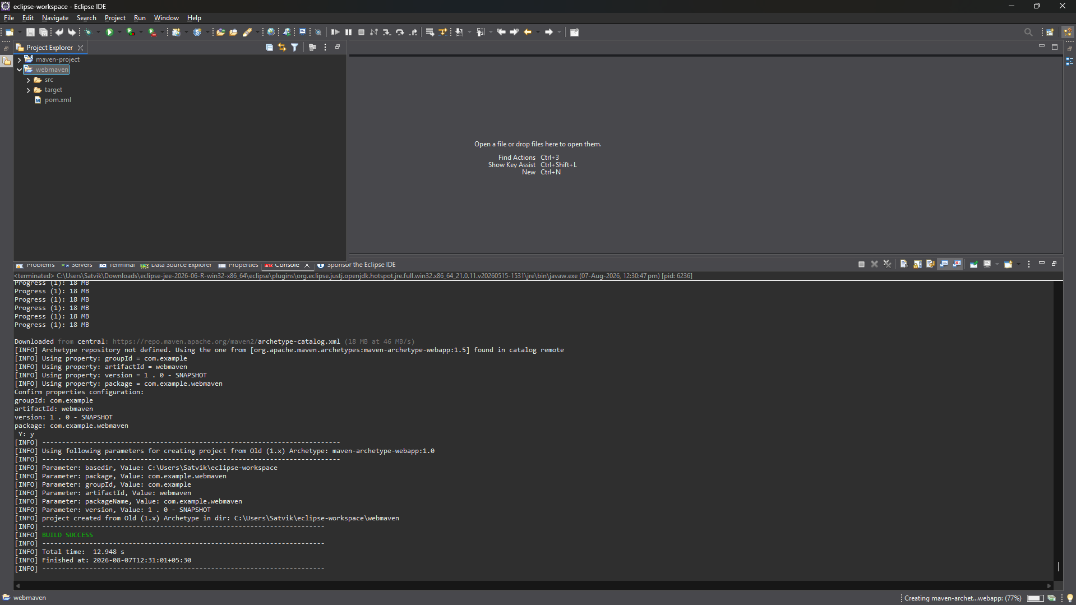

Step 5: Add Maven Dependencies
└── 5.1 Open the **pom.xml** file in the Maven project.
└── 5.2 Add the necessary dependencies for your web project (e.g., Servlet, JSP):
Go to browser -> Open mvnrepository.com
Search for 'Java Servlet API' -> Select the latest version.
Copy the dependency code -> Paste it in MavenWeb’s pom.xml under the target folder
└── Example:
```xml
<dependency>
<groupId>javax.servlet</groupId>
<artifactId>javax.servlet-api</artifactId>
<version>4.0.1</version>
<scope>provided</scope>
</dependency>
```
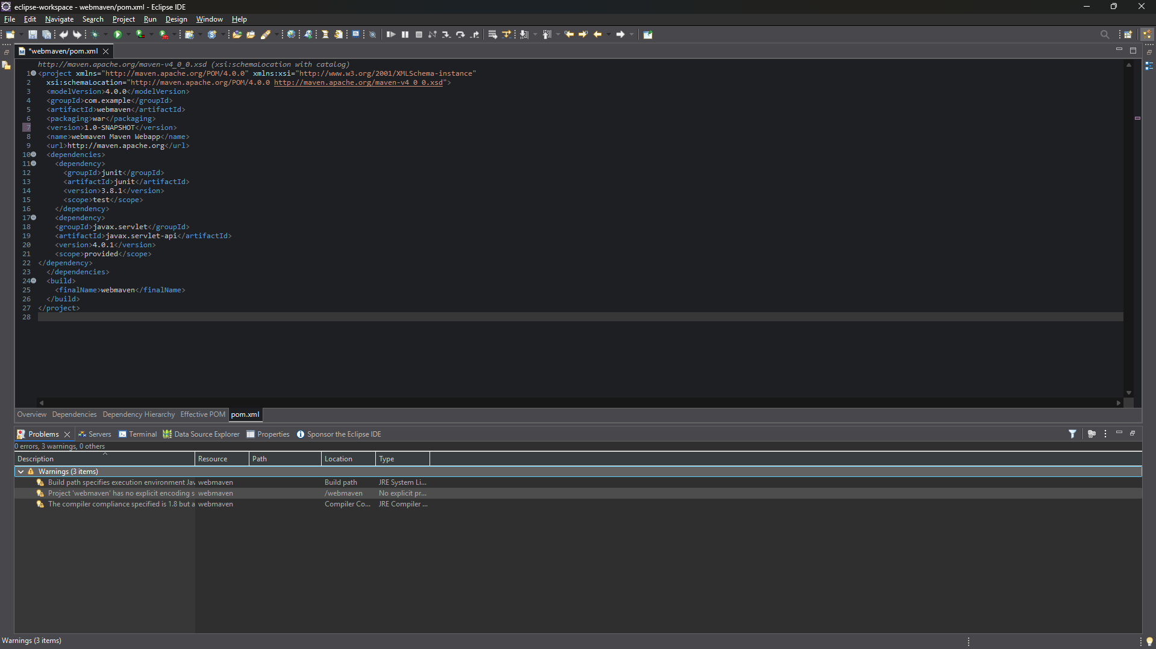

Step 6:-. Configure server:
└── Window -> Show View -> Servers
└── Add server -> Select Tomcat v9.0 server -> Click Next
└── Configure server options (e.g., ports, server location).
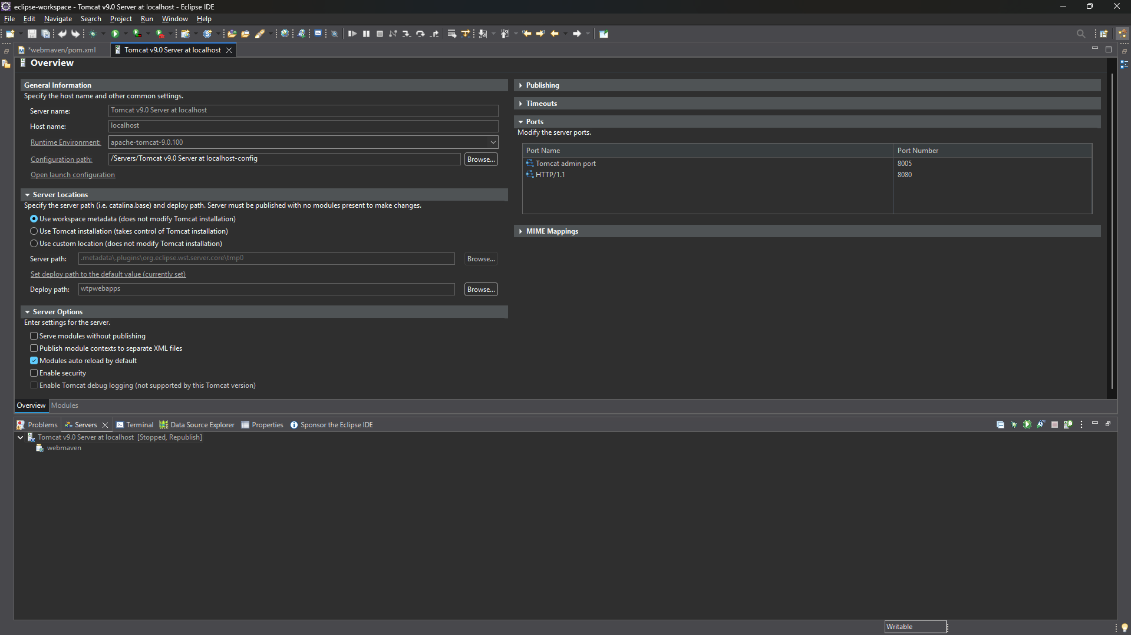
Step 7:-. Modify 'tomcat-users.xml':
└── Add role and user details under <tomcat-users> tag.
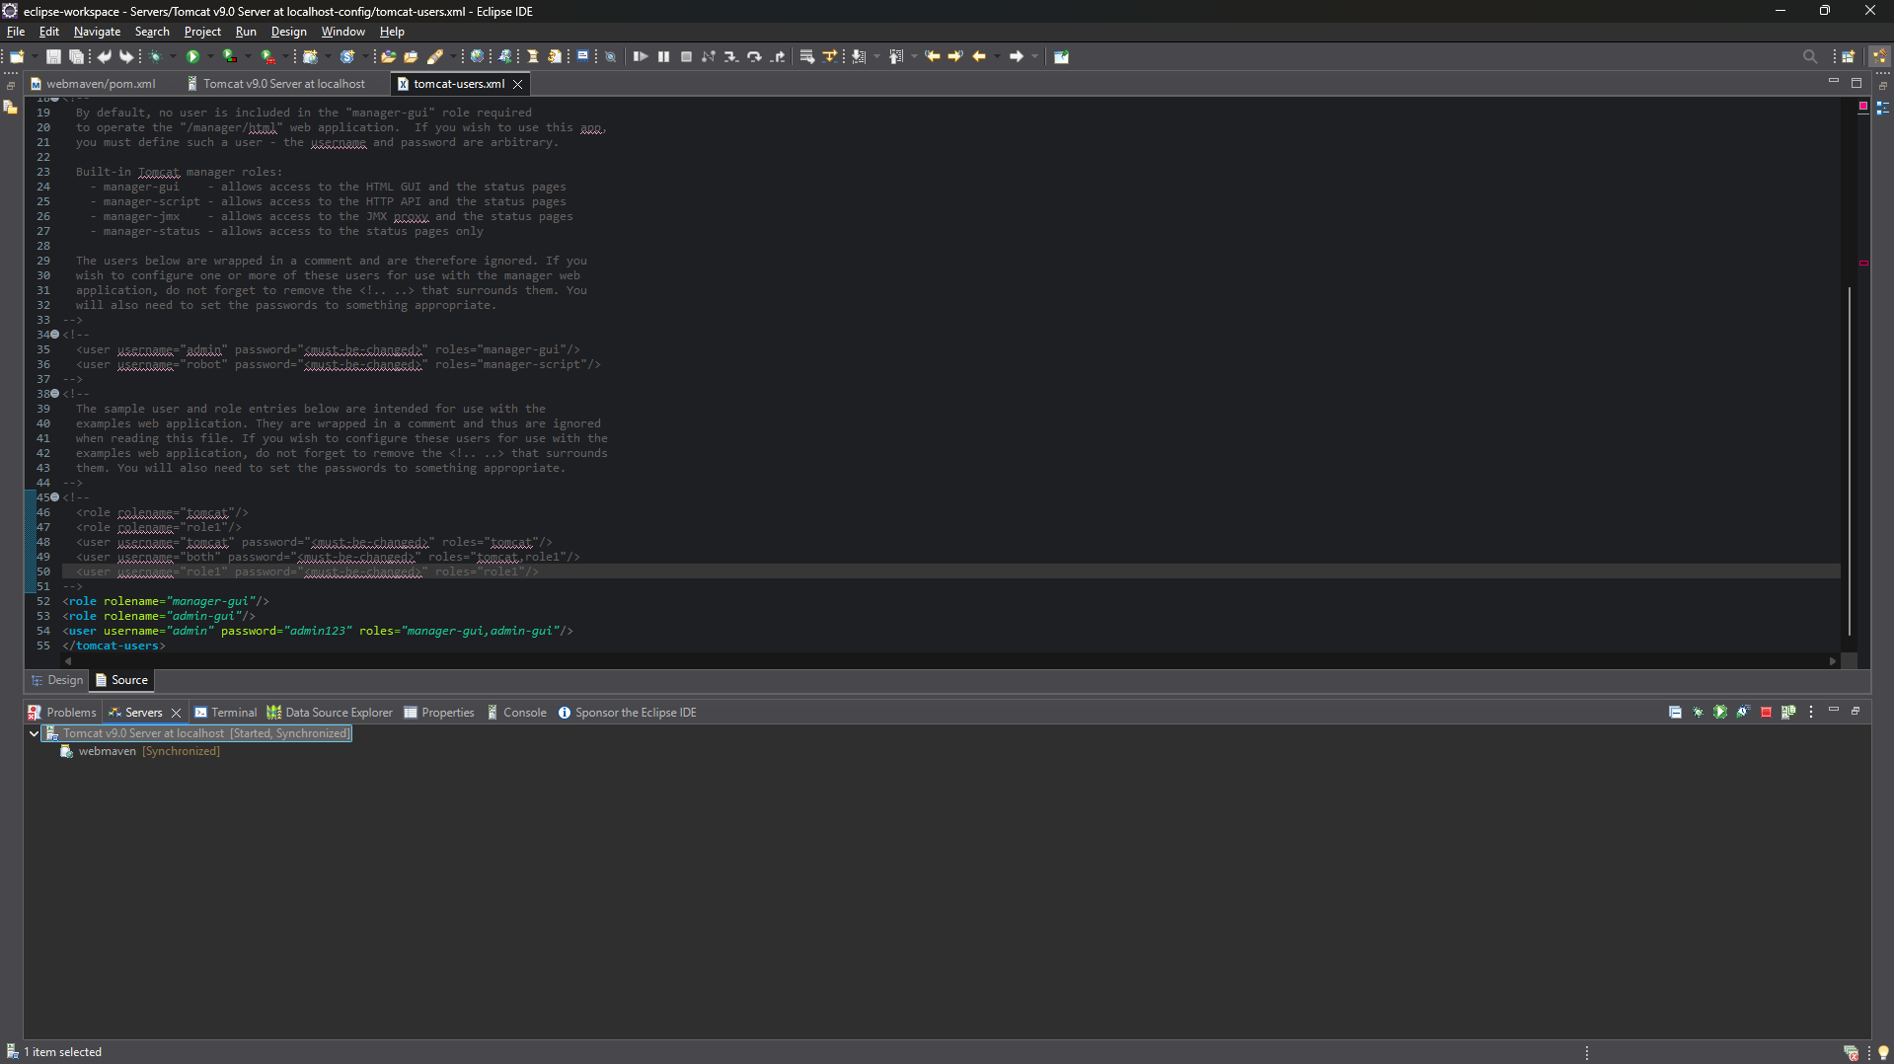

Step 8:. Build the project:
└── Right-click on index.jsp -> Run As -> Maven Clean
└── Right-click on index.jsp -> Run As -> Maven Install
└── Right-click on index.jsp -> Run As -> Maven Test
└── Right-click on index.jsp -> Run As -> Maven Build
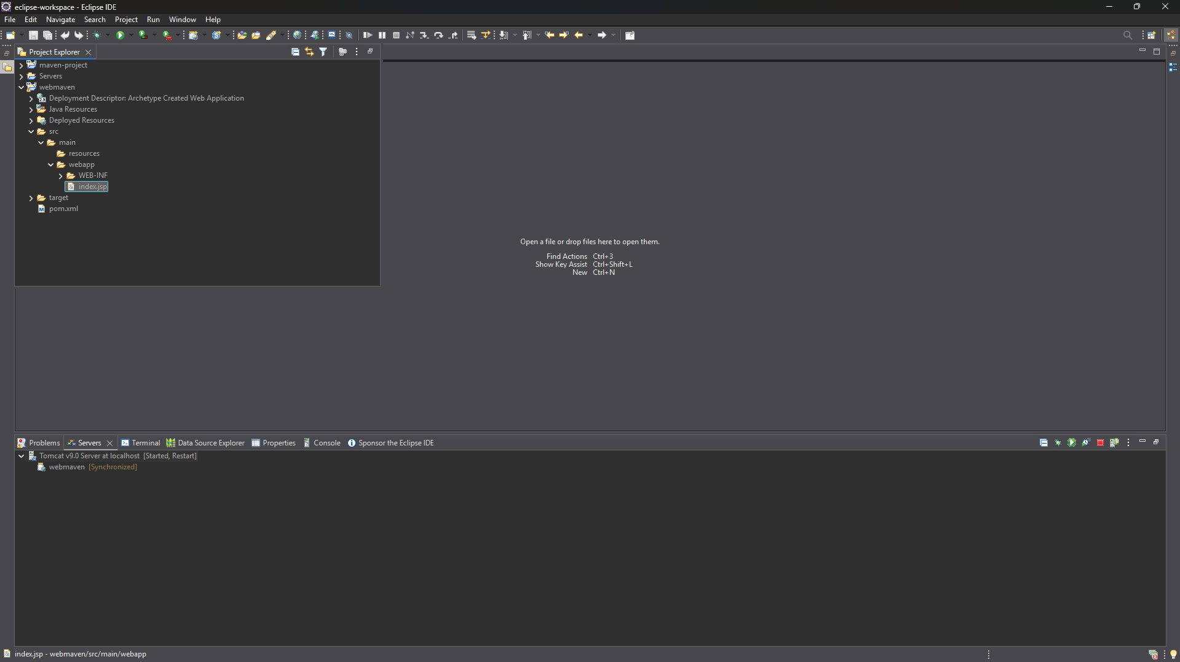
Maven clean:
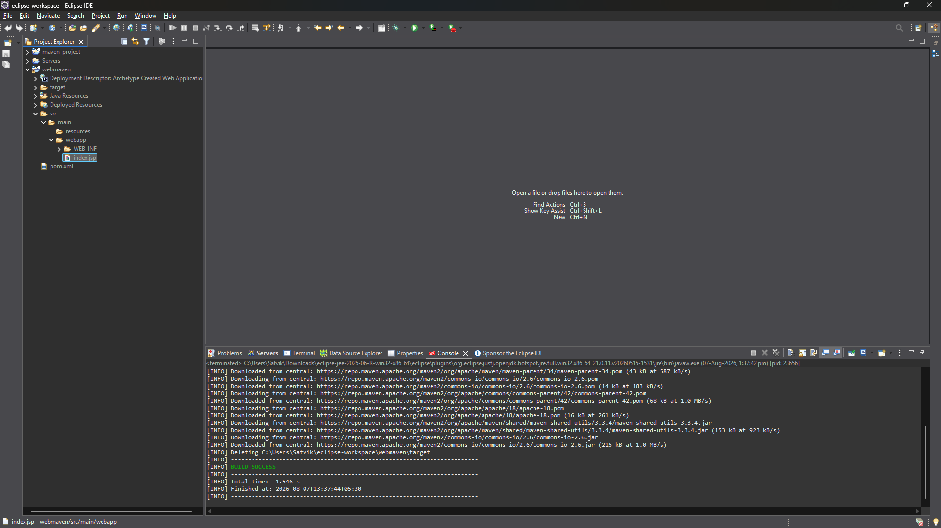

Maven test:
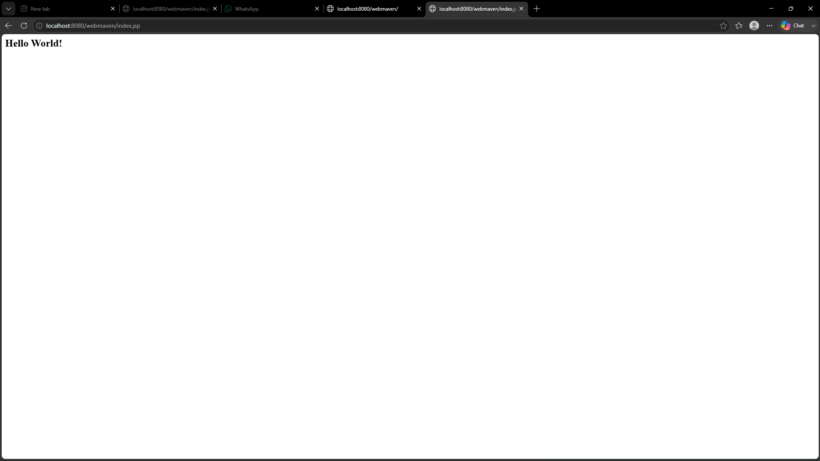

Maven install:
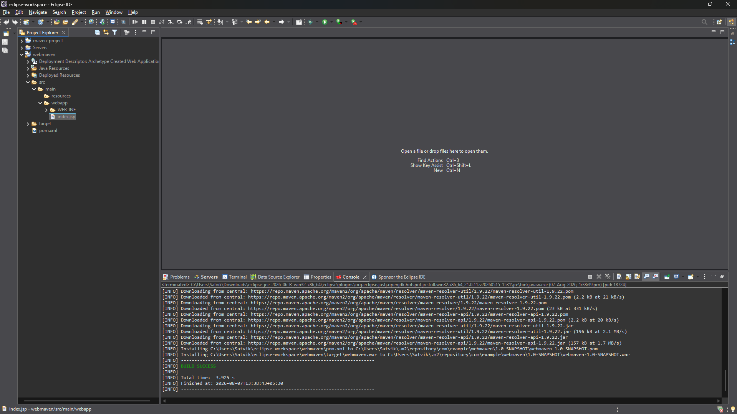

Step 10:
Maven build(goals:clean install):
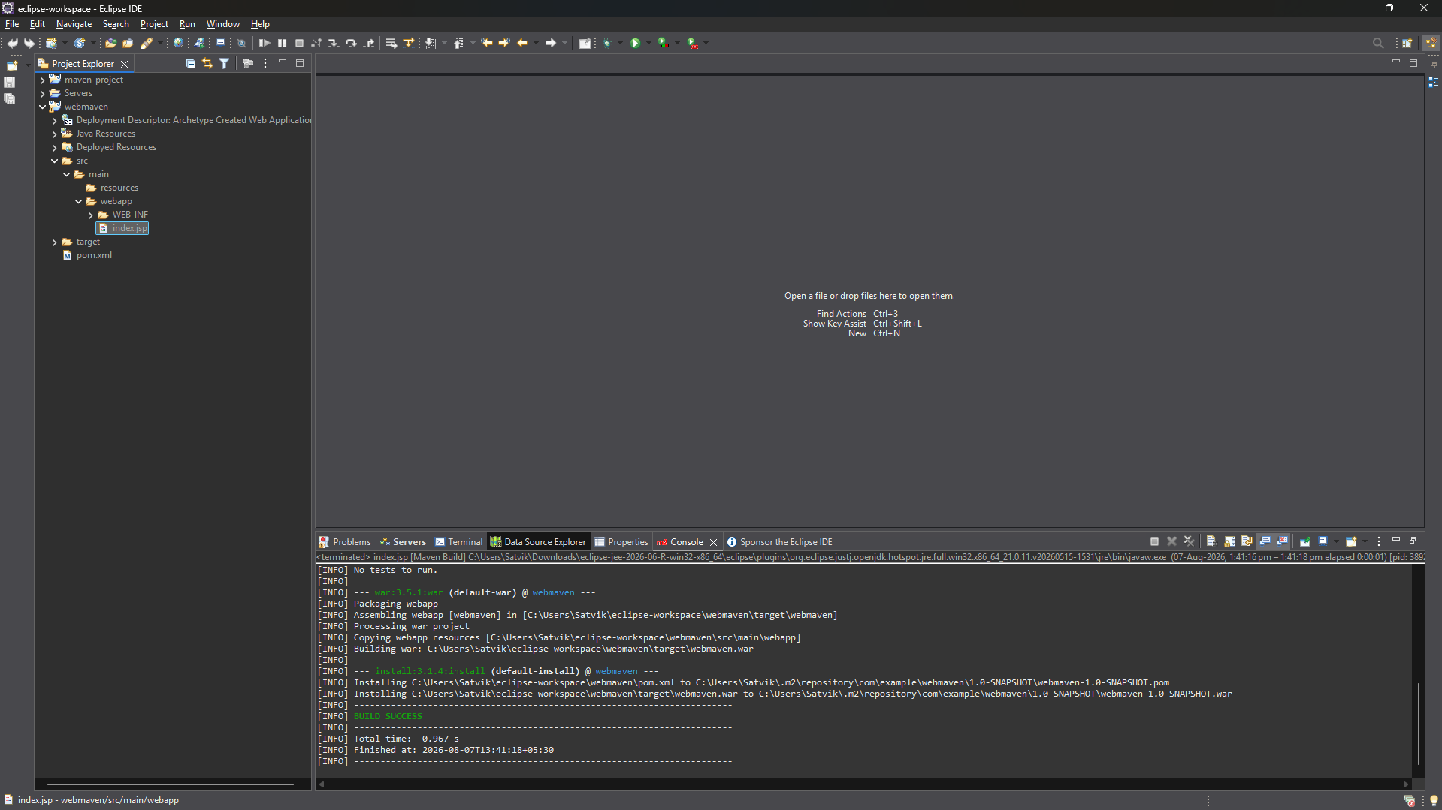

Step 11 & step 12
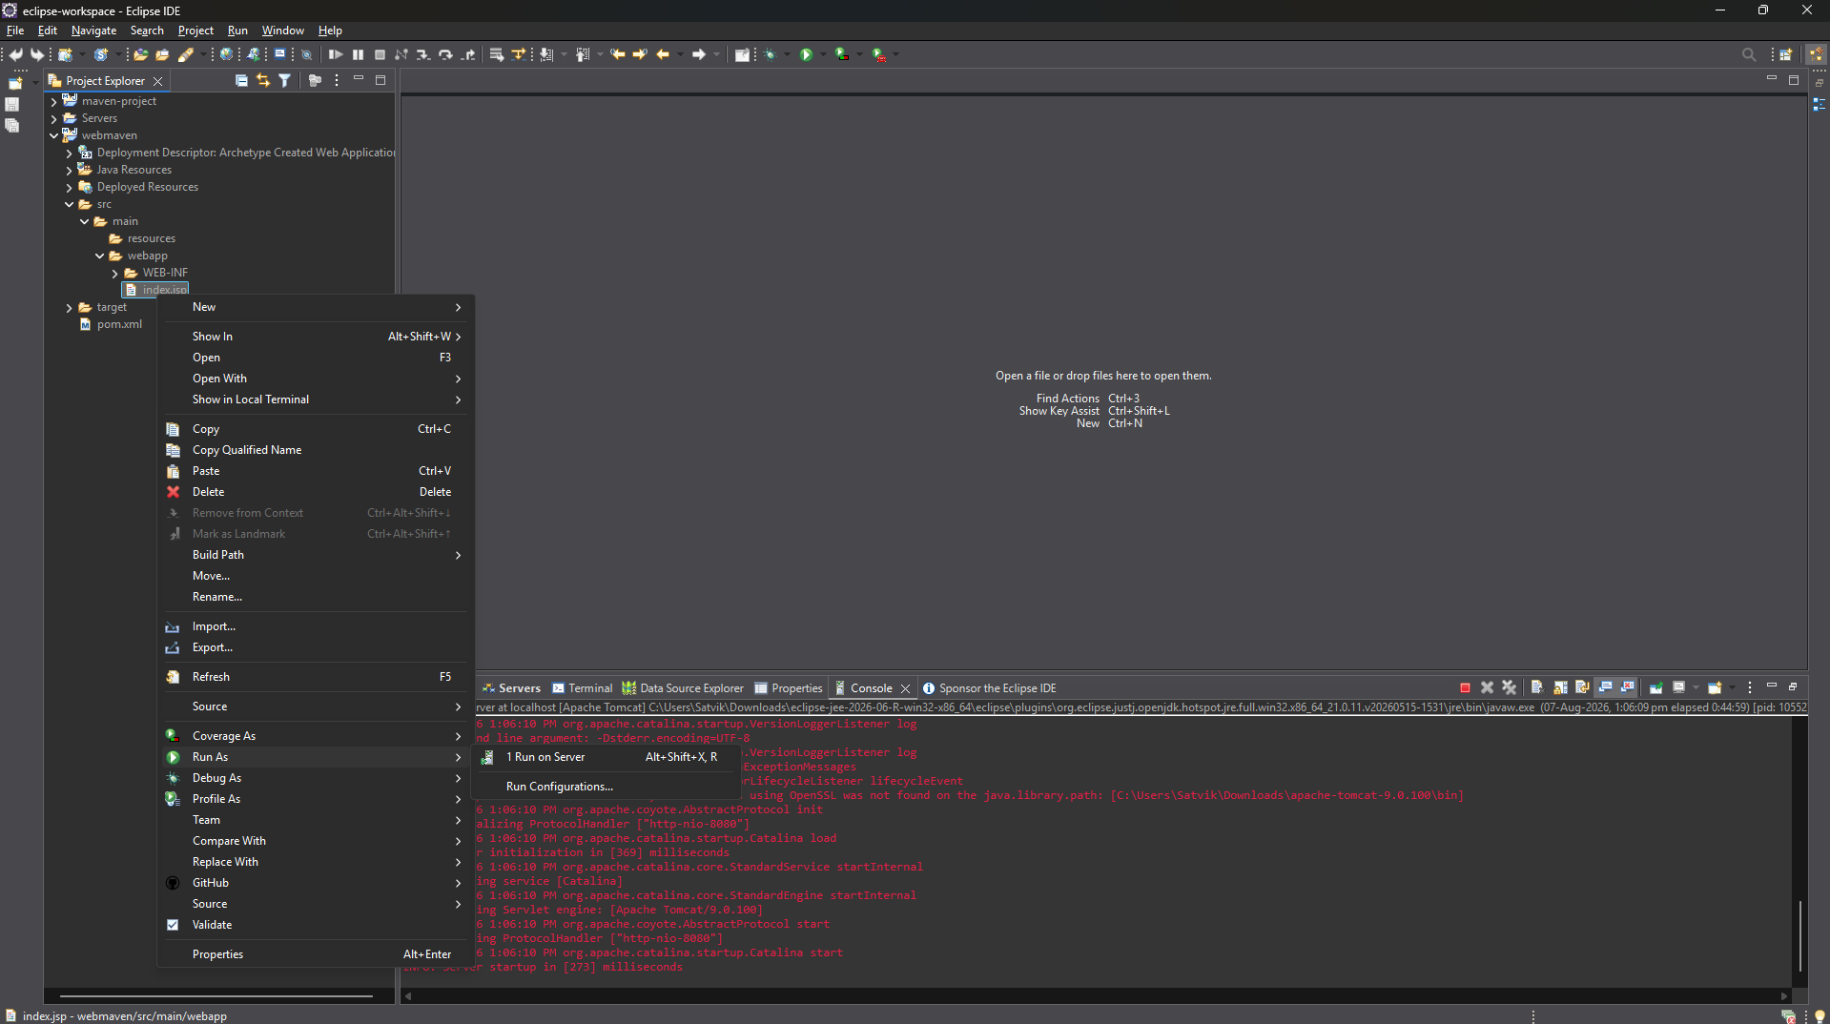
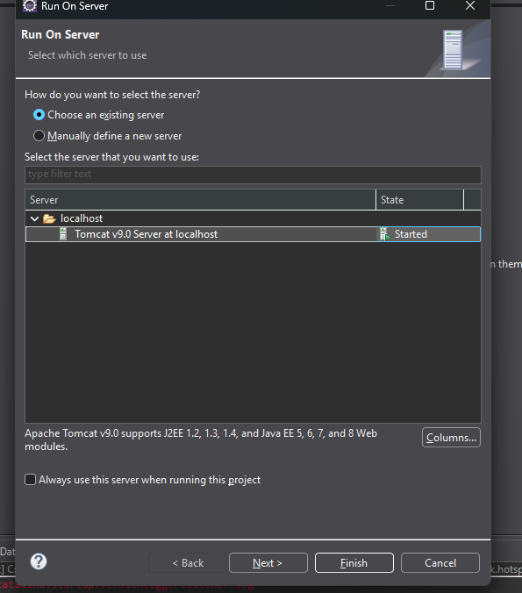
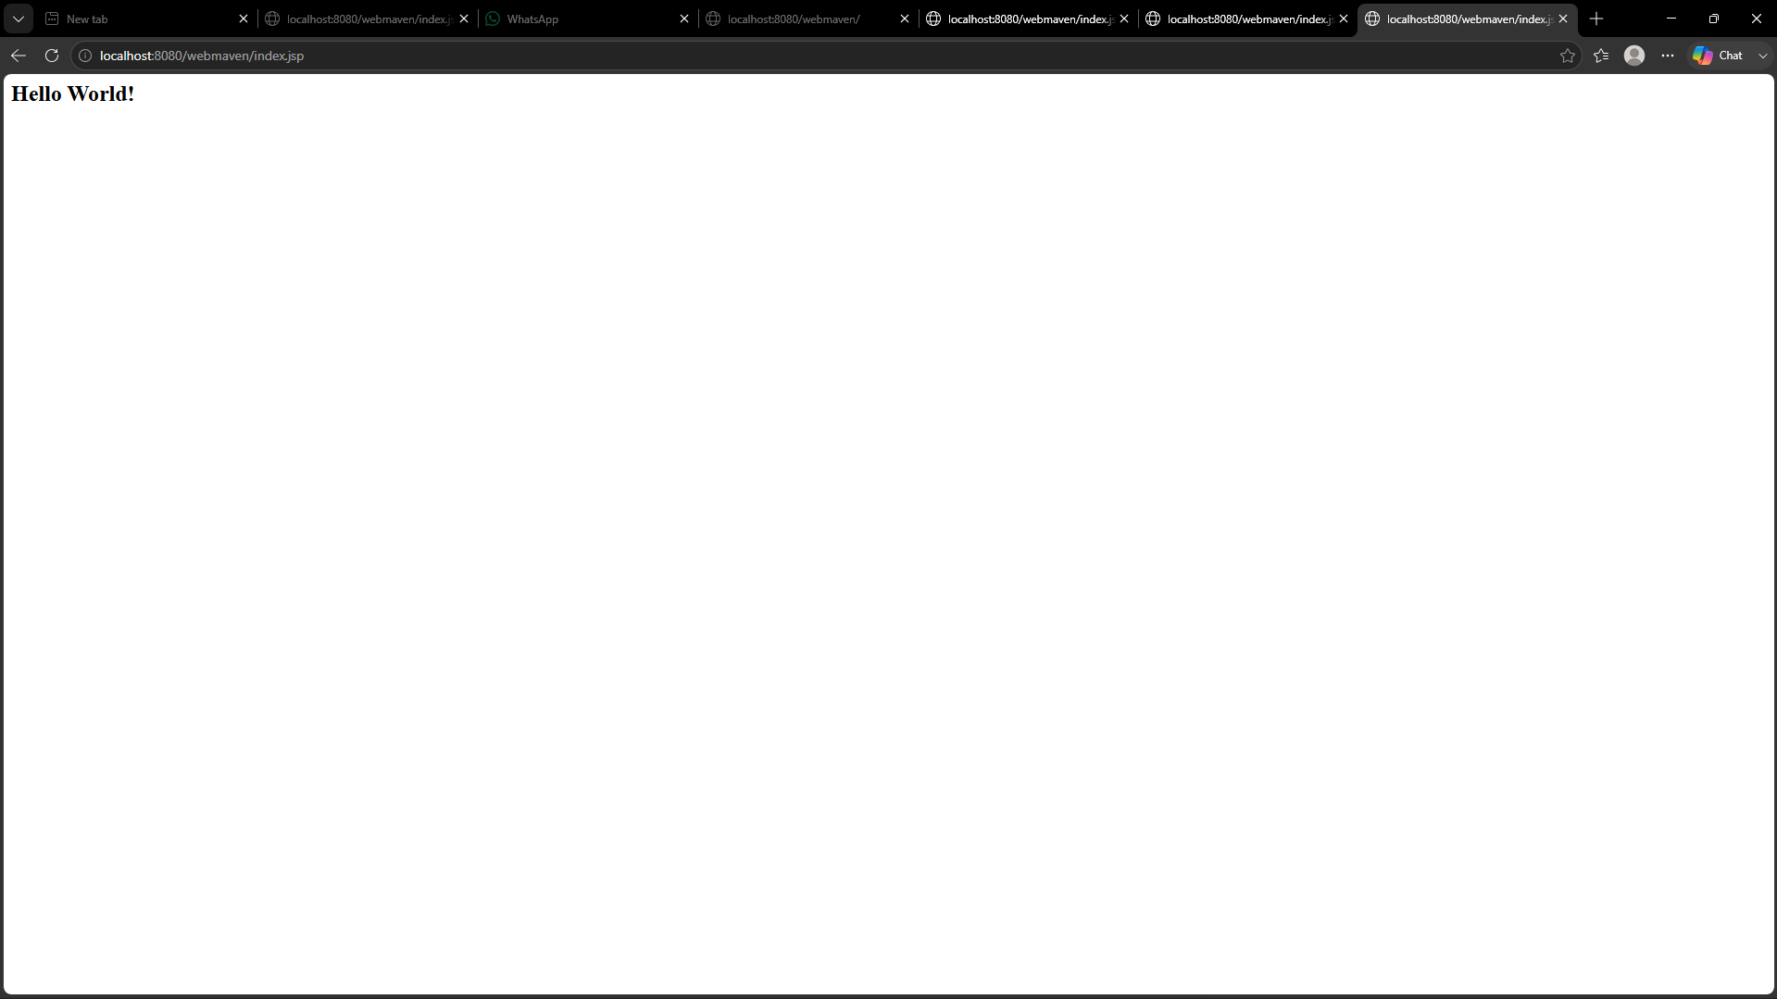

Push to github:
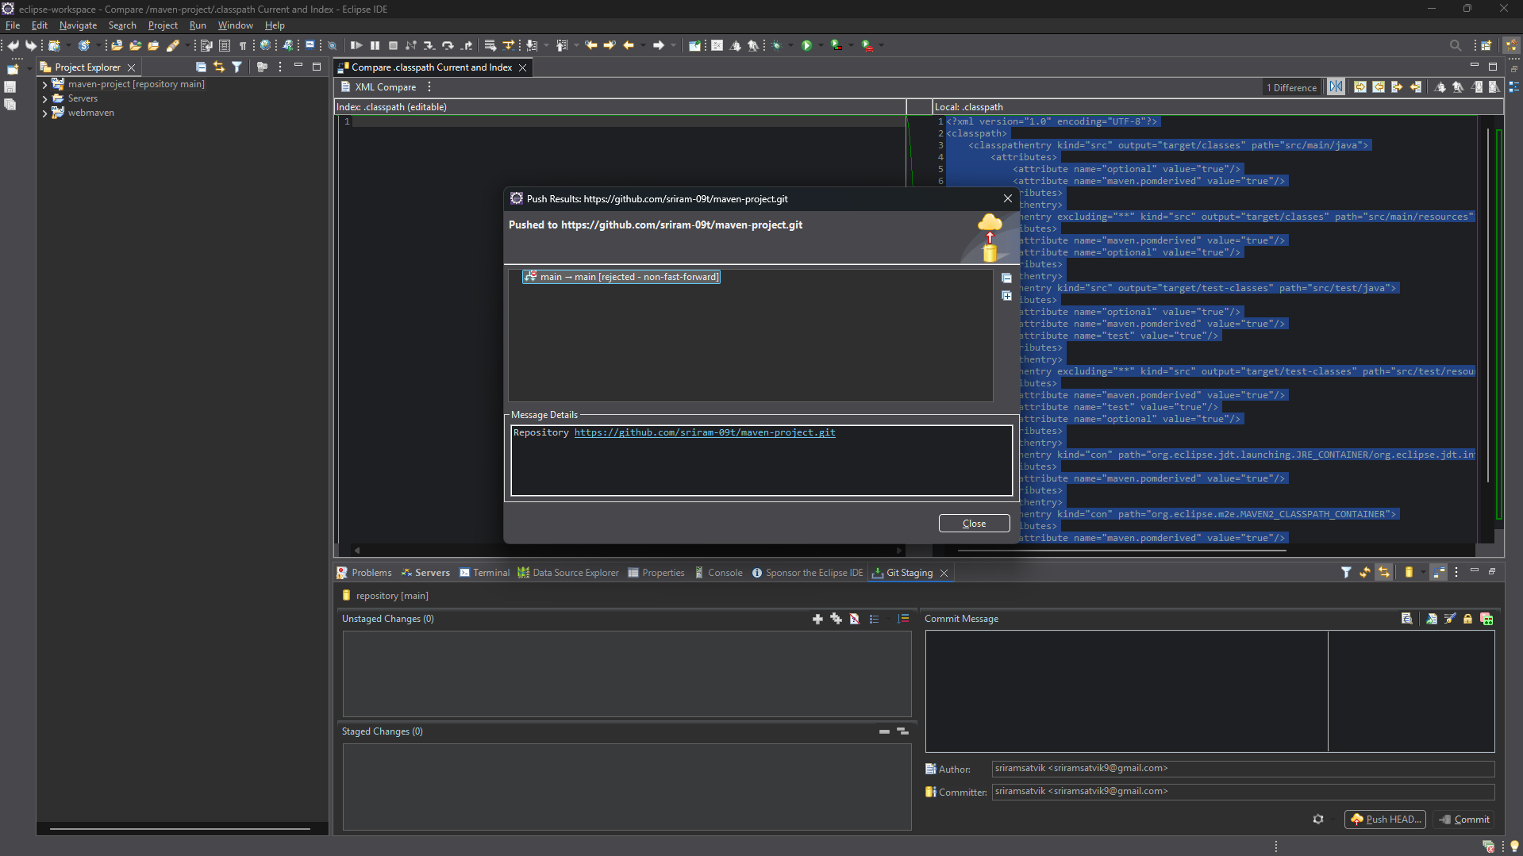

- Configure Java Version via Compiler Plugin:
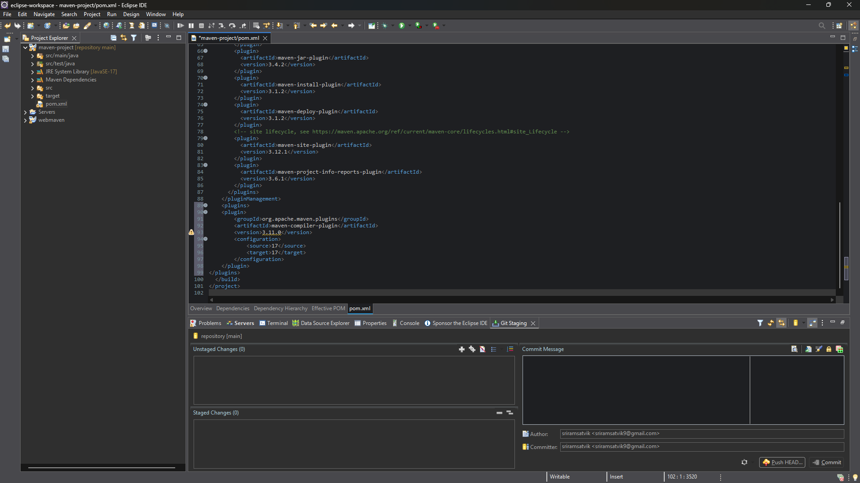
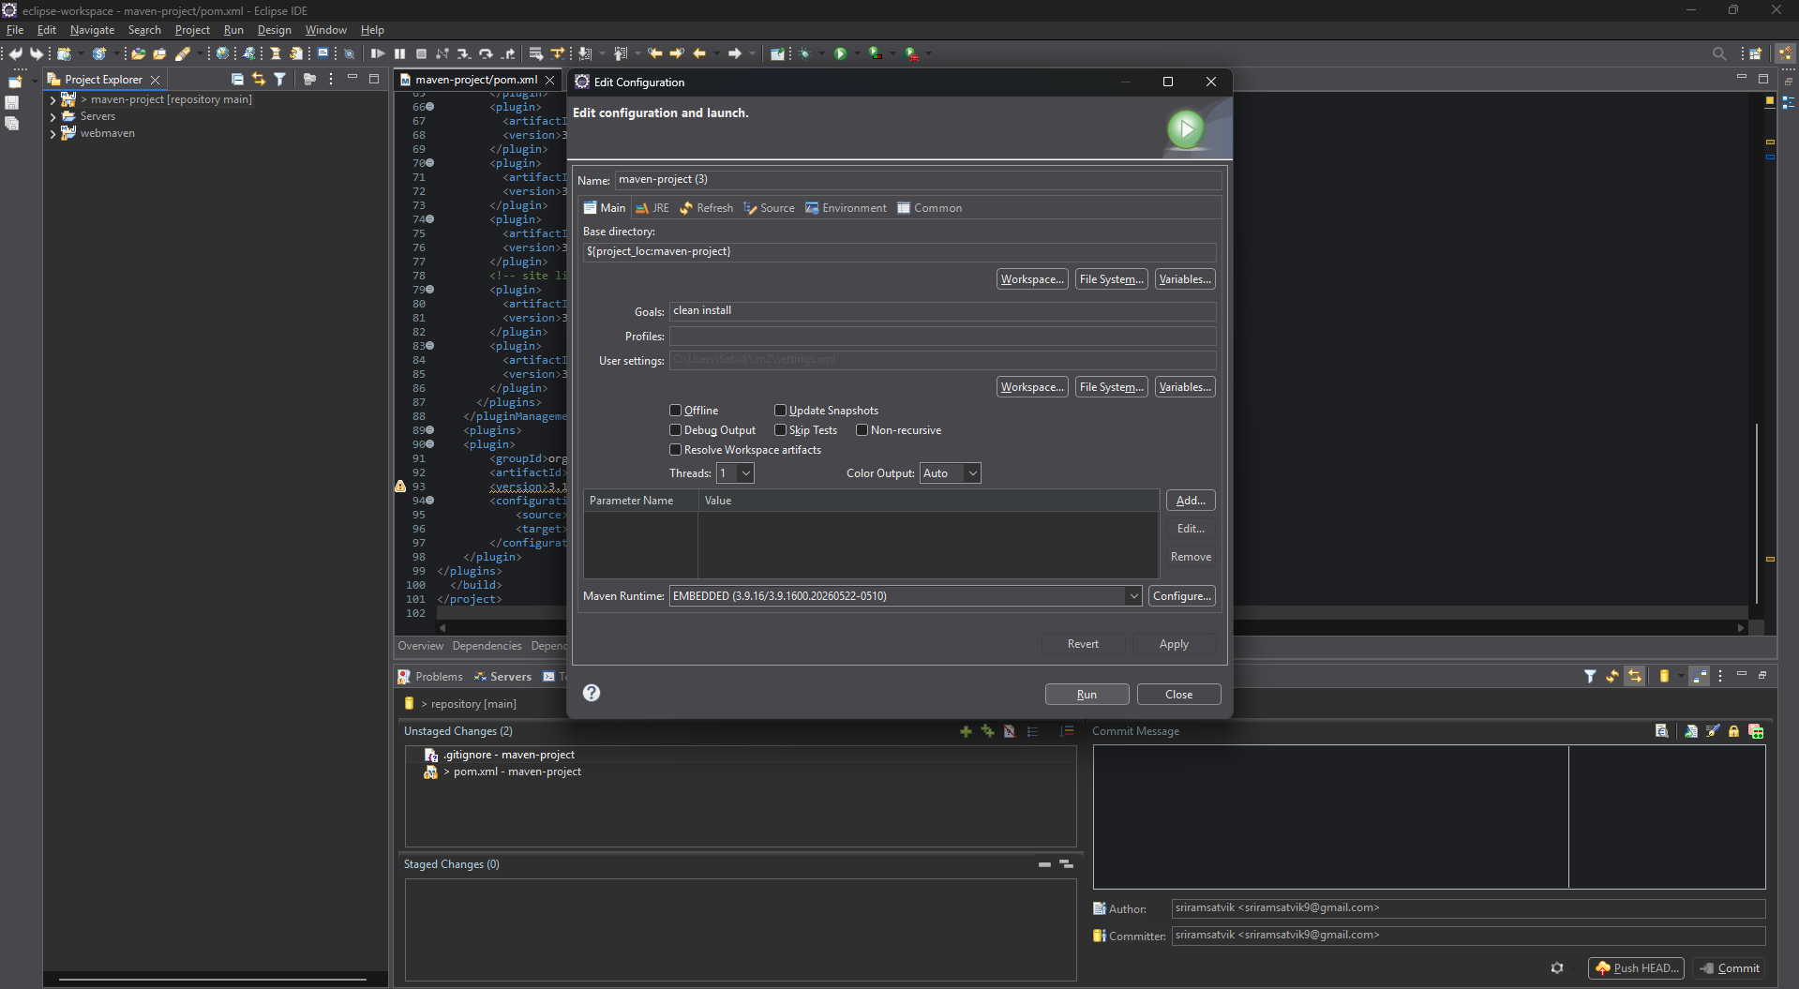
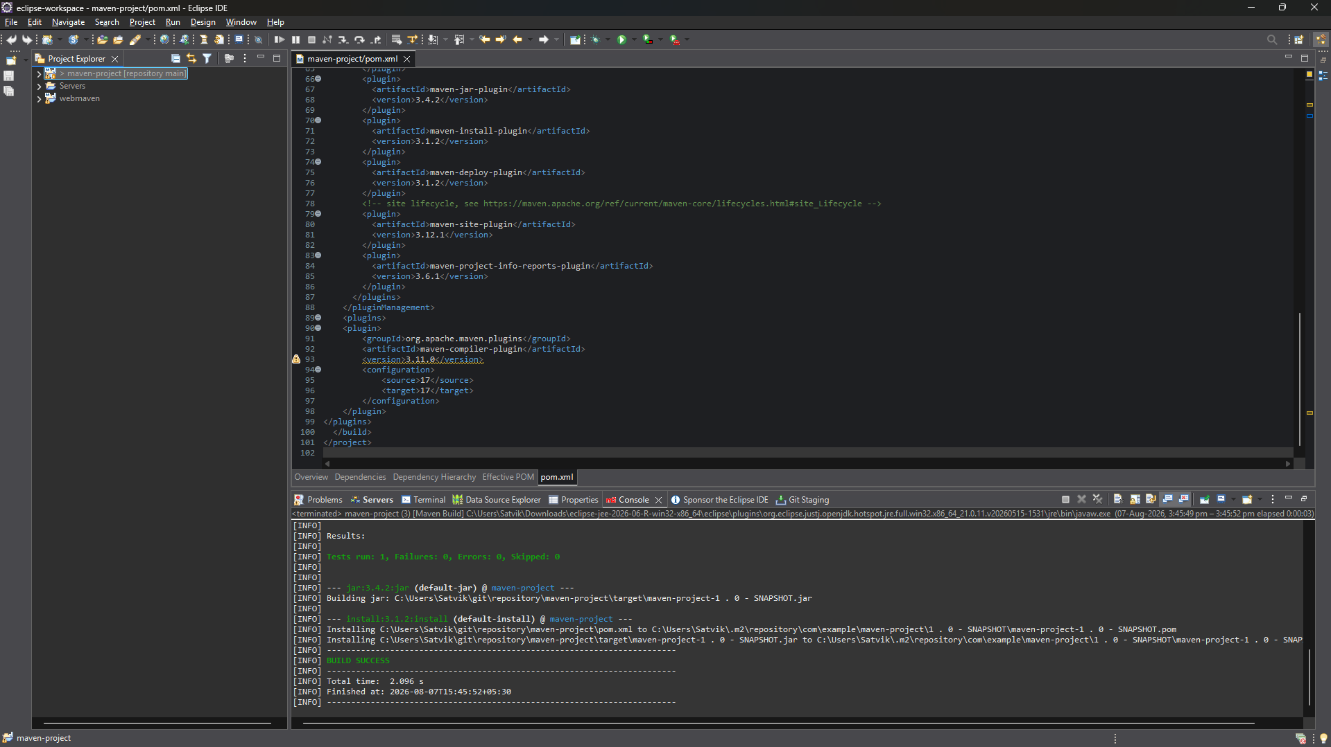
4 JUnit Testing and Reports
Place test files in src/test/java. Example:
public class AppTest {
@Test
public void testSum() {
assertEquals(5, 2 + 3);
}
}
Run:
mvn test
Check:
- target/test-classes/ → compiled test .class files
- target/surefire-reports/ → .txt or .xml test results
If test fails → corresponding log and failure trace shown

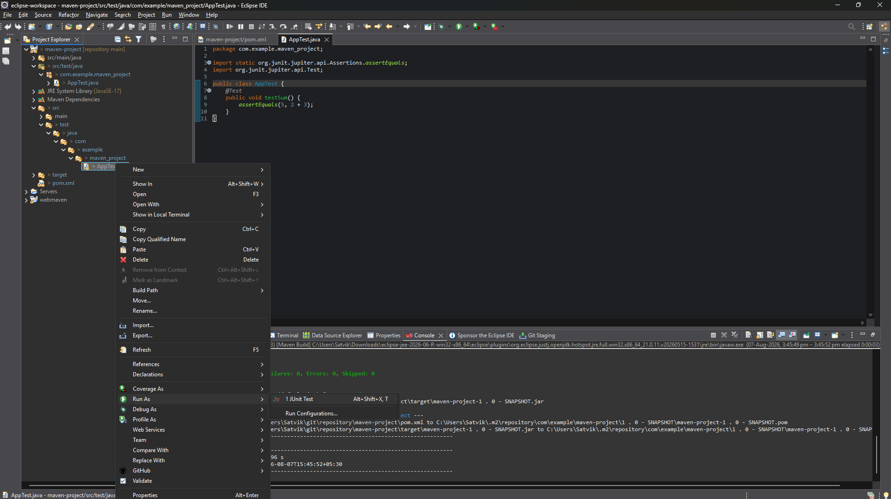
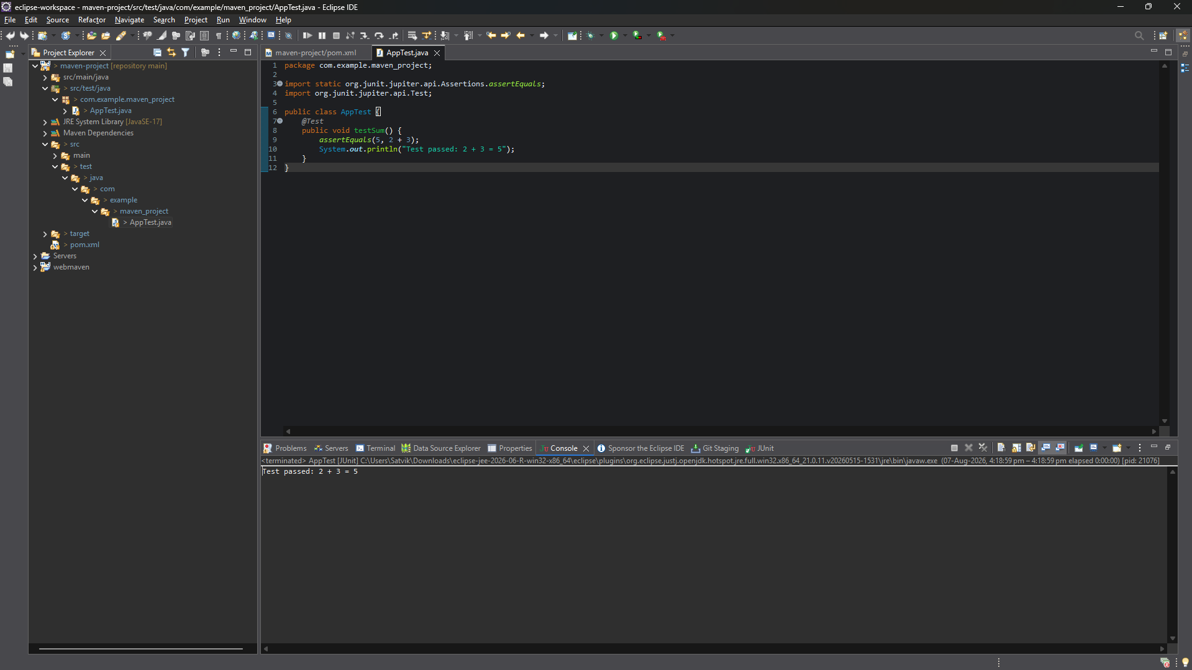
5.handling Errors in pom.xml
- Typos in version numbers or missing repositories cause BUILD FAILURE
- Maven shows precise error in console
- Fix the dependency tag → re-run mvn clean install

6.Adding Resource Files
Put config.properties inside:
src/main/resources/config.properties
To read:
InputStream input = getClass().getClassLoader().getResourceAsStream("config.properties");
After build, check target/classes/ → file should exist there.

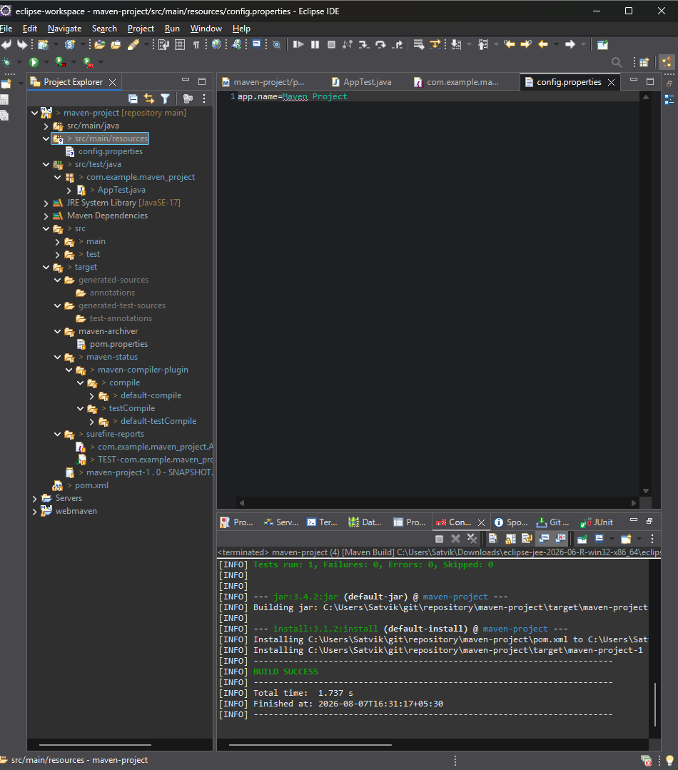

7.Multi-Module and Parent Projects
Structure:
parent/
├── pom.xml (packaging: pom)
├── core/
| └── pom.xml
└── web/
└── pom.xml
- Parent pom.xml defines <modules> and common dependencies
- Each submodule builds independently into its target/ directory
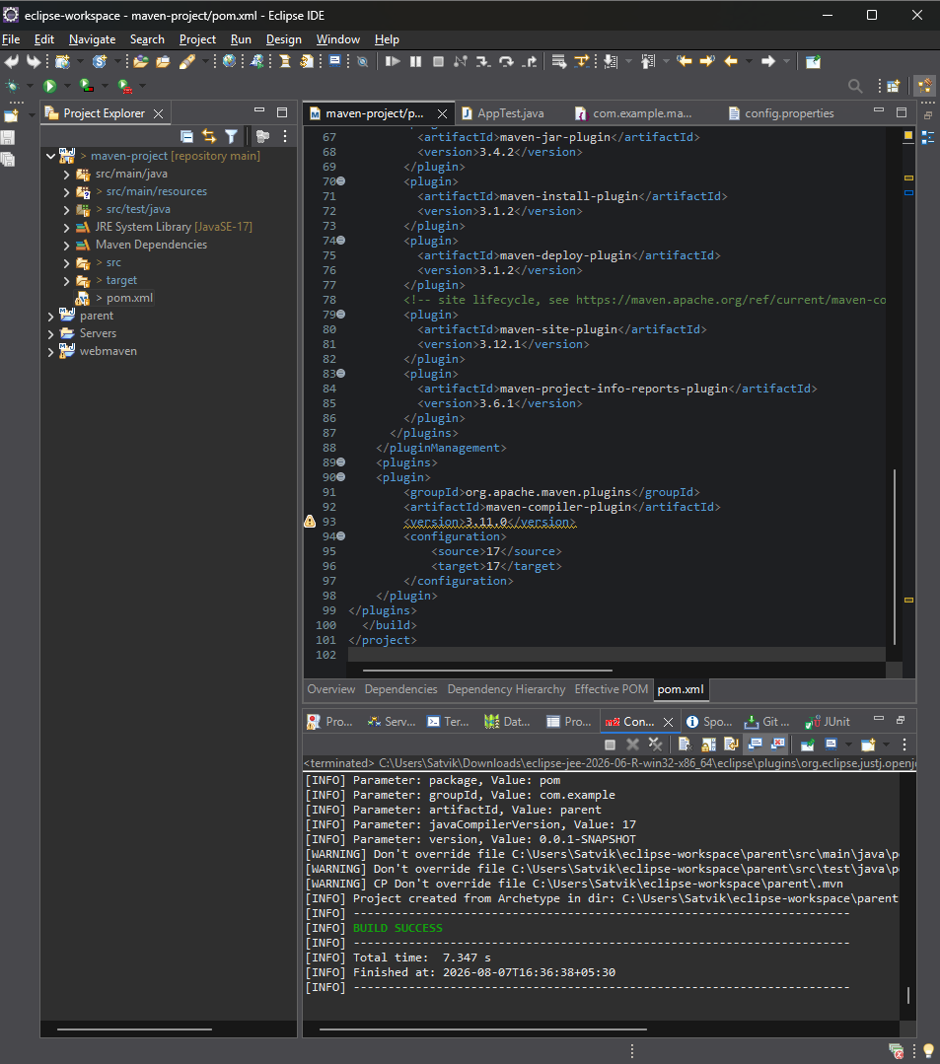
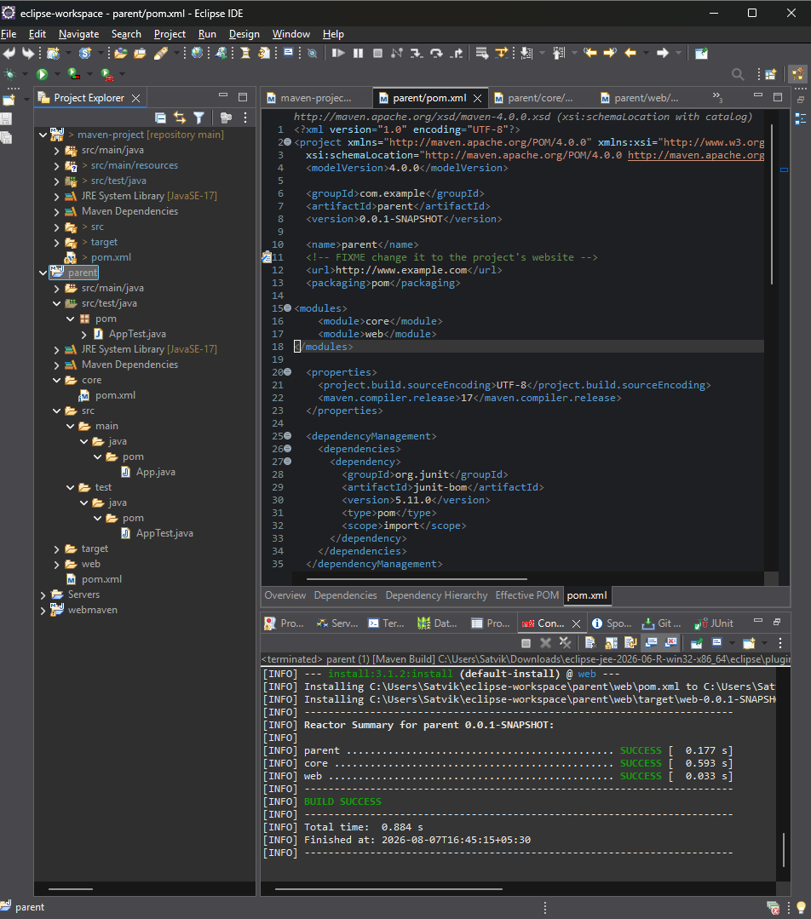

8.Executable JARs
Add to pom.xml:
<build>
<plugins>
<plugin>
<groupId>org.apache.maven.plugins</groupId>
<artifactId>maven-jar-plugin</artifactId>
<configuration>
<archive>
<manifest>
<mainClass>com.example.Main</mainClass>
</manifest>
</archive>
</configuration>
</plugin>
</plugins>
</build>
Run:
mvn package
java -jar target/myapp.jar

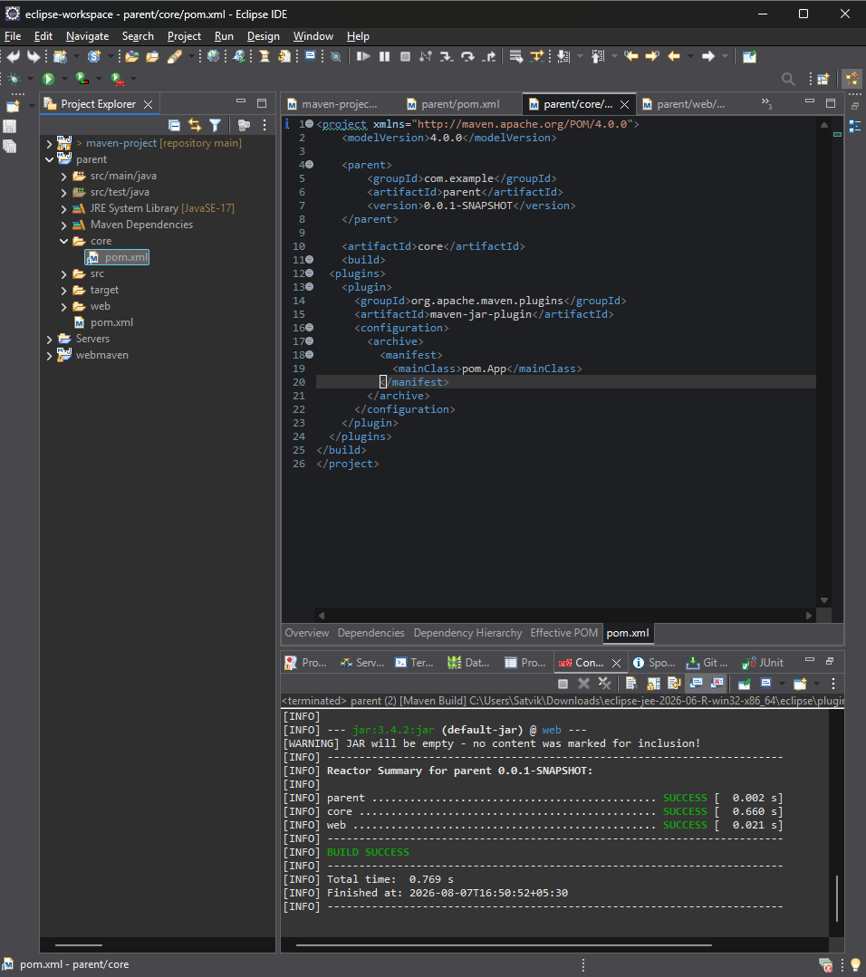
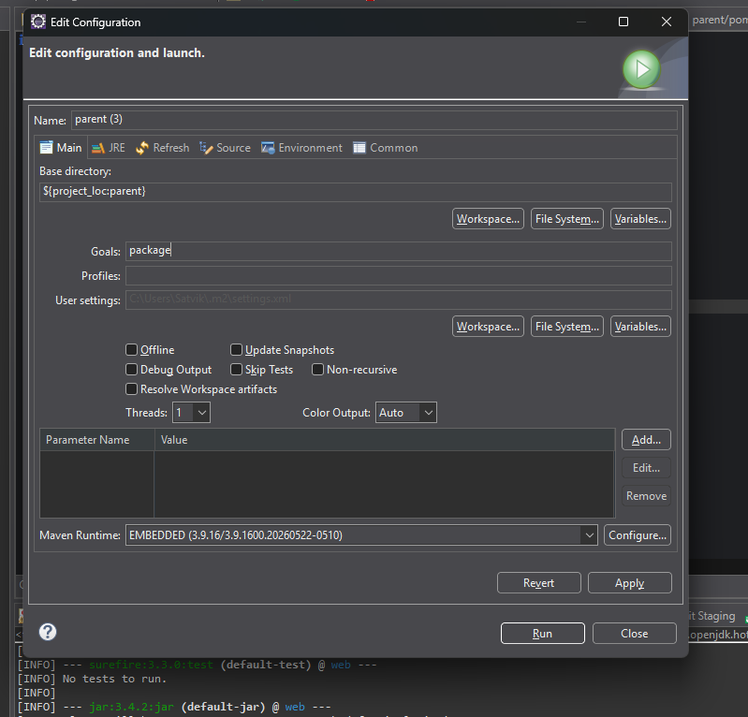

9.Building a war file
Create a Maven web project with structure:
src/main/webapp/
└── WEB-INF/web.xml

Add:
<packaging>war</packaging>
Command:
mvn package
Generates target/mywebapp.war → deploy on Tomcat server.
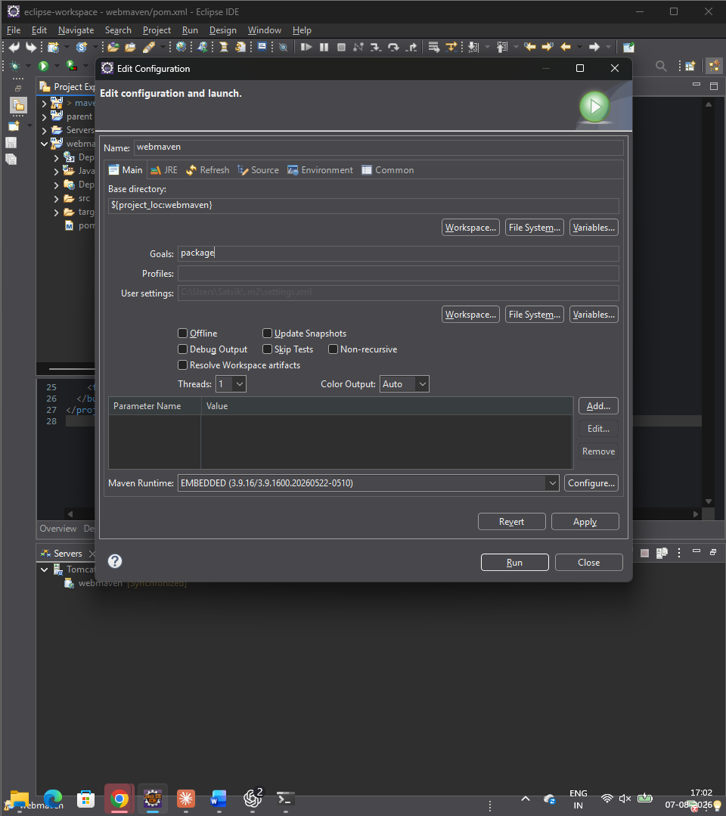

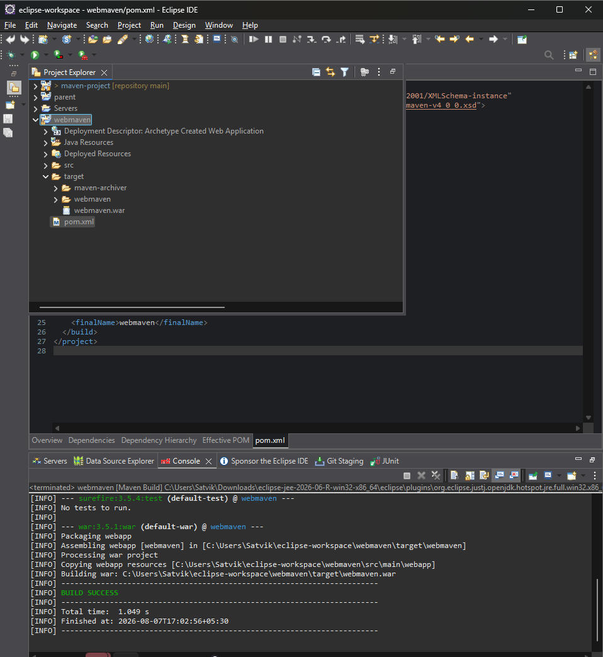

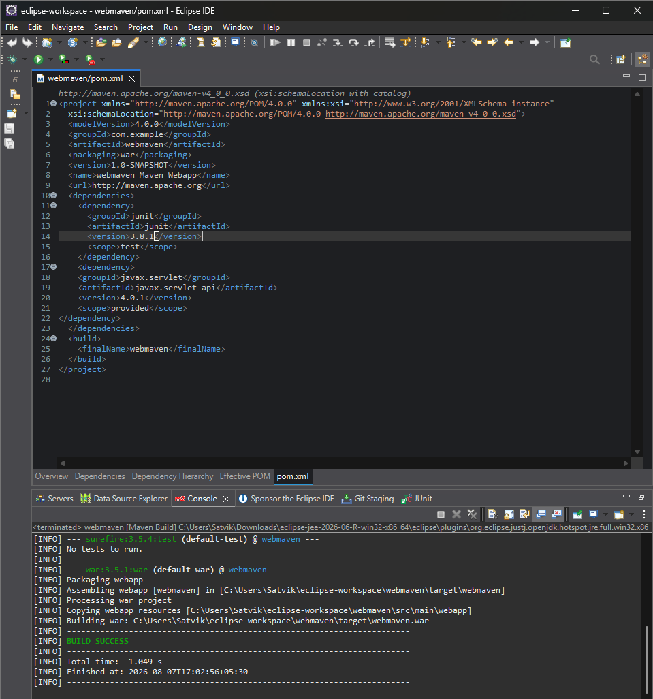

10.Scenario-Based Questions:
Q1. If your error is "Failed to execute goal maven-compiler-plugin:3.8.1:compile", how do you resolve it using Maven terminal?
Answer:
- Run the build with debug output to see the real cause: mvn clean compile -X
- Or use short error mode: mvn clean compile -e
- Check Java version alignment in pom.xml (source/target must match installed JDK)
- Verify which JDK Maven is using: mvn -version
- Force re-download of dependencies if corrupted: mvn clean compile -U
Q2. A dependency you added is not recognized by the compiler. How do you confirm it is available in .m2 and listed in the dependency tree?
Answer:
- Check pom.xml entry for correct groupId, artifactId, version
- Print dependency tree: mvn dependency:tree
- Search for the specific dependency: mvn dependency:tree | grep <artifact-name>
- Check if it physically exists in local repo: find ~/.m2/repository -iname "<artifact-name>*"
- Force re-resolve dependencies: mvn clean install -U
- Confirm it is on the classpath: mvn dependency:build-classpath
Q3. A teammate sends a .patch file for a bug fix. How would you apply it and include it in your Maven build?
Answer:
- Dry run to check the patch applies cleanly: git apply --check teammate-fix.patch
- Apply the patch: git apply teammate-fix.patch
- For non-git diffs: patch -p1 < teammate-fix.patch
- Review changes: git status and git diff
- Rebuild the project: mvn clean install
- Commit the change: git add . followed by git commit -m "Apply patch"
Q4. You have multiple JUnit test failures and want to rerun only failed tests. How would you approach this?
Answer:
- Run full test suite first: mvn test
- Rerun failed tests automatically: mvn test -Dsurefire.rerunFailingTestsCount=2
- Target specific failed test classes: mvn test -Dtest=ClassA,ClassB
- Check failure details in report files: target/surefire-reports/
Q5. Your Maven build fails due to "Unsupported class version error." What plugin and configuration would you review?
Answer:
- Review maven-compiler-plugin configuration in pom.xml
- Check source and target tags, or use the release tag instead
- Confirm JDK version being used: mvn -version and java -version
- Ensure source/target/release matches the JVM that will run the compiled code
Q6. You need to change your Java application from a WAR to a standalone JAR. What pom.xml changes are needed?
Answer:
- Change packaging tag value from war to jar
- Remove maven-war-plugin from build plugins
- Remove or adjust servlet-api and other container-provided dependencies
- Delete src/main/webapp directory if no longer needed
- Add maven-jar-plugin and specify mainClass in the manifest configuration
- Optionally add maven-shade-plugin to bundle dependencies into one runnable JAR
Q7. You are required to change the default build output directory from target/ to build_output/. How would you configure it?
Answer:
- Add a directory tag inside the build section of pom.xml:
<build>
<directory>${project.basedir}/build_output</directory>
</build>
- This redirects compiled classes, test classes, final artifact, and reports to the new folder
Q8. You want to skip tests during the Maven build. What command would you use?
Answer:
- Skip running tests but still compile them: mvn install -DskipTests
- Skip both compiling and running tests: mvn install -Dmaven.test.skip=true
Q9. How would you generate a site report (with test coverage, dependency analysis) for a Maven project?
Answer:
- Add JaCoCo plugin to pom.xml for coverage reporting
- Run tests to generate coverage data: mvn test
- Generate the full site report: mvn site
- View the report: open target/site/index.html
- For dependency analysis only: mvn dependency:analyze
Q10. How do you build a Java project using Maven, and what files are generated in the target/ folder after running mvn clean install?
Answer:
- Command: mvn clean install
- Files generated:
  - classes/ (compiled main source)
  - test-classes/ (compiled test source)
  - surefire-reports/ (test result reports)
  - final packaged artifact (.jar or .war)
  - maven-archiver/pom.properties (build metadata)
Q11. How does Maven resolve dependency conflicts when two libraries use different versions of the same dependency, and how can you view and manage the dependency tree?
Answer:
- Maven uses "nearest wins" strategy — the version declared closest to your project wins
- If both are at the same depth, the one declared first in pom.xml wins
- View tree: mvn dependency:tree
- View with conflict details: mvn dependency:tree -Dverbose
- Force a specific version by declaring it directly in your own dependencies section
- Exclude an unwanted transitive version using the exclusions tag
- Enforce consistent versions across modules using dependencyManagement
Q12. How do you write and run a JUnit test in a Maven project, and where are the compiled test classes and reports stored after running mvn test?
Answer:
- Add JUnit dependency with test scope in pom.xml
- Place test class under src/test/java, matching the package of the class under test
- Run tests: mvn test
- Compiled test classes location: target/test-classes/
- Test reports location: target/surefire-reports/
Q13. How can you create an executable JAR with a main method using Maven, and which plugin helps configure this behavior?
Answer:
- Use maven-jar-plugin to set the Main-Class in the manifest
- If dependencies also need to be bundled, add maven-shade-plugin or maven-assembly-plugin (with jar-with-dependencies descriptor)
- Build and run: mvn clean package followed by java -jar target/app.jar
Q14. How do you install and use a custom third-party JAR file in your Maven project, and how can you confirm it's included in the build and classpath?
Answer:
- Install into local repo: mvn install:install-file -Dfile=lib.jar -DgroupId=com.custom -DartifactId=custom-lib -Dversion=1.0 -Dpackaging=jar
- Reference it as a normal dependency in pom.xml using the same coordinates
- Confirm inclusion in tree: mvn dependency:tree | grep custom-lib
- Confirm it's on the classpath: mvn dependency:build-classpath
- Confirm file exists in repo: find ~/.m2/repository/com/custom -name "*.jar"
Q15. How do you create a Maven web project that packages into a WAR file, and what is the standard folder structure for such a project?
Answer:
- Generate project: mvn archetype:generate -DarchetypeArtifactId=maven-archetype-webapp
- Set packaging tag to war in pom.xml
- Standard structure:
  - src/main/java (Java source)
  - src/main/resources (config files)
  - src/main/webapp/WEB-INF/web.xml (deployment descriptor)
  - src/main/webapp/index.jsp
  - src/test/java (unit tests)
Q16. What command do you use to build a WAR file in Maven, where is it generated, and how can you deploy it to a server like Apache Tomcat?
Answer:
- Build command: mvn clean package
- Output location: target/<artifactId>-<version>.war
- Deployment options:
  - Manual copy: cp target/app.war $CATALINA_HOME/webapps/
  - Automated deploy using tomcat7-maven-plugin: mvn tomcat7:deploy
  - Manual upload through Tomcat Manager web interface
Q17. How do you add JSTL and servlet-api dependencies in a Maven web project, and why should the servlet API use provided scope instead of compile?
Answer:
- Add jstl-api and jstl-impl dependencies to pom.xml
- Add javax.servlet-api dependency with scope set to provided
- Reason for provided scope:
  - The servlet container (Tomcat) already supplies this at runtime
  - provided makes it available only at compile time, excluding it from the packaged WAR
  - Prevents duplicate/conflicting servlet-api versions between your app and the container
Q18. How do you set up a multi-module Maven web project with separate modules for core logic and web interface, and how are these modules built and connected?
Answer:
- Parent pom.xml has packaging set to pom and lists modules: core-module, web-module
- Each child module declares a parent section referencing the parent pom
- web-module includes core-module as a normal dependency
- Build entire project from parent directory: mvn clean install
- Maven's reactor automatically builds core-module first, then web-module, based on the dependency order
Q19. How do you configure a Maven web project, and how does its packaging and execution differ from a traditional WAR-based application?
Answer:
- Typically refers to a Spring Boot style project using spring-boot-starter-web and spring-boot-maven-plugin
- Packaging tag set to jar
- Build and run: mvn clean package followed by java -jar target/app.jar
- Key differences from traditional WAR:
  - Packaged as a self-contained executable JAR with an embedded server (Tomcat/Jetty)
  - Runs directly with java -jar, no external app server needed
  - Servlet container bundled with compile scope instead of provided
  - Better suited for containerized (Docker) and cloud deployments

Conclusion
Mastering Maven empowers students to structure projects efficiently, manage complex dependencies, and automate testing and packaging. By practicing real-world scenarios—such as resolving build errors, handling resource files, applying patches, and deploying to servers—students gain valuable hands-on experience aligned with professional software development workflows. Maven not only streamlines builds but also enforces standardization and reusability across projects. Through Maven, students learn efficient project management, dependency control, multi-module integration, and reproducible builds. Understanding Maven’s lifecycle, plugin system, and error handling prepares students for professional DevOps and CI/CD workflows. This lab equips students with hands-on experience in packaging, testing, resolving conflicts, and deploying real-world Java and Web applications.

